I220999
ShaharyarRizwan
CS-B
Web Task2 Report

My version of the game
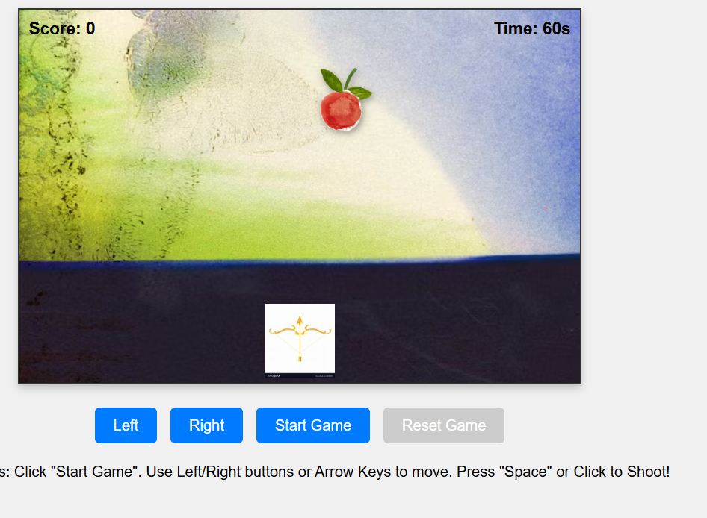

Gemini Version of the Game
Gemini Prompt: Provide me the complete codes for all the files in order to complete this assignment, make it as good as possible and also make the game aesthetic and pleasing to the eye.I also attached the index.html and .pdf files given by Ma’am.
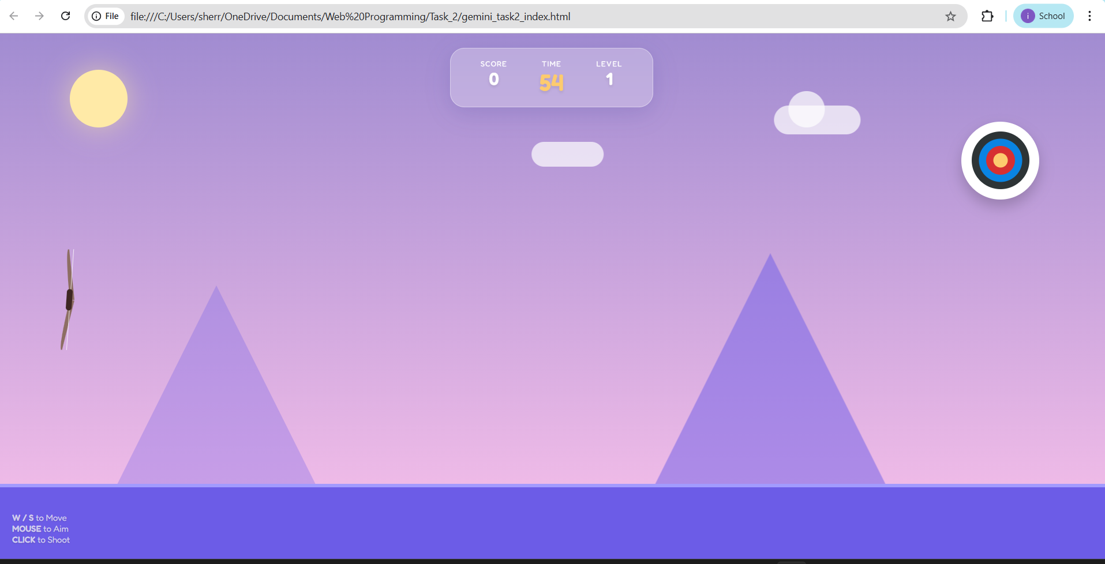

Difference between Gemini and my version
The Gemini version is much more visually appealing due to CSS-only scenery while my version is a simple boxed game container with background images taken from google, furthermore in Gemini the difficulty of the game is better as it also added obstacles whereas I made the target shrink in size and speed up. In gemini the bow can move in any direction while in my version it can only move horizontally

