Information Security-Assignment 2 Report
Shaharyar Rizwan
I220999
Cs-A

1. GitHub Workflow
I forked and then cloned the repo that was provided to us and committed all the code files to the repo which can be easily accessed.

2. PKI Setup & Certificates

2.1. Implementation
The system is built on a custom Public Key Infrastructure (PKI). This was implemented using two Python scripts:
- scripts/gen_ca.py: This script generates a 4096-bit RSA private key (ca.key) and a self-signed X.509 root certificate (ca.crt).
- scripts/gen_cert.py: This script uses the CA's key and certificate to issue new, signed certificates for end-entities. We use this to generate server.crt/server.key and client.crt/client.key.

2.2. Certificate Verification
During the initial handshake, mutual authentication is performed:
- The client sends its certificate to the server.
- The server sends its certificate to the client.
- The server uses pki.verify_certificate() to check that the client's certificate:
  - Has a valid signature from the known ca.crt.
  - Is not expired.
  - Has the expected Common Name (CN), "client".
- The client performs the exact same checks on the server's certificate.
If any check fails, the connection is immediately dropped with a "BAD_CERT" error, as demonstrated in the Testing section.

2.3. Evidence (Certificate Inspection)
The following openssl command confirms the details of the server certificate, showing its Issuer (our Root CA) and Subject (the server itself).
Command:openssl x509 -in certs/server.crt -text -noout
Output: (venv) C:\Users\sherr\OneDrive\Documents\infoSec_Assignment2\securechat-skeleton-i220999>openssl x509 -in certs/server.crt -text -noout
Certificate:
Data:
Version: 3 (0x2)
Serial Number:
2d:9e:43:e1:2f:3a:ac:f4:f7:c7:9e:a1:2c:47:11:87:f4:f0:6f:e2
Signature Algorithm: sha256WithRSAEncryption
Issuer: C=PK, ST=Islamabad, L=Islamabad, O=FAST NUCES, CN=My SecureChat Root CA
Validity
Not Before: Nov 16 11:37:55 2025 GMT
Not After : Nov 16 11:37:55 2026 GMT
Subject: C=PK, ST=Islamabad, O=FAST NUCES, CN=server
Subject Public Key Info:
Public Key Algorithm: rsaEncryption
Public-Key: (2048 bit)
Modulus:
00:cd:7e:e8:00:93:95:da:ee:35:4a:00:8a:04:21:
9e:f8:b2:35:24:fc:91:ad:85:00:db:ec:43:8f:5e:
86:bb:48:4d:ef:59:58:dc:32:61:2c:21:e7:13:1b:
e4:e1:67:69:22:ed:13:7b:ed:4e:10:50:9f:05:5b:
f8:0b:0a:a6:72:20:c9:00:cc:09:86:4f:e0:8b:c4:
e3:75:28:cb:be:88:f7:65:35:81:6c:2e:d4:31:05:
10:af:25:a0:9f:11:95:b6:fc:28:fe:c2:9d:92:38:
94:89:33:29:17:f5:fc:29:25:48:78:8f:19:61:42:
17:56:d4:21:02:51:ca:99:70:80:db:cf:dc:21:a4:
c8:77:1f:88:a9:94:1c:a7:1f:57:85:4c:ef:c7:96:
e6:29:db:d4:ec:c9:12:2b:87:2d:37:5a:2f:f8:ca:
e4:bd:79:c0:dc:3b:86:df:69:08:b5:a8:c9:36:61:
53:ca:a3:fc:cd:af:06:72:68:5d:c9:5c:c2:b3:57:
31:95:48:fc:b1:65:bd:17:7e:6f:0c:3e:4c:2b:cb:
89:9e:40:47:9b:d6:68:a6:10:c9:b6:99:77:6f:91:
28:a3:a3:c4:2b:86:5f:1d:e1:2a:cb:66:90:70:b0:
b1:9a:b3:ed:0d:93:6d:f5:8f:1b:6a:51:b5:04:27:
05:5f
Exponent: 65537 (0x10001)
X509v3 extensions:
X509v3 Subject Alternative Name:
DNS:server
Signature Algorithm: sha256WithRSAEncryption
Signature Value:
55:ce:9d:d2:1f:88:cb:ff:2c:79:db:7f:d2:ab:02:22:e4:31:
03:39:53:60:ff:c6:d0:cf:7f:95:e7:99:65:3a:12:8b:2b:c8:
90:f7:aa:b7:a9:98:8b:be:93:3f:3f:d2:43:a6:ac:af:3b:7c:
7b:80:1e:54:c8:af:7f:01:c9:ca:36:a6:b1:60:42:fe:00:10:
6d:19:ba:5a:d0:5b:41:a7:e3:d0:3e:08:1f:23:f9:06:ab:43:
2c:ae:c1:4f:03:7f:57:ca:3f:92:90:df:26:65:36:08:17:37:
06:9a:1c:71:dd:da:08:fb:83:91:f7:f8:a5:d8:30:f4:7d:dd:
66:21:b9:c6:f1:3a:ef:04:43:61:1d:54:c6:a2:7e:dc:c9:57:
16:e0:65:b3:f6:fd:aa:bf:1e:4b:05:a3:1c:2c:82:c9:12:05:
c6:43:82:b9:4b:9b:6e:2e:d8:99:b2:60:95:9d:82:f7:50:b8:
b1:ab:9f:39:56:7a:eb:7c:ff:49:98:fb:ab:34:b8:57:5e:2b:
49:94:16:42:f2:1b:94:85:08:81:1a:45:b4:92:20:06:a5:32:
7d:1a:e5:a1:e4:bd:28:5f:2e:ab:7e:68:ae:3e:b6:7f:21:cd:
4a:7a:c6:a9:77:50:37:68:5a:da:0d:93:ad:13:c7:97:65:bb:
99:db:47:91:2f:14:4e:d7:ea:1b:46:54:02:b2:1b:15:15:44:
cf:97:91:63:11:57:8f:72:a4:77:c1:26:85:36:67:46:f9:24:
a1:64:4b:06:b5:7a:0b:e8:0d:c2:90:5c:4e:e8:9e:3a:dc:50:
9b:95:4f:3b:57:de:df:68:84:cd:8f:72:f4:49:db:35:63:5a:
68:eb:c0:8d:ba:53:3b:30:a3:10:5d:c0:f8:4f:7d:83:e6:b9:
ca:8a:c6:a8:f4:44:1e:3e:01:85:f0:68:6d:6f:81:08:06:13:
8b:e7:a3:22:65:4e:c0:8a:24:55:03:bf:6d:5f:ec:75:60:96:
89:84:3a:72:3f:16:34:ca:64:89:f2:b5:7d:54:62:a9:cf:45:
f5:97:a6:11:71:43:b5:e6:bd:4f:18:4d:9b:b9:93:6b:29:b3:
86:bd:ef:7c:f7:03:e3:e4:b3:90:a7:3e:3a:dd:33:c2:69:a7:
ec:4a:34:7e:b3:b0:e2:a4:0d:61:43:c2:ce:d1:ce:42:0e:4a:
2a:6f:64:6b:9d:c0:b7:9b:0e:6f:39:6f:fb:75:76:b1:2e:e2:
e3:ec:f4:05:5c:86:aa:f2:a5:ff:58:ba:21:83:9e:2e:94:9f:
0d:62:f7:ca:5f:7f:4a:94:4b:57:89:0a:fd:66:c5:8f:ab:02:
1a:8a:32:30:c9:34:78:4d

3. Registration & Login Security
This phase ensures user credentials are never transmitted in plaintext and are never stored in a reversible format.
- Temporary Key Exchange: After mutual certificate validation, the client and server perform a temporary Diffie-Hellman (DH) exchange
- Key Derivation: Both sides derive a temporary AES-128 key from this DH secret.
- Encrypted Credentials: The client sends its login data (email, password) encrypted with this temporary AES key.
- Server-Side Hashing: The server decrypts the payload.
  - On Register: The server generates a 16-byte random salt using utils.generate_salt() and hashes the password using utils.hash_password(salt, password).
  - On Login: The server fetches the user's salt from the database and re-computes the hash.
- Secure Storage: The server stores only the salt and the pwd_hash (a SHA-256 hex string) in the users table in MySQL ensuring passwords are not stored in plain text
- Verification: The login is successful only if the client-sent password, when hashed with the stored salt, matches the stored hash.
This process achieves confidentiality (no plaintext creds) and integrity (salted hashing).
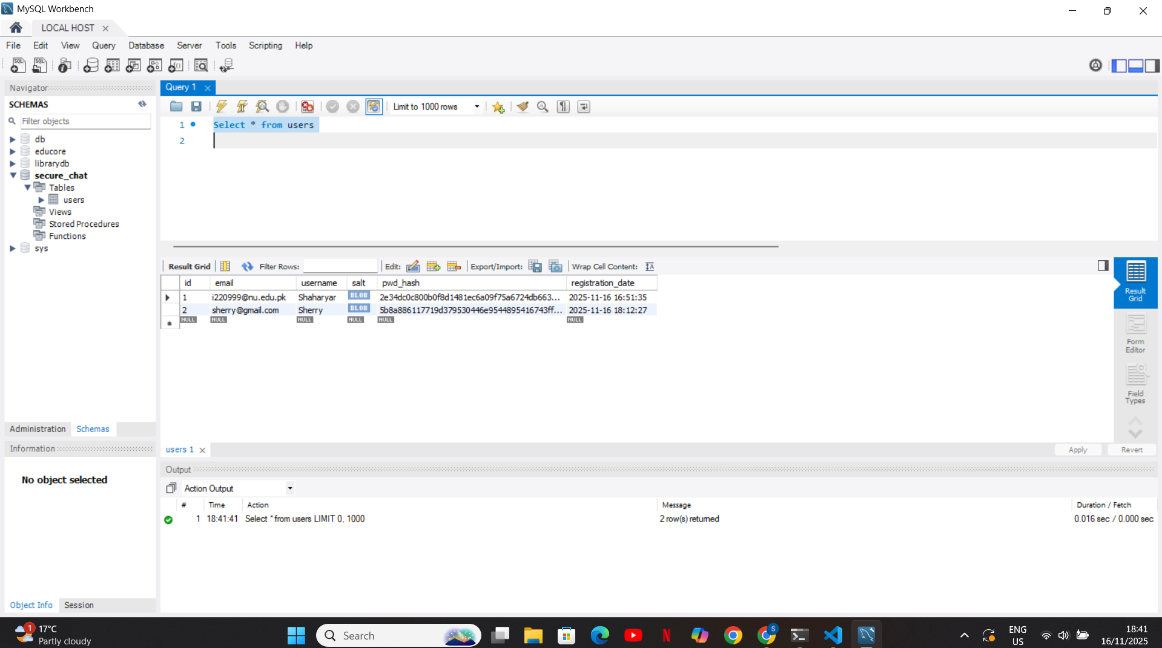

4. Encrypted Chat (AES-128)
Once a user is authenticated, a new key is established for the chat session.
- Session Key Exchange: A second, post-authentication DH exchange is performed
- Session Key Derivation: A unique, 16-byte AES-128 session key (session_key) is derived using the dh.derive_session_key function, which implements the K=Trunc16(SHA256(Ks)) formula from the spec.
- Confidentiality: All subsequent messages are encrypted using aes.encrypt_aes_cbc() and decrypted using aes.decrypt_aes_cbc(). This ensures all chat content is confidential.
This is proved by the Wireshark Test in the Testing section, which shows all application data is unreadable.

5. Integrity, Authenticity & Non-Repudiation
CIANR goals are met by signing every message and the entire session.
- Per-Message Integrity & Authenticity:
  - Before sending a message, the sender (e.g., client) computes h = SHA256(seqno || timestamp || base64(ciphertext)).
  - This hash h is signed with the client's client.key using sign.sign_data() (RSA-PSS).
  - The server receives the message, re-computes the same hash h, and verifies the signature using the client's public key (from client.crt) via sign.verify_signature().
  - If the signature is invalid, it's a "SIG_FAIL" (tampering). This provides per-message integrity and authenticity.
- Non-Repudiation (SessionReceipt):
  - The TranscriptManager class logs every verified message (from both sides) to an in-memory list.
  - At logout, the client computes Transcript_Hash = SHA256(full_transcript_string).
  - The client signs this Transcript_Hash with its private key, creating a SessionReceipt.
  - This receipt is saved to server_session_receipt.json and the log to server_transcript.log.
  - The verify_transcript.py script proves this: it re-computes the hash of the log file and compares it to the hash in the signed receipt. If they match, the transcript is authentic and unmodified.
This is proven by the Tampering Test in the Testing section.

6. Testing & Evidence
This section provides the evidence for the claims made above.

6.1. Wireshark Test (Confidentiality)
Test: I ran the client and server while capturing on the loopback adapter. I registered, logged in, and sent messages. Result: As shown below, the TCP stream for the port 12345 shows the certificates in plaintext (as expected), but all subsequent data, including the login credentials and chat messages, is encrypted and unreadable.
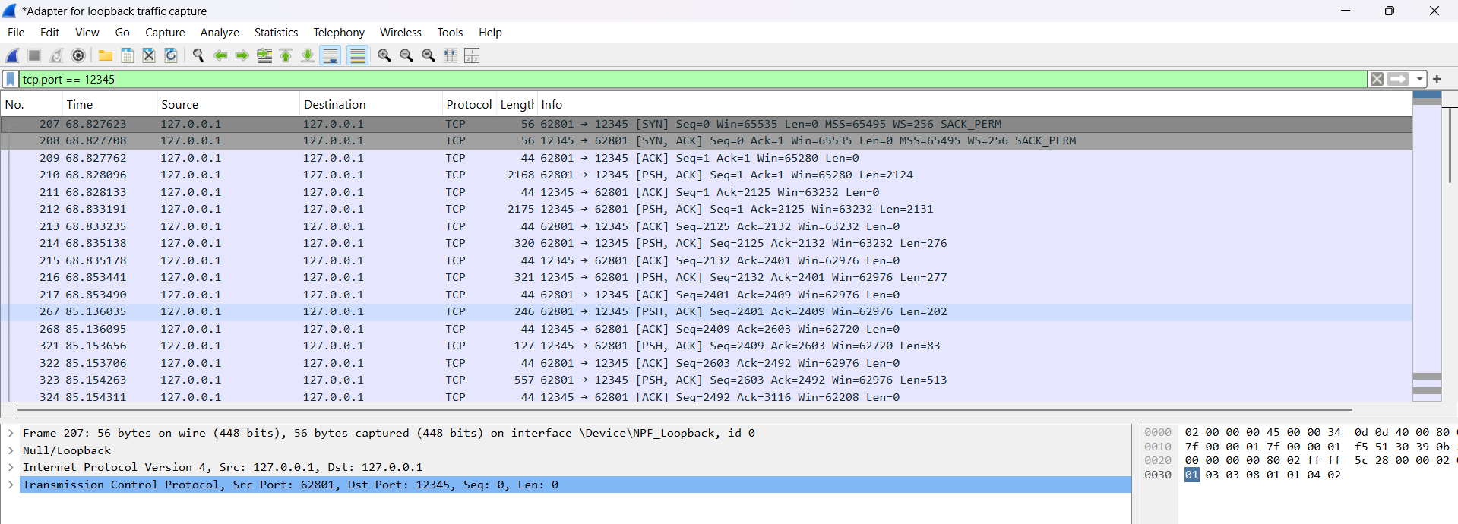
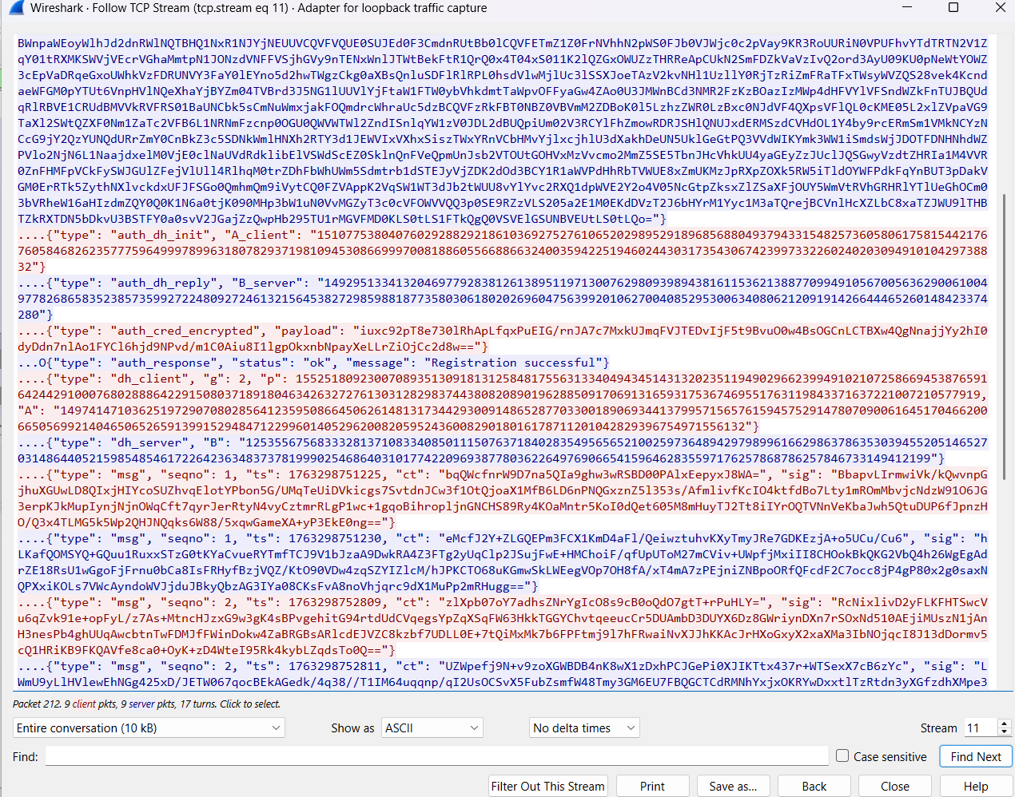
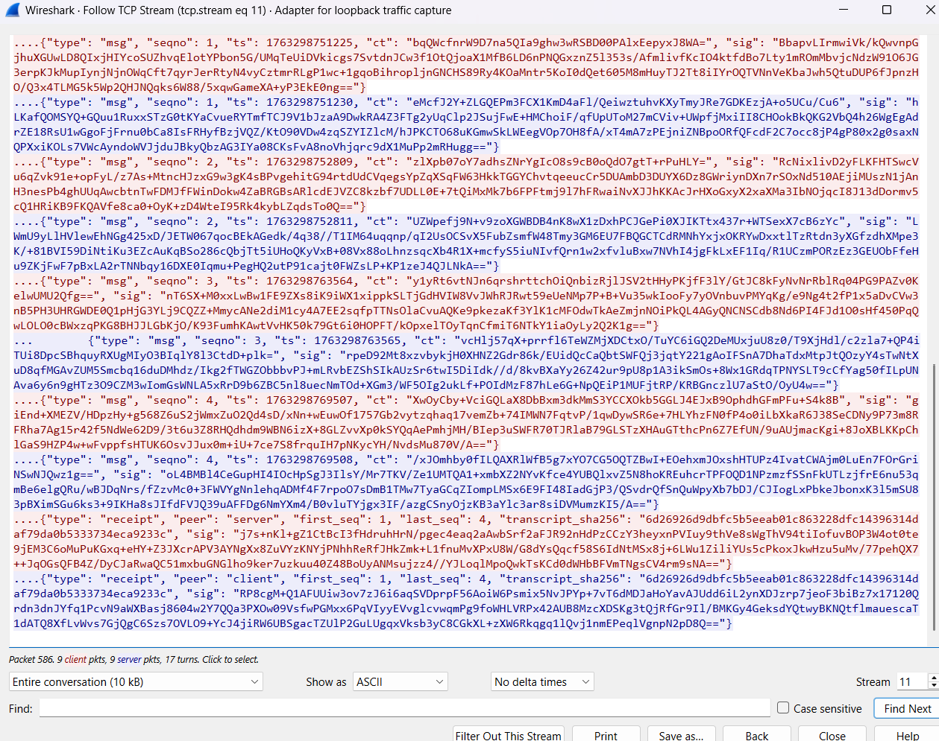

6.2. Invalid Certificate Test (Authenticity)
Test: I modified app/server.py to expect a Common Name of "wrong_name" instead of "client". Result: The server immediately rejected the client's valid certificate. The server console shows the "CN mismatch" error, and the client console shows the BAD_CERT message from the server. This proves the server's certificate validation logic is working correctly.
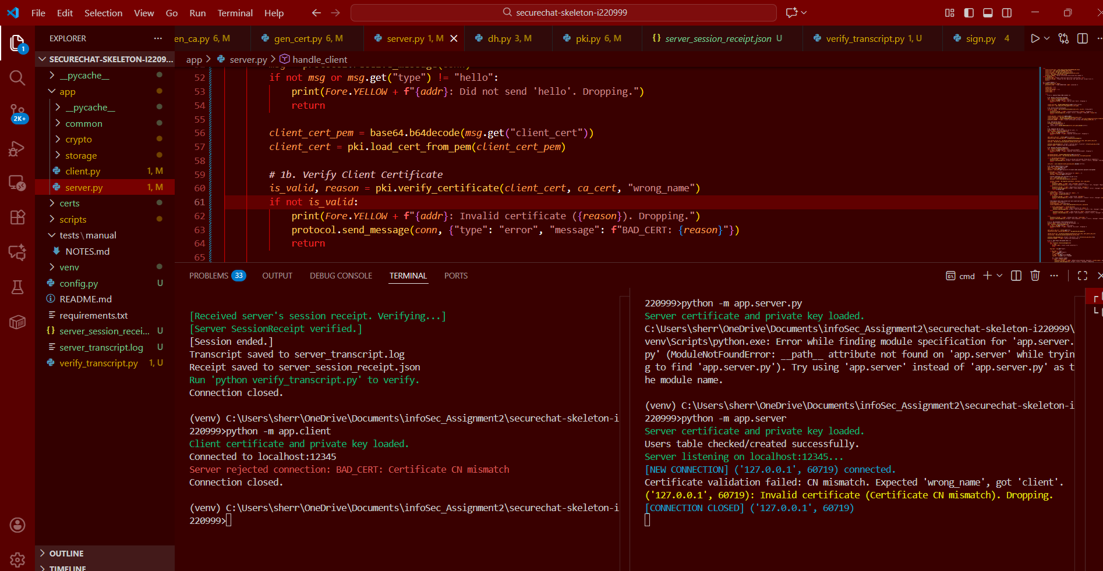

6.3. Tampering Test (Integrity & Non-Repudiation)
Test: I ran a full session, then manually modified the server_transcript.log file by adding !!TAMPERED!! to it. I then ran the verifier script. Result: The verifier script detected the modification. It re-computed the hash of the tampered file, found it did not match the hash stored in the signed server_session_receipt.json, and reported a "HASH MISMATCH". This proves the session receipt guarantees the integrity of the transcript.
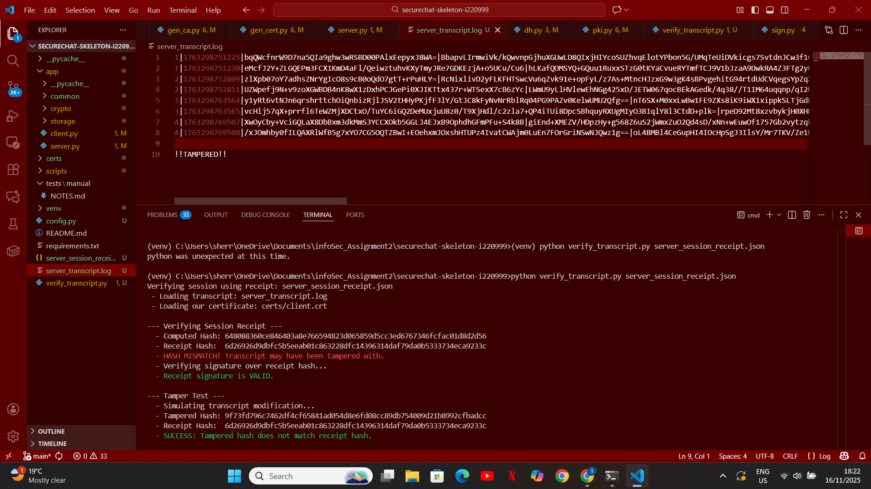

6.4. Replay Test (Freshness)
Test: I modified app/client.py to send every message twice, back-to-back. The server should accept the first one (e.g., seqno=1) and reject the identical second one (also seqno=1) as a replay.
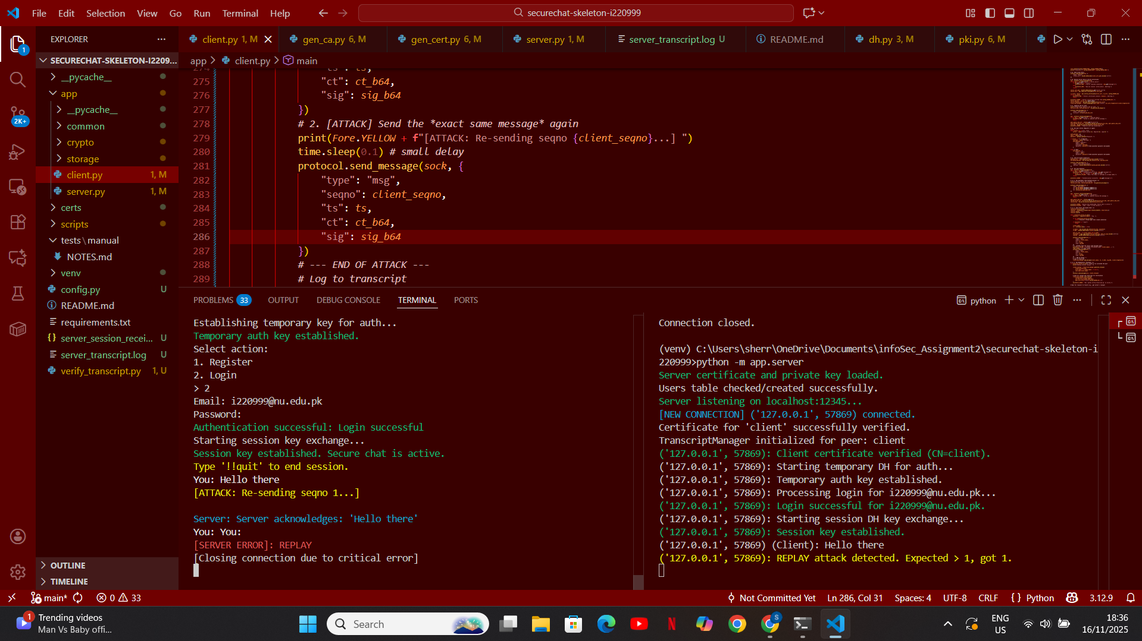

6.5.- Transcript + signed SessionReceipt
