1. Testing & Evidence

1.1. Wireshark Test (Confidentiality)
Test: I ran the client and server while capturing on the loopback adapter. I registered, logged in, and sent messages. Result: As shown below, the TCP stream for the port 12345 shows the certificates in plaintext (as expected), but all subsequent data, including the login credentials and chat messages, is encrypted and unreadable.
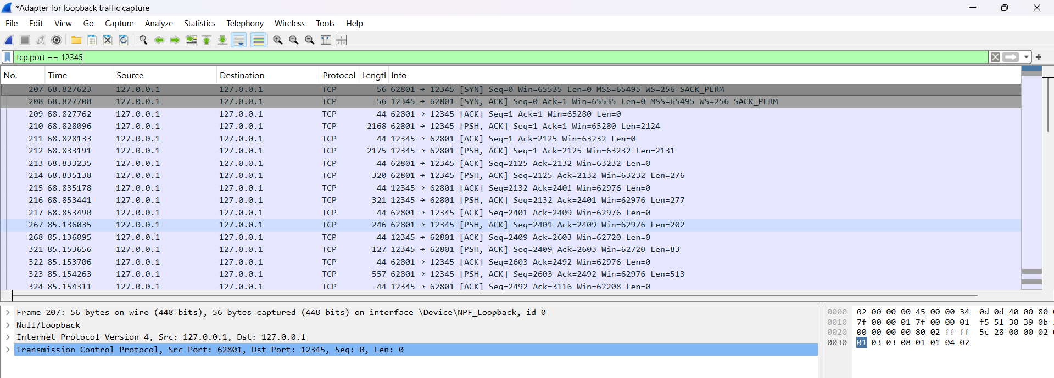
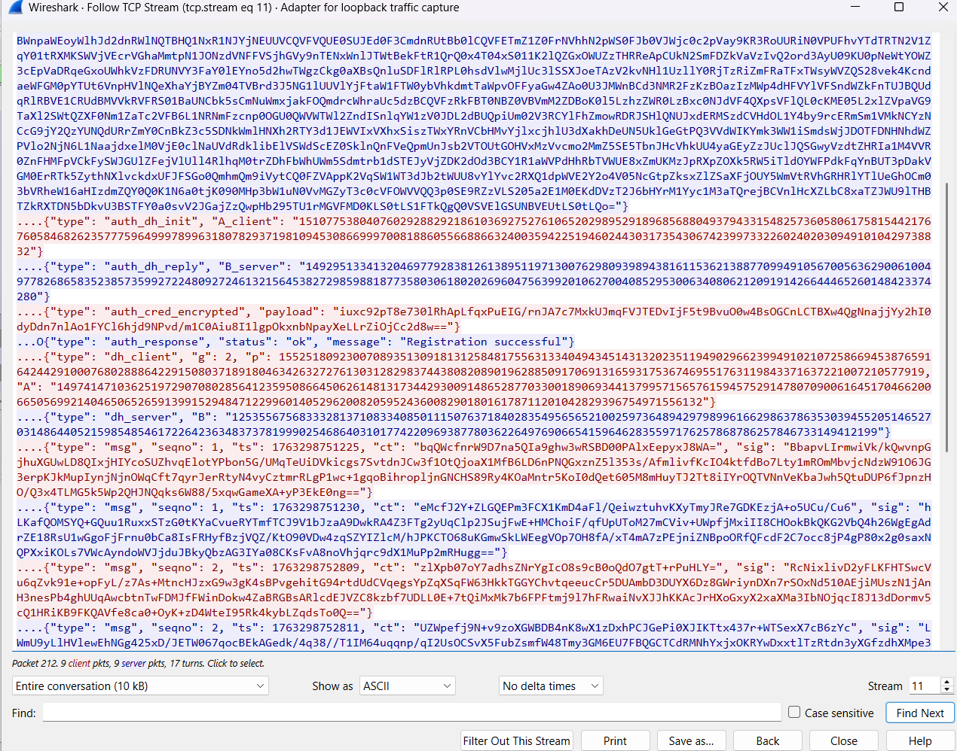
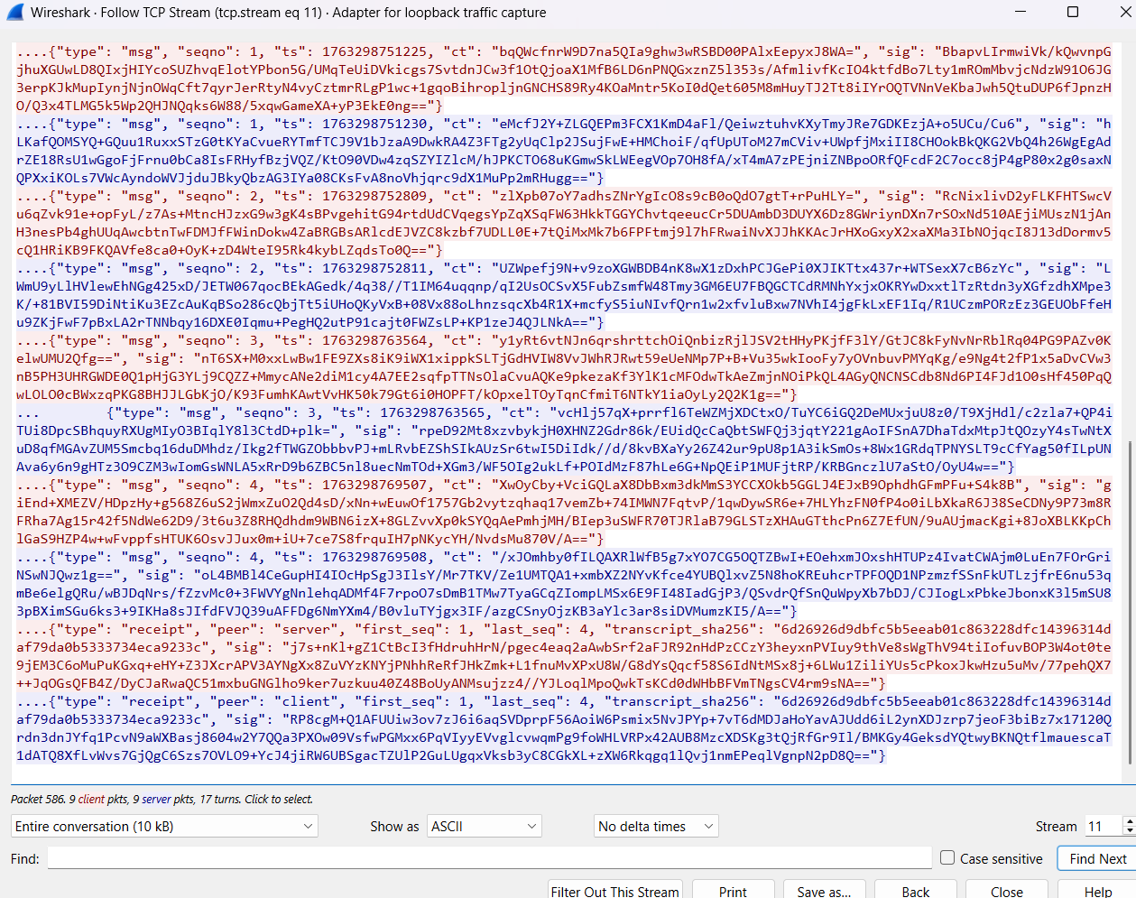

1.2. Invalid Certificate Test (Authenticity)
Test: I modified app/server.py to expect a Common Name of "wrong_name" instead of "client". Result: The server immediately rejected the client's valid certificate. The server console shows the "CN mismatch" error, and the client console shows the BAD_CERT message from the server. This proves the server's certificate validation logic is working correctly.
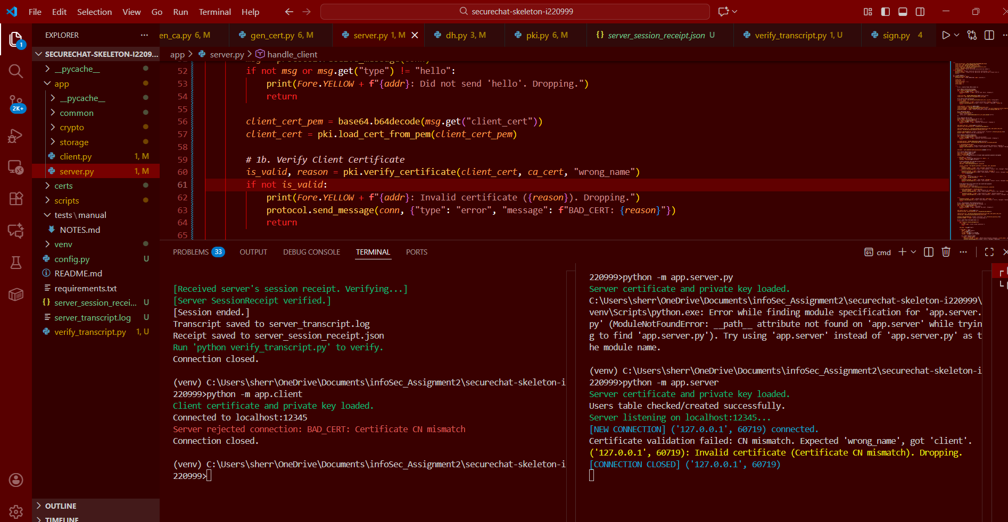

1.3. Tampering Test (Integrity & Non-Repudiation)
Test: I ran a full session, then manually modified the server_transcript.log file by adding !!TAMPERED!! to it. I then ran the verifier script. Result: The verifier script detected the modification. It re-computed the hash of the tampered file, found it did not match the hash stored in the signed server_session_receipt.json, and reported a "HASH MISMATCH". This proves the session receipt guarantees the integrity of the transcript.
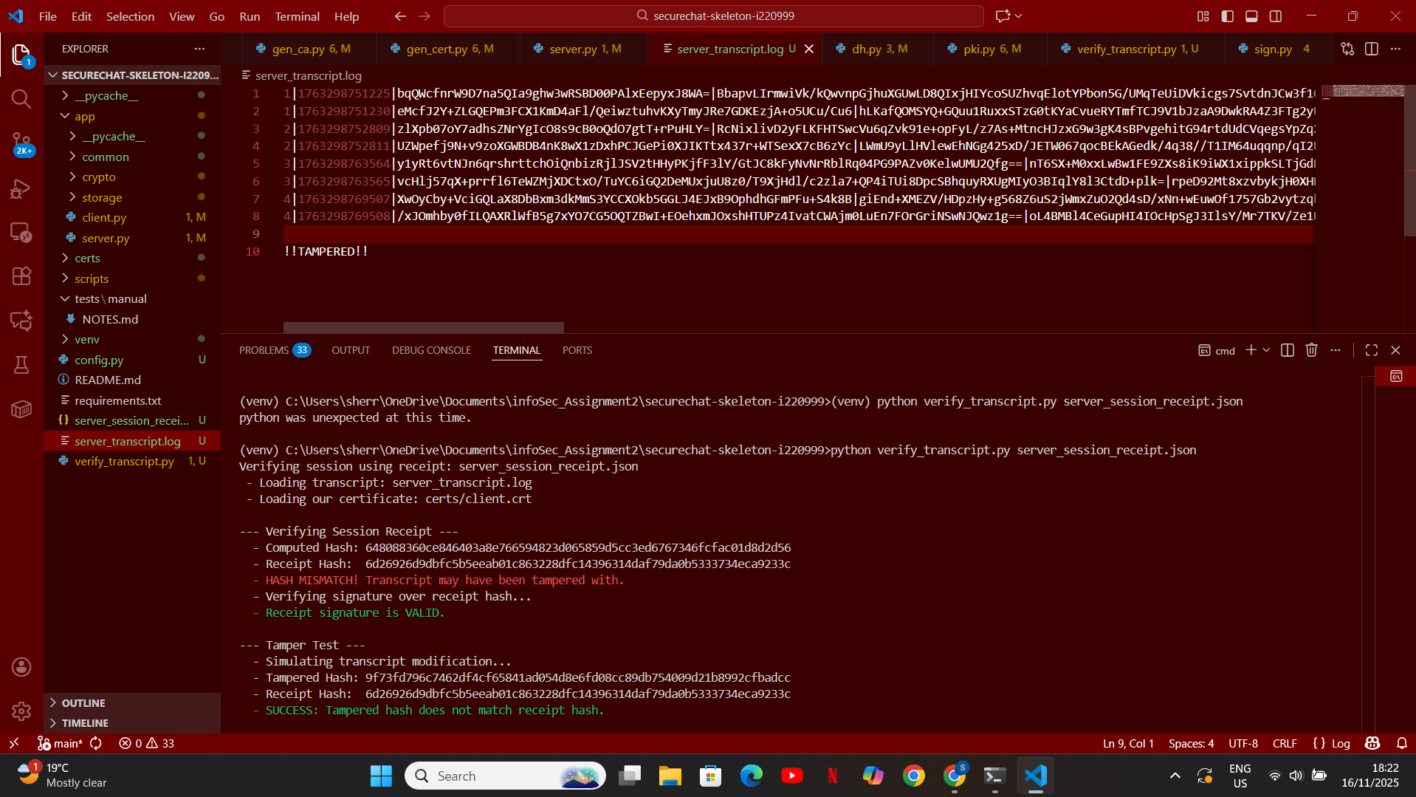

1.4. Replay Test (Freshness)
Test: I modified app/client.py to send every message twice, back-to-back. The server should accept the first one (e.g., seqno=1) and reject the identical second one (also seqno=1) as a replay.
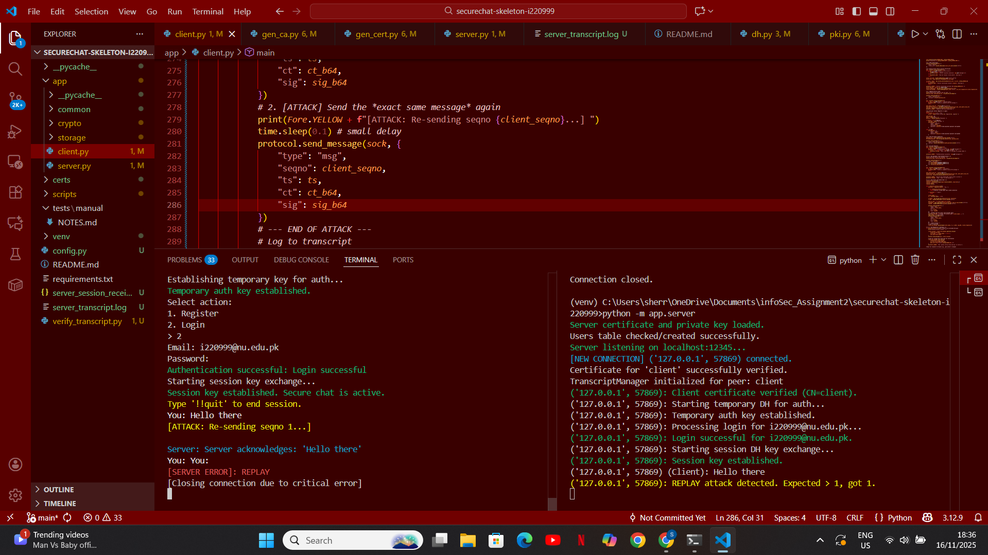

1.5.- Transcript + signed SessionReceipt
