🧠 Dietician Agent - Complete Learning Guide
A comprehensive guide to understanding how this AI-powered dietician application was built using Ollama, FastAPI, MongoDB, and React.

Table of Contents
- 1. Project Overview
- 2. Architecture
- 3. Technology Stack
- 4. Backend Deep Dive
- 5. Ollama Integration - Deep Dive
- 6. Database Design
- 7. API Endpoints
- 8. Frontend Overview
- 9. How to Explain This Project

1. Project Overview

What Does This Application Do?
The Dietician Agent is an AI-powered health assistant that:
- Analyzes lab reports using computer vision (OCR)
- Identifies health issues from extracted lab values
- Generates personalized 7-day meal plans based on health conditions
- Tracks patient progress over time to improve recommendations

Key Innovation
This project runs entirely on local hardware using Ollama - no cloud APIs, no subscription costs, and complete data privacy.

2. System Architecture
The following diagram shows how all components interact:
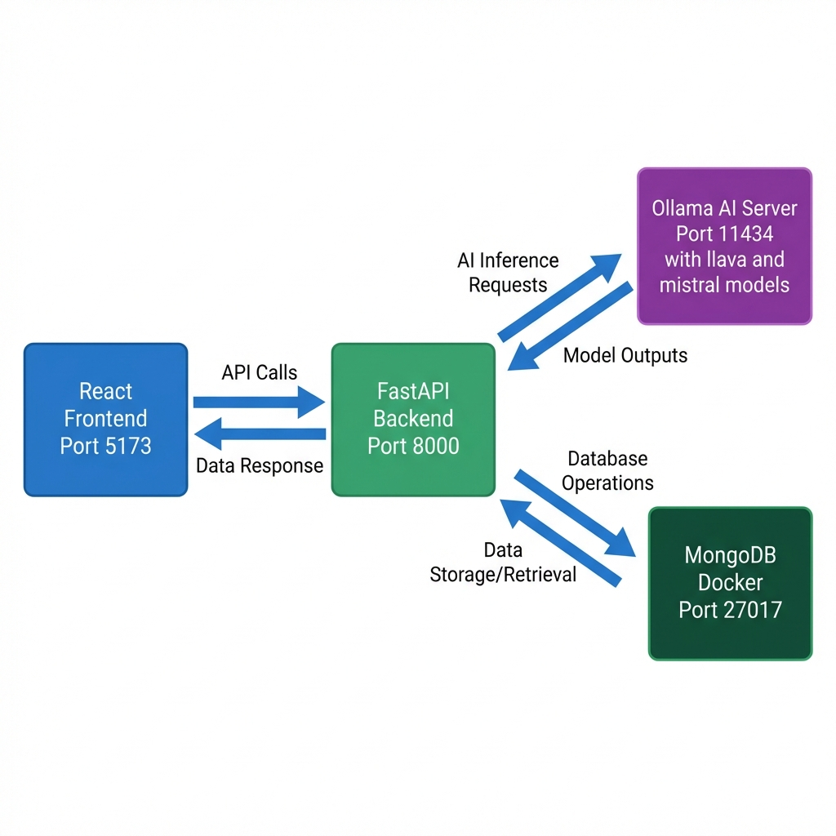

Data Flow
Here is the step-by-step flow of data through the system:
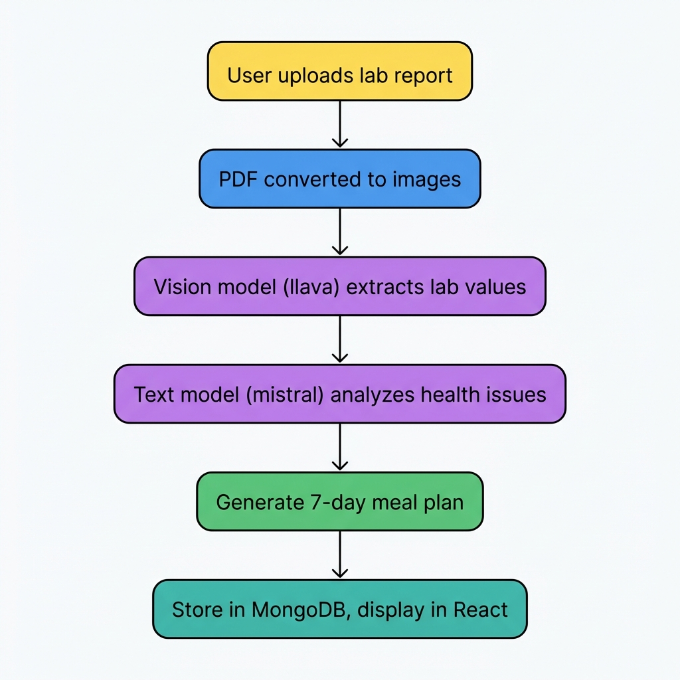

3. Technology Stack
Layer | Technology | Purpose
Frontend | React + Vite | User interface
Backend | FastAPI (Python) | REST API server
Database | MongoDB (Docker) | Store patients, reports, plans
AI Runtime | Ollama | Run LLMs locally
Vision Model | llava:7b | Extract text from images
Text Model | mistral / llama3.2 | Generate analysis & plans

Why These Technologies?
FastAPI: Async Python framework, perfect for AI workloads
MongoDB: Schema-less, handles varied lab report structures
Ollama: Simple API for running open-source LLMs locally
React: Modern, component-based UI

4. Backend Deep Dive

Project Structure
backend/
├── app/
│ ├── config.py # Environment variables
│ ├── main.py # FastAPI app setup
│ ├── database/
│ │ └── mongodb.py # Database connection
│ ├── models/
│ │ ├── patient.py # Pydantic models for patients
│ │ ├── lab_report.py # Models for lab data
│ │ └── diet_plan.py # Models for meal plans
│ ├── routes/
│ │ ├── patients.py # Patient CRUD endpoints
│ │ ├── reports.py # Lab report upload/analysis
│ │ └── diet.py # Diet plan generation
│ └── services/
│ ├── ollama_client.py # Wrapper for Ollama API
│ ├── ocr_service.py # Lab report extraction
│ ├── diet_planner.py # Meal plan generation
│ └── progress_analyzer.py # Track improvements
├── .env # Configuration
└── requirement.txt # Dependencies

config.py - Configuration Management
from pydantic_settings import BaseSettings
class Settings(BaseSettings):
mongodb_url: str # MongoDB connection string
ollama_url: str # Ollama server address
vision_model: str # Model for OCR (llava:7b)
text_model: str # Model for text (mistral)
ollama_timeout: int # Request timeout
class Config:
env_file = ".env" # Load from .env file
settings = Settings()

Why Pydantic Settings?
- Automatically reads from .env file
- Type validation at startup
- Easy to change models without code changes

5. Ollama Integration - Deep Dive
This is the core innovation of the project!

What is Ollama?
Ollama is a tool that lets you run Large Language Models (LLMs) locally on your own computer. Think of it as "Docker for AI models."
Feature | Cloud APIs (OpenAI) | Ollama (Local)
Cost | $0.01-0.06 per 1K tokens | Free forever
Privacy | Data sent to cloud | Data stays local
Speed | Depends on internet | Depends on GPU
Availability | Requires internet | Works offline

How Ollama Works
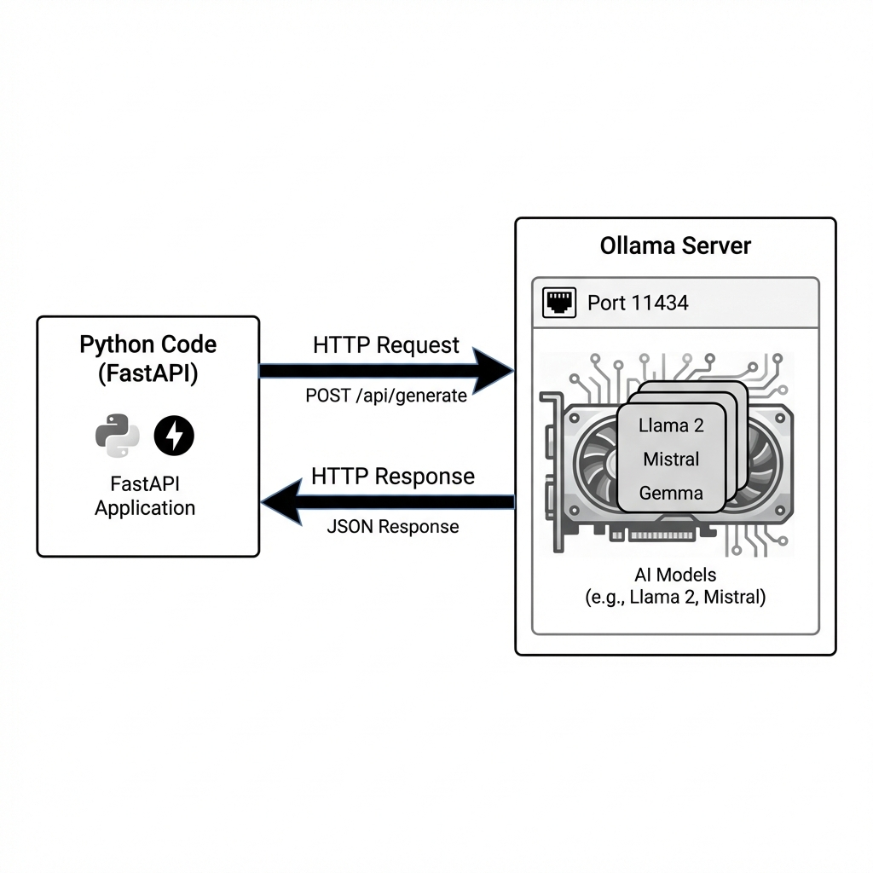

Key Insight: Ollama is just an HTTP server. Your code doesn't need any special Ollama library - just make HTTP requests!

The ollama_client.py Code
import httpx
import base64
from app.config import settings
class OllamaClient:
def __init__(self):
# Ollama server URL from .env
self.base_url = settings.ollama_url
self.timeout = httpx.Timeout(float(settings.ollama_timeout))
async def generate(self, model: str, prompt: str, num_predict: int = 8192):
"""Send a text prompt and get a response"""
async with httpx.AsyncClient(timeout=self.timeout) as client:
response = await client.post(
f"{self.base_url}/api/generate",
json={
"model": model,
"prompt": prompt,
"stream": False,
"options": {
"num_predict": num_predict,
"num_ctx": 8192,
}
},
)
return response.json()["response"]
async def generate_with_image(self, model: str, prompt: str, image_path: str):
"""Send an image to a vision model"""
with open(image_path, "rb") as f:
image_b64 = base64.b64encode(f.read()).decode()
async with httpx.AsyncClient(timeout=self.timeout) as client:
response = await client.post(
f"{self.base_url}/api/generate",
json={
"model": model,
"prompt": prompt,
"images": [image_b64], # KEY: Base64 encoded images
},
)
return response.json()["response"]

Key Parameters
Parameter | Purpose
num_predict | Maximum tokens to generate (increase for longer outputs)
num_ctx | Context window size (input + output tokens)
temperature | Randomness (0 = deterministic, 1 = creative)
stream | Set false to get complete response at once

Common Ollama Issues & Solutions
Issue | Cause | Solution
Connection refused | Ollama not running | Run ollama serve on desktop
Model not found | Model not downloaded | Run ollama pull model_name
Response cut off | num_predict too low | Increase to 8192 or higher
Timeout error | Model too slow | Increase OLLAMA_TIMEOUT in .env
Out of memory | Model too big | Use smaller model (7b vs 13b)

6. Database Design

Collections

patients
{
"_id": "ObjectId",
"name": "John Doe",
"email": "john@example.com",
"dietary_preference": {
"type": "veg",
"allergies": ["nuts", "dairy"],
"cuisines": ["Indian", "Mediterranean"],
"meal_frequency": 3
},
"created_at": "2024-01-17T12:00:00Z"
}

lab_reports
{
"_id": "ObjectId",
"patient_id": "string",
"extracted_data": {
"hemoglobin": {"value": 14.5, "unit": "g/dL", "status": "normal"},
"glucose": {"value": 126, "unit": "mg/dL", "status": "high"}
},
"health_analysis": {
"issues": ["Elevated glucose indicates prediabetes"],
"recommendations": ["Reduce sugar intake"]
}
}

7. API Endpoints

Patients API
Method | Endpoint | Description
POST | /api/patients/ | Register new patient
GET | /api/patients/search?email=... | Find patient by email
GET | /api/patients/{id} | Get patient details
GET | /api/patients/{id}/history | Get all reports and plans

Reports API
Method | Endpoint | Description
POST | /api/reports/upload | Upload and analyze lab report
GET | /api/reports/{id} | Get report details

Diet Plans API
Method | Endpoint | Description
POST | /api/diet/generate/{report_id} | Generate 7-day meal plan
GET | /api/diet/{id} | Get diet plan details

8. Frontend Overview

Component Structure
frontend/src/
├── components/
│ ├── PatientForm.jsx # New patient registration
│ ├── LabReportUpload.jsx # Drag & drop file upload
│ ├── HealthAnalysis.jsx # Display extracted lab data
│ └── DietPlanView.jsx # 7-day meal plan display
├── services/
│ └── api.js # API client for backend
├── App.jsx # Main app with navigation
└── index.css # Dark theme styling

9. How to Explain This Project

Elevator Pitch (30 seconds)
"I built an AI-powered dietician that runs entirely on local hardware. It uses computer vision to read lab reports, identifies health issues like high cholesterol or diabetes risk, and generates personalized 7-day meal plans. The key innovation is using Ollama to run open-source models like Llava and Mistral locally, so there's no cloud dependency and complete data privacy."

Technical Deep Dive (5 minutes)
1. The Problem:
Traditional health apps require expensive APIs like OpenAI or cloud-based services. I wanted to build something that runs completely locally.
2. The Solution:
I used Ollama, which lets you run LLMs on consumer hardware. On my RTX 3070 with 8GB VRAM, I can run vision models and text generation locally.
3. Key Challenges:
• Vision models sometimes hallucinate values - I added validation
• JSON parsing was tricky - LLMs don't always output valid JSON
• Response truncation - had to increase num_predict to 8192 tokens
4. What I Learned:
• How to integrate AI models into production applications
• The importance of prompt engineering for structured output
• Async programming patterns with FastAPI
• How to handle AI failures gracefully in UX

Key Takeaways
1. Ollama makes local AI accessible - No complex setup, just ollama pull model
2. Prompt engineering is crucial - Getting structured JSON output requires careful prompts
3. Error handling is non-negotiable - AI models can fail or produce garbage
4. Environment variables are your friend - Easy to swap models without code changes
5. MongoDB is great for AI apps - Schema-less design handles varied AI outputs

