Playwright UI Automation Test Report
Project Name: ___UI Automation Testing with Playwright
Participant: Shahbaz Ahmad
Date: 18-07-2026
Branch: shahbaz-final-capstone
Assessment: Final Capstone

Question NO 2

Objective
The objective of this automation project is to validate the core functionality of the tripStack application using Playwright with website
https://tripstack.doomple.com/
The automated test suite verifies critical user workflows — login, flight search, and search validation — and ensures that the application behaves as expected across supported browsers. The framework is designed to provide reliable, maintainable, and scalable UI automation.

Github Link
My Branch name is shahbaz-final-capstone and link is ust-sdet-training/SDET at shahbaz-final-capstone

User Story
As a user, I want to log in and search for flights successfully so that I can complete my booking without errors and receive the expected results from the system.
As a user, I want to perform the application workflow successfully so that I can complete my task without errors and receive the expected results from the system.
- Home page of is visible .
- Search text box is working as per given parameter
- Negative search that is not matched
- Empty search
- Filter flight
- Select seat
- Fill details
- Book ticket
- Check the PNR

Environment Setup
- Tools: Node.js, Playwright Test Runner, TypeScript/JavaScript, VS Code
Install Commands:
- npm init playwright@latest
- npm install dotenv
- npm install winston
- npx playwright install
- Reporting Tools: HTML Reporter, Allure

Framework Architecture
The framework is built using:
- Page Object Model (for UI abstraction)(Homepage)
- Fixtures (for reusable setup like login, credentials)(tests)
- Test files (business scenarios)(flight.spec.ts)
- Config file (playwright.config.ts)

Workflow
1. Start test execution
2. Load fixtures ( page,test,expect)
3. Navigate using page.goto(https://tripstack.doomple.com/)
4. Use Page Object methods
5. Execute assertions
6. Generate report

Folder Structure
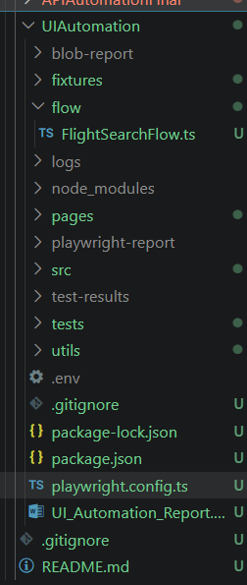

Page Object Model
Each UI page is represented as a class containing locators and methods. This improves maintainability and avoids duplication. I create HomePage for visible home page and search negative and positive actions.
BasePage
Respective Page
Flow
Test(with log evidence and screenshot)

Fixtures Usage
Fixtures are used to provide reusable resources like home page, session. So that can access home page method and we can use POM Homepage in test easily assert all the things by using home

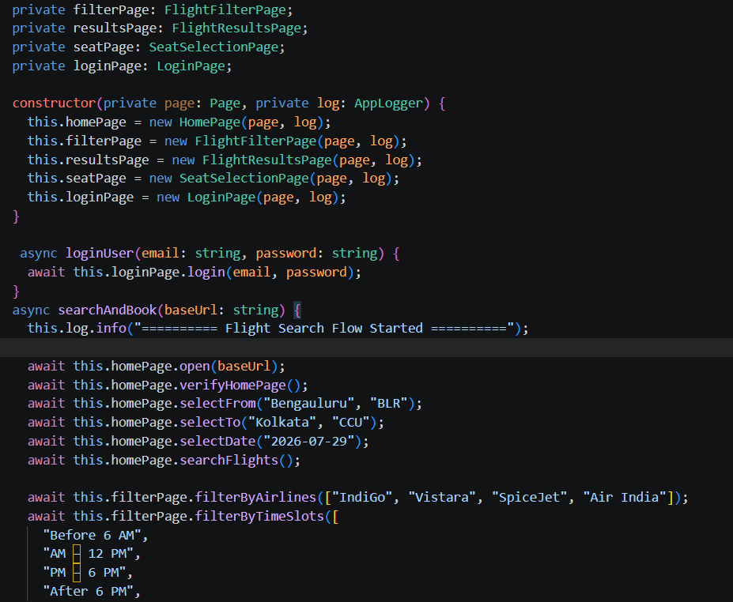
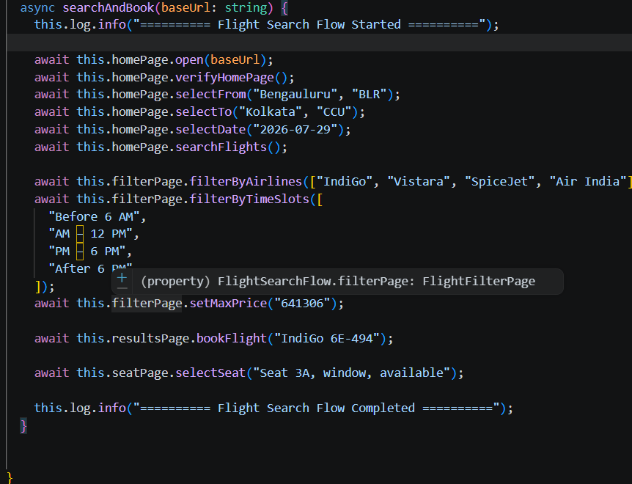

Test Case ID | Description | Status
TC_001 | Verify Home Page | Passed
TC_002 | Verify Valid Flight Search | Passed

Negative Scenarios
Test Case ID | Description | Status
TC_003 | Verify Invalid Product Search | Passed
TC_004 | Verify Empty Search Validation | Passed

Commands
- npx playwright test --headed
- npx playwright show-report

Result Evidence
Attach screenshots, videos, and trace files generated during execution.
In cmd run the command and it run all 4 test pass
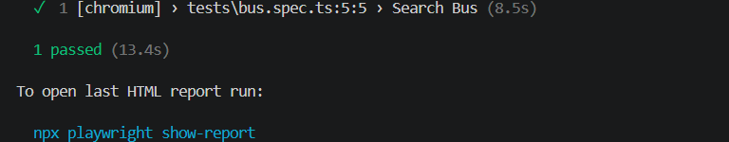

How to Solve Issues
Check locators specific for element(search,home logo,shirt)
Wait for url,load content
Auto retries and use auto wait
fixture setup,
test data, and
network conditions.

Limitations
Dependent on UI stability, network speed, and environment configuration and number of user so ,we only run here in headed mode so that url can easily fetch

Conclusion
Playwright framework ensures scalable, maintainable, and fast UI automation using modern testing practices.
Today I did home page verification ,search text working with positive search like product list is available and negative search like not found and empty search;

