API Testing Report
Name : Shahbaz Ahmad
GitHub branch: capstone/307424-shahbaz-ahmad
Date: 21-07-2026

Section C : - Api Automation

Objective
To design, develop, and execute API automation tests ensuring reliability, scalability, and correctness of REST APIs using a structured framework. Website https://demoqa.com/
GithubLink:- RajaVUst/SDET-2 at capstone/307424-shahbaz-ahmad

Environment Setup
Java, Maven, RestAssured, IntelliJ IDEA / Vs code Allure Reporting.

Workflow
1. Read configuration from Config.java
2. Build request using SpecFactory
3.ClientPage
4. Execute post API
5. Validate response
6. Generate report

Folder Structure
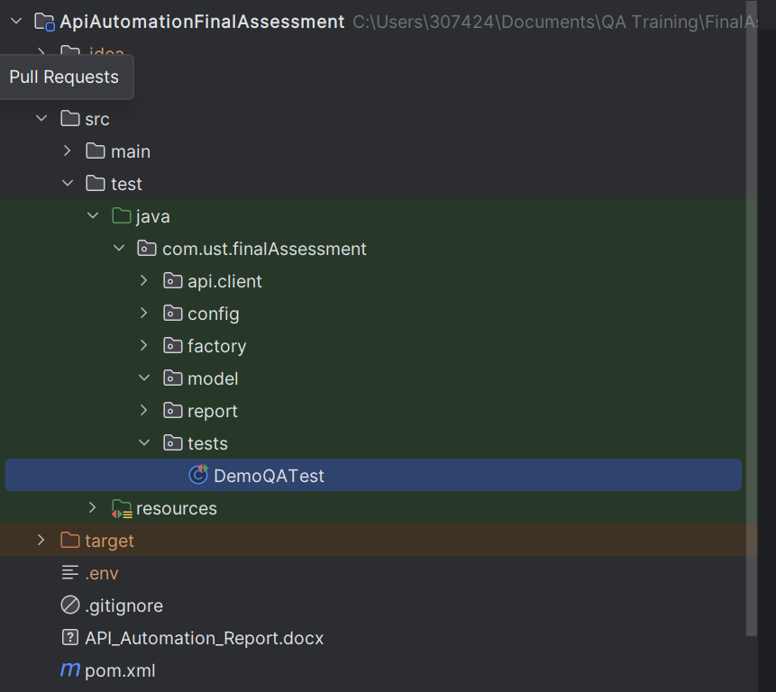
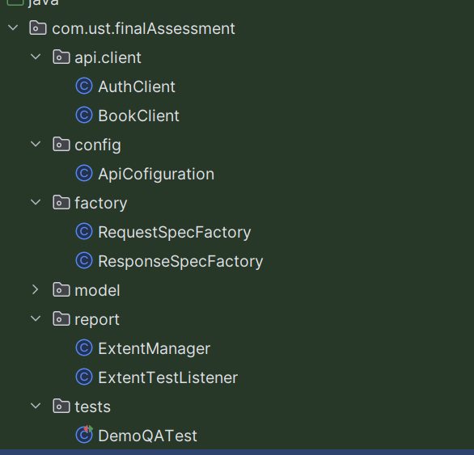

Scenario
Create a user , generate a authentication token, and retrieve this list of books using the token

Commands
- mvn clean test
- mvn test
- allure generate target/allure-results --clean -o target/allure-report
- allure serve target/allure-results

Result Evidence & Screenshots
Code
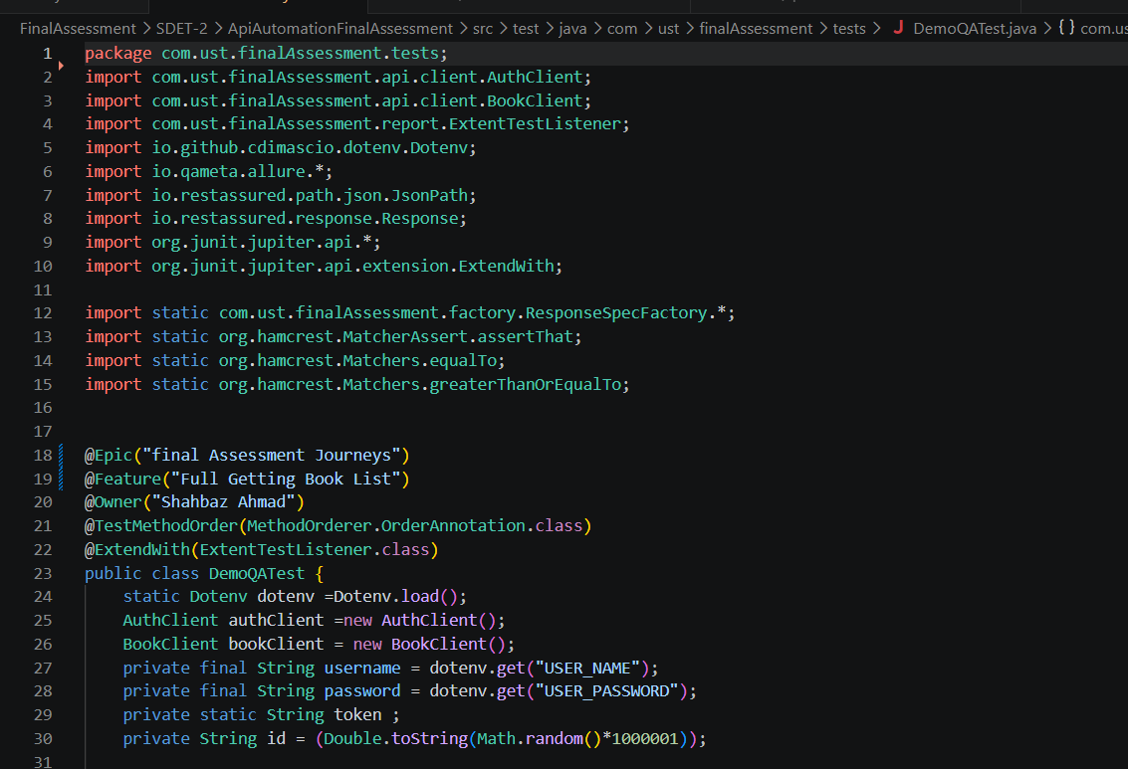
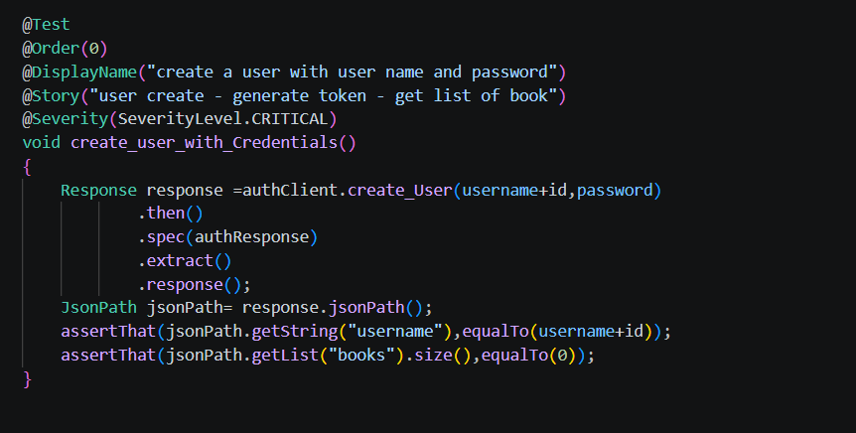
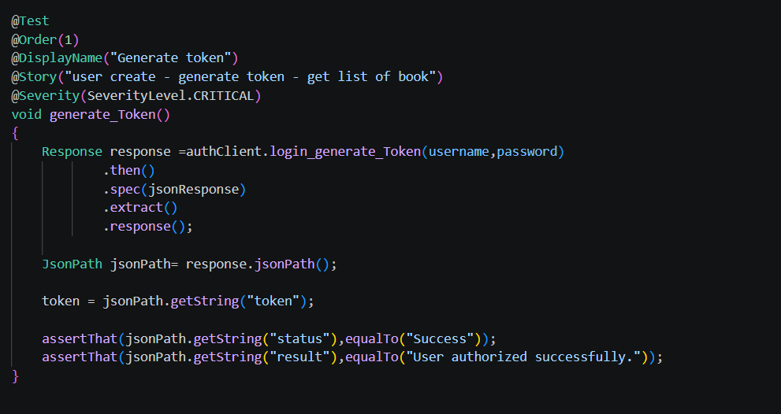
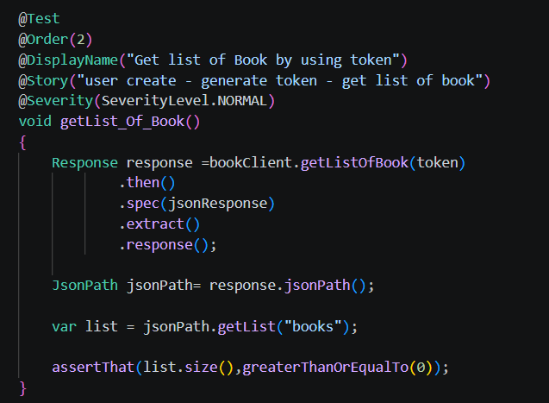

Config.java
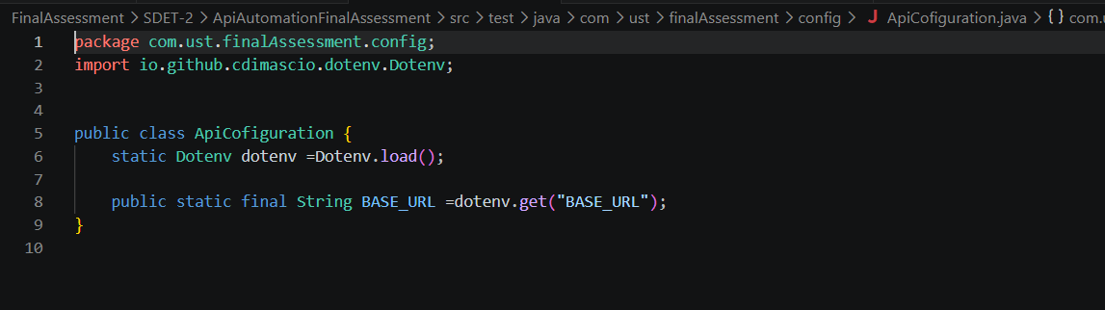

SpecFactory.java
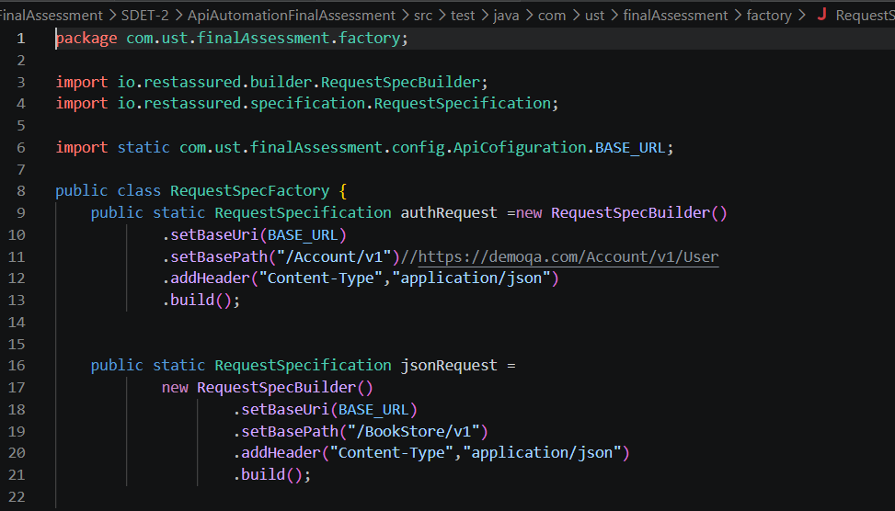
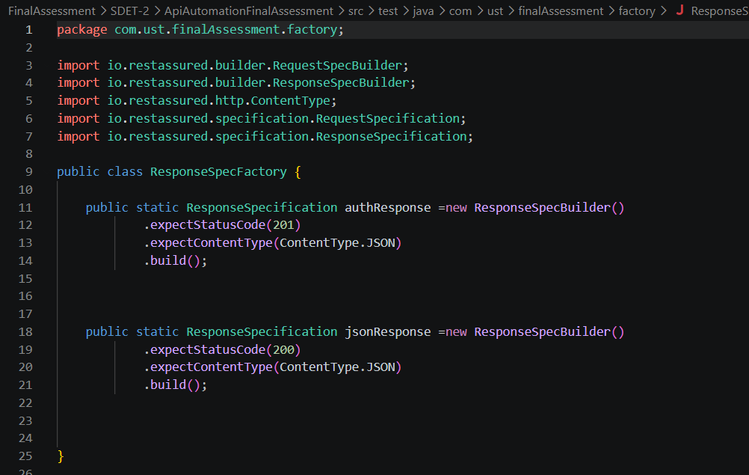

Result
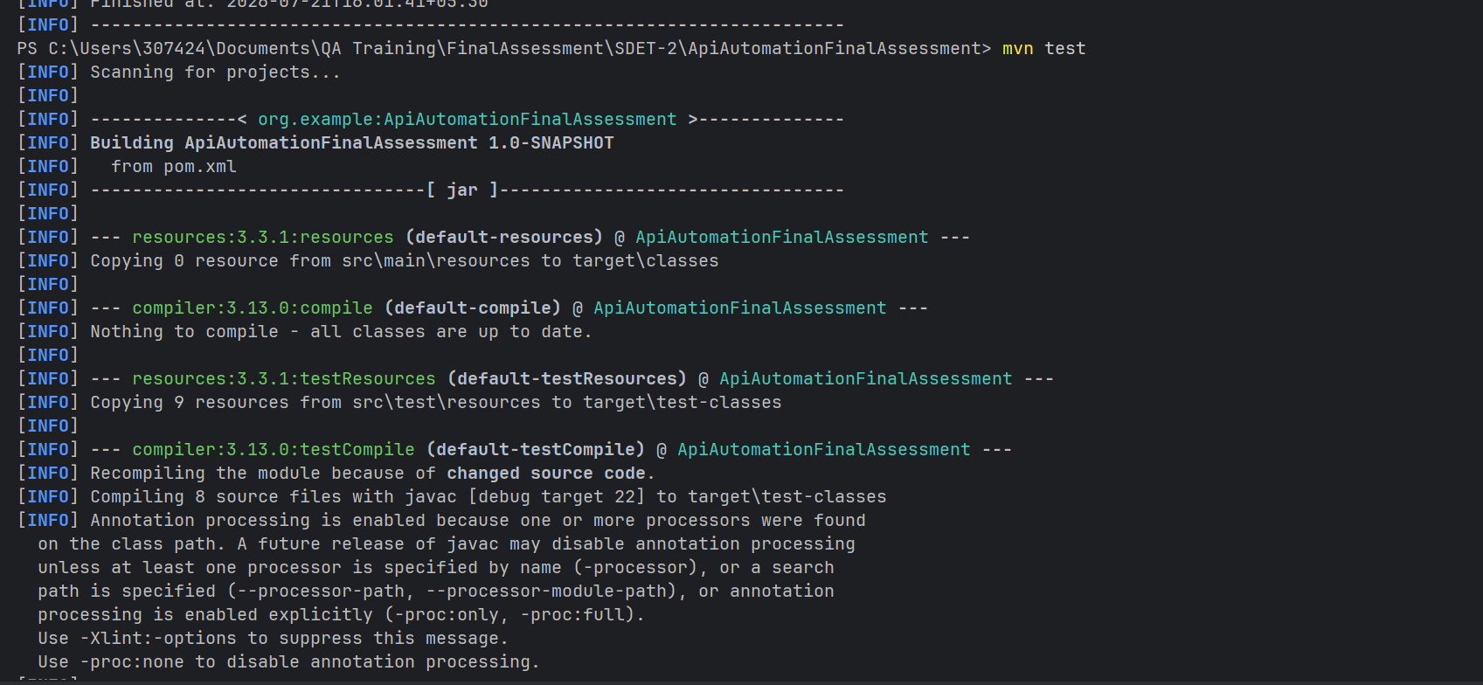
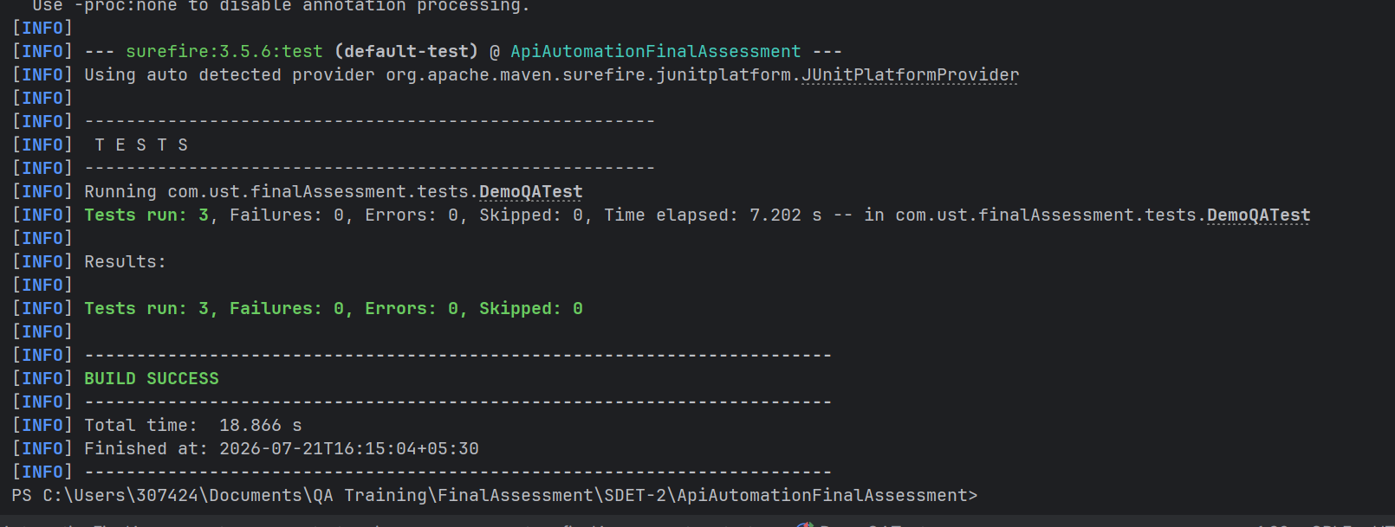
Spark Report
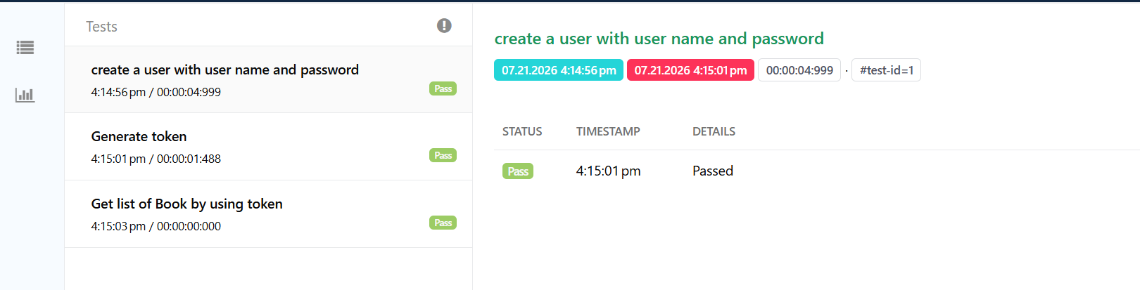
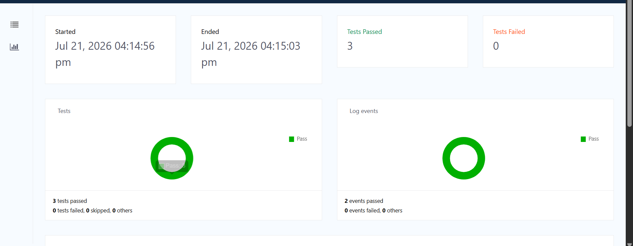

Explaination
- First create user by using username and password
- By using same username and password generate authorization token
- By using Authorization token get list of books

Limitations
Dependent on environment configuration, external API availability.

Conclusion
The framework integrates RestAssured for robust API testing, enabling validation of backend services and endpoints.
It supports data-driven and reusable API utilities, improving scalability and reducing duplication.
API layers are modularized, ensuring maintainable request/response handling and validation logic.
Enables end-to-end validation, where data created via API can be reused for UI validation.
Ensures high reliability and coverage of backend workflows.
Easily scalable—new API test cases can be added without impacting existing ones.

