Playwright UI Automation Test Report
Project Name: UI Automation Testing with Playwright
Participant: Shahbaz Ahmad
Date: 21-07-2026
Branch: capstone/307424-shahbaz-ahmad
Assessment: Retail Mart Playwright UI Automation

Section B UI Automation

Objective
The objective of this automation project is to validate the core functionality of the application using Playwright with website https://chess-agent-83252463.figma.site/
The automated test suite verifies critical user workflows and ensures that the application behaves as expected across supported browsers. The framework is designed to provide reliable, maintainable, and scalable UI automation.

Github Link
My Branch name is capstone/307424-shahbaz-ahmad and link is RajaVUst/SDET-2 at capstone/307424-shahbaz-ahmad

Environment Setup
- Tools: Node.js, Playwright Test Runner, TypeScript/JavaScript, VS Code
Install Commands:
- npm init playwright@latest
- npm install dotenv
- npm install winston
- npx playwright install
- Reporting Tools: HTML Reporter, Allure

Workflow
1. Start test execution
2. Load fixtures ( page,test,expect)
3. Navigate using page.goto(https://chess-agent-83252463.figma.site/)
4. Use Page Object methods
5. Execute assertions
6. Generate report

Folder Structure
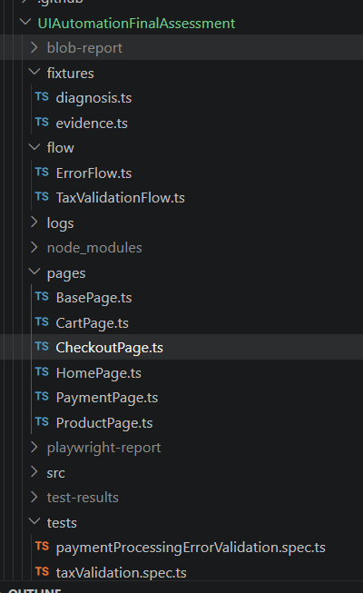
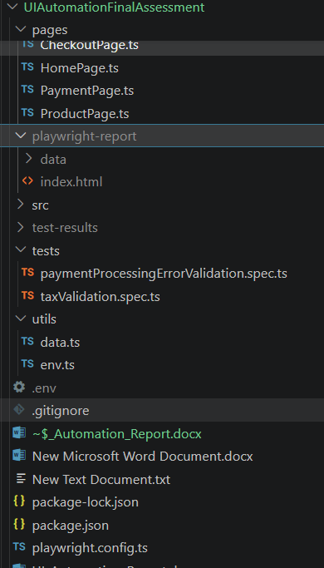

Page Object Model
Each UI page is represented as a class containing locators and methods. This improves maintainability and avoids duplication. I create HomePage for visible home page and search negative and positive actions.

Fixtures Usage
Fixtures are used to provide reusable resources like home page, session. So that can access home page method and we can use POM Homepage in test easily assert all the things by using home

Code – Tax validation

Test Case ID | Description | Status
TC_001 | Verify tax validation | Passed
TC_002 | Verify payment error | Passed

Commands
- npx playwright test --headed
- npx playwright show-report
- npx playwright test

Result Evidence
Attach screenshots, videos, and trace files generated during execution.
In cmd run the command and it run all 2 test pass
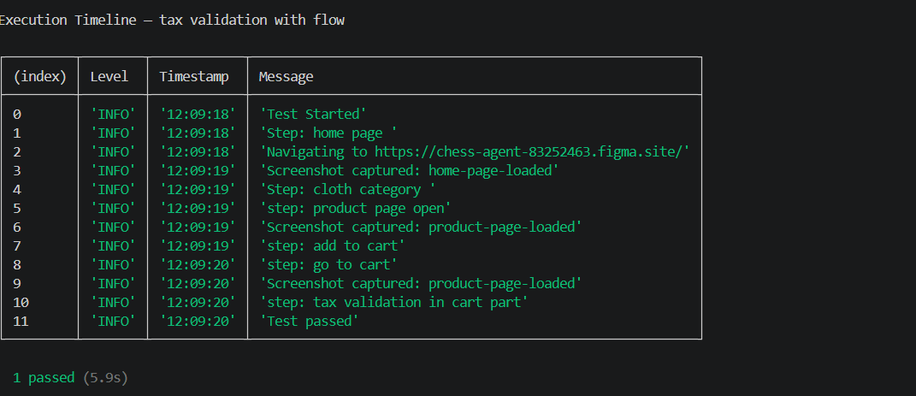
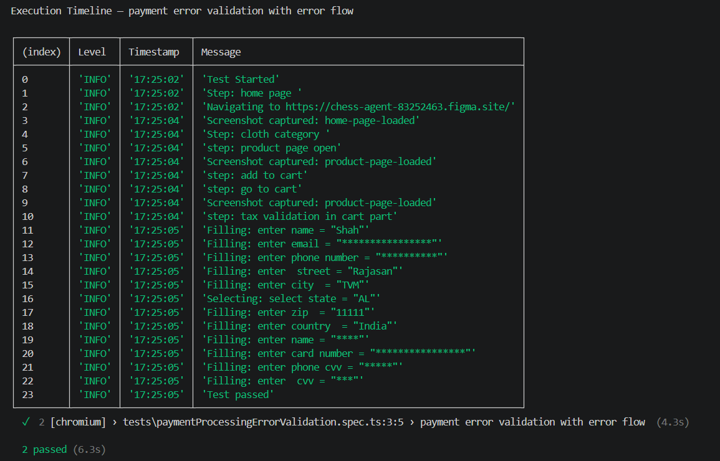

Limitations
Dependent on UI stability, network speed, and environment configuration and number of user so ,we only run here in headed mode so that url can easily fetch

Conclusion
Playwright framework ensures scalable, maintainable, and fast UI automation using modern testing practices.
Today I did home page verification ,search text working with positive search like product list is available and negative search like not found and empty search;

