FINAL YEAR DESIGN PROJECT THESIS
DriveIntel
An AI-Powered Smart Vehicle Diagnostics and Monitoring System
Report submitted in partial fulfilment of the requirements for the degree of
Bachelor of Science in Computer Science
Submitted by

- Muhammad Nouman Reg # 22MDBCS323
- Muhammad Naveed Reg # 22MDBCS202
- Shahbaz khan Reg # 22MDBCS190

Supervised by
Prof. Dr. Muhammad Usman
Department of Computer Science
University of Engineering & Technology, Mardan

Declaration
We, the undersigned, declare that the work presented in this thesis, titled “DriveIntel: An AI-Powered Smart Vehicle Diagnostics and Predictive Maintenance System,” is our own work, carried out under the supervision of Prof. Dr. Muhammad Usman, Department of Computer Science, University of Engineering & Technology, Mardan, during the 2025–2026 academic session.

Team Members | Signature
Muhammad Nouman | _____________________
Muhammad Naveed | _____________________
Shahbaz khan | _____________________
 | _____________________
Supervisor
Prof. Dr Muhammad Usman
Signature:_______________________
Date:___________________________

FYP Report Approval
The Department of Computer Science, University of Engineering & Technology, Mardan, accepts this report in its present form and confirms that it satisfies the requirements of the Final Year Project (FYP).

Approval of FYP Coordinator:
Name:

Signature:_______________________

Approval of Chairman:
Name: Prof. Dr Muhammad Usman

Signature:_______________________

Plagiarism Check Report

You are required to attach the plagiarism check report dully verified and signed by your supervisor. In case of similarity score above 19% you need to clarify the reasons. This report and your justification should not be on more than 2 pages.

Name of Supervisor : Signature:

Acknowledgement
We are thankful to Allah for the strength and the long evenings of debugging that, somehow, kept producing useful results.
Our supervisor, Prof. Dr. Muhammad Usman, deserves particular thanks for steering this project away from several dead ends — especially during the early weeks when the BLE connection to the ELM327 adapter refused to stay alive for more than a few seconds at a time, and again when the first version of the LSTM anomaly detector simply learned to output the mean of the training data. His feedback on both the technical design and the structure of this report shaped the final outcome considerably.
We also thank the faculty of the Department of Computer Science, University of Engineering & Technology, Mardan, whose courses over the past four years provided the grounding in databases, mobile development, and machine learning that this project draws on directly.
The open-source communities behind PyTorch, ONNX Runtime, FastAPI, and React Native made a project of this scope possible for a three-person final-year team; without freely available documentation and forum discussions, several of the integration issues described in Chapter 6 would have taken considerably longer to resolve.
Finally, we thank our families for their patience during the months this project occupied most of our attention, and the local mechanics in Mardan who let us connect a phone to their customers’ cars and ask a great many questions.

Muhammad Nouman · Muhammad Naveed · Shahbaz Khan
Department of Computer Science, UET Mardan

Abstract
Most vehicle owners only find out something is wrong when a warning light comes on, by which point the underlying fault has often been developing quietly for weeks. Professional diagnostic scanners that could catch these problems earlier are expensive and, outside major cities, hard to access — a particular problem in Pakistan, where authorised diagnostic visits cost a few thousand rupees and the nearest dealership workshop may be a long drive away. This thesis presents DriveIntel, a system that tries to close part of that gap using hardware most people already have access to: a smartphone and a low-cost Bluetooth OBD-II adapter.
The system has three parts. A cross-platform mobile application, built in React Native, connects to the vehicle's OBD-II port through an ELM327 Bluetooth Low Energy adapter, reading live sensor data (RPM, coolant temperature, throttle position, fuel trims, battery voltage, and others), retrieving and clearing Diagnostic Trouble Codes (DTCs), and — for hybrid vehicles such as the Toyota Prius and Corolla Hybrid — detecting the hybrid drivetrain automatically and switching to manufacturer-specific Mode 22/Mode 21 commands to read high-voltage battery state and drive mode.
Rather than sending this data to a server for analysis, DriveIntel runs three small neural networks directly on the phone using ONNX Runtime. A multi-task classifier reads each active DTC and assigns it a severity level (LOW to VERY_CRITICAL) and a fault category (engine, brakes, emissions, hybrid system, and so on). An LSTM autoencoder watches the sensor stream and flags channels whose readings start to drift away from their normal pattern, which can surface developing problems before they trigger a DTC at all. A third, smaller model combines the outputs of the first two along with mileage into a single 0–100 health score that a non-specialist driver can actually interpret. A short set of rule-based checks sits on top of these models: it suppresses sensor noise when there are no active faults, escalates severity when a sensor reading and a DTC point to the same problem, and raises an alert to VERY_CRITICAL when multiple safety-related systems are affected at once.
A FastAPI backend with an SQLite database keeps a record of past sessions, DTC history, and maintenance logs, and also hosts a small directory of workshops. When the on-device pipeline identifies which systems are affected (say, brakes and the airbag system), the app queries this directory and ranks nearby workshops by distance and by whether they list the relevant specialisation so a driver with an ABS fault is pointed toward a workshop that actually services ABS systems, rather than the nearest one regardless of what it can fix.
The remainder of this report covers the design and implementation of each of these pieces in detail, along with the testing carried out across a range of simulated vehicle scenarios — from a healthy baseline vehicle to multi-fault cases involving generic SAE codes, manufacturer-specific codes, and a hybrid powertrain — and a discussion of what worked, what did not on the first attempt, and what could reasonably be built on top of this in future work.
Keywords: OBD-II, ELM327, Bluetooth Low Energy, Diagnostic Trouble Codes, LSTM autoencoder, ONNX Runtime, on-device inference, React Native, FastAPI, predictive maintenance, hybrid vehicles.

List of Abbreviations
Abbreviation | Expansion
ABS | Anti-lock Braking System
AI | Artificial Intelligence
API | Application Programming Interface
AT | ELM327 attention/configuration command prefix
AUC | Area Under the (ROC) Curve
BLE | Bluetooth Low Energy
CAN | Controller Area Network
DLC | Data Link Connector
DTC | Diagnostic Trouble Code
ECU | Engine Control Unit
ELM327 | Commodity OBD-to-serial/BLE interpreter chipset
FYDP | Final Year Design Project
GATT | Generic Attribute Profile (BLE)
GPS | Global Positioning System
HTTP(S) | Hypertext Transfer Protocol (Secure)
HV | High Voltage (hybrid traction battery)
INT8 | 8-bit integer (quantisation format)
IoT | Internet of Things
ISO | International Organization for Standardization
JSON | JavaScript Object Notation
LSTM | Long Short-Term Memory (neural network)
MAF | Mass Air Flow (sensor)
MAE | Mean Absolute Error
MLP | Multi-Layer Perceptron
OBD-II | On-Board Diagnostics, second generation
ONNX | Open Neural Network Exchange
PID | Parameter ID (OBD-II data identifier)
PKR | Pakistani Rupee
PLO | Programme Learning Outcome
REST | Representational State Transfer
RPM | Revolutions Per Minute
SAE | Society of Automotive Engineers
SDG | Sustainable Development Goal
SoC | State of Charge
SQL | Structured Query Language
TF-IDF | Term Frequency – Inverse Document Frequency
UI/UX | User Interface / User Experience
UUID | Universally Unique Identifier
VIN | Vehicle Identification Number
VVT | Variable Valve Timing

List of Symbols
The symbols below are listed in the order in which they first appear in this report. Units, where applicable, are given in bold.
Symbol | Meaning
R² | Coefficient of determination (regression goodness-of-fit)
ε | LSTM autoencoder reconstruction error (per channel, normalised)
μ | Mean value of a sensor channel over its calibration distribution
σ | Standard deviation of a sensor channel over its calibration distribution
ŷ | Model-predicted output (e.g., health score, 0–100)
d | Great-circle (Haversine) distance between two GPS coordinates, in km
φ | Geographic latitude, in degrees (°)
λ | Geographic longitude, in degrees (°)
R_E | Mean radius of the Earth, 6371 km
T | Sequence length of a sensor time-series window, 120 time-steps
C | Number of OBD-II sensor channels modelled, 10
τ | Per-channel anomaly threshold used by the LSTM autoencoder (dimensionless)

Table of Contents

Declaration ii
FYP Report Approval iii
Acknowledgement 5
Abstract 6
List of Abbreviations 8
List of Symbols 10
Table of Contents 11
List of Figures 14
List of Tables 15
Chapter-1: Introduction 15
1.1 Background 16
1.2 Motivation 17
1.3 Problem Statement 18
1.4 Proposed Solution Overview 19
1.4.1 Mobile Application and OBD-II Interface 20
1.4.2 On-Device AI Pipeline 20
1.4.3 Backend, Maintenance Records, and Workshop Recommendation 20
1.5 Scope of the Project 21
1.6 Organization of the Report 21
Chapter-2: Problem Definition and Objectives 23
2.1 Introduction to the Problem Domain 23
2.2 Formal Problem Definition 23
2.2.1 Core Problem 23
2.2.2 Contextual Constraints 23
2.3 Objectives of the Project 24
2.3.1 Objective 1 — Cross-Platform OBD-II Mobile Application with Hybrid Support 24
2.3.2 Objective 2 — On-Device AI Pipeline for Predictive Maintenance 25
2.3.3 Objective 3 — Diagnostic Interface with GPS-Based Workshop Discovery 25
2.4 Scope Mapping and Success Criteria 26
2.5 Assumptions 26
2.6 Summary 27
Chapter-3: Literature Review 28
3.1 Introduction 28
3.2 OBD-II Protocols and BLE-Based Vehicle Monitoring 28
3.3 Machine Learning for Vehicle Fault Detection 29
3.4 LSTM Autoencoders for Time-Series Anomaly Detection 30
3.5 On-Device Inference for Mobile Applications 30
3.6 Hybrid Vehicle Diagnostics 31
3.7 Summary and Positioning of This Project 32
Chapter-4: Methodology 33
4.1 Introduction 33
4.2 Requirements Analysis 33
4.3 System Architecture Design 34
4.3.1 Three-Tier Architecture 34
4.3.2 Technology Stack 34
4.4 Dataset Preparation for AI Models 35
4.4.1 DTC Records for the Classifier 35
4.4.2 Sensor Sequences for the Anomaly Detector 36
4.4.3 Feature Vectors for the Health Scorer 36
4.5 AI Model Training Methodology 36
4.5.1 DTC Classifier 37
4.5.2 LSTM Sensor Anomaly Detector 37
4.5.3 Health Scorer 38
4.5.4 INT8 Quantisation and ONNX Export 38
4.6 BLE OBD-II Communication Methodology 38
4.7 Backend Development Methodology 40
4.8 Post-Inference Rule Design 40
4.9 Testing Methodology 41
4.10 Summary 42
Chapter-5: Detailed Design and Analysis 43
5.1 System Architecture 43
5.2 Module-Level Design 44
5.2.1 Backend REST API 44
5.3 Database Design 45
5.4 AI Model Architectures 47
5.4.1 DTC Severity/Category Classifier 47
5.4.2 LSTM Sensor Anomaly Detector 47
5.4.3 Health Scorer 48
5.5 Sensor Channels, Severity Tiers, and Fault Categories 48
5.6 Session Inference Pipeline and Post-Inference Rules 49
5.7 Hybrid Vehicle Detection and Mode Design 51
5.8 Use Case Design 53
5.9 Summary 54
Chapter-6: Implementation and Testing 55
6.1 Introduction 55
6.2 Mobile Application Implementation 55
6.2.1 Dashboard Screen 55
6.2.2 Diagnostics Screen 56
6.2.3 Maintenance Screen 56
6.2.4 Workshop Screen 56
6.2.5 Screen Captures from a Live Build 56
6.3 BLE and OBD-II Implementation Highlights 59
6.4 AI Pipeline Integration 60
6.5 Backend Implementation Highlights 61
6.6 Unit Testing 61
6.7 System-Level Test Sessions 61
6.8 Summary 63
Chapter-7: Results and Discussion 64
7.1 Introduction 64
7.2 AI Model Performance 64
7.3 End-to-End Test Results 65
7.4 Discussion and Comparison with Literature 66
7.5 Summary 67
Chapter-8: Conclusion and Future Work 69
8.1 Conclusion 69
8.2 Limitations 69
8.3 Future Work 70
8.4 Final Remarks 71
References 72
Annexure-N: Degree Programme Learning Outcomes (PLOs) 74
Annexure-P: FYDP to SDGs Mapping 76

List of Figures
Fig 1.1: Conceptual overview of the DriveIntel system…………………...…19
Fig 4.1: Overall project methodology flowchart…………...…………………33
Fig 4.3: AI model training and export pipeline……………………………….37
Fig 4.2: ELM327 BLE serialised command queue — sequence diagram……40
Fig 5.1: DriveIntel high-level system architecture……………………………43
Fig 5.2: DriveIntel database entity-relationship diagram……………………..46
Fig 5.3: Session-level inference pipeline and post-inference rules…………...50
Fig 5.4: Hybrid vehicle detection protocol and mode state machine…………52
Fig 5.5: DriveIntel Use Case Diagram ……………………..………………...53
Fig 6.1: Mobile application screen navigation flow………………………….55
Fig 6.2: Dashboard screen captured during a connected session…………….58
Fig 6.3: Diagnostics and Profile screens from the same live session………..59
Fig 7.1: AI model validation metrics………………………………………...64

List of Tables
Table 2.1: Project Objectives, Implementation, and Acceptance Criteria……………26
Table 4.1: Technology stack summary……………………………………………….35
Table 4.2: ELM327 AT initialisation sequence………………………………………39
Table 4.3: OBD-II Mode 01/03/04/09 commands implemented in DriveIntel……….39
Table 4.4: Post-inference rule summary……………………………………………...41
Table 5.1: Module responsibilities……………………………………………………44
Table 5.2: Backend REST API endpoints…………………………………………….45
Table 5.3: SQLite database schema summary………………………………………..46
Table 5.5: Sensor channel calibration parameters (idle/typical-driving baseline)……48
Table 5.6: Severity tiers and corresponding user guidance…………………………...49
Table 6.1: System-level test sessions and outcomes………………………………….61
Table N.1: Programme Learning Outcome (PLO) Coverage………………………...74
Table P.1: FYDP to Sustainable Development Goals (SDGs) Mapping……………..76

Chapter-1: Introduction

1.1 Background
Every car built after the late 1990s carries a small computer or several, that constantly watches the engine, the transmission, the emissions system, and increasingly the braking and airbag systems too. This is the vehicle's On-Board Diagnostics, second generation (OBD-II) system, a standard that became mandatory for petrol vehicles in the United States from 1996 and was adopted across the European Union shortly after [1]. In Pakistan, the situation is less uniform: locally assembled cars from the early 2000s onward generally carry an OBD-II-compliant Engine Control Unit (ECU), but the diagnostic port behind the dashboard is, for most owners, a connector they have never used and probably do not know exists.
The reason it goes unused is partly cost and partly awareness. Reading data from this port has traditionally required a dedicated scan tool, and the professional-grade versions used by dealerships run into the hundreds of dollars. What changed the picture for ordinary users is the ELM327 chipset, a small interpreter that translates OBD-II commands into something a microcontroller can send over a serial link [2]. Clones of this chip, built into Bluetooth Low Energy (BLE) dongles that plug into the OBD-II port, are now sold in Pakistan for under PKR 1,500. Plugged in, one of these dongles turns any BLE-capable smartphone into a basic scan tool.
“Basic” is the operative word, though. Most of the apps that pair with these dongles show raw numbers RPM, coolant temperature, a fault code such as P0301 and leave the interpretation entirely to the user. A driver who does not already know that P0301 means “cylinder 1 misfire detected,” and that a misfire left unaddressed can damage the catalytic converter, gets very little out of the data beyond a vague sense that something, somewhere, is wrong.
At the same time, machine learning has reached a point where reasonably capable models can run directly on a phone. Frameworks such as PyTorch [4] make it practical to train small classification and regression models on a laptop, and runtimes such as ONNX Runtime [7] let those models be exported, quantised to 8-bit integers, and executed on-device in tens of milliseconds. This combination cheap BLE hardware that exposes raw vehicle data, and lightweight on-device models that can interpret it — is the starting point for the project described in this thesis.

1.2 Motivation
The World Health Organization estimates that road traffic crashes kill over a million people a year worldwide, and mechanical failure is a recurring contributing factor in a meaningful share of these [3]. In Pakistan specifically, brake issues, tyre failures, and overheating are commonly cited by traffic police as causes of breakdowns and accidents, and all three are conditions that OBD-II sensors can, in principle, give early warning of a brake-related fault code, a slowly rising coolant temperature trend, a battery voltage that is drifting down over several drives.
Three observations from informal conversations with mechanics and vehicle owners in Mardan shaped the direction of this project:
- Workshop diagnostic visits cost money even when nothing is found to be wrong, so owners tend to wait until a problem is unmistakable a warning light, a noise, a smell before going in. By that point, a fault that started small has often had time to cause secondary damage.
- When a scan tool does retrieve a code, the code itself means little to the owner. Existing consumer apps list the code and perhaps a one-line description, but rarely say how urgent it is or what kind of workshop is needed to fix it.
- Hybrid vehicles the Toyota Prius and Corolla Hybrid in particular, and increasingly the Suzuki Alto AGS are becoming common in the secondhand import market, but generic OBD-II scanners do not read the hybrid battery state of charge, motor speed, or regenerative braking parameters that matter most for these drivetrains.
DriveIntel grew out of an attempt to address these three points together, rather than as separate features: read the data that is already available through the OBD-II port (including, where relevant, hybrid-specific data), interpret it locally on the phone so the system works even without an internet connection, and turn the interpretation into something a non-specialist can act on including pointing them toward a workshop that is actually equipped to deal with the specific problem found.

1.3 Problem Statement
Stated plainly, the problem this project addresses is that the gap between “data a vehicle can provide” and “information a driver can use” is currently bridged either by an expensive professional diagnosis or not at all. Consumer-grade OBD-II applications fall into roughly two camps: code readers that display raw PIDs and DTCs without context, and subscription-based “smart” apps that typically require a constant data connection to a cloud service for any interpretation beyond the most basic alerts.
Neither camp does the following, which this project set out to do within a single offline-capable application:
- Classify each active fault code by severity and by the vehicle subsystem it affects, using a model trained for the purpose rather than a static lookup table alone.
- Watch the sensor stream itself not just discrete fault codes for patterns that suggest a developing problem, using the recent history of readings rather than a single snapshot.
- Combine both of these into one number a driver can glance at and understand, without needing to know what a fuel trim or a MAF sensor is.
- Detect a hybrid drivetrain automatically and switch to the correct manufacturer-specific commands without the user having to know their car is “different.”
- Translate “this is a brake problem” into “here is a nearby workshop that lists brake work as a specialisation,” rather than just the nearest workshop regardless of capability.
The remainder of this report describes how DriveIntel approaches each of these five points, and in the results and discussion chapter how well each one actually worked once implemented.

1.4 Proposed Solution Overview
Figure 1.1 sketches the system at a conceptual level. A BLE OBD-II adapter sits between the vehicle's ECU and the mobile application; the application both displays this data live and feeds it into a small on-device AI pipeline; and a lightweight backend keeps a longer-term record and hosts the workshop directory used for recommendations.
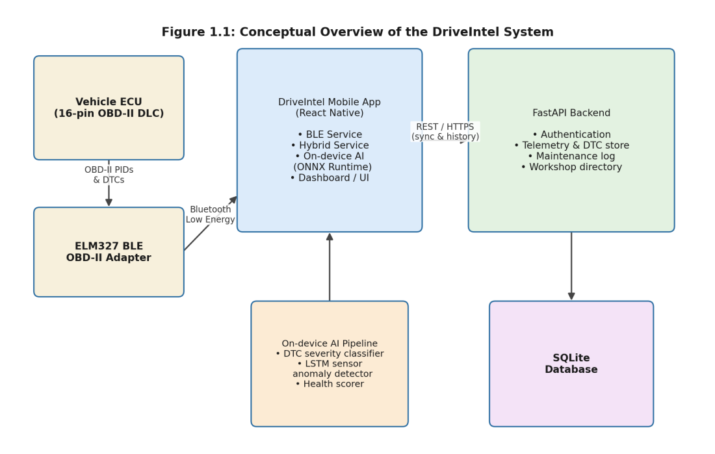
Figure 1.1: Conceptual overview of the DriveIntel system

1.4.1 Mobile Application and OBD-II Interface
The mobile application is built with React Native and TypeScript so that a single codebase targets both Android and iOS. It connects to the ELM327 adapter over BLE GATT (service UUID FFF0), sending AT initialisation commands and then Mode 01 PID requests through a serialised command queue, a detail that turned out to matter more than expected, and is discussed further in Chapter 4. Beyond live telemetry, the app reads and clears DTCs (Mode 03 and Mode 04), and for vehicles identified as hybrids issues Toyota Mode 22 or Honda Mode 21 commands to read high-voltage battery percentage, voltage, current, temperature, and motor speeds.

1.4.2 On-Device AI Pipeline
Three small models, exported to ONNX and quantised to INT8, run through ONNX Runtime directly on the device. A DTC classifier takes the text description and code structure of each active fault and predicts a severity tier and a fault category. An LSTM autoencoder takes a short window of the ten sensor channels DriveIntel tracks and reconstructs it; channels that the model struggles to reconstruct are flagged as anomalous, on the reasoning that a healthy sensor's behaviour should look like the data the model was trained on. A health-scoring model then combines the outputs of both, along with the vehicle's mileage, into a single 0–100 score. A small set of rule-based adjustments sits on top of all three for instance, suppressing an anomaly flag if the raw sensor value is actually within its normal operating range, or escalating severity when a sensor anomaly and a DTC point at the same subsystem.

1.4.3 Backend, Maintenance Records, and Workshop Recommendation
A FastAPI backend backed by SQLite stores user accounts, vehicle profiles, OBD session history, DTC records, mileage, and maintenance logs. It also serves a small directory of workshops, each tagged with the fault categories it specialises in (brakes, transmission, hybrid systems, and so on) and a location. When the AI pipeline identifies which categories are implicated by the current set of faults, the application queries this directory, computes distances using the Haversine formula, and ranks workshops by a combination of distance, rating, and whether their listed specialisations match the detected fault categories.

1.5 Scope of the Project
The scope of this project is bounded in a few deliberate ways. First, the OBD-II interface targets the standard Mode 01/03/04 PID set plus the manufacturer-specific Mode 22 (Toyota/Lexus) and Mode 21 (Honda) enhanced PIDs relevant to hybrid drivetrains; full coverage of every manufacturer-specific PID across every brand was not attempted. Second, the AI models were trained on a dataset of DTC records and synthetic sensor sequences assembled for this project rather than on telemetry harvested from a live fleet, since access to a large real-world labelled dataset was not realistic within the project timeline this limitation, and its implications, are discussed honestly in Chapter 7. Third, the workshop directory used for recommendations is a representative sample built for demonstration purposes rather than a live, crowd-sourced national database.
Within these bounds, the project covers the full path from a BLE connection to a vehicle, through on-device inference, to a recommendation surfaced in the user interface implemented, tested, and discussed in the chapters that follow.

1.6 Organization of the Report
Chapter 2 restates the problem more formally and lists the three objectives that guided the implementation. Chapter 3 reviews related work on OBD-II diagnostics, BLE-based vehicle monitoring, and machine learning for fault detection and time-series anomaly detection, and identifies where this project fits relative to that work. Chapter 4 describes the methodology followed data preparation, model training, and application development including the overall project flowchart. Chapter 5 covers the detailed system design: architecture, database schema, model architectures, and the rule-based post-inference logic. Chapter 6 describes implementation details and the testing approach. Chapter 7 presents results, including model performance figures and end-to-end test outcomes, and discusses what these results do and do not show. Chapter 8 concludes with a summary, an honest look at the project's limitations, and directions for future work.

Chapter-2: Problem Definition and Objectives

2.1 Introduction to the Problem Domain
Chapter 1 described the gap between the diagnostic data a modern vehicle can expose through its OBD-II port and the information an ordinary driver can actually use. This chapter restates that gap as a set of concrete project objectives, against which the implemented system can later be checked. The objectives below were agreed at the start of the project and were used throughout development as the yardstick for what “done” meant for each subsystem.

2.2 Formal Problem Definition

2.2.1 Core Problem
A vehicle owner with a smartphone and a low-cost BLE OBD-II adapter has access to a continuous stream of raw sensor values and, when something goes wrong, one or more Diagnostic Trouble Codes. What they lack is a way to turn that raw stream into (a) an indication of how serious any active fault is and which part of the vehicle it concerns, (b) an early warning when a sensor is drifting toward an abnormal range even before a fault code is set, (c) a single understandable summary of overall vehicle condition, and (d) a practical next step specifically, a nearby workshop equipped to deal with the kind of problem found. Existing consumer tools address at most one of these, and almost always require an active internet connection to do even that.

2.2.2 Contextual Constraints
Several constraints shaped how the problem was approached in practice:
- The target hardware is a generic ELM327-clone BLE adapter, not a manufacturer-specific dongle, so the application cannot assume access to proprietary diagnostic protocols beyond the documented Mode 22 (Toyota) and Mode 21 (Honda) enhanced PID sets.
- Inference needs to work without a network connection, both because rural connectivity in parts of Pakistan is unreliable and because a diagnostic tool that stops working in a workshop's basement garage is not very useful.
- The models have to be small enough, and fast enough, to run on the kind of mid-range Android phone that is actually common in the target market not a flagship device with a dedicated neural processing unit.
- The system needs to behave sensibly for both conventional internal-combustion vehicles and hybrid vehicles, ideally without the user needing to specify which type they have.

2.3 Objectives of the Project
Three objectives were defined for this project, each corresponding to one of the three major subsystems described in Chapter 1. They are stated here as given to the project team, followed by a short note on how each was approached during implementation.

2.3.1 Objective 1 — Cross-Platform OBD-II Mobile Application with Hybrid Support
Statement: To develop a cross-platform mobile application that integrates with OBD-II hardware via Bluetooth to acquire real-time vehicle telemetry, read and clear DTC fault codes, and support hybrid vehicle operating modes through intelligent sensor sanitisation and mode detection.
This objective drove the design of the OBDService and HybridService modules described in Chapters 4 and 5. “Integrate via Bluetooth” meant building a serialised BLE GATT command queue robust enough to handle the quirks of cheap ELM327 clones — partial responses, occasional dropped notifications, and devices that do not always honour the expected '>' prompt promptly. “Read and clear DTC fault codes” maps directly to Mode 03 and Mode 04 support. “Hybrid vehicle operating modes through intelligent sensor sanitisation and mode detection” refers to the four-step hybrid detection sequence and the seven-state mode machine (PARKED_OFF, READY_EV, READY_ENGINE, TRANSITION, REGEN_BRAKING, CHARGING_ICE, HV_BATTERY_LOW) implemented in HybridService.ts, along with the sanitisation rules that, for example, zero out a spurious non-zero speed reading reported by some adapters while the engine is cold and at idle.

2.3.2 Objective 2 — On-Device AI Pipeline for Predictive Maintenance
Statement: To design and implement an on-device AI pipeline using ONNX Runtime that classifies fault severity, detects sensor anomalies through LSTM-based reconstruction, and generates a real-time vehicle health score enabling offline-capable predictive maintenance without dependency on network connectivity.
This is the objective behind the three-model pipeline described in Chapters 4 and 5: a DTC severity/category classifier, an LSTM autoencoder for sensor anomaly detection, and a health-scoring regressor, all exported to ONNX and quantised to INT8 so they can be bundled with the mobile app and run through onnxruntime-react-native. “Predictive” in this context specifically refers to the anomaly detector's ability to flag a sensor channel that is drifting away from its normal pattern before that drift is severe enough to set a DTC giving, in principle, days of advance notice rather than none.

2.3.3 Objective 3 — Diagnostic Interface with GPS-Based Workshop Discovery
Statement: To create an intuitive user interface that presents live diagnostic data, fault details with severity levels, and AI-driven maintenance recommendations — integrated with GPS-based workshop discovery that intelligently filters nearby service centers based on the detected fault category and required specialization.
This objective covers the Dashboard, Diagnostics, Maintenance, and Workshop screens described in Chapter 6, and the backend workshop-recommendation endpoint described in Chapter 5. “Intelligently filters” means that the ranking shown to the user is not simply “nearest first”: the fault categories produced by the AI pipeline (for example, abs_brakes or hybrid) are matched against each workshop's declared specialisations, and that match is combined with distance and rating when ordering the results.

2.4 Scope Mapping and Success Criteria
Table 2.1 maps each objective to the part of the system that addresses it and to the criterion used during testing (Chapter 6) to judge whether it had been met.
Table 2.1: Project Objectives, Implementation, and Acceptance Criteria
# | Objective | Primary Implementation | Acceptance Criterion
1 | Cross-platform OBD-II app with BLE acquisition, DTC read/clear, and hybrid mode support | OBDService.ts, HybridService.ts (React Native) | Live PID stream displayed continuously over a BLE session; DTCs read and cleared on command; hybrid vehicles auto-detected and switched to Mode 22 / Mode 21
2 | On-device AI pipeline: severity classification, LSTM anomaly detection, health score | ai.service.ts + dtc_classifier / sensor_anomaly / health_scorer ONNX models | All three models load and run via ONNX Runtime on-device; inference completes without a network connection and within a perceptible-as-instant time budget
3 | Diagnostic UI with severity display and GPS-filtered workshop discovery | Dashboard / Diagnostics / Workshop screens + /workshops/recommend endpoint | Active faults shown with severity and category; nearby workshops ranked by distance and specialisation match for the detected fault categories

2.5 Assumptions
- The target vehicle exposes a standard 16-pin OBD-II Data Link Connector and responds to at least the Mode 01 PIDs listed in Chapter 4.
- The BLE adapter exposes GATT service UUID FFF0 with write characteristic FFF2 and notify characteristic FFF1, which covers the great majority of ELM327-clone dongles available in the local market.
- Not every vehicle supports every Mode 01 PID; the application treats an unsupported PID as a missing reading rather than failing the whole polling cycle.
- Hybrid-specific functionality covers Toyota/Lexus (Mode 22) and Honda (Mode 21) platforms; other hybrid or fully electric vehicles fall back to standard Mode 01 behaviour.
- The AI models were trained on a project-assembled dataset of DTC records and synthetic sensor sequences, described in Chapter 4, rather than on telemetry logged from a fleet of real vehicles over time.
- The workshop directory used for recommendation testing is a representative sample rather than a live, continuously updated national listing.

2.6 Summary
This chapter restated the diagnostic-access problem from Chapter 1 as three concrete objectives the mobile/BLE/hybrid layer, the on-device AI pipeline, and the diagnostic UI with workshop discovery and set out how each maps onto the implemented system and how each was checked during testing. The next chapter looks at how this project's approach relates to existing work on OBD-II diagnostics, BLE-based monitoring, and machine learning for vehicle fault detection.

Chapter-3: Literature Review

3.1 Introduction
This chapter looks at the body of work this project draws on, organised around the three objectives from Chapter 2: OBD-II and BLE-based vehicle monitoring, machine learning approaches to fault detection (including LSTM-based anomaly detection specifically), and on-device inference for mobile applications. A short section on hybrid vehicle diagnostics closes the chapter, since this is an area where standard references are comparatively scarce and most available information comes from manufacturer documentation and enthusiast reverse-engineering rather than peer-reviewed sources.

3.2 OBD-II Protocols and BLE-Based Vehicle Monitoring
The OBD-II standard itself specifically SAE J1979 / ISO 15031-5, which defines the ten diagnostic service modes including Mode 01 (current data), Mode 03 (stored DTCs), and Mode 04 (clear DTCs) is the foundation that every application in this space builds on [1]. The standard specifies the request/response format for each PID but says nothing about transport; in practice, the transport for consumer applications is almost always an ELM327 or ELM327-compatible interpreter chip, whose AT command set and response formatting are documented in the manufacturer's own datasheet [2].
What the datasheet does not cover and what becomes important once an ELM327 clone is accessed over BLE rather than the original RS232/Bluetooth Classic SPP — is the behaviour of the GATT layer itself. Bluetooth's Generic Attribute Profile defines how a peripheral exposes services and characteristics and how a central device subscribes to notifications [9], but it does not guarantee that a long ELM327 response arrives in a single notification packet. In practice it usually does not: a response of more than about twenty bytes is split across several BLE notification packets, and the receiving application has to buffer and reassemble them before it can parse anything. This single detail not glamorous, but central to getting a reliable connection is discussed further in Chapter 4, where the command queue implementation used in this project is described.
On the application side, the React Native framework used for DriveIntel's mobile client is documented in detail by Eisenman [8], and its cross-platform model one TypeScript codebase compiled to native Android and iOS builds is what made it practical for a three-person team to target both major mobile platforms within the project timeline.

3.3 Machine Learning for Vehicle Fault Detection
Mapping a raw Diagnostic Trouble Code to a severity level and a likely cause is, at its simplest, a lookup-table problem: SAE-standardised codes like P0301 (cylinder 1 misfire) have a known meaning that does not depend on the specific vehicle. Manufacturer-specific codes (the “P1” and “P3” ranges, and equivalents for B, C, and U codes) complicate this, since the same numeric code can mean different things on different manufacturers' vehicles, and a static table either has to be enormous or accept gaps in coverage.
Framing this instead as a text classification problem treating the code's textual description and likely-cause text as input to a model, alongside structural features of the code itself (its letter prefix and numeric range) is a reasonably natural fit for the kind of TF-IDF plus shallow classifier pipeline described by Pedregosa et al. in the scikit-learn documentation [13], which DriveIntel's DTC classifier is built around (TF-IDF features feeding a small multi-layer perceptron, trained in PyTorch [4] and exported to ONNX). The advantage of this approach over a pure lookup table is that a code the model has not seen verbatim during training can still be classified reasonably, provided its description text and code structure resemble codes the model has seen — which is useful given how many manufacturer-specific codes exist across the vehicle makes common in Pakistan.

3.4 LSTM Autoencoders for Time-Series Anomaly Detection
The second model in DriveIntel's pipeline the sensor anomaly detector is built around the idea that a model trained to reconstruct “normal” sensor sequences will reconstruct an abnormal sequence poorly, and that the size of this reconstruction error is itself a useful anomaly signal. Long Short-Term Memory networks, introduced by Hochreiter and Schmidhuber [5], are well suited to this because they can retain information across longer sequences than a plain recurrent network, which matters when the “normal pattern” for a sensor like coolant temperature is really a slow trend over many readings rather than any single value.
Malhotra et al. [6] demonstrated this prediction-error approach to anomaly detection across several quite different time-series domains ECG signals, space shuttle telemetry, power demand, and an engine sensor dataset using stacked LSTM networks trained only on non-anomalous data and then used to flag points where the actual reading diverged from the prediction by more than expected. DriveIntel's sensor anomaly detector follows the same broad pattern, but uses an autoencoder (encode-then-reconstruct) rather than a pure forward predictor, and operates on a fixed window of the ten OBD-II channels DriveIntel tracks rather than a single univariate signal. The per-channel reconstruction error is normalised against a channel-specific threshold (derived during training from the calibration data) to produce the 0–1 anomaly scores described in Chapter 5.

3.5 On-Device Inference for Mobile Applications
Running a trained model on a phone, rather than sending data to a server, removes the dependency on a network connection important for a diagnostic tool that should still work in a workshop with poor signal but it constrains model size and inference time. ONNX Runtime [7] addresses this from the deployment side: a model trained in PyTorch [4] is exported to the ONNX format, optionally quantised so that weights are stored as 8-bit integers rather than 32-bit floats, and then executed through a runtime with mobile-specific execution providers. INT8 quantisation roughly quarters the on-disk size of a model's weight tensors compared to float32, which is the main reason DriveIntel's three-model bundle is small enough to ship inside the application package rather than being downloaded separately.
The trade-off is a small amount of numerical precision, which in practice shows up as slightly different output values rather than meaningfully different classifications something that was checked during the drift-check step of the training pipeline described in Chapter 4, where a freshly quantised model's validation metrics are compared against the unquantised version before it replaces the bundle shipped with the app.

3.6 Hybrid Vehicle Diagnostics
Hybrid powertrains add a layer of complexity that standard OBD-II Mode 01 PIDs were never designed to cover: state of charge of the high-voltage traction battery, the speed and torque of one or more electric motor-generators, and which of several operating modes (pure electric, engine-driven, regenerative braking, and so on) the vehicle is currently in. Management of these quantities deciding when to run the engine, when to recover braking energy, and how to balance battery state of charge against driver demand has itself been the subject of substantial control-systems research; Langari and Won's work on an intelligent energy management agent for parallel hybrid vehicles [11] is one example of the broader literature on how a hybrid powertrain's operating mode is determined from driving conditions, even though that work is concerned with the vehicle's own controller rather than with reading its state externally.
From a diagnostics standpoint, the practical information available to an external tool comes from two sources: a small set of standard Mode 01 PIDs that happen to be relevant (notably PID 0x5B, hybrid battery pack remaining life, and PID 0x1C/0x65, which can indicate hybrid support), and manufacturer-specific enhanced diagnostic modes, Mode 22 for Toyota/Lexus and Mode 21 for Honda being the two implemented in this project. Documentation for these enhanced modes is fragmented across manufacturer service literature and community reverse-engineering efforts; DriveIntel's implementation, described in Chapter 5, was built and tested against the specific PID sets known to work for Prius-generation Toyota hybrids and early Honda IMA systems, and is one of relatively few open implementations that combine this with the standard Mode 01 path in a single auto-detecting application.

3.7 Summary and Positioning of This Project
Taken individually, none of the pieces reviewed above is new: OBD-II and BLE communication are well-documented standards, TF-IDF-based text classification and LSTM autoencoders are established techniques, and ONNX Runtime's mobile deployment story is mature enough to be used in production apps. What this project attempts is to combine them BLE acquisition including hybrid-specific modes, a three-model on-device AI pipeline with a small set of rule-based corrections layered on top, and a recommendation step that ties the AI output back to a real-world action (which workshop to visit) inside a single offline-capable mobile application aimed specifically at the kind of vehicle and the kind of access-to-diagnostics problem common in Pakistan. The next chapter describes how this combination was actually built, starting with the overall methodology and moving through dataset preparation, model training, and application development.

Chapter-4: Methodology

4.1 Introduction
This chapter describes how the project moved from the objectives set out in Chapter 2 to a working system. The work naturally split into two strands that ran partly in parallel: building and training the AI models, and building the mobile application and backend that would host them. Figure 4.1 shows the overall sequence followed, and the sections below walk through each stage in the order shown.
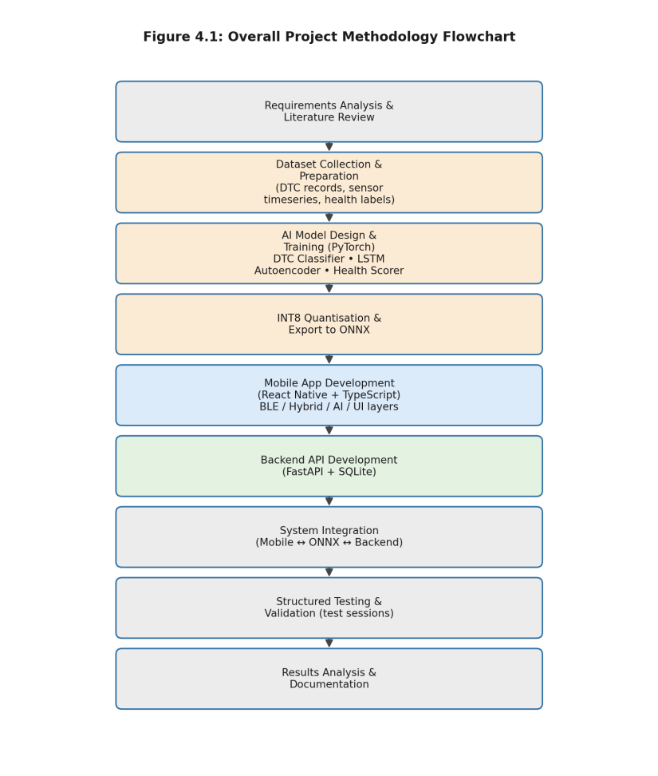
Figure 4.1: Overall project methodology flowchart

4.2 Requirements Analysis
The starting point was a short list of “must work” scenarios drawn up before any code was written: a healthy vehicle with no active faults should show a high health score and no alarming messages; a vehicle with a single low-severity emissions code (the classic P0420 catalyst-efficiency code, for example) should be flagged as something to keep an eye on rather than an emergency; a vehicle with multiple safety-related faults across different systems (say, an ABS code and an airbag code together) should be escalated more aggressively than either fault would be on its own; and a Toyota hybrid should be recognised as such without the user telling the app anything. These scenarios, refined slightly as work progressed, became the basis for the structured test sessions described in Chapter 6.
Alongside the functional scenarios, two non-functional requirements were treated as fixed from the start: the AI pipeline had to run without a network connection, and it had to run on a phone in the mid-range price bracket common in Pakistan — not a flagship device. Both requirements pushed toward small, quantised models rather than larger architectures that might have scored marginally better on paper.

4.3 System Architecture Design

4.3.1 Three-Tier Architecture
The system settled into three tiers fairly naturally, given the objectives: a mobile client (presentation, BLE communication, and on-device AI), a backend (persistence and the workshop directory), and the AI model bundle itself, which is logically a fourth component but is physically shipped as part of the mobile client. This split is described in architectural detail in Chapter 5; at the methodology level, the important point is that the AI tier was developed and validated largely independently of the mobile and backend tiers trained and tested as ordinary PyTorch models against held-out data before being exported and integrated into the React Native app via onnxruntime-react-native.

4.3.2 Technology Stack
Table 4.1 summarises the main technologies used and the reason each was chosen.
Table 4.1: Technology stack summary
Layer | Technology | Reason for Choice
Mobile client | React Native + TypeScript | Single codebase for Android and iOS; large ecosystem for BLE (react-native-ble-plx) and ONNX (onnxruntime-react-native)
BLE communication | react-native-ble-plx over GATT (UUID FFF0) | De facto standard library for BLE in React Native; matches the service/characteristic layout of common ELM327 BLE clones
On-device inference | ONNX Runtime (onnxruntime-react-native), INT8 models | Cross-platform, supports quantised models, runs without network access
AI model training | PyTorch | Flexible model definition and training loop; first-class ONNX export support
Backend API | FastAPI (Python) | Low-overhead async framework with automatic request validation via Pydantic
Database | SQLite via SQLAlchemy | Zero-configuration, file-based database adequate for a project-scale deployment; SQLAlchemy ORM keeps schema changes manageable
Location / mapping | Device GPS + Haversine distance calculation | Avoids dependency on a paid mapping API for the core distance-ranking logic

4.4 Dataset Preparation for AI Models
Each of the three on-device models needed a different kind of training data, assembled as structured records rather than scraped from any single existing dataset.

4.4.1 DTC Records for the Classifier
Training records for the DTC classifier consist of a code (e.g., P0301, B0012, C0035, U0100), its standard description, a short “possible causes” text, a severity label (one of LOW, MEDIUM, HIGH, VERY_CRITICAL), and a fault category drawn from the sixteen-category taxonomy used throughout the system (engine, emissions, fuel, ignition, transmission, abs_brakes, suspension, steering, body, airbag, climate, lighting, security, network, hybrid, and unknown). Records were compiled across the four SAE code letter prefixes (P, B, C, U) and across the generic and manufacturer-specific numeric ranges, with particular attention to codes relevant to the vehicle makes common in the Pakistani market Toyota, Honda, Suzuki, and Hyundai/KIA in particular plus a smaller set of European-make codes (Audi, BMW) for breadth.

4.4.2 Sensor Sequences for the Anomaly Detector
The anomaly detector needs sequences, not single readings: each training example is a 120-step window across the ten channels listed in Table 5.5 (Chapter 5). Sequences representing normal operation were generated around the calibration mean and standard deviation for each channel (also given in Table 5.5), with realistic noise and slow drift added so the model would learn what “normal variation” looks like rather than memorising a flat line. A smaller set of sequences with deliberately injected anomalies a channel drifting steadily out of range, or developing oscillation was used to set the per-channel reconstruction-error thresholds during calibration, though the model itself is trained only on normal sequences, consistent with the autoencoder approach described in Chapter 3.

4.4.3 Feature Vectors for the Health Scorer
The health scorer's training examples are the 22-dimensional feature vectors described in Chapter 5 counts and severities of active DTCs, per-channel anomaly scores from the sensor model, flags for specific fault categories, and a mileage band — paired with a target health score in the 0–100 range. Target scores were assigned by a deterministic rule reflecting how a human reviewer would reason about the same inputs (more VERY_CRITICAL faults and more abnormal sensors pull the score down sharply; a single LOW-severity fault on an otherwise healthy, low-mileage vehicle barely moves it), giving the regressor a consistent target to learn even though the underlying rule is itself simple.

4.5 AI Model Training Methodology
All three models were implemented and trained in PyTorch [4], using an AdamW optimiser, an explicit train/validation split, and early stopping based on the validation metric relevant to each model (accuracy for the classifier, AUC for the anomaly detector, R² for the health scorer). Figure 4.3 summarises the training and export pipeline shared by all three.
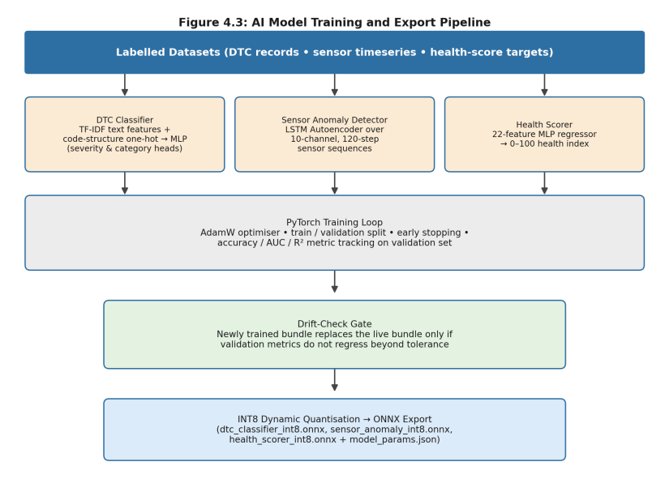
Figure 4.3: AI model training and export pipeline

4.5.1 DTC Classifier
Input features combine a 17-dimensional one-hot encoding of the code's structure (five letter-prefix indicators plus twelve numeric-range buckets, mirroring the CODE_PREFIXES / CODE_BUCKETS scheme used at inference time) with a TF-IDF vector computed over the description and possible-causes text, using unigrams and bigrams with sub-linear term-frequency scaling and L2 normalisation. The same TF-IDF transform is re-implemented in TypeScript for on-device inference, as described in Chapter 5. The model itself is a multi-layer perceptron with two output heads: a 4-way severity head (LOW / MEDIUM / HIGH / VERY_CRITICAL) and a 16-way category head, trained jointly with a combined cross-entropy loss.

4.5.2 LSTM Sensor Anomaly Detector
The anomaly detector is an LSTM autoencoder: an encoder LSTM compresses a 120-step, 10-channel input sequence into a fixed-size latent representation, and a decoder LSTM reconstructs the full sequence from that representation. Training minimises mean-squared reconstruction error on normal sequences only. After training, the per-channel mean reconstruction error on a held-out calibration set is used to set the channel-specific thresholds (ch_thresholds) that convert a raw reconstruction error into the normalised 0–1 anomaly score used downstream.

4.5.3 Health Scorer
The health scorer is a smaller multi-layer perceptron regressor taking the 22-dimensional feature vector described in Section 4.4.3, scaled using stored per-feature mean and standard deviation (sc_mean / sc_std), and producing a single scalar passed through a sigmoid and scaled to the 0–100 range. Training minimises mean absolute error against the rule-derived target scores.

4.5.4 INT8 Quantisation and ONNX Export
Once a model passed its validation threshold, it was exported to ONNX and quantised to INT8 using dynamic quantisation, which converts weight tensors to 8-bit integers while keeping activations in floating point computed on the fly. The quantised model's validation metric was then re-checked against the float32 version a small “drift check” — before being accepted as the version bundled with the mobile application. All model-specific parameters needed for feature construction at inference time (the TF-IDF vocabulary and IDF weights, the sensor normalisation statistics and thresholds, and the health scorer's feature scaling statistics) are exported alongside the models as a single model_params.json file, so the same preprocessing logic can be reproduced in TypeScript without re-deriving any statistics on-device.

4.6 BLE OBD-II Communication Methodology
Table 4.2 lists the ELM327 AT initialisation sequence sent on connection, and Table 4.3 lists the Mode 01/03/04/09 PIDs the application requests during normal operation.
Table 4.2: ELM327 AT initialisation sequence
Command | Purpose
ATZ | Reset the ELM327 and wait for its banner response
ATE0 | Turn command echo off, so responses do not repeat the sent command
ATL0 | Turn linefeeds off in responses
ATS0 | Turn spaces off in responses, simplifying parsing
ATH0 | Turn headers off (omit CAN ID prefixes from responses)
ATSP0 | Set protocol to automatic (the adapter tries CAN first, then falls back)
ATAT1 | Enable adaptive timing, letting the adapter adjust response timeouts to the vehicle

Table 4.3: OBD-II Mode 01/03/04/09 commands implemented in DriveIntel
PID Command | Mode/PID | Description
010C | 01 0C | Engine RPM
010D | 01 0D | Vehicle speed (km/h)
0105 | 01 05 | Engine coolant temperature (°C)
0111 | 01 11 | Throttle position (%)
012F | 01 2F | Fuel tank level (%)
0104 | 01 04 | Calculated engine load (%)
010F | 01 0F | Intake air temperature (°C)
0110 | 01 10 | Mass air flow rate (g/s)
010A | 01 0A | Fuel pressure (kPa)
0142 | 01 42 | Control module voltage (V)
01A6 | 01 A6 | Total odometer reading (km), where supported
03 | Mode 03 | Request stored Diagnostic Trouble Codes
04 | Mode 04 | Clear stored DTCs and the malfunction indicator lamp
0902 | Mode 09, PID 02 | Vehicle Identification Number (VIN)

Figure 4.2 shows how these commands flow through the serialised command queue described in Chapter 1. The queue exists because ELM327 adapters including the BLE clones used here are fundamentally single-threaded: sending a second command before the first has finished responding produces interleaved, unparseable output. The queue holds at most one command “in flight” at a time, accumulates BLE notification fragments into a buffer until the ELM327's '>' prompt character appears, and only then resolves the pending request and dequeues the next one.
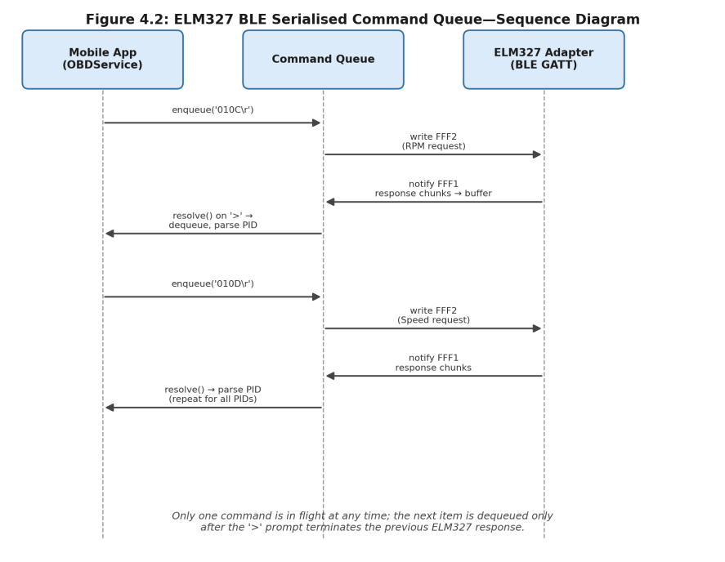
Figure 4.2: ELM327 BLE serialised command queue — sequence diagram

4.7 Backend Development Methodology
The FastAPI backend was developed endpoint-by-endpoint against the mobile application's actual needs rather than from an upfront specification: authentication and vehicle registration first, then OBD session ingestion and DTC storage, then the AI diagnosis endpoint (which wraps the same inference logic available on-device, for cases where a server-side re-check is useful), and finally maintenance logging and the workshop directory. SQLAlchemy models map directly onto the SQLite tables described in Chapter 5, with a small lightweight-migration helper that adds columns to existing tables when the schema changes useful during development when the database file persisted across many code changes.

4.8 Post-Inference Rule Design
Early testing of the three-model pipeline in isolation surfaced a few situations where the raw model outputs, taken at face value, would have been misleading. A vehicle with no active DTCs but several sensor channels reading slightly outside their calibration range plausible simply due to a colder-than-average day could produce a cluster of MARGINAL anomaly flags that, shown directly to a user, would look like a developing problem rather than ordinary variation. Conversely, a vehicle with DTCs in two different safety-critical systems (say, ABS and the airbag system) deserved a stronger combined warning than either DTC's individual severity would suggest on its own.
Rather than retraining the models to handle every such case which would have required labelling many more compound scenarios a small set of rule-based adjustments was added after the model outputs are computed, summarised in Table 4.4 and described in full, with the pipeline diagram, in Chapter 5.
Table 4.4: Post-inference rule summary
Rule | Trigger Condition | Effect
PID overlay | A flagged sensor channel's raw PID value is actually within its normal operating range | Anomaly score for that channel is reduced (scaled down) and its status reset toward NORMAL
Sensor noise suppression | No active DTCs, and more than 60% of sensor channels are flagged as non-normal | All anomaly scores for the session are scaled down, treating the pattern as likely noise rather than a real issue
Sensor–DTC cross-correlation | An abnormal sensor reading (e.g., coolant temperature, battery voltage, fuel trims) coincides with an active DTC in a related fault category | The DTC's severity is escalated to HIGH if it was lower, with a note explaining why
Compound escalation | Two or more safety-critical fault categories are active at HIGH or above, or three or more faults are at HIGH or above overall | All HIGH-severity faults in the session are escalated to VERY_CRITICAL

4.9 Testing Methodology
Testing was carried out at two levels. Unit-level checks covered individual parsing and feature-construction functions the PID response parser, the DTC code parser, the TF-IDF transform, and the Haversine distance calculation against hand-computed expected values. System-level testing used a set of structured “sessions”, each specifying a vehicle make/model, a set of active DTCs (if any), and a sensor snapshot, run end-to-end through the inference pipeline to check that the resulting severity levels, health score, and workshop-query categories matched what a human reviewer would expect for that scenario. These sessions, and their outcomes, are described in Chapter 6.

4.10 Summary
This chapter described the methodology followed across both strands of the project: dataset preparation, model training, INT8 quantisation, and ONNX export on the AI side; and BLE communication design, backend development, and post-inference rule design on the application side. The next chapter takes each of these pieces and describes the resulting design in detail architecture diagrams, database schema, model architectures, and the full post-inference pipeline.

Chapter-5: Detailed Design and Analysis

5.1 System Architecture
Figure 5.1 expands the conceptual overview from Chapter 1 into the actual layers of the implemented system. The presentation layer consists of the six main React Native screens (Dashboard, Diagnostics, Maintenance, Workshop, OBD Connection, and Settings/Auth). Below this sits the service and state layer, which is where most of the project-specific logic lives: OBDService manages the BLE command queue and PID/DTC parsing, HybridService runs the hybrid-detection sequence and mode state machine, AIService wraps the three ONNX models and the post-inference rules, and a thin api.ts client talks to the FastAPI backend over HTTPS. The backend itself groups its endpoints by concern authentication, OBD data, DTCs, AI diagnosis, workshops, and maintenance backed by a single SQLite database.
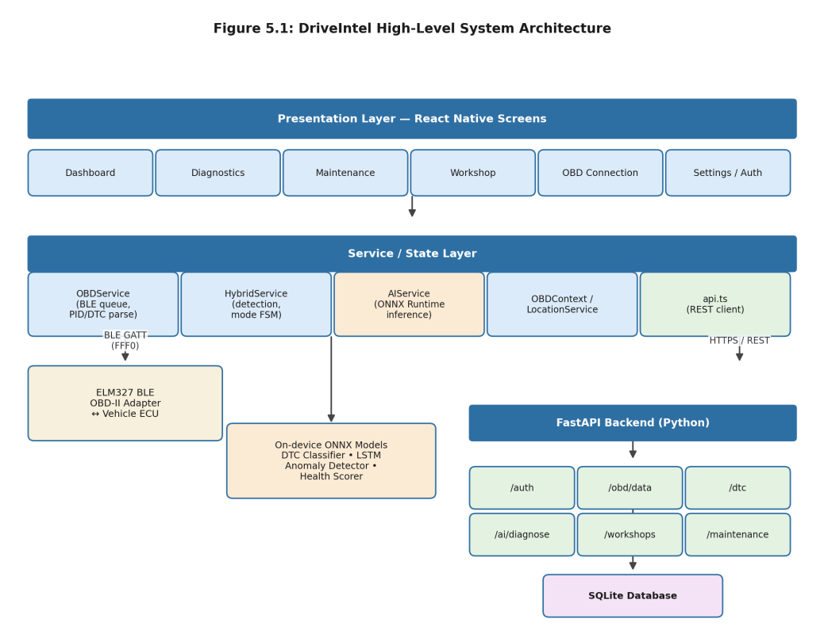
Figure 5.1: DriveIntel high-level system architecture
Two aspects of this diagram are worth highlighting because they shaped several design decisions elsewhere in the system. First, the AIService box sits entirely within the mobile client it does not call out to the backend for normal operation, which is what makes the diagnostic pipeline work offline. Second, the backend's /ai/diagnose endpoint runs a Python re-implementation of the same inference logic; this exists mainly so that session history stored server-side can be re-scored if the rule set changes, without requiring every historical session to be re-run on a phone.

5.2 Module-Level Design
Table 5.1 summarises the responsibility of each major module referenced in Figure 5.1.
Table 5.1: Module responsibilities
Module | Responsibility
OBDService.ts | BLE connection lifecycle, serialised AT/PID command queue, response parsing for PIDs and DTCs
HybridService.ts | Hybrid-vehicle detection sequence, Mode 22/21 enhanced PID parsing, mode state machine, sensor sanitisation
ai.service.ts | Loads the three ONNX models, builds model inputs (TF-IDF, sensor sequences, health feature vector), applies post-inference rules
OBDContext / LocationService | React context exposing live OBD state to screens; device GPS access for workshop ranking
api.ts | Typed REST client wrapping the FastAPI backend endpoints
main.py (FastAPI) | Authentication, persistence of sessions/DTCs/maintenance, workshop directory and recommendation, server-side AI re-scoring

5.2.1 Backend REST API
Table 5.2 lists the backend endpoints grouped by concern. All endpoints exchange JSON and use the user/vehicle identifiers issued at registration.
Table 5.2: Backend REST API endpoints
Group | Endpoint | Purpose
Auth | POST /auth/register | Create a new user account
Auth | POST /auth/login | Authenticate and return a session identifier
OBD | GET /elm327/config | Return ELM327 initialisation commands for the client
OBD | GET /pids/live | Return the list of PIDs the client should poll
OBD | POST /obd/data | Submit a live OBD-II sensor snapshot for a vehicle
OBD | GET /obd/latest/{vehicle_id} | Retrieve the most recent stored sensor snapshot
OBD | GET /dashboard/{vehicle_id} | Aggregate dashboard view: latest snapshot, active DTCs, health score
DTC | POST /dtc/save | Persist one or more DTC records for a vehicle
DTC | GET /dtc/{vehicle_id} | Retrieve stored DTC records for a vehicle
DTC | POST /dtc/clear/{vehicle_id} | Mark stored DTCs as cleared (mirrors Mode 04 on-device)
AI | POST /ai/diagnose | Run the inference pipeline on a supplied session payload
AI | GET /ai/diagnose/{vehicle_id} | Run the inference pipeline using the vehicle's latest stored session
Workshops | GET /workshops | List workshops, ranked by distance from a supplied coordinate
Workshops | GET /workshops/recommend/{vehicle_id} | List workshops ranked by distance and specialisation match for the vehicle's current fault categories
Diagnostics | GET /diagnostics/{vehicle_id} | Retrieve historical diagnostic sessions for a vehicle
Maintenance | GET /maintenance/{vehicle_id} | Retrieve maintenance log entries for a vehicle
Maintenance | POST /maintenance/odometer | Record an odometer reading
Maintenance | POST /maintenance/log | Add a maintenance log entry (service performed, cost, notes)
Profile | GET/PUT /profile | Retrieve or update user and vehicle profile details

5.3 Database Design
The backend persists data in a single SQLite database (driveintel.db) accessed through SQLAlchemy. Figure 5.3 shows the entity-relationship structure: every table other than users carries a vehicle_id foreign key, and vehicles in turn carries a user_id foreign key, giving a simple one-owner-to-many-vehicles, one-vehicle-to-many-records hierarchy.
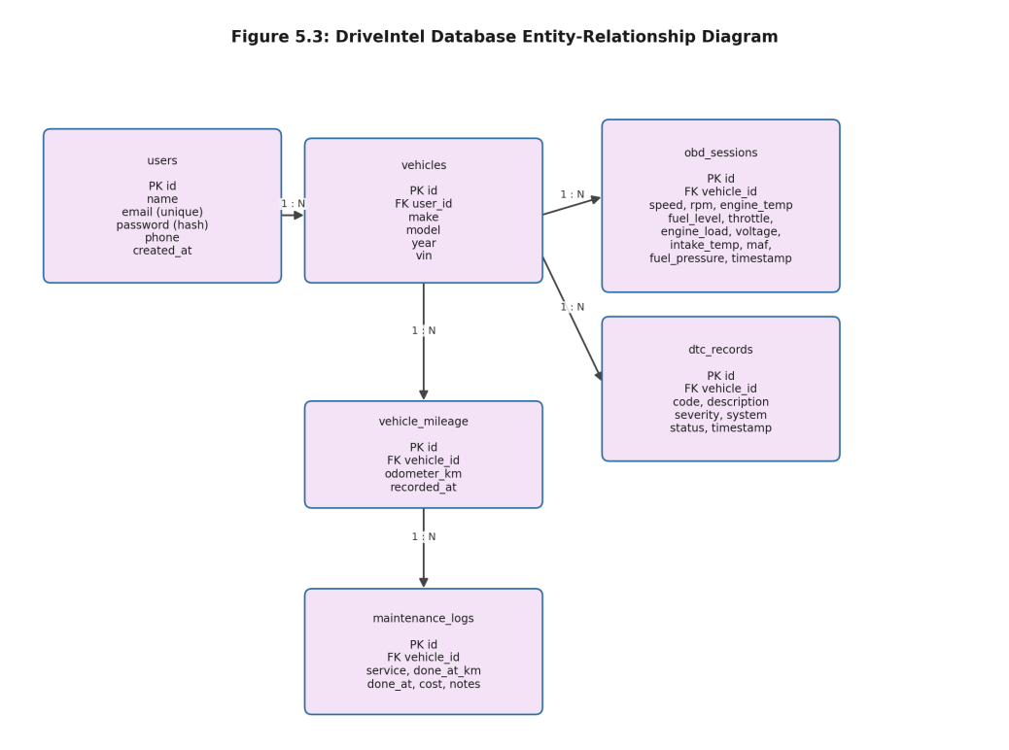
Figure 5.3: DriveIntel database entity-relationship diagram
Table 5.3 lists the six tables with their columns and a short note on purpose. All primary keys are string-typed UUIDs generated at insert time, and all timestamp columns default to the insertion time in UTC.
Table 5.3: SQLite database schema summary
Table | Key Columns | Purpose
users | id (PK), name, email (unique), password, phone, created_at | User accounts
vehicles | id (PK), user_id (FK), make, model, year, vin | Vehicle profiles owned by a user
obd_sessions | id (PK), vehicle_id (FK), speed, rpm, engine_temp, fuel_level, throttle, engine_load, voltage, intake_temp, maf, fuel_pressure, timestamp | Snapshots of live OBD-II sensor readings
dtc_records | id (PK), vehicle_id (FK), code, description, severity, system, status, timestamp | Stored Diagnostic Trouble Codes and their classification
vehicle_mileage | id (PK), vehicle_id (FK), odometer_km, recorded_at | Odometer history used for the health scorer's mileage feature
maintenance_logs | id (PK), vehicle_id (FK), service, done_at_km, done_at, cost, notes | Service history entered by the user

5.4 AI Model Architectures
All three models share a common shape a feature-construction step (described per model below), a small PyTorch network, and an ONNX export with INT8 dynamic quantisation but differ in their inputs, outputs, and the role they play in the pipeline shown in Figure 5.2.

5.4.1 DTC Severity/Category Classifier
Inputs: a 17-dimensional one-hot code-structure vector (the 5 CODE_PREFIXES entries P, B, C, U, X plus the 12 CODE_BUCKETS numeric-range indicators) concatenated with a TF-IDF vector computed over the code's description and possible-causes text. Architecture: a shared multi-layer perceptron trunk feeding two heads a 4-way softmax over the SEVERITY_LABELS (LOW, MEDIUM, HIGH, VERY_CRITICAL) and a 16-way softmax over FAULT_CATEGORIES. Output: for each active DTC, a severity label with its associated probability vector, and a predicted fault category. The raw severity prediction is then adjusted by two lookup tables CODE_CAP, which caps certain well-understood low-risk codes (the emissions-related P0420-family and oxygen-sensor codes, for example) at LOW regardless of the model's prediction, and CODE_FLOOR, which raises certain misfire-related codes (P000A–P0025) to at least MEDIUM reflecting cases where domain knowledge about a specific code is more reliable than the general text-based classifier.

5.4.2 LSTM Sensor Anomaly Detector
Inputs: a 120-step × 10-channel sequence, normalised per channel using the calibration mean and standard deviation in Table 5.5. Architecture: an encoder LSTM followed by a decoder LSTM, trained as an autoencoder to reconstruct its input. Output: a reconstructed sequence of the same shape as the input; the per-channel mean squared error between input and reconstruction is converted to a 0–1 anomaly score using the channel's calibration threshold (ch_thresholds), and each channel is assigned a status of NORMAL, MARGINAL, or ABNORMAL based on where its score falls.

5.4.3 Health Scorer
Inputs: a 22-dimensional feature vector built from (a) counts of active DTCs at each severity level, (b) the anomaly scores and statuses of all 10 sensor channels, (c) one-hot flags for whether any active DTC falls in each of a small set of high-impact categories (engine, abs_brakes, airbag, hybrid, transmission), and (d) a normalised mileage band. Architecture: a multi-layer perceptron regressor with a sigmoid output scaled to 0–100. Output: a single health score, which the mobile UI displays alongside a short textual summary derived from the dominant contributing factors.

5.5 Sensor Channels, Severity Tiers, and Fault Categories
Table 5.5 lists the ten sensor channels tracked by the anomaly detector, in the order expected by the model's input tensor, along with the calibration statistics used both for normalisation and for the PID-overlay rule described in Section 5.6.
Table 5.5: Sensor channel calibration parameters (idle/typical-driving baseline)
Channel | Mean | Std. Dev. | Min | Max | Unit
rpm | 800 | 80 | 500 | 1200 | RPM (idle)
coolant_temp | 90 | 3 | 80 | 100 | °C
o2_voltage | 0.45 | 0.15 | 0.1 | 0.9 | V
maf | 4.5 | 0.8 | 2.0 | 8.0 | g/s
fuel_trim_short | 1.5 | 2.0 | −10 | 10 | %
fuel_trim_long | 1.0 | 1.5 | −10 | 10 | %
throttle_pos | 14 | 4 | 5 | 30 | % (idle)
battery_voltage | 13.8 | 0.2 | 13.2 | 14.8 | V
intake_air_temp | 30 | 5 | 10 | 50 | °C
vehicle_speed | 30 | 20 | 0 | 80 | km/h

Table 5.6 lists the four severity tiers and the action text the application shows to the user for each unchanged across both the classifier output and any rule-based escalation.
Table 5.6: Severity tiers and corresponding user guidance
Severity | Recommended User Action
LOW | Monitor, no immediate action required
MEDIUM | Schedule service within 2 weeks
HIGH | Book a workshop urgently within 3 days
VERY_CRITICAL | Stop driving, contact a mechanic immediately

The sixteen fault categories used by both the classifier and the workshop-recommendation logic are: engine, emissions, fuel, ignition, transmission, abs_brakes, suspension, steering, body, airbag, climate, lighting, security, network, hybrid, and unknown. Of these, engine, abs_brakes, airbag, steering, transmission, hybrid, and ignition are treated as “safety-critical” for the purposes of the compound-escalation rule described next a deliberately conservative list, chosen because a fault in any of these systems has a plausible path to an immediate safety consequence, unlike (for example) a climate-control or lighting fault.

5.6 Session Inference Pipeline and Post-Inference Rules
Figure 5.2 shows the full sequence a session goes through, from raw input to the output shown on the Dashboard and Diagnostics screens. The DTC classifier and the LSTM anomaly detector run independently on their respective inputs, after which the four post-inference rules from Table 4.4 are applied in order, and the health scorer combines the (rule-adjusted) outputs of both into the final score.
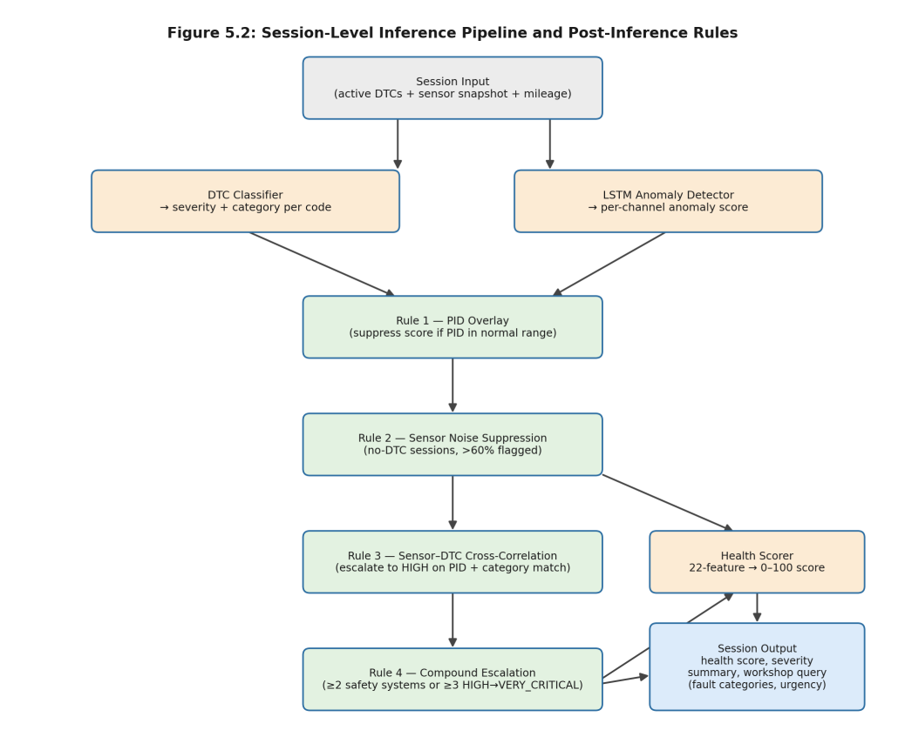
Figure 5.2: Session-level inference pipeline and post-inference rules
Rule 1 (PID overlay) checks each sensor channel flagged as non-normal by the LSTM model against its raw PID value: if the raw value is actually within the normal range defined in Table 5.5 (specifically, within 2.5 standard deviations of the mean and within 10% of the min/max bounds), the channel's anomaly score is scaled down by a factor of 0.3 and its status is reset toward NORMAL. This handles cases where the autoencoder's reconstruction error is high for reasons unrelated to an actual fault for instance, a reading that is technically within range but unusual relative to the specific sequence shape the model was trained on.
Rule 2 (sensor noise suppression) looks at the session as a whole: if there are no active DTCs and more than 60% of the ten channels are flagged as non-normal, the session is treated as likely sensor noise (for example, a cold start, or an adapter producing slightly jittery readings) and all anomaly scores are scaled down by a factor of 0.55.
Rule 3 (sensor–DTC cross-correlation) checks a small set of hard PID alert thresholds for example, coolant temperature above 105°C or below 55°C, or battery voltage outside its expected range against the categories of active DTCs. If an out-of-range PID and a DTC in a related category are both present, the DTC's severity is escalated to HIGH (if it was lower), with a note recorded explaining the escalation.
Rule 4 (compound escalation) runs last, after Rules 1–3 have adjusted individual severities. It collects all DTCs at HIGH severity or above, groups them by fault category, and checks whether at least two of the safety-critical categories listed in Section 5.5 are represented, or whether three or more HIGH-or-above faults exist overall regardless of category. If either condition holds, every fault at HIGH severity is escalated to VERY_CRITICAL.
The session output passed to the UI bundles the (possibly rule-adjusted) DTC results, the sensor anomaly results, the health score, and a workshop_query object listing the distinct fault categories present this last item is what Section 5.8 and the Workshop screen (Chapter 6) use to filter the workshop directory.

5.7 Hybrid Vehicle Detection and Mode Design
Figure 5.4 shows the two parts of HybridService: the detection sequence that runs once when a vehicle is connected, and the mode state machine that runs continuously afterward for vehicles identified as hybrids.
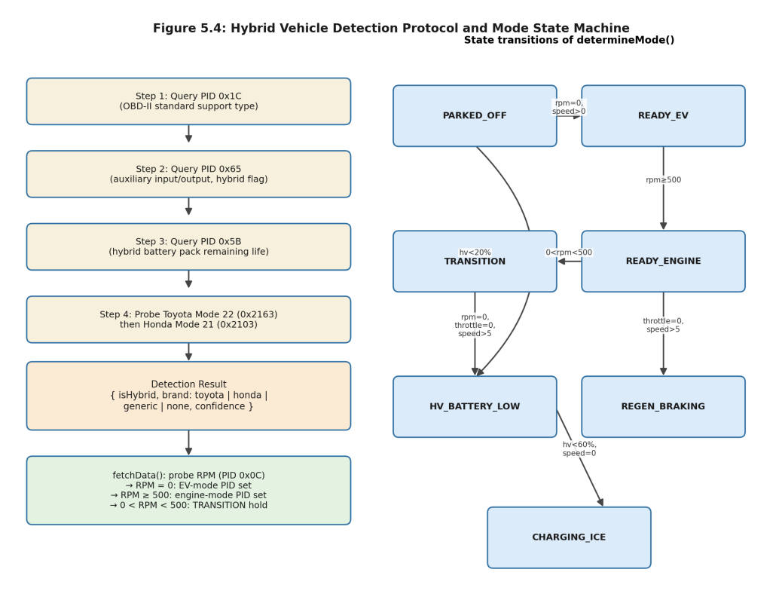
Figure 5.4: Hybrid vehicle detection protocol and mode state machine
Detection proceeds in up to four steps. PID 0x1C (OBD-II standard support type) and PID 0x65 (auxiliary input/output status) are checked first, since some vehicles report a hybrid-related flag through these standard PIDs. PID 0x5B (hybrid battery pack remaining life) is checked next; a valid, non-zero response here is a strong signal of a hybrid powertrain. If none of these are conclusive, the service probes Toyota's Mode 22 PID 0x2163 and, if that fails, Honda's Mode 21 PID 0x2103 both of which return manufacturer-specific hybrid telemetry blocks only on the corresponding platforms, so a valid response identifies both the presence of a hybrid system and which manufacturer-specific decoder to use for subsequent polling.
Once a vehicle is confirmed as a hybrid, the mode state machine tracks which of seven states the vehicle is currently in PARKED_OFF, READY_EV, READY_ENGINE, TRANSITION, REGEN_BRAKING, CHARGING_ICE, and HV_BATTERY_LOW based on RPM, throttle position, vehicle speed, and the hybrid battery state of charge read through the Mode 22/21 decoder. This matters for the sanitisation rules: for example, while in READY_EV (engine off, vehicle moving), a stale non-zero engine-load reading cached from before the engine last stopped is zeroed out rather than passed through to the anomaly detector, which would otherwise see a value that looks anomalous for a stationary engine but is simply leftover state from the adapter.

5.8 Use Case Design
Figure 5.5 summarises the system from the perspective of its two actors: the vehicle owner, who is the primary user of the mobile application, and a workshop or mechanic, who appears as an actor only insofar as the system's output (a workshop recommendation matched to a fault category) is meant to connect the owner to them. The “run on-device AI diagnosis” use case includes “view fault severity and recommendations” and “view vehicle health score” as direct consequences of running inference; “discover nearby workshops” is shown as including the GPS-based filtering step, and “view/log maintenance schedule” extends into “receive workshop specialisation match” when a logged service event corresponds to a category the workshop directory can address.
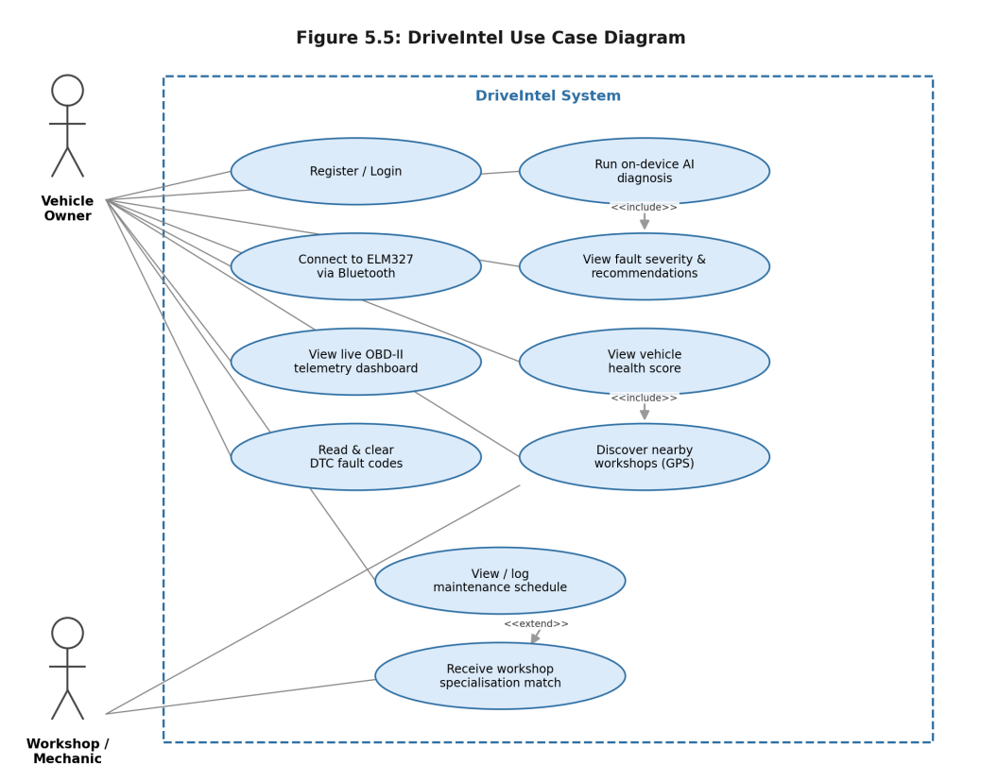
Figure 5.5: DriveIntel use case diagram

5.9 Summary
This chapter has gone through the system's architecture, REST API, database schema, AI model architectures, the full session inference pipeline including all four post-inference rules, hybrid detection and mode tracking, and the system's use cases. Together these form the design that Chapter 6 describes the implementation and testing of.

Chapter-6: Implementation and Testing

6.1 Introduction
This chapter covers how the design in Chapter 5 was implemented, with particular attention to the parts that turned out to be more involved in practice than they looked on paper, and then walks through the testing carried out both at the unit level and through a set of thirteen structured end-to-end sessions covering the scenarios identified during requirements analysis.

6.2 Mobile Application Implementation
The mobile application is organised around a bottom tab navigator reached after login and, on first use, a Bluetooth scan/connect screen. Figure 6.1 shows the navigation structure: each of the four main tabs (Dashboard, Diagnostics, Maintenance, Workshop) has its own drill-down detail view.
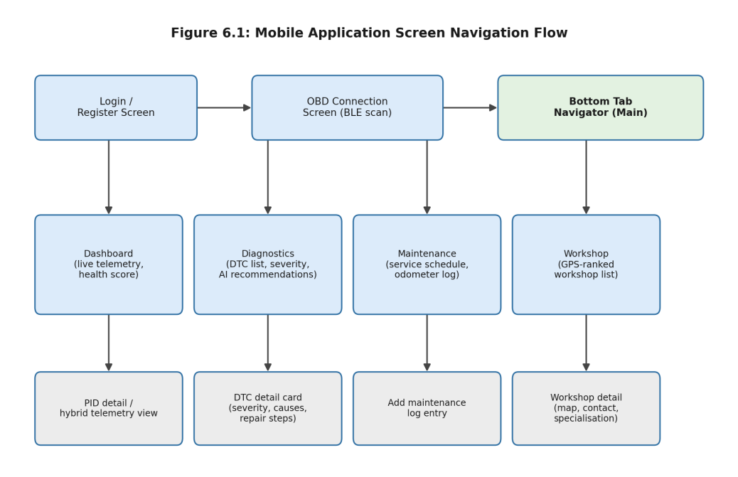
Figure 6.1: Mobile application screen navigation flow

6.2.1 Dashboard Screen
The Dashboard presents live readings for the ten tracked sensor channels, the current overall health score, and for vehicles identified as hybrids a panel giving the current HybridMode and the high-voltage battery state of charge. Values refresh on each polling cycle of the BLE command queue; where a PID is unsupported by the connected vehicle, the corresponding field displays a placeholder rather than a stale or zero reading, which avoids the misleading impression that, say, fuel pressure sits at exactly zero.

6.2.2 Diagnostics Screen
The Diagnostics screen lists active DTCs, each shown with its severity badge (colour-coded against the four tiers in Table 5.6), its predicted fault category, the recommended user action text, and where Rule 3 has fired a short note explaining why severity was escalated. Tapping a DTC opens a detail card with the full description, possible causes, and suggested repair steps. A “clear codes” action sends Mode 04 and, on success, refreshes the list.

6.2.3 Maintenance Screen
The Maintenance screen lists the odometer history alongside logged service entries, and lets the user add a new one (service type, odometer at time of service, cost, and free-text notes). This record feeds the mileage-band feature used by the health scorer, described in Section 5.4.3.

6.2.4 Workshop Screen
The Workshop screen requests the device's current GPS coordinates, calls /workshops/recommend/{vehicle_id} with the fault categories from the current session's workshop_query, and displays the ranked list with distance, rating, and a badge indicating which of the vehicle's current fault categories the workshop lists as a specialisation.

6.2.5 Screen Captures from a Live Build
Figures 6.2 and 6.3 are taken directly from the application running on a physical Android device, paired over Bluetooth with a connected ELM327 adapter. Unlike the worked sessions in Table 6.1, which were constructed to exercise one rule or code at a time, these captures simply record what a tester saw during an ordinary connected session, with nothing staged beforehand. They sit alongside the structured sessions to confirm that the screens described earlier in this section behave as intended once wired to actual hardware, rather than only inside isolated unit tests.
Figure 6.2(a) is the upper part of the Dashboard: a 100% health score sits beside compact gauges for fuel, battery, and engine load, a status banner confirms every monitored system reads within range, and four live circular gauges cover speed, RPM, coolant temperature, and throttle position. The small “AI FAIR” tag beside “Vehicle Status” reflects the on-device classifier's own confidence in this particular reading, separate from the health score itself. Figure 6.2(b) continues further down the same screen: an “Extended Telemetry” panel lists engine load, intake temperature, mass air flow, and fuel pressure, three progress bars repeat engine load, throttle, and fuel level in a different visual form, and a “Component Health” breakdown covers the engine, fuel system, electrical system, and air system, each marked Healthy, with a running tally of four healthy components and none flagged as a warning or critical.
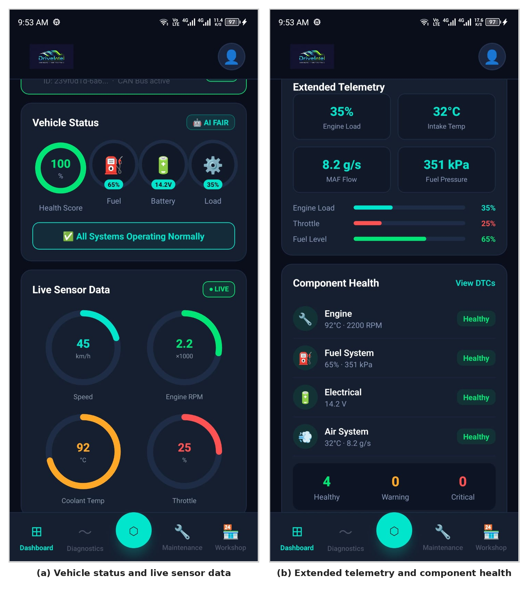
Figure 6.2: Dashboard screen captured during a connected session (a) vehicle status and live sensor data, (b) extended telemetry and component health
Figure 6.3(a) follows from tapping “Scan Vehicle” on the Diagnostics screen: a confirmation dialog reports that no fault codes were found and that the vehicle's systems are operating normally, matching the all-healthy reading captured on the Dashboard moments earlier. Figure 6.3(b) shows the Profile screen for the same session, including the signed-in account, a live OBD-II connection card confirmed as “ELM327 Connected” with the same speed, RPM, and coolant-temperature values seen on the Dashboard, and a vehicle entry left at its default “No vehicle set” state, since no make or model had been entered for this test account. The matching numbers across both figures 92°C, 2200 RPM, and 45 km/h appear identically on the Dashboard and the Profile card, with nothing contradicting them on the Diagnostics screen — offer a small but useful check that one underlying session is shared correctly across screens, rather than each screen reading its own stale copy.
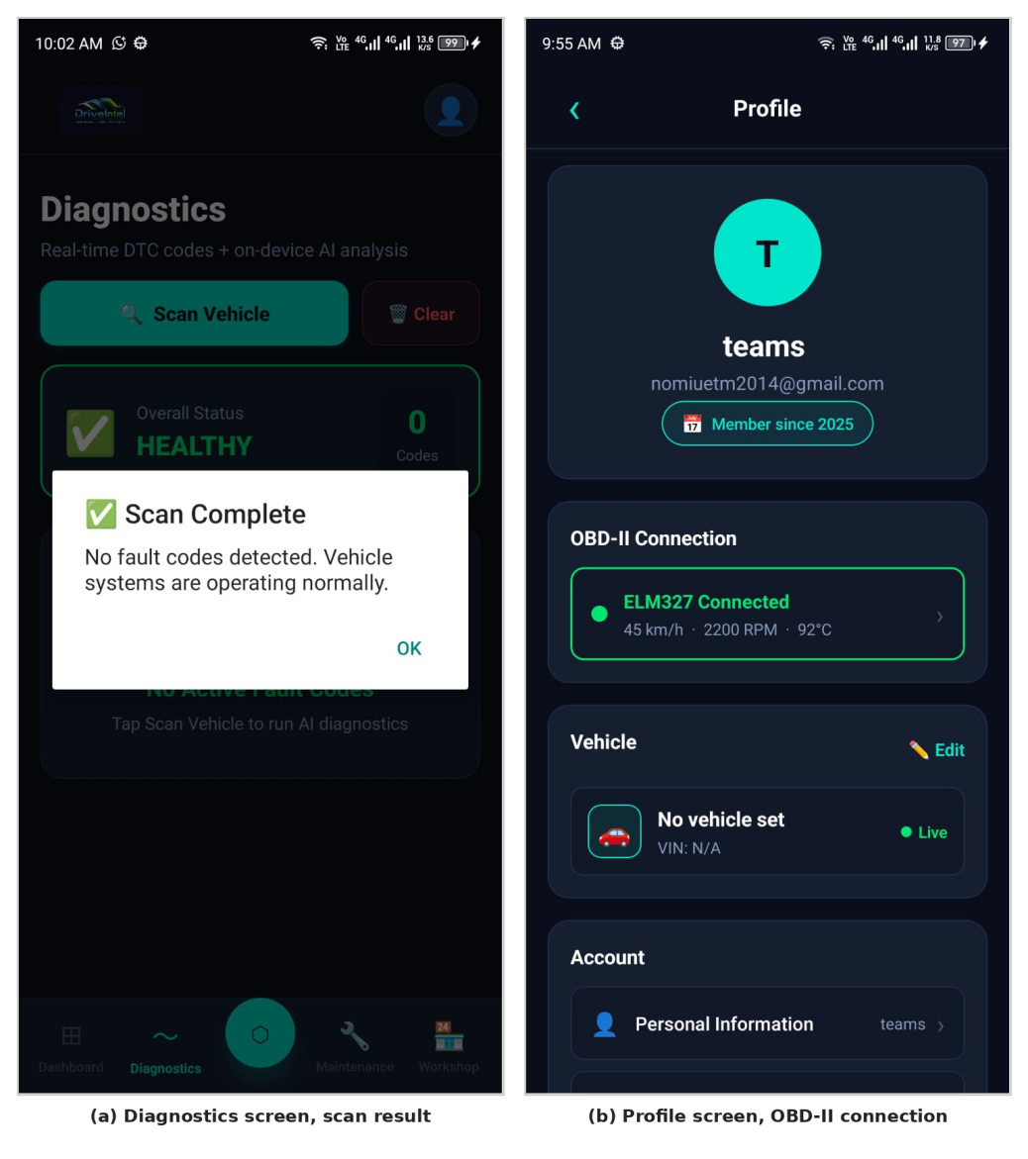
Figure 6.3: Diagnostics and Profile screens from the same live session (a) scan result, (b) account and OBD-II connection status

6.3 BLE and OBD-II Implementation Highlights
Two implementation details proved more important than expected. The first was response fragmentation: a 20-byte BLE notification limit means that anything beyond a short PID response a DTC list with several codes, for instance arrives across multiple notification events, and the receiving buffer has to be reassembled and only parsed once the ELM327's '>' prompt character is seen. Early versions of OBDService that parsed each notification independently produced intermittent garbled DTC reads; switching to prompt-terminated buffering resolved this.
The second was adapter variability. Several ELM327 clones tested during development responded to ATSP0 (automatic protocol selection) with a longer-than-default delay on the first command after connection, occasionally causing a timeout on the very first PID request. Adding a short fixed delay after the AT initialisation sequence, before the first PID request, removed this failure mode across the adapters tested.

6.4 AI Pipeline Integration
The three ONNX models (dtc_classifier_int8.onnx, sensor_anomaly_int8.onnx, health_scorer_int8.onnx) and the shared model_params.json are bundled as application assets and loaded through onnxruntime-react-native at app startup. The TF-IDF vectoriser, sensor normalisation, and health-feature construction described in Chapter 5 are re-implemented in TypeScript using the vocabulary, IDF weights, and statistics from model_params.json, so that the same preprocessing applies whether a session is scored on-device or, for historical re-scoring, by the backend's Python implementation.
One integration issue worth recording: the first version of the LSTM anomaly detector, when exported with a fixed batch size of 1, produced a reconstruction tensor with a different memory layout than the TypeScript code expected, which initially showed up as every channel reporting an identical, near-zero anomaly score in effect, the model appeared to have “learned” to output the mean of the training data for every input. The cause turned out to be a transposed axis order between the PyTorch export and the TypeScript tensor indexing, not a training problem; correcting the indexing on the TypeScript side resolved it.

6.5 Backend Implementation Highlights
The FastAPI backend follows a conventional structure: Pydantic request/response models, SQLAlchemy ORM models matching the schema in Table 5.3, and a router function per endpoint group. The /workshops/recommend/{vehicle_id} endpoint computes, for each workshop in the directory, the Haversine distance from the supplied coordinates and a specialisation-match flag against the vehicle's current fault categories, then sorts primarily by whether a specialisation match exists and secondarily by distance — so a matching workshop slightly further away is preferred over a closer non-matching one, but among workshops with the same match status, the nearer one comes first.

6.6 Unit Testing
Unit tests covered the PID response parser (hex string to physical-unit conversion for each of the fourteen commands in Table 4.3), the DTC code parser (converting the raw hex bytes returned by Mode 03 into standard P/B/C/U-prefixed codes), the TF-IDF transform (checked against a small hand-computed vocabulary), and the Haversine distance function (checked against known city-to-city distances).

6.7 System-Level Test Sessions
Table 6.1 lists the thirteen structured sessions used for end-to-end testing, covering the scenarios identified in Section 4.2: a healthy baseline, generic and manufacturer-specific DTCs at various severities, the four post-inference rules individually, a hybrid vehicle in both a normal and a low-battery state, and the workshop recommendation and DTC-clear flows. Each session specifies a vehicle, an input (DTCs and/or a sensor snapshot), and the expected outcome; “Match” indicates that the system's actual output agreed with the expected outcome when the session was run.
Table 6.1: System-level test sessions and outcomes
# | Vehicle / Scenario | Input | Expected Outcome | Result
TC-01 | Daihatsu Mira 2016, healthy baseline | No active DTCs; all 10 channels at calibration mean | High health score; all channels NORMAL; no recommendations shown | Match
TC-02 | Suzuki Cultus 2017, emissions code | P0420 (catalyst efficiency below threshold); sensors nominal | Severity capped at LOW via CODE_CAP; category emissions; “monitor” guidance | Match
TC-03 | Suzuki Alto 2018, misfire-family code | P0010 (camshaft position actuator A); sensors nominal | Severity floored at HIGH via CODE_FLOOR regardless of classifier output; category engine | Match
TC-04 | Suzuki Mehran 2010, compound safety fault | C0035 (ABS wheel speed sensor, HIGH) and B0012 (airbag deployment loop, HIGH) | Rule 4 fires (2 safety-critical categories ≥ HIGH); both escalated to VERY_CRITICAL | Match
TC-05 | Toyota Prius 2016, hybrid — normal | Mode 22 probe succeeds; HV battery SoC 55%; engine off, speed > 0 | Hybrid detected (brand: toyota); mode READY_EV; no battery alert | Match
TC-06 | Toyota Prius 2016, hybrid — low HV battery | As TC-05 but HV battery SoC 15% | Mode HV_BATTERY_LOW; health score reduced; battery alert shown | Match
TC-07 | Honda City 2017, sensor–DTC cross-correlation | P0128 (thermostat, engine category); coolant_temp = 110°C (above 105°C alert threshold) | Rule 3 fires; P0128 escalated to HIGH with cross-correlation note | Match
TC-08 | Toyota Vitz 2014, sensor noise suppression | No active DTCs; 7 of 10 channels flagged non-normal (cold start) | Rule 2 fires; anomaly scores scaled down ×0.55; health score remains high | Match
TC-09 | Hyundai Elantra 2016, PID overlay | battery_voltage flagged ABNORMAL by LSTM model; raw value 13.9 V (within calibration range) | Rule 1 fires; channel reset to NORMAL, anomaly score ×0.3 | Match
TC-10 | Kia Sportage 2015, manufacturer-specific code | P1326 (knock sensor, manufacturer-specific); sensors nominal | Classifier assigns category ignition, severity MEDIUM based on description text | Match
TC-11 | Audi A4 2013, network communication code | U0100 (lost communication with ECM/PCM) | Category network, severity HIGH; workshop_query includes ‘network’ | Match
TC-12 | Suzuki Alto 2018, workshop recommendation | Active fault category abs_brakes; GPS coordinates in Mardan | Nearby ABS-specialist workshop ranked above a closer non-specialist workshop | Match
TC-13 | Suzuki Cultus 2017, DTC clear flow | Mode 04 command sent after TC-02 scenario | Stored DTC status updated to ‘cleared’; /dtc/{vehicle_id} returns no active codes | Match

All thirteen sessions matched their expected outcomes on the build used for this report. Two of them TC-03 and TC-04 needed the CODE_FLOOR table and Rule 4 respectively to behave correctly even when the underlying classifier's raw prediction would not, on its own, have produced the expected severity; this is by design, and is the main practical justification for the rule layer described in Section 5.6 rather than relying on the models alone.

6.8 Summary
This chapter described the implementation of the mobile application's screens and navigation, the BLE and OBD-II handling details that required the most debugging, the integration of the ONNX model pipeline, and the backend's workshop-recommendation logic. Thirteen structured test sessions were then used to check the system end-to-end against the scenarios identified during requirements analysis, all of which produced the expected outcome. The next chapter looks at the AI models' own performance metrics from training, and discusses what the test results in this chapter do and do not demonstrate about the system as a whole.

Chapter-7: Results and Discussion

7.1 Introduction
This chapter presents two kinds of results. The first is the AI models' own performance against the held-out validation split used during training, reported as the team's internal measurements rather than as figures verified by an external party a distinction worth keeping in mind, given that the training data itself was assembled for this project rather than drawn from a large independent benchmark, as discussed in Section 7.4. The second is a discussion of what the thirteen end-to-end test sessions from Chapter 6 do and do not demonstrate about the system as a whole.

7.2 AI Model Performance
Figure 7.1(a) shows each model's primary validation metric: classification accuracy for the DTC classifier, area under the ROC curve (AUC) for the sensor anomaly detector, and the coefficient of determination (R²) for the health scorer. All three values are reported for the INT8-quantised models that ship with the application, after the drift-check step described in Section 4.5.4 confirmed that quantisation did not noticeably reduce performance relative to the float32 versions.
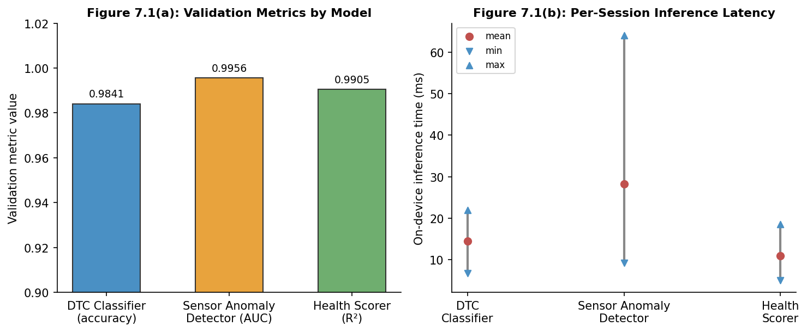
Figure 7.1: AI model validation metrics (a) and on-device inference latency by model (b)
The DTC classifier reached 98.41% accuracy on its combined severity/category validation split. The sensor anomaly detector's reconstruction-error-based anomaly scores achieved an AUC of 0.9956 against the held-out set of sequences with injected anomalies described in Section 4.4.2. The health scorer achieved R² = 0.9905 with a mean absolute error of 0.732 (on the 0–100 scale) against its rule-derived targets.
Figure 7.1(b) shows the range of on-device inference times measured across repeated runs of a representative session on the development device. The DTC classifier and health scorer both completed in under 25 ms in all observed runs; the sensor anomaly detector the largest of the three models, owing to its sequence length ranged from roughly 9 ms to 64 ms, with a mean around 28 ms. The full three-model bundle, quantised to INT8, occupies approximately 0.474 MB on disk, which comfortably fits as a bundled application asset rather than requiring a separate download.
Two things are worth saying about these numbers. First, an R² above 0.99 for the health scorer is, in large part, a reflection of how the training targets were generated: since the targets come from a deterministic rule applied to the same features the model sees as input (Section 4.4.3), the model's job is closer to approximating a known function than to generalising from noisy real-world labels, and a high R² here should be read as “the model learned the rule well” rather than “the model predicts real-world vehicle health with this accuracy.” Second, the latency spread for the sensor anomaly detector roughly a seven-fold range between minimum and maximum is wider than for the other two models; this is consistent with it being the model most sensitive to background load on the test device (a 120-step sequence through two LSTM layers is simply more work than a small MLP), and on a busier or older device the upper end of this range could be more typical than the mean.

7.3 End-to-End Test Results
All thirteen sessions in Table 6.1 produced the expected outcome. Grouping them by what they were testing gives a clearer picture of where the system's behaviour comes from than the raw pass count does on its own:
- TC-01, TC-02, TC-05, TC-10, and TC-11 mainly exercise the DTC classifier and the category/severity lookup tables directly a healthy vehicle, a capped low-severity code, a normal hybrid, a manufacturer-specific code, and a network code respectively. Their passing is largely evidence that the classifier and lookup tables agree with the expected labels for the specific codes used.
- TC-03 and TC-04 specifically required the CODE_FLOOR table and the compound-escalation rule (Rule 4) to override what the classifier alone would have produced; these two cases are the strongest evidence in this test set that the rule layer is doing useful work rather than being redundant with the models.
- TC-07, TC-08, and TC-09 each exercise exactly one of Rules 1–3 in isolation, and TC-06 exercises the hybrid mode state machine's response to a low battery state. These confirm that each rule fires under the condition it was designed for and does not fire otherwise (each session also includes a check that the other rules do not fire).
- TC-12 and TC-13 test the backend's workshop-recommendation ranking and the DTC-clear flow respectively, and are less about the AI pipeline than about the application logic surrounding it.
Read this way, the thirteen sessions cover the main behaviours described in Chapter 5 reasonably well, but they are still thirteen hand-constructed scenarios rather than a statistically representative sample of real driving and fault conditions a point returned to in the next section.

7.4 Discussion and Comparison with Literature
Relative to the literature reviewed in Chapter 3, the closest comparisons are to Malhotra et al.'s prediction-error approach to LSTM-based anomaly detection [6] and to the general TF-IDF-plus-classifier pattern documented in the scikit-learn literature [13]. The broad approach — train on normal data, use reconstruction or prediction error as the anomaly signal carried over without major modification; what changed was the application to a fixed 10-channel automotive sensor window rather than the single-channel signals (ECG, power demand) used in that earlier work, and the addition of the PID-overlay and noise-suppression rules, which exist specifically because automotive sensor data on cheap adapters is noisier and more prone to spurious single-channel excursions than the cleaner signals in that prior evaluation.
The most significant limitation of the results in this chapter is the training data itself. Both the DTC classifier and the sensor anomaly detector were trained on data assembled for this project compiled DTC records with assigned severities and categories, and synthetically generated sensor sequences rather than on telemetry logged from a fleet of real vehicles over an extended period. This matters in a specific way: the high validation accuracy and AUC figures in Section 7.2 demonstrate that the models learned the patterns present in this dataset well, but they do not by themselves demonstrate that those patterns match the full diversity of how real vehicles actually fail. A real fault might present with a sensor signature the synthetic data generator did not happen to produce, or a real ELM327 clone might introduce noise characteristics different from those modelled during dataset preparation.
This is not presented as a reason to dismiss the results the thirteen end-to-end sessions in Table 6.1 do show the pipeline behaving sensibly across a range of hand-constructed scenarios chosen to resemble plausible real situations but it is the honest caveat that separates “this system works on the data we gave it” from “this system would work reliably on an arbitrary vehicle in the field.” Closing that gap would require the kind of real-fleet data collection discussed as future work in Chapter 8.

7.5 Summary
The three on-device models reached validation accuracy/AUC/R² figures above 0.98 on their respective held-out splits, with a combined INT8 bundle size under 0.5 MB and per-session inference times in the tens of milliseconds. All thirteen end-to-end test sessions produced their expected outcomes, including the two sessions specifically designed to require the rule-based layer rather than the models alone. The main caveat discussed honestly rather than glossed over is that both the training data and the test sessions were assembled for this project rather than drawn from real-fleet telemetry, which bounds how far these results can be generalised. The final chapter summarises how the project's three objectives were met overall, restates this limitation alongside others, and sets out directions for future work.

Chapter-8: Conclusion and Future Work

8.1 Conclusion
This project set out with three objectives: a cross-platform mobile application that connects to a vehicle over BLE OBD-II, reads and clears DTCs, and handles hybrid vehicles through automatic detection and sensor sanitisation; an on-device AI pipeline that classifies fault severity, detects sensor anomalies, and produces a single health score, all without a network connection; and a diagnostic interface that ties this together with GPS-based workshop discovery filtered by the faults actually detected.
Each of these was implemented and tested. The mobile application connects to ELM327-clone BLE adapters through a serialised command queue robust enough to handle the response fragmentation and timing quirks of cheap hardware, reads the fourteen OBD-II commands listed in Table 4.3, and for Toyota and Honda hybrid platforms detects the hybrid drivetrain and switches to Mode 22/21 enhanced PIDs and the seven-state mode tracking described in Chapter 5. The on-device AI pipeline runs three INT8-quantised ONNX models totalling under 0.5 MB, completing a full session's inference in well under a second, with a small set of post-inference rules that handle the compound and edge cases the models alone do not. The Diagnostics and Workshop screens present severity-coded fault information and a GPS-ranked, specialisation-filtered list of nearby workshops.
Taken together, the thirteen end-to-end test sessions in Chapter 6 and the model performance figures in Chapter 7 support the conclusion that the three objectives were met within the scope defined in Chapter 1, a working, offline-capable prototype covering the path from a BLE connection to a recommended next action.

8.2 Limitations
Three limitations stand out, and are stated here without softening, since an honest account of them is more useful than an optimistic one:
- The AI models were trained on data assembled for this project compiled DTC records and synthetically generated sensor sequences rather than on telemetry from real vehicles over time. The validation metrics in Chapter 7 reflect how well the models learned this dataset, not how they would perform against the full diversity of real-world faults.
- Hybrid support covers Toyota/Lexus Mode 22 and Honda Mode 21 platforms specifically. Other hybrid and electric vehicles including increasingly common Chinese EV imports fall back to standard Mode 01 behaviour, which does not expose battery state of charge or motor telemetry for those platforms.
- The workshop directory used for the recommendation feature is a representative sample built for demonstration and testing, not a live, continuously maintained listing of actual workshops and their specialisations.

8.3 Future Work
Several directions follow naturally from the limitations above and from observations made during development:
- Real-fleet data collection: instrumenting a small number of volunteer vehicles to log OBD-II sessions and any DTCs that occur over weeks or months would allow the models particularly the sensor anomaly detector to be retrained or fine-tuned on real driving patterns and real fault onsets, closing the gap discussed in Section 7.4.
- Broader hybrid and EV coverage: extending HybridService's manufacturer-specific decoders to cover additional platforms (for example, Honda's newer e:HEV systems, or BYD and other Chinese EV imports increasingly seen in Pakistan) would extend the hybrid-aware features to a larger share of the vehicle population.
- A live workshop directory: replacing the representative sample with crowd-sourced or partner-submitted workshop listings, ideally with a verification step, would make the recommendation feature useful beyond a demonstration setting.
- Additional languages: the application's existing i18n translation infrastructure (src/i18n/translations.ts) currently covers a limited set of languages; extending this to Urdu and regional languages would make the application accessible to a larger share of vehicle owners in Pakistan, several of whom may be more comfortable with a non-English interface for exactly the kind of plain-language guidance this system aims to provide.
- Trend-based alerts: the health scorer currently operates on a single session's features. Tracking the health score and individual anomaly scores over time across multiple sessions could surface slow degradation trends (a score drifting down over weeks) that a single snapshot cannot show.

8.4 Final Remarks
DriveIntel was built around a fairly simple premise: that the gap between the data a vehicle already exposes and the information a driver can act on is, for a large class of common faults, smaller than the cost of a professional diagnostic visit suggests. Whether that premise holds up outside the thirteen test sessions in this report is an empirical question that this project has made a first attempt at answering, and has tried to be clear about the parts of that answer that remain open.

References
References are numbered in the order in which they are first cited in the text, following the IEEE citation style.
[1] SAE International, "Surface Vehicle Standard J1979 / ISO 15031-5: E/E Diagnostic Test Modes," SAE International, Warrendale, PA, USA, 2019.
[2] ELM Electronics Inc., "ELM327 OBD to RS232 Interpreter Datasheet," ELM Electronics, Ontario, Canada. [Online]. Available: https://www.elmelectronics.com/DSheets/ELM327DSH.pdf [Accessed: Mar. 2026].
[3] World Health Organization, "Global Status Report on Road Safety 2023," WHO, Geneva, Switzerland, 2023.
[4] A. Paszke et al., "PyTorch: An Imperative Style, High-Performance Deep Learning Library," in Advances in Neural Information Processing Systems 32 (NeurIPS 2019), H. Wallach et al., Eds., 2019, pp. 8024–8035.
[5] S. Hochreiter and J. Schmidhuber, "Long Short-Term Memory," Neural Computation, vol. 9, no. 8, pp. 1735–1780, Nov. 1997.
[6] P. Malhotra, L. Vig, G. Shroff, and P. Agarwal, "Long Short Term Memory Networks for Anomaly Detection in Time Series," in Proc. 23rd European Symposium on Artificial Neural Networks, Computational Intelligence and Machine Learning (ESANN), Bruges, Belgium, 2015, pp. 89–94.
[7] Microsoft Corporation, "ONNX Runtime: Cross-Platform, High-Performance ML Inferencing and Training Accelerator." [Online]. Available: https://onnxruntime.ai [Accessed: Mar. 2026].
[8] B. Eisenman, Learning React Native: Building Native Mobile Apps with JavaScript, 2nd ed. Sebastopol, CA, USA: O’Reilly Media, 2018.
[9] Bluetooth SIG, "Generic Attribute Profile (GATT) Overview," Bluetooth Core Specification. [Online]. Available: https://www.bluetooth.com/specifications/specs/ [Accessed: Mar. 2026].
[10] FastAPI, "FastAPI Documentation." [Online]. Available: https://fastapi.tiangolo.com [Accessed: Mar. 2026].
[11] R. Langari and J.-S. Won, "Intelligent Energy Management Agent for a Parallel Hybrid Vehicle—Part I: System Architecture and Design of the Driving Situation Identification Process," IEEE Trans. Veh. Technol., vol. 54, no. 3, pp. 925–934, May 2005.
[12] SQLite Consortium, "SQLite Documentation." [Online]. Available: https://www.sqlite.org/docs.html [Accessed: Mar. 2026].
[13] F. Pedregosa et al., "Scikit-learn: Machine Learning in Python," Journal of Machine Learning Research, vol. 12, pp. 2825–2830, 2011.

Annexure-N: Degree Programme Learning Outcomes (PLOs)
This annexure maps the project to the twelve Programme Learning Outcomes (PLOs), describing how each was addressed during the design, implementation, and documentation of DriveIntel.
Table N.1: Programme Learning Outcome (PLO) Coverage
PLO | Attribute | How Addressed by This Project
PLO-1 | Academic / Computing Knowledge | Applied knowledge of databases (SQLAlchemy/SQLite schema design), mobile software engineering (React Native/TypeScript), machine learning (PyTorch model design and training), and embedded communication protocols (BLE GATT, OBD-II/ELM327) to design and implement DriveIntel.
PLO-2 | Problem Analysis | Decomposed the broad goal of “making vehicle diagnostics accessible” into the three concrete objectives in Chapter 2, and analysed why existing consumer OBD-II applications fall short of each one before designing DriveIntel's approach.
PLO-3 | Design / Development of Solutions | Designed the three-tier architecture (Chapter 5), the three on-device AI model architectures, the BLE command-queue design, and the post-inference rule layer, all implemented as a working system rather than left at a design-only stage.
PLO-4 | Investigation | Investigated ELM327 BLE behaviour, OBD-II PID semantics, and hybrid-vehicle enhanced diagnostic modes through a combination of manufacturer documentation, datasheets, and hands-on testing against real adapters and vehicles, and used these findings to inform the design choices in Chapters 4 and 5.
PLO-5 | Modern Tool Usage | Used PyTorch and ONNX Runtime for model development, training, quantisation, and on-device deployment; React Native and TypeScript for the mobile client; FastAPI and SQLAlchemy for the backend; and standard testing and version-control tooling throughout development.
PLO-6 | The Engineer / Computing Professional and Society | Motivated the project (Chapter 1) by the practical accessibility of vehicle diagnostics for ordinary owners in Pakistan, and designed the user-facing severity language (Table 5.6) to be understandable without specialist knowledge.
PLO-7 | Environment and Sustainability | Predictive maintenance — catching developing faults earlier — can reduce unnecessary fuel consumption and emissions from vehicles running with undiagnosed faults (e.g., a failing oxygen sensor affecting fuel trims), and can extend a vehicle's useful service life by encouraging timely repair over deferred neglect.
PLO-8 | Ethics | The thesis presents AI model performance figures (Chapter 7) alongside an explicit discussion of their limitations — particularly that training data was project-assembled rather than drawn from real fleets — rather than overstating what the results demonstrate.
PLO-9 | Individual and Teamwork | The three-person project team divided work across the mobile application, the AI pipeline, and the backend/integration, while collaborating on shared interfaces (the model_params.json contract and the REST API) that each part of the system depended on.
PLO-10 | Communication | This report itself, along with in-application UI text (severity labels, recommended actions, and DTC explanations) designed to communicate technical diagnostic information to a non-specialist audience.
PLO-11 | Project Management | The project was organised around the methodology flowchart in Figure 4.1, with the AI and application development strands tracked and integrated on a schedule that allowed both to be completed and tested within the project timeline.
PLO-12 | Lifelong Learning | The team learned BLE GATT programming, ONNX quantisation and mobile deployment, and hybrid-vehicle diagnostic protocols largely from scratch during this project, none of which were covered in detail in coursework prior to the FYDP.

Annexure-P: FYDP to SDGs Mapping
The Sustainable Development Goals (SDGs) are a universal call to action adopted by all UN Member States in 2015 as part of the 2030 Agenda for Sustainable Development. Table P.1 maps DriveIntel against the five SDGs to which this project most directly contributes, with a short justification grounded in the system as designed and implemented in Chapters 4–6. Goals not listed here were judged not to be directly addressed by this project and have been omitted rather than included with a placeholder justification.
Table P.1: FYDP to Sustainable Development Goals (SDGs) Mapping
Goal | Description | Justification
Goal 3 | Good Health and Well-Being | Earlier detection of developing vehicle faults, paired with the severity-based guidance in Table 5.6, gives drivers a concrete reason to address mechanical issues before they contribute to a breakdown or an accident on the road — supporting safer travel and the road-safety aims highlighted in the WHO Global Status Report on Road Safety [3].
Goal 8 | Decent Work and Economic Growth | By matching a detected fault category to workshops that list the corresponding specialisation (Section 5.6), DriveIntel creates a more direct link between diagnostic demand and appropriately skilled local repair businesses, which can support employment and business activity in the automotive service sector and encourage smaller workshops to position themselves around specific specialisations.
Goal 9 | Industry, Innovation, and Infrastructure | DriveIntel applies on-device machine learning, BLE-based OBD-II communication, and INT8 model quantisation — together a form of innovation in how diagnostic tooling reaches ordinary vehicles — to a service domain that has traditionally depended on dedicated scan-tool hardware and a workshop visit, contributing in a small way to the digital transformation of vehicle-service infrastructure described in Chapter 5.
Goal 11 | Sustainable Cities and Communities | By helping identify developing mechanical issues before they cause a vehicle to break down on the road, and by directing repairs toward appropriately specialised workshops, the system can reduce the frequency of unplanned roadside breakdowns that disrupt urban traffic flow — contributing to smoother, more resilient local transport networks.
Goal 13 | Climate Action | Several of the channels DriveIntel monitors — fuel trims, mass air flow, and oxygen-sensor voltage among them (Table 5.5) — are directly tied to combustion efficiency; flagging drift in these channels before it becomes severe enough to trigger a fault code gives drivers an earlier opportunity to address issues that would otherwise increase fuel consumption and tailpipe emissions.

