**Software Requirements**

**Specification**

**for**

**<Yatra>**

**Version 1.0 approved**

**Prepared by <Yatra Team>**

**<RK University>**

**<28/08/2022>**

***Copyright © 2022 by Yatra Team. Permission is granted to use, modify, and distribute this document.***

# Table of Contents

Table of Contents ii

Revision History ii

1. Introduction 1
   1. Purpose 1
   2. Document Conventions 1
   3. Intended Audience and Reading Suggestions 1
   4. Product Scope 1
   5. References 1
2. Overall Description 2
   1. Product Perspective 2
   2. Product Functions 2
   3. User Classes and Characteristics 2
   4. Operating Environment 2
   5. Design and Implementation Constraints 2
   6. User Documentation 2
   7. Assumptions and Dependencies 3
3. External Interface Requirements 3
   1. User Interfaces 3
   2. Hardware Interfaces 3
   3. Software Interfaces 3
   4. Communications Interfaces 3
4. System Features 4
   1. System Feature 1 4
   2. System Feature 2 (and so on) 4
5. Other Nonfunctional Requirements 4
   1. Performance Requirements 4
   2. Safety Requirements 5
   3. Security Requirements 5
   4. Software Quality Attributes 5
   5. Business Rules 5
6. Other Requirements 5

Appendix A: Glossary 5

Appendix B: Analysis Models 5

Appendix C: To Be Determined List 6

# Revision History

|  |  |  |  |
| --- | --- | --- | --- |
| **Name** | **Date** | **Reason For Changes** | **Version** |
| Yatra | 16/09/2022 | Initial Phase | 1.0 |
|  |  |  |  |

# Introduction

## Purpose

SCM provides centralized control for the planning, design, manufacturing, inventory, and distribution phases required to produce and sell a company's products.

This project is developed to facilitate supply chain management to automate its operations of keeping records and storing them further facilitating easy access. The software is capable enough to allow the concerned person to store and retrieve any type of record with just a single click of the mouse. The software allows an Interactive, Self-describing User Interface environment where even standalone users can work very comfortably and efficiently. Data redundancy will be removed and will require a one-time investment only.

A goal of supply chain management is to improve efficiency by coordinating the efforts of the various entities in the supply chain. This can result in a company achieving a competitive advantage over its rivals and enhancing the quality of the products it produces, both of which can lead to increased sales and revenue.

## Document Conventions

Times New Roman font has been used with a font size of 12 as the standard or typographical convention while typing this SRS.

## Intended Audience and Reading Suggestions

This document is intended for the developers, project managers, users, testers, and documentation writers. This document contains the purpose, scope, perspective, functions, operating environment, various constraints and interfaces, system features and requirements, diagrams, and other rules.

## Product Scope

This document represents specification of the SCM system requirements. It serves as the baseline document on which the subsequent software development life cycle phases are built.

## Definitions, Acronyms and Abbreviations

|  |  |
| --- | --- |
| **Term** | **Description** |
| SYSTEM | Supply Chain Management Software. |
| RKU | RK University |
| SCM | Supply Chain Management |
| STD | State Transition Diagram |
| SRS | Software Requirements Specification |
| ERP | Enterprise Resource Planning |

## Overview

## This SRS document is organized as flows:

## Overall description of SCM includes product perspective, product functions, SCM’s user characteristics, constraints, assumptions & dependencies, and apportioning of requirements.

## Specific Requirements include interface requirements, functional requirements, performance requirements, logical database requirements, design constraints, and software system attributes.

## Change management process.

## References

The references of this document are:

* SCM vision document v.1.2.
* Use Case & STD Documentation v.1.5
* SCM Conceptual [Class Model and Sequence Diagram](https://drive.google.com/drive/folders/1iED214KNokdZsj10Yz51FqbnCAUI5_hS?usp=sharing) document v.2.0
* SCM Screen layouts document v.1.2.
* <https://www.investopedia.com/terms/s/scm.asp>
* <https://www.oracle.com/in/scm/what-is-supply-chain-management/#:~:text=What%20is%20SCM%20(Supply%20Chain,product%20at%20its%20final%20destination>.
* <https://www.ibm.com/in-en/topics/supply-chain-management>
* <https://en.wikipedia.org/wiki/Supply_chain_management>
* <https://www.techtarget.com/searcherp/Guide-to-supply-chain-management>
* [Figma Design](https://www.figma.com/file/mI1bfsEuGJAbm4ZrXIr9XL/Yatra?node-id=0%3A1)

# Overall Description

## Product Perspective

The perspective of product conduct in delivering Yatra company products like vegetables, IT products, Business Consultation, and other IT services in a fast way and less cost than another alternative way. There are other well-known SCM systems from Oracle and SAP, they are used in big companies and connect with other systems but with the same main functionality that is provided by our SCM. Our system scope is limited by Yatra and their requests.

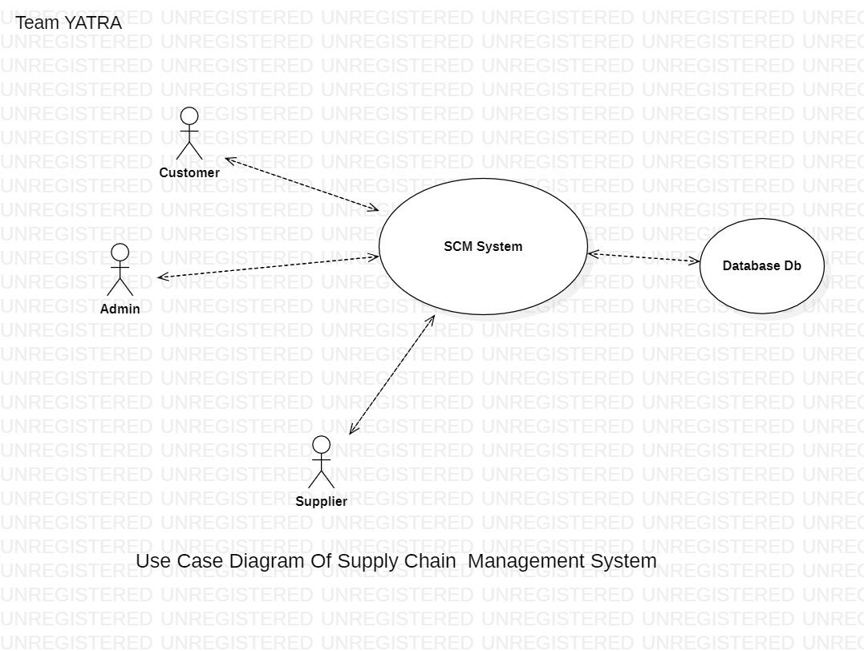

## Product Functions

**Yatra SCM will:**

* Provide a simple Customer service management process
* Determine mutually satisfying goals between the organization and customers
* Establish and maintain customer rapport
* Produce positive feelings in the organization and the customers
* Maintain Procurement process
* Manage Product development and commercialization
* Coordinate with customer relationship management to identify customer-articulated needs
* Select materials and suppliers in conjunction with procurement
* Develop production technology in manufacturing flow to manufacture and integrate into the best supply chain flow for the product/market combination.
* Maintain Manufacturing flow management process
* Manage Physical distribution
* Maintain Outsourcing and Partnerships
* Maintain Measurement Performance
* Maintain Cost Performance
* Maintain Customer Service Performance
* Maintain Productivity measures Performance
* Maintain Asset measurement Performance
* Maintain Quality Performance

**Functionalities Provided by Yatra:**

* + Logistic Management
  + Transportation Details
  + Material Management
  + Warehousing
  + Cold Storage Details
  + Contracting Details
  + Inventory Management for Retailers
  + Role-Based Access for Retailers, Farmers, Dealers
  + Data Backup
  + Notification System
  + Payment Reminder

## User Classes and Characteristics

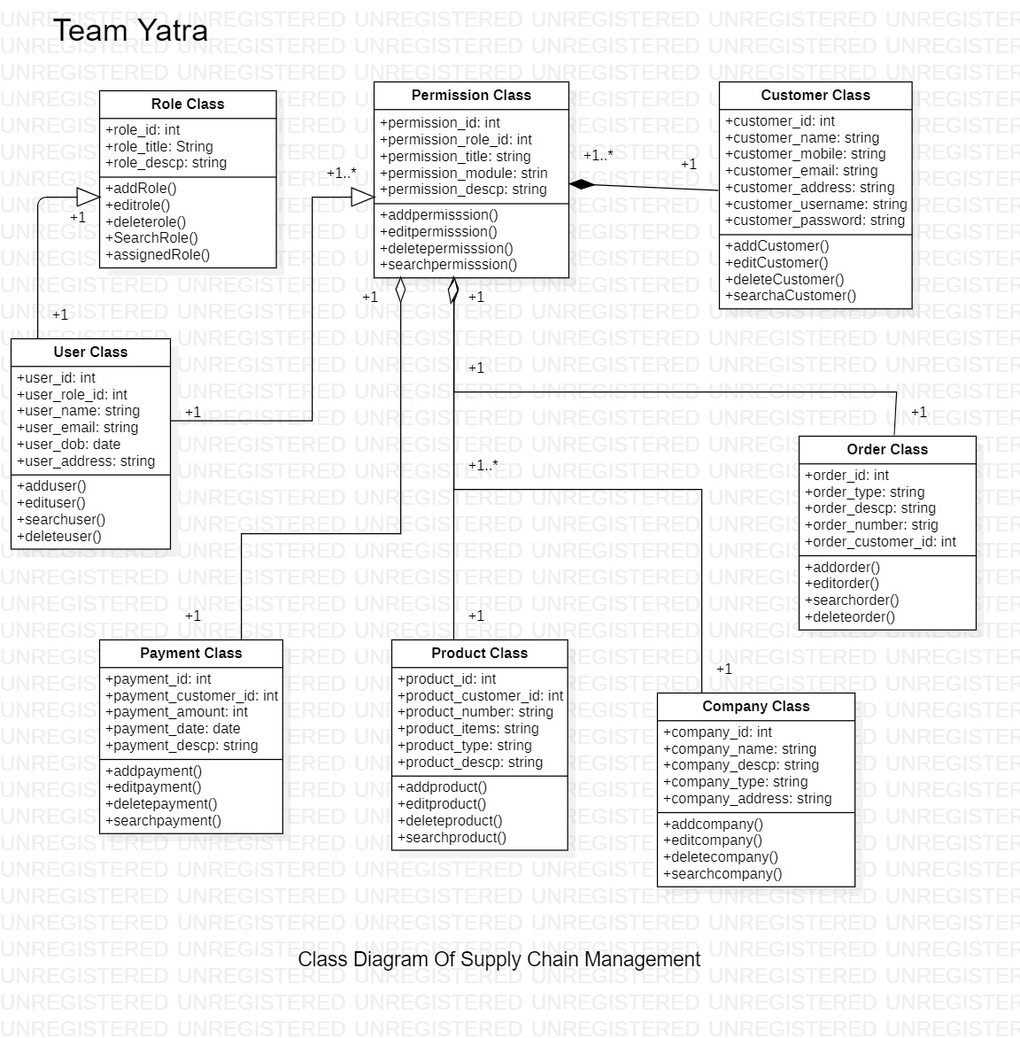

The users are Yatra’s employees, customers, Companies, and suppliers.

## Operating Environment

## The device must be of Android Operating System.

## Android Smart Phones and Tablets with minimum version 5.1 and above

## Design and Implementation Constraints

The system has many constraints. For example, the system must be android, and all tools must be compliant with android technologies, i.e., We must use Android and java as a programming language and Firebase, and SQL Lite as DBMS. We are also constrained by Yatra's framework and the system will later be integrated with the other two modules in the framework. Yatra has some programming standards that we must commit to.

## User Documentation

Any user of the software system is the target audience for user documentation generated about the software system. A range of short document types (e.g., guidelines, tutorials, frequently asked questions) in Hypertext Markup Language (HTML) and/or Portable Document Format (PDF) format must describe the use of the software system.

## Assumptions & Dependencies

We assume that the server machine of the system has a suitable Android OS**.** The system must have a connection to the internet and device must be of Android Operating System.

# External Interface Requirements

## User Interfaces

The system is an Android App based system so, it will interact with its users with a device components interface. The users move through pages containing activities or directions to some other activities.

The system interface will look like following:

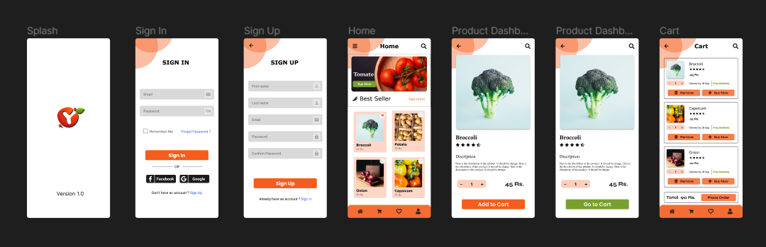

## Hardware Interfaces

* The system has no hardware interface requirements till yet.
* For billing it will require somehow hardware interfaces for bill scanning and all, but right now we haven’t used any hardware interfaces.
* Mobile’s Camera

## Software Interfaces

|  |  |
| --- | --- |
| Name | Android Studio |
| Mnemonic | AS |
| Specification Number | 2021 2.1.16 - Windows |
| Version Number | Version 2.1.16 |
| Source | https://developer.android.com/studio |
| Purpose of Interfacing | The system must use Android Operating System. |

|  |  |
| --- | --- |
| Name | Firebase |
| Mnemonic | FB |
| Specification Number | N/A |
| Version Number | Version 30.4.1 |
| Source | https://firebase.google.com/support/release-notes/android#latest_sdk_versions |
| Purpose of Interfacing | Authentication and Storing User Data Base |

|  |  |
| --- | --- |
| Name | SQL Lite |
| Mnemonic | N/A |
| Specification  Number | N/A |
| Version Number | **SQLite version** 3.39.3 |
| Source | https://www.sqlite.org/download.html |
| Purpose of Interfacing | For storing the Data of Inventory management system |

|  |  |
| --- | --- |
| Name | Java |
| Mnemonic | N/A |
| Specification  Number | N/A |
| Version Number | **Java version** 8.0 |
| Source | https://www.java.com/en/download/help/version_manual.html |
| Purpose of Interfacing | For Backend |

## Communications Interfaces

The SCM system will use TCP/IP as the main communication protocol through the internet/network.

Also, it might communicate with external systems in the future, such as customer relationship management systems and HR systems. The scope of our system does not require us to interact with other interfaces, but it can be customized.

# System Features

This section of the SRS describes the requirements for the system’s features. Specifically, requirements for component functionality, data curation, and software system administration are defined.

* 1. **Volatile Data Stream**

### The VDS component of the software system must comply with all enumerated requirements for an application to execute an MTConnect Agent (Data Exchange Between Shop Floor equipment and a software application used for monitoring and data analysis) in the standard.

## Query-able Data Repository

## The QDR component of the software system must retrieve data from an indexed database based on a user-defined query request via an app user interface, an endpoint query, and/or an API call.

## The QDR must provide the administrator with the ability to predefine queries for use by non-administrator users.

## The QDR must enable the administrator to limit query results by date ranges and/or several records.

## When configured in a query by the administrator, the QDR must provide the user with a list of all available devices in the database and all available associated data elements for that device.

## The user may be provided the ability to select what data elements to retrieve via the predefined query.

## The user must have the ability to select the time range and/or several records for the data to retrieve via the query.

## The user must have the ability to retrieve and view data as formatted ASCII, CSV, JSON, Pdf, or XML.

## Data Curation

## This subsection of the SRS describes the requirements for data curation within the software system.

## The software system must provide a function to store and manage data in a database according to a data-structure template (e.g., schema, ontology).

# Other Non-functional Requirements

## 5.1 Performance Requirements

The system must handle concurrent users and their operations. The system must accomplishof transactions. This is due to the nature of data, which is only text information that does not usually exceed 50 KB per transaction.

**5.2 Safety Requirements**

There are no requirements for Mean Time between Failures (MTBF) or Mean Time to Failures (MTTF) for this version of the software system defined in this SRS. However, in accordance with industry recommended practices, the software system should undergo feature testing, load testing, and regression testing are prior to releasing and/or deployment.

**5.3 Availability Requirements**

Reasonable efforts should be made to ensure the software system is available with an uptime of 95%. The uptime is calculated as the percentage of time during the year in which the software system was available to the public. A 95% uptime percentage allows for an average of 18.25 days per year, 36 hours per month, or 8.4 hours per week of downtime.

**5.4 Security Requirements**

The software system defined in this SRS must follow industry-recommended practices for secure software development. At a minimum, the software development must practice the principle of least privilege for defining access-level requirements of the software system and its associated services. The production-release version of the software system must pass an automated dynamic application security testing tool.

The system has only three roles for coordinators (Admin), suppliers, and customers only that make our system secure access online and these authentications will prevent and illegal access.

**5.5 Maintainability Requirements**

The architecture, design, implementation, and documentation of the application must minimize the maintenance costs of the software system. The maximum person-time required to fix a security defect (including regression testing and documentation update) must not exceed two person days. Otherwise, the software system must be taken offline or the offending feature disabled. The average person-time required to make a minor enhancement (including testing and documentation update) must not exceed one person per week.

The system is designed in modules where errors can be detected and fixed easily. This makes it easier to install updates and new functionality if required.

**5.6 Portability**

The system can operate in any of the latest Android operating systems with the latest version. Due to the nature of the system, the host machine must also have Android installed.

**5.7 Business Model**

The system must have at least a Super-User role and a user role defined for accessing and interacting with the system. Additional roles may be defined for the system if the business rules for the administrator and user roles are satisfied. At a minimum, the Super-User role must account for the data explorer, data curator, and administrator account type requirements described in Section.

At a minimum, the User role must account for the data explorer account-type requirements described in Section.

**The following business rules must apply to the administrator and user roles.**

**5.6.1 Super-User Role Business Rules**

* Superuser Role/001 Maintains all VDS and QDR back-end system configurations
* Superuser Role/002 Maintains all VDS and QDR schemas and templates
* Maintains all user groups and user accounts
* Maintains all QDR predefined queries

**5.6.2 User Role Business Rules**

* Connects to and retrieves and reads data from VDS and QDR in conformance with the maintained VDS and QDR schemas and templates.

# Other Requirements

* Up to now there is not any legal requirements from government.

# Appendix:

# 

# 

