Olist Business Discovery
HVIA Task 01 — Data Analysis Internship
Dataset: Olist Brazilian E-Commerce Public Dataset (Kaggle, ~99,000 orders, 2016–2018)

1. About Olist
Olist is a Brazilian company that helps small and medium businesses sell online. Instead of each seller building their own store and managing shipping and payments separately, Olist gives them one platform that connects to more than 170 marketplaces and handles the technology side: listing products, taking payments, managing orders, and coordinating delivery.
Over time Olist grew from a marketplace connector into a wider ecosystem that also includes an ERP, business credit for sellers, logistics and shipping tools, and AI features. Its customers are the sellers, and its value comes from removing the operational work a small business would otherwise struggle to handle on its own.
The dataset used in this report is from 2016–2018, so it shows an earlier stage of the company. It is still useful because the core business model — connecting small sellers to buyers across Brazil through one platform — has not changed.

2. Understanding the Dataset
The data comes in 9 separate files: orders, order items, customers, sellers, products, payments, reviews, geolocation, and a category name translation file. Each order can contain more than one item, and each item can come from a different seller, so all the files needed to be joined together using order ID, product ID, and seller ID before any analysis could start.
After joining every table into one master table, there were 113,425 rows, but only 98,657 of those rows were unique orders. This matters a lot for the analysis: a table like this has one row per item, not one row per order, so anything counted directly from the rows (like "number of orders" or "number of late deliveries") will be wrong unless it is grouped back to one row per order first. This was the single most important lesson from the cleaning stage and it changes almost every result in this report.

Missing values
Several columns had missing values, and almost all of them were missing for a real reason rather than by mistake:
- Delivery dates (order_delivered_carrier_date, order_delivered_customer_date) were missing mainly for orders that were still shipping, cancelled, or unavailable — not delivered yet, so there is no delivery date to show.
- Review score was missing for orders where the customer simply never left a review.
- Product category and product dimension fields were missing for a small number of products with incomplete listings.
Because of this, missing delivery dates and missing reviews were left as empty rather than filled in with an average or a guess, since filling them would have invented information that was never true. Only 8 rows were removed completely: these were marked "delivered" but had no delivery date at all, which does not make sense and looks like a data entry error rather than a real missing value.

3. Key Findings — The Business Story

Finding 1: About 1 in 12 orders arrives late
Looking only at orders that were actually delivered, 8.1% arrived after the estimated delivery date shown to the customer. That is roughly 7,825 late orders out of 96,469 delivered orders.

Finding 2: Late delivery destroys customer satisfaction almost immediately
Review scores drop sharply once an order is late:
- On-time orders average a review score of 4.29 out of 5.
- Late orders average only 2.57 out of 5.
The drop is not gradual. Orders that are even 1 to 3 days late already fall from about 4.0 down to around 2.7–3.2, and by 6 to 10 days late the average score sits close to 1.6 to 1.8. In other words, customers do not need to wait long to become unhappy — a short delay is almost as damaging to the review score as a long one. This is the clearest and strongest pattern in the whole dataset.
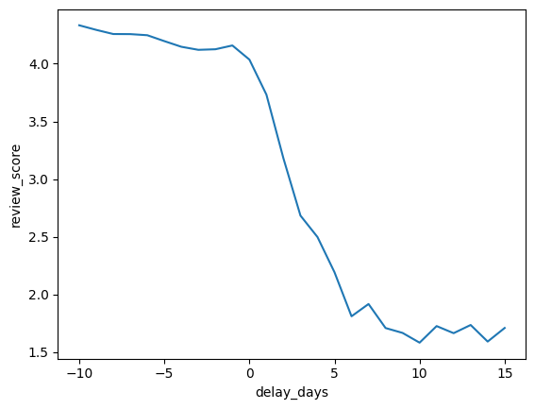
Average review score vs. delivery delay (days). Negative values mean the order arrived early.

Finding 3: Some states are far more likely to receive late orders
Looking at late orders as a percentage of each state's total orders (not just raw counts, since bigger states naturally have more late orders simply because they have more orders overall), a clear regional gap appears. The states below have the highest late delivery rates, all well above the 8.1% national average:
State | Late delivery rate
Alagoas (AL) | 23.9%
Maranhão (MA) | 19.7%
Piauí (PI) | 16.0%
Ceará (CE) | 15.3%
Sergipe (SE) | 15.2%
Bahia (BA) | 14.0%
Rio de Janeiro (RJ) | 13.5%

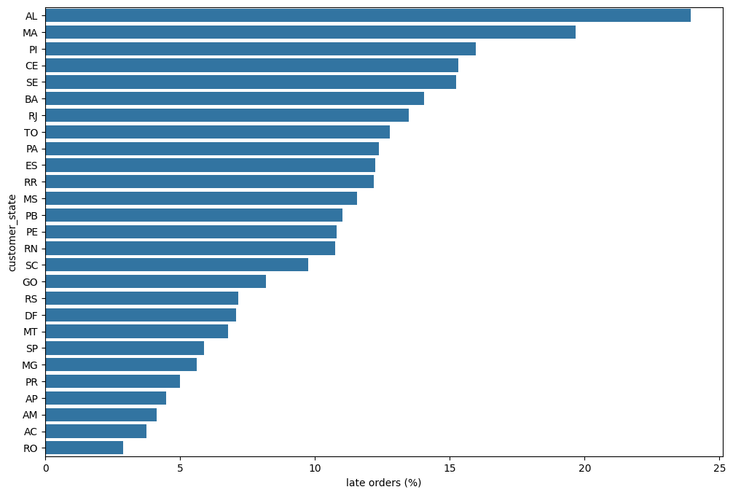
Late delivery rate by customer state, all 27 states (%).
The states with the worst delivery performance are concentrated in Brazil's North and Northeast, which are farther from São Paulo, where most sellers and logistics infrastructure are based. This points to a distance and infrastructure problem rather than a random or seller-specific issue.

Finding 4: Delivery problems are concentrated in a small group of sellers
Most sellers with enough order volume to judge fairly stay under a 10% late rate. But a small number of sellers, each with 30 or more delivered orders, have late rates between 23% and 35% — three to four times the platform average. This means delivery delay is not spread evenly across all sellers; a small group is responsible for a large share of the problem, and improving just these sellers' shipping process could meaningfully reduce late orders overall.

Finding 5: Revenue is highly concentrated in a few states
The top 5 customer states account for 73.8% of total revenue in the dataset:
State | Share of revenue
São Paulo (SP) | 38.2%
Rio de Janeiro (RJ) | 13.4%
Minas Gerais (MG) | 11.7%
Rio Grande do Sul (RS) | 5.5%
Paraná (PR) | 5.0%

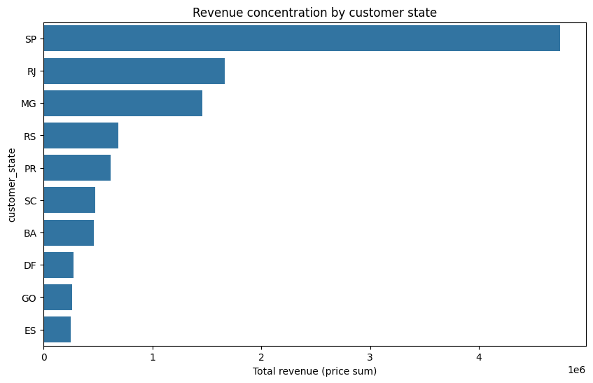
Total revenue by customer state (top 10 shown).
This means Olist's revenue depends heavily on a handful of states doing well. It also means the states with the worst late delivery rates (AL, MA, PI, CE, SE) are not the states the revenue depends on most, which is useful context — the delay problem is a growth and reputation risk in underserved regions rather than an immediate threat to the biggest markets.

Finding 6: Very few customers come back to buy again
Only 3.05% of unique customers placed more than one order in this two-year period. The large majority of customers (about 97%) bought exactly once. This is a low repeat-purchase rate for an e-commerce platform, and it is worth noting that customers on Olist are usually buying from an individual seller's shop rather than from "Olist" as a recognizable brand, which may make it harder to build repeat loyalty compared with a single unified store.

Smaller patterns worth noting
- Health & Beauty, Watches & Gifts, and Bed & Bath categories bring in the most revenue, and some of these same high-demand categories also show above-average late rates (for example Electronics and Baby products), suggesting that high demand puts extra pressure on fulfilment in exactly the categories that matter most for revenue.
- Payment method has only a small effect on late delivery (boleto 8.9% vs voucher 7.2%), so this is not a meaningful driver on its own.

4. Things to Keep in Mind (Limitations)
A few honest caveats about this analysis:
- Estimated delivery dates are set by Olist or the seller, and if these estimates are set unusually generously, some deliveries could look "on time" while still being slow in absolute terms. The 8.1% late rate should be read as "later than the promise made to the customer," not as an absolute speed measurement.
- Orders that were cancelled or marked unavailable were left out of the delay analysis because they never reached the shipping stage. These still represent lost sales and unhappy customers and are a separate problem worth investigating on its own.
- This dataset only covers 2016–2018, so these numbers reflect an earlier period of Olist's growth, not necessarily its current operations.

5. What HVIA Could Offer Olist
The clearest opportunity is around logistics and delivery reliability, not a generic analytics package. The data shows three connected facts: delays are concentrated in specific regions, a small group of sellers is responsible for a disproportionate share of the delays, and even a short delay causes a steep drop in customer satisfaction.
Based on this, HVIA could offer a delivery risk system that flags an order as high-risk for lateness at the moment it is placed, using the seller's history, the destination state, and the product category. This would let Olist step in early — for example, setting a more honest delivery estimate, prioritising the shipment, or proactively messaging the customer — before the order is late and the review is lost, rather than reacting after the damage is already done.
This fits directly into two of HVIA's core offerings: Logistics Intelligence, for the delay-risk prediction itself, and Analytics & Decision Systems, for an ongoing dashboard that tracks which sellers and regions are improving or getting worse over time.

6. Outreach Message Draft
Hi[ name ],
I've been working with Olist's public order data as part of a data analysis project, and one pattern stood out enough that I wanted to share it. Looking at delivered orders, about 8% arrive later than the estimated date — but the effect on customer reviews is much bigger than that number suggests: average review scores drop from 4.3 to 2.6 once an order is late, and the drop happens almost immediately, even with delays of just a day or two. The problem is also concentrated: a handful of states have late rates 2 to 3 times the platform average, and a small group of sellers accounts for a disproportionate share of the delays.
At HVIA we build data and AI tools for exactly this kind of problem — in this case, a system that could flag high-risk shipments before they go out, so the issue can be caught early instead of showing up as a bad review later.
Would you be open to a short call to see if this is something worth exploring for Olist's operations?
Best Regards,
Shahd.

