Final Project
Advanced Data Analysis Training
Dataset: WFP Global Food Prices (2026)
Source: Kaggle
 | Team Member Name
1 | Shahd Fawzy
2 | Youssef Nasser Omar
3 | Ahmed Abbas Ebedy
4 | Menna Mahmoud
5 | Marina Hany

1. Introduction
For our final project we used the WFP Global Food Prices dataset (Kaggle) to study food prices across countries in 2026. As a team of 5, we split the work: Python for cleaning and the main analysis, Excel for quick checks, Power BI and Tableau for interactive dashboards, and Machine Learning as a next step for prediction.

1.1 About the Dataset
Published on Kaggle, originally collected by the World Food Programme (WFP).
- Raw size: 85,289 rows x 17 columns.
- After cleaning: 84,920 rows (dropped ~0.4% with missing values).
- Coverage: 59 countries, 12 months of 2026.
Column | Meaning
countryiso3 | 3-letter country code.
date | Month of the price record (2026).
admin1 / admin2 | Region and sub-region inside the country.
market | Local market where the price was recorded.
market_id / commodity_id | Reference ID numbers only, not real quantities.
latitude / longitude | Market coordinates, used for maps.
category | Food group (cereals, vegetables, meat, dairy, etc.).
commodity | Specific item, e.g. Rice, Sugar, Onions.
unit | Unit of the price: KG, L, Head, Day, etc.
priceflag / pricetype | How the price was collected; Retail or Wholesale.
currency / price | Local currency and price in that currency.
usdprice | Price converted to USD — used for fair comparison across countries.

1.2 Tools We Used
- Python — cleaning and full exploratory analysis (pandas, matplotlib, seaborn, plotly).
- Excel — quick manual checks on smaller slices of the data.
- Power BI — interactive dashboard for filtering by country/category.
- Tableau — second interactive dashboard, focused on maps and trends (full documentation in Section 7).
- Machine Learning — planned next step to predict prices (Section 8).

2. EXCEL
2.1 Data Cleaning with Power Query
- The raw dataset was loaded into the Power Query Editor.
- Cleaned the dataset by removing empty rows and filtering out null values so they do not impact any calculations.
- Formatted and verified data types: text for geographic and commodity names, date format for date records, and numeric/currency format for prices.
- Applied Steps in Power Query: Source -> Check data Type -> Removed Blank Rows.
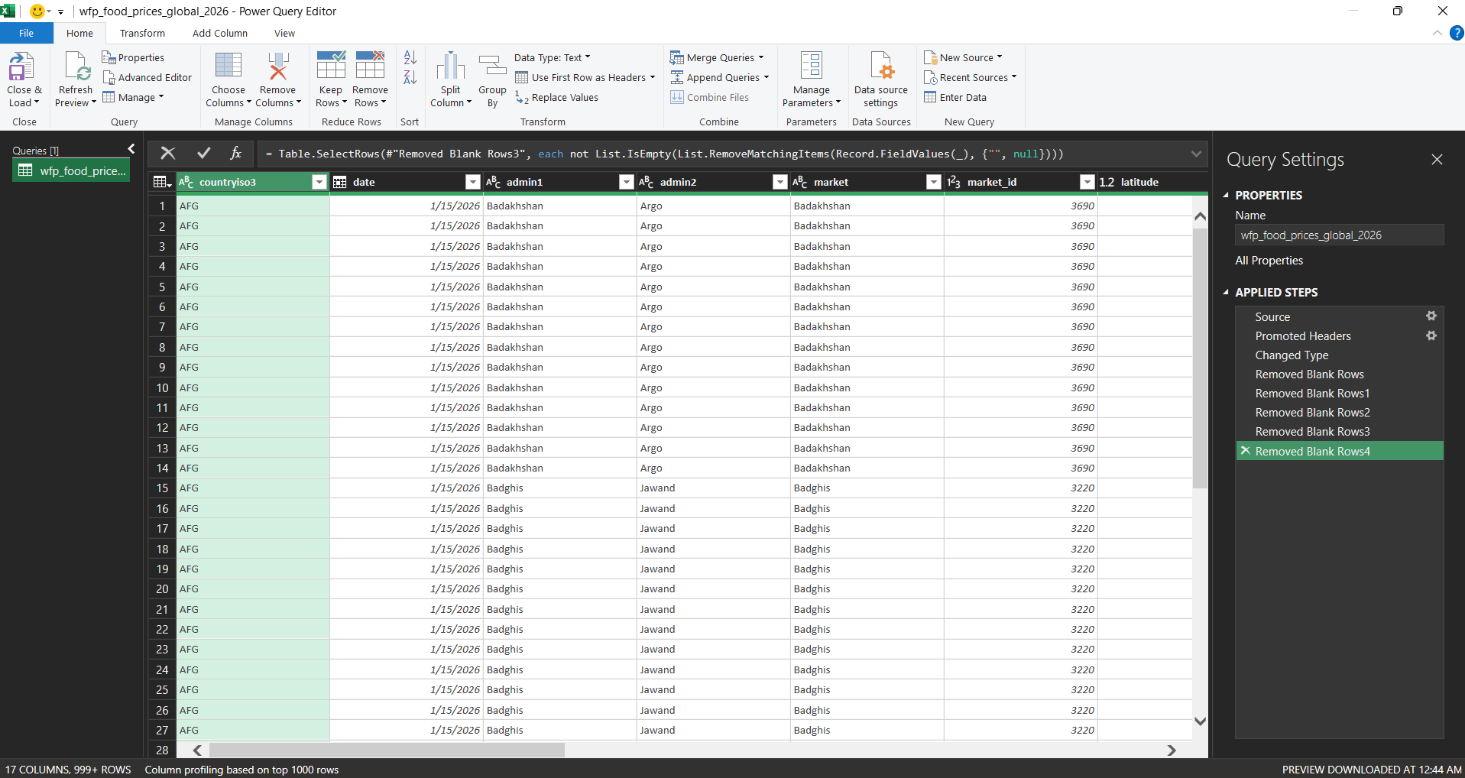

2.2 Converting to Excel Table & F5 Blanks Verification
- Loaded the cleaned data back into Excel and converted the data range into an official Excel Table.
- Used the COUNTA function to verify the total row count, confirming 84,920 valid data records.
- Average (USPice) = 84.06$
- Formatted and verified data types: text for geographic and commodity names, date format for date records, and numeric currency format for the usdprice column. I specifically applied the US Dollar ($) currency format here because all analysis and comparisons must be standardized in USD; while countries originally reported prices in local currency
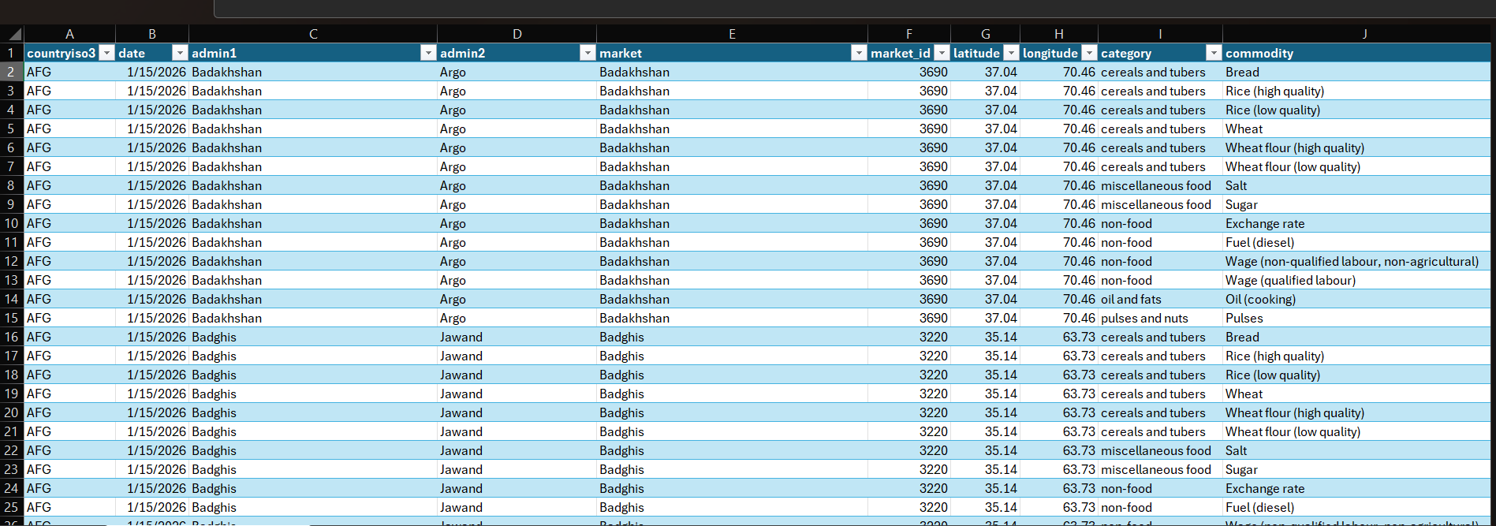
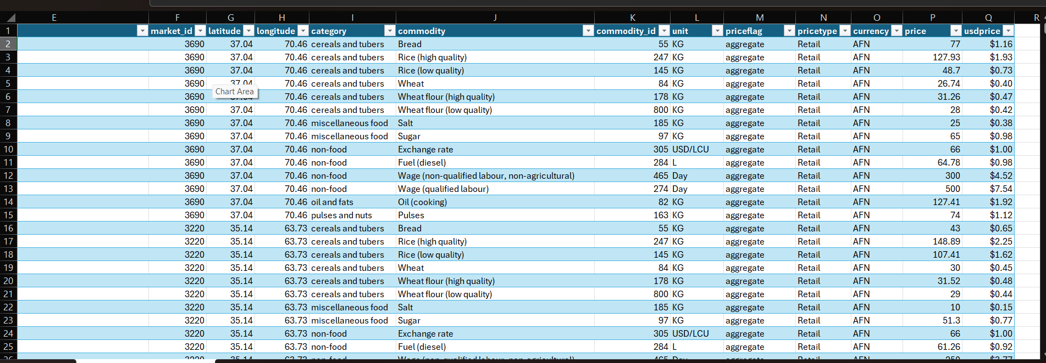

2.3. Pivot Table Analysis
A. Top 5 Most Expensive and Top 5 Cheapest Administrative Regions
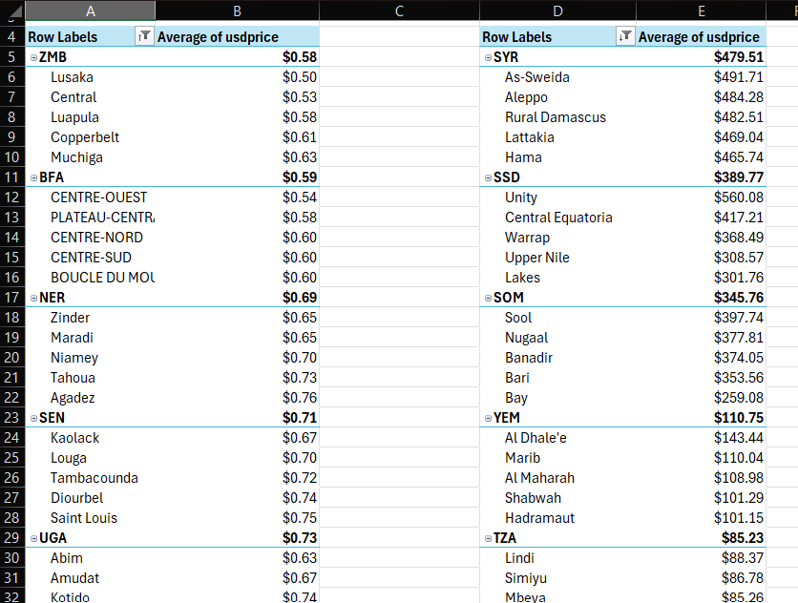

B. Which Food Category Costs the Most?
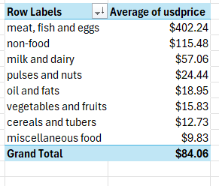

C. Monthly Price Trajectory (Sugar vs. Wheat)
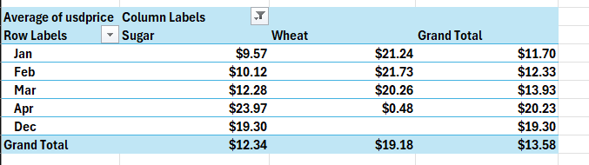

D. Price Gap Across Markets (High vs. Low Quality Wheat Flour)
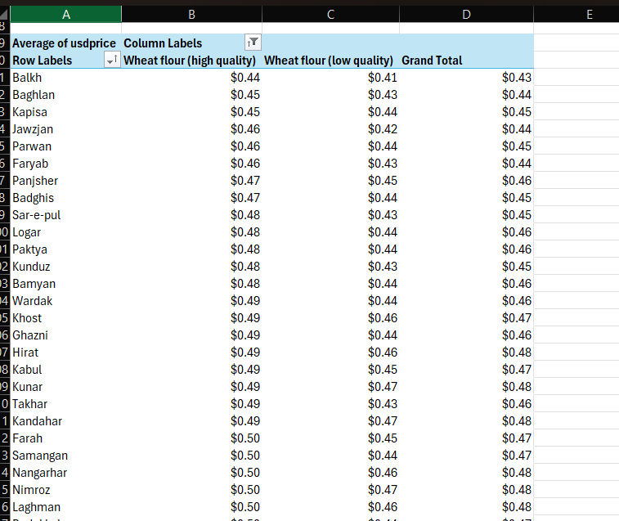

E. Monthly Price across food category
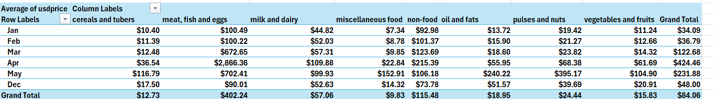

F. Country per count of categories
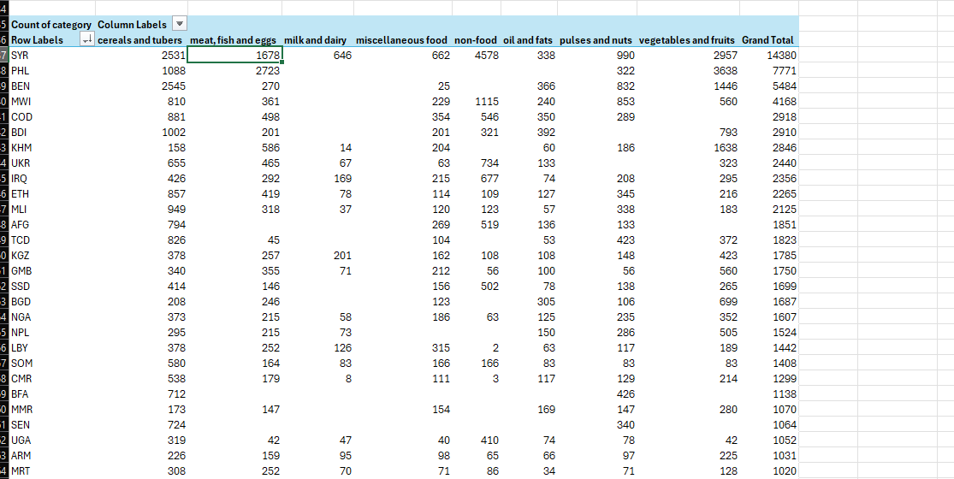
2.4. Interactive Dashboard & Visualizations
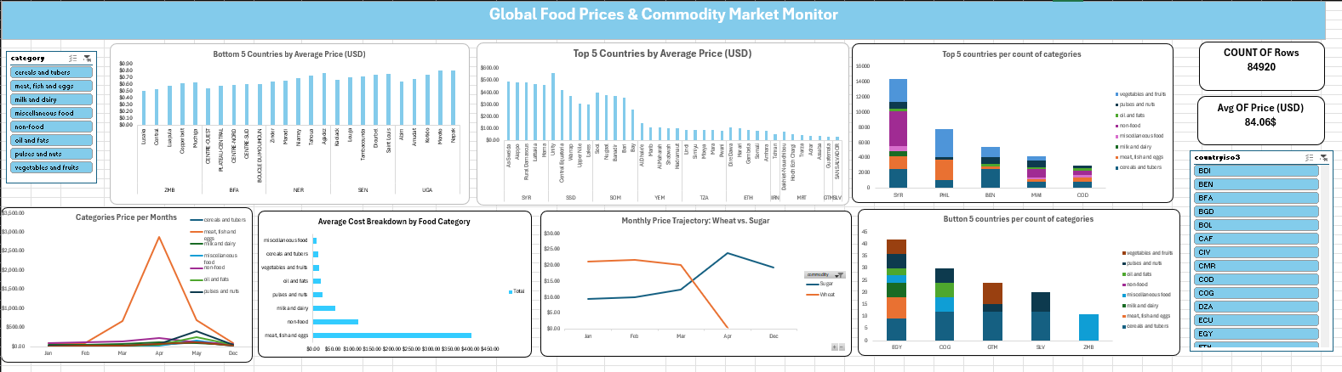

  - Slicer
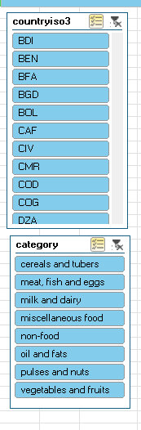

B. Top 5 Most Expensive and Top 5 Cheapest Administrative Regions
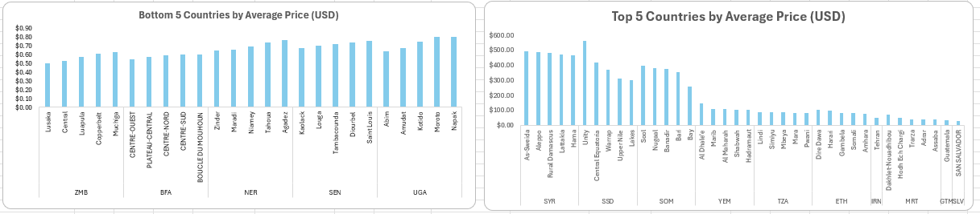
C. Monthly Price across food category

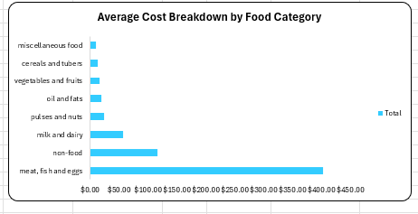

D. Monthly Price Trajectory (Sugar vs. Wheat)
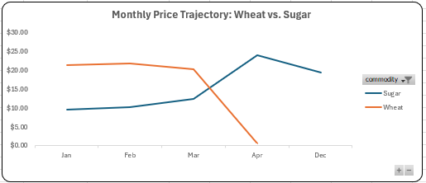
E. Categories Price per Months
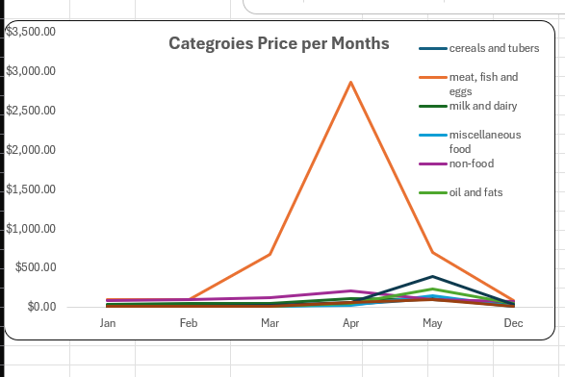

F. Top 5 countries per count of categories
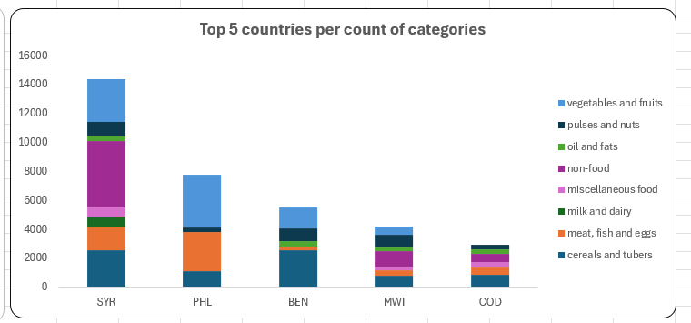
G. Button 5 countries per count of categories
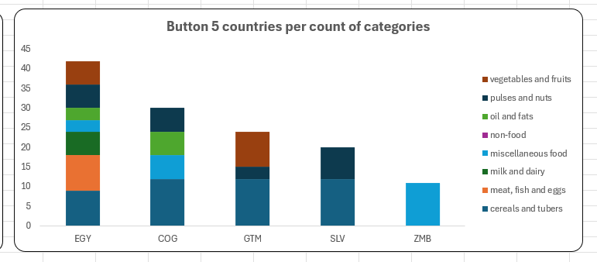

3. Tableau Dashboard
Tool: Tableau Public | Dataset: Global Food Prices
Dashboard link: https://public.tableau.com/app/profile/youssef.nasser4221/viz/GlobalFoodPricesDashboard1/GlobalFoodPricesDashboard?publish=yes

3.1 Project Overview
We used Tableau Public to turn the raw data into one interactive dashboard, so prices could be explored by time, category, commodity, country, and price type.

3.2 Main Columns Used
- countryiso3, category, commodity, date, market, pricetype
- price (original) and usdprice (used for comparisons)
- currency, unit, latitude/longitude (for the map)

3.3 KPI Cards
- Total Records = 84,920
- Average USD Price = 84.06
- #Countries = 59
- #Markets = 1,722

3.4 Filters
Four filters make the dashboard interactive: Countryiso3, Category, Pricetype, and Date.

3.5 Full Dashboard
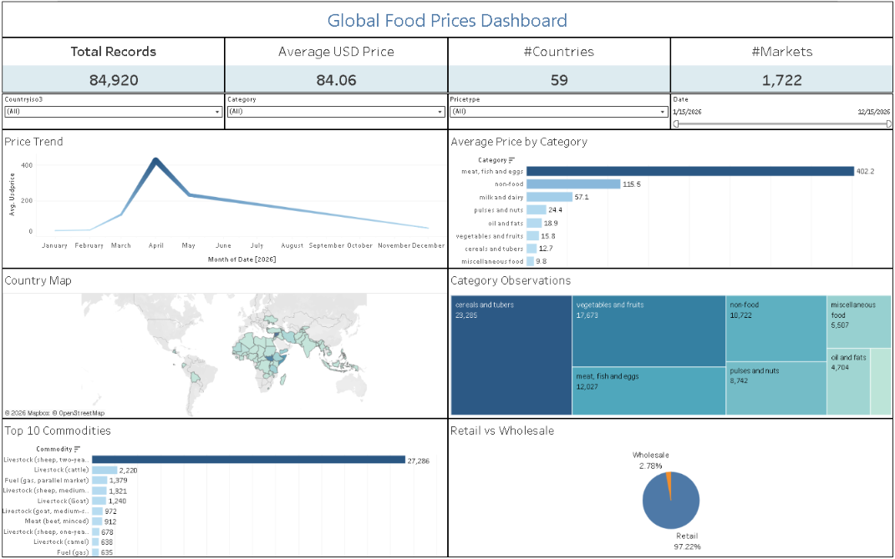
Figure T1. Full dashboard: KPI cards, filters, and six charts.

3.6 Charts
Price Trend — line chart, Month(Date) vs AVG(Usdprice); shows how average price changes over time.
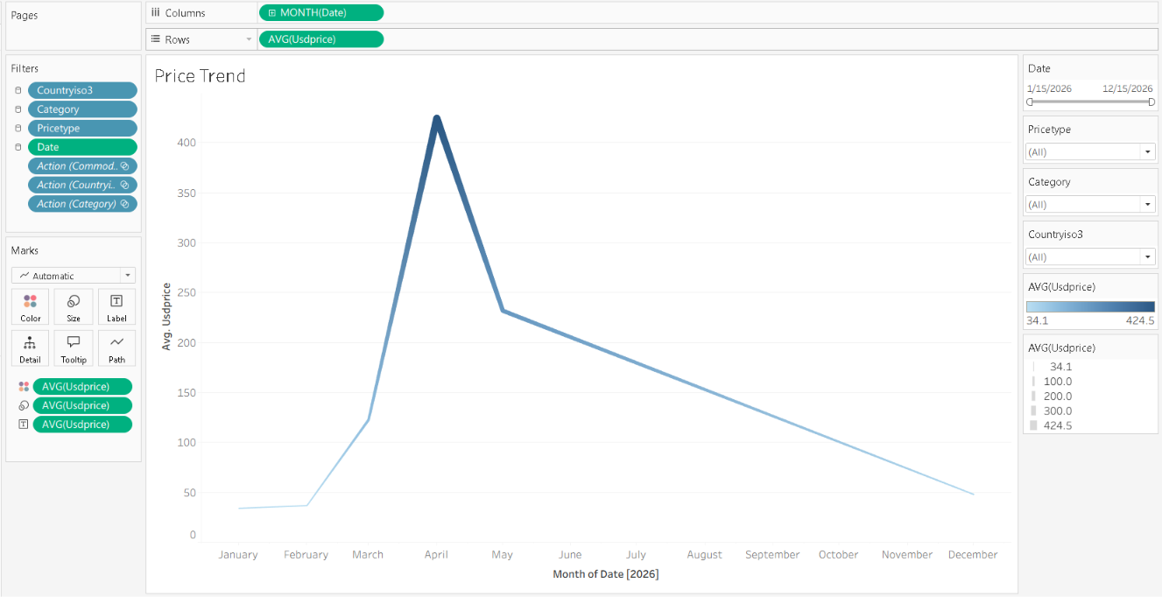
Figure T2. Price Trend
Average Price by Category — bar chart comparing average prices between food categories.
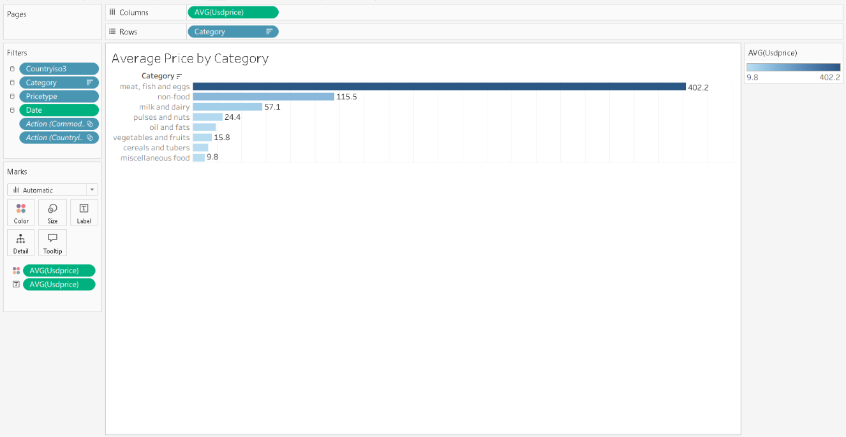
Figure T3. Average Price by Category
Country Map — geographic view of where observations are located.
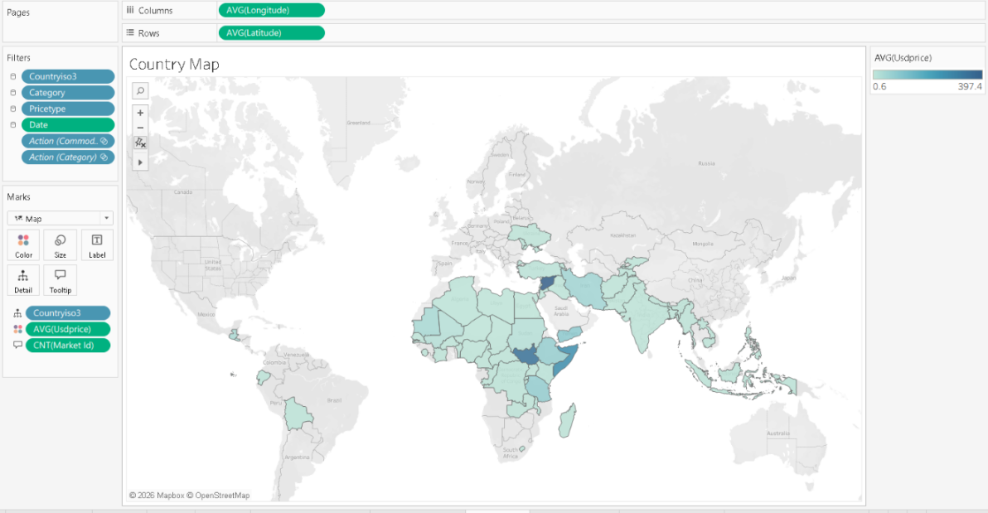
Figure T4. Country Map
Category Observations — treemap sized by count of records; bigger block = more records.
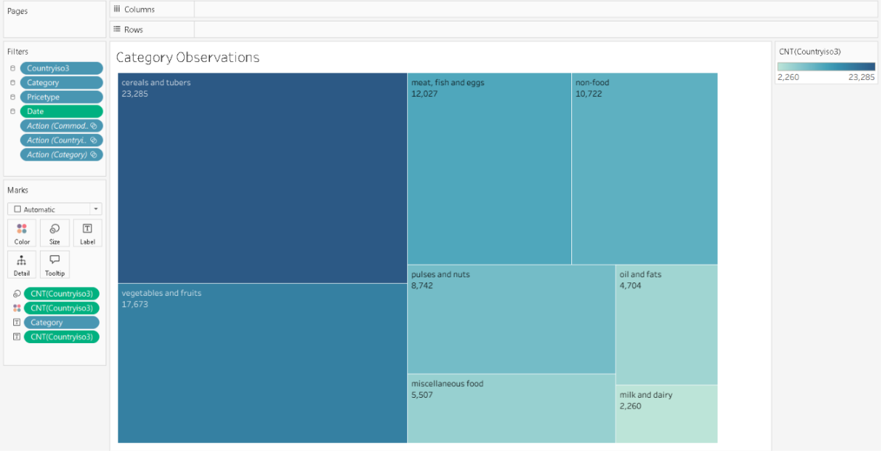
Figure T5. Category Observations
Top 10 Commodities — average price for the 10 most common commodities.
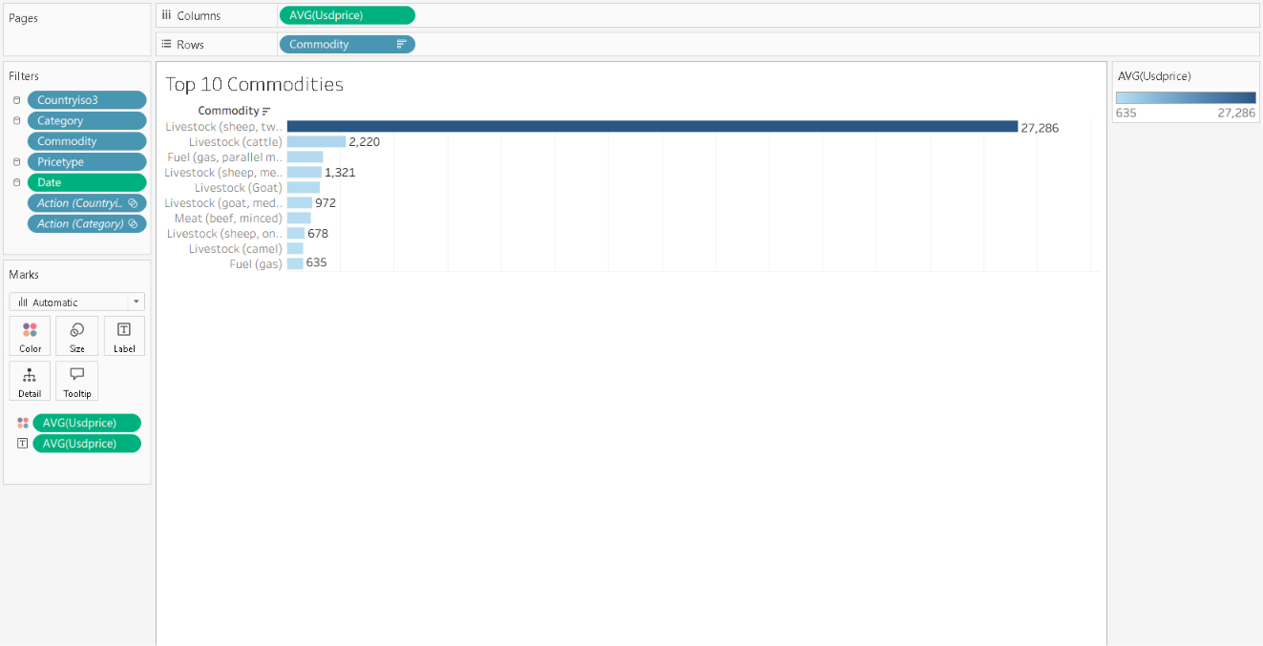
Figure T6. Top 10 Commodities
Retail vs Wholesale — pie chart showing the share of retail vs wholesale observations.
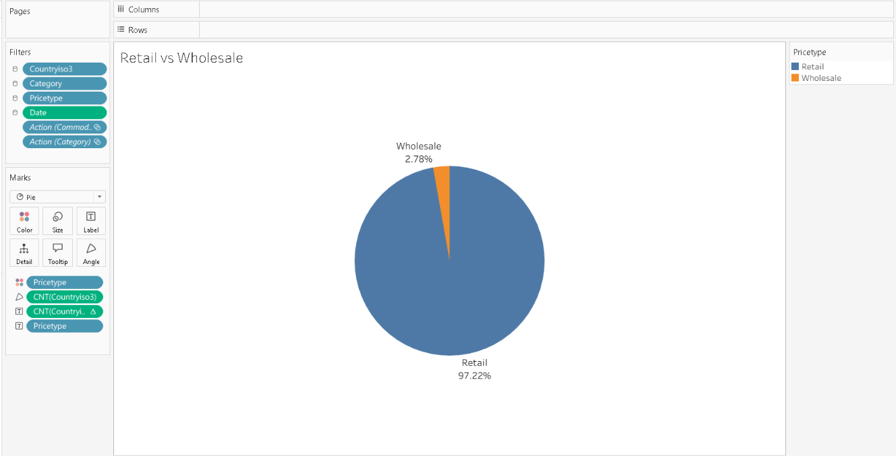
Figure T7. Retail vs Wholesale

3.7 Dashboard Design
Layout order: title, KPI cards, filters, then the six charts.

3.8 Conclusion
The dashboard brings the main results into one place: summary numbers, filters, time trend, category comparison, map, commodity analysis, and retail vs wholesale.

4. Power BI
- 4.1 Power query steps:
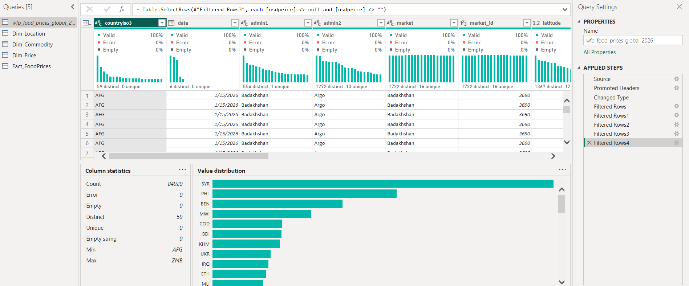
- In the original table I applied data cleaning and filtering operations to remove all records containing null or empty values across 5 columns (admin 1,admin 2,longitude,latitude,usd price) that have null values< 1%
- The resulted No. of total records was 84,920 rows after cleaning

4.2 For creating Star Schema:
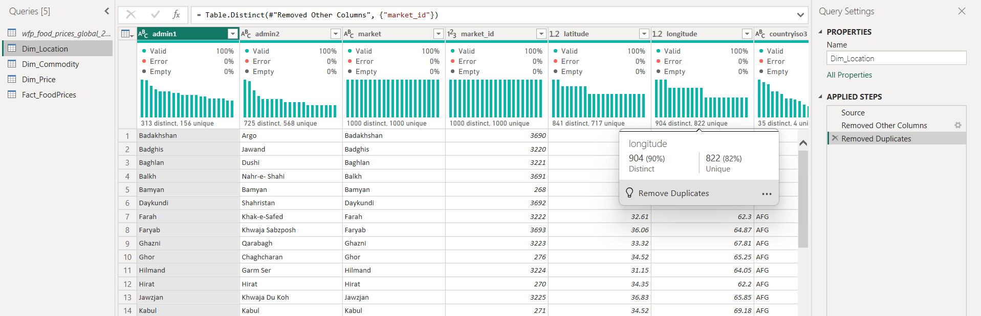
4.2.1 Applied Steps Breakdown(Dim_Location):
- Source: References the primary dataset (wfp_food_prices_global_2026) as the base input.
- Removed Other Columns: kept only the columns relevant to market identity and geography (admin1, admin2, market, market_id, latitude, longitude, countryiso3), removing other columns details.
- Removed Duplicates: based on market_id(primary key)
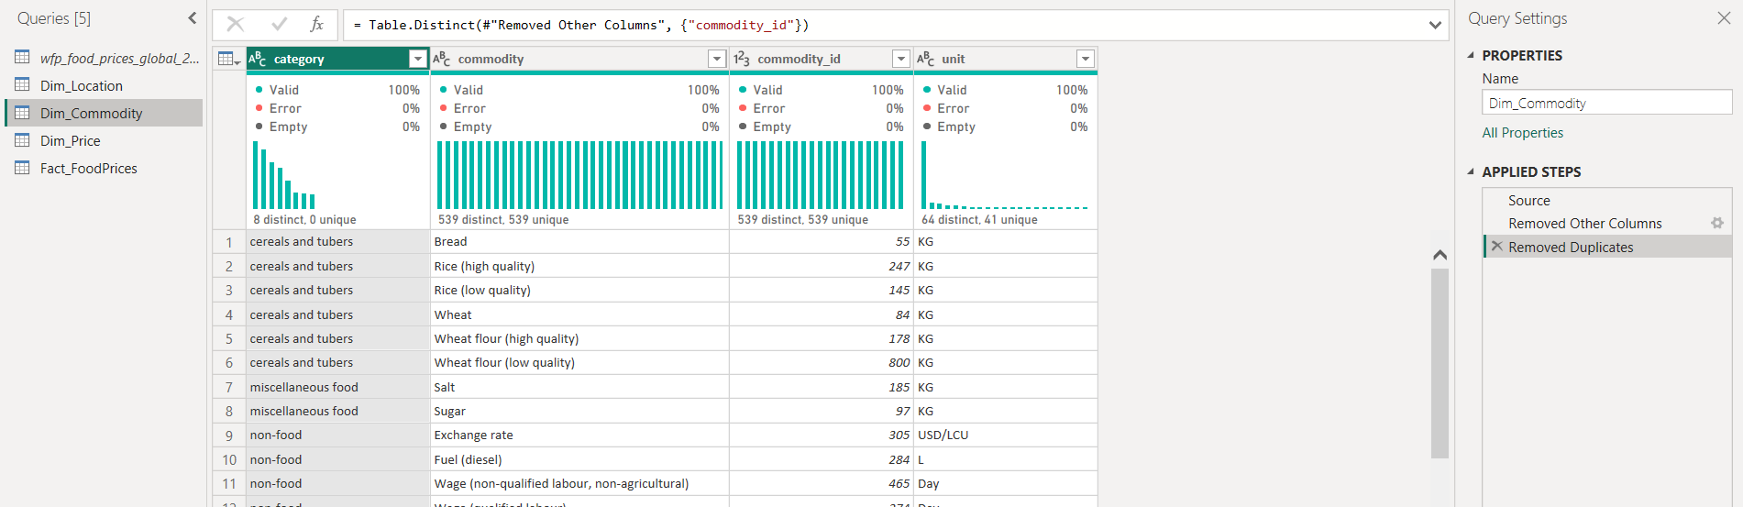
4.2.2 Applied Steps Breakdown(Dim_commodity):
- Source: References the main dataset (wfp_food_prices_global_2026) as the primary input.
- Removed Other Columns: Keeps only product-related attributes (category, commodity, commodity_id, unit), filtering out geographic and price details.
- Removed Duplicates: based on commodity_id as the primary key.
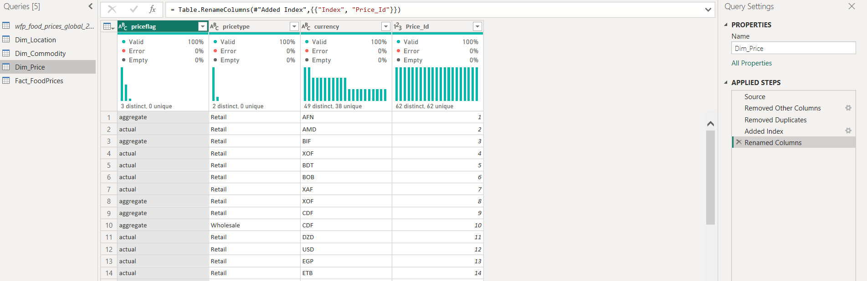
4.2.3 Applied Steps Breakdown(Dim_price):
- Source: References the primary dataset (wfp_food_prices_global_2026).
- Removed Other Columns: kept only metadata attributes (priceflag, pricetype, currency), filtering out other columns.
- Removed Duplicates: Eliminates redundant combinations to establish a distinct list of price attributes.
- Added new column (price_id): Generates an incremental numeric index starting at 1.
- Renamed Columns: Renames the generated index column to Price_Id, serving as the primary key for model relationships to connect with fact table.
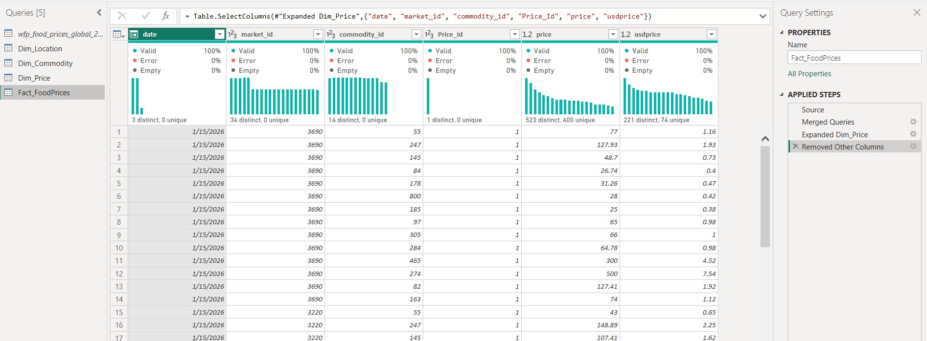
4.2.4 Objective of fact table:
"To build the central Fact Table (Fact_FoodPrices) within the Star Schema model by retaining Foreign Keys (market_id, commodity_id, Price_Id, date) to connect with dimension tables, alongside core numeric metrics (price, usdprice)."
4.2.5 Applied Steps Breakdown(Fact_FoodPrices):
- Source: Connects to the primary cleaned dataset (wfp_food_prices_global_2026).
- Merged Queries: Performs a lookup/join with the Dim_Price dimension table using matching price metadata columns.
- Expanded Dim_Price: Extracts the generated surrogate key (Price_Id) into the fact query.
- Removed Other Columns: Keeps only Foreign Keys and numeric measures (date, market_id, commodity_id, Price_Id, price, usdprice), discarding redundant text attributes.

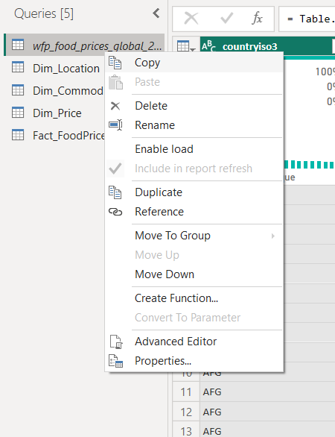
Action Taken: in the primary table I Disabled Load to Data Model as it is no longer needed in the following steps(Enable Load unchecked)

4.2.6
B) Star Schema & Relationships steps(Model View):
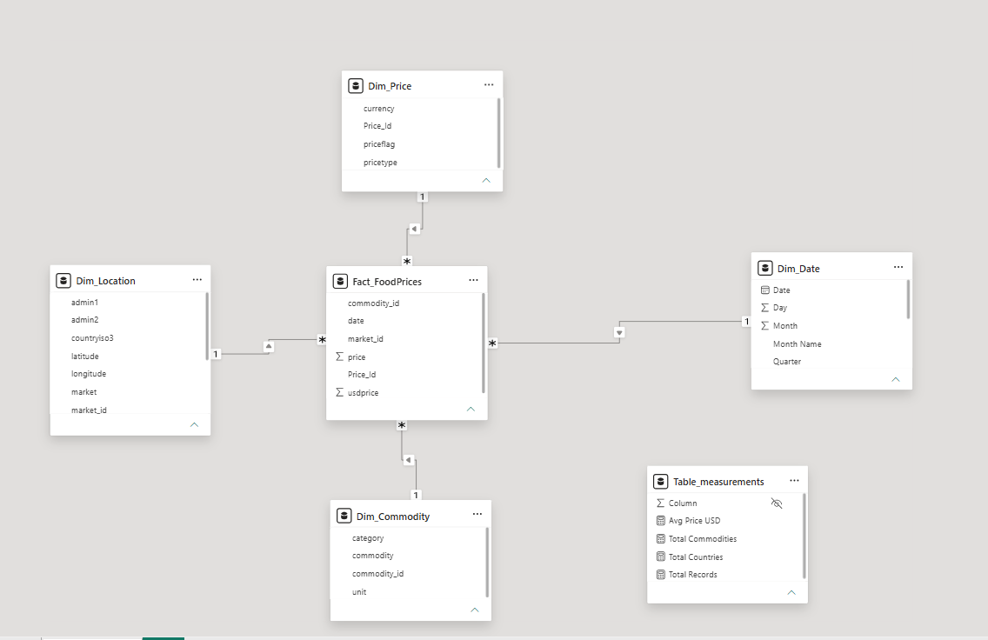
4.2.7 Relationship Configuration
- Cardinality: One-to-Many relationships configured from each Dimension table to the Fact table.
- Cross-Filter Direction: Single Direction from dimensions to Fact_FoodPrices to adhere to data modeling best practices.
4.2.8 Measures Table:
- Table Name: Table_measurements
- Description: created to store and organize DAX calculations:
  - Avg Price USD
  - Total Commodities
  - Total Countries
  - Total Records

4.2.9 Dim_date table:
- this table generates a continuous Date Dimension table bounded by start (MinDate) and end (MaxDate) dates in Fact_FoodPrices[date]. It extracts key attributes—Date, Year, Month, Month Name , Quarter , and Day.


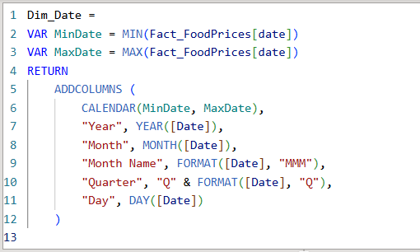

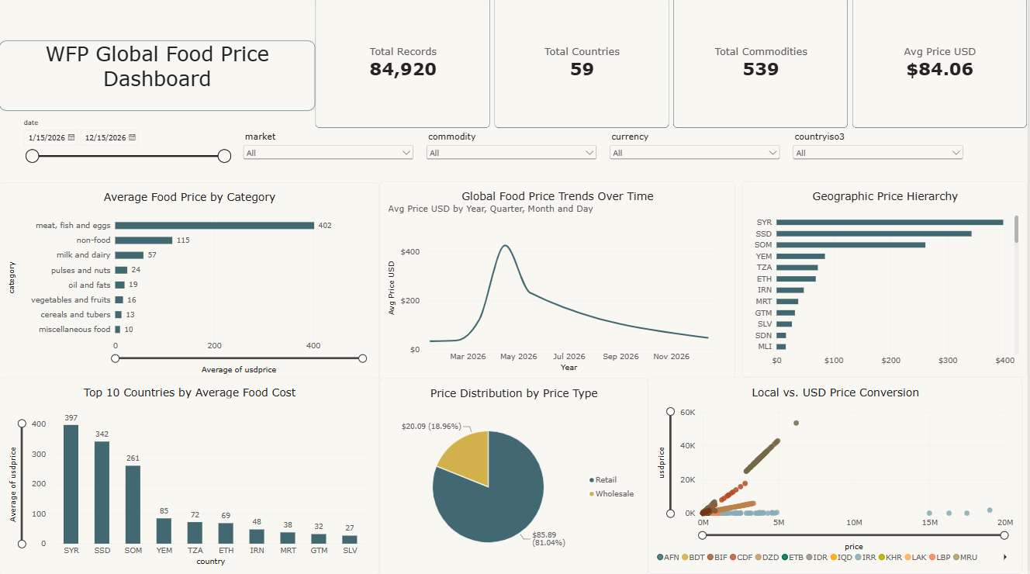
4.3 C) Dashboard steps:

4.3.1 KPI Cards
- Total Records: Displays 84,920 records.
- Total Countries: Highlights coverage across 59 distinct countries.
- Total Commodities: Tracks 539 individual food and non-food items.
- Avg Price USD: Summarizes the overall average food price at $84.06.
4.3.2 Slicers
- Date Range Slicer: Timeline slider filtering data from 1/15/2026 to 12/15/2026.
- Dropdown Slicers: Allows multi-level filtering by Market, Commodity, Currency, and Country ISO Code
4.3.3 Visualization (charts)
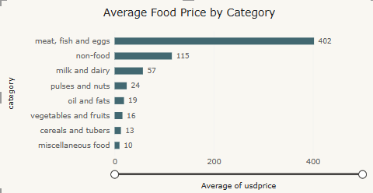
- This bar chart shows the average cost (in USD) of food across different categories. It highlights that meat, fish, and eggs are by far the most expensive category at $402, while basic food items like grains, fruits, and vegetables remain the most affordable, averaging under $20.
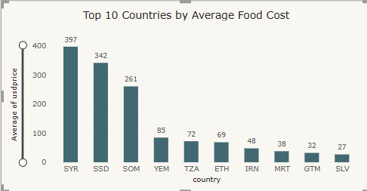
- This column chart illustrates the top ten countries with the highest average food prices in US dollars. Syria leads with the most expensive average cost at $397, closely followed by South Sudan at $342 and Somalia at $261, while average costs drop sharply for the remaining nations, ranging from $85 in Yemen down to $27 in El Salvador.
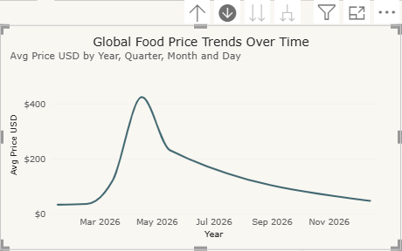
- This line chart illustrates global food price movements throughout 2026, revealing a sharp surge in average prices during the spring that peaked at over $400 in April before steadily declining toward lower, more stable levels near $48 by the end of the year.
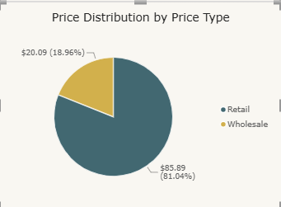
- This pie chart highlights the proportion of pricing types in the dataset, revealing that retail listings dominate the data at 81.04% with an average price of $85.89, whereas wholesale transactions make up just 18.96% of records with a lower average price of $20.09.
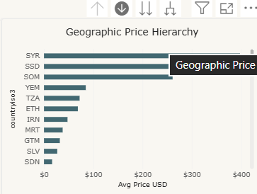
- This horizontal bar chart displays average food prices across different geographic locations using a drillable hierarchy. It allows users to explore price variations starting at the country level—where Syria, South Sudan, and Somalia show the highest average costs—and drill down further into regional levels(Admin 1), local districts(Admin 2), and specific markets.
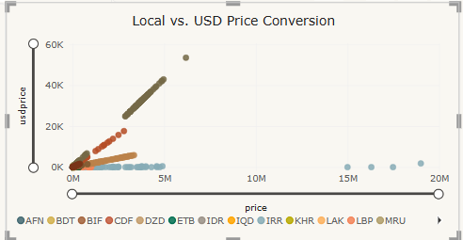
- This scatter plot maps local currency prices against their standardized USD equivalent across various currencies. It highlights currency conversion relationships and detects outliers, showing how massive nominal values in highly inflated local currencies (such as IRR reaching up to 20 million) translate into relatively low standardized USD amounts.
4.3.4 Key insights:
- Protein costs the most: Meat, fish, and eggs are by far the most expensive food items, averaging $402. This is much higher than basic foods like rice and wheat, which average only $13.
- Huge price gaps between countries: Food is most expensive in countries facing crisis. Syria ($397), South Sudan ($342), and Somalia ($261) have the highest average costs, while countries like El Salvador are much cheaper at $27.
- A big price spike in the spring: Global food prices jumped sharply in early 2026, reaching a peak of over $400 in April, before dropping back down below $50 by the end of the year.
- Most prices are from retail stores: About 81% of the data comes from retail shops with an average price of $85.89, while wholesale prices make up 19% with a much lower average of $20.09.
- Currency exchange masks real costs: Some local currencies show massive numbers—like millions of Iranian Rials for basic items—even though the actual price is much lower when converted to US dollars.

5. Python
Function | Why we used it
read_csv / head / tail | Loaded the file and previewed rows.
shape / info / dtypes | Checked size and data types of each column.
describe() | Quick statistics for numeric columns.
select_dtypes() | Split columns into numeric vs. text/category.
nunique() | Counted unique values per column.
isna().sum() | Found missing values (mainly admin1/2, coordinates, usdprice).
duplicated().sum() | Checked duplicates — result was 0.
dropna() | Removed rows with missing values: 85,289 -> 84,920.
to_datetime() | Converted date to a real date type for monthly grouping.

5.1 Our Analysis Approach
The unit column is not consistent — KG covers ~71% of rows, the rest is L, Head, Day, Unit, etc. Mixing them (e.g. a kilo of rice with a live goat priced per Head) made our first charts unreadable, so most per-unit comparisons were filtered to KG only, which keeps most of the data and matches the natural unit for most food.
We rebuilt the correlation heatmap to drop market_id / commodity_id — these are just reference numbers, not real quantities, and including them produced fake-looking correlations.
Our first heatmap (commodity x category) was ~90% empty because every commodity belongs to only one category. We changed it to commodity x month, which are genuinely independent, so the heatmap actually shows how prices moved over time.

5.2 Charts and What We Learned

Chart 1: Top 15 Countries by Number of Records
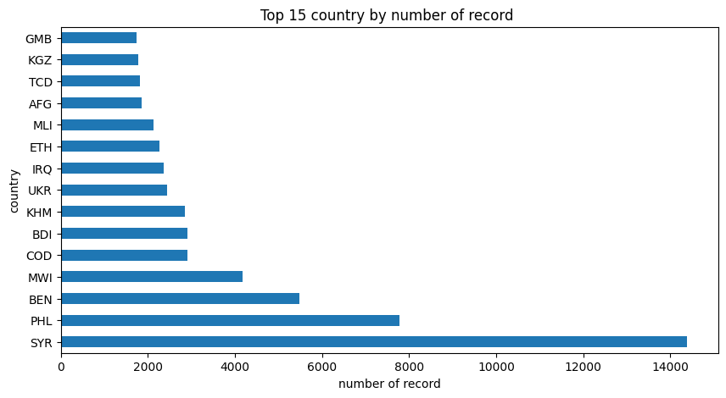
Figure 1. Top 15 Countries by Number of Records
Syria, Philippines, and Benin have the most records. Coverage is uneven across countries.

Chart 2: Number of Records by Category
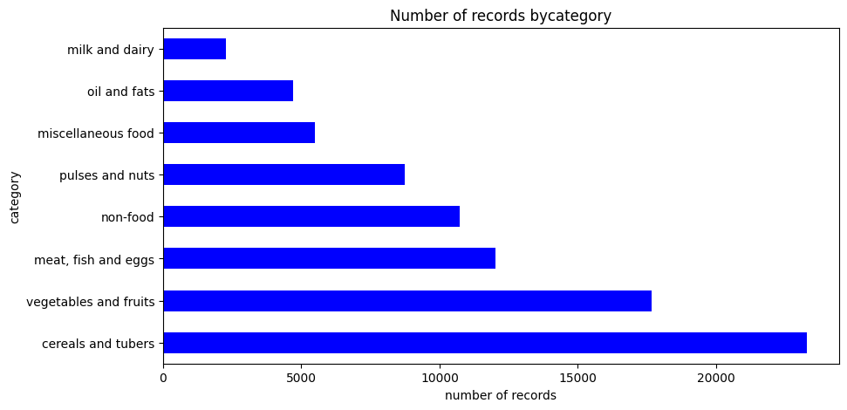
Figure 2. Number of Records by Category
Cereals & tubers has the most records; milk & dairy the fewest, so its averages are less reliable.

Chart 3: Top 15 Commodities by Number of Records
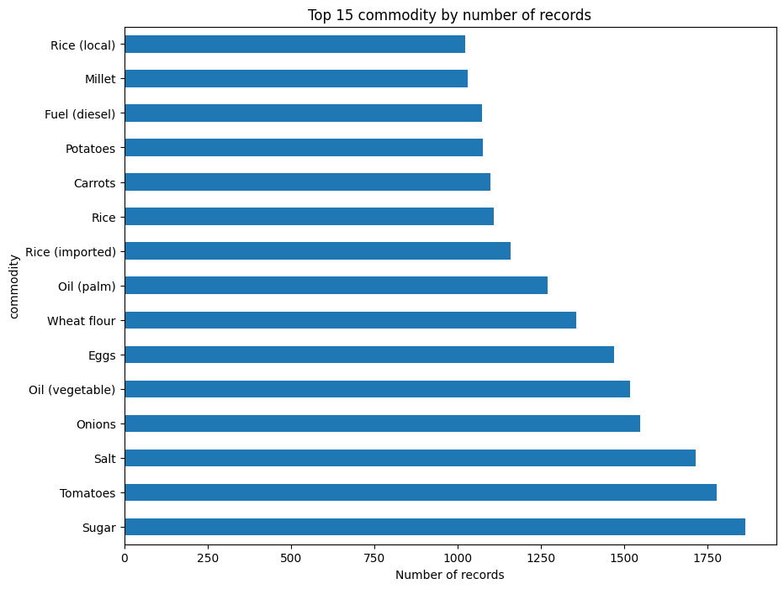
Figure 3. Top 15 Commodities by Number of Records
Sugar, Tomatoes, and Salt are the most recorded commodities.

Chart 4: Commodity Category Distribution (Pie)
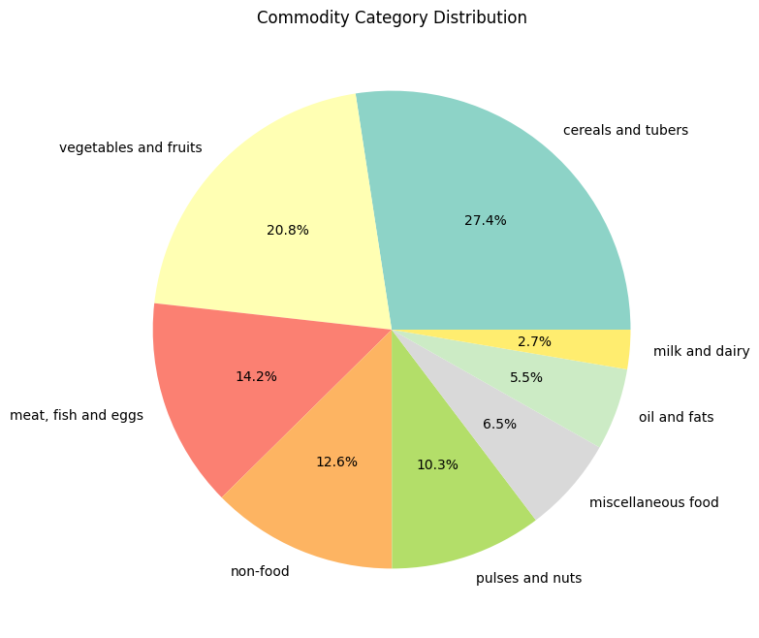
Figure 4. Commodity Category Distribution (Pie)
Cereals & tubers (27.4%) and vegetables & fruits (20.8%) make up almost half the dataset.

Chart 5: Distribution of Food Prices in USD
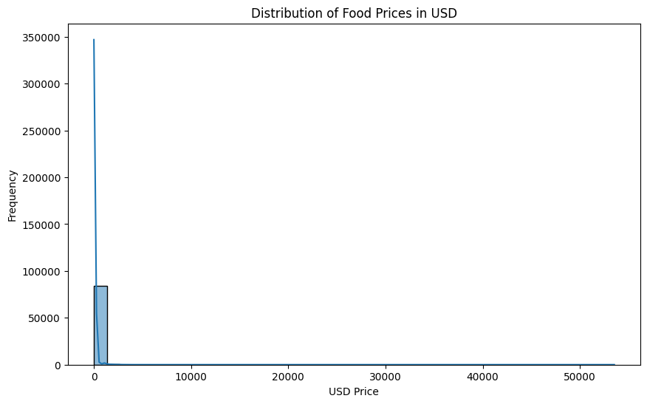
Figure 5. Distribution of Food Prices in USD
Prices are squeezed near zero with a long tail to 50,000 USD — clear extreme outliers.

Chart 6: Distribution of usdPrice by Category (Boxplot)
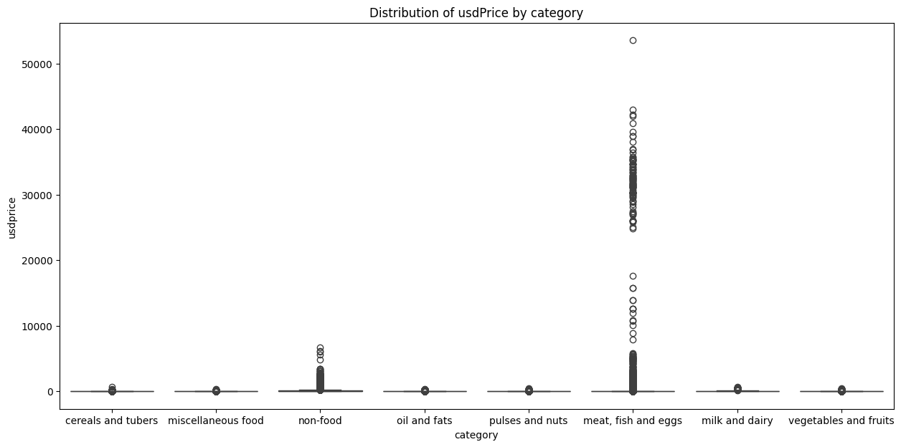
Figure 6. Distribution of usdPrice by Category (Boxplot)
Outliers in meat/fish/eggs and non-food squash every other category flat — this is why we filtered to KG.

Chart 7: Average Price by Category
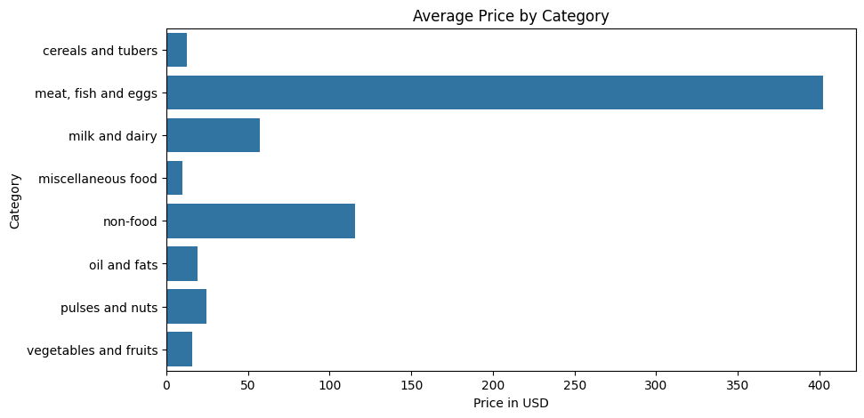
Figure 7. Average Price by Category
Meat/fish/eggs shows an average of ~$400, clearly skewed upward by outliers.

Chart 8: Median Price by Category
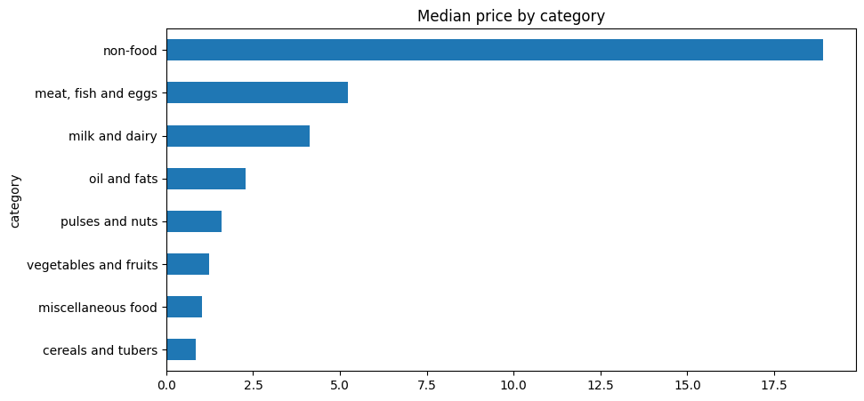
Figure 8. Median Price by Category
The median tells a more honest story: non-food is highest (~$19), meat drops to ~$5.

Chart 9: Average Price by Country (Top 15)
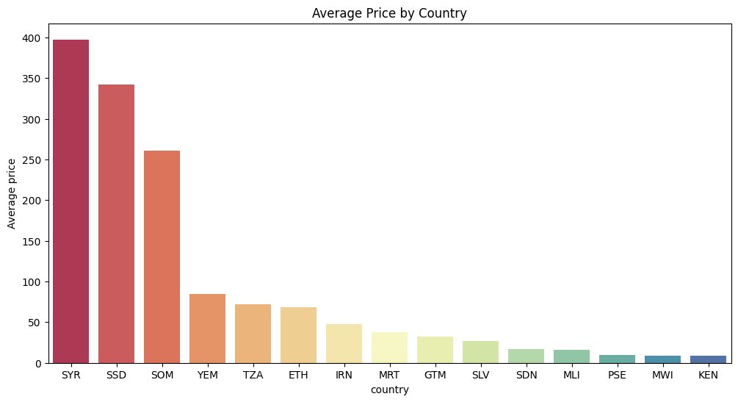
Figure 9. Average Price by Country (Top 15)
Syria, South Sudan, and Somalia top the list — countries in conflict/crisis show the highest prices.

Chart 10: Median Price per KG Over Time by Category
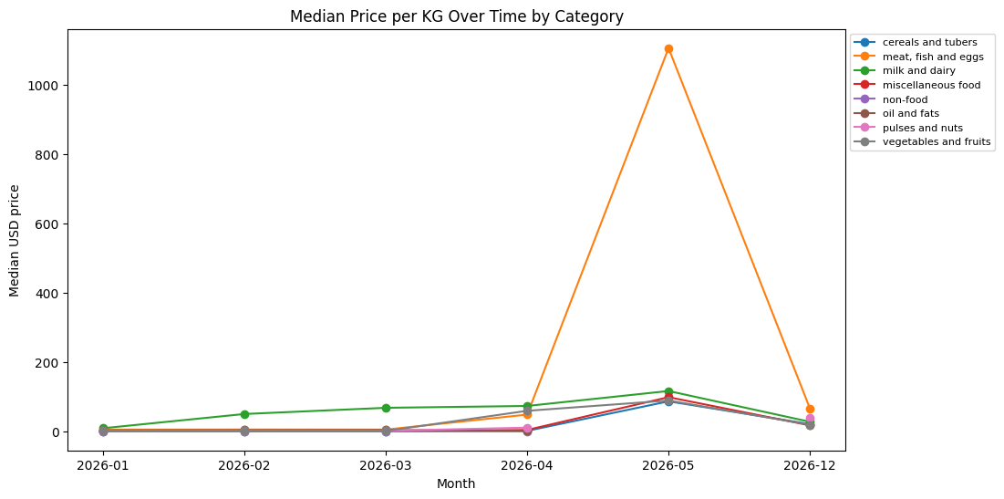
Figure 10. Median Price per KG Over Time by Category
Meat/fish/eggs spikes sharply around May 2026; other categories stay flatter (April/May/Dec have fewer records).

Chart 11: Retail vs Wholesale Median Price per KG
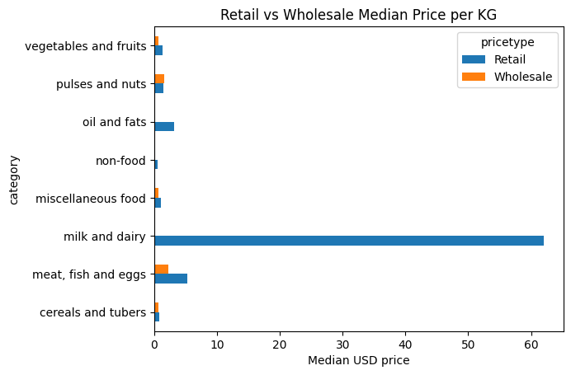
Figure 11. Retail vs Wholesale Median Price per KG
Milk & dairy has the biggest retail-vs-wholesale gap, reflecting distribution/processing cost.

Chart 12: Commodity Record Count vs Average Price
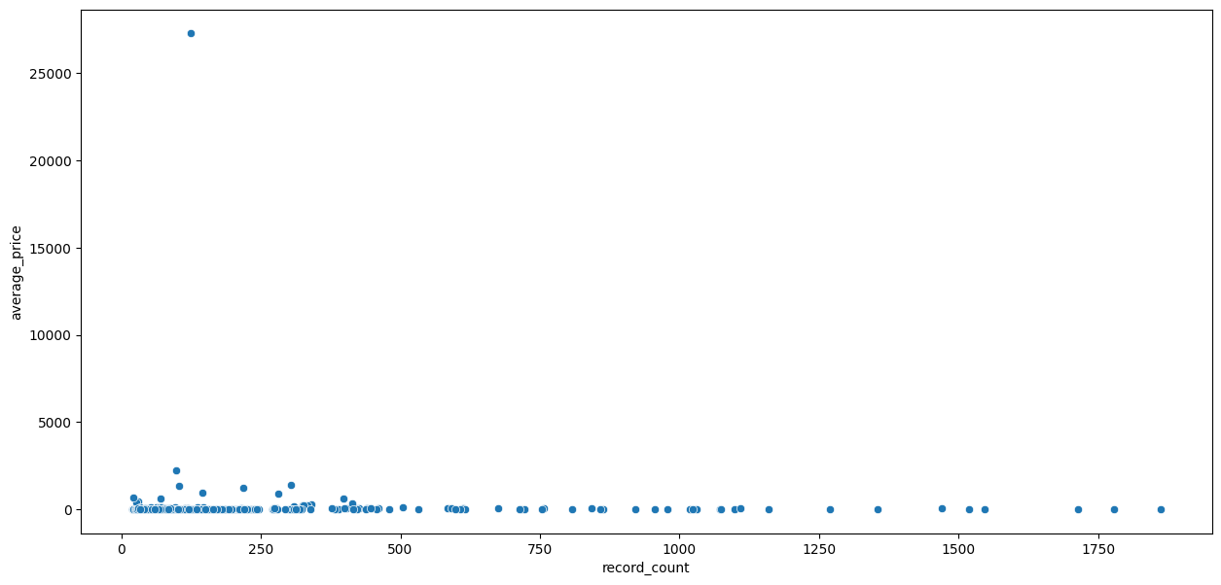
Figure 12. Commodity Record Count vs Average Price
Commodities with very few records show unusually high averages — another outlier warning.

Chart 13: Market Locations Colored by Price
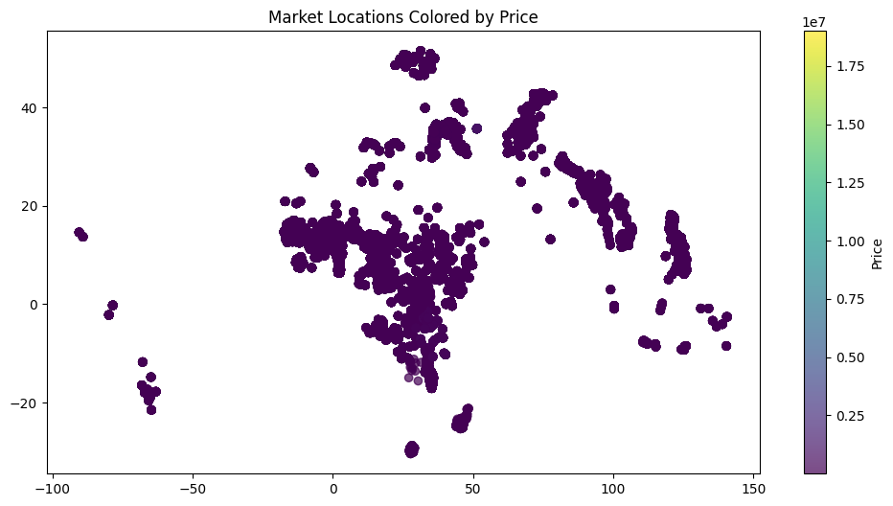
Figure 13. Market Locations Colored by Price
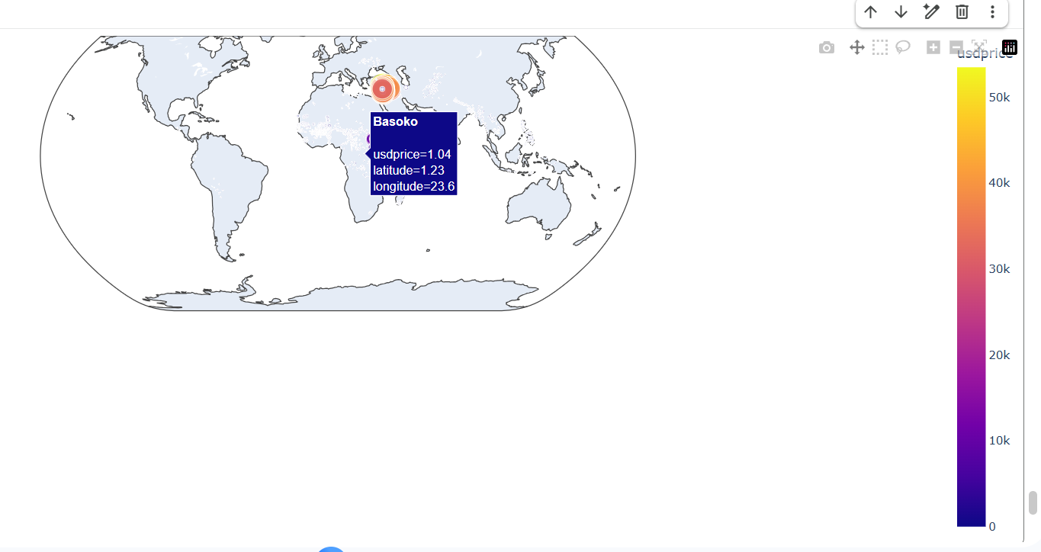

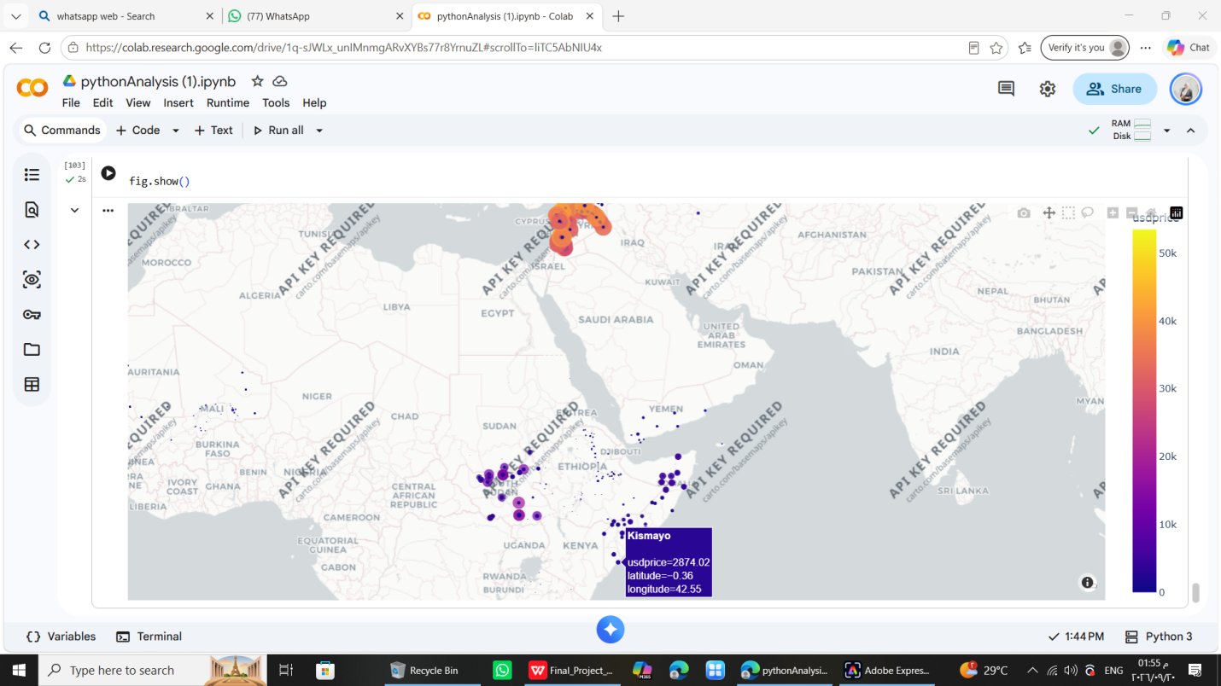
Shows where markets are concentrated (Africa, South/Central Asia, Latin America); colored by local currency so not directly comparable.

Chart 14: Pairplot: Latitude, Longitude, USD Price
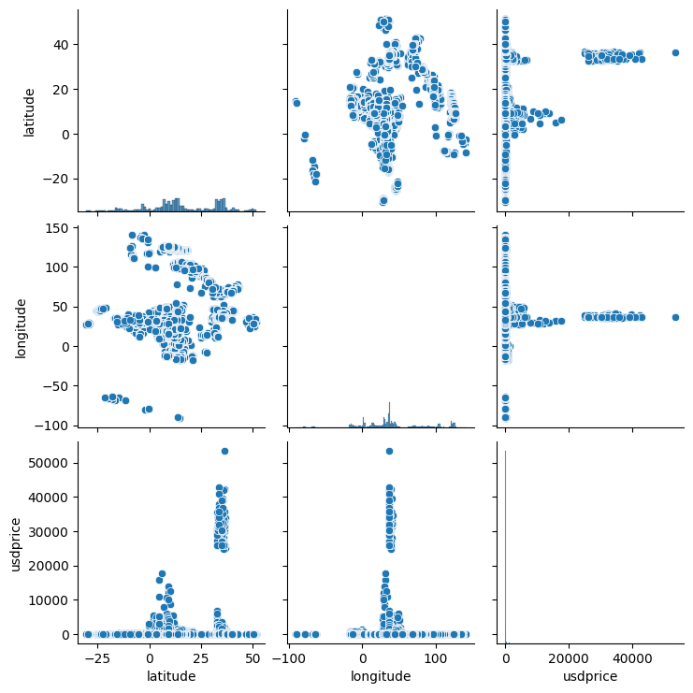
Figure 14. Pairplot: Latitude, Longitude, USD Price
Confirms a small cluster of extreme price outliers, regardless of location.

Chart 15: Correlation Heatmap
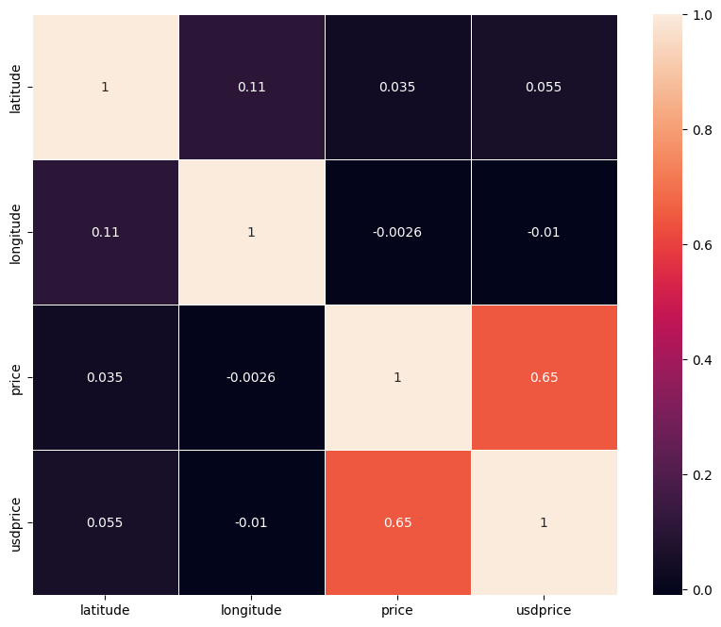
Figure 15. Correlation Heatmap
price and usdprice correlate strongly (0.65); location has almost no relationship with price.

Chart 16: Distinct Markets Sampled per Country (Top 15)
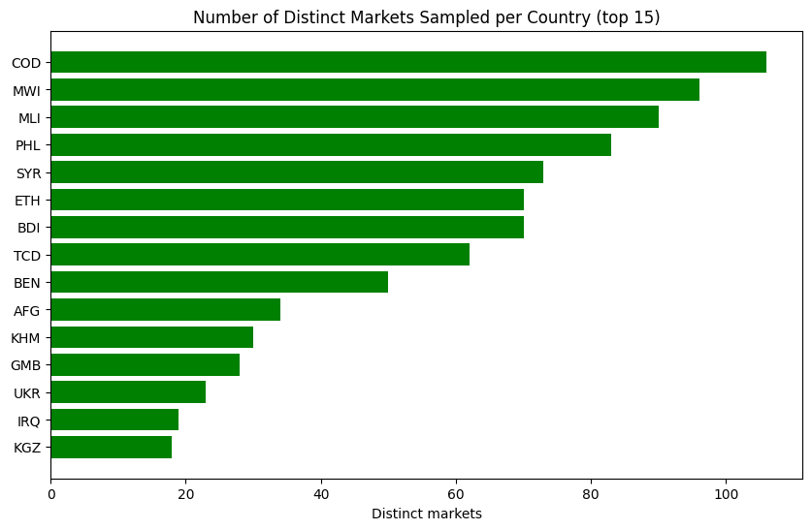
Figure 16. Distinct Markets Sampled per Country (Top 15)
DR Congo has 100+ sampled markets; countries with few markets give less reliable results.

Chart 17: Median USD Price by Commodity and Month
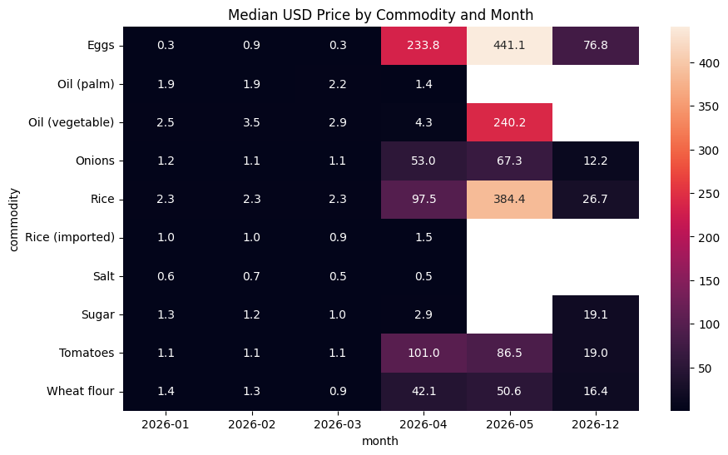
Figure 17. Median USD Price by Commodity and Month
Eggs and Rice both jump around April-May 2026 then fall back by December.

6. Machine Learning — Implemented Prediction Component
For the Machine Learning part, I started from the same cleaned WFP dataset and focused on moving from describing food prices to predicting them. The goal was to build a clear regression workflow using market, commodity, geographical, and time information to estimate the USD price per kilogram.

6.1 Objective and Problem Definition
The main question for this part was: Can the USD price per kilogram of a food commodity be predicted from its market, commodity, geographical, and temporal attributes?
I treated the task as regression because the target variable, usdprice, is a continuous numeric value. The model is therefore expected to estimate a number rather than assign a category.
I selected usdprice as the target instead of the original price column because the dataset contains different local currencies. Using USD gives the model one common numerical scale for cross-country comparison.
I did not frame the task as time-series forecasting. After the final ML filtering, only five observation dates remained, so the available temporal sequence was not sufficient for a conventional forecasting setup. The final task is therefore price prediction from the available attributes.

6.2 How I Approached the Problem as an ML Engineer
I treated the modeling work as a sequence of decisions rather than starting with one model immediately:
• Define a comparable target and a consistent ML population.
• Choose market, geographical, commodity, and temporal features.
• Use GroupShuffleSplit to control group leakage.
• Build a reusable preprocessing pipeline.
• Compare Linear Regression and XGBoost, test target transformations, and tune the final XGBoost model.

6.3 ML Data Preparation
The ML work started from the team’s cleaned dataset of 84,920 rows, so no additional missing-value or duplicate removal was required. The focus was on field representation, target definition, and the modeling population.
One issue appeared in the date column. Excel stores dates internally as serial day numbers, so the values were read by pandas as numbers. I converted them to a real datetime field and then extracted year and month for the model.
df["date"] = pd.to_datetime(df["date"], unit="D", origin="1899-12-30")
df["year"] = df["date"].dt.year
df["month"] = df["date"].dt.month
The next issue was that the full dataset mixes several units, price types, and price-status flags. I did not mix these observations directly because a price per kilogram, a price per liter, and a price per unit do not represent the same measurement basis. I therefore defined a consistent modeling population.
ml_filtered = df[
(df["unit"] == "KG") &
(df["pricetype"] == "Retail") &
(df["priceflag"] == "actual")
].copy()
Filter | Meaning | Why it was used
unit == KG | Prices expressed per kilogram. | Creates one common measurement basis.
pricetype == Retail | Retail market prices. | Keeps the target population consistent.
priceflag == actual | Actual price observations. | Avoids aggregate/estimated price flags in the ML population.

After this filtering, 41,944 observations remained. The filtered ML dataset also contained five observation dates, which is the final temporal basis used in the prediction task.

6.4 Features and Target Design
The final feature set was kept interpretable, combining geography, market, commodity, category, and time information.
Feature | Role in the model
countryiso3 | Country identifier and broad geographical context.
admin1 | First administrative region.
admin2 | Second administrative region.
market | Specific market where the price was recorded.
category | Broad food category.
commodity | Specific food commodity.
unit | Measurement unit; fixed to KG after filtering.
pricetype | Retail / wholesale type; fixed to Retail after filtering.
priceflag | Actual / aggregate status; fixed to actual after filtering.
year | Year extracted from date; fixed to 2026 in this snapshot.
month | Month extracted from date; the main varying temporal feature.

Some available columns were intentionally not used in the final feature matrix. price was not selected because it is expressed in local currencies. currency was therefore also not useful as a common numerical target representation. market_id and commodity_id are reference identifiers rather than quantities or meaningful ordered measurements, so they were excluded from the predictive feature set. latitude and longitude were also not included; the final feature design kept the more directly interpretable country-region-market hierarchy, while the team’s exploratory analysis showed very little simple linear relationship between coordinates and price.
I retained unit, pricetype, and priceflag in the feature definition for pipeline consistency, even though they have little or no variation after the final filter. The same applies to year in the current 2026 snapshot. These fields are therefore not expected to add meaningful predictive variation in this version.
Two target versions were prepared: y_log = log(1 + usdprice) for Linear Regression and y_raw = usdprice for XGBoost. The choice came from controlled experiments described later.

6.5 Train-Test Split and Leakage Control
A simple random row split was not enough because the same country + market + commodity can appear on multiple dates. Splitting such rows across train and test could make the test problem easier than the intended unseen-group scenario.
To control this, I created a group identifier from countryiso3, market, and commodity and used GroupShuffleSplit with an 80/20 test size. This keeps each complete group entirely inside either the training set or the test set.
groups = (
ml_filtered["countryiso3"].astype(str) + "_" +
ml_filtered["market"].astype(str) + "_" +
ml_filtered["commodity"].astype(str)
)
gss = GroupShuffleSplit(n_splits=1, test_size=0.20, random_state=42)
train_idx, test_idx = next(gss.split(X, groups=groups))
X_train = X.iloc[train_idx].copy()
X_test = X.iloc[test_idx].copy()
y_log_train = y_log.iloc[train_idx].copy()
y_raw_train = y_raw.iloc[train_idx].copy()
y_raw_test = y_raw.iloc[test_idx].copy()
Split item | Result
Training rows | 33,552
Test rows | 8,392
Training groups | 14,057
Test groups | 3,515
Overlapping groups | 0
Test size | 20%
Random seed | 42

train_groups = set(groups.iloc[train_idx])
test_groups = set(groups.iloc[test_idx])
print("Overlapping groups:", len(train_groups.intersection(test_groups)))
The verification output was Overlapping groups: 0. This is the direct check that no country-market-commodity group crossed the train/test boundary. This split is a group-generalization evaluation, not a chronological forecasting evaluation; dates can still appear in both train and test.

6.6 Preprocessing Pipeline
Most final features are categorical text values. I used OneHotEncoder for categorical columns and left numeric features unchanged.
The preprocessing was placed inside a scikit-learn Pipeline for every model. handle_unknown="ignore" prevents errors if the test data or a future observation contains a category that was not seen during fitting. Keeping preprocessing inside the pipeline also keeps the train/test transformation sequence reproducible and avoids performing a separate manual fit on the full dataset.

6.7 Model Development
The final comparison used three models: Linear Regression as the baseline, Basic XGBoost as the first non-linear model, and Tuned XGBoost as the adjusted final configuration. All three used the same train/test split.

6.7.1 Linear Regression — Baseline
Linear Regression was used as a simple baseline. Because the raw target is strongly right-skewed, the final version was trained on the log-transformed target.
linear_model = Pipeline([
("preprocessor", preprocessor),
("model", LinearRegression())
])
linear_model.fit(X_train, y_log_train)
print("Linear Regression model trained.")
The predictions are converted back to the original USD/kg scale with np.expm1 before calculating the final metrics. This keeps the reported MAE and RMSE in the same units as the real target.
linear_pred = linear_model.predict(X_test)
linear_pred = np.expm1(linear_pred)
linear_true = y_raw_test
linear_mae = mean_absolute_error(linear_true, linear_pred)
linear_rmse = mean_squared_error(linear_true, linear_pred) ** 0.5
linear_r2 = r2_score(linear_true, linear_pred)
print("Linear Regression Results")
print(f"MAE: {linear_mae:.4f}")
print(f"RMSE: {linear_rmse:.4f}")
print(f"R2: {linear_r2:.4f}")
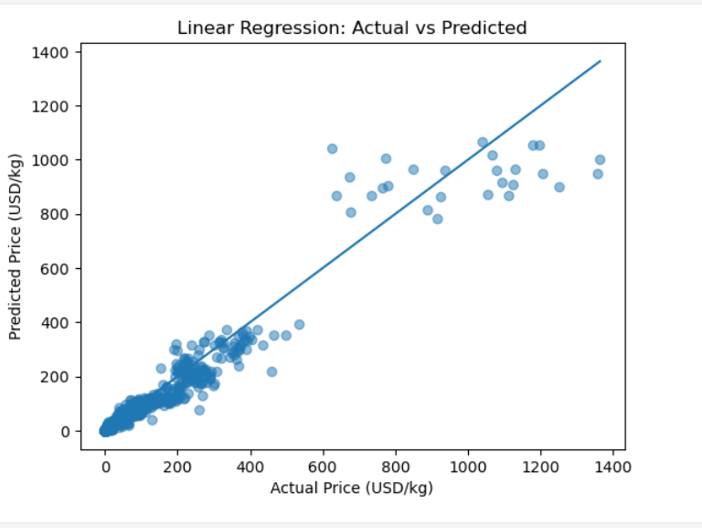
Figure ML1. Linear Regression: Actual vs Predicted
The plot compares actual prices with predicted prices. The diagonal line represents the ideal case where predicted price equals actual price. The wider spread at higher prices is consistent with the stronger error values seen in the regression metrics.

6.7.2 Basic XGBoost
XGBoost was used next because the feature space contains categorical variables and non-linear interactions between geography, commodity, and market.
xgb_model = Pipeline([
("preprocessor", preprocessor),
("model", XGBRegressor(
n_estimators=300,
learning_rate=0.05,
max_depth=6,
subsample=0.8,
colsample_bytree=0.8,
objective="reg:squarederror",
random_state=42,
n_jobs=-1
))
])
xgb_model.fit(X_train, y_raw_train)
print("XGBoost model trained.")
xgb_pred = xgb_model.predict(X_test)
xgb_true = y_raw_test
xgb_mae = mean_absolute_error(xgb_true, xgb_pred)
xgb_rmse = mean_squared_error(xgb_true, xgb_pred) ** 0.5
xgb_r2 = r2_score(xgb_true, xgb_pred)
print("XGBoost Results")
print(f"MAE: {xgb_mae:.4f}")
print(f"RMSE: {xgb_rmse:.4f}")
print(f"R2: {xgb_r2:.4f}")
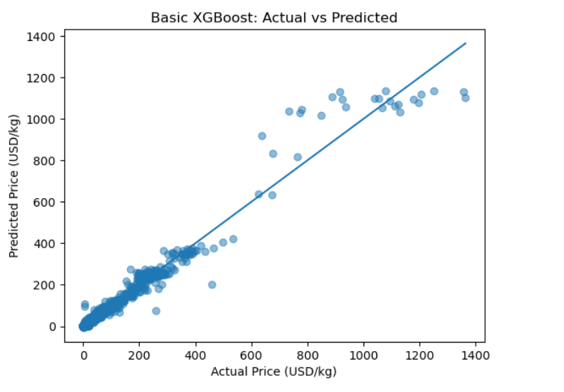
Figure ML2. Basic XGBoost: Actual vs Predicted
Compared with Linear Regression, the Basic XGBoost plot is more tightly concentrated around the ideal diagonal through most of the price range. The improvement is also visible in the evaluation metrics.

6.7.3 Tuned XGBoost
After the Basic XGBoost result, I adjusted the main model-capacity and learning settings by increasing boosting rounds and tree depth and reducing the learning rate, while keeping the other settings unchanged.
tuned_xgb = Pipeline([
("preprocessor", preprocessor),
("model", XGBRegressor(
n_estimators=500,
learning_rate=0.03,
max_depth=7,
subsample=0.8,
colsample_bytree=0.8,
objective="reg:squarederror",
random_state=42,
n_jobs=-1
))
])
tuned_xgb.fit(X_train, y_raw_train)
print("Tuned XGBoost model trained.")
Parameter | Basic XGBoost | Tuned XGBoost | Role
n_estimators | 300 | 500 | Number of boosting rounds / trees.
learning_rate | 0.05 | 0.03 | Step size while building the model.
max_depth | 6 | 7 | Maximum tree depth.
subsample | 0.8 | 0.8 | Fraction of rows sampled per boosting step.
colsample_bytree | 0.8 | 0.8 | Fraction of features sampled per tree.
objective | reg:squarederror | reg:squarederror | Regression objective.
random_state | 42 | 42 | Reproducibility.
n_jobs | -1 | -1 | Uses available CPU threads.

tuned_pred = tuned_xgb.predict(X_test)
tuned_true = y_raw_test
tuned_mae = mean_absolute_error(tuned_true, tuned_pred)
tuned_rmse = mean_squared_error(tuned_true, tuned_pred) ** 0.5
tuned_r2 = r2_score(tuned_true, tuned_pred)
print("Tuned XGBoost Results")
print(f"MAE: {tuned_mae:.4f}")
print(f"RMSE: {tuned_rmse:.4f}")
print(f"R2: {tuned_r2:.4f}")
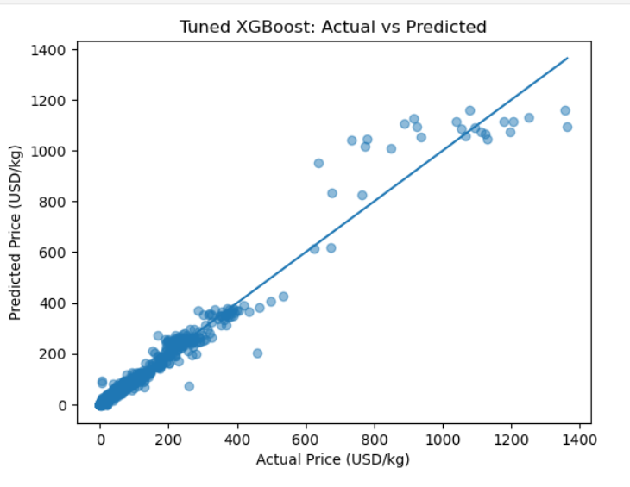
Figure ML3. Tuned XGBoost: Actual vs Predicted
The tuned model gives the lowest MAE and RMSE and the highest R² among the final three-model comparison. The scatter plot is also more concentrated around the diagonal than the Linear Regression plot. Some high-price observations still remain below the ideal line, so the highest-price cases are not modeled perfectly.

6.8 Target Transformation Experiments
A key development step was testing raw and log-transformed targets for each model family and comparing them on the original USD/kg scale.
Model / target | MAE | RMSE | R² | Final decision
Linear Regression + log target | 3.0694 | 15.6676 | 0.9492 | Retained
Linear Regression + raw target | 10.8312 | 28.9535 | 0.8264 | Not used
Basic XGBoost + log target | 2.7623 | 15.5449 | 0.9500 | Not used
Basic XGBoost + raw target | 2.3594 | 11.3357 | 0.9734 | Retained
Tuned XGBoost + log target | 2.5256 | 14.3848 | 0.9571 | Not used
Tuned XGBoost + raw target | 2.2316 | 11.2245 | 0.9739 | Retained

The result was clear for this project: the log transformation helped Linear Regression substantially, while both XGBoost versions performed better on the raw target. Therefore, the final notebook prepares both target versions once and assigns the appropriate version to each model.
For the log-trained Linear Regression model, predictions are converted back with np.expm1 before evaluation. The XGBoost models are trained directly on y_raw, so their predictions are already on the original USD/kg scale.

6.9 Alternative Model Experiment: CatBoost
I also tested CatBoost Regressor because the dataset contains many categorical variables, using the same held-out test set and regression metrics.
Model | MAE | RMSE | R² | Status
CatBoost Regressor | 2.8425 | 16.0394 | 0.9467 | Not retained in final notebook

The CatBoost experiment was useful for model exploration, but its test metrics were weaker than the final XGBoost configuration. I therefore removed it from the final notebook so the presentation and comparison could stay focused on the three models that formed the final workflow.

6.10 Evaluation Metrics
All final model metrics were calculated on the same held-out test set and reported on the original USD/kg scale. These values are regression metrics, not accuracy percentages.
Metric | Formula | Meaning
MAE | MAE = (1/n) × Σ|y − ŷ| | Average absolute prediction error. Lower is better.
RMSE | RMSE = √((1/n) × Σ(y − ŷ)²) | Penalizes larger errors more strongly than MAE. Lower is better.
R² | R² = 1 − SSres / SStot | Proportion of target variance explained on the evaluation set. Closer to 1 is better.

6.11 Final Results and Interpretation
The three retained models were evaluated on the same X_test and the original USD/kg target scale.
Model | MAE (USD/kg) | RMSE (USD/kg) | R²
Linear Regression | 3.0694 | 15.6676 | 0.9492
Basic XGBoost | 2.3594 | 11.3357 | 0.9734
Tuned XGBoost | 2.2316 | 11.2245 | 0.9739

The final tuned XGBoost configuration produced the strongest numerical results among the tested models, with MAE = 2.2316 USD/kg, RMSE = 11.2245 USD/kg, and R² = 0.9739 on the held-out test set. The improvement is visible in both the metric comparison and the actual-vs-predicted scatter plot.
The tuned model has the lowest MAE and RMSE and the highest R² in the final three-model comparison.

6.12 Limitations and Future Improvements
The current ML component has several limitations:
• The filtered ML population contains only five observation dates, so the current implementation is a prediction model rather than a future time-series forecasting model.
• The group-based split measures generalization to unseen country-market-commodity groups. It does not measure performance on a future date after the latest recorded date.
• The underlying dataset has uneven coverage across countries, markets, categories, and commodities, so some patterns may be supported by more observations than others.
• The target distribution contains extreme high-price observations. The final scatter plot shows that some high-price cases are still predicted below the ideal diagonal.

6.13 Final ML Achievements
The completed Machine Learning component produced a reproducible prediction workflow with clear data decisions, leakage control, model experiments, and a final comparison.
• Defined a clear business/analytical prediction question and selected usdprice as a comparable global target.
• Used GroupShuffleSplit and verified zero overlapping groups between training and testing data.
• Developed and evaluated Linear Regression, Basic XGBoost, and Tuned XGBoost.
• Tested raw vs. log-transformed targets and kept the representation that worked better for each model family.
• Finished with a tuned XGBoost model achieving MAE 2.2316, RMSE 11.2245, and R² 0.9739 on the held-out test set.

