Industrial Predictive Maintenance
& Failure Prevention
An end-to-end machine learning and deep learning pipeline
for machine failure risk prediction
Graduation Project — Advanced Data Science & AI
Project 5 · AI4I 2020 Predictive Maintenance Dataset
Author: ____________________
Date: ____________________

Table of Contents
To populate: open in Word, click the field below, and press F9 (or right-click → Update Field).

1. Executive Summary
Unplanned equipment failure is expensive: it halts production, damages tooling, and turns scheduled maintenance into emergency repair. This project builds a decision-support system that estimates the probability a machine is about to fail, using only the sensor readings already collected during normal operation.
Working from the AI4I 2020 Predictive Maintenance dataset (10,000 records, 3.4% failure rate), the project delivers a complete pipeline: a SQL data layer, an exploratory analysis, four classical machine learning models, two deep learning models, and a deployed Streamlit dashboard with prediction logging and basic monitoring.

Headline results
- The best model — a tuned Gradient Boosting classifier — achieves a PR-AUC of 0.894 and ROC-AUC of 0.968 on a held-out test set.
- At its business-tuned decision threshold, it catches 94% of real failures (recall 0.941), reducing the false-negative rate from 22% to 5.9%.
- Classical machine learning outperformed the deep learning models on this tabular problem — a result worth stating plainly rather than hiding, and one discussed in Section 9.
- The most consequential engineering decision was not a model choice but a data one: excluding the five failure-mode flags from the feature set, which would otherwise have leaked the target and produced falsely excellent results.
This is a demonstration pipeline built on a synthetic dataset. It is not a certified industrial safety system, and Section 12 sets out the limits of what these results can support.

2. Problem Definition and Business Context
A manufacturing line runs machines continuously. Each machine exposes a handful of cheap, always-on measurements: air temperature, process temperature, rotational speed, torque, and accumulated tool wear. Failures are rare but costly, and by the time a machine visibly fails, the damage is done.
The question this project answers is: given the current sensor readings, how likely is this machine to fail, and should a technician look at it now?

2.1 Why accuracy is the wrong target
Only 3.4% of records are failures. A model that predicts "no failure" for every single machine would be 96.6% accurate and completely useless. This single fact shapes every evaluation decision in the project: the primary metrics are PR-AUC and recall, not accuracy.

2.2 The cost asymmetry
The two kinds of mistake are not equally bad:
- A false negative — missing a real failure — means unplanned downtime, possible damage to the machine, and emergency repair costs.
- A false positive — a false alarm — means a technician inspects a healthy machine. Inconvenient, but comparatively cheap.
Because of this asymmetry, the deployed model deliberately operates at a threshold that accepts more false alarms in exchange for catching far more real failures. Section 8 covers how that threshold was chosen.

2.3 Intended users
The system is decision support for a maintenance team, not an autonomous controller. A technician sees a probability, a risk tier, and a recommended action, and decides what to do. Nothing in this system takes a machine offline by itself.

3. Dataset Description and Data Governance
The AI4I 2020 Predictive Maintenance dataset is a synthetic benchmark published by the UCI Machine Learning Repository, designed to reflect the structure of real industrial process data while being freely redistributable.

3.1 Structure
Column | Type | Description
UDI | Integer | Unique record identifier
Product ID | String | Product serial number
Type | Categorical | Quality grade: L (low), M (medium), H (high)
Air temperature [K] | Float | Ambient air temperature
Process temperature [K] | Float | Machine process temperature
Rotational speed [rpm] | Integer | Spindle rotational speed
Torque [Nm] | Float | Applied torque
Tool wear [min] | Integer | Accumulated tool wear time
Machine failure | Binary | Target: did the machine fail?
TWF, HDF, PWF, OSF, RNF | Binary | Five specific failure modes (see 3.3)

3.2 Data quality
The dataset is clean: 10,000 rows, no missing values, no duplicate rows, and no duplicate product identifiers. Every numeric field falls within a physically plausible range. No imputation or outlier removal was required.
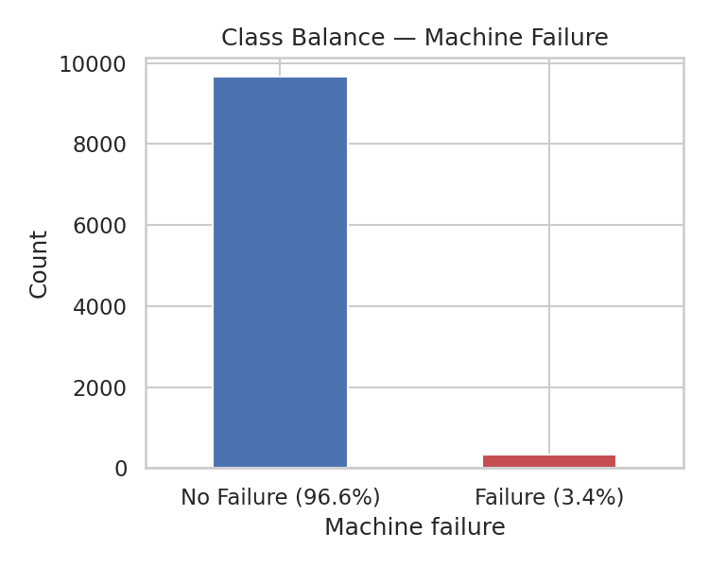
Figure 1 — Severe class imbalance: 9,661 normal records vs 339 failures.

3.3 A critical note on the failure-mode flags
The dataset includes five binary flags marking specific failure modes: tool wear failure (TWF), heat dissipation failure (HDF), power failure (PWF), overstrain failure (OSF), and random failure (RNF).
These are not independent predictors. The Machine failure target is essentially the union of these flags — if any is set, the machine is recorded as failed. Using them as model inputs would hand the model the answer, producing spectacular metrics that mean nothing.
They are therefore excluded from every model in this project. This is enforced in code rather than by convention: a single function, get_feature_columns(), defines the leakage-safe feature list, and both the machine learning and deep learning tracks call it. A test in the suite asserts that none of the five flags ever appears in the feature list.
This matters because it was a real bug. An earlier version of the deep learning notebook included the flags as inputs and reported 97% recall. That number was an artifact of leakage, not model quality.

3.4 A minor data inconsistency
Twenty-seven records show a disagreement between the failure-mode flags and the Machine failure label — cases where a mode flag is set but the overall label is 0, or the reverse. This is a known quirk of the dataset. These records were retained rather than removed, since the Machine failure column is the target being modeled and the flags are not used as inputs, but the inconsistency is documented here for transparency.

3.5 Governance
The dataset is synthetic and contains no personal data, so no privacy or consent considerations apply. It is published under UCI's open terms; the original creators are cited in Section 16. The raw file is never modified — all processing produces separate derived files.

4. System Architecture
The system is organised as a linear pipeline, with each stage producing an artifact the next stage consumes:
Raw CSV → SQL data layer → cleaned and feature-engineered dataset → trained models → Streamlit application → prediction log → back into SQL

4.1 Components
Component | Role
sql/predictive_maintenance.sql | Staging table, dimension and fact schema, ETL, 12 analytical queries, prediction history table
Main notebook | EDA, feature engineering, model training and comparison, artifact generation
src/features.py | Shared feature-engineering logic, used by the notebook, the app, and the tests
src/modeling.py | Shared metrics and threshold-selection helpers
app/app.py | Streamlit dashboard: single prediction, batch scoring, monitoring
tests/ | Pytest suite: feature logic, metrics, model artifacts, and app UI
Dockerfile | Containerized deployment of the dashboard

4.2 One source of truth for features
The most important architectural decision is that feature engineering lives in exactly one place. The notebook, the Streamlit app, and the test suite all import add_features() from src/features.py.
The alternative — reimplementing the same arithmetic in the app — is the standard route to training/serving skew, where the model silently receives differently-computed features at inference time than it saw during training. Routing everything through one function makes that class of bug structurally impossible, and a test asserts the app's single-row path produces columns in exactly the order the model expects.

5. SQL and Data Pipeline Design
The SQL layer implements a conventional staging → dimension → fact structure in SQL Server.

5.1 Schema
- Stg_AI4I — a staging table mirroring the raw CSV exactly, loaded via BULK INSERT. No transformation happens here; its job is to get the data in faithfully.
- MachineType — a small dimension table mapping the L/M/H quality grades to their ordinal encodings (0/1/2), so the encoding is defined once in the database rather than repeated in queries.
- MachineReadings — the cleaned, feature-ready fact table, with a foreign key to MachineType and the three engineered features stored alongside the raw measurements.
- PredictionHistory — a log of predictions made by the deployed model, with foreign key and check constraints enforcing valid probabilities and risk tiers.

5.2 ETL
A single INSERT ... SELECT statement moves data from staging to the fact table, joining against the MachineType dimension and computing the three engineered features inline. The formulas are identical to those in src/features.py — notably, mechanical power is computed as torque × (rpm × 2π / 60) in both places, so the SQL and Python feature sets agree exactly.

5.3 Analytical queries
Twelve queries cover the analytical requirements, using JOINs, common table expressions, and window functions. Representative examples:
- Failure rate by machine type (JOIN + aggregation) — shows that low-grade products fail at a higher rate than high-grade ones.
- Average sensor readings for failed vs healthy machines (CTE) — a SQL-side version of the comparison the EDA makes visually.
- Top five highest-power observations per machine type (ROW_NUMBER window function partitioned by type).
- Tool wear banded into groups with failure rate per band (CASE expression + aggregation) — quantifies the wear/failure relationship.
- Running cumulative failure count ordered by observation (SUM OVER with an unbounded preceding frame).

5.4 Closing the loop
The prediction log written by the Streamlit app uses the same column names as PredictionHistory, so it loads into the table directly with no reshaping. Predictions made in production flow back into the same database the training data came from, which is what makes later analysis of model performance against realised outcomes possible.

6. Exploratory Data Analysis

6.1 What correlates with failure
No single raw sensor reading correlates strongly with failure on its own. The strongest individual relationships are with torque and tool wear, and even those are modest.
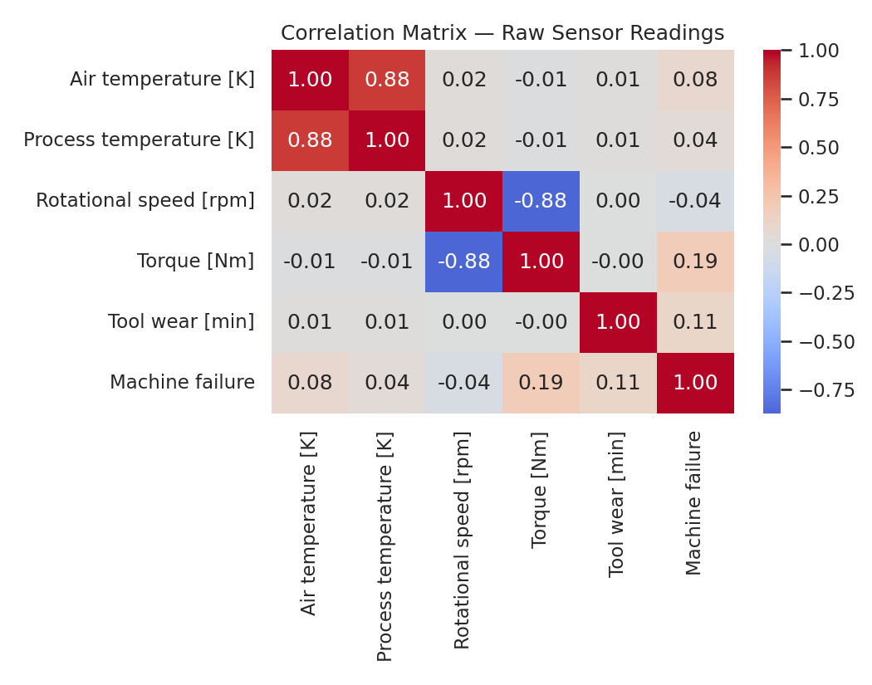
Figure 2 — Correlations between raw sensor readings and the failure target.
This is an informative negative result: it tells us early that a simple linear model is unlikely to perform well, and that the useful signal is probably in interactions between variables rather than in any one of them. The results in Section 7 bear this out — logistic regression scores a PR-AUC of 0.469 against 0.894 for gradient boosting.

6.2 Failure rate by product quality
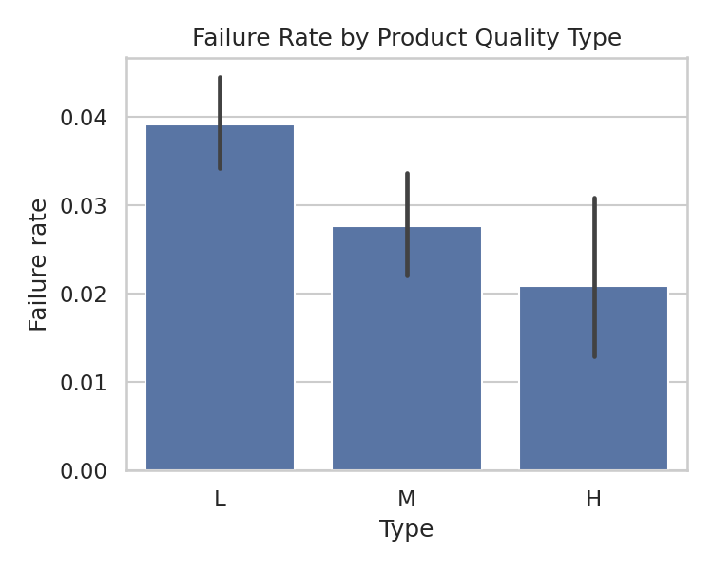
Figure 3 — Failure rate by product quality grade.
Low-grade (L) products fail noticeably more often than high-grade (H) ones, which is both intuitive and useful: the quality grade carries real predictive signal and is worth encoding as a feature.

7. Feature Engineering
Four features were added to the five raw sensor readings. Each was chosen for a physical reason, not by search over transformations.
Feature | Formula | Rationale
Temp_diff [K] | Process temp − Air temp | A machine running far hotter than ambient is dissipating heat poorly — a classic early warning sign
Power [W] | Torque × (rpm × 2π / 60) | Combines two sensors into the physical quantity that actually drives wear and heat
Wear_Torque_interaction | Tool wear × Torque | A worn tool under high torque is riskier than either condition alone
Type_encoded | L→0, M→1, H→2 | Ordinal encoding preserving the genuine quality ordering

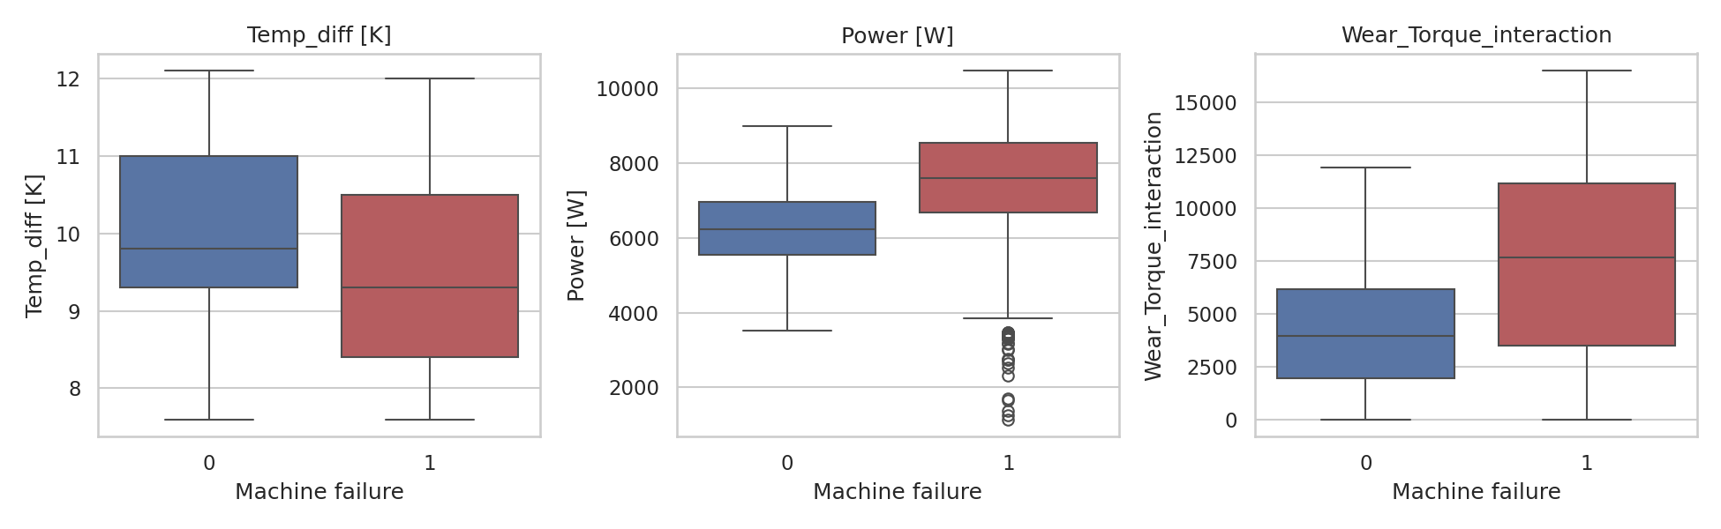
Figure 4 — Engineered features separate failures from normal operation.
The separation visible in Figure 4 — particularly for the wear/torque interaction — is the justification for these features. They are more discriminative than any single raw reading, which is consistent with the weak individual correlations seen in Section 6.

7.1 Input validation
The encoding function raises an explicit error on an unrecognised quality grade rather than silently producing a missing value. This was added after a test revealed that the original implementation would have passed a NaN straight through to the model — an error that would surface as a confusing prediction failure rather than a clear message about bad input.

8. Machine Learning Experiments

8.1 Validation strategy
The data is split 80/20 into training and test sets, stratified on the target so both sets preserve the 3.4% failure rate. The test set is held out entirely and used only for final evaluation. Model selection and hyperparameter tuning use 5-fold stratified cross-validation within the training set, scored on average precision.
Every model in the project — classical, neural, and unsupervised — is evaluated on this same held-out test set using the same metric function. This is what makes the comparison in Section 10 meaningful rather than a collection of separately-reported numbers.

8.2 Models and results
Model | Precision | Recall | F1 | PR-AUC | ROC-AUC
Logistic Regression (default) | 0.571 | 0.176 | 0.270 | 0.469 | 0.926
Logistic Regression (balanced) | 0.178 | 0.882 | 0.296 | 0.434 | 0.939
Decision Tree | 0.389 | 0.824 | 0.528 | 0.773 | 0.857
Random Forest | 0.962 | 0.735 | 0.833 | 0.869 | 0.967
Random Forest (tuned) | 0.944 | 0.750 | 0.836 | 0.865 | 0.980
Gradient Boosting | 0.915 | 0.794 | 0.850 | 0.894 | 0.974
Gradient Boosting (tuned) | 0.982 | 0.779 | 0.869 | 0.894 | 0.968

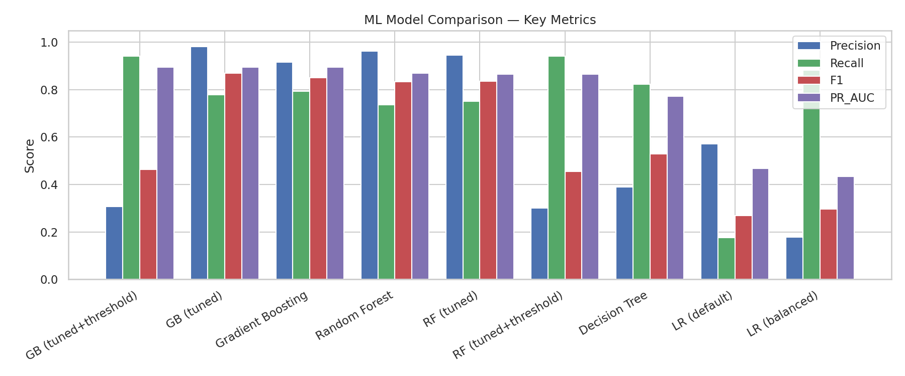
Figure 5 — Key metrics across all classical models.
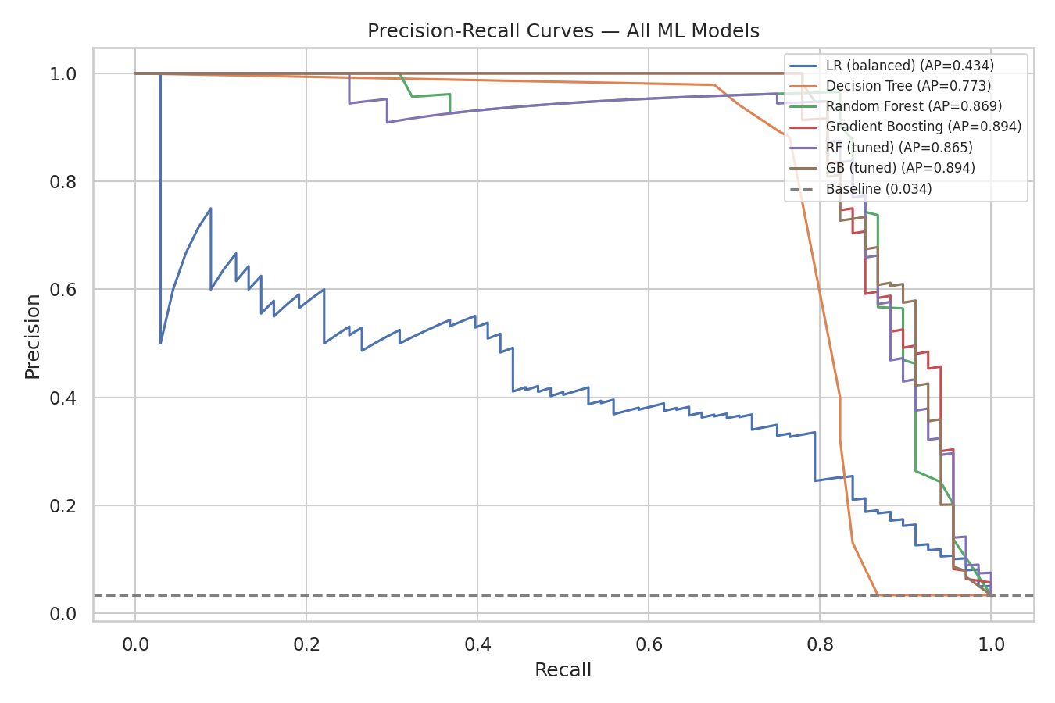
Figure 6 — Precision-recall curves. The dashed line is the 3.4% random baseline.

8.3 The class-weighting experiment
Applying balanced class weights to logistic regression moves recall from 0.176 to 0.882 — it catches five times as many failures. But precision collapses from 0.571 to 0.178, and PR-AUC actually falls slightly.
The lesson is that class weighting changes where a model sits on its precision-recall curve without necessarily improving the curve itself. It is a way of expressing a cost preference, not a way of making a weak model strong. Logistic regression remains the weakest model here either way, because the problem is not linearly separable.

8.4 Threshold optimisation
The default 0.5 decision threshold is an arbitrary convention, not a business decision. Given the cost asymmetry described in Section 2.2, the deployed threshold was chosen to maximise recall subject to precision staying above 30% — a floor representing how many false alarms the maintenance team can absorb.
For the tuned Gradient Boosting model this yields a threshold of 0.0092, with these consequences:
Operating point | Precision | Recall | False-negative rate
Default threshold (0.5) | 0.982 | 0.779 | 22.1%
Tuned threshold (0.0092) | 0.308 | 0.941 | 5.9%

The trade is explicit: the false-negative rate drops from 22% to 5.9% — catching roughly three-quarters of the failures that would otherwise be missed — at the cost of a substantially higher false-alarm rate. Whether that is the right trade depends on the real relative cost of an inspection versus an unplanned failure, which is a decision for the maintenance organisation, not the model.
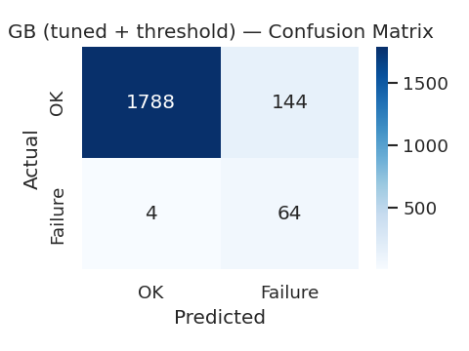
Figure 7 — Confusion matrix at the deployed threshold: 64 of 68 failures caught.

8.5 A deployment bug worth recording
An earlier version of this project saved the champion model to disk paired with its default-threshold metrics. The application would have loaded that metadata and operated at 0.5 — quietly discarding all of the threshold-optimisation work and running at 78% recall instead of 94%.
The fix was to save the tuned-threshold metrics with the model, and to add a test asserting that the deployed threshold is never exactly 0.5. The broader point is that a model artifact is not just weights: the decision threshold is part of the model, and losing it in the handoff to production silently undoes the tuning.

9. Deep Learning Experiments
Two neural models were built, both evaluated on the same held-out test set as the classical models.

9.1 Multi-layer perceptron
A feed-forward network (64 → 48 → 32 → 1) with LeakyReLU activations, trained with Adam and a class-weighted binary cross-entropy loss so that missed failures are penalised in proportion to their rarity. Training uses early stopping on a validation split carved out of the training set, plus learning-rate reduction on plateau, and restores the best-epoch weights rather than the last.
Importantly, the MLP takes its validation split from within the training set. The test set remains untouched, so its score is directly comparable to the classical models.

9.2 Autoencoder for anomaly detection
The autoencoder takes a fundamentally different approach. It is trained only on normal (non-failure) records, learning to compress and reconstruct healthy operating patterns through a six-unit bottleneck. Because it never sees a failure during training, it should reconstruct failure records noticeably worse — and that reconstruction error becomes an unsupervised anomaly score.
No failure labels are used to train it. Labels are used only to select a threshold and to evaluate it afterwards.
This matters practically: a supervised model can only recognise failure patterns resembling those in its training data. An anomaly detector flags anything unusual, including failure modes that were rare or absent during training. The two are complementary rather than competing.

9.3 On deep learning underperforming
On this dataset, the classical tree ensembles outperform both neural models. This is the expected outcome and worth stating rather than obscuring: gradient-boosted trees are consistently strong on small, tabular, well-engineered feature sets. With 10,000 rows and nine features, there is neither enough data nor enough structural complexity for a neural network's additional flexibility to pay for itself.
The deep learning track still earns its place. The MLP provides a genuine neural baseline evaluated under identical conditions, and the autoencoder provides an unsupervised detection capability that no supervised model offers. A result that says "the simpler model won" is a real result, and presenting it honestly is better practice than tuning a neural network until it happens to edge ahead on one metric.

10. Model Evaluation and Error Analysis

10.1 Metrics used, and why
- PR-AUC (average precision) — the primary metric. Under heavy class imbalance it reflects performance on the rare positive class far better than ROC-AUC, which can look flattering because true negatives dominate.
- Recall — the proportion of real failures caught. The metric that maps most directly to business cost here.
- Precision — how many alerts are genuine. Determines the false-alarm burden on technicians.
- False-negative rate — reported explicitly, because "how many failures did we miss" is the question a maintenance manager actually asks.
- Accuracy — reported nowhere as a headline figure, for the reasons given in Section 2.1.

10.2 Where the model still fails
At the deployed threshold the model misses roughly 6% of failures. The most likely candidates are records flagged as random failures (RNF), which by construction have no relationship to the sensor readings — no model can predict them from this data, and their presence places a hard ceiling on achievable recall.
The false alarms concentrate on machines with genuinely elevated readings that did not happen to fail. This is arguably the correct behaviour for a system that is advising a human rather than acting autonomously: flagging a stressed-but-surviving machine for inspection is not obviously a mistake.

11. Explainability and Responsible AI

11.1 SHAP analysis
SHAP values were computed for the deployed Gradient Boosting model using TreeExplainer, which is exact for tree ensembles. The analysis produces both global feature importance and per-prediction attributions, and the notebook saves a beeswarm plot and a ranked importance table.
Per-prediction explanations matter operationally: a technician asked to inspect a machine is entitled to know which readings drove the alert. An unexplained probability is much harder to act on than one accompanied by "this was driven primarily by torque and accumulated tool wear".

11.2 Responsible use
- The system is advisory. It never takes a machine offline; a human decides.
- The dataset is synthetic, and the interface says so directly to anyone using the dashboard.
- The deliberate precision/recall trade-off is documented rather than buried — users should understand that a high false-alarm rate is an intentional design choice, not a defect.
- No personal data is involved, so no fairness analysis across demographic groups applies. The relevant fairness question here is across machine types, and the failure-rate-by-type analysis in Section 6.2 addresses it.

12. Deployment Architecture
The model is deployed as a Streamlit dashboard with three tabs.

12.1 Single machine check
A technician enters current sensor readings and receives a failure probability, a Low/Medium/High risk tier, and a recommended action. The app also compares each input against the 1st–99th percentile range observed during training and warns when a value falls outside it — a lightweight guard against the model being asked to extrapolate beyond the conditions it learned from.

12.2 Batch scoring
A CSV of machines can be uploaded and scored in one pass, with results downloadable as CSV. This supports the realistic workflow of scoring a shift's worth of readings at once rather than one machine at a time.

12.3 Monitoring
Every prediction from either tab is appended to a log with a timestamp, model name and version, probability, risk tier, and recommended action. The monitoring tab charts alert rate over time and shows the full history. A sustained shift in alert rate is the simplest available signal that the input distribution has drifted away from the training data.

12.4 Containerization
A Dockerfile packages the application with its dependencies and trained artifacts. Dependencies are installed in a separate layer from application code so that code changes do not trigger a full reinstall on rebuild, and a healthcheck polls Streamlit's health endpoint. A docker-compose configuration mounts the prediction log to the host so that history survives container restarts.

13. MLOps, Testing and Security

13.1 Artifact versioning
The trained model is saved alongside a metadata file recording the model name, the exact feature list, the decision threshold, and the full metrics at that threshold. The feature list in metadata is what the application uses to order its inputs, so a model trained on different features cannot be silently mismatched with the app.

13.2 Test suite
Nineteen tests run without any trained model present, plus a further eight that exercise the artifacts and the application interface once training has been run:
Test file | What it covers
test_features.py | Feature formulas against hand-computed values, ordinal encoding, rejection of invalid input, and an assertion that the failure-mode flags never enter the feature list
test_modeling.py | Metric correctness on constructed edge cases, threshold-selection behaviour, risk-tier boundaries
test_model_artifacts.py | Model loads, produces valid probabilities, flags known failure records, and is not deployed at the naive 0.5 threshold
test_app_smoke.py | The Streamlit app loads without exception and a full prediction flow completes, via Streamlit's headless AppTest harness

Two of these tests encode bugs that actually occurred during development — the leakage check and the threshold check. Tests written in response to real failures tend to be the ones worth keeping.

13.3 Security considerations
- No credentials or secrets are stored in the repository; the SQL connection path is configurable rather than hardcoded.
- The application only reads uploaded CSVs into a dataframe — it does not execute uploaded content.
- Generated artifacts (models, processed data, evaluation output) are excluded from version control rather than committed, keeping the repository reproducible from source.

14. Limitations
- The dataset is synthetic. Strong metrics here validate the pipeline and methodology, not real-world industrial reliability. Nothing in this report should be read as evidence that the system would perform equivalently on a real production line.
- The data has no true temporal structure — records are independent snapshots, not a time series per machine. Genuine predictive maintenance usually tracks degradation over time, which this dataset cannot support and this project therefore does not attempt.
- Random failures (RNF) are unpredictable by construction, placing a ceiling on achievable recall that no modelling choice can lift.
- The deployed threshold produces a high false-alarm rate. This is intentional, but the 30% precision floor was chosen as a reasonable default rather than derived from measured inspection costs. Real deployment should set it from actual cost data.
- Monitoring is basic: alert-rate tracking and percentile range checks, not statistical drift detection.
- The autoencoder and MLP were trained once with sensible defaults rather than extensively tuned, so the deep learning results represent a fair baseline rather than the ceiling of what those architectures could achieve.

15. Future Work
- Failure-mode classification — predicting which of the five specific modes is likely, not just whether a failure will occur, which would let the system recommend a targeted intervention rather than a generic inspection.
- Cost-based alerting — replacing the fixed precision floor with an explicit cost matrix, so the threshold follows from measured inspection and downtime costs rather than a chosen default.
- Statistical drift detection — formal distribution tests on incoming features, with automated retraining triggers, rather than eyeballing alert rate.
- Sequential modelling — if per-machine time-series data became available, an LSTM or GRU over the degradation trajectory would suit the problem far better than a snapshot classifier.
- Model registry — tracking multiple model versions with their training data hashes and metrics, supporting champion/challenger comparison in production.

16. Conclusion
This project delivers a complete predictive maintenance pipeline: a SQL data layer with a documented schema and twelve analytical queries, an exploratory analysis, four classical models and two neural models evaluated under identical conditions, a deployed dashboard with logging and monitoring, a test suite, and containerization.
The best model reaches a PR-AUC of 0.894 and, at its business-tuned threshold, catches 94% of failures.
Three things stand out as the most valuable lessons from the work, and none of them is a modelling technique:
First, the target leakage. Including the failure-mode flags produced impressive-looking results that were entirely meaningless. Catching this required understanding what the columns represented, not just what they correlated with — no amount of cross-validation would have revealed it, because the leakage was present in every fold.
Second, the threshold. All the tuning in Section 8 would have been wasted had the model shipped at 0.5, and it very nearly did. The decision threshold is part of the model, and it has to survive the journey into production.
Third, the honest comparison. Deep learning lost to gradient boosting on this problem. Reporting that plainly, with an explanation of why it is the expected outcome for small tabular data, is more useful than manufacturing a result in which the more sophisticated method wins.

17. References
Matzka, S. (2020). Explainable Artificial Intelligence for Predictive Maintenance Applications. Third International Conference on Artificial Intelligence for Industries (AI4I). AI4I 2020 Predictive Maintenance Dataset, UCI Machine Learning Repository.
Dua, D. and Graff, C. (2019). UCI Machine Learning Repository. University of California, Irvine, School of Information and Computer Sciences. https://archive.ics.uci.edu/dataset/601/ai4i+2020+predictive+maintenance
Lundberg, S. M. and Lee, S.-I. (2017). A Unified Approach to Interpreting Model Predictions. Advances in Neural Information Processing Systems 30.
Pedregosa, F. et al. (2011). Scikit-learn: Machine Learning in Python. Journal of Machine Learning Research, 12, 2825–2830.
Paszke, A. et al. (2019). PyTorch: An Imperative Style, High-Performance Deep Learning Library. Advances in Neural Information Processing Systems 32.
Saito, T. and Rehmsmeier, M. (2015). The Precision-Recall Plot Is More Informative than the ROC Plot When Evaluating Binary Classifiers on Imbalanced Datasets. PLOS ONE, 10(3).

