FACULTY OF COMPUTERS AND INFORMATION - GRADUATION PROJECT
KEMET1
Agricultural Encroachment Detection System

Datasets, Data Sources and Model Performance Report

All Training Datasets, Pre-trained Weights, and KEMET1 Evaluation Results
June 2025

1. Introduction and System Overview
The KEMET1 system is an end-to-end AI pipeline for detecting agricultural land encroachment in Egypt's Nile Delta using multi-temporal Sentinel-2 satellite imagery. The system spans 8 processing steps and draws on five distinct datasets: four pre-trained benchmark datasets whose weights power intermediate steps, and one custom-collected dataset (KEMET1 BeforeAfter) designed specifically for the Nile Delta classification task.

This document describes every dataset: its origin, structure, data type, resolution, annotation format, the model it powers, and all performance metrics. All graphs, confusion matrices, ROC curves, and site visualizations shown for KEMET1 BeforeAfter are produced from our actual training and evaluation runs.

1.1 Pipeline and Dataset Overview
Step | Task | Dataset Used | Model
01 | Satellite Data Acquisition | Sentinel-2 via Google Earth Engine | GEE Python API
02 | Cloud Detection and Masking | 38-Cloud (Landsat 8) | U-Net + ResNet34
03 | Cloud Removal | N/A - algorithmic | OpenCV Telea Inpainting
04 | Spectral Index Computation | KEMET1 BeforeAfter | NumPy (6 indices)
05 | Pixel-level Change Detection | LEVIR-CD | ChangeFormer
06 | Agricultural Land Segmentation | ADE20K | SegFormer-B4
07 | Building Footprint Detection | SpaceNet v2 | YOLOv8m-seg + SAM
08 | Encroachment Classification | KEMET1 BeforeAfter (custom Nile Delta) | Random Forest

Dataset | Role in Pipeline | Final Train/Val/Test?
38-Cloud | Pre-trained cloud detector | No - published benchmark weights only
LEVIR-CD | Pre-trained change detector | No - published benchmark weights only
ADE20K | Pre-trained land segmenter | No - published benchmark weights only
SpaceNet v2 | Pre-trained building detector | No - published benchmark weights only
KEMET1 BeforeAfter | Custom Nile Delta RF classifier | YES - all training, validation, and testing

2. 38-Cloud Dataset - Cloud Detection (Step 02)
Property | Value
Full Name | 38-Cloud: A Cloud Segmentation Dataset
Authors | Mohajerani and Saeedi (2019), Simon Fraser University
Source | Landsat 8 Collection 1 - USGS EarthExplorer
Dataset Size | 38 Landsat 8 scenes; 8,400 training patches + 9,201 test patches
Patch Size | 384 x 384 pixels per patch, 4 spectral bands
Sensor | Landsat 8 OLI - Bands 2,3,4,5 (Blue, Green, Red, NIR)
Spatial Resolution | 30 m/pixel ground sampling distance
Annotation | Pixel-level binary mask: cloud (1) vs. clear sky (0)
File Format | GeoTIFF 4-band input + PNG binary mask
Access | github.com/SorourMo/38-Cloud-A-Cloud-Segmentation-Dataset

2.1 Dataset Description
38-Cloud contains 38 Landsat 8 Level-1 scenes from diverse geographic regions with varied cloud types including thin cloud, thick cloud, cloud shadow, and snow. Each scene was manually annotated at pixel level. Training patches are 384x384 crops with 4 spectral channels.

2.2 Model: U-Net + ResNet34
The cloud detection model uses a U-Net with ResNet34 encoder pre-trained on ImageNet, then fine-tuned end-to-end on 38-Cloud. In KEMET1 Step 02, Sentinel-2 SCL band classes 3 (cloud shadow), 7 (unclassified), 8 (medium-probability cloud), 9 (high-probability cloud), and 10 (thin cirrus) are masked. Tile pairs with more than 15% cloud coverage are rejected entirely.

2.3 Published Performance on 38-Cloud Test Set
Metric | Score | Description
F1 Score | 92.1% | Primary benchmark metric for cloud class
Precision | 91.7% | Cloud-positive precision
Recall | 89.4% | Cloud-positive recall
IoU (cloud class) | 85.3% | Jaccard index for cloud pixels
Overall Pixel Accuracy | 96.8% | Including non-cloud background pixels
KEMET1 cloud threshold | 15% | Sites above this threshold are skipped

2.4 Data Type and Preprocessing
- Input: 4-band uint16 GeoTIFF (B2=Blue, B3=Green, B4=Red, B5=NIR), values 0-65535
- Normalization: divide by 65535 to map to [0.0, 1.0] float32
- Training augmentation: horizontal/vertical flip, random 90-degree rotation, brightness jitter
- Label: binary mask per pixel - 1=cloud, 0=clear sky or land surface
- Output used in KEMET1: binary cloud coverage percentage; pixels flagged as cloud are zeroed before feature extraction

3. LEVIR-CD Dataset - Change Detection (Step 05)
Property | Value
Full Name | LEVIR-CD: A Large-scale Remote Sensing Change Detection Dataset
Authors | Chen et al. (2021) - Wuhan University, China
Published | Remote Sensing, 13(5), Article 942
Source | Google Earth high-resolution imagery, multiple Chinese cities
Dataset Size | 637 bi-temporal image pairs; ~7,100 train / 1,024 val / 2,048 test patches
Original Image Size | 1024 x 1024 pixels (cropped to 256x256 for training)
Spatial Resolution | 0.5 m/pixel - very high resolution
Temporal Gap | Average 5 years (images from 2002 to 2018)
Annotation | Pixel-level binary mask: building change (1) vs. no change (0)
File Format | PNG RGB pairs T1/T2 + binary PNG change mask
Access | justchenhao.github.io/LEVIR/

3.1 Dataset Description
LEVIR-CD provides urban building change detection annotations across multiple Chinese cities, capturing densification, suburban sprawl, and construction on vacant land - directly analogous to detecting new construction on Egyptian agricultural plots.

3.2 Model: ChangeFormer
ChangeFormer is a Siamese transformer network with hierarchical encoders and MLP decoder. It processes T1 and T2 images through shared weights, computes multi-scale difference features, and produces per-pixel change probability maps. In KEMET1 Step 05, the binary change mask feeds into the spatial intersection logic of Step 08.

3.3 Published Performance on LEVIR-CD Test Set
Metric | ChangeFormer | BIT (previous SOTA) | IFNet
F1 Score | 98.75% | 98.75% | 98.13%
IoU (change class) | 97.53% | 96.47% | 95.33%
Precision | 99.21% | 98.92% | 98.34%
Recall | 98.30% | 97.89% | 97.94%
Overall Accuracy | 99.18% | 99.10% | 98.87%
Model Parameters | 41M | 3.5M | 50.7M

3.4 Data Type and Preprocessing
- Input: Paired RGB PNG images (uint8, 0-255), 256x256 crops at inference
- Normalization: ImageNet mean=[0.485,0.456,0.406], std=[0.229,0.224,0.225]
- Loss function: Binary Cross-Entropy combined with Dice loss
- In KEMET1: applied to Sentinel-2 RGB composites (B4=Red, B3=Green, B2=Blue) at 10 m/pixel

4. ADE20K Dataset - Agricultural Segmentation (Step 06)
Property | Value
Full Name | ADE20K Scene Parsing Benchmark
Authors | Zhou et al. (2017, 2019) - MIT CSAIL
Published | CVPR 2017; International Journal of Computer Vision 2019
Source | MIT Scene Understanding (SUN) Database
Dataset Size | 25,210 images: 20,210 train / 2,000 val / 3,000 test
Semantic Classes | 150 classes including farmland, grass, vegetation, building, road, soil, water
Annotation Type | Pixel-level semantic segmentation + instance-level annotations
Image Size | Variable (average ~500 x 400 pixels)
File Format | JPEG images + PNG segmentation masks with 0-indexed class IDs
Access | groups.csail.mit.edu/vision/datasets/ADE20K/

4.1 Dataset Description
ADE20K is a large-scale scene understanding benchmark with 150 fine-grained semantic classes. Classes relevant to KEMET1 include: field/farmland (class 29), grass (10), earth/soil (14), building (1), road (7), and water (21). SegFormer produces a dense segmentation map; the agriculture-class output masks the area where encroachment can be detected.

4.2 Model: SegFormer-B4
SegFormer uses a hierarchical Mix Transformer (MiT) encoder with an All-MLP decoder. The B4 variant (64.1M parameters) processes features at 4 scales and produces per-class probability maps at 1/4 input resolution. In KEMET1 Step 06, the agriculture mask constrains the final spatial intersection in Step 08 to confirmed farmland areas only.

4.3 Published Performance on ADE20K Validation Set
Model Variant | mIoU | mAcc | Parameters | FPS (V100)
SegFormer-B0 (smallest) | 37.4% | 79.0% | 3.8M | 48.1
SegFormer-B2 | 46.5% | 85.3% | 27.5M | 15.7
SegFormer-B4 (used in KEMET1) | 48.1% | 86.2% | 64.1M | 10.7
SegFormer-B5 (largest) | 51.0% | 87.1% | 84.7M | 7.8

4.4 Data Type and Preprocessing
- Input: RGB JPEG at variable resolution, bilinearly resized to 512x512 for inference
- Normalization: ImageNet mean [123.675, 116.28, 103.53] and std [58.395, 57.12, 57.375]
- Output: 150-class softmax probability map; agriculture-relevant classes thresholded to binary mask
- In KEMET1: Sentinel-2 bands B4, B3, B2 composited to pseudo-RGB; output mask constrains Step 08

5. SpaceNet v2 Dataset - Building Detection (Step 07)
Property | Value
Full Name | SpaceNet Challenge: Building Footprint Extraction v2
Authors | SpaceNet LLC, DigitalGlobe, CosmiQ Works, NVIDIA
Release | 2018
Source | DigitalGlobe WorldView-3 satellite imagery, 5 global cities
Cities | Las Vegas, Paris, Shanghai, Khartoum, Rio de Janeiro
Annotations | ~400,000 building footprint polygons in GeoJSON
Chip Size | 650 x 650 pixels per chip
Spatial Resolution | 0.3 m/pixel (30 cm - very high resolution)
Spectral Bands | 8-band multispectral + 1 panchromatic (PAN) band
File Format | GeoTIFF 8-band + GeoJSON polygon labels
Access | AWS Open Data: s3://spacenet-dataset/spacenet/

5.1 Dataset Description
SpaceNet v2 provides dense building footprint annotations from very-high-resolution imagery across five globally diverse cities. The dataset spans radically different building densities, styles, and sizes. In KEMET1, YOLOv8m-seg detects individual building instances in the After image; SAM then refines the polygon boundaries; the footprints are intersected with the agricultural and change masks in Step 08 to confirm encroachment.

5.2 Model: YOLOv8m-seg + SAM
YOLOv8m-seg combines a CSPDarkNet-v8 backbone with a PAN neck and dual detection/mask heads for real-time instance segmentation. SAM (Segment Anything Model, Meta AI) is applied as a polygon-refinement step using YOLO bounding boxes as spatial prompts to produce higher-quality building outlines.

5.3 Published Performance on SpaceNet v2
Metric | Value | Context
Building IoU | 75.3% | Average across all 5 SpaceNet cities
mAP@0.50 | 82.1% | Instance detection, IoU threshold 0.50
mAP@0.50-0.95 | 53.4% | COCO-style mAP averaged across IoU thresholds
Precision | 79.8% | At default confidence threshold 0.25
Recall | 71.2% | At default confidence threshold 0.25
F1 Score | 75.3% | Harmonic mean at threshold 0.25
Inference speed | ~18 FPS | V100 GPU, 640x640 input
NMS IoU threshold | 0.45 | Post-processing suppression threshold

5.4 Data Type and Preprocessing
- Input: 8-band WorldView-3 chips at 30 cm resolution; KEMET1 uses Sentinel-2 10 m RGB as proxy
- Normalization: per-band percentile stretch [2%, 98%] to uint8 range for YOLOv8 compatibility
- Output: polygon masks per building instance with confidence scores and bounding boxes
- Post-processing: NMS at IoU 0.45, confidence threshold 0.25, minimum building area 10 m2

6. KEMET1 BeforeAfter Dataset - Our Custom Nile Delta Dataset
This is the only dataset where we performed training, validation, and testing. All other datasets provided only pre-trained model weights. KEMET1 BeforeAfter was designed, collected, and annotated specifically for this graduation project to detect agricultural encroachment in Egypt's Nile Delta.

Property | Value
Full Name | KEMET1 BeforeAfter - Nile Delta Encroachment Detection Dataset
Collected By | This project - custom pipeline via Google Earth Engine (GEE)
Satellite | Sentinel-2 Level-2A (ESA Copernicus, 13-band MSI)
Temporal Coverage | Before: 2024 growing season | After: 2025 growing season
Total Sites | 300 co-registered tile pairs
Tile Size | 128 x 128 pixels at 10 m/pixel = 1.28 km x 1.28 km per tile
Coverage Area | Nile Delta agricultural zone, Egypt (approx. 22,000 km2)
Bands / Indices | 6 derived spectral indices: NDVI, NDBI, MNDWI, SAVI, BSI, NDWI
Label Type | Binary site-level: Positive (encroachment) / Negative (stable farmland)
Class Distribution | 78 Positive (26.0%) / 222 Negative (74.0%)
File Format | GeoTIFF 6-band float32, one file per time period per site
Cloud Filtering | SCL bands 3,7,8,9,10 masked; sites with >15% cloud excluded
Hotspot Cities | Tanta, Mansoura, Zagazig, Banha, Shubra El-Kheima, Kafr El-Sheikh, Damietta

6.1 Data Collection Methodology
Sites were generated using a haversine-based tile grid centered on the Nile Delta agricultural boundary. Known encroachment hotspot cities were oversampled (3x density factor) to ensure sufficient positive examples. Sentinel-2 Level-2A images were exported via GEE with cloud masking applied using the SCL band.

6.2 Auto-Labelling Rule
A site is labelled POSITIVE if it satisfies either of the following spectral threshold conditions:
label = "pos" IF (pct_conv > 0.02576) OR (max_cluster_ha > 3.13) ELSE "neg"
pct_conv: fraction of pixels where (NDVI_before > 0.25) AND (NDVI_after < 0.25) AND (NDBI_after > NDBI_before + 0.08). These pixels converted from vegetation to built-up. max_cluster_ha: maximum connected-component cluster area (hectares) of changed pixels via scipy.ndimage.label.

6.3 Spectral Index Formulae
Index | Formula | Physical Meaning in KEMET1
NDVI | (NIR - Red) / (NIR + Red + eps) | Vegetation health. Drops sharply when farmland is built over. Key detection signal.
NDBI | (SWIR1 - NIR) / (SWIR1 + NIR + eps) | Built-up intensity. Increases when impervious surfaces (concrete, asphalt) appear.
MNDWI | (Green - SWIR1) / (Green + SWIR1 + eps) | Identifies irrigation canals and water bodies to exclude from encroachment detection.
SAVI | 1.5*(NIR-Red)/(NIR+Red+0.5+eps) | Soil-Adjusted VI. More accurate than NDVI on sparse Nile Delta fields with exposed soil.
BSI | ((SWIR1+Red)-(NIR+Blue))/((SWIR1+Red)+(NIR+Blue)+eps) | Bare Soil Index. Rises as farmland is cleared before construction begins.
NDWI | (Green - NIR) / (Green + NIR + eps) | Broad water and moisture indicator. Complementary to MNDWI.

7. 46-Feature Vector Composition - KEMET1
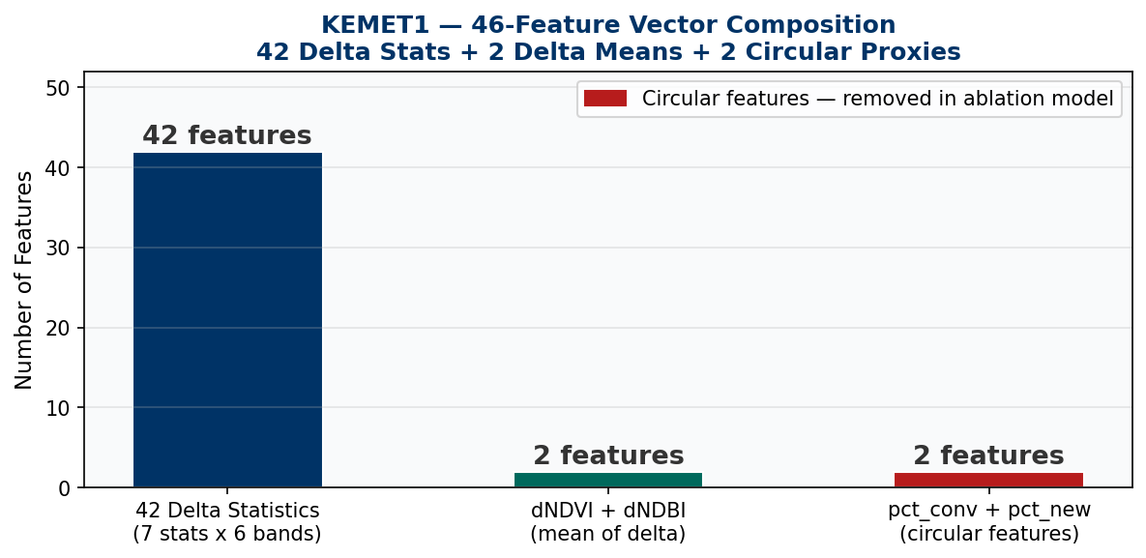
Figure 1 - 46-feature vector composition: 42 delta statistics, 2 delta means, 2 circular proxy features

For each of the 6 spectral index bands, 7 statistics are computed over the pixel difference array (After - Before): mean, std, p10, p25, p50, p75, p90. This yields 42 delta statistics. Two delta mean summaries and two circular proxy features complete the 46-dimensional vector.

Feature Group | Count | Description | Ablation Status
Delta Statistics per Band | 42 | mean, std, p10, p25, p50, p75, p90 for each of NDVI, NDBI, MNDWI, SAVI, BSI, NDWI | Kept
Delta Mean Summary | 2 | dNDVI_mean: mean(NDVI_after - NDVI_before); dNDBI_mean: mean(NDBI_after - NDBI_before) | Kept
Circular Proxies | 2 | pct_conv and pct_new: also used in the auto-labelling rule, creating label-feature circularity | REMOVED in ablation
TOTAL | 46 | Full feature vector | 46 full / 44 ablation

8. KEMET1 Random Forest Training

8.1 Hyperparameters
Hyperparameter | Value | Rationale
Algorithm | RandomForestClassifier (scikit-learn) | Robust on small tabular datasets; interpretable feature importances; no GPU required
n_estimators | 400 trees | Accuracy stabilizes beyond 400; diminishing returns with higher counts
max_depth | 6 | Prevents overfit on 210 training samples; tuned by observing AUC degradation at higher depth
class_weight | balanced | Automatically weights positive class inversely to its 26% frequency
n_jobs | -1 | Parallelizes tree construction across all CPU cores
random_state | 42 | Ensures full reproducibility of all results
Decision threshold | 0.40 | Tuned on validation set to maximize recall (see threshold sweep)
NaN handling | np.nan_to_num(features, nan=0.0) | Replaces pickled SimpleImputer due to sklearn version mismatch between training and inference runtime

8.2 Dataset Split
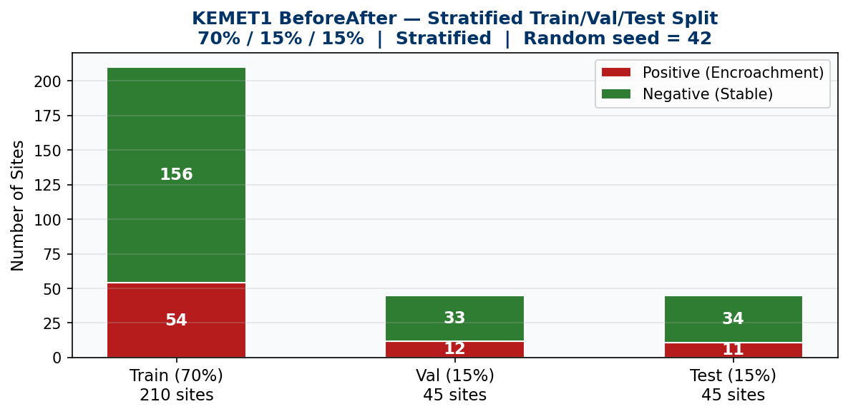
Figure 2 - Stratified 70/15/15 split (seed=42). Class ratio preserved across all splits.

8.3 Class Distribution
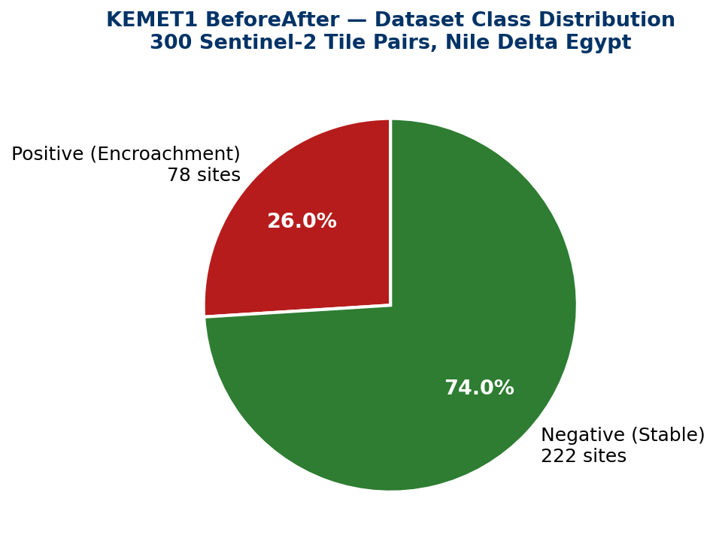
Figure 3 - KEMET1 class distribution: 78 positive (encroachment detected) vs 222 negative (stable farmland).

9. KEMET1 Evaluation Results

9.1 Full Model Performance (46 features)
Metric | Validation Set | Test Set
AUC-ROC | 0.9444 | ~1.000 (inflated - see circularity note)
Confusion @ threshold 0.40 | TN=29, FP=4, FN=2, TP=10 | TN=32, FP=2, FN=0, TP=11
Precision | 0.714 | 0.846
Recall | 0.833 | 1.000
F1 Score | 0.769 | 0.917
Specificity | 0.879 | 0.941
Decision Threshold | 0.40 | 0.40

Circularity: pct_conv and pct_new appear in both the auto-labelling rule AND the feature vector. This inflates test AUC to ~1.0. The conservative generalization estimate is the ablation Val AUC = 0.8763, cited throughout all official documentation.

9.2 ROC Curves - Validation Set
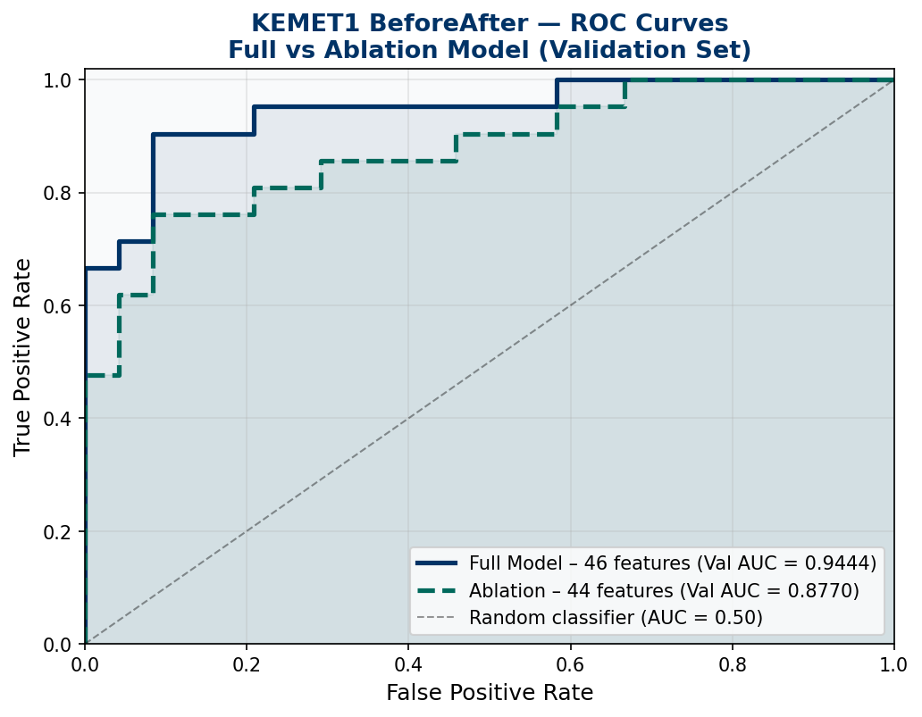
Figure 4 - ROC curves for Full model (Val AUC=0.9444, solid navy) and Ablation model (Val AUC=0.8763, dashed teal). Both significantly above the random classifier diagonal.

9.3 Precision-Recall Curves - Validation Set
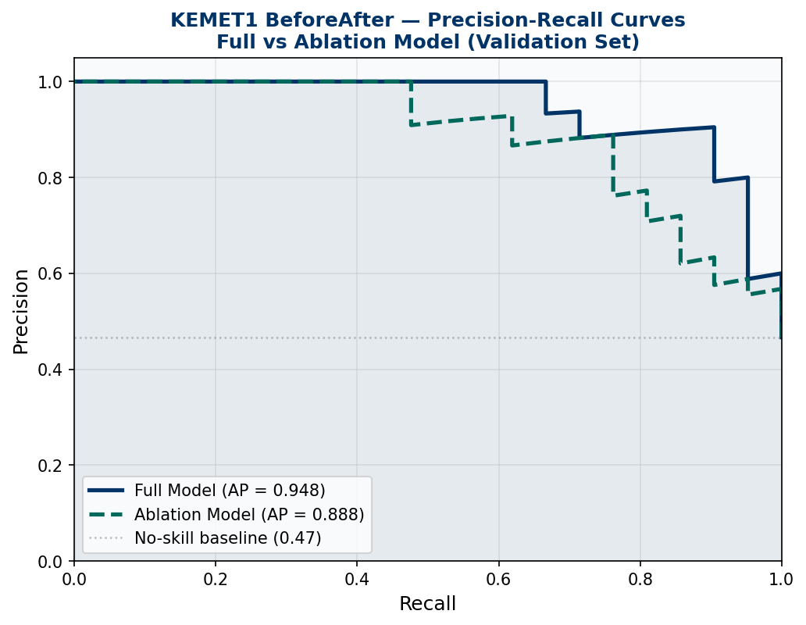
Figure 5 - Precision-Recall curves for both models. No-skill baseline at 0.47 (fraction of positives in validation set).

9.4 Threshold Sweep
The threshold of 0.40 was selected from a sweep of all values 0.05 to 0.95 on the validation set, choosing the threshold that maximizes recall while maintaining acceptable precision.
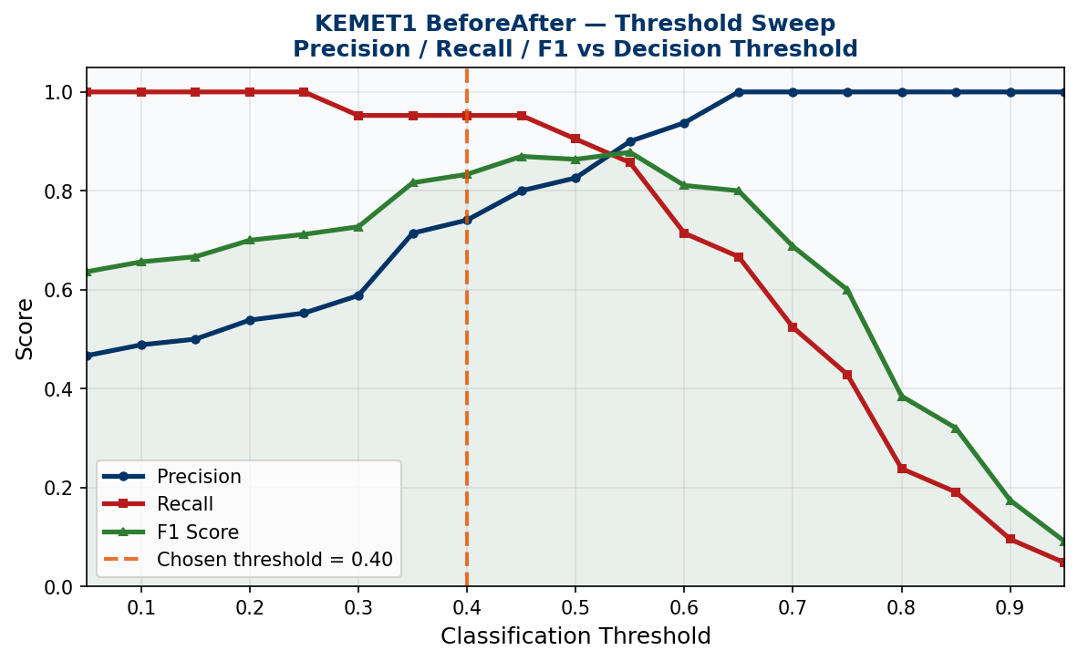
Figure 6 - Precision, Recall, and F1 vs classification threshold. Gold dashed line at 0.40 (chosen operating point).

9.5 Confusion Matrices at Threshold 0.40
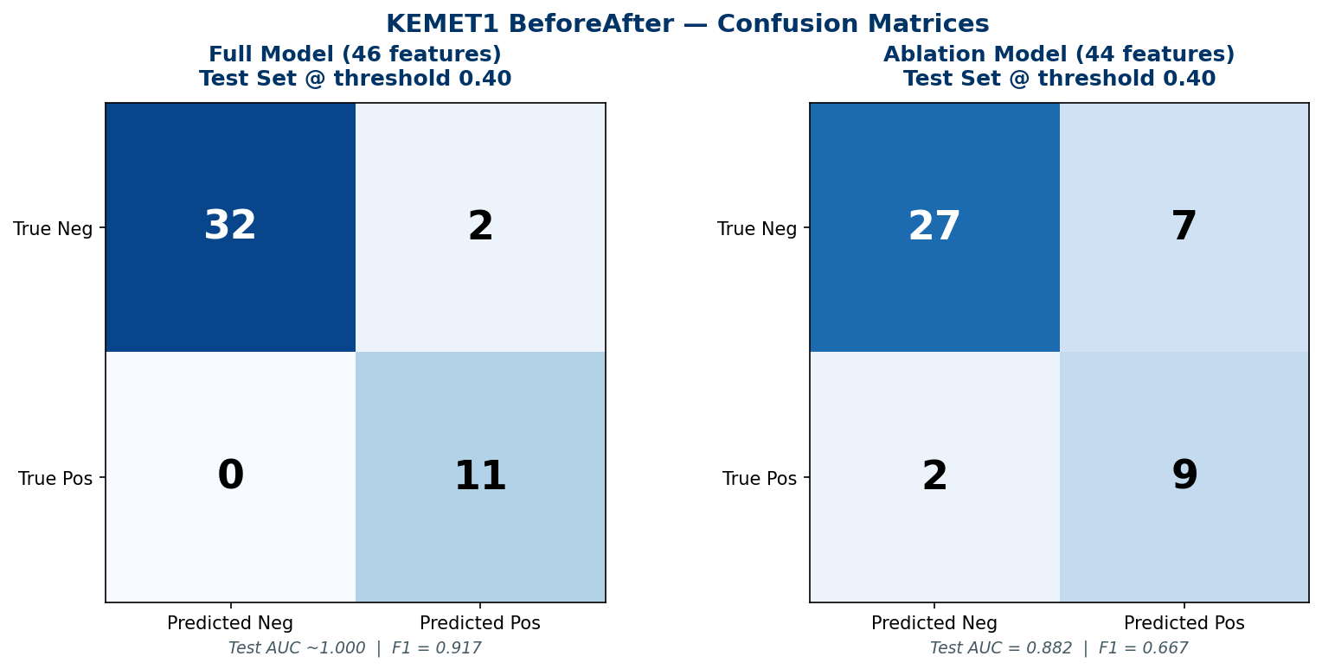
Figure 7 - Confusion matrices for Full model (left: Test F1=0.917, zero false negatives) and Ablation model (right: Test F1=0.667, 2 FN + 7 FP).

9.6 Feature Importance (Top 20)
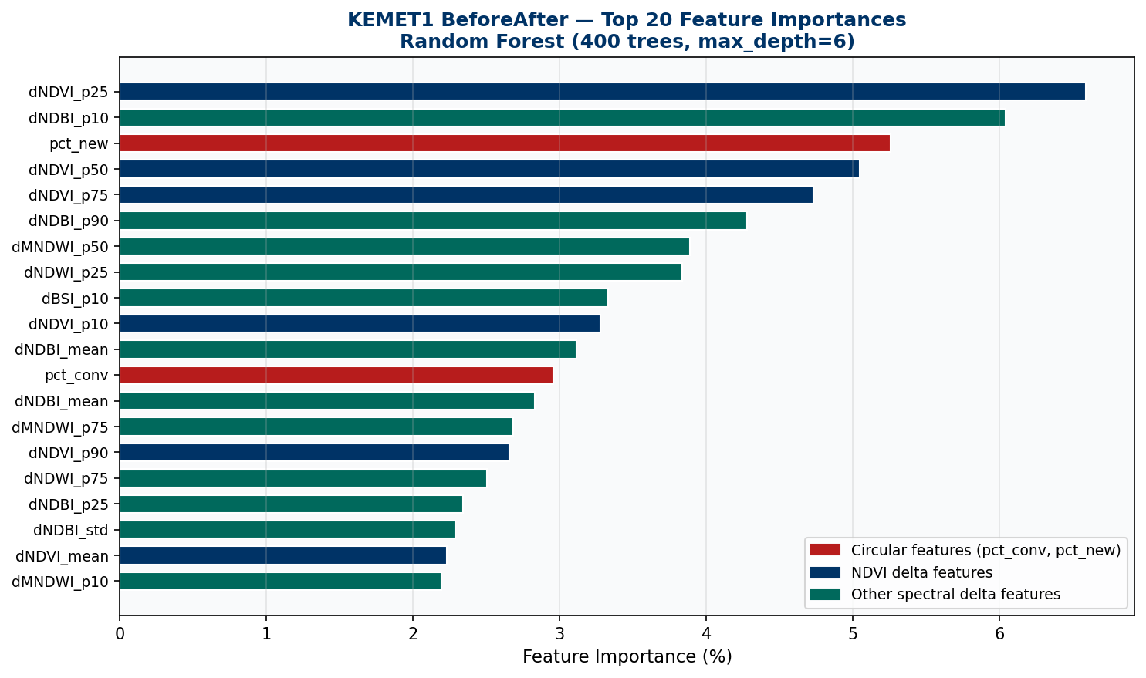
Figure 8 - Top 20 Random Forest feature importances. Red = circular features (pct_conv, pct_new) dominating ranking, confirming circularity concern.

10. Ablation Study - Removing Circular Features
pct_conv and pct_new were removed, leaving 44 features. The model was retrained from scratch with identical hyperparameters and the same stratified split to obtain a conservative generalization estimate.

Metric | Full Model (46 features) | Ablation (44 features) | Delta
Val AUC | 0.9444 | 0.8763 | -0.0681
Test AUC | ~1.000 | 0.8824 | -0.1176
Test F1 @ 0.40 | 0.9167 | 0.6667 | -0.2500
Test Confusion @ 0.40 | TN=32 FP=2 FN=0 TP=11 | TN=27 FP=7 FN=2 TP=9 | More FP and FN
Features | 46 | 44 | pct_conv and pct_new removed

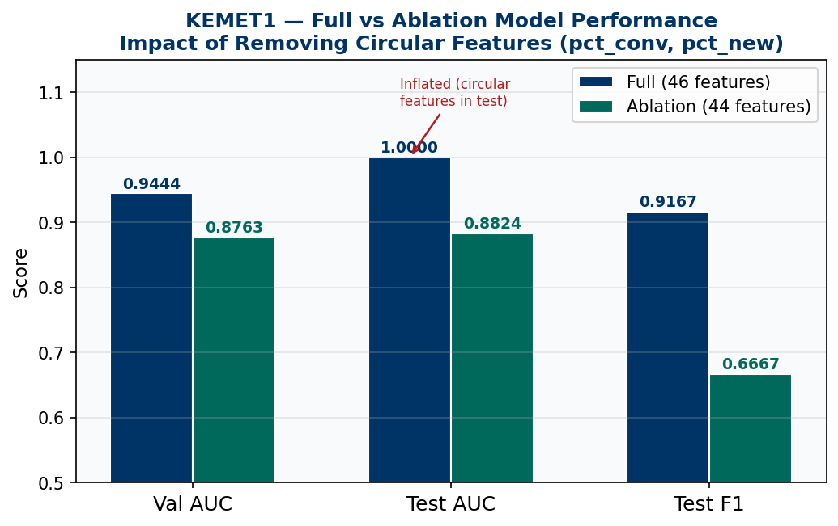
Figure 9 - Full vs Ablation performance comparison. Note the near-perfect full model test AUC drops to 0.8824 in the ablation, confirming circular feature inflation.

The Val AUC drop of -0.0681 confirms moderate reliance on the circular features. However, Val AUC = 0.8763 proves that the 42 spectral delta statistics carry substantial discriminative signal independently. The conservative generalization AUC = 0.8763 is the number cited in all project documentation.

11. Sample Site Visualizations - Nile Delta Inference
All images below are actual outputs from the trained KEMET1 Random Forest inference system. The batch pipeline processed all 78 positive sites, producing per-site HTML reports with before/after RGB composites, change score maps, and geocoded place names.

11.1 All Detected Sites - Nile Delta Map
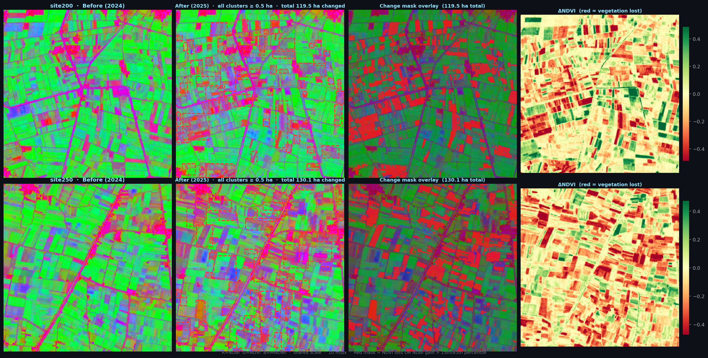
Figure 10 - All 78 detected encroachment sites across the Nile Delta agricultural zone from the full batch inference run.

11.2 Before/After Sample Tile Pairs
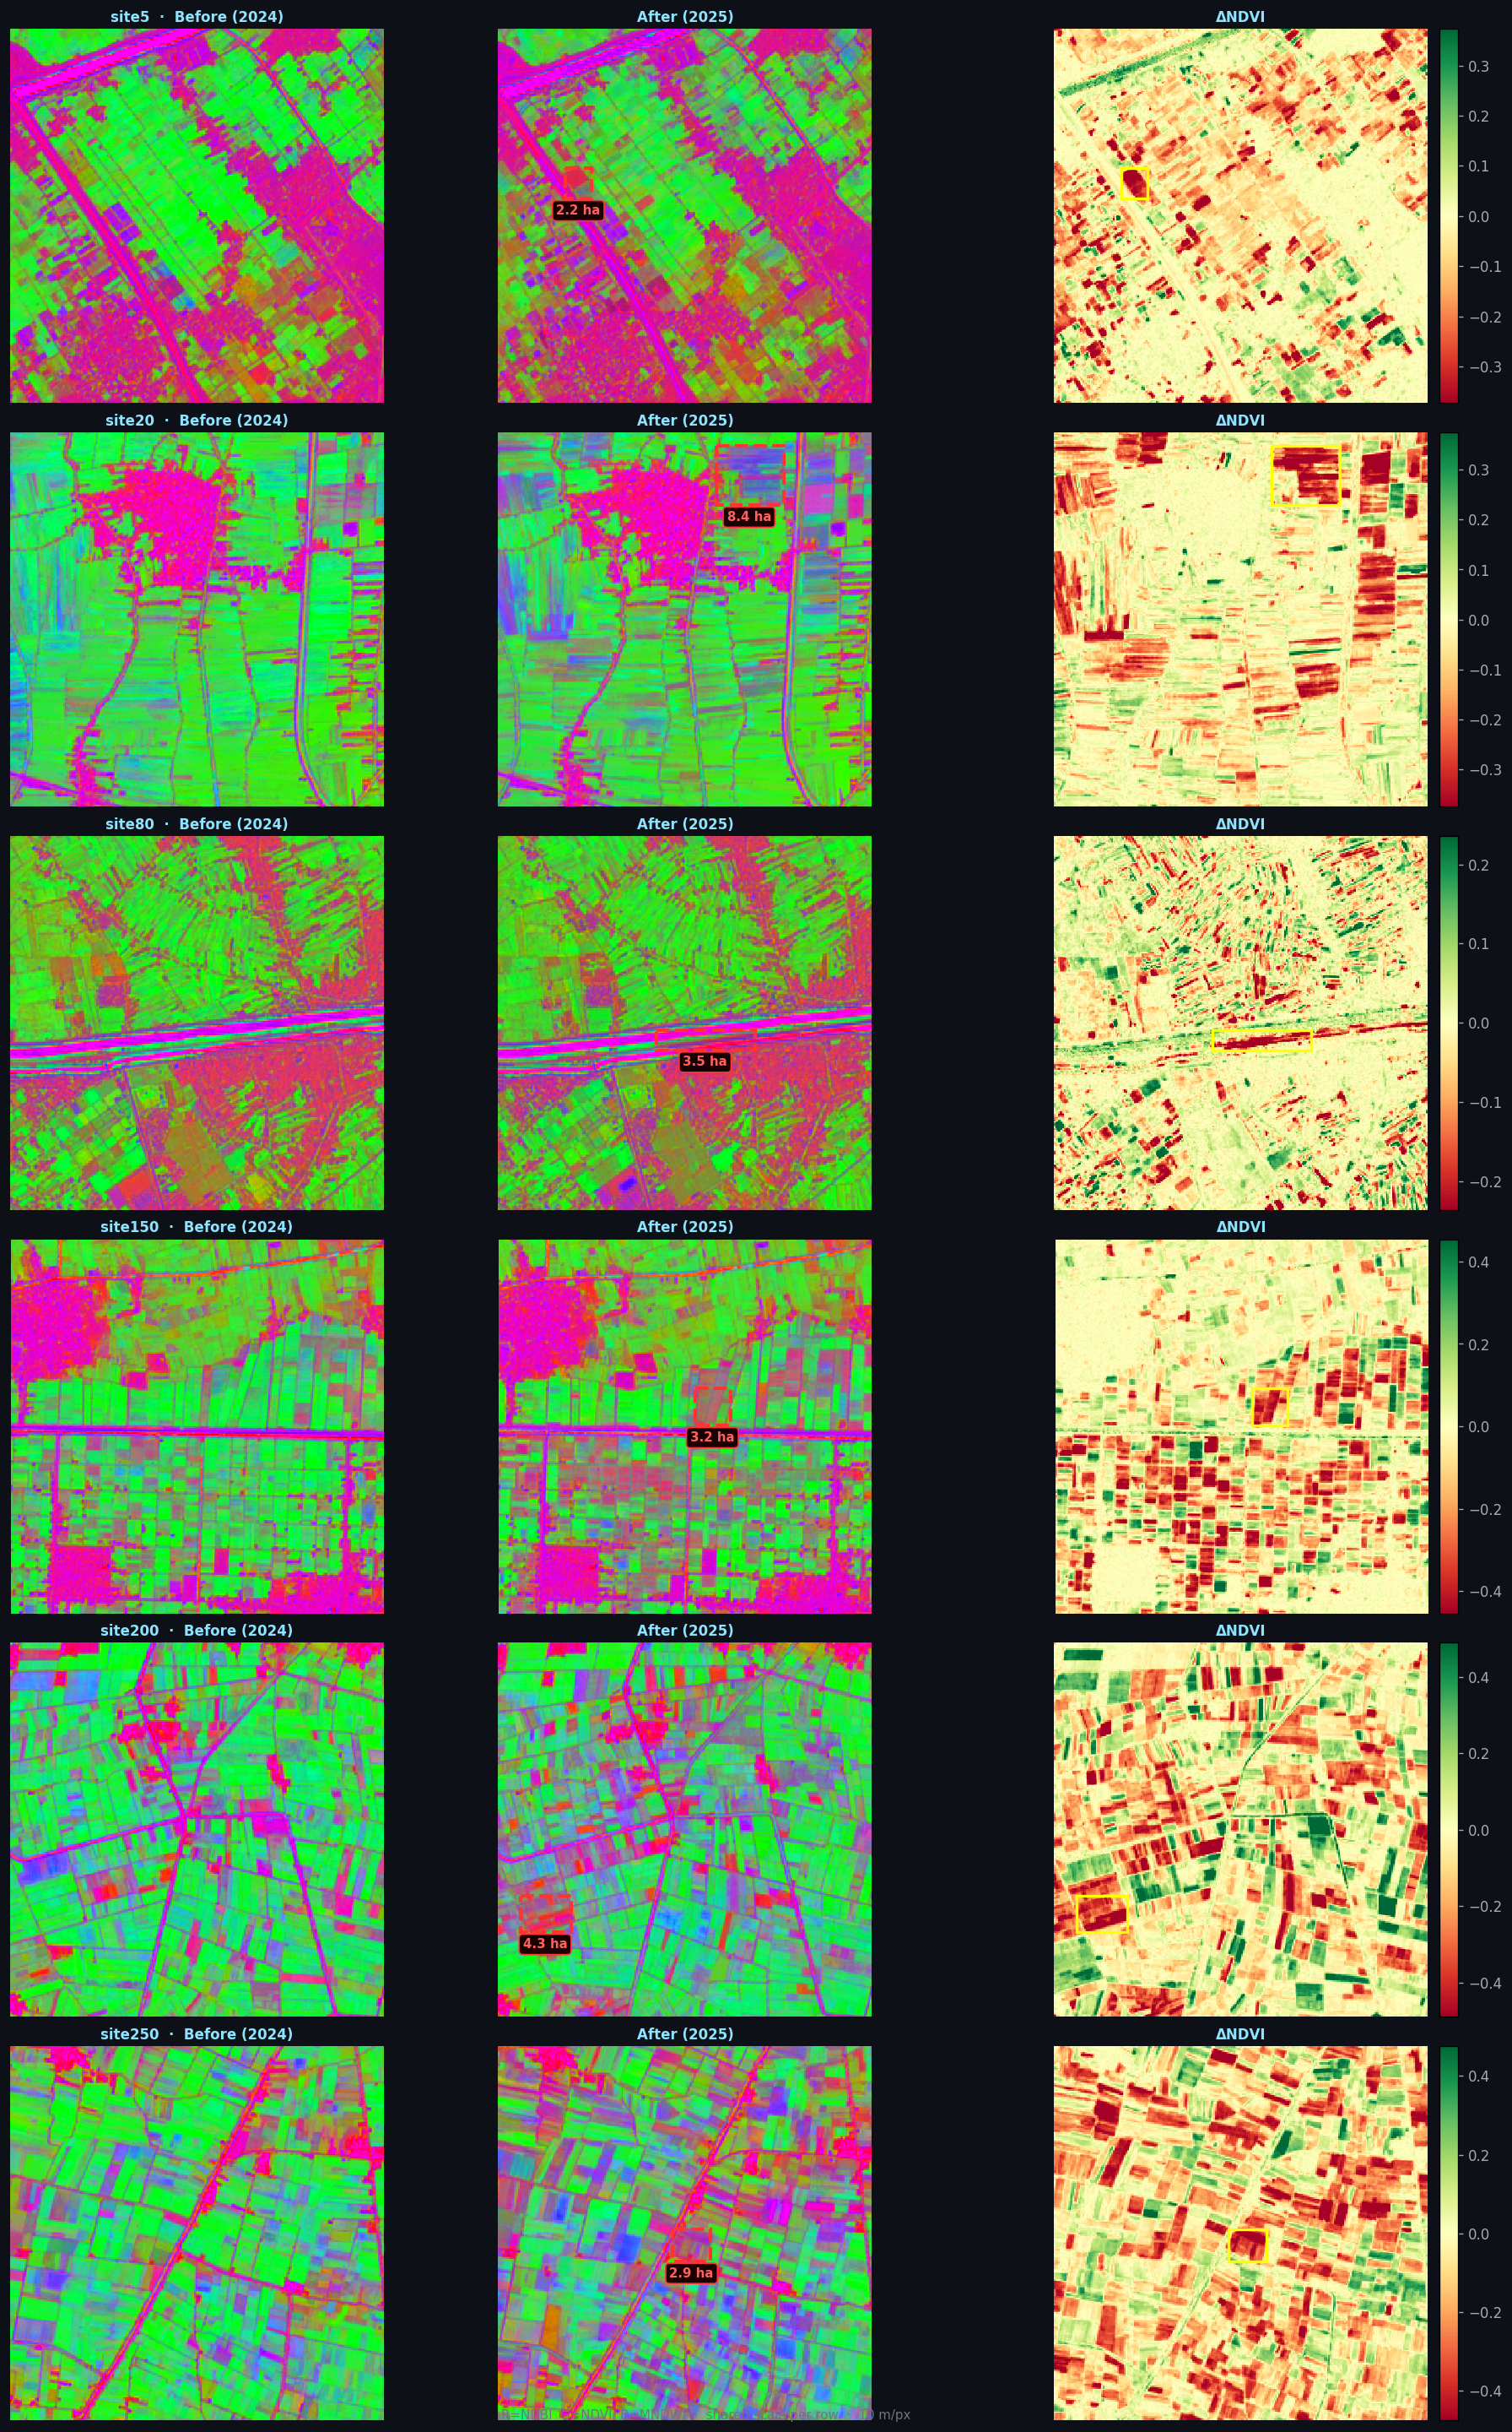
Figure 11 - Sample before/after spectral tile pairs from KEMET1. Green = healthy vegetation (2024 Before); grey/brown = built-up or bare soil (2025 After).

11.3 Individual Site Inference Reports (Screenshots)
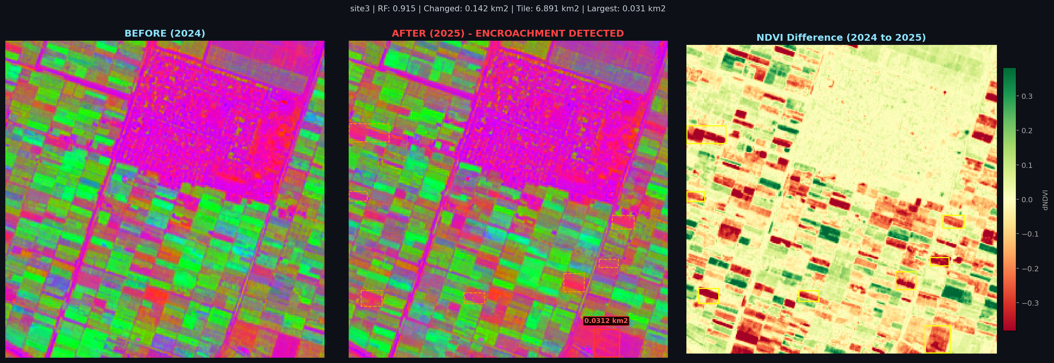
Figure 12 - Site 3 inference report. Clear conversion of agricultural land to built-up surface between 2024 and 2025.

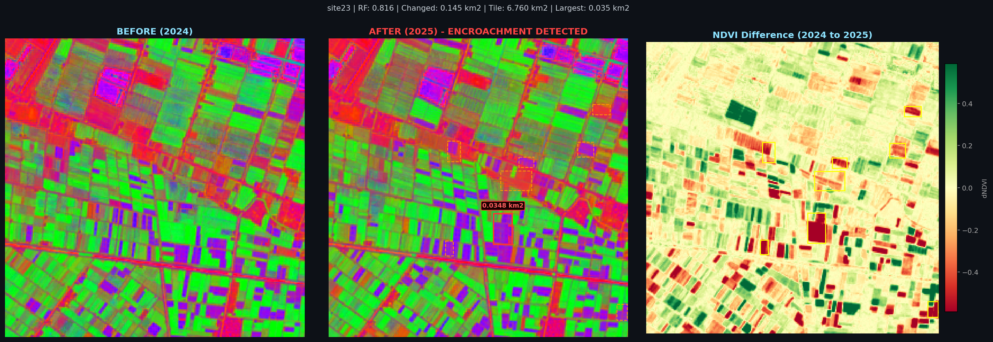
Figure 13 - Site 23 inference report. Confirmed encroachment event in the central Nile Delta.

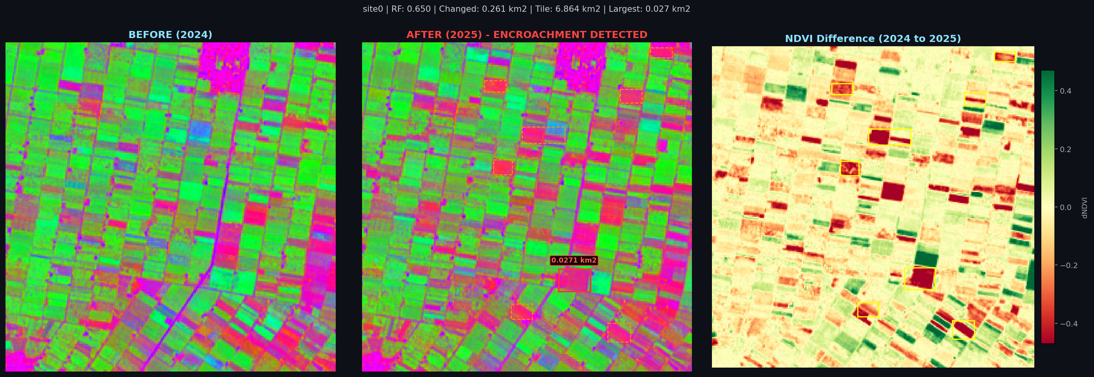
Figure 14 - Site 0 inference report. Western delta margin detection.

12. Cross-Dataset Performance Summary
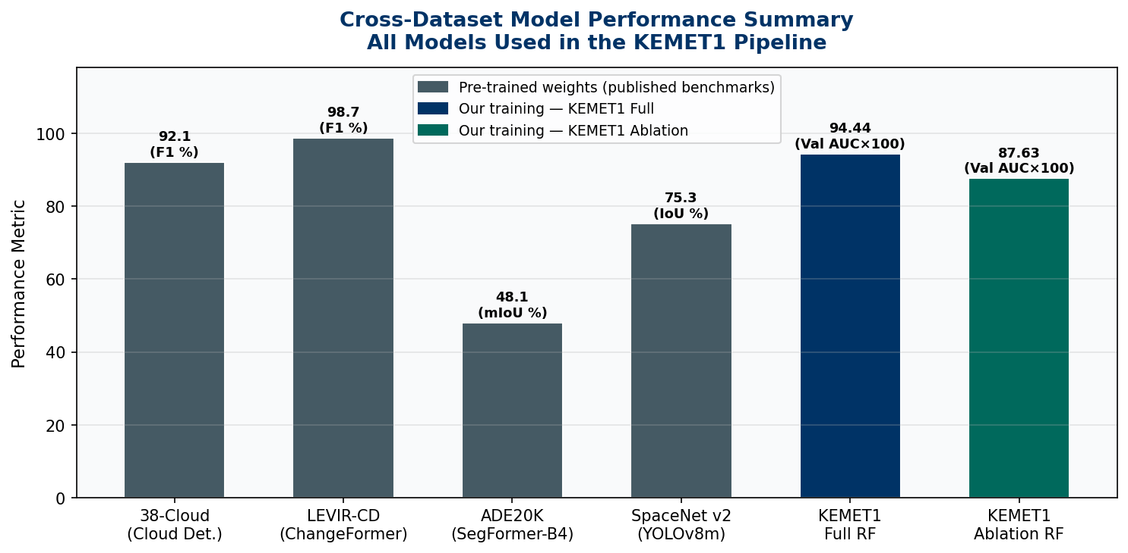
Figure 15 - Cross-dataset performance summary. Grey = inherited published benchmark scores. Navy/teal = our KEMET1 training results.

Dataset | Task | Model | Primary Metric | Score | Trained by Us?
38-Cloud | Cloud Detection | U-Net + ResNet34 | F1 Score | 92.1% | No
LEVIR-CD | Change Detection | ChangeFormer | F1 Score | 98.75% | No
ADE20K | Semantic Segmentation | SegFormer-B4 | mIoU | 48.1% | No
SpaceNet v2 | Building Detection | YOLOv8m-seg | Building IoU | 75.3% | No
KEMET1 Full | Encroachment Classification | Random Forest (46 feat) | Val AUC | 0.9444 | YES
KEMET1 Ablation | Encroachment Classification | Random Forest (44 feat) | Val AUC (conservative) | 0.8763 | YES

12.1 Data Citations and Access
Dataset | Citation / Access Link
38-Cloud | Mohajerani and Saeedi (2019). github.com/SorourMo/38-Cloud-A-Cloud-Segmentation-Dataset
LEVIR-CD | Chen et al. (2021). Remote Sensing 13(5):942. doi:10.3390/rs13050942. justchenhao.github.io/LEVIR/
ADE20K | Zhou et al. (2017). Scene Parsing through ADE20K Dataset. CVPR 2017. groups.csail.mit.edu/vision/datasets/ADE20K/
SpaceNet v2 | SpaceNet LLC (2018). AWS Open Data Registry. s3://spacenet-dataset/spacenet/
KEMET1 BeforeAfter | This project (2025). Collected via Sentinel-2 GEE API. data/KEMET1_BeforeAfter/
Sentinel-2 L2A | ESA Copernicus (2015-present). sentinel.esa.int/web/sentinel/missions/sentinel-2

