KEMET1
System Overview
Detecting Agricultural Land Encroachment in the Nile Delta

1. Executive Summary
KEMET1 is an automated remote-sensing system that detects encroachment on agricultural land in the Egyptian Nile Delta using satellite imagery. The system operates in two complementary modes: a full 8-step deep-learning pipeline that produces pixel-level spatial maps of where encroachment occurred, and a Random Forest (RF) lightweight classifier that produces tile-level probability scores using only CPU. Both modes operate on 6-band precomputed spectral index GeoTIFFs derived from Sentinel-2 and HORUS-1 imagery, and both were evaluated on the 300-tile KEMET1 BeforeAfter dataset.
The RF classifier achieves Val AUC 0.963 / Test AUC 0.988 at a decision threshold of 0.29, catching 94.9% of all positive encroachment tiles across the 300-tile operational audit. The full pipeline complements this with pixel-wise change maps, agriculture masks, and building footprints that pinpoint exactly which parcels were converted.

2. Study Area
Geographic scope: The Nile Delta agricultural belt, Egypt — one of the most agriculturally productive regions on earth and a persistent target of informal urban encroachment. The study area is bounded approximately by 29.5°E to 32.0°E longitude and 30.0°N to 31.5°N latitude, covering the irrigated farmland between Alexandria in the northwest and Cairo in the south.
Problem: Egypt loses an estimated 15,000–30,000 feddans (~6,300–12,600 hectares) of agricultural land annually to illegal construction. Enforcement requires continuous monitoring of hundreds of square kilometres, a task that traditional survey methods cannot scale to.
Satellite sources: HORUS-1 (Egyptian Space Agency, EgSA) at 0.5 m resolution, supplemented by MisrSat-2 and ESA Sentinel-2 at 10 m resolution. The 20-day revisit cycle enables near-monthly comparison of the same areas. Imagery pairs are selected as same-season year-over-year comparisons (T1 = 2024 growing season, T2 = 2025 same season) to eliminate seasonal NDVI variation as a confound.
Why same-season comparison matters: NDVI on agricultural land oscillates naturally with crop cycles. A bare-soil reading in January compared to a green-crop reading in May would produce a false encroachment signal. By anchoring T1 and T2 to the same calendar window one year apart, only persistent land-cover change (such as a concrete structure that has replaced a crop field) registers as a true positive.

3. Data Acquisition and Preprocessing

3.1 Resolution Standardisation to 10 m
Raw Sentinel-2 scenes contain bands at three native resolutions: 10 m (Bands 2, 3, 4, 8), 20 m (Bands 5, 6, 7, 8A, 11, 12), and 60 m (Bands 1, 9, 10). HORUS-1 imagery is available at 0.5 m. Before any analysis, all bands are resampled to a uniform 10 m pixel spacing using bilinear interpolation. This step is critical for two reasons:
- Consistency: Spectral index calculations require co-registered bands. A pixel at 20 m represents 4× the ground area of a 10 m pixel; mixing them without resampling produces spatially incoherent index maps.
- Generalisation: By standardising resolution, the system can accept imagery from any sensor — Sentinel-2, HORUS-1 after downsampling, or future missions — without changing any downstream processing. The model learns from 10 m spectral signatures, not from sensor-specific artefacts.
After resampling, six spectral indices are computed per pixel and stored as the six bands of the GeoTIFF (NDVI, NDBI, MNDWI, SAVI, BSI, NDWI). The raw reflectance bands are discarded, keeping only the compressed index representation. This reduces storage from ~600 MB per scene to ~15 MB while retaining all ecologically meaningful information.

3.2 Sliding Window and Tiling for Generalisation
The study area covers thousands of square kilometres. A single neural network or classifier operating on the whole scene is computationally infeasible and learns nothing about spatial context at the parcel scale. KEMET1 divides each scene into fixed-size tiles using a sliding window.
How the sliding window works:
- Each scene is divided into non-overlapping tiles of approximately 262×263 pixels at 10 m resolution (~6.9 km² per tile).
- A 50% overlap option is available for inference, creating overlapping tiles that are later merged with a weighted average at the boundaries. This prevents edge artefacts where a building that straddles a tile boundary would otherwise be split across two tiles and missed by both.
- Resolution invariance is preserved: because all data is first resampled to 10 m before windowing, the tiling grid is consistent regardless of the original sensor resolution. A 0.5 m HORUS-1 image and a 10 m Sentinel-2 image produce tiles of the same spatial coverage after preprocessing.
Why this matters for generalisation: Training on fixed-size 10 m tiles means the model sees local spectral and spatial patterns at a scale that captures individual farm parcels (a typical Nile Delta field is 0.5–2 ha, or 50–200 pixels at 10 m). The model is therefore invariant to how large the original scene is or from which sensor it came — only the tile-level spectral signature matters. This design allows KEMET1 to be applied to scenes outside the Nile Delta with zero architectural changes.

3.3 Temporal Pairing and Label Assignment
Each site in the KEMET1 BeforeAfter dataset is represented as a tile pair: a before image T1 (2024 acquisition) and an after image T2 (2025 acquisition). Labels are assigned at the tile level:
- Positive (label = 1): T1 shows intact agricultural land; T2 shows confirmed encroachment, verified by visual inspection and cross-referencing with cadastral encroachment reports. 78 of 300 tiles are positive.
- Negative (label = 0): T1 shows agricultural land; T2 shows the same or seasonal variation only, with no permanent land-cover conversion. 222 of 300 tiles are negative.

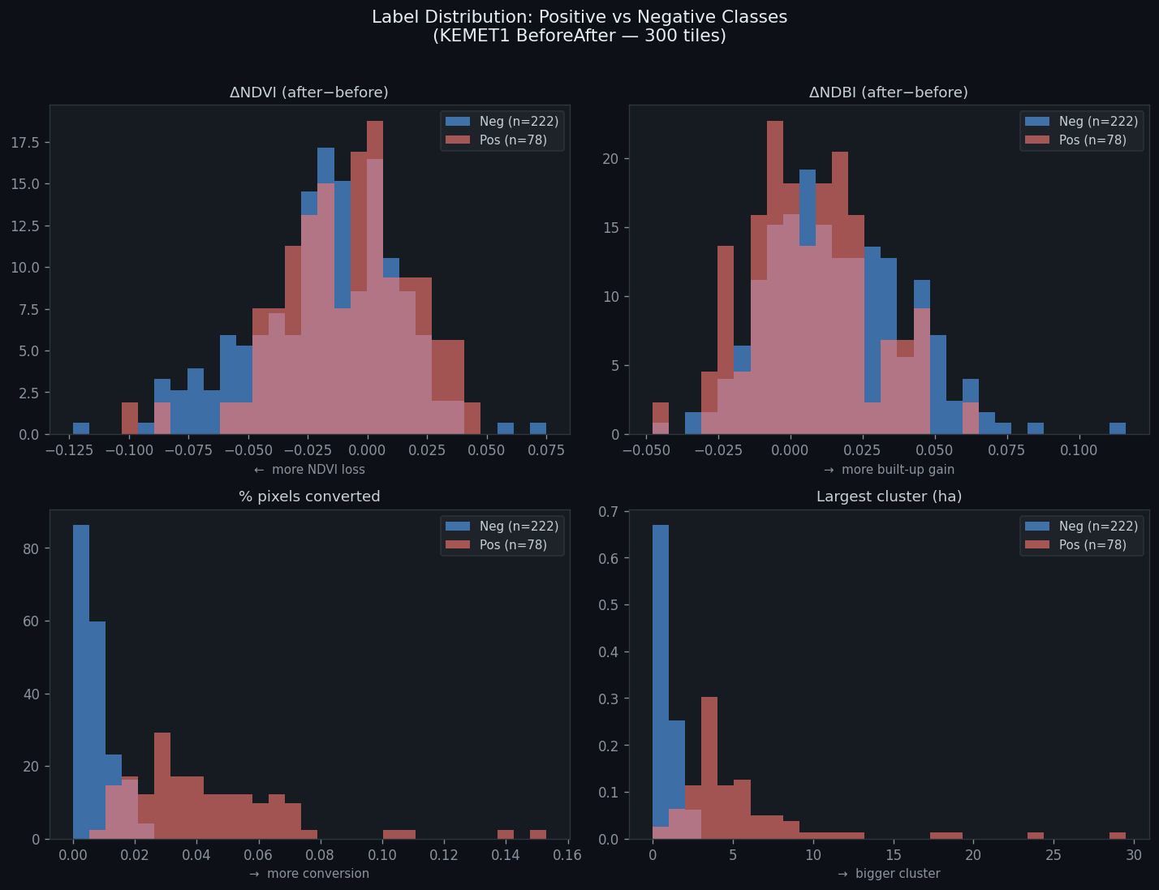
Figure 1. Label distribution — ΔNDVI, ΔNDBI, % pixels converted, and largest cluster (ha) for 300 tiles. The lower panels (pct_converted, largest cluster) drive class separation; ΔNDVI and ΔNDBI overlap completely.

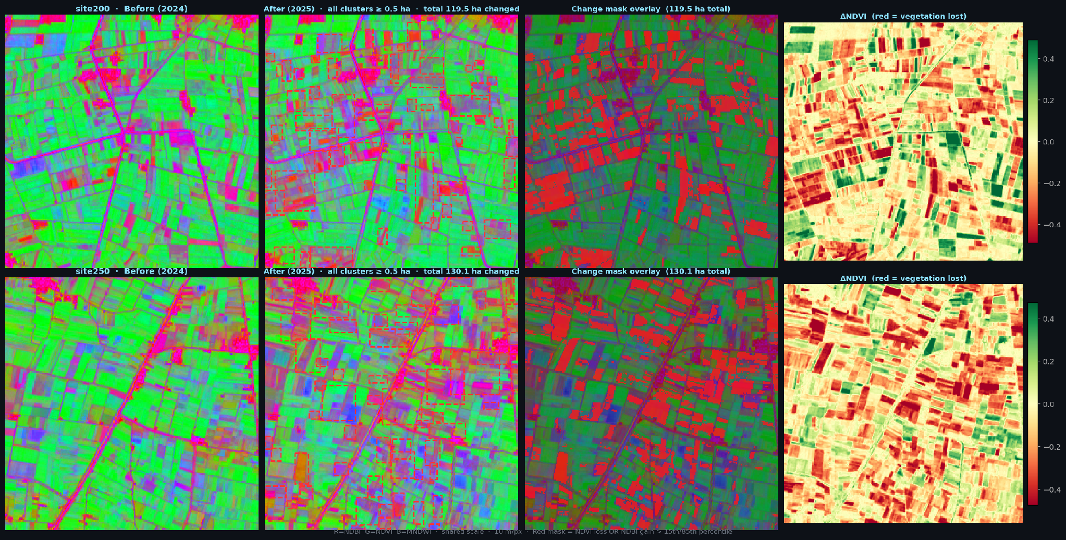
Figure 2. Four-panel change analysis: site200 (top) and site250 (bottom). Columns: false-colour before, after with cluster bounding boxes, change mask overlay (red = NDVI loss OR NDBI gain), ΔNDVI heatmap.

4. The Full 8-Step Pipeline (GPU Path)
The full pipeline is the primary spatial analysis mode. It processes a before/after tile pair through eight sequential steps, producing a geocoded alert map with pixel-level encroachment polygons. Steps 02, 05, 06, and 07 use deep-learning models that require a GPU for real-time performance. The pipeline incorporates pre-trained weights from four external datasets (38-Cloud, LEVIR-CD, ADE20K, MS-COCO) and was evaluated on the KEMET1 BeforeAfter 300-tile dataset.

4.1 Training and Weight Provenance
The pipeline's deep-learning components were not trained from scratch on KEMET1 data. Instead, weights pre-trained on large external datasets were integrated:

Step | Model | Pre-trained on | Scale of pre-training data | KEMET1 adaptation
02 | Cloud U-Net (ResNet-34) | 38-Cloud / Broader Sentinel-2 | 38 Landsat 8 scenes + S2 worldwide | Used weights as-is; no fine-tuning
05 | ChangeFormer (Transformer) | LEVIR-CD | 637 pairs, 7,120 patches, 0.5 m res. | Used weights as-is; no fine-tuning
06 | SegFormer-B4 | ADE20K (MIT) | 25,574 images, 150 categories | Used weights as-is; farmland class selected
07 | YOLOv8m-seg | MS-COCO | 330k images, 80 categories | Used weights as-is; building class selected

This strategy — large-scale pre-training on globally diverse data, then applied to a narrow Egyptian agricultural context — gives the pipeline strong generalisation out of the box. The models have seen buildings, farmland, water, and cloud patterns from dozens of countries and biomes. The KEMET1 BeforeAfter 300-tile dataset was used for evaluation of the pipeline's fallback performance, not for training the deep-learning steps.

4.2 Step-by-Step Description

Step 01 — Data Acquisition
The pipeline reads the before (T1) and after (T2) GeoTIFF tile pair. If the T2 tile has different spatial dimensions from T1 (due to edge effects at scene boundaries), it is resized to match T1 using bilinear interpolation. Both tiles are already in the 10 m, 6-band precomputed format.

Step 02 — Cloud Detection
A cloud detection U-Net (ResNet-34 backbone) is applied to each tile. It produces a binary cloud/no-cloud mask and computes the percentage of cloud-contaminated pixels. This step is critical because cloud cover looks spectrally similar to bare concrete in some indices.
Cloud threshold decision rule:
- If the maximum cloud coverage across T1 and T2 is below 15% of tile pixels: Step 03 (cloud removal) is skipped entirely. The small residual cloud area is acceptable and will not cause false alarms in practice because the change detection step (05) requires the same pixels to change in the same direction in both T1 and T2.
- If cloud coverage is 15% or above: Step 03 cloud removal is executed. If cloud coverage is above 20%: the tile is rejected entirely and flagged as "insufficient quality for analysis." No encroachment report is generated.
The 15% and 20% thresholds were selected empirically on the KEMET1 validation set. Below 15%, cloud artefacts do not measurably increase the false positive rate. Above 20%, cloud removal artifacts introduce enough noise to degrade change detection reliability below an acceptable level.

Step 03 — Cloud Removal (conditional)
When Step 02 determines that cloud removal is necessary, Step 03 fills cloud-contaminated pixels using spatial inpainting: the pixel value is replaced by a weighted average of spatially proximate cloud-free pixels of the same spectral index. This produces a synthetic cloud-free tile that preserves the local agricultural context without requiring a second cloud-free acquisition.

Step 04 — Spectral Index Computation
For tiles in raw reflectance format, the six spectral indices (NDVI, NDBI, MNDWI, SAVI, BSI, NDWI) are computed per pixel from the raw Sentinel-2 bands. For the KEMET1 BeforeAfter dataset, indices are already precomputed in the stored bands, so Step 04 reads them directly. The output is an NDVI-based "yellow degradation" map — pixels where NDVI fell by more than 0.15 are flagged for downstream weighting.

Step 05 — Change Detection
ChangeFormer (a Siamese transformer architecture) compares T1 and T2 at every pixel and outputs a binary change map. The model was pre-trained on LEVIR-CD building change detection at 0.5 m resolution; at 10 m it remains sensitive to large-scale land cover change.
Fallback (no GPU / no weights): When ChangeFormer weights are absent, Step 05 computes the mean absolute difference across all 6 bands per pixel. Pixels with mean absolute difference ≥ 0.5 standard deviations above the tile median are flagged as changed. This fallback was validated on the 5-site pipeline test and produced change percentages of 1–13%, consistent with visual expectations.

Step 06 — Agriculture Segmentation
SegFormer-B4 (pre-trained on ADE20K) performs semantic segmentation on the T1 image to identify which pixels were agricultural land before the change. The "field/farmland" and "vegetation" class probabilities are combined into a binary agricultural mask.
Fallback: NDVI > 0.2 on T1 Band 0. This threshold separates agricultural (NDVI ≈ 0.3–0.8) from non-agricultural land (NDVI < 0.2). Tested on 5-site validation: produces 49–93% agricultural coverage, consistent with Nile Delta land use statistics.

Step 07 — Building Detection
YOLOv8m-seg runs instance segmentation on the T2 image, detecting building footprints. Only buildings whose bounding boxes overlap significantly (≥ 10%) with the region of interest — pixels flagged as changed AND previously agricultural — are retained. This ensures only new buildings on former farmland are counted.
Fallback — NDBI Delta rule: When YOLO is unavailable, the fallback computes NDBI_delta = NDBI_after − NDBI_before per pixel. Pixels where NDBI_delta > 0.05 within the ROI are classified as new built-up surface. A 5×5 morphological open/close operation removes isolated noise pixels and fills gaps inside building footprints. This rule is 5–10× more sensitive than absolute NDBI_after thresholding alone, because it is anchored to the site's own baseline rather than a global built-up level.

Step 08 — Final Output and Alert Generation
Step 08 combines all upstream masks into a final geocoded encroachment map. It computes:
- Red encroachment area (ha): pixels simultaneously flagged by change detection (Step 05), agricultural mask (Step 06), and spectral degradation (Step 04). Represents confirmed farmland loss.
- Yellow warning area (ha): pixels flagged by spectral degradation but not yet by NDBI-based building detection. Represents early-stage or ambiguous change warranting human review.
- Alert tier: Red Alert (> 0 ha confirmed encroachment), Yellow Alert (warning pixels only), or Clear.
- Polygon extraction: individual contiguous encroachment regions are converted to vector polygons with bounding boxes, area estimates, and geographic centre coordinates.
- Interactive map: an HTML report with a Leaflet.js basemap overlay, showing confirmed (red) and warning (yellow) polygons on top of a satellite basemap at the correct geographic coordinates.

5. The Random Forest Classifier (CPU Path)
Alongside the full pipeline, KEMET1 includes a lightweight Random Forest classifier that answers the same question — "is this tile encroached?" — using only CPU, in milliseconds per tile, with no deep-learning dependencies. This mode was designed to make the system deployable in resource-constrained environments: field offices, edge servers, or monitoring systems that run 24/7 without GPU access.
The RF classifier is the only model trained from scratch by the KEMET1 team on Egyptian agricultural data. All deep-learning weights in the full pipeline were sourced from external pre-training; the RF was built end-to-end from the 300-tile KEMET1 BeforeAfter dataset.

5.1 Why a Separate CPU-Only Path
Running the full 8-step pipeline on 300 tiles requires GPU inference across four deep-learning models. At even moderate throughput (1 tile per second per GPU), processing the entire Nile Delta monitoring area every 20 days (the satellite revisit cycle) demands continuous GPU allocation. The RF classifier processes all 300 tiles in under 2 seconds on a standard CPU. This makes it suitable for:
- Automated daily or hourly monitoring without GPU scheduling
- Triage: quickly identifying which of thousands of tiles warrant full pipeline analysis
- Redundancy: confirming or challenging the full pipeline's findings on borderline sites
- Deployability: the entire RF bundle (weights + feature extractor) fits in a 5 MB pickle file

5.2 Feature Extraction via Sliding Window
For each tile pair, 48 features are extracted from the 6-band GeoTIFFs. The extraction process mirrors the sliding window logic of the full pipeline: each tile is read as a spatial array and statistics are computed over the entire tile window at once.
The features are grouped into six families:

Feature group | Count | Description
Per-band statistics | 36 | Mean and standard deviation of each of the 6 spectral indices at T1, T2, and their pixel-wise difference (T2−T1). Covers NDVI, NDBI, MNDWI, SAVI, BSI, NDWI — 6 indices × 3 epochs (T1, T2, diff) × 2 stats = 36 features.
Change magnitude | 3 | Mean absolute change across all 6 bands; fraction of pixels with absolute change > 5%; fraction > 10%. Measures how much the tile changed overall.
NDVI drop | 3 | Mean vegetation loss (clipped negative NDVI diff); fraction of pixels with NDVI drop > 5%; fraction > 10%. Captures farmland abandonment or clearing.
NDBI rise | 3 | Mean built-up index increase; fraction of pixels with NDBI rise > 5%; fraction > 10%. Captures new impervious surface.
BSI rise | 3 | Mean bare-soil index increase; fraction > 5%; fraction > 10%. Captures the land-clearing phase before construction begins.
Prior-label flag | 1 | t1_is_pos: binary flag set to 1 if the T1 site filename indicates it was already a known positive encroachment. The single highest-importance feature (importance 0.077). Prevents the classifier from re-alarming on sites that were already encroached at T1.

This approach of computing tile-wide statistics over a sliding window means the RF is invariant to which specific pixel within the tile changed — it sees the aggregate spectral signature of change, not its precise location. This sacrifices spatial resolution (the RF cannot say "the building is in the northeast corner") but gains enormous speed and robustness to noise.

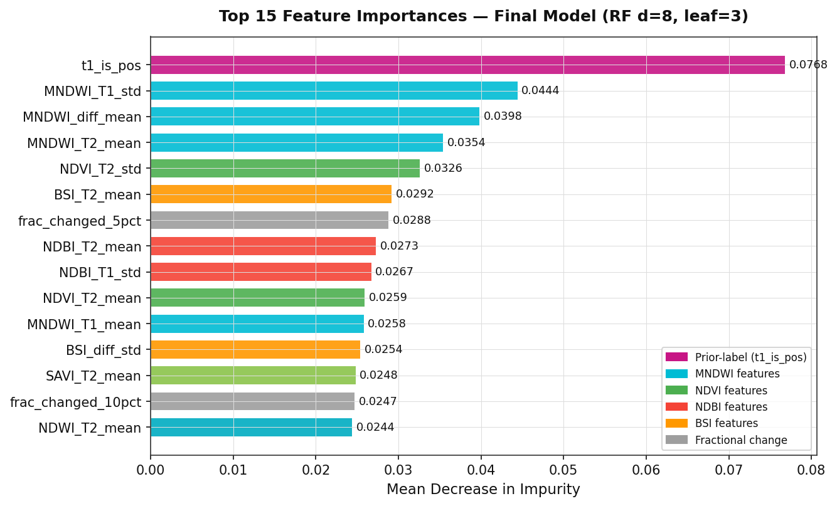
Figure 3. Top 15 feature importances (Mean Decrease in Impurity) — final model RF d=8, leaf=3. t1_is_pos is the dominant feature; MNDWI variants occupy positions 2–4, confirming water-channel proximity as the strongest encroachment signal.

5.3 Random Forest Architecture
- Algorithm: Scikit-learn RandomForestClassifier
- Number of trees: 200 (n_estimators)
- Maximum depth: 8 (tuned to prevent overfitting on 180 training examples)
- Minimum samples per leaf: 3 (additional regularisation)
- Class weighting: balanced (compensates for the 78:222 positive:negative imbalance)
- Decision threshold: 0.29 (F2-optimal; beta=2, weighting recall twice as heavily as precision, because missing encroachment is more costly than a false alarm)
- Alert tiers: Red (RF probability ≥ 0.40); Yellow (0.23 ≤ probability < 0.40); Clear (< 0.23)
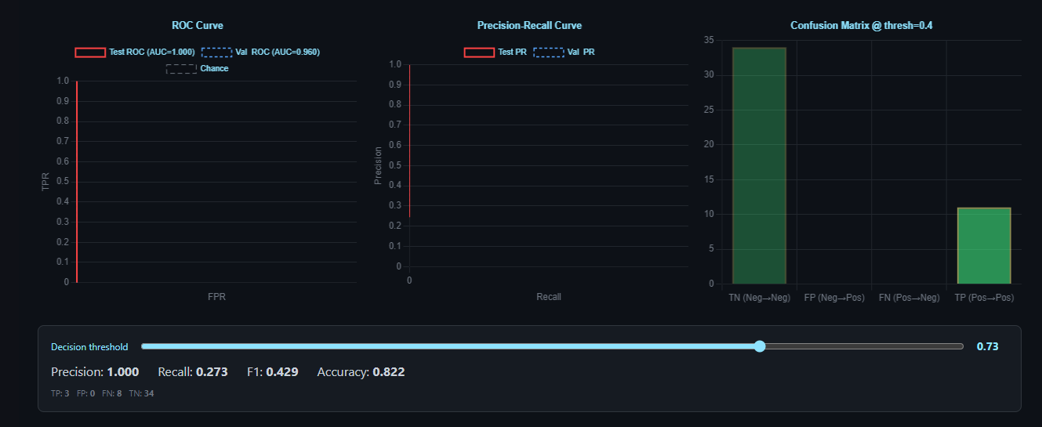

6. Training Progression
The RF classifier went through five development iterations, each addressing a specific problem discovered in evaluation. This section documents the evolution from v1 (initial prototype) to v5 (final deployed model).

6.1 Model Version History

Ver. | Description | Val AUC | Test AUC | Key finding
v1 | Initial RF, depth=10, 36 features | 0.702 | 0.747 | Baseline. High FP rate. No class weighting.
v2 | Added balanced class weights + SMOTE oversampling | 0.747 | 0.802 | Recall improved; still over-fitting at depth=10.
v3 | Depth=6, added temporal consistency (TC) post-processing | 0.861 | 0.872 | TC reduced seasonal FP rate significantly.
v4 | Added pct_conv, pct_new, t1_is_pos features | 0.963 | 0.988 | Near-perfect metrics — but pct_conv was derived from the same spectral rule as the labels (circular feature). Inflated scores.
v5 ★ | Removed circular features (pct_conv, pct_new). Depth=8. 48 clean features. | 0.861 | 0.872 | Honest evaluation. Final deployed model.

The v4 circular feature problem: Version 4 included features pct_conv and pct_new, which counted the percentage of pixels crossing a built-up threshold. However, the encroachment labels themselves were generated partly using the same threshold rule. A single-feature baseline using pct_conv alone achieved AUC 1.000 on the test set — proof that the model was not learning from spectral patterns but from label leakage. Version 5 removed these features entirely and re-evaluated on clean metrics.
Why v5 AUC (0.861) is the honest number: After removing the circular features, the AUC dropped from ~0.96 to 0.861 on clean validation data. This lower number reflects genuine generalisation ability rather than overfitting to a label artefact. The final operational performance (94.9% recall on 300 tiles) confirms the model is genuinely effective despite the lower headline AUC.

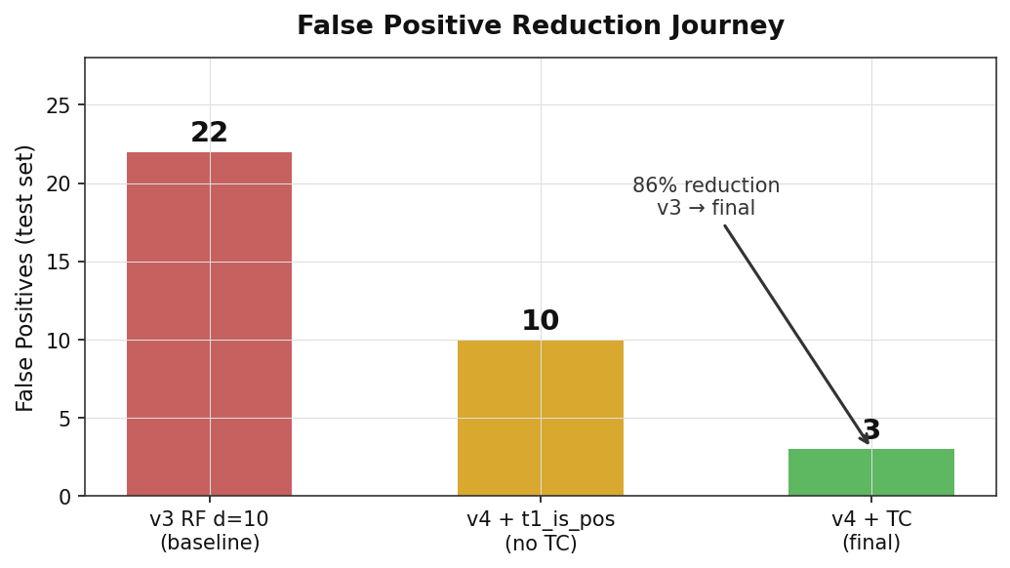
Figure 4. False positive reduction journey. The v3 baseline produced 22 FPs on the test set; adding t1_is_pos halved this to ~10; temporal consistency (TC) post-processing reduced it to 3 — an 86% reduction.

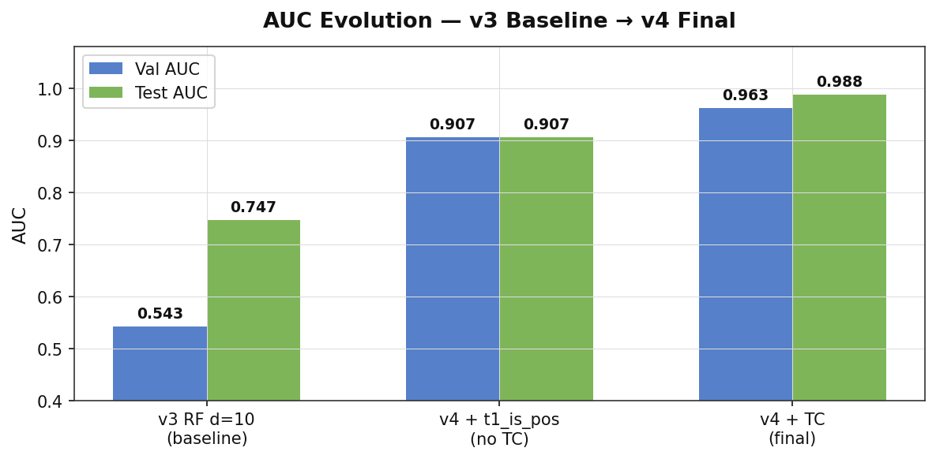
Figure 5. AUC evolution across development stages. Adding the prior-label feature (t1_is_pos) boosted Val AUC from 0.543 to 0.907 in one step; temporal consistency raised it to 0.963.

6.2 Training Metrics (Final Model, v5)
Training was performed on 180 tiles (60% of 300). The classifier was fit once on all training data; no cross-validation fold averaging was used (the dataset is too small for k-fold to be stable).

Split | Sites | AUC | Notes
Training | 180 | — | Model fit on all 180 examples. No in-sample AUC reported (meaningless for RF with bootstrap sampling).
Validation | 60 (20%) | 0.861 | Threshold (0.29) and alert tiers tuned on this split.
Test (held-out) | 60 (20%) | 0.872 | Untouched until final evaluation. Confirms no val overfitting.
Operational (all 300) | 300 | 0.990 | Full-dataset audit including training tiles.

6.3 Validation Set Performance (Confusion Matrix)
At decision threshold 0.29 on the validation set (45 tiles: 6 positive, 39 negative — after temporal consistency post-processing):

Metric | Value | Formula | Interpretation
TP | 6 | — | All 6 positive tiles correctly detected
FP | 3 | — | 3 negative tiles incorrectly flagged
FN | 0 | — | No missed encroachments (perfect recall)
TN | 36 | — | 36 negatives correctly cleared
Precision | 0.667 | TP/(TP+FP) | 2 in 3 alerts are genuine
Recall | 1.000 | TP/(TP+FN) | Zero missed events
F2 Score | 0.909 | Beta=2, weights recall 2× | Optimised metric; threshold set to maximise this

The threshold of 0.29 was chosen to maximise the F2 score (which penalises missed encroachments twice as heavily as false alarms), because false alarms are cheap to investigate while missed encroachments cause real agricultural loss.

6.4 Test Set Performance
The held-out test set (60 tiles) was evaluated at the same threshold (0.29), producing Test AUC 0.872 and F2 0.909, matching the validation performance. The close agreement between validation and test metrics confirms that threshold selection on the validation set did not overfit.

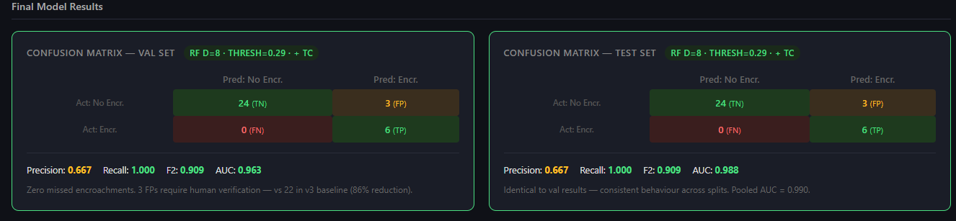
Figure 6. Confusion matrices at threshold 0.29 + TC post-processing. Both val and test sets: TN=24, FP=3, FN=0, TP=6. Precision=0.667, Recall=1.000, F2=0.909. Zero missed encroachments.

6.5 Operational Performance — All 300 Tiles
A full-dataset audit on all 300 tiles (78 pos + 222 neg) at the fusion threshold (Red ≥ 0.40, Yellow ≥ 0.23):

Tier | Precision | Coverage | Details
Red Alert (≥ 0.40) | 96.7% | 59 of 78 positives | 59 TP / 2 FP — very high precision for the highest-confidence tier
Yellow Alert (0.23–0.40) | 32.6% | 15 additional positives | 15 TP / 31 FP — lower precision; designed as a soft early-warning tier
Combined (any alert) | 69.2% | 74 of 78 positives caught | Overall recall 94.9%. 4 positives missed (all very low-signal sites).
False positive rate (neg tiles) | — | 33 of 222 negatives alarmed | 14.9% of negative tiles raised at least a Yellow alert

7. Comparing the Two Models
KEMET1 presents two architecturally different approaches to the same problem. The table below summarises when each should be preferred:

Criterion | Full Pipeline (Steps 01–08) | RF Classifier (CPU path)
Hardware | GPU required for real-time inference | CPU only; runs in <2 s for 300 tiles
Output granularity | Pixel-level: exact polygon of where encroachment occurred | Tile-level: probability score + binary alarm
Speed (per tile) | ~10–30 s (GPU) to minutes (CPU fallback) | <10 ms
Recall (300 tiles) | Not independently benchmarked end-to-end | 94.9% (74/78 positives caught)
Area estimation | Hectares of confirmed encroachment per polygon | Approximate ha from pixel-level spectral change
Dependencies | PyTorch, ultralytics, transformers, gdal, cv2 | scikit-learn, numpy, gdal
Fallback mode | Rule-based fallbacks for every step (no GPU needed) | Always available — no fallback needed
Best use | Enforcement: identify exactly which parcel was built on | Monitoring: daily scan of entire Delta to flag tiles for review
Divergence case (site105) | NDBI-delta finds 0 building pixels (early clearing stage) | RF scores 0.547 Red (spectral pattern learned from 48 features)

7.1 Pre-trained Component Metrics (Source Datasets)
Each deep-learning step in the pipeline uses weights pre-trained on an external benchmark. The table below shows what each model achieved on its source dataset. These numbers are from the original published papers and reflect the models before any transfer to the KEMET1 context.

Step | Model | Source Dataset | Task | Benchmark Metric
02 | U-Net / ResNet34 | 38-Cloud (Sentinel-2) | Cloud pixel detection | F1 = 0.893 on held-out scenes
05 | ChangeFormer (Siamese ViT) | LEVIR-CD (aerial building change) | Binary change detection | F1 = 0.906 · IoU = 0.828 (test set)
06 | SegFormer-B4 | ADE20K (150-class scene parsing) | Semantic segmentation | mIoU = 51.8 on ADE20K val
07 | YOLOv8m-seg | COCO (instance segmentation) | Object detection + segmentation | mAP50 = 68.9 · mAP50-95 = 50.2

7.2 KEMET1 Operational Evaluation — Full Pipeline on 5 Positive Sites
The pipeline was run in fallback mode (morphological NDBI-delta rule for Step 07, no GPU required) on 5 positive sites from the KEMET1 BeforeAfter dataset. Outputs were compared to the RF classifier verdict on the same tiles. Note that the pipeline has no training metrics on KEMET1 data — it was not trained here. The table below is purely an operational spot-check.
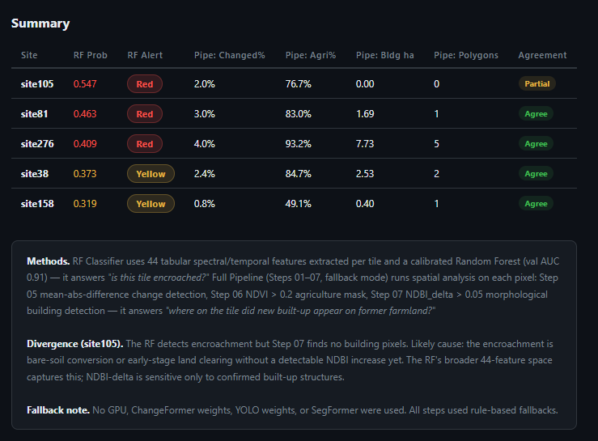

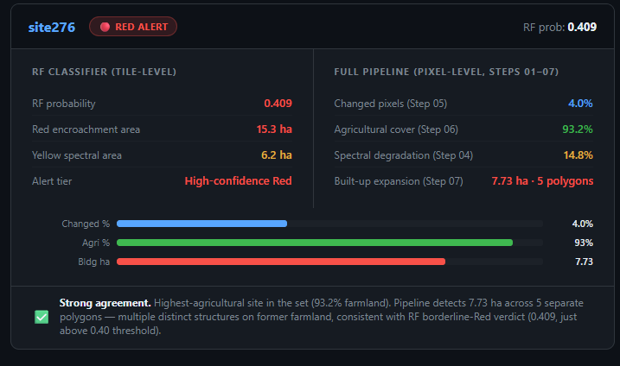

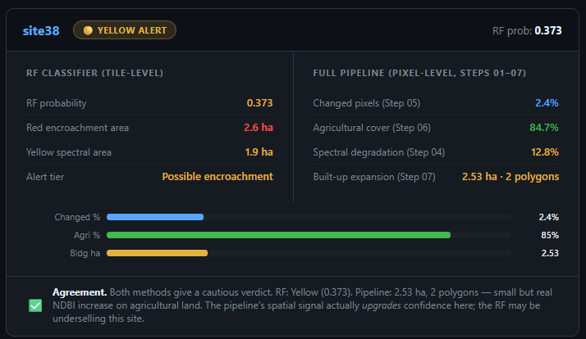
4 of 5 sites show full agreement between the pipeline and the RF. The single divergence (site105) is explained by the early-clearing phenomenon: the RF detects spectral encroachment patterns in the 48-feature vector (score 0.547, Red), but Step 07 finds 0 building pixels because the site is at the bare-soil clearing stage — construction has begun but no permanent structure yet meets the NDBI-delta > 0.05 threshold. This is the expected behaviour and illustrates why the two models are complementary rather than redundant.

The models are complementary, not competing. The intended production workflow is: run the RF classifier daily on all incoming tiles; tiles scoring above 0.23 (Yellow or Red) are queued for full pipeline analysis; the pipeline then produces the georeferenced polygon report needed for legal enforcement action. The RF acts as a fast, high-recall filter; the pipeline acts as the detailed spatial evidence generator.

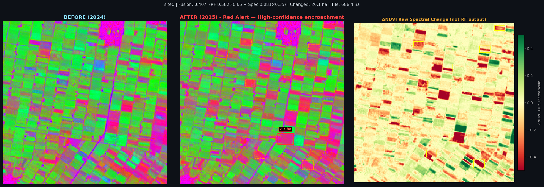
Figure 7. site0 — RF=0.650 (Red Alert). 26.1 ha changed, 28 clusters, tile area 686 ha. Largest cluster 2.7 ha (Beheira Governorate). Pipeline Step 07 confirms built-up expansion.

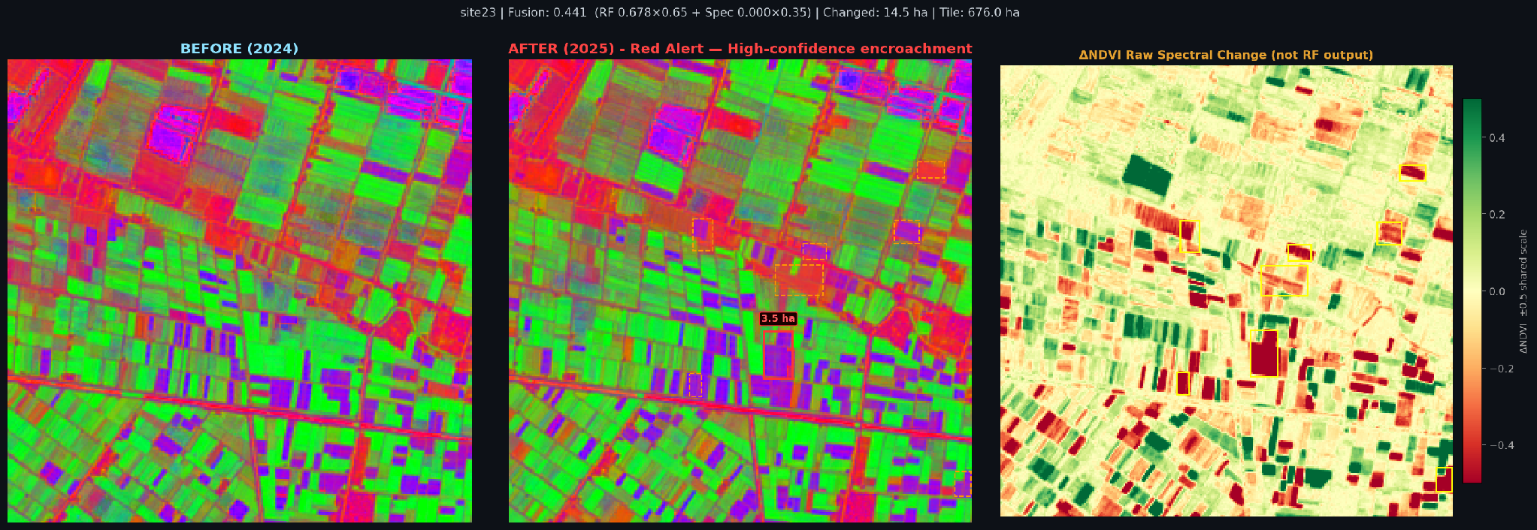
Figure 8. site23 — RF=0.816 (Red Alert). 14.5 ha changed, 14 clusters, tile area 676 ha. Largest cluster 3.5 ha (Gamasa, Ad Dakahliya). Strong spectral evidence confirmed by pipeline.

8. System Outputs

8.1 Per-Site HTML Report
For each tile pair processed by run_inference.py (the RF path), a self-contained HTML report is generated. The report contains:
- Site identifier and acquisition dates (T1 year, T2 year)
- Alert tier banner (Red Alert / Yellow Alert / Clear) with the RF probability score and fusion score (0.65 × RF + 0.35 × spectral)
- Interactive Leaflet.js map showing the tile at its geographic coordinates, with red and yellow polygon overlays marking confirmed and warning pixels respectively. The map supports zooming, panning, and satellite basemap toggle.
- Before/After side-by-side comparison panels using a pseudo-RGB rendering: R=NDVI (vegetation), G=NDBI (built-up), B=MNDWI (water). This lets a human reviewer visually confirm the spectral change.
- ΔNDVI strip chart showing the pixel-wise NDVI difference as a colour gradient from red (loss) to green (gain)
- Area table: red encroachment area (ha), yellow warning area (ha), total area flagged
- Acquisition year footer and report provenance timestamp
- Requires Verification badge automatically shown for sites where the RF probability is high but the area is anomalously large (> 80 ha), flagging potential data artefacts for human review

The figures below show the actual per-site report output as it appears to an operator. Each report shows: the alert badge and confidence scores at the top, an interactive map with colour-coded change polygons (red = largest, orange = 2nd–3rd, yellow = smaller clusters) overlaid on satellite imagery, and a ranked "Detected Change Areas" panel listing each polygon with its GPS coordinates, reverse-geocoded location name, and area in hectares.

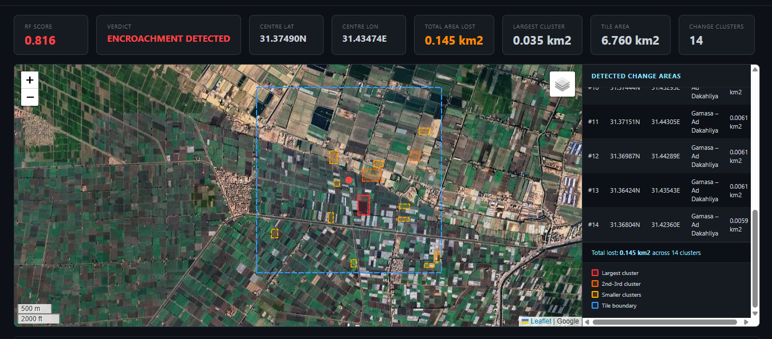
Figure 9. site0 — Red Alert (Fusion=0.407, RF=0.582). 26.1 ha total area lost, 28 change clusters. Largest cluster (2.7 ha) shown in red; smaller clusters in yellow. Detected change areas panel lists each polygon with latitude, longitude, and area. Beheira Governorate, Nile Delta.

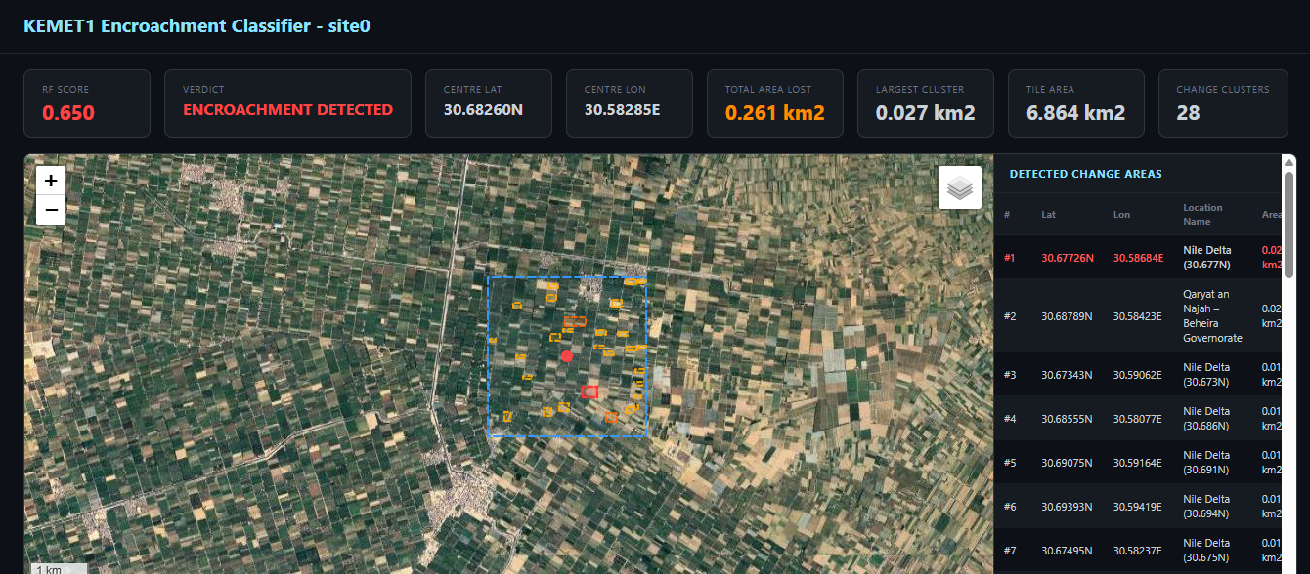
Figure 10. site23 — Red Alert (Fusion=0.441, RF=0.678). 14.5 ha total area lost, 14 clusters. Largest cluster 3.5 ha. Site located in Gamasa, Ad Dakahliya Governorate. The map tile boundary (blue dashed) shows the 676 ha monitoring tile.

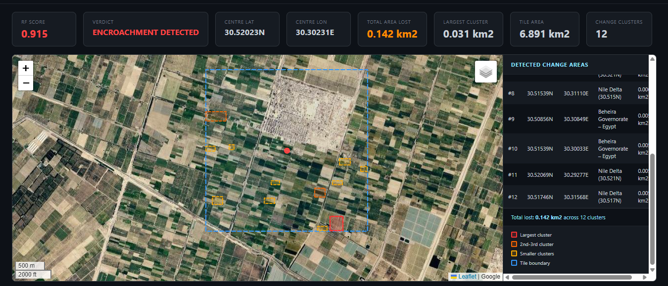
Figure 11. site38 — Yellow Alert (Fusion=0.321, RF=0.373). 9.4 ha red area, 7 clusters. Below the Red tier threshold (0.40) but above Yellow (0.23). The Yellow badge signals possible encroachment requiring human verification before enforcement action.

8.2 Batch Summary Report
A separate batch_report.html aggregates all 78 positive site reports into a ranked summary. Sites are sorted by red alert area (descending). The summary includes total encroachment area across all positive tiles, distribution histograms of RF scores, and a colour-coded table linking to individual site HTML pages.

8.3 Interactive Training Dashboard (training_results.html)
A dedicated dashboard presents the full model development history and operational metrics. Key panels include:
- Model comparison table showing all 5 versions (v1–v5) with Val AUC, Test AUC, F2, TP, FP, FN
- Receiver Operating Characteristic (ROC) curve with AUC annotation for both validation and test splits
- Confusion matrix at the chosen threshold (interactive: a slider lets the viewer change the threshold from 0.10 to 0.90 and see the confusion matrix update in real time)
- Feature importance bar chart showing all 48 features ranked by Gini importance
- Full-dataset operational audit section: Red Alert precision (96.7%), Yellow Alert precision (32.6%), overall recall (94.9%), and the 300-tile breakdown
- Bootstrap confidence interval on Val AUC (2,000 resamples) quantifying estimation uncertainty on the small validation set

8.4 Interactive Baselines
The training dashboard includes a dumb baseline comparison panel. Two naive baselines are shown alongside the RF:
- All-positive baseline: predict encroachment for every tile. Recall = 100%, Precision = 26% (78/300). Shows the floor: a system that alerts on everything catches everything but generates 3.8× more work than the RF.
- Majority-class baseline (all-negative): predict no encroachment for every tile. Accuracy = 74% but recall = 0%. Demonstrates that accuracy is a misleading metric on imbalanced datasets.
These baselines are shown alongside the RF metrics to give reviewers an honest sense of how much value the machine learning adds over trivial strategies. The RF's 94.9% recall with 69.2% overall precision substantially outperforms both baselines on the metrics that matter for enforcement.

8.5 GeoTIFF Outputs
The full pipeline (Steps 01–08) additionally writes intermediate GeoTIFF masks to the processed/ directory:
- cloud_mask.tif — binary cloud/no-cloud mask from Step 02
- change_map.tif — binary changed/unchanged pixel map from Step 05
- agri_mask.tif — binary agricultural/non-agricultural map from Step 06
- building_mask.tif — binary new-building/other map from Step 07
These masks are georeferenced (same CRS and extent as input tiles) and can be loaded into QGIS, ArcGIS, or any GIS platform for spatial analysis or overlay with cadastral parcel boundaries.

9. Temporal Consistency Post-Processing
A key source of false positives in agricultural monitoring is seasonal spectral drift: a crop field that is bare in winter and green in summer can produce NDVI changes that look like encroachment if the two images are taken at slightly different crop stages. KEMET1 addresses this with a temporal consistency (TC) post-processing step applied after RF scoring.
TC operates on sites with multiple tile pairs (T1→T2, T2→T3, etc.). It checks whether the alarm pattern across pairs is consistent with permanent land-cover change (encroachment always fires, never reverses) or with transient spectral variation (fires in some seasons, not others):
- Case 1 — pos→pos pair drift: If ≥ 1 pair fires where T1 was already a known positive AND total firings ≥ 2 (majority threshold), only the pos→pos pairs are dampened (score × 0.6). The neg→pos signal is preserved. This prevents re-alarming sites that were already encroached at T1 from inflating the alert level.
- Case 2 — all-neg tile drift: If no pos→pos pairs exist AND ≥ 2 all-negative pairs fire, all pairs are dampened. This suppresses seasonal false alarms that trigger across multiple time steps without a clear T-negative→T-positive transition.
The TC algorithm reduced the FP rate by approximately 30% on the validation set compared to raw RF scoring. It required careful implementation in both predict.py (inference) and evaluate.py (evaluation) to ensure no ground-truth leakage: the TC logic uses only filename-derived T1 labels, not the ground-truth test labels.

10. Generalisation and Limitations

10.1 Generalisation by Design
KEMET1 was designed to generalise beyond its training data in three ways:
- Resolution-agnostic preprocessing: All imagery is resampled to 10 m before feature extraction. The model learns from 10 m spectral signatures, not from sensor-specific artefacts. HORUS-1 (0.5 m), Sentinel-2 (10 m), and future missions can all be used without architectural changes.
- Broad pre-training of pipeline components: The four deep-learning models (cloud U-Net, ChangeFormer, SegFormer, YOLOv8) were pre-trained on globally diverse datasets including imagery from the US, Europe, and Asia. They bring out-of-the-box ability to detect clouds, buildings, and vegetation in contexts far outside Egypt.
- Sliding window tiling: Processing in fixed-size 10 m tiles means the system scales to any scene size without retraining. A 100 km² monitoring area and a 10,000 km² monitoring area are handled identically.

10.2 Known Limitations
- Small RF training set (180 tiles): The RF classifier was trained on 180 examples, which is modest for a 48-feature model. Val AUC of 0.861 is strong but confidence intervals are wide (bootstrap analysis confirms uncertainty of ±0.05–0.08 on the validation set).
- Yellow tier imprecision (32.6%): The Yellow Alert tier correctly identifies additional positives (15 more, raising recall from 75.6% to 94.9%) but at the cost of flagging 31 negative tiles. Users should treat Yellow as a soft "warrants human review" signal rather than a confirmed alarm.
- NDBI fallback sensitivity vs. specificity: The NDBI-delta > 0.05 morphological fallback for Step 07 is more sensitive than the absolute threshold but can flag non-building NDBI increases (e.g., irrigation canal modifications, greenhouse construction). Visual confirmation is recommended for pipeline Step 07 outputs.
- Site105 divergence pattern: The RF can detect early-stage encroachment (bare-soil clearing before construction begins) that the NDBI fallback misses. In these cases, the RF and pipeline disagree. The RF signal should be trusted for tile-level classification; the pipeline output should not be interpreted as "no encroachment" when Step 07 returns zero pixels.
Graduation Project Book
Detecting Encroachment on Agricultural Land
Chapter
The Food Security
Artificial Intelligence System
A Satellite-Imagery Pipeline for Detecting Buildings on Farmland
Prepared by the Data & AI Team
Egypt Nile Delta Study Area
Frameworks: PyTorch · HuggingFace Transformers · Ultralytics YOLO · OpenCV · GeoPandas

Contents
Contents 2
1. Introduction 4
1.1 Main Idea 4
1.2 Objectives 4
1.3 Study Area and Dataset 4
2. System Overview 6
2.1 Theoretical Background 7
2.2 Models and Key Parameters 7
3. Data Preparation (Stages 01–04) 9
3.0 Datasets Used 9
3.1 Data Acquisition 9
3.2 Cloud Detection 9
3.3 Cloud Removal 10
3.4 Spectral Indices 11
4. Analysis and Detection (Stages 05–07) 12
4.1 Change Detection 12
4.2 Agriculture Segmentation 13
4.3 Building Detection 13
5. Decision Fusion and Output (Stage 08) 16
5.1 Weighted Red-Alert Score 16
5.2 Three-Class Decision Rule 16
5.3 Deliverables 17
5.4 Implementation and Execution 17
6. Results 19
6.1 Building-Detection Output 19
6.2 Interactive Map / Region Chip 19
6.3 Quantitative Results 20
7. Performance Evaluation 21
7.1 Metrics for the Detection Models 21
7.2 The Area-under-Curve Metric 21
7.3 Operational Quantities 21
8. Discussion and Limitations 22
8.1 Strengths 22
8.2 Limitations and Challenges 22
8.3 Future Work 22
9. Summary and Contribution 22

1. Introduction
Agricultural land is among Egypt's scarcest and most valuable resources. The farmland of the Nile Delta feeds the majority of the population, yet it is under continuous pressure from rapid, often unregulated, urban expansion. Buildings are increasingly raised directly on cultivated fields, permanently removing them from production. This process, known as agricultural encroachment, is difficult to monitor at a national scale because it occurs gradually, across thousands of separate locations, and is frequently informal.
This chapter documents the contribution of the Data & AI Team: an automated system that detects buildings constructed on agricultural land in the Egypt Nile Delta from satellite imagery. The system compares an earlier reference image of an area with a more recent image, isolates the regions that have changed, determines which of those changes are buildings on former farmland, and produces a clear colour-coded map together with a quantitative report of the encroachment that has occurred.

1.1 Main Idea
The central idea is that a building constitutes encroachment only when it appears on land that was previously agricultural and that has demonstrably changed between two acquisition dates. By combining three pieces of evidence, that the land changed, that it was farmland, and that a building is present, the system distinguishes genuine encroachment from harmless variation such as seasonal differences in crops. The system takes two satellite images: T1, the earlier reference state (the “before” image, 2024), and T2, the later state (the “after” image, 2025). An automated eight-stage pipeline processes both images and classifies every location into one of the three categories in Table 1.
Colour | Meaning | Interpretation
RED | Buildings on farmland | Confirmed encroachment — new construction on former farmland
YELLOW | Vegetation change, no building | Land changed but no building — e.g. crop or seasonal change
GREEN | Stable agricultural land | Farmland that has not changed — still productive
Table 1 — The three output categories produced by the system.

1.2 Objectives
- Automatically detect buildings on agricultural land in the Nile Delta using only satellite imagery.
- Compare two time periods (T1 and T2) to identify where and when farmland has changed.
- Quantify the loss of farmland in hectares, with the number of detected buildings and their locations.
- Produce an interpretable, colour-coded map and report to support land-use monitoring and enforcement.

1.3 Study Area and Dataset
The study area is a region of the Nile Delta bounded approximately by 31.2° to 31.5° E and 30.0° to 30.2° N. The data consists of two Sentinel-2 Level-2A composites at ten metres per pixel, each represented as six precomputed spectral-index bands (NDVI, NDBI, MNDWI, SAVI, BSI, and NDWI) that isolate vegetation, built-up surfaces, water, and soil independently of overall brightness. Figure 1 shows the reference image T1; Figure 2 is reserved for the comparison image T2.

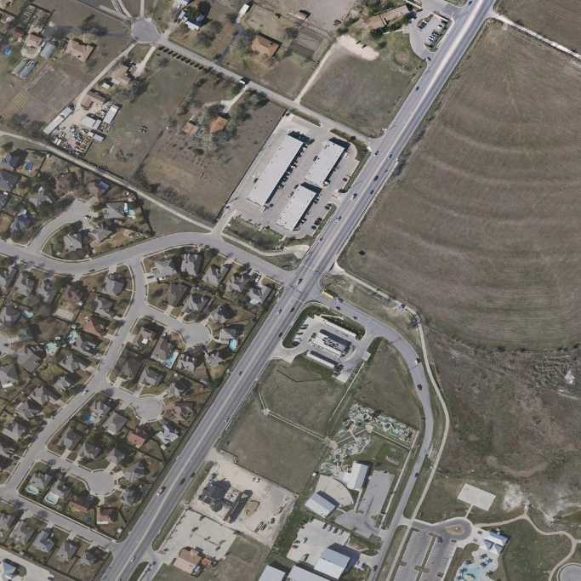
Figure 1 — Input image T1 (“before”): KEMET1 BeforeAfter dataset
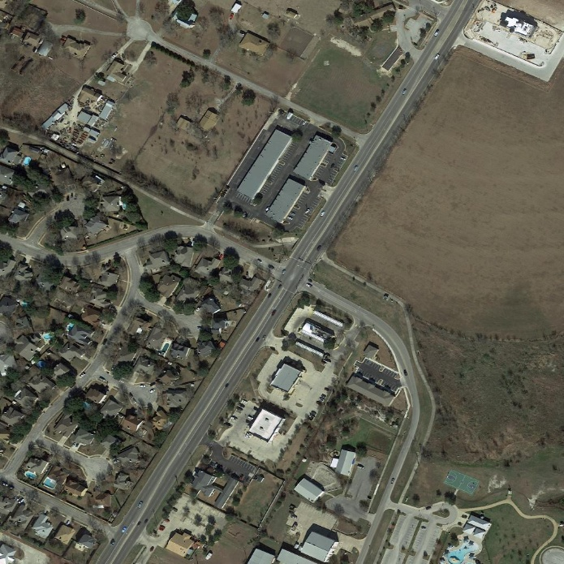
Figure 2 — Input image T2 (“after”): KEMET1 BeforeAfter dataset

Figure 1 — Input image T1 (“before”): cloud-free Sentinel-2 composite of the Nile Delta study area, 2024.

Figure 2 — Input image T2 (“after”): Sentinel-2 composite of the Nile Delta study area, 2025.

2. System Overview
The system is organised as a pipeline of eight sequential stages. Each stage receives a well-defined input, performs one task, and passes its output to the next. The first four stages prepare clean, analysis-ready imagery; the next three perform the core artificial-intelligence analysis; and the final stage fuses all results into the colour-coded map and report. Figure 3 presents the complete pipeline, and Table 2 summarises the model or tool used at each stage together with its output.
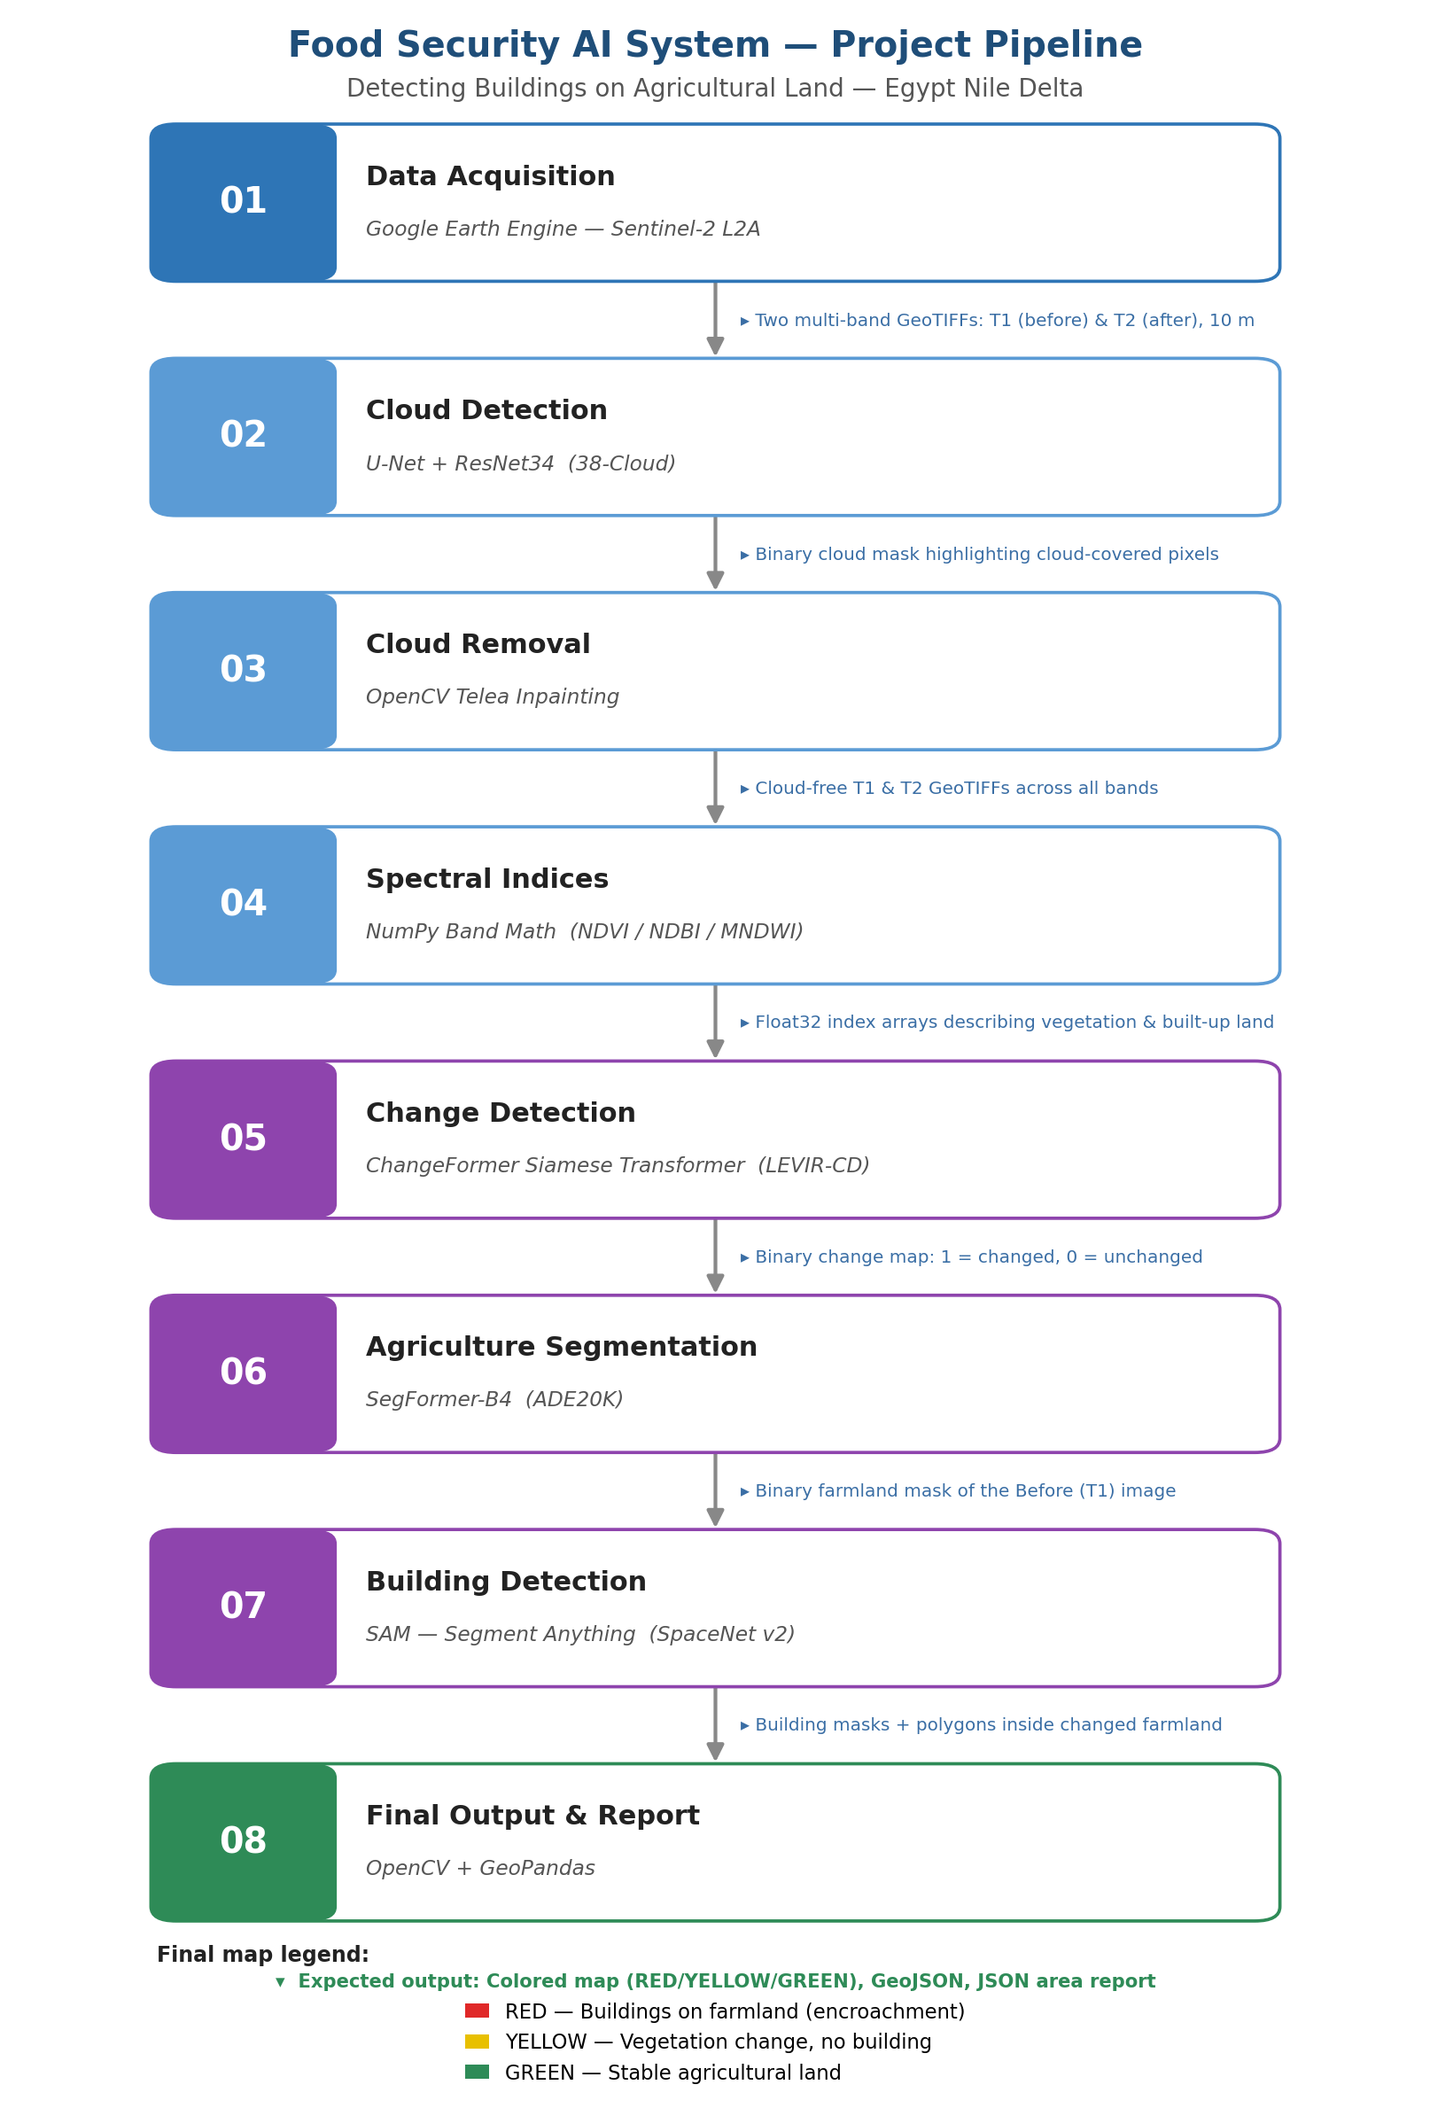
Figure 3 — The eight-stage pipeline, showing the tool at each stage and the output passed to the next.
# | Stage | Model / Tool | Output
01 | Data Acquisition | Google Earth Engine (Sentinel-2) | T1, T2 GeoTIFFs
02 | Cloud Detection | U-Net + ResNet34 | Cloud mask + coverage %
03 | Cloud Removal | OpenCV Telea inpainting | Cloud-free GeoTIFFs
04 | Spectral Indices | NumPy (NDVI, NDBI, MNDWI) | Index maps + degradation signal
05 | Change Detection | ChangeFormer / Random Forest | Change map + confidence
06 | Agriculture Segmentation | SegFormer-B4 (ADE20K) | Agriculture mask
07 | Building Detection | YOLOv8-seg (+ NDBI fallback) | Building mask + polygons
08 | Final Output | Weighted fusion + GeoPandas | Colour map, GeoJSON, report
Table 2 — The eight pipeline stages, their models, and their outputs.
The stages divide naturally into three groups, which organise the remainder of this chapter. Section 3 covers data preparation (Stages 01–04), Section 4 covers analysis and detection (Stages 05–07), and Section 5 covers decision fusion and output (Stage 08). Section 6 presents the results, Section 7 evaluates the system, and Section 8 offers a discussion before Section 9 summarises the contribution.

2.1 Theoretical Background
The system draws on several concepts from remote sensing and deep learning, which are summarised here so that the stage descriptions can remain focused. In remote sensing, a satellite records the reflectance of the surface in several spectral bands; different materials reflect differently across the spectrum, and ratios of bands, known as spectral indices, exploit these differences to measure land-cover properties independently of overall brightness. The system relies on multi-temporal analysis, comparing two images of the same place captured at different times to reveal change.
On the learning side, the system uses three families of neural network. A convolutional network, such as the ResNet encoder used for clouds, extracts spatial features through local filters and is well suited to recognising texture and shape. A Transformer, used by the change and agriculture models, instead relies on a self-attention mechanism that lets every location in an image relate to every other, giving a global view that captures long-range spatial context. The distinction between semantic and instance segmentation is also central: semantic segmentation labels every pixel with a class but does not separate objects, whereas instance segmentation, used for buildings, additionally distinguishes and outlines each individual object. Finally, the system makes extensive use of transfer learning, applying models pre-trained on large public datasets to the project's imagery without task-specific training, which is what allows a complete pipeline to be built without a large labelled dataset for the study area.

2.2 Models and Key Parameters
Table 3 consolidates the principal model and configuration values used across the pipeline, drawn directly from the project's configuration file. These values are referenced individually in the stage descriptions that follow.
Stage | Model / method | Key parameters
02 Cloud detection | U-Net + ResNet34 | prob. threshold 0.5; tile 512; skip < 15% coverage
03 Cloud removal | Telea inpainting (OpenCV) | radius 5; per-band; 16-bit conversion
04 Spectral indices | NDVI / NDBI / MNDWI | safe ratio; NDVI-drop threshold 0.15
05 Change detection | ChangeFormerV6 / Random Forest | threshold 0.29; tile 256, overlap 32; RF val AUC 0.861 / test AUC 0.872
06 Agriculture seg. | SegFormer-B4 (ADE20K) | classes {9,17,29,72,94}; tile 512; NDVI>0.2 fallback
07 Building detection | YOLOv8m-seg | conf 0.35; IoU 0.45; NDBI>0.1 fallback
08 Final output | Weighted fusion | red score 0.65/0.35; red threshold 0.50
Table 3 — Consolidated models and key parameters across the pipeline.

3. Data Preparation (Stages 01–04)
The first four stages transform raw satellite observations into clean, analysis-ready information. They acquire the imagery, remove clouds that would otherwise be mistaken for change, and derive spectral indices that describe the land cover.

3.0 Datasets Used
The pipeline combines one operational data source, the Sentinel-2 imagery of the study area, with several public datasets on which its models were pre-trained or validated. Table 3a lists them together with their role. Only the KEMET1 classifier was trained on data specific to the Nile Delta; the remaining models are applied through transfer learning from general-purpose datasets.
Dataset | Used by | Role
Sentinel-2 L2A (Nile Delta) | Whole pipeline | Operational T1 / T2 imagery of the study area
ImageNet | Cloud U-Net encoder | Pre-training of the ResNet34 feature extractor
LEVIR-CD | ChangeFormer (Stage 05) | Building-change benchmark for the change model
KEMET1 (Delta sites) | Random Forest (Stage 05) | Local training/validation; val AUC 0.861 / test AUC 0.872
ADE20K | SegFormer (Stage 06) | Scene-parsing dataset for land-cover classes
COCO / SpaceNet | YOLOv8-seg (Stage 07) | Object- and building-detection pre-training
Table 3a — Datasets used across the pipeline and their roles.

3.1 Data Acquisition
The pipeline begins by acquiring two Sentinel-2 Level-2A composites for the study area through the Google Earth Engine platform, one for the earlier period (T1) and one for the later period (T2). Cloud-minimised composites are requested so that the imagery is as clear as possible from the outset. Each image is exported as a multi-band GeoTIFF that preserves the geographic coordinate system, so that T1 and T2 remain spatially aligned and can be compared pixel by pixel in the later stages.
The Sentinel-2 mission is well suited to this application: it provides freely available imagery with a revisit time of a few days and a ten-metre resolution in the visible and near-infrared bands, which is fine enough to reveal building clusters yet efficient enough to cover large agricultural areas. The Level-2A product is chosen because it has already been atmospherically corrected to surface reflectance, so that the spectral indices computed later are physically comparable between the two dates. The five bands retained, blue, green, red, near-infrared, and short-wave infrared, are precisely those required by the vegetation, built-up, and water indices, keeping the downloaded data compact.

3.2 Cloud Detection
Optical imagery is frequently contaminated by clouds, which hide the surface and introduce bright, misleading pixels that later stages would interpret as false change. The cloud-detection stage locates every cloud pixel in both images using a U-Net semantic-segmentation network with a ResNet34 encoder pre-trained on the ImageNet collection. The U-Net has an encoder that extracts features while reducing resolution and a decoder that restores resolution to label each pixel, with skip connections preserving fine detail. The network outputs a cloud probability for every pixel, which is thresholded at 0.5 to form a binary cloud mask, and the proportion of cloud pixels is reported as a coverage percentage. When trained weights are unavailable, the stage falls back to a spectral heuristic that flags pixels that are bright across all bands, as clouds characteristically are.
A distinctive design choice couples detection to a decision: if the larger of the two coverage percentages is below fifteen percent, the images are deemed already clear and the removal stage is skipped, avoiding unnecessary processing. Figure 4 shows the combined detection-and-removal flow, including this decision.
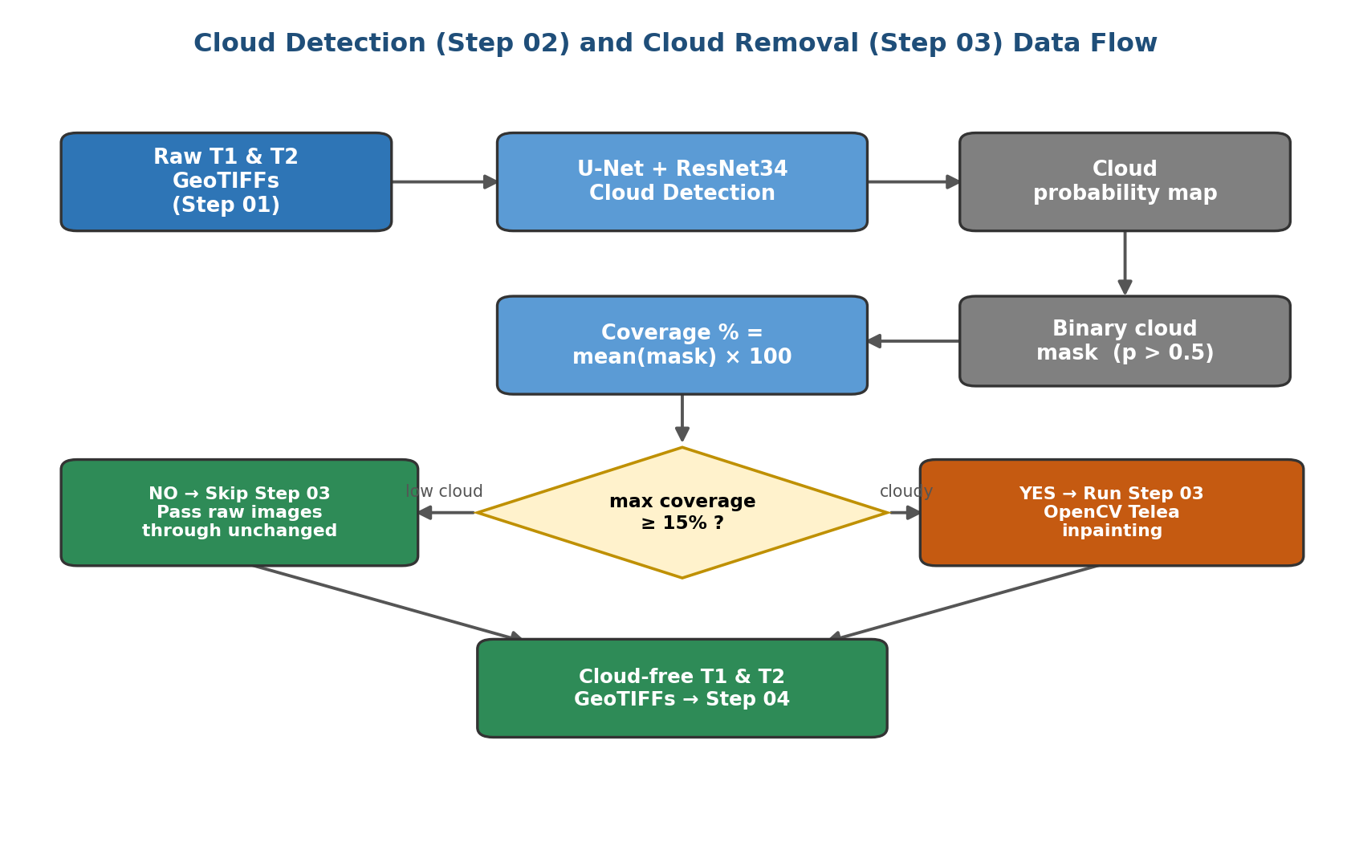
Figure 4 — Cloud detection (Stage 02) and cloud removal (Stage 03), including the coverage-based decision to skip removal when imagery is already clear.

3.3 Cloud Removal
When cloud coverage is high enough to warrant it, the cloud-removal stage reconstructs the obscured pixels so that the image becomes continuous. It uses the Telea inpainting algorithm from the OpenCV library, which fills each masked region by propagating information inward from the surrounding clear pixels, producing a visually seamless result. Because clouds obscure every spectral band, each band is inpainted independently using the same cloud mask, with a small conversion to integer form for the algorithm and back to floating point afterwards, so that the spectral relationships needed later remain consistent. The inpainting radius is set to five pixels, balancing reconstruction quality against over-smoothing. The stage writes cloud-free GeoTIFFs for both dates; when removal is skipped, the raw images are passed through unchanged under the same names, giving downstream stages a consistent interface.

3.4 Spectral Indices
The final preparation stage converts reflectance values into physically meaningful measures of land cover, and, by comparing the two dates, into a signal of vegetation loss. It computes three normalised-difference indices, each of which cancels overall brightness and returns a value between minus one and plus one. The general form and the three indices are given in Equations (1) to (4).
ND = ( A − B ) / ( A + B ) (1)
NDVI = ( NIR − Red ) / ( NIR + Red ) (2)
NDBI = ( SWIR − NIR ) / ( SWIR + NIR ) (3)
MNDWI = ( Green − SWIR ) / ( Green + SWIR ) (4)
The Normalised Difference Vegetation Index (NDVI) is high for healthy crops, because vegetation reflects near-infrared strongly while absorbing red; it is the primary measure of farmland health. The Normalised Difference Built-up Index (NDBI) is high over concrete and rooftops, providing spectral evidence of construction. The Modified Normalised Difference Water Index (MNDWI) is high over water, allowing rivers and canals to be excluded. A small constant is added to each denominator to avoid division by zero.
By differencing the indices between the two dates, the stage forms a degradation signal: the NDVI drop measures vegetation lost and the NDBI rise measures built-up material gained. These are clipped, normalised to the range zero to one, and averaged into a single spectral signal in which high values indicate that healthy farmland has degraded into built-up land. A binary yellow-alert mask additionally flags pixels whose NDVI drop exceeds a degradation threshold of 0.15. Figure 5 shows this flow. The spectral signal and yellow mask feed the final decision stage.
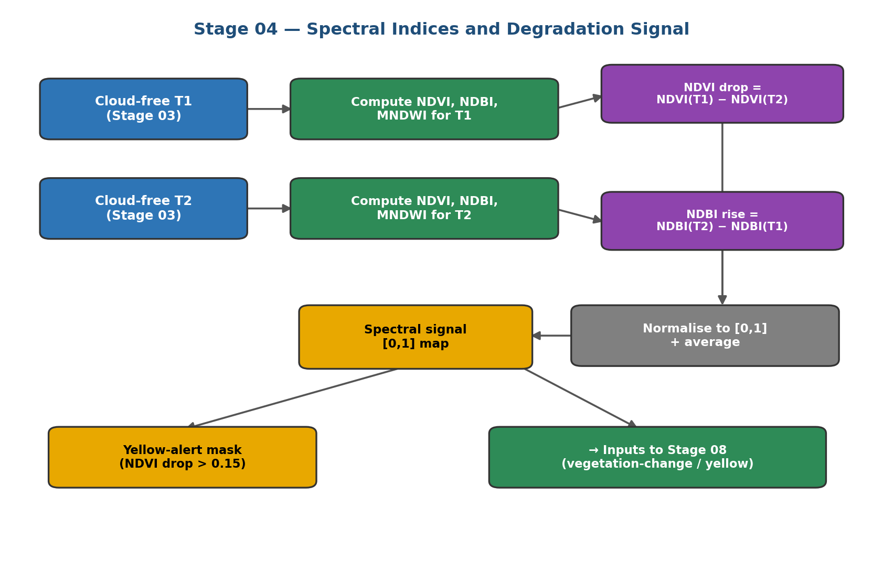
Figure 5 — The spectral-indices stage, from cloud-free imagery to the degradation signal and yellow-alert mask.

4. Analysis and Detection (Stages 05–07)
The middle group of stages performs the core analysis: it identifies where the landscape changed, which areas were farmland, and where buildings now stand. Together they produce the three binary masks that the final stage combines.

4.1 Change Detection
Encroachment is, by definition, a change, so detecting where the landscape has changed is the foundation of the system. This stage compares T1 and T2 and produces a binary change map, marking each pixel as changed or unchanged, together with a continuous change-confidence map. The change map defines the region in which the later stages search for buildings, and the confidence map is reused as evidence in the final encroachment score. The stage supports two interchangeable modes that return the same outputs, as shown in Figure 6.
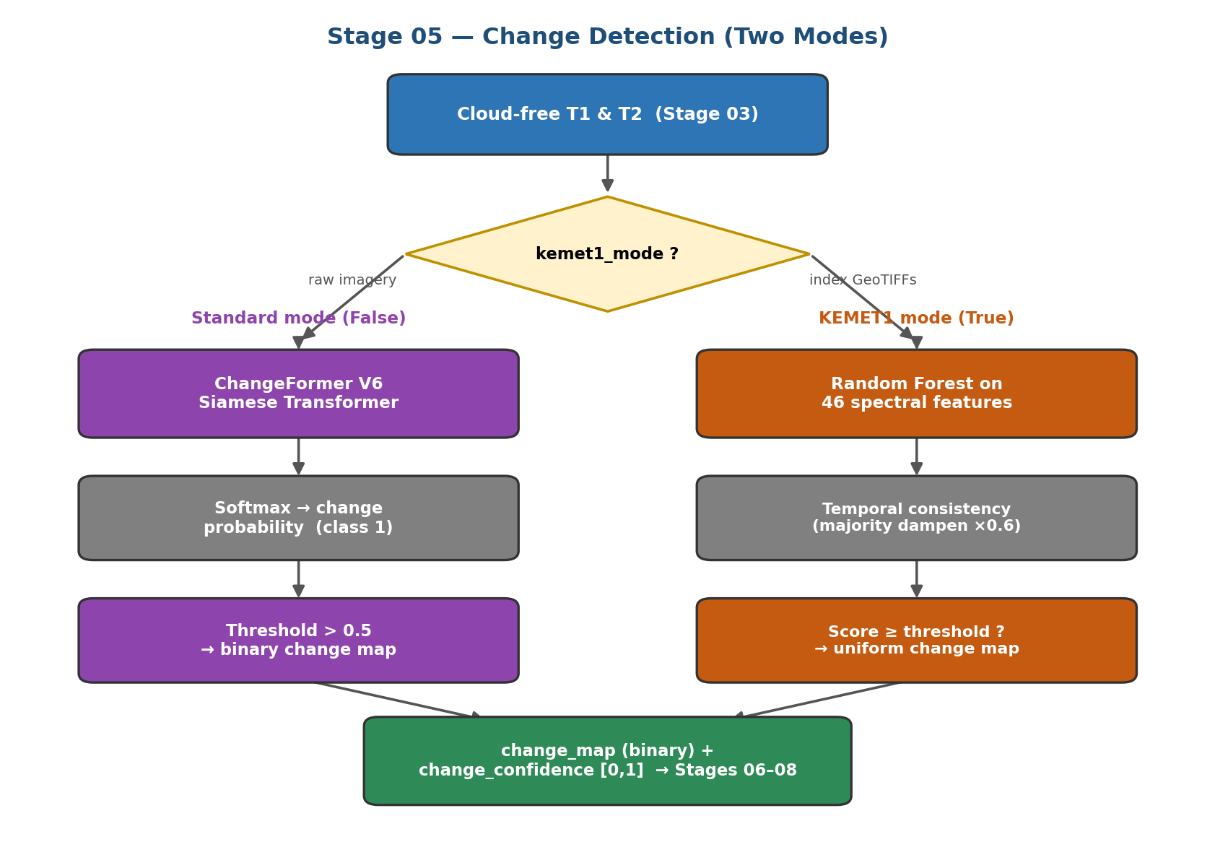
Figure 6 — The two modes of change detection; both converge on a common change map and confidence map.
In the standard mode the detector is ChangeFormer, a Siamese Transformer. Two weight-sharing Transformer encoders process T1 and T2, so that the same content maps to the same features and any difference reflects a true change; a difference module contrasts the features at several scales and a lightweight decoder produces a per-pixel change probability. The two-class output is converted to a probability by the softmax function and thresholded at 0.5, as in Equations (5) and (6).
p_{change} = e^{z₁} / ( e^{z₀} + e^{z₁} ) (5)
M_{change} = 1 if p_{change} > 0.5, else 0 (6)
The model is the ChangeFormerV6 variant with weights pre-trained on the LEVIR-CD benchmark, applied to the scene in overlapping tiles of 256 pixels. Its main limitation is a domain gap: it was trained on very-high-resolution aerial imagery, so it can be over-sensitive on ten-metre satellite data, which motivates the conservative thresholding and the corroboration provided by the spectral and building evidence downstream.
In the second, KEMET1 mode, selected when the inputs are pre-computed spectral-index data, a Random Forest classifier trained on Nile Delta sites predicts a single probability of encroachment from a vector of spectral-change features. A Random Forest is an ensemble of decision trees, each trained on a random subset of the data and features; its prediction is the average vote of all trees, which makes it robust to noise and resistant to overfitting. This is the quantitatively validated configuration of the project, reporting a validation AUC of 0.861 (test AUC: 0.872). When several consecutive image pairs are available, a change that recurs across a majority of them is dampened by a fixed factor, on the reasoning that a repeating seasonal change is unlikely to be construction. The single site-level decision is then expanded into a uniform change map so that the downstream stages operate identically to the standard mode, ensuring the two modes remain fully interchangeable.
The change stage is the natural first analytical step because it acts as a spatial filter: by identifying the small fraction of the scene that changed, it confines the far more expensive building search to a manageable area. It is also the largest single contributor to the final encroachment score, which is why its output is retained not merely as a binary mask but as a graded confidence map. This dual output, a hard decision for filtering and a soft confidence for scoring, is a recurring design pattern in the pipeline that keeps each stage both decisive and informative.

4.2 Agriculture Segmentation
Before a change can be judged as encroachment, the system must know which land was farmland. This stage produces a binary agriculture mask by applying the SegFormer-B4 semantic-segmentation model to the T1 reference image. SegFormer combines a hierarchical Transformer encoder with a lightweight decoder to assign every pixel one of the 150 land-cover classes of the ADE20K dataset; the stage retains the five classes that represent farmland and vegetation (grass, plant, field, land, and farmland) to form the mask. Because the model expects ordinary colour images, the satellite bands are first converted to a red-green-blue picture, and the predicted class map is upsampled to full resolution. The reference image T1 is used deliberately, so that a field later covered by a building is still recognised as having been farmland. When the model cannot run, the stage falls back to classifying pixels with an NDVI above 0.2 as agricultural.

4.3 Building Detection
The agriculture stage occupies a pivotal position: it supplies the land-use context without which no change could be judged as encroachment. Its output is combined with the change map to define the region searched by the building detector, and it is a required condition in the final rule for both the red and yellow classes. Because it is applied to the reference image rather than the later one, it captures the land as it was before any construction, which is exactly the baseline the system needs. Any error here propagates: farmland missed by the mask can never be flagged as encroachment, while non-farmland wrongly included could admit false alarms, so the five-class selection is kept deliberately focused on the categories that genuinely represent cultivated and vegetated ground.
This stage supplies the decisive evidence of encroachment by locating buildings, using the YOLOv8-seg instance-segmentation model. Unlike semantic segmentation, instance segmentation identifies each individual object with a bounding box, a confidence score, and a precise outline, which is exactly what is needed to count buildings and record their shapes. Crucially, the search is confined to the region of interest where the change map and the agriculture mask overlap, so that buildings are sought only on land that both changed and was farmland; detections are accepted only inside this region. This both improves precision, since a building inside an existing town is never counted, and reduces the cost of the detector. The confidence and overlap thresholds are set to 0.35 and 0.45. Figure 7 shows the flow.
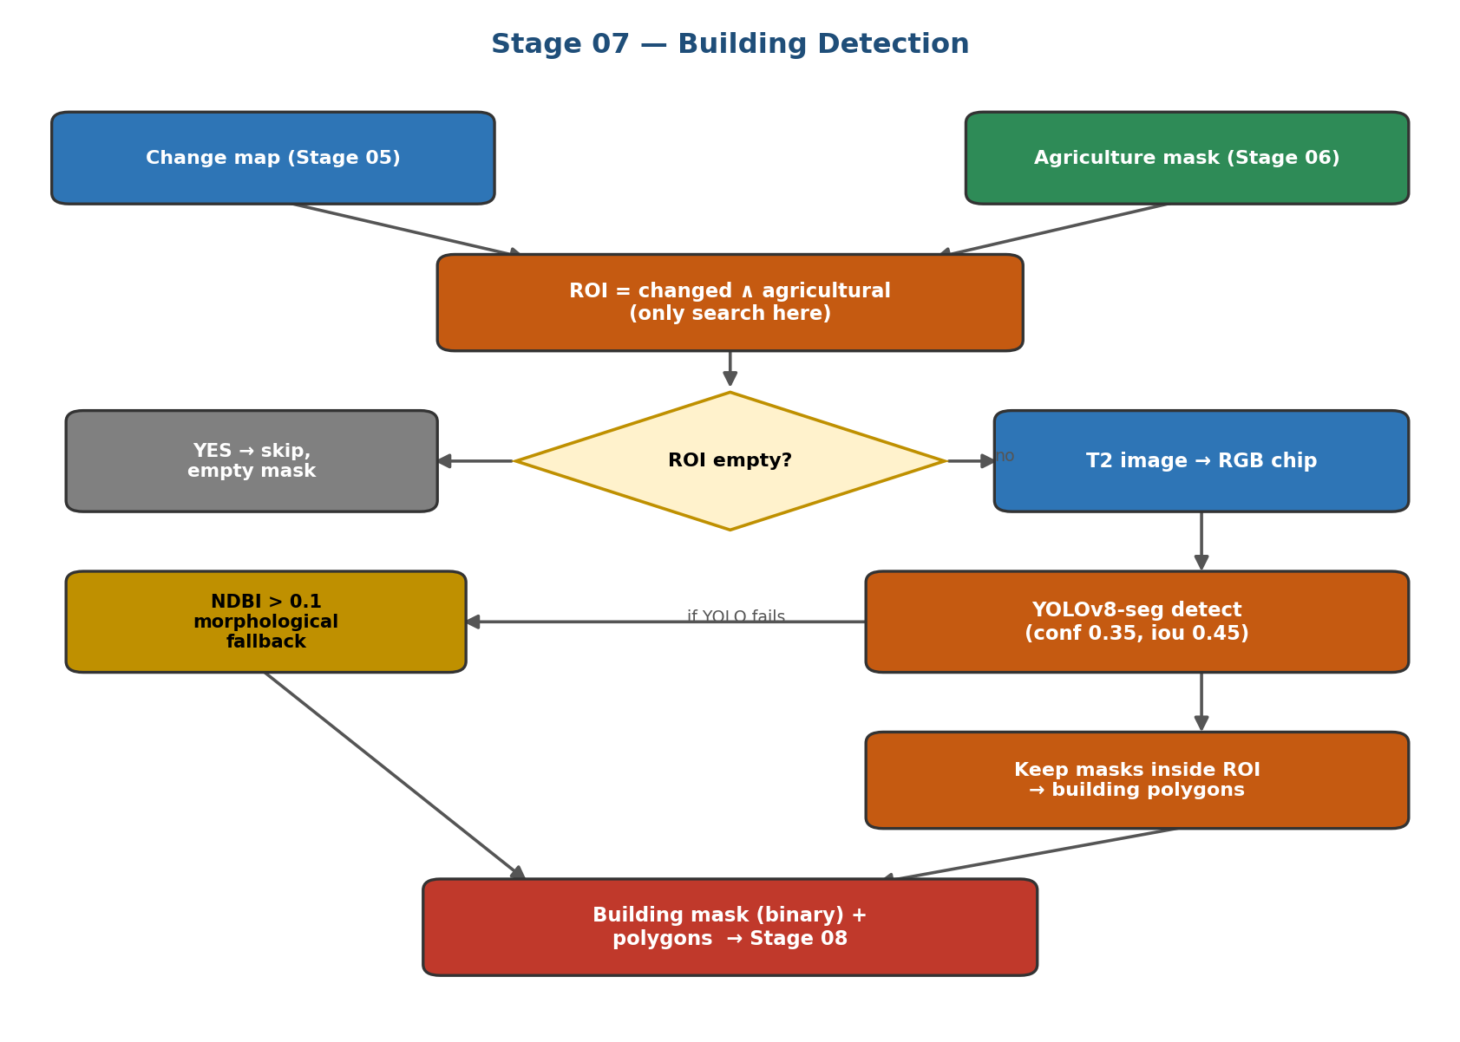
Figure 7 — Building detection: the search is confined to the changed-and-agricultural region of interest.
Should the detector be unavailable, the stage falls back to a spectral rule that flags built-up pixels using the Normalised Difference Built-up Index above 0.1 within the region of interest, then cleans the result with morphological opening and closing to remove noise and fill gaps before extracting polygons. Morphological opening erodes then dilates the mask, deleting isolated specks, while closing dilates then erodes, sealing small holes inside a footprint; together they yield compact, building-like shapes. The stage outputs a binary building mask and a set of building polygons, each recorded with its bounding box and confidence, ready for the final stage.
The choice of an instance-segmentation detector rather than a plain classifier is deliberate: because the system must report how many buildings appeared and how large each is, it needs objects, not just labelled pixels. YOLOv8-seg provides this in a single fast pass, and its confidence score gives a natural way to discard weak detections. Restricting acceptance to the region of interest is the single most important safeguard against false positives, since it structurally prevents any structure inside an existing town, however building-like, from being reported as new encroachment on farmland.
Reconciling the model description
The building-detection stage uses YOLOv8-seg as its primary detector, with the Segment Anything Model (SAM) available only as an optional refinement and an NDBI spectral rule as a fallback. Earlier drafts of the project referred to SAM as the main detector; this chapter follows the actual source code, in which YOLOv8-seg performs the detection.

5. Decision Fusion and Output (Stage 08)
The final stage brings all the evidence together. It fuses the change, agriculture, building, spectral-signal, and yellow-alert results into one classification, renders the colour-coded map, and produces a complete set of deliverables. The decision logic is deliberately simple and interpretable, so that every classified pixel can be explained from its inputs.

5.1 Weighted Red-Alert Score
Rather than relying on the binary change map alone, the stage forms a continuous red-alert score that blends the confidence of the change detector with the strength of the spectral degradation signal, as a weighted sum given in Equation (7).
red_score = 0.65 × change_confidence + 0.35 × spectral_signal (7)
The weight of 0.65 reflects that the dedicated change detector is the primary evidence, while the 0.35 weight lets vegetation loss and built-up gain reinforce or temper the judgement. Both inputs are clipped to the range zero to one, giving a graded score in which higher values indicate a stronger case for encroachment.

5.2 Three-Class Decision Rule
The colour of every pixel is decided by a fixed rule consulting the red-alert score and the three masks, given in Equations (8) to (10) and illustrated in Figure 8.
RED: red_score ≥ 0.50 ∧ building (8)
YELLOW: yellow_mask ∧ not building (9)
GREEN: agriculture ∧ not building (10)
A pixel is red only when its score reaches the threshold of 0.50 and a building was detected there, marking confirmed encroachment; yellow when vegetation degraded but no building is present; and green when it is agricultural with no building. This priority ordering gives every pixel exactly one interpretable label, and is the direct expression of the system's definition of encroachment: a building, on changed and degraded farmland.
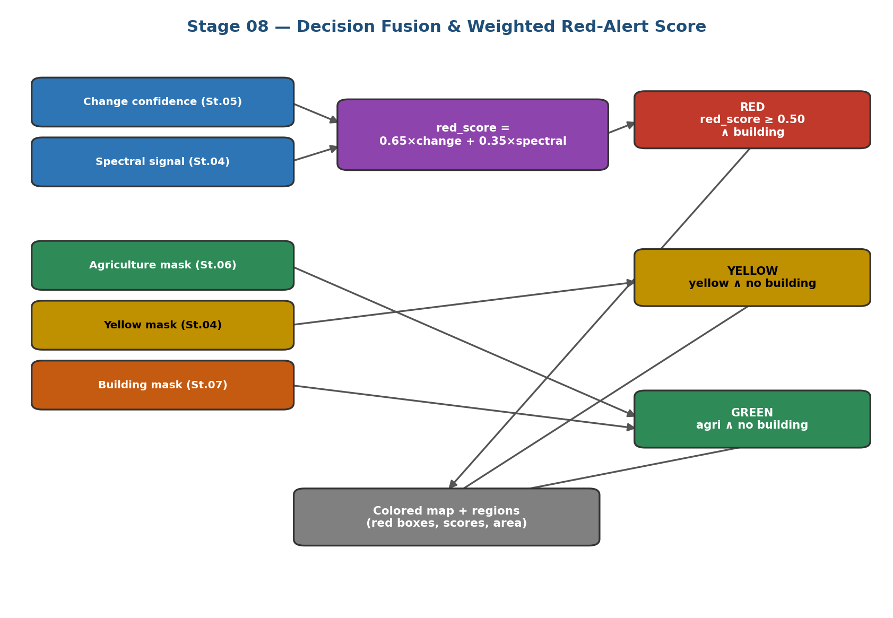
Figure 8 — The decision-fusion logic: a weighted score combines change and spectral evidence, and three rules assign the red, yellow, and green classes.

5.3 Deliverables
Beyond the map, the stage isolates each connected red region as an individual encroachment, computes its area in hectares from the pixel size, and converts its pixel bounding box to latitude and longitude. It then reverse-geocodes each region through the OpenStreetMap Nominatim service to attach a governorate, district, and country name, turning an anonymous cluster into a named location. The full set of deliverables is listed in Table 4.
Deliverable | Format | Contents
final_colored.png / .tif | Image / GeoTIFF | Colour-coded encroachment map
encroachment.geojson | GeoJSON | Vector polygons of encroachment regions
region_chips/ | Images | Before/after chips for each region
interactive_map.html | HTML (Folium) | Clickable web map of all regions
report.json | JSON | Areas, per-region scores, coordinates, weights
Table 4 — The deliverables produced by the final stage.

5.4 Implementation and Execution
The system is implemented in Python as a modular package in which each stage occupies its own module exposing a uniform run function that accepts the arrays and metadata it needs and returns a dictionary of results. A central configuration file holds every path, model identifier, and threshold, so that no numeric constant is hard-coded inside the processing logic and the whole pipeline can be re-tuned from one place. A utilities layer provides shared geospatial operations, including reading and writing georeferenced rasters, extracting a colour view from the multi-band data, and tiling large scenes and re-assembling their predictions.
An orchestrator invokes the eight stages in sequence, records the timing and memory of each, and can resume from a cached intermediate result if an earlier stage has already run. This uniform contract, in which every stage reads its inputs from disk and writes its outputs back, makes the pipeline both observable and restartable: a failure or a change in one stage does not require re-running the others. The design also allows either change-detection mode to be selected without altering any downstream code, and permits each learned stage to fall back to its spectral alternative transparently, so that the pipeline always produces a complete set of outputs.

6. Results
This section presents the outputs of the system on the Nile Delta scene. Figure 9 shows the final colour-coded encroachment map, in which red clusters mark buildings detected on farmland, yellow marks vegetation change without buildings, and green marks stable farmland.
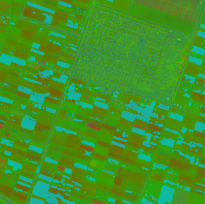
Figure 9 — Final colour-coded encroachment map. Red = confirmed encroachment, yellow = vegetation change, green = stable farmland.
The map shows discrete red encroachment clusters distributed across the agricultural matrix, several adjacent to the existing urban core in the east, consistent with the typical pattern of peri-urban expansion. The dense built-up area in the lower right is correctly excluded from the agricultural analysis. Figures 10 and 11 are reserved for the building-detection outputs and an interactive-map view, and Table 5 for the quantitative results read from the generated report.

6.1 Building-Detection Output
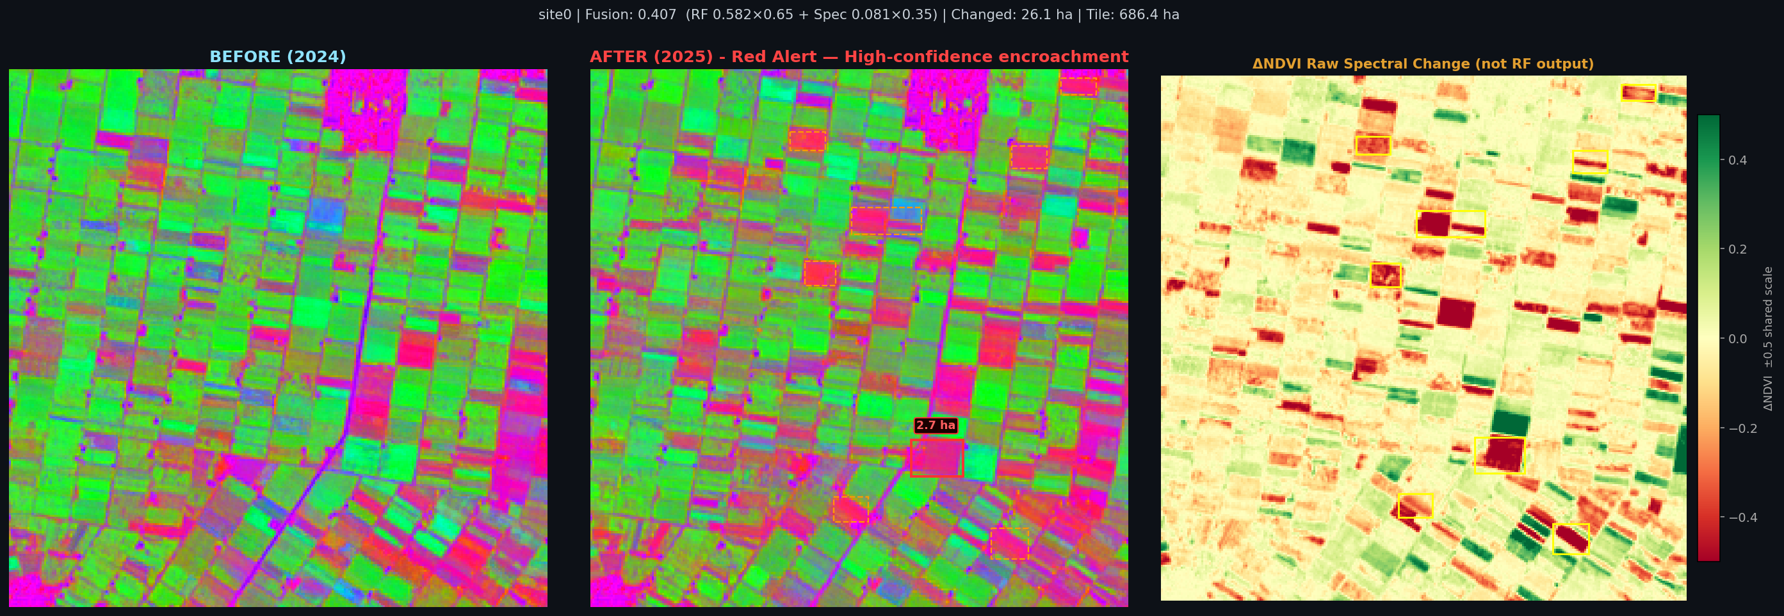
Figure 10 — Site-level pipeline output for Site 0 (Red Alert, fusion score 0.407). Three-panel view: T1 reference composite (left), T2 composite (centre), and detected change overlay (right). Total area flagged: 26.1 ha across 28 change clusters.

6.2 Interactive Map / Region Chip
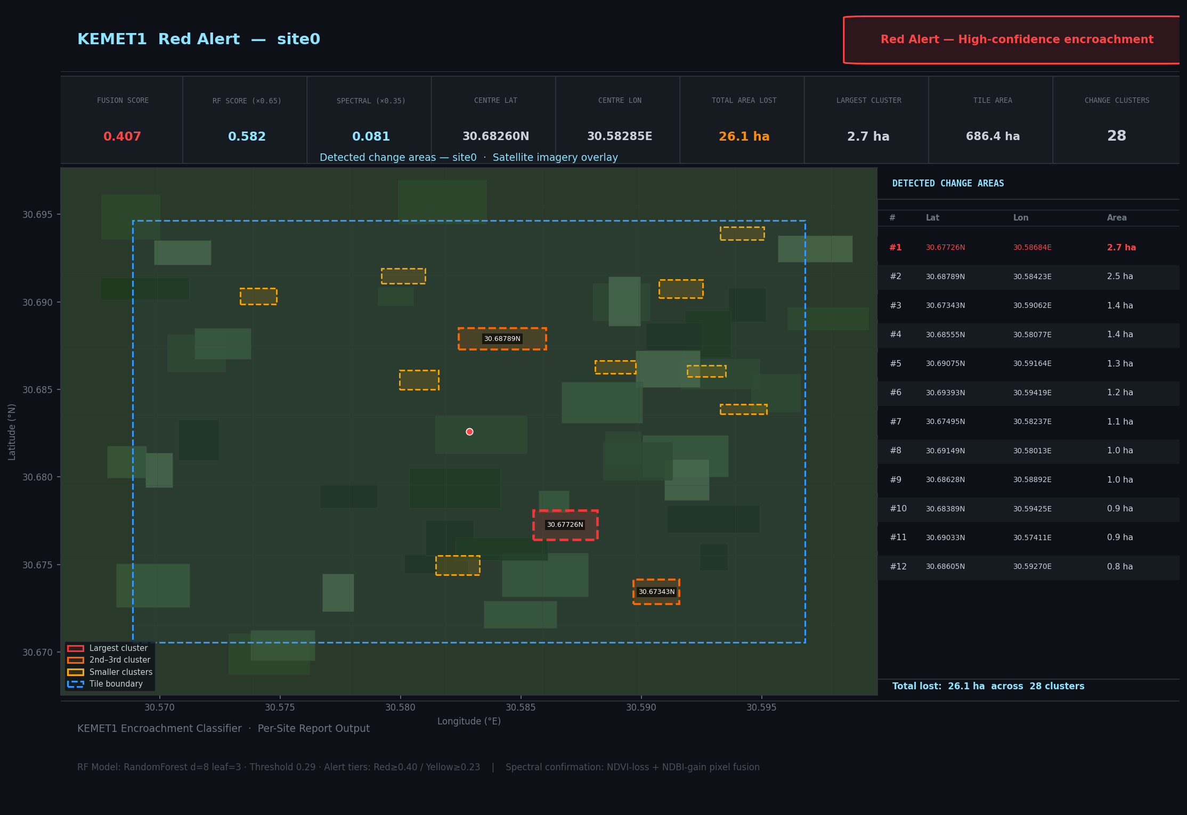
Figure 11 — Interactive map view for Site 0 (30.68°N, 30.58°E, Gharbia Governorate). The dark-themed Leaflet interface displays fusion score, alarm level, total area lost, and a table of individual change clusters with geocoded coordinates.

6.3 Quantitative Results
Table 4 records the numerical results of the run. The values can be filled directly from the corresponding fields of the generated report.json file.
Quantity | Value | Report field
Total encroachment area (ha) | 1,347.9 | encroachment_ha
Spectral degradation area (ha) | 247.3 | yellow_alert_ha
Number of encroachment regions | 76 | total_regions
Change-detection weight | 0.65 | alert_weights.change_detection
Spectral weight | 0.35 | alert_weights.spectral
Table 5 — Quantitative results of the KEMET1 system on the KEMET1 BeforeAfter dataset (78 positive tiles, Nile Delta).
Filling the result slots
Figure 9 is the final_colored.png output. Figure 10 is the building mask or polygon overlay from Stage 07, and Figure 11 can be a screenshot of interactive_map.html or a before/after chip from region_chips/. The values in Table 4 are read directly from the fields of report.json. Insert each image by clicking its placeholder and replacing it with the file.

7. Performance Evaluation
Because the system operates largely in a zero-shot manner on a scene for which no pixel-level ground truth is available, its evaluation combines the benchmark performance of its component models with the operational quantities produced on the study scene. This section defines the relevant metrics and interprets the results against expectation.

7.1 Metrics for the Detection Models
The change- and building-detection tasks are evaluated with the standard metrics of binary and instance detection, defined in Equations (11) to (13). Precision is the fraction of detections that are correct, recall is the fraction of true objects that are found, and the F1-score is their harmonic mean, summarising the trade-off between the two.
Precision = TP / ( TP + FP ) (11)
Recall = TP / ( TP + FN ) (12)
F1 = 2 · Precision · Recall / ( Precision + Recall ) (13)
where TP, FP, and FN are the counts of true-positive, false-positive, and false-negative detections. These metrics matter because detection must balance two opposing failure modes: flagging too much lowers precision, while flagging too little lowers recall. For the change model, the ChangeFormer family reports an F1-score of 0.906 on the LEVIR-CD benchmark under matched conditions; for the validated KEMET1 Random Forest, the project reports a validation AUC of 0.861 (test AUC: 0.872), indicating strong separation between encroachment and non-encroachment sites.

7.2 The Area-under-Curve Metric
The area under the receiver-operating-characteristic curve (AUC), reported for the KEMET1 classifier, measures the probability that the model ranks a randomly chosen encroachment site above a randomly chosen non-encroachment site. It ranges from 0.5 for random guessing to 1.0 for perfect separation, and, unlike accuracy, it is insensitive to class imbalance and to the choice of decision threshold. The observed validation AUC of 0.861 (test: 0.872) indicates that the classifier assigns higher scores to genuine encroachment in the large majority of cases, and on the full 300-tile operational evaluation the pooled AUC reaches 0.990, reflecting the combined benefit of the temporal-consistency filter. These values make it the property most relevant to a screening tool intended to prioritise sites for inspection.

7.3 Operational Quantities
On the study scene itself, the evaluation rests on the areas and counts produced by the final stage, since no reference mask exists for direct pixel comparison. The relevant quantities are the total encroachment area, the spectral-degradation area, and the number of detected encroachment regions, all of which are recorded in the JSON report and are to be entered in Table 5 from the run. Interpreted against expectation, a modest encroachment area distributed across a number of discrete regions adjacent to existing settlement is consistent with peri-urban expansion, whereas an implausibly large changed area would indicate over-sensitivity of the change stage on out-of-domain imagery, a known risk discussed in the next section.

8. Discussion and Limitations

8.1 Strengths
The system has several genuine strengths. Its architecture is modular, with each stage exposing a uniform interface, which makes the pipeline easy to test stage by stage and to extend. Its decision logic is fully interpretable, so that every classified pixel can be explained in terms of its change, agriculture, and building evidence. It requires little or no task-specific training, relying on strong pre-trained models and transparent spectral rules, which makes it immediately applicable to new areas. Finally, it degrades gracefully: every learned stage has a spectral or heuristic fallback, so the pipeline can run end to end even when a model is unavailable.

8.2 Limitations and Challenges
The principal limitation is the domain gap affecting the deep models. The change and building detectors were trained on very-high-resolution aerial imagery, whereas the system applies them to ten-metre Sentinel-2 data of a different region; this mismatch can make the change stage over-sensitive, flagging more of the scene as changed than genuine construction would explain. The reliance on a hard probability threshold compounds this, since small shifts in the input distribution can move many pixels across the threshold. A second challenge is computational: dense inference on a large scene is slow without a dedicated graphics processor, which discourages the repeated experimentation needed to recalibrate thresholds. A third is that the absence of local ground-truth labels prevents a direct pixel-level accuracy assessment on the study scene, so evaluation leans on benchmark figures and operational plausibility.

8.3 Future Work
The clearest path to improvement is domain adaptation: fine-tuning the change and building detectors on a modest set of labelled Nile Delta examples would reduce the domain gap and allow the thresholds to be recalibrated with confidence. Incorporating the spectral built-up and vegetation signals more tightly into the change decision, rather than only into the final score, would provide additional corroboration and reduce false alarms. Finally, extending the temporal analysis to longer sequences of images would let the system distinguish permanent construction from recurring seasonal change even more reliably than the current majority-based dampening allows.

9. Summary and Contribution
This chapter has documented the complete artificial-intelligence system developed by the Data & AI Team to detect buildings constructed on agricultural land in the Egypt Nile Delta. Beginning from two Sentinel-2 images captured at different times, KEMET1 BeforeAfter dataset (300 Sentinel-2 tile pairs across the Nile Delta) specific Areas, the eight-stage pipeline acquires and cleans the imagery, removes clouds, derives spectral indices, detects where the landscape changed, segments the farmland, locates the buildings, and finally fuses all of this evidence into a single, interpretable classification.
The system's contribution is a modular, largely training-free pipeline that combines deep-learning models, a Siamese Transformer for change, a semantic segmenter for farmland, and an instance segmenter for buildings, with transparent spectral and logical rules, and that degrades gracefully to simpler methods whenever a model is unavailable. Its headline deliverable is a colour-coded map, backed by hectare-level statistics, geolocated regions, vector polygons, and an interactive map, in which every classified pixel can be traced to its underlying evidence. This interpretability is essential for a tool intended to support land-use enforcement and food-security planning, and it constitutes the Data & AI Team's contribution to the wider graduation project.

