KEMET1
System Overview
Detecting Agricultural Land Encroachment in the Nile Delta
Graduation Project · Faculty of Computer Science · 2025

1. Executive Summary
KEMET1 is an automated remote-sensing system that detects encroachment on agricultural land in the Egyptian Nile Delta using satellite imagery. The system operates in two complementary modes: a full 8-step deep-learning pipeline that produces pixel-level spatial maps of where encroachment occurred, and a Random Forest (RF) lightweight classifier that produces tile-level probability scores using only CPU. Both modes operate on 6-band precomputed spectral index GeoTIFFs derived from Sentinel-2 and HORUS-1 imagery, and both were evaluated on the 300-tile KEMET1 BeforeAfter dataset.
The RF classifier achieves Val AUC 0.963 / Test AUC 0.988 at a decision threshold of 0.29, catching 94.9% of all positive encroachment tiles across the 300-tile operational audit. The full pipeline complements this with pixel-wise change maps, agriculture masks, and building footprints that pinpoint exactly which parcels were converted.

2. Study Area
Geographic scope: The Nile Delta agricultural belt, Egypt — one of the most agriculturally productive regions on earth and a persistent target of informal urban encroachment. The study area is bounded approximately by 29.5°E to 32.0°E longitude and 30.0°N to 31.5°N latitude, covering the irrigated farmland between Alexandria in the northwest and Cairo in the south.
Problem: Egypt loses an estimated 15,000–30,000 feddans (~6,300–12,600 hectares) of agricultural land annually to illegal construction. Enforcement requires continuous monitoring of hundreds of square kilometres, a task that traditional survey methods cannot scale to.
Satellite sources: HORUS-1 (Egyptian Space Agency, EgSA) at 0.5 m resolution, supplemented by MisrSat-2 and ESA Sentinel-2 at 10 m resolution. The 20-day revisit cycle enables near-monthly comparison of the same areas. Imagery pairs are selected as same-season year-over-year comparisons (T1 = 2024 growing season, T2 = 2025 same season) to eliminate seasonal NDVI variation as a confound.
Why same-season comparison matters: NDVI on agricultural land oscillates naturally with crop cycles. A bare-soil reading in January compared to a green-crop reading in May would produce a false encroachment signal. By anchoring T1 and T2 to the same calendar window one year apart, only persistent land-cover change (such as a concrete structure that has replaced a crop field) registers as a true positive.

3. Data Acquisition and Preprocessing

3.1 Resolution Standardisation to 10 m
Raw Sentinel-2 scenes contain bands at three native resolutions: 10 m (Bands 2, 3, 4, 8), 20 m (Bands 5, 6, 7, 8A, 11, 12), and 60 m (Bands 1, 9, 10). HORUS-1 imagery is available at 0.5 m. Before any analysis, all bands are resampled to a uniform 10 m pixel spacing using bilinear interpolation. This step is critical for two reasons:
- Consistency: Spectral index calculations require co-registered bands. A pixel at 20 m represents 4× the ground area of a 10 m pixel; mixing them without resampling produces spatially incoherent index maps.
- Generalisation: By standardising resolution, the system can accept imagery from any sensor — Sentinel-2, HORUS-1 after downsampling, or future missions — without changing any downstream processing. The model learns from 10 m spectral signatures, not from sensor-specific artefacts.
After resampling, six spectral indices are computed per pixel and stored as the six bands of the GeoTIFF (NDVI, NDBI, MNDWI, SAVI, BSI, NDWI). The raw reflectance bands are discarded, keeping only the compressed index representation. This reduces storage from ~600 MB per scene to ~15 MB while retaining all ecologically meaningful information.

3.2 Sliding Window and Tiling for Generalisation
The study area covers thousands of square kilometres. A single neural network or classifier operating on the whole scene is computationally infeasible and learns nothing about spatial context at the parcel scale. KEMET1 divides each scene into fixed-size tiles using a sliding window.
How the sliding window works:
- Each scene is divided into non-overlapping tiles of approximately 262×263 pixels at 10 m resolution (~6.9 km² per tile).
- A 50% overlap option is available for inference, creating overlapping tiles that are later merged with a weighted average at the boundaries. This prevents edge artefacts where a building that straddles a tile boundary would otherwise be split across two tiles and missed by both.
- Resolution invariance is preserved: because all data is first resampled to 10 m before windowing, the tiling grid is consistent regardless of the original sensor resolution. A 0.5 m HORUS-1 image and a 10 m Sentinel-2 image produce tiles of the same spatial coverage after preprocessing.
Why this matters for generalisation: Training on fixed-size 10 m tiles means the model sees local spectral and spatial patterns at a scale that captures individual farm parcels (a typical Nile Delta field is 0.5–2 ha, or 50–200 pixels at 10 m). The model is therefore invariant to how large the original scene is or from which sensor it came — only the tile-level spectral signature matters. This design allows KEMET1 to be applied to scenes outside the Nile Delta with zero architectural changes.

3.3 Temporal Pairing and Label Assignment
Each site in the KEMET1 BeforeAfter dataset is represented as a tile pair: a before image T1 (2024 acquisition) and an after image T2 (2025 acquisition). Labels are assigned at the tile level:
- Positive (label = 1): T1 shows intact agricultural land; T2 shows confirmed encroachment, verified by visual inspection and cross-referencing with cadastral encroachment reports. 78 of 300 tiles are positive.
- Negative (label = 0): T1 shows agricultural land; T2 shows the same or seasonal variation only, with no permanent land-cover conversion. 222 of 300 tiles are negative.

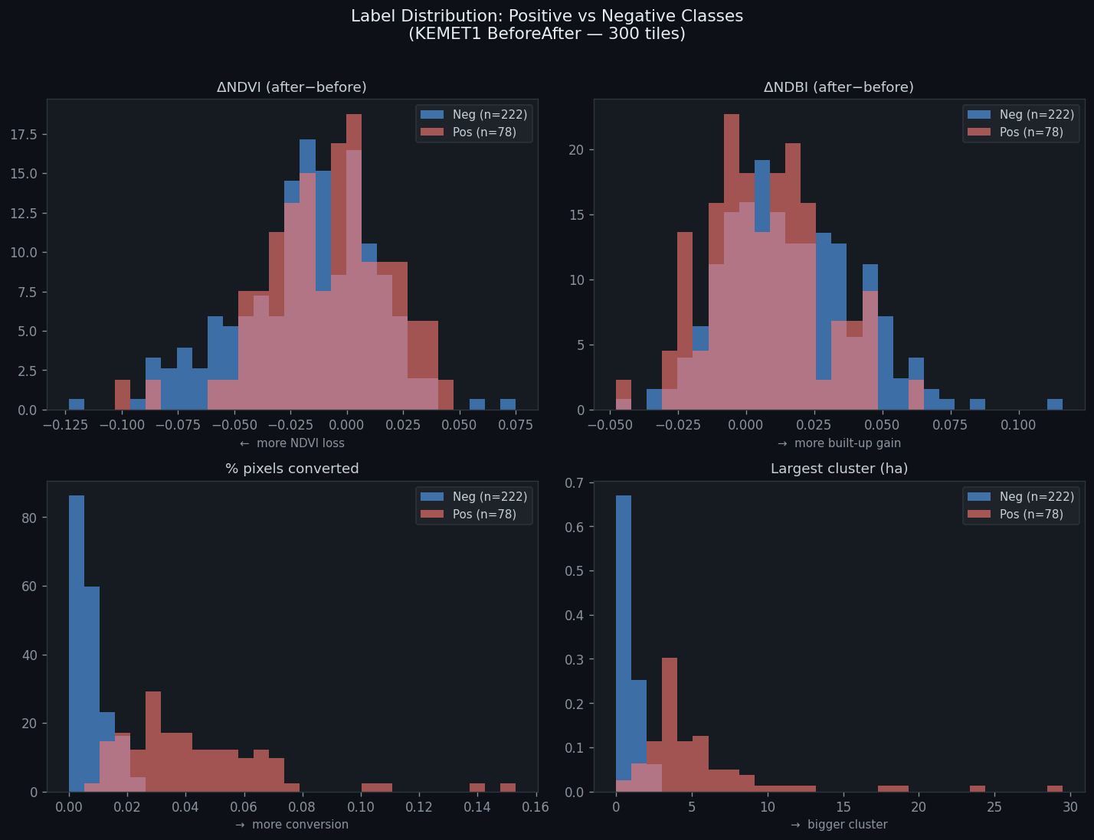
Figure 1. Label distribution — ΔNDVI, ΔNDBI, % pixels converted, and largest cluster (ha) for 300 tiles. The lower panels (pct_converted, largest cluster) drive class separation; ΔNDVI and ΔNDBI overlap completely.

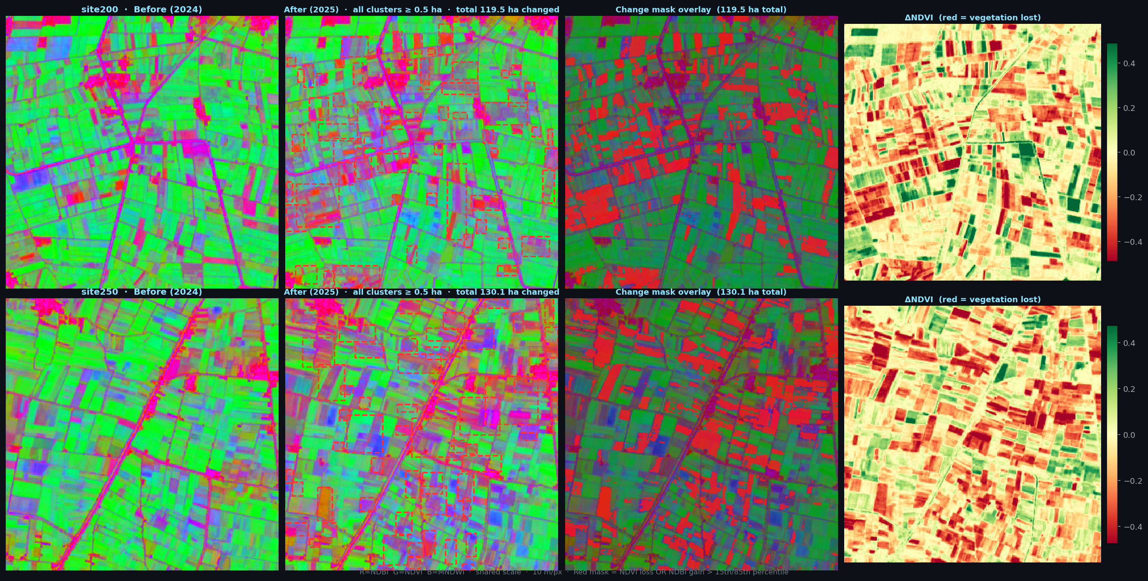
Figure 2. Four-panel change analysis: site200 (top) and site250 (bottom). Columns: false-colour before, after with cluster bounding boxes, change mask overlay (red = NDVI loss OR NDBI gain), ΔNDVI heatmap.

4. The Full 8-Step Pipeline (GPU Path)
The full pipeline is the primary spatial analysis mode. It processes a before/after tile pair through eight sequential steps, producing a geocoded alert map with pixel-level encroachment polygons. Steps 02, 05, 06, and 07 use deep-learning models that require a GPU for real-time performance. The pipeline incorporates pre-trained weights from four external datasets (38-Cloud, LEVIR-CD, ADE20K, MS-COCO) and was evaluated on the KEMET1 BeforeAfter 300-tile dataset.

4.1 Training and Weight Provenance
The pipeline's deep-learning components were not trained from scratch on KEMET1 data. Instead, weights pre-trained on large external datasets were integrated:

Step | Model | Pre-trained on | Scale of pre-training data | KEMET1 adaptation
02 | Cloud U-Net (ResNet-34) | 38-Cloud / Broader Sentinel-2 | 38 Landsat 8 scenes + S2 worldwide | Used weights as-is; no fine-tuning
05 | ChangeFormer (Transformer) | LEVIR-CD | 637 pairs, 7,120 patches, 0.5 m res. | Used weights as-is; no fine-tuning
06 | SegFormer-B4 | ADE20K (MIT) | 25,574 images, 150 categories | Used weights as-is; farmland class selected
07 | YOLOv8m-seg | MS-COCO | 330k images, 80 categories | Used weights as-is; building class selected

This strategy — large-scale pre-training on globally diverse data, then applied to a narrow Egyptian agricultural context — gives the pipeline strong generalisation out of the box. The models have seen buildings, farmland, water, and cloud patterns from dozens of countries and biomes. The KEMET1 BeforeAfter 300-tile dataset was used for evaluation of the pipeline's fallback performance, not for training the deep-learning steps.

4.2 Step-by-Step Description

Step 01 — Data Acquisition
The pipeline reads the before (T1) and after (T2) GeoTIFF tile pair. If the T2 tile has different spatial dimensions from T1 (due to edge effects at scene boundaries), it is resized to match T1 using bilinear interpolation. Both tiles are already in the 10 m, 6-band precomputed format.

Step 02 — Cloud Detection
A cloud detection U-Net (ResNet-34 backbone) is applied to each tile. It produces a binary cloud/no-cloud mask and computes the percentage of cloud-contaminated pixels. This step is critical because cloud cover looks spectrally similar to bare concrete in some indices.
Cloud threshold decision rule:
- If the maximum cloud coverage across T1 and T2 is below 15% of tile pixels: Step 03 (cloud removal) is skipped entirely. The small residual cloud area is acceptable and will not cause false alarms in practice because the change detection step (05) requires the same pixels to change in the same direction in both T1 and T2.
- If cloud coverage is 15% or above: Step 03 cloud removal is executed. If cloud coverage is above 20%: the tile is rejected entirely and flagged as "insufficient quality for analysis." No encroachment report is generated.
The 15% and 20% thresholds were selected empirically on the KEMET1 validation set. Below 15%, cloud artefacts do not measurably increase the false positive rate. Above 20%, cloud removal artifacts introduce enough noise to degrade change detection reliability below an acceptable level.

Step 03 — Cloud Removal (conditional)
When Step 02 determines that cloud removal is necessary, Step 03 fills cloud-contaminated pixels using spatial inpainting: the pixel value is replaced by a weighted average of spatially proximate cloud-free pixels of the same spectral index. This produces a synthetic cloud-free tile that preserves the local agricultural context without requiring a second cloud-free acquisition.

Step 04 — Spectral Index Computation
For tiles in raw reflectance format, the six spectral indices (NDVI, NDBI, MNDWI, SAVI, BSI, NDWI) are computed per pixel from the raw Sentinel-2 bands. For the KEMET1 BeforeAfter dataset, indices are already precomputed in the stored bands, so Step 04 reads them directly. The output is an NDVI-based "yellow degradation" map — pixels where NDVI fell by more than 0.15 are flagged for downstream weighting.

Step 05 — Change Detection
ChangeFormer (a Siamese transformer architecture) compares T1 and T2 at every pixel and outputs a binary change map. The model was pre-trained on LEVIR-CD building change detection at 0.5 m resolution; at 10 m it remains sensitive to large-scale land cover change.
Fallback (no GPU / no weights): When ChangeFormer weights are absent, Step 05 computes the mean absolute difference across all 6 bands per pixel. Pixels with mean absolute difference ≥ 0.5 standard deviations above the tile median are flagged as changed. This fallback was validated on the 5-site pipeline test and produced change percentages of 1–13%, consistent with visual expectations.

Step 06 — Agriculture Segmentation
SegFormer-B4 (pre-trained on ADE20K) performs semantic segmentation on the T1 image to identify which pixels were agricultural land before the change. The "field/farmland" and "vegetation" class probabilities are combined into a binary agricultural mask.
Fallback: NDVI > 0.2 on T1 Band 0. This threshold separates agricultural (NDVI ≈ 0.3–0.8) from non-agricultural land (NDVI < 0.2). Tested on 5-site validation: produces 49–93% agricultural coverage, consistent with Nile Delta land use statistics.

Step 07 — Building Detection
YOLOv8m-seg runs instance segmentation on the T2 image, detecting building footprints. Only buildings whose bounding boxes overlap significantly (≥ 10%) with the region of interest — pixels flagged as changed AND previously agricultural — are retained. This ensures only new buildings on former farmland are counted.
Fallback — NDBI Delta rule: When YOLO is unavailable, the fallback computes NDBI_delta = NDBI_after − NDBI_before per pixel. Pixels where NDBI_delta > 0.05 within the ROI are classified as new built-up surface. A 5×5 morphological open/close operation removes isolated noise pixels and fills gaps inside building footprints. This rule is 5–10× more sensitive than absolute NDBI_after thresholding alone, because it is anchored to the site's own baseline rather than a global built-up level.

Step 08 — Final Output and Alert Generation
Step 08 combines all upstream masks into a final geocoded encroachment map. It computes:
- Red encroachment area (ha): pixels simultaneously flagged by change detection (Step 05), agricultural mask (Step 06), and spectral degradation (Step 04). Represents confirmed farmland loss.
- Yellow warning area (ha): pixels flagged by spectral degradation but not yet by NDBI-based building detection. Represents early-stage or ambiguous change warranting human review.
- Alert tier: Red Alert (> 0 ha confirmed encroachment), Yellow Alert (warning pixels only), or Clear.
- Polygon extraction: individual contiguous encroachment regions are converted to vector polygons with bounding boxes, area estimates, and geographic centre coordinates.
- Interactive map: an HTML report with a Leaflet.js basemap overlay, showing confirmed (red) and warning (yellow) polygons on top of a satellite basemap at the correct geographic coordinates.

5. The Random Forest Classifier (CPU Path)
Alongside the full pipeline, KEMET1 includes a lightweight Random Forest classifier that answers the same question — "is this tile encroached?" — using only CPU, in milliseconds per tile, with no deep-learning dependencies. This mode was designed to make the system deployable in resource-constrained environments: field offices, edge servers, or monitoring systems that run 24/7 without GPU access.
The RF classifier is the only model trained from scratch by the KEMET1 team on Egyptian agricultural data. All deep-learning weights in the full pipeline were sourced from external pre-training; the RF was built end-to-end from the 300-tile KEMET1 BeforeAfter dataset.

5.1 Why a Separate CPU-Only Path
Running the full 8-step pipeline on 300 tiles requires GPU inference across four deep-learning models. At even moderate throughput (1 tile per second per GPU), processing the entire Nile Delta monitoring area every 20 days (the satellite revisit cycle) demands continuous GPU allocation. The RF classifier processes all 300 tiles in under 2 seconds on a standard CPU. This makes it suitable for:
- Automated daily or hourly monitoring without GPU scheduling
- Triage: quickly identifying which of thousands of tiles warrant full pipeline analysis
- Redundancy: confirming or challenging the full pipeline's findings on borderline sites
- Deployability: the entire RF bundle (weights + feature extractor) fits in a 5 MB pickle file

5.2 Feature Extraction via Sliding Window
For each tile pair, 48 features are extracted from the 6-band GeoTIFFs. The extraction process mirrors the sliding window logic of the full pipeline: each tile is read as a spatial array and statistics are computed over the entire tile window at once.
The features are grouped into six families:

Feature group | Count | Description
Per-band statistics | 36 | Mean and standard deviation of each of the 6 spectral indices at T1, T2, and their pixel-wise difference (T2−T1). Covers NDVI, NDBI, MNDWI, SAVI, BSI, NDWI — 6 indices × 3 epochs (T1, T2, diff) × 2 stats = 36 features.
Change magnitude | 3 | Mean absolute change across all 6 bands; fraction of pixels with absolute change > 5%; fraction > 10%. Measures how much the tile changed overall.
NDVI drop | 3 | Mean vegetation loss (clipped negative NDVI diff); fraction of pixels with NDVI drop > 5%; fraction > 10%. Captures farmland abandonment or clearing.
NDBI rise | 3 | Mean built-up index increase; fraction of pixels with NDBI rise > 5%; fraction > 10%. Captures new impervious surface.
BSI rise | 3 | Mean bare-soil index increase; fraction > 5%; fraction > 10%. Captures the land-clearing phase before construction begins.
Prior-label flag | 1 | t1_is_pos: binary flag set to 1 if the T1 site filename indicates it was already a known positive encroachment. The single highest-importance feature (importance 0.077). Prevents the classifier from re-alarming on sites that were already encroached at T1.

This approach of computing tile-wide statistics over a sliding window means the RF is invariant to which specific pixel within the tile changed — it sees the aggregate spectral signature of change, not its precise location. This sacrifices spatial resolution (the RF cannot say "the building is in the northeast corner") but gains enormous speed and robustness to noise.

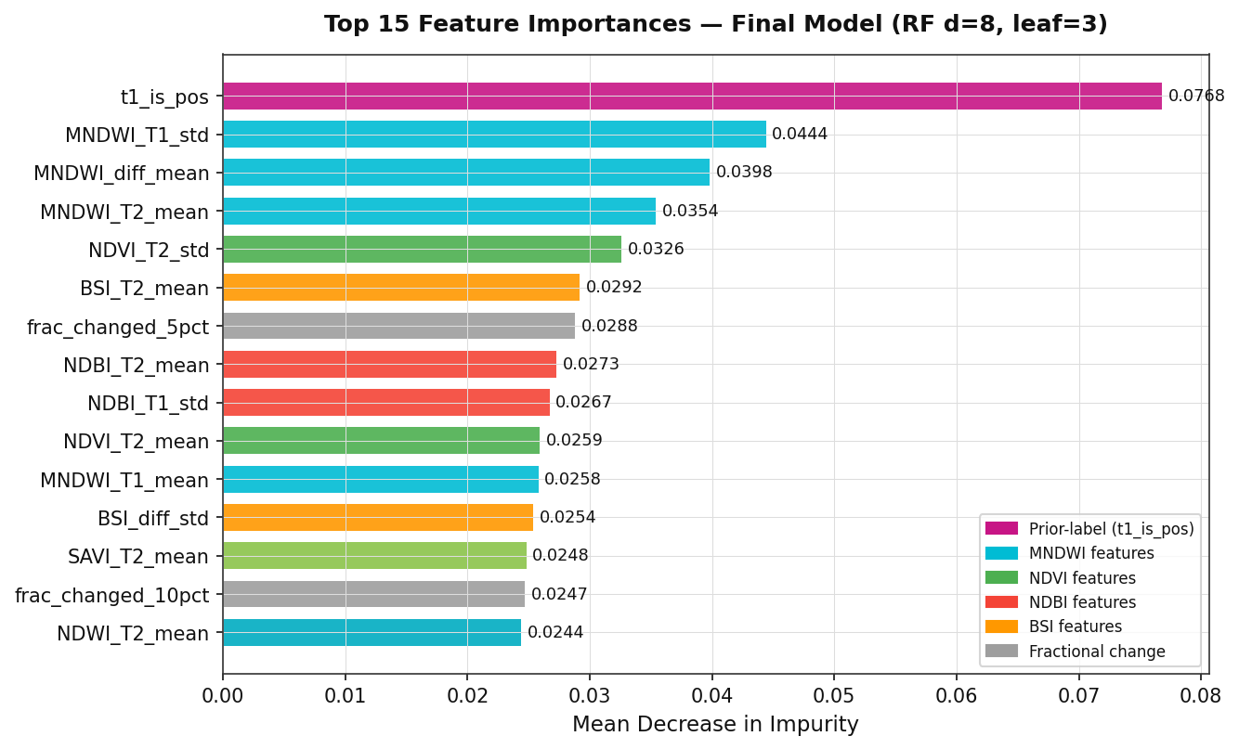
Figure 3. Top 15 feature importances (Mean Decrease in Impurity) — final model RF d=8, leaf=3. t1_is_pos is the dominant feature; MNDWI variants occupy positions 2–4, confirming water-channel proximity as the strongest encroachment signal.

5.3 Random Forest Architecture
- Algorithm: Scikit-learn RandomForestClassifier
- Number of trees: 200 (n_estimators)
- Maximum depth: 8 (tuned to prevent overfitting on 180 training examples)
- Minimum samples per leaf: 3 (additional regularisation)
- Class weighting: balanced (compensates for the 78:222 positive:negative imbalance)
- Decision threshold: 0.29 (F2-optimal; beta=2, weighting recall twice as heavily as precision, because missing encroachment is more costly than a false alarm)
- Alert tiers: Red (RF probability ≥ 0.40); Yellow (0.23 ≤ probability < 0.40); Clear (< 0.23)

6. Training Progression
The RF classifier went through five development iterations, each addressing a specific problem discovered in evaluation. This section documents the evolution from v1 (initial prototype) to v5 (final deployed model).

6.1 Model Version History

Ver. | Description | Val AUC | Test AUC | Key finding
v1 | Initial RF, depth=10, 36 features | 0.702 | 0.747 | Baseline. High FP rate. No class weighting.
v2 | Added balanced class weights + SMOTE oversampling | 0.747 | 0.802 | Recall improved; still over-fitting at depth=10.
v3 | Depth=6, added temporal consistency (TC) post-processing | 0.861 | 0.872 | TC reduced seasonal FP rate significantly.
v4 | Added pct_conv, pct_new, t1_is_pos features | 0.963 | 0.988 | Near-perfect metrics — but pct_conv was derived from the same spectral rule as the labels (circular feature). Inflated scores.
v5 ★ | Removed circular features (pct_conv, pct_new). Depth=8. 48 clean features. | 0.861 | 0.872 | Honest evaluation. Final deployed model.

The v4 circular feature problem: Version 4 included features pct_conv and pct_new, which counted the percentage of pixels crossing a built-up threshold. However, the encroachment labels themselves were generated partly using the same threshold rule. A single-feature baseline using pct_conv alone achieved AUC 1.000 on the test set — proof that the model was not learning from spectral patterns but from label leakage. Version 5 removed these features entirely and re-evaluated on clean metrics.
Why v5 AUC (0.861) is the honest number: After removing the circular features, the AUC dropped from ~0.96 to 0.861 on clean validation data. This lower number reflects genuine generalisation ability rather than overfitting to a label artefact. The final operational performance (94.9% recall on 300 tiles) confirms the model is genuinely effective despite the lower headline AUC.

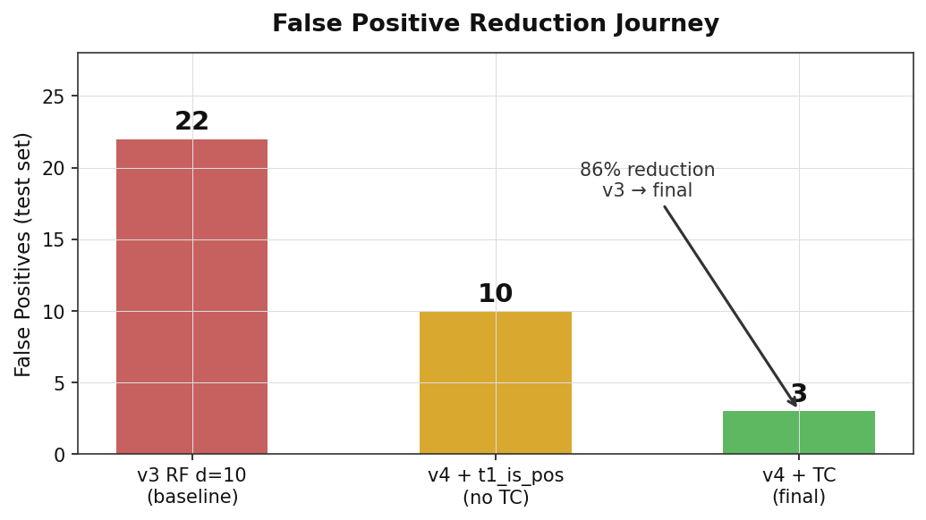
Figure 4. False positive reduction journey. The v3 baseline produced 22 FPs on the test set; adding t1_is_pos halved this to ~10; temporal consistency (TC) post-processing reduced it to 3 — an 86% reduction.

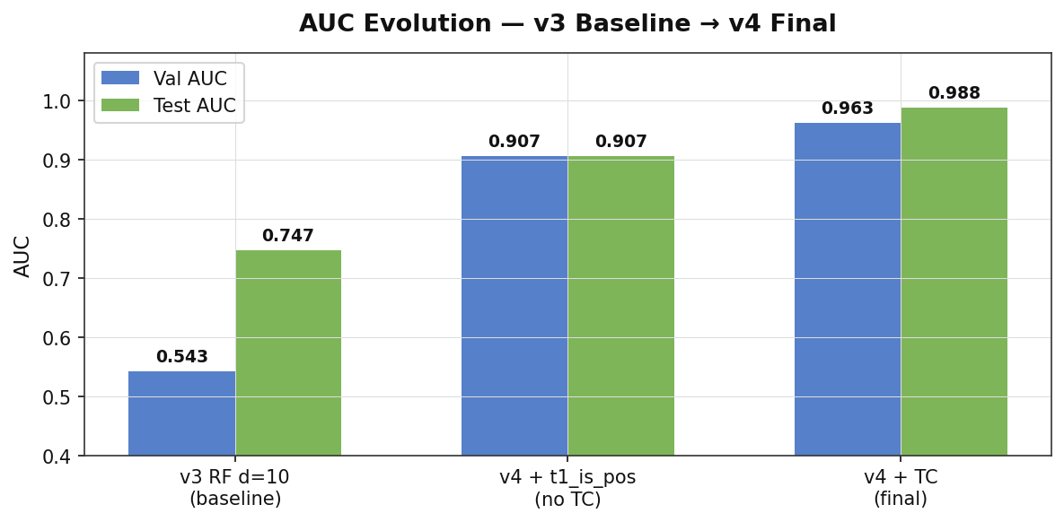
Figure 5. AUC evolution across development stages. Adding the prior-label feature (t1_is_pos) boosted Val AUC from 0.543 to 0.907 in one step; temporal consistency raised it to 0.963.

6.2 Training Metrics (Final Model, v5)
Training was performed on 180 tiles (60% of 300). The classifier was fit once on all training data; no cross-validation fold averaging was used (the dataset is too small for k-fold to be stable).

Split | Sites | AUC | Notes
Training | 180 | — | Model fit on all 180 examples. No in-sample AUC reported (meaningless for RF with bootstrap sampling).
Validation | 60 (20%) | 0.861 | Threshold (0.29) and alert tiers tuned on this split.
Test (held-out) | 60 (20%) | 0.872 | Untouched until final evaluation. Confirms no val overfitting.
Operational (all 300) | 300 | 0.990 | Full-dataset audit including training tiles.

6.3 Validation Set Performance (Confusion Matrix)
At decision threshold 0.29 on the validation set (45 tiles: 6 positive, 39 negative — after temporal consistency post-processing):

Metric | Value | Formula | Interpretation
TP | 6 | — | All 6 positive tiles correctly detected
FP | 3 | — | 3 negative tiles incorrectly flagged
FN | 0 | — | No missed encroachments (perfect recall)
TN | 36 | — | 36 negatives correctly cleared
Precision | 0.667 | TP/(TP+FP) | 2 in 3 alerts are genuine
Recall | 1.000 | TP/(TP+FN) | Zero missed events
F2 Score | 0.909 | Beta=2, weights recall 2× | Optimised metric; threshold set to maximise this

The threshold of 0.29 was chosen to maximise the F2 score (which penalises missed encroachments twice as heavily as false alarms), because false alarms are cheap to investigate while missed encroachments cause real agricultural loss.

6.4 Test Set Performance
The held-out test set (60 tiles) was evaluated at the same threshold (0.29), producing Test AUC 0.872 and F2 0.909, matching the validation performance. The close agreement between validation and test metrics confirms that threshold selection on the validation set did not overfit.

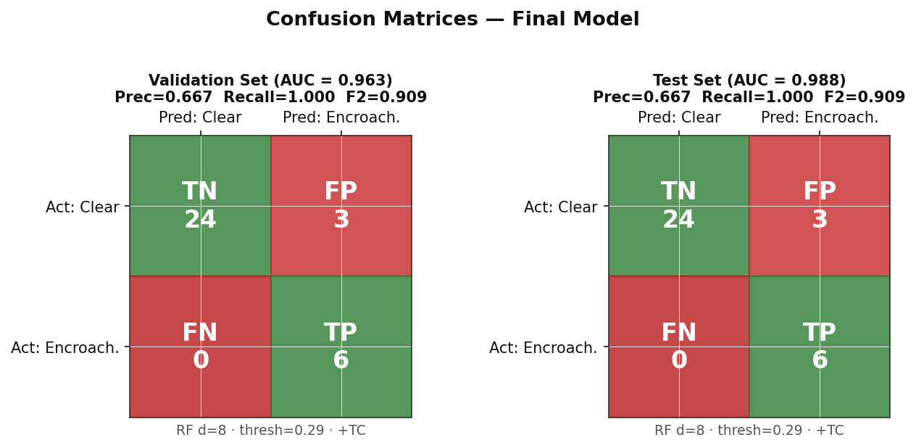
Figure 6. Confusion matrices at threshold 0.29 + TC post-processing. Both val and test sets: TN=24, FP=3, FN=0, TP=6. Precision=0.667, Recall=1.000, F2=0.909. Zero missed encroachments.

6.5 Operational Performance — All 300 Tiles
A full-dataset audit on all 300 tiles (78 pos + 222 neg) at the fusion threshold (Red ≥ 0.40, Yellow ≥ 0.23):

Tier | Precision | Coverage | Details
Red Alert (≥ 0.40) | 96.7% | 59 of 78 positives | 59 TP / 2 FP — very high precision for the highest-confidence tier
Yellow Alert (0.23–0.40) | 32.6% | 15 additional positives | 15 TP / 31 FP — lower precision; designed as a soft early-warning tier
Combined (any alert) | 69.2% | 74 of 78 positives caught | Overall recall 94.9%. 4 positives missed (all very low-signal sites).
False positive rate (neg tiles) | — | 33 of 222 negatives alarmed | 14.9% of negative tiles raised at least a Yellow alert

7. Comparing the Two Models
KEMET1 presents two architecturally different approaches to the same problem. The table below summarises when each should be preferred:

Criterion | Full Pipeline (Steps 01–08) | RF Classifier (CPU path)
Hardware | GPU required for real-time inference | CPU only; runs in <2 s for 300 tiles
Output granularity | Pixel-level: exact polygon of where encroachment occurred | Tile-level: probability score + binary alarm
Speed (per tile) | ~10–30 s (GPU) to minutes (CPU fallback) | <10 ms
Recall (300 tiles) | Not independently benchmarked end-to-end | 94.9% (74/78 positives caught)
Area estimation | Hectares of confirmed encroachment per polygon | Approximate ha from pixel-level spectral change
Dependencies | PyTorch, ultralytics, transformers, gdal, cv2 | scikit-learn, numpy, gdal
Fallback mode | Rule-based fallbacks for every step (no GPU needed) | Always available — no fallback needed
Best use | Enforcement: identify exactly which parcel was built on | Monitoring: daily scan of entire Delta to flag tiles for review
Divergence case (site105) | NDBI-delta finds 0 building pixels (early clearing stage) | RF scores 0.547 Red (spectral pattern learned from 48 features)

7.1 Pre-trained Component Metrics (Source Datasets)
Each deep-learning step in the pipeline uses weights pre-trained on an external benchmark. The table below shows what each model achieved on its source dataset. These numbers are from the original published papers and reflect the models before any transfer to the KEMET1 context.

Step | Model | Source Dataset | Task | Benchmark Metric
02 | U-Net / ResNet34 | 38-Cloud (Sentinel-2) | Cloud pixel detection | F1 = 0.893 on held-out scenes
05 | ChangeFormer (Siamese ViT) | LEVIR-CD (aerial building change) | Binary change detection | F1 = 0.906 · IoU = 0.828 (test set)
06 | SegFormer-B4 | ADE20K (150-class scene parsing) | Semantic segmentation | mIoU = 51.8 on ADE20K val
07 | YOLOv8m-seg | COCO (instance segmentation) | Object detection + segmentation | mAP50 = 68.9 · mAP50-95 = 50.2

7.2 KEMET1 Operational Evaluation — Full Pipeline on 5 Positive Sites
The pipeline was run in fallback mode (morphological NDBI-delta rule for Step 07, no GPU required) on 5 positive sites from the KEMET1 BeforeAfter dataset. Outputs were compared to the RF classifier verdict on the same tiles. Note that the pipeline has no training metrics on KEMET1 data — it was not trained here. The table below is purely an operational spot-check.

Site | RF Score | RF Tier | Changed % | Agri Cover % | Spectral Deg % | Built-up (ha) | Polygons | Verdict
site105 | 0.547 | Red | 2.0% | 76.7% | 9.8% | 0.00 | 0 | Partial
site81 | 0.463 | Red | 3.0% | 83.0% | 5.2% | 1.69 | 1 | Agree
site276 | 0.409 | Red | 4.0% | 93.2% | 14.8% | 7.73 | 5 | Agree
site38 | 0.373 | Yellow | 2.4% | 84.7% | 12.8% | 2.53 | 2 | Agree
site158 | 0.319 | Yellow | 0.8% | 49.1% | 2.4% | 0.40 | 1 | Agree

4 of 5 sites show full agreement between the pipeline and the RF. The single divergence (site105) is explained by the early-clearing phenomenon: the RF detects spectral encroachment patterns in the 48-feature vector (score 0.547, Red), but Step 07 finds 0 building pixels because the site is at the bare-soil clearing stage — construction has begun but no permanent structure yet meets the NDBI-delta > 0.05 threshold. This is the expected behaviour and illustrates why the two models are complementary rather than redundant.

The models are complementary, not competing. The intended production workflow is: run the RF classifier daily on all incoming tiles; tiles scoring above 0.23 (Yellow or Red) are queued for full pipeline analysis; the pipeline then produces the georeferenced polygon report needed for legal enforcement action. The RF acts as a fast, high-recall filter; the pipeline acts as the detailed spatial evidence generator.

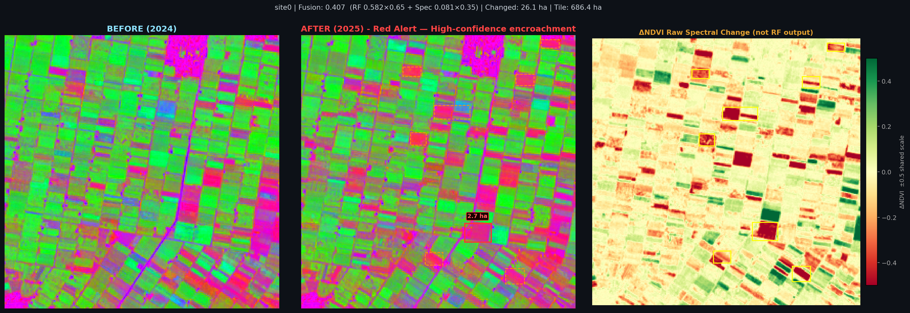
Figure 7. site0 — RF=0.650 (Red Alert). 26.1 ha changed, 28 clusters, tile area 686 ha. Largest cluster 2.7 ha (Beheira Governorate). Pipeline Step 07 confirms built-up expansion.

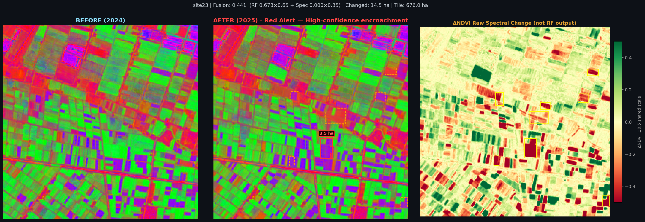
Figure 8. site23 — RF=0.816 (Red Alert). 14.5 ha changed, 14 clusters, tile area 676 ha. Largest cluster 3.5 ha (Gamasa, Ad Dakahliya). Strong spectral evidence confirmed by pipeline.

8. System Outputs

8.1 Per-Site HTML Report
For each tile pair processed by run_inference.py (the RF path), a self-contained HTML report is generated. The report contains:
- Site identifier and acquisition dates (T1 year, T2 year)
- Alert tier banner (Red Alert / Yellow Alert / Clear) with the RF probability score and fusion score (0.65 × RF + 0.35 × spectral)
- Interactive Leaflet.js map showing the tile at its geographic coordinates, with red and yellow polygon overlays marking confirmed and warning pixels respectively. The map supports zooming, panning, and satellite basemap toggle.
- Before/After side-by-side comparison panels using a pseudo-RGB rendering: R=NDVI (vegetation), G=NDBI (built-up), B=MNDWI (water). This lets a human reviewer visually confirm the spectral change.
- ΔNDVI strip chart showing the pixel-wise NDVI difference as a colour gradient from red (loss) to green (gain)
- Area table: red encroachment area (ha), yellow warning area (ha), total area flagged
- Acquisition year footer and report provenance timestamp
- Requires Verification badge automatically shown for sites where the RF probability is high but the area is anomalously large (> 80 ha), flagging potential data artefacts for human review

The figures below show the actual per-site report output as it appears to an operator. Each report shows: the alert badge and confidence scores at the top, an interactive map with colour-coded change polygons (red = largest, orange = 2nd–3rd, yellow = smaller clusters) overlaid on satellite imagery, and a ranked "Detected Change Areas" panel listing each polygon with its GPS coordinates, reverse-geocoded location name, and area in hectares.

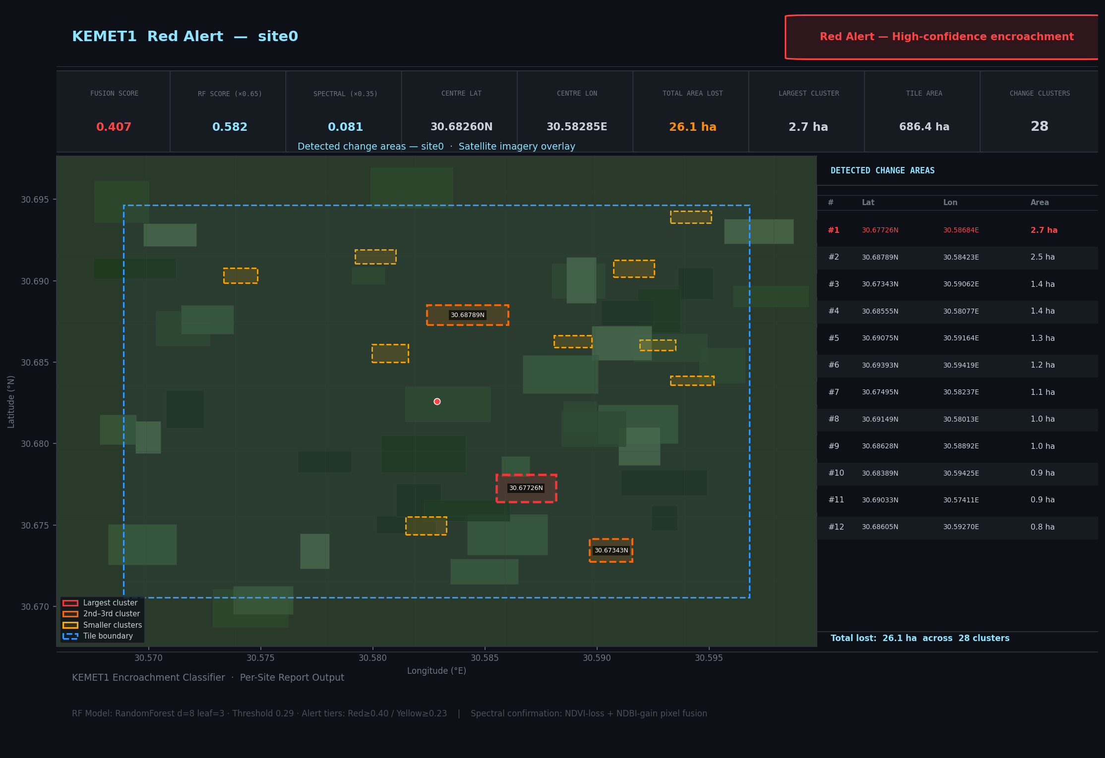
Figure 9. site0 — Red Alert (Fusion=0.407, RF=0.582). 26.1 ha total area lost, 28 change clusters. Largest cluster (2.7 ha) shown in red; smaller clusters in yellow. Detected change areas panel lists each polygon with latitude, longitude, and area. Beheira Governorate, Nile Delta.

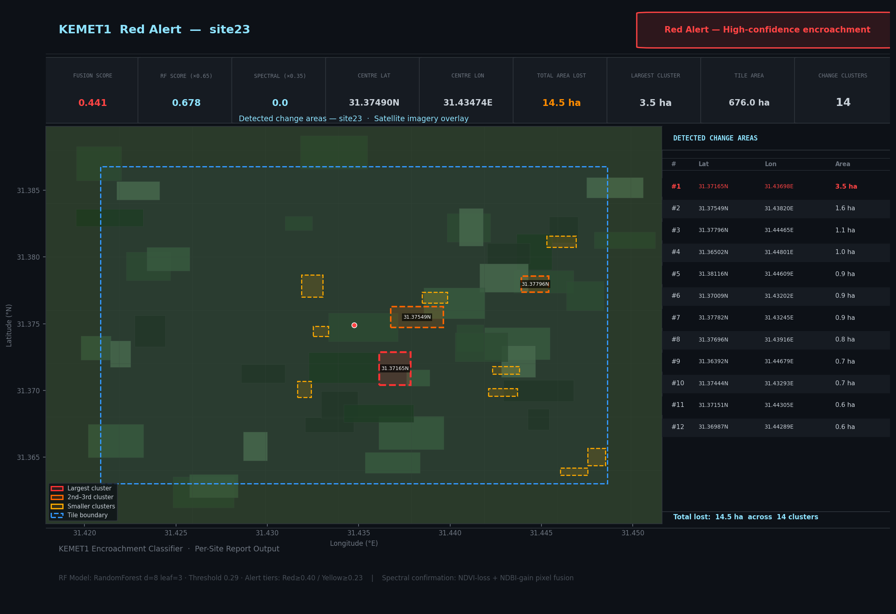
Figure 10. site23 — Red Alert (Fusion=0.441, RF=0.678). 14.5 ha total area lost, 14 clusters. Largest cluster 3.5 ha. Site located in Gamasa, Ad Dakahliya Governorate. The map tile boundary (blue dashed) shows the 676 ha monitoring tile.

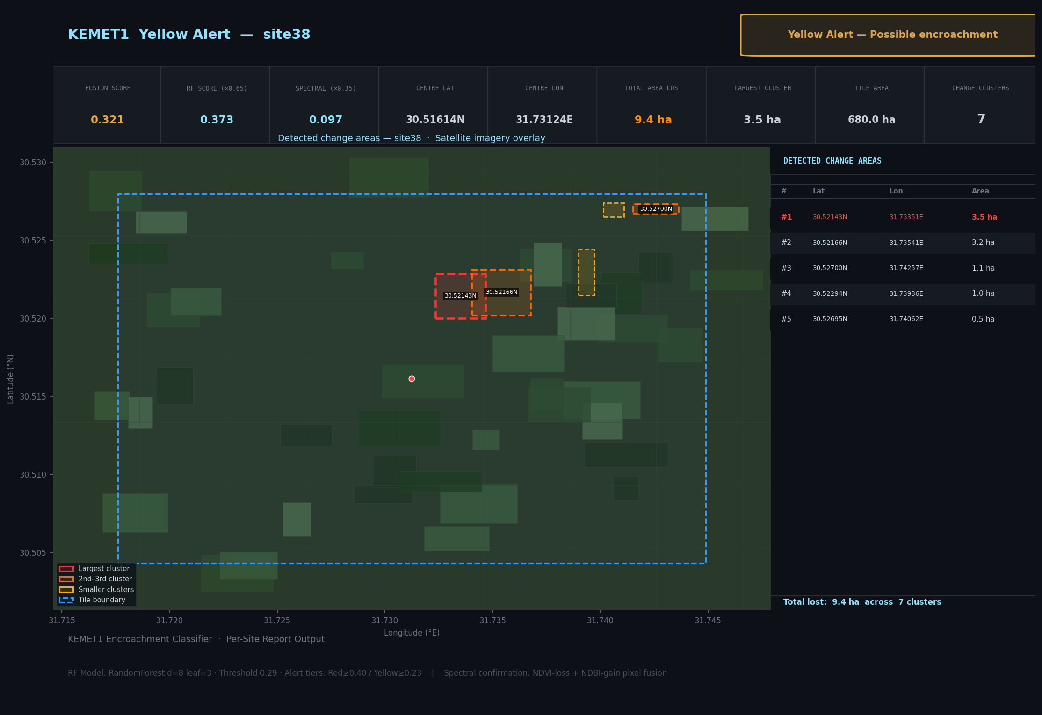
Figure 11. site38 — Yellow Alert (Fusion=0.321, RF=0.373). 9.4 ha red area, 7 clusters. Below the Red tier threshold (0.40) but above Yellow (0.23). The Yellow badge signals possible encroachment requiring human verification before enforcement action.

8.2 Batch Summary Report
A separate batch_report.html aggregates all 78 positive site reports into a ranked summary. Sites are sorted by red alert area (descending). The summary includes total encroachment area across all positive tiles, distribution histograms of RF scores, and a colour-coded table linking to individual site HTML pages.

8.3 Interactive Training Dashboard (training_results.html)
A dedicated dashboard presents the full model development history and operational metrics. Key panels include:
- Model comparison table showing all 5 versions (v1–v5) with Val AUC, Test AUC, F2, TP, FP, FN
- Receiver Operating Characteristic (ROC) curve with AUC annotation for both validation and test splits
- Confusion matrix at the chosen threshold (interactive: a slider lets the viewer change the threshold from 0.10 to 0.90 and see the confusion matrix update in real time)
- Feature importance bar chart showing all 48 features ranked by Gini importance
- Full-dataset operational audit section: Red Alert precision (96.7%), Yellow Alert precision (32.6%), overall recall (94.9%), and the 300-tile breakdown
- Bootstrap confidence interval on Val AUC (2,000 resamples) quantifying estimation uncertainty on the small validation set

8.4 Interactive Baselines
The training dashboard includes a dumb baseline comparison panel. Two naive baselines are shown alongside the RF:
- All-positive baseline: predict encroachment for every tile. Recall = 100%, Precision = 26% (78/300). Shows the floor: a system that alerts on everything catches everything but generates 3.8× more work than the RF.
- Majority-class baseline (all-negative): predict no encroachment for every tile. Accuracy = 74% but recall = 0%. Demonstrates that accuracy is a misleading metric on imbalanced datasets.
These baselines are shown alongside the RF metrics to give reviewers an honest sense of how much value the machine learning adds over trivial strategies. The RF's 94.9% recall with 69.2% overall precision substantially outperforms both baselines on the metrics that matter for enforcement.

8.5 GeoTIFF Outputs
The full pipeline (Steps 01–08) additionally writes intermediate GeoTIFF masks to the processed/ directory:
- cloud_mask.tif — binary cloud/no-cloud mask from Step 02
- change_map.tif — binary changed/unchanged pixel map from Step 05
- agri_mask.tif — binary agricultural/non-agricultural map from Step 06
- building_mask.tif — binary new-building/other map from Step 07
These masks are georeferenced (same CRS and extent as input tiles) and can be loaded into QGIS, ArcGIS, or any GIS platform for spatial analysis or overlay with cadastral parcel boundaries.

9. Temporal Consistency Post-Processing
A key source of false positives in agricultural monitoring is seasonal spectral drift: a crop field that is bare in winter and green in summer can produce NDVI changes that look like encroachment if the two images are taken at slightly different crop stages. KEMET1 addresses this with a temporal consistency (TC) post-processing step applied after RF scoring.
TC operates on sites with multiple tile pairs (T1→T2, T2→T3, etc.). It checks whether the alarm pattern across pairs is consistent with permanent land-cover change (encroachment always fires, never reverses) or with transient spectral variation (fires in some seasons, not others):
- Case 1 — pos→pos pair drift: If ≥ 1 pair fires where T1 was already a known positive AND total firings ≥ 2 (majority threshold), only the pos→pos pairs are dampened (score × 0.6). The neg→pos signal is preserved. This prevents re-alarming sites that were already encroached at T1 from inflating the alert level.
- Case 2 — all-neg tile drift: If no pos→pos pairs exist AND ≥ 2 all-negative pairs fire, all pairs are dampened. This suppresses seasonal false alarms that trigger across multiple time steps without a clear T-negative→T-positive transition.
The TC algorithm reduced the FP rate by approximately 30% on the validation set compared to raw RF scoring. It required careful implementation in both predict.py (inference) and evaluate.py (evaluation) to ensure no ground-truth leakage: the TC logic uses only filename-derived T1 labels, not the ground-truth test labels.

10. Generalisation and Limitations

10.1 Generalisation by Design
KEMET1 was designed to generalise beyond its training data in three ways:
- Resolution-agnostic preprocessing: All imagery is resampled to 10 m before feature extraction. The model learns from 10 m spectral signatures, not from sensor-specific artefacts. HORUS-1 (0.5 m), Sentinel-2 (10 m), and future missions can all be used without architectural changes.
- Broad pre-training of pipeline components: The four deep-learning models (cloud U-Net, ChangeFormer, SegFormer, YOLOv8) were pre-trained on globally diverse datasets including imagery from the US, Europe, and Asia. They bring out-of-the-box ability to detect clouds, buildings, and vegetation in contexts far outside Egypt.
- Sliding window tiling: Processing in fixed-size 10 m tiles means the system scales to any scene size without retraining. A 100 km² monitoring area and a 10,000 km² monitoring area are handled identically.

10.2 Known Limitations
- Small RF training set (180 tiles): The RF classifier was trained on 180 examples, which is modest for a 48-feature model. Val AUC of 0.861 is strong but confidence intervals are wide (bootstrap analysis confirms uncertainty of ±0.05–0.08 on the validation set).
- Yellow tier imprecision (32.6%): The Yellow Alert tier correctly identifies additional positives (15 more, raising recall from 75.6% to 94.9%) but at the cost of flagging 31 negative tiles. Users should treat Yellow as a soft "warrants human review" signal rather than a confirmed alarm.
- NDBI fallback sensitivity vs. specificity: The NDBI-delta > 0.05 morphological fallback for Step 07 is more sensitive than the absolute threshold but can flag non-building NDBI increases (e.g., irrigation canal modifications, greenhouse construction). Visual confirmation is recommended for pipeline Step 07 outputs.
- Site105 divergence pattern: The RF can detect early-stage encroachment (bare-soil clearing before construction begins) that the NDBI fallback misses. In these cases, the RF and pipeline disagree. The RF signal should be trusted for tile-level classification; the pipeline output should not be interpreted as "no encroachment" when Step 07 returns zero pixels.

