Graduation Project Book
Detecting Encroachment on Agricultural Land
Chapter
The Food Security
Artificial Intelligence System
A Satellite-Imagery Pipeline for Detecting Buildings on Farmland
Prepared by the Data & AI Team
Egypt Nile Delta Study Area
Frameworks: PyTorch · HuggingFace Transformers · Ultralytics YOLO · OpenCV · GeoPandas

Contents
Contents 2
1. Introduction 4
1.1 Main Idea 4
1.2 Objectives 4
1.3 Study Area and Dataset 4
2. System Overview 6
2.1 Theoretical Background 7
2.2 Models and Key Parameters 7
3. Data Preparation (Stages 01–04) 9
3.0 Datasets Used 9
3.1 Data Acquisition 9
3.2 Cloud Detection 9
3.3 Cloud Removal 10
3.4 Spectral Indices 11
4. Analysis and Detection (Stages 05–07) 12
4.1 Change Detection 12
4.2 Agriculture Segmentation 13
4.3 Building Detection 13
5. Decision Fusion and Output (Stage 08) 16
5.1 Weighted Red-Alert Score 16
5.2 Three-Class Decision Rule 16
5.3 Deliverables 17
5.4 Implementation and Execution 17
6. Results 19
6.1 Building-Detection Output 19
6.2 Interactive Map / Region Chip 19
6.3 Quantitative Results 20
7. Performance Evaluation 21
7.1 Metrics for the Detection Models 21
7.2 The Area-under-Curve Metric 21
7.3 Operational Quantities 21
8. Discussion and Limitations 22
8.1 Strengths 22
8.2 Limitations and Challenges 22
8.3 Future Work 22
9. Summary and Contribution 22

1. Introduction
Agricultural land is among Egypt's scarcest and most valuable resources. The farmland of the Nile Delta feeds the majority of the population, yet it is under continuous pressure from rapid, often unregulated, urban expansion. Buildings are increasingly raised directly on cultivated fields, permanently removing them from production. This process, known as agricultural encroachment, is difficult to monitor at a national scale because it occurs gradually, across thousands of separate locations, and is frequently informal.
This chapter documents the contribution of the Data & AI Team: an automated system that detects buildings constructed on agricultural land in the Egypt Nile Delta from satellite imagery. The system compares an earlier reference image of an area with a more recent image, isolates the regions that have changed, determines which of those changes are buildings on former farmland, and produces a clear colour-coded map together with a quantitative report of the encroachment that has occurred.

1.1 Main Idea
The central idea is that a building constitutes encroachment only when it appears on land that was previously agricultural and that has demonstrably changed between two acquisition dates. By combining three pieces of evidence, that the land changed, that it was farmland, and that a building is present, the system distinguishes genuine encroachment from harmless variation such as seasonal differences in crops. The system takes two satellite images: T1, the earlier reference state (the “before” image, 2024), and T2, the later state (the “after” image, 2025). An automated eight-stage pipeline processes both images and classifies every location into one of the three categories in Table 1.
Colour | Meaning | Interpretation
RED | Buildings on farmland | Confirmed encroachment — new construction on former farmland
YELLOW | Vegetation change, no building | Land changed but no building — e.g. crop or seasonal change
GREEN | Stable agricultural land | Farmland that has not changed — still productive
Table 1 — The three output categories produced by the system.

1.2 Objectives
- Automatically detect buildings on agricultural land in the Nile Delta using only satellite imagery.
- Compare two time periods (T1 and T2) to identify where and when farmland has changed.
- Quantify the loss of farmland in hectares, with the number of detected buildings and their locations.
- Produce an interpretable, colour-coded map and report to support land-use monitoring and enforcement.

1.3 Study Area and Dataset
The study area is a region of the Nile Delta bounded approximately by 31.2° to 31.5° E and 30.0° to 30.2° N. The data consists of two Sentinel-2 Level-2A composites at ten metres per pixel, each represented as six precomputed spectral-index bands (NDVI, NDBI, MNDWI, SAVI, BSI, and NDWI) that isolate vegetation, built-up surfaces, water, and soil independently of overall brightness. Figure 1 shows the reference image T1; Figure 2 is reserved for the comparison image T2.

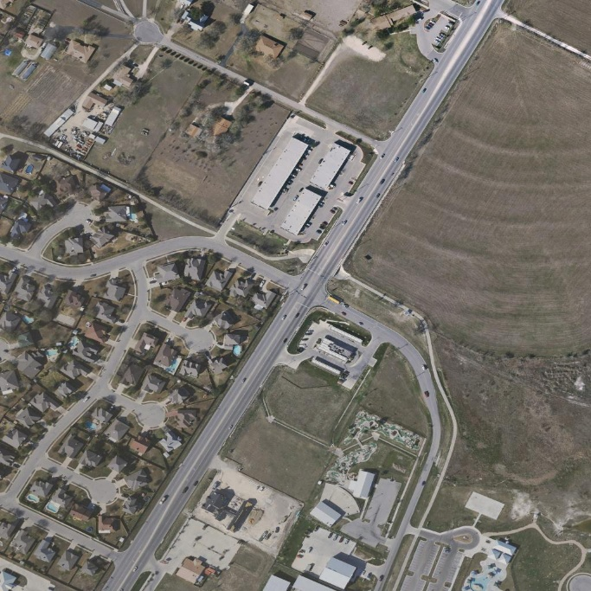
Figure 1 — Input image T1 (“before”): KEMET1 BeforeAfter dataset
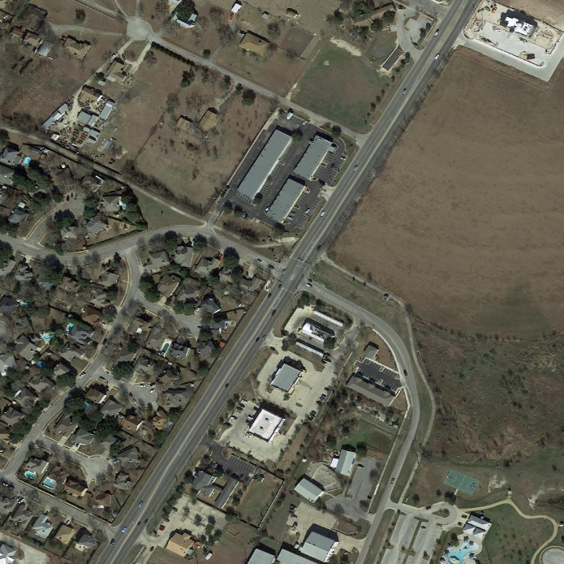
Figure 2 — Input image T2 (“after”): KEMET1 BeforeAfter dataset

Figure 1 — Input image T1 (“before”): cloud-free Sentinel-2 composite of the Nile Delta study area, 2024.

Figure 2 — Input image T2 (“after”): Sentinel-2 composite of the Nile Delta study area, 2025.

2. System Overview
The system is organised as a pipeline of eight sequential stages. Each stage receives a well-defined input, performs one task, and passes its output to the next. The first four stages prepare clean, analysis-ready imagery; the next three perform the core artificial-intelligence analysis; and the final stage fuses all results into the colour-coded map and report. Figure 3 presents the complete pipeline, and Table 2 summarises the model or tool used at each stage together with its output.
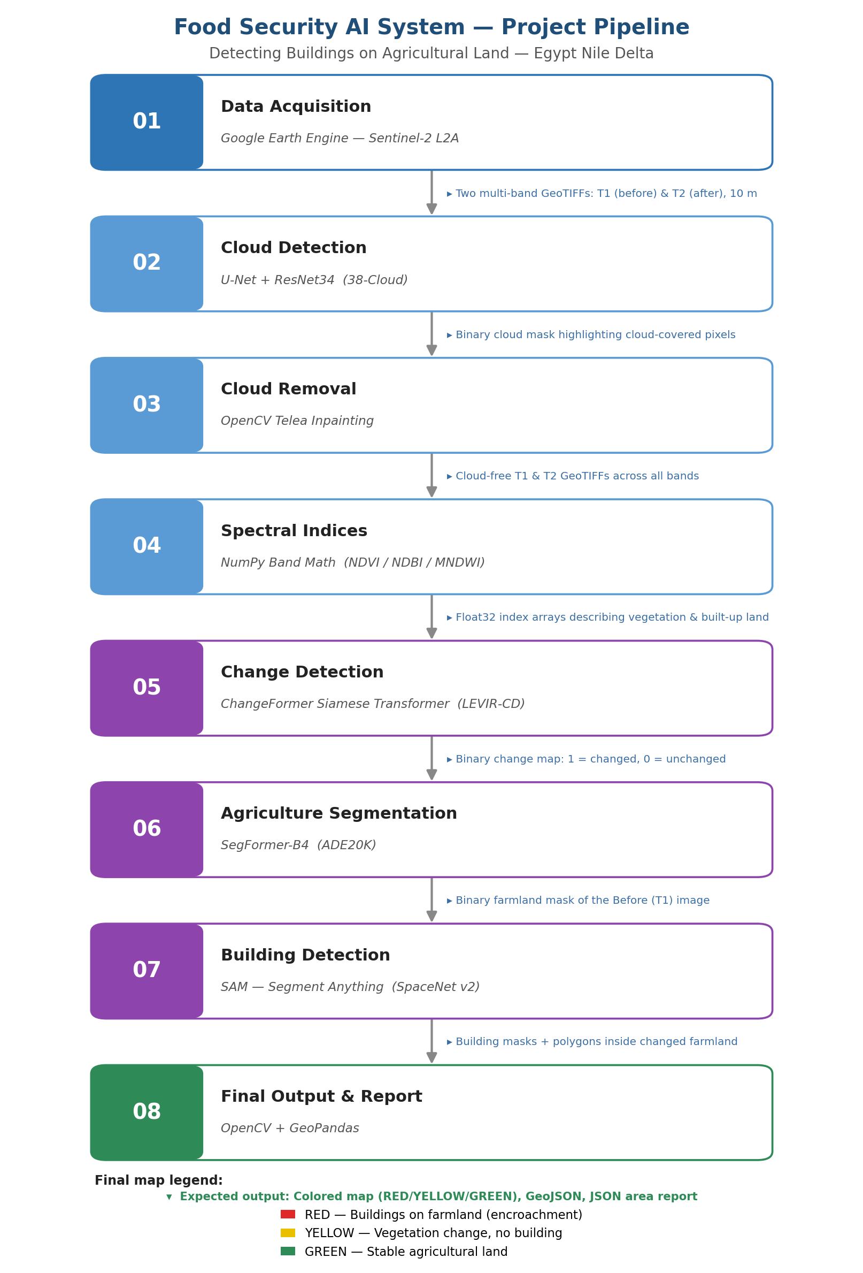
Figure 3 — The eight-stage pipeline, showing the tool at each stage and the output passed to the next.
# | Stage | Model / Tool | Output
01 | Data Acquisition | Google Earth Engine (Sentinel-2) | T1, T2 GeoTIFFs
02 | Cloud Detection | U-Net + ResNet34 | Cloud mask + coverage %
03 | Cloud Removal | OpenCV Telea inpainting | Cloud-free GeoTIFFs
04 | Spectral Indices | NumPy (NDVI, NDBI, MNDWI) | Index maps + degradation signal
05 | Change Detection | ChangeFormer / Random Forest | Change map + confidence
06 | Agriculture Segmentation | SegFormer-B4 (ADE20K) | Agriculture mask
07 | Building Detection | YOLOv8-seg (+ NDBI fallback) | Building mask + polygons
08 | Final Output | Weighted fusion + GeoPandas | Colour map, GeoJSON, report
Table 2 — The eight pipeline stages, their models, and their outputs.
The stages divide naturally into three groups, which organise the remainder of this chapter. Section 3 covers data preparation (Stages 01–04), Section 4 covers analysis and detection (Stages 05–07), and Section 5 covers decision fusion and output (Stage 08). Section 6 presents the results, Section 7 evaluates the system, and Section 8 offers a discussion before Section 9 summarises the contribution.

2.1 Theoretical Background
The system draws on several concepts from remote sensing and deep learning, which are summarised here so that the stage descriptions can remain focused. In remote sensing, a satellite records the reflectance of the surface in several spectral bands; different materials reflect differently across the spectrum, and ratios of bands, known as spectral indices, exploit these differences to measure land-cover properties independently of overall brightness. The system relies on multi-temporal analysis, comparing two images of the same place captured at different times to reveal change.
On the learning side, the system uses three families of neural network. A convolutional network, such as the ResNet encoder used for clouds, extracts spatial features through local filters and is well suited to recognising texture and shape. A Transformer, used by the change and agriculture models, instead relies on a self-attention mechanism that lets every location in an image relate to every other, giving a global view that captures long-range spatial context. The distinction between semantic and instance segmentation is also central: semantic segmentation labels every pixel with a class but does not separate objects, whereas instance segmentation, used for buildings, additionally distinguishes and outlines each individual object. Finally, the system makes extensive use of transfer learning, applying models pre-trained on large public datasets to the project's imagery without task-specific training, which is what allows a complete pipeline to be built without a large labelled dataset for the study area.

2.2 Models and Key Parameters
Table 3 consolidates the principal model and configuration values used across the pipeline, drawn directly from the project's configuration file. These values are referenced individually in the stage descriptions that follow.
Stage | Model / method | Key parameters
02 Cloud detection | U-Net + ResNet34 | prob. threshold 0.5; tile 512; skip < 15% coverage
03 Cloud removal | Telea inpainting (OpenCV) | radius 5; per-band; 16-bit conversion
04 Spectral indices | NDVI / NDBI / MNDWI | safe ratio; NDVI-drop threshold 0.15
05 Change detection | ChangeFormerV6 / Random Forest | threshold 0.29; tile 256, overlap 32; RF val AUC 0.861 / test AUC 0.872
06 Agriculture seg. | SegFormer-B4 (ADE20K) | classes {9,17,29,72,94}; tile 512; NDVI>0.2 fallback
07 Building detection | YOLOv8m-seg | conf 0.35; IoU 0.45; NDBI>0.1 fallback
08 Final output | Weighted fusion | red score 0.65/0.35; red threshold 0.50
Table 3 — Consolidated models and key parameters across the pipeline.

3. Data Preparation (Stages 01–04)
The first four stages transform raw satellite observations into clean, analysis-ready information. They acquire the imagery, remove clouds that would otherwise be mistaken for change, and derive spectral indices that describe the land cover.

3.0 Datasets Used
The pipeline combines one operational data source, the Sentinel-2 imagery of the study area, with several public datasets on which its models were pre-trained or validated. Table 3a lists them together with their role. Only the KEMET1 classifier was trained on data specific to the Nile Delta; the remaining models are applied through transfer learning from general-purpose datasets.
Dataset | Used by | Role
Sentinel-2 L2A (Nile Delta) | Whole pipeline | Operational T1 / T2 imagery of the study area
ImageNet | Cloud U-Net encoder | Pre-training of the ResNet34 feature extractor
LEVIR-CD | ChangeFormer (Stage 05) | Building-change benchmark for the change model
KEMET1 (Delta sites) | Random Forest (Stage 05) | Local training/validation; val AUC 0.861 / test AUC 0.872
ADE20K | SegFormer (Stage 06) | Scene-parsing dataset for land-cover classes
COCO / SpaceNet | YOLOv8-seg (Stage 07) | Object- and building-detection pre-training
Table 3a — Datasets used across the pipeline and their roles.

3.1 Data Acquisition
The pipeline begins by acquiring two Sentinel-2 Level-2A composites for the study area through the Google Earth Engine platform, one for the earlier period (T1) and one for the later period (T2). Cloud-minimised composites are requested so that the imagery is as clear as possible from the outset. Each image is exported as a multi-band GeoTIFF that preserves the geographic coordinate system, so that T1 and T2 remain spatially aligned and can be compared pixel by pixel in the later stages.
The Sentinel-2 mission is well suited to this application: it provides freely available imagery with a revisit time of a few days and a ten-metre resolution in the visible and near-infrared bands, which is fine enough to reveal building clusters yet efficient enough to cover large agricultural areas. The Level-2A product is chosen because it has already been atmospherically corrected to surface reflectance, so that the spectral indices computed later are physically comparable between the two dates. The five bands retained, blue, green, red, near-infrared, and short-wave infrared, are precisely those required by the vegetation, built-up, and water indices, keeping the downloaded data compact.

3.2 Cloud Detection
Optical imagery is frequently contaminated by clouds, which hide the surface and introduce bright, misleading pixels that later stages would interpret as false change. The cloud-detection stage locates every cloud pixel in both images using a U-Net semantic-segmentation network with a ResNet34 encoder pre-trained on the ImageNet collection. The U-Net has an encoder that extracts features while reducing resolution and a decoder that restores resolution to label each pixel, with skip connections preserving fine detail. The network outputs a cloud probability for every pixel, which is thresholded at 0.5 to form a binary cloud mask, and the proportion of cloud pixels is reported as a coverage percentage. When trained weights are unavailable, the stage falls back to a spectral heuristic that flags pixels that are bright across all bands, as clouds characteristically are.
A distinctive design choice couples detection to a decision: if the larger of the two coverage percentages is below fifteen percent, the images are deemed already clear and the removal stage is skipped, avoiding unnecessary processing. Figure 4 shows the combined detection-and-removal flow, including this decision.
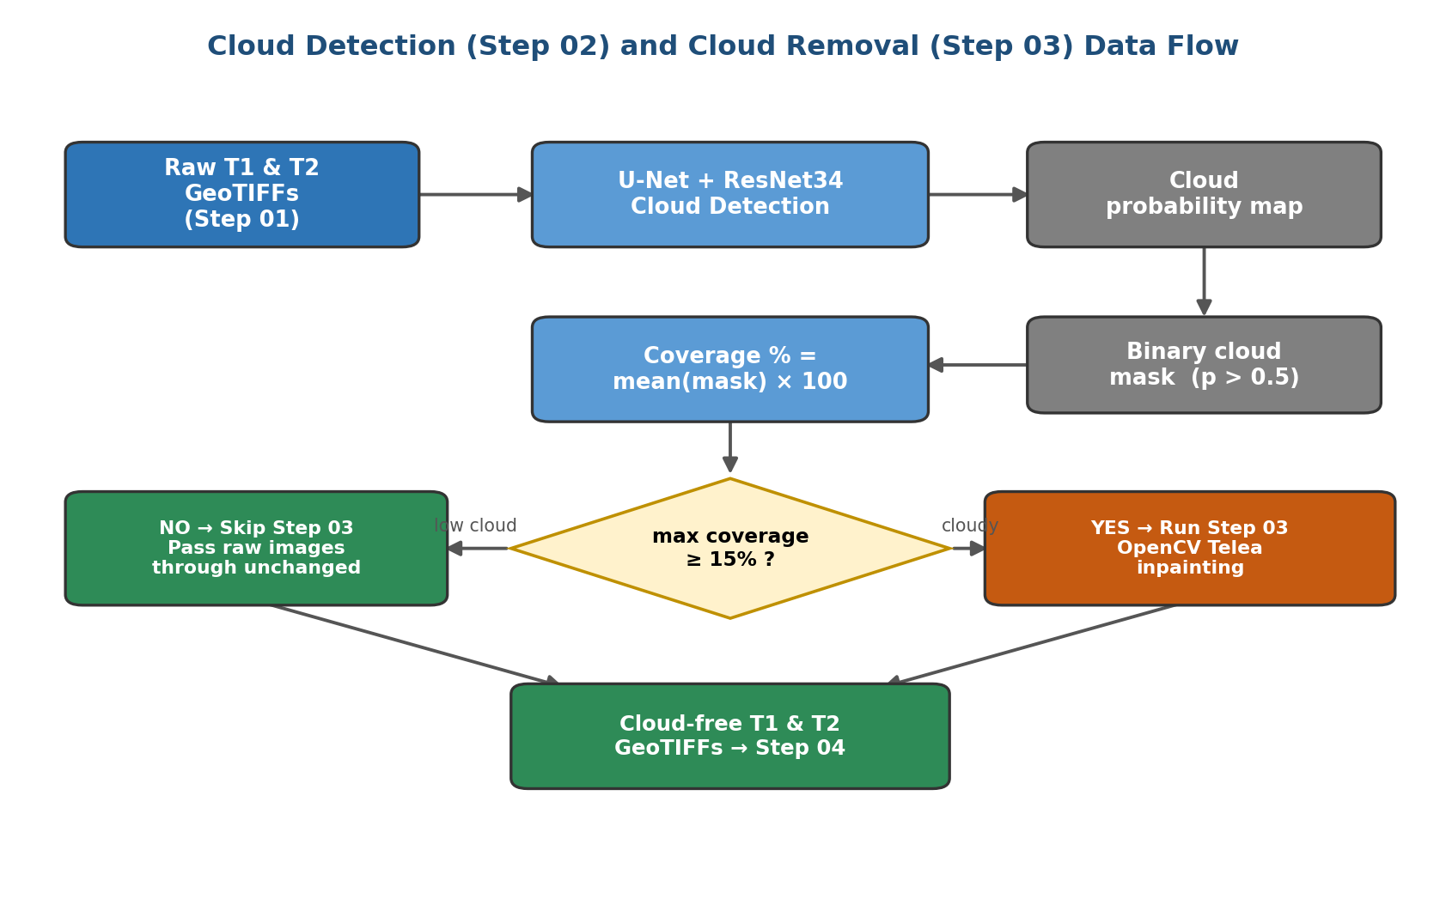
Figure 4 — Cloud detection (Stage 02) and cloud removal (Stage 03), including the coverage-based decision to skip removal when imagery is already clear.

3.3 Cloud Removal
When cloud coverage is high enough to warrant it, the cloud-removal stage reconstructs the obscured pixels so that the image becomes continuous. It uses the Telea inpainting algorithm from the OpenCV library, which fills each masked region by propagating information inward from the surrounding clear pixels, producing a visually seamless result. Because clouds obscure every spectral band, each band is inpainted independently using the same cloud mask, with a small conversion to integer form for the algorithm and back to floating point afterwards, so that the spectral relationships needed later remain consistent. The inpainting radius is set to five pixels, balancing reconstruction quality against over-smoothing. The stage writes cloud-free GeoTIFFs for both dates; when removal is skipped, the raw images are passed through unchanged under the same names, giving downstream stages a consistent interface.

3.4 Spectral Indices
The final preparation stage converts reflectance values into physically meaningful measures of land cover, and, by comparing the two dates, into a signal of vegetation loss. It computes three normalised-difference indices, each of which cancels overall brightness and returns a value between minus one and plus one. The general form and the three indices are given in Equations (1) to (4).
ND = ( A − B ) / ( A + B ) (1)
NDVI = ( NIR − Red ) / ( NIR + Red ) (2)
NDBI = ( SWIR − NIR ) / ( SWIR + NIR ) (3)
MNDWI = ( Green − SWIR ) / ( Green + SWIR ) (4)
The Normalised Difference Vegetation Index (NDVI) is high for healthy crops, because vegetation reflects near-infrared strongly while absorbing red; it is the primary measure of farmland health. The Normalised Difference Built-up Index (NDBI) is high over concrete and rooftops, providing spectral evidence of construction. The Modified Normalised Difference Water Index (MNDWI) is high over water, allowing rivers and canals to be excluded. A small constant is added to each denominator to avoid division by zero.
By differencing the indices between the two dates, the stage forms a degradation signal: the NDVI drop measures vegetation lost and the NDBI rise measures built-up material gained. These are clipped, normalised to the range zero to one, and averaged into a single spectral signal in which high values indicate that healthy farmland has degraded into built-up land. A binary yellow-alert mask additionally flags pixels whose NDVI drop exceeds a degradation threshold of 0.15. Figure 5 shows this flow. The spectral signal and yellow mask feed the final decision stage.
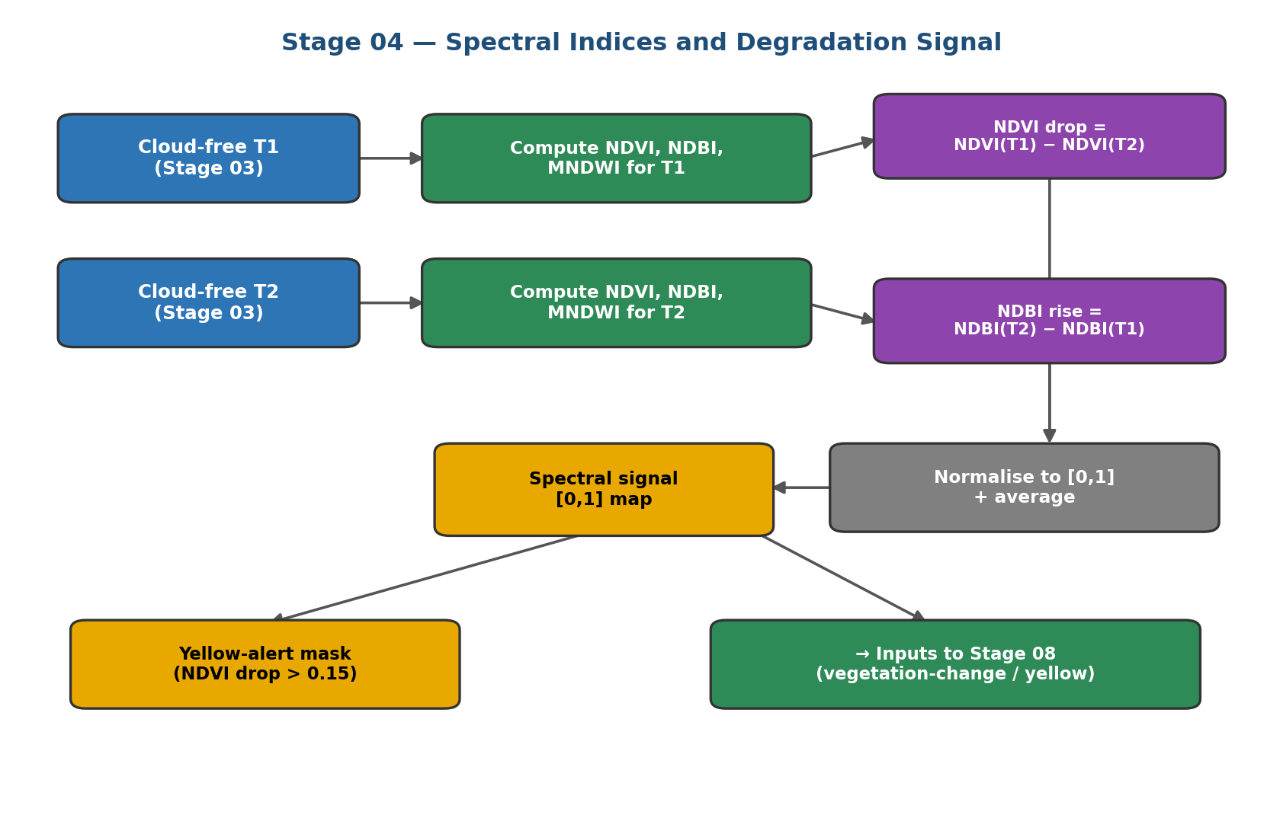
Figure 5 — The spectral-indices stage, from cloud-free imagery to the degradation signal and yellow-alert mask.

4. Analysis and Detection (Stages 05–07)
The middle group of stages performs the core analysis: it identifies where the landscape changed, which areas were farmland, and where buildings now stand. Together they produce the three binary masks that the final stage combines.

4.1 Change Detection
Encroachment is, by definition, a change, so detecting where the landscape has changed is the foundation of the system. This stage compares T1 and T2 and produces a binary change map, marking each pixel as changed or unchanged, together with a continuous change-confidence map. The change map defines the region in which the later stages search for buildings, and the confidence map is reused as evidence in the final encroachment score. The stage supports two interchangeable modes that return the same outputs, as shown in Figure 6.
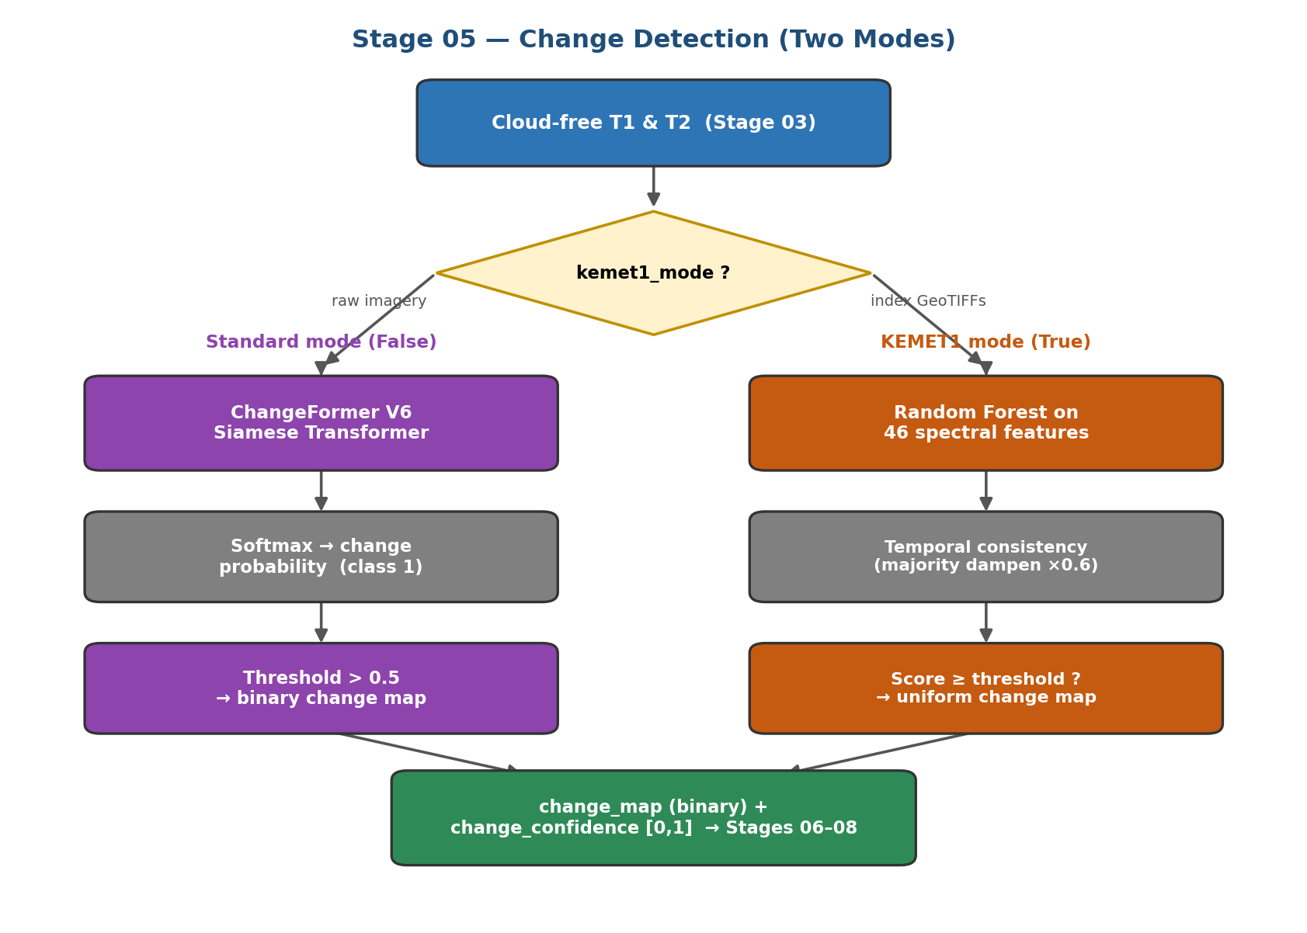
Figure 6 — The two modes of change detection; both converge on a common change map and confidence map.
In the standard mode the detector is ChangeFormer, a Siamese Transformer. Two weight-sharing Transformer encoders process T1 and T2, so that the same content maps to the same features and any difference reflects a true change; a difference module contrasts the features at several scales and a lightweight decoder produces a per-pixel change probability. The two-class output is converted to a probability by the softmax function and thresholded at 0.5, as in Equations (5) and (6).
p_{change} = e^{z₁} / ( e^{z₀} + e^{z₁} ) (5)
M_{change} = 1 if p_{change} > 0.5, else 0 (6)
The model is the ChangeFormerV6 variant with weights pre-trained on the LEVIR-CD benchmark, applied to the scene in overlapping tiles of 256 pixels. Its main limitation is a domain gap: it was trained on very-high-resolution aerial imagery, so it can be over-sensitive on ten-metre satellite data, which motivates the conservative thresholding and the corroboration provided by the spectral and building evidence downstream.
In the second, KEMET1 mode, selected when the inputs are pre-computed spectral-index data, a Random Forest classifier trained on Nile Delta sites predicts a single probability of encroachment from a vector of spectral-change features. A Random Forest is an ensemble of decision trees, each trained on a random subset of the data and features; its prediction is the average vote of all trees, which makes it robust to noise and resistant to overfitting. This is the quantitatively validated configuration of the project, reporting a validation AUC of 0.861 (test AUC: 0.872). When several consecutive image pairs are available, a change that recurs across a majority of them is dampened by a fixed factor, on the reasoning that a repeating seasonal change is unlikely to be construction. The single site-level decision is then expanded into a uniform change map so that the downstream stages operate identically to the standard mode, ensuring the two modes remain fully interchangeable.
The change stage is the natural first analytical step because it acts as a spatial filter: by identifying the small fraction of the scene that changed, it confines the far more expensive building search to a manageable area. It is also the largest single contributor to the final encroachment score, which is why its output is retained not merely as a binary mask but as a graded confidence map. This dual output, a hard decision for filtering and a soft confidence for scoring, is a recurring design pattern in the pipeline that keeps each stage both decisive and informative.

4.2 Agriculture Segmentation
Before a change can be judged as encroachment, the system must know which land was farmland. This stage produces a binary agriculture mask by applying the SegFormer-B4 semantic-segmentation model to the T1 reference image. SegFormer combines a hierarchical Transformer encoder with a lightweight decoder to assign every pixel one of the 150 land-cover classes of the ADE20K dataset; the stage retains the five classes that represent farmland and vegetation (grass, plant, field, land, and farmland) to form the mask. Because the model expects ordinary colour images, the satellite bands are first converted to a red-green-blue picture, and the predicted class map is upsampled to full resolution. The reference image T1 is used deliberately, so that a field later covered by a building is still recognised as having been farmland. When the model cannot run, the stage falls back to classifying pixels with an NDVI above 0.2 as agricultural.

4.3 Building Detection
The agriculture stage occupies a pivotal position: it supplies the land-use context without which no change could be judged as encroachment. Its output is combined with the change map to define the region searched by the building detector, and it is a required condition in the final rule for both the red and yellow classes. Because it is applied to the reference image rather than the later one, it captures the land as it was before any construction, which is exactly the baseline the system needs. Any error here propagates: farmland missed by the mask can never be flagged as encroachment, while non-farmland wrongly included could admit false alarms, so the five-class selection is kept deliberately focused on the categories that genuinely represent cultivated and vegetated ground.
This stage supplies the decisive evidence of encroachment by locating buildings, using the YOLOv8-seg instance-segmentation model. Unlike semantic segmentation, instance segmentation identifies each individual object with a bounding box, a confidence score, and a precise outline, which is exactly what is needed to count buildings and record their shapes. Crucially, the search is confined to the region of interest where the change map and the agriculture mask overlap, so that buildings are sought only on land that both changed and was farmland; detections are accepted only inside this region. This both improves precision, since a building inside an existing town is never counted, and reduces the cost of the detector. The confidence and overlap thresholds are set to 0.35 and 0.45. Figure 7 shows the flow.
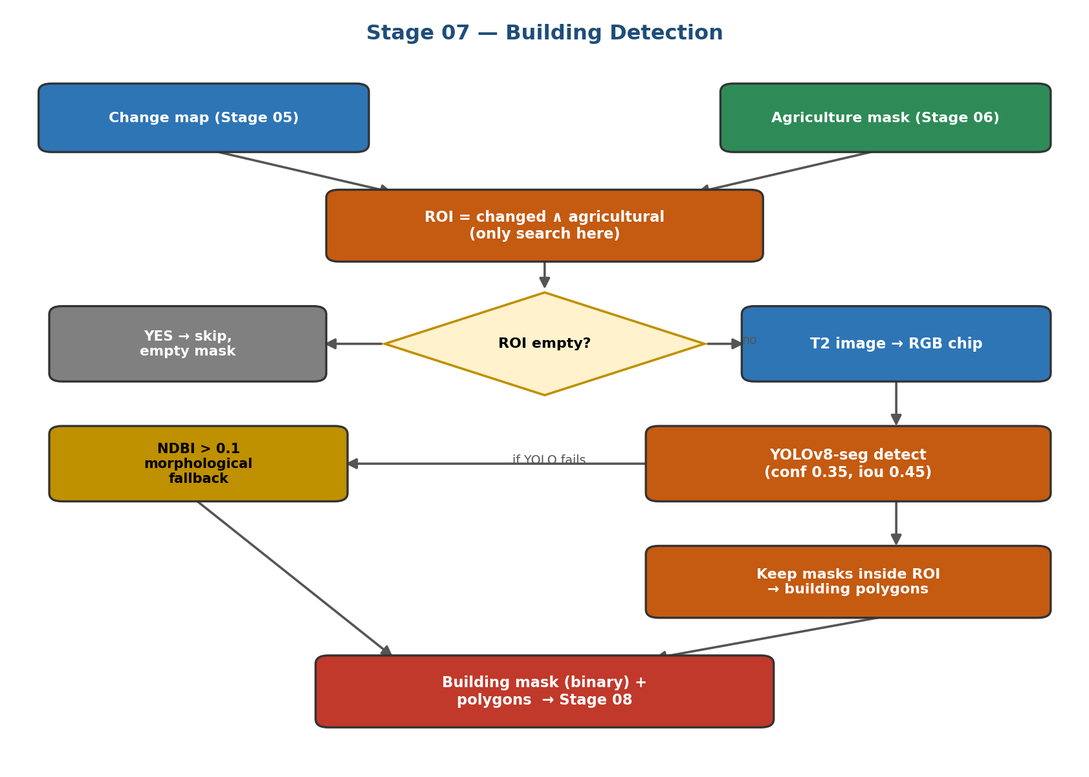
Figure 7 — Building detection: the search is confined to the changed-and-agricultural region of interest.
Should the detector be unavailable, the stage falls back to a spectral rule that flags built-up pixels using the Normalised Difference Built-up Index above 0.1 within the region of interest, then cleans the result with morphological opening and closing to remove noise and fill gaps before extracting polygons. Morphological opening erodes then dilates the mask, deleting isolated specks, while closing dilates then erodes, sealing small holes inside a footprint; together they yield compact, building-like shapes. The stage outputs a binary building mask and a set of building polygons, each recorded with its bounding box and confidence, ready for the final stage.
The choice of an instance-segmentation detector rather than a plain classifier is deliberate: because the system must report how many buildings appeared and how large each is, it needs objects, not just labelled pixels. YOLOv8-seg provides this in a single fast pass, and its confidence score gives a natural way to discard weak detections. Restricting acceptance to the region of interest is the single most important safeguard against false positives, since it structurally prevents any structure inside an existing town, however building-like, from being reported as new encroachment on farmland.
Reconciling the model description
The building-detection stage uses YOLOv8-seg as its primary detector, with the Segment Anything Model (SAM) available only as an optional refinement and an NDBI spectral rule as a fallback. Earlier drafts of the project referred to SAM as the main detector; this chapter follows the actual source code, in which YOLOv8-seg performs the detection.

5. Decision Fusion and Output (Stage 08)
The final stage brings all the evidence together. It fuses the change, agriculture, building, spectral-signal, and yellow-alert results into one classification, renders the colour-coded map, and produces a complete set of deliverables. The decision logic is deliberately simple and interpretable, so that every classified pixel can be explained from its inputs.

5.1 Weighted Red-Alert Score
Rather than relying on the binary change map alone, the stage forms a continuous red-alert score that blends the confidence of the change detector with the strength of the spectral degradation signal, as a weighted sum given in Equation (7).
red_score = 0.65 × change_confidence + 0.35 × spectral_signal (7)
The weight of 0.65 reflects that the dedicated change detector is the primary evidence, while the 0.35 weight lets vegetation loss and built-up gain reinforce or temper the judgement. Both inputs are clipped to the range zero to one, giving a graded score in which higher values indicate a stronger case for encroachment.

5.2 Three-Class Decision Rule
The colour of every pixel is decided by a fixed rule consulting the red-alert score and the three masks, given in Equations (8) to (10) and illustrated in Figure 8.
RED: red_score ≥ 0.50 ∧ building (8)
YELLOW: yellow_mask ∧ not building (9)
GREEN: agriculture ∧ not building (10)
A pixel is red only when its score reaches the threshold of 0.50 and a building was detected there, marking confirmed encroachment; yellow when vegetation degraded but no building is present; and green when it is agricultural with no building. This priority ordering gives every pixel exactly one interpretable label, and is the direct expression of the system's definition of encroachment: a building, on changed and degraded farmland.
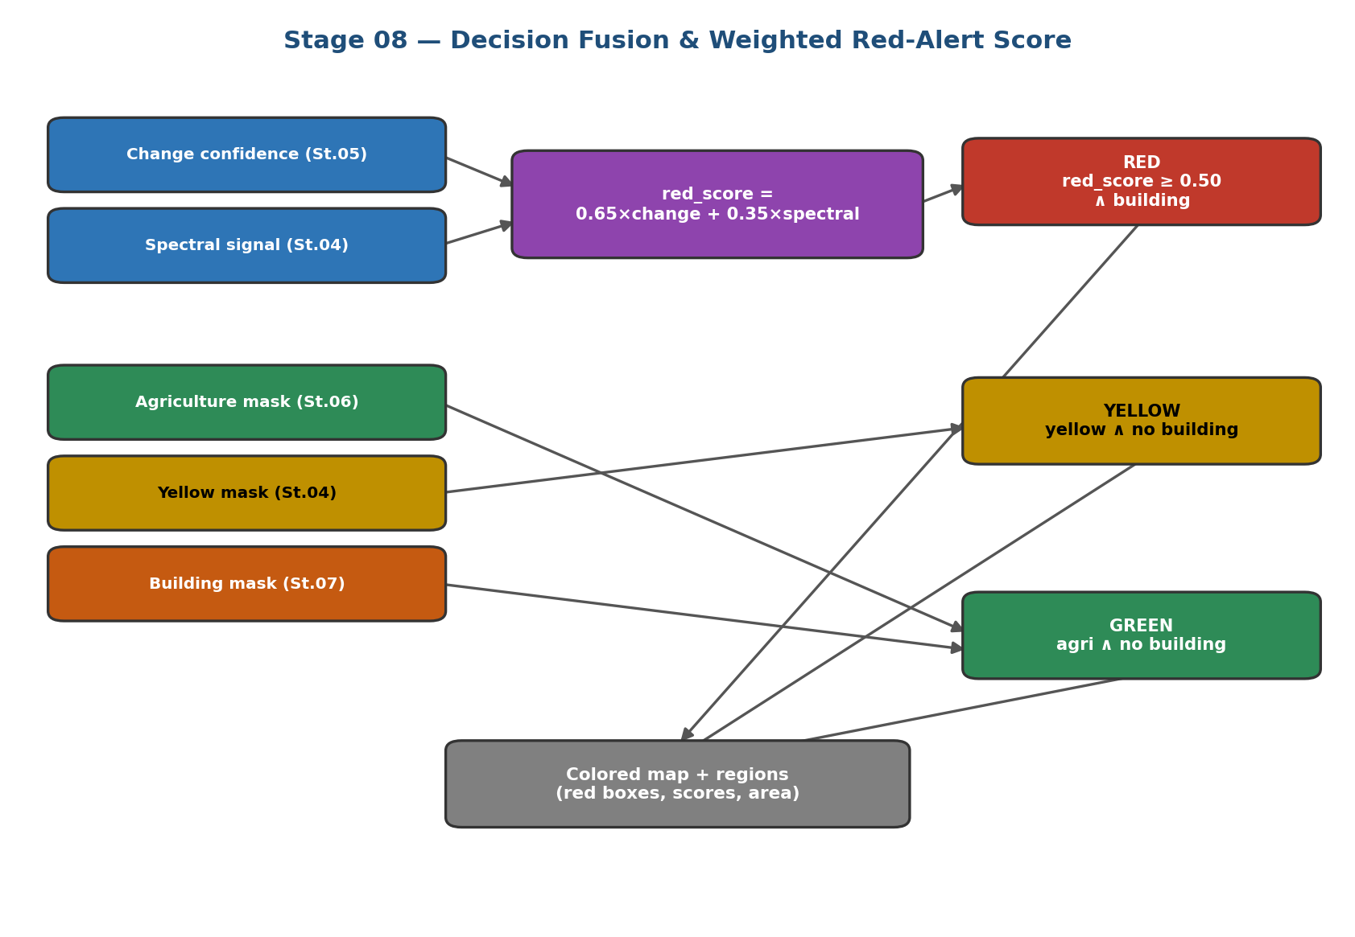
Figure 8 — The decision-fusion logic: a weighted score combines change and spectral evidence, and three rules assign the red, yellow, and green classes.

5.3 Deliverables
Beyond the map, the stage isolates each connected red region as an individual encroachment, computes its area in hectares from the pixel size, and converts its pixel bounding box to latitude and longitude. It then reverse-geocodes each region through the OpenStreetMap Nominatim service to attach a governorate, district, and country name, turning an anonymous cluster into a named location. The full set of deliverables is listed in Table 4.
Deliverable | Format | Contents
final_colored.png / .tif | Image / GeoTIFF | Colour-coded encroachment map
encroachment.geojson | GeoJSON | Vector polygons of encroachment regions
region_chips/ | Images | Before/after chips for each region
interactive_map.html | HTML (Folium) | Clickable web map of all regions
report.json | JSON | Areas, per-region scores, coordinates, weights
Table 4 — The deliverables produced by the final stage.

5.4 Implementation and Execution
The system is implemented in Python as a modular package in which each stage occupies its own module exposing a uniform run function that accepts the arrays and metadata it needs and returns a dictionary of results. A central configuration file holds every path, model identifier, and threshold, so that no numeric constant is hard-coded inside the processing logic and the whole pipeline can be re-tuned from one place. A utilities layer provides shared geospatial operations, including reading and writing georeferenced rasters, extracting a colour view from the multi-band data, and tiling large scenes and re-assembling their predictions.
An orchestrator invokes the eight stages in sequence, records the timing and memory of each, and can resume from a cached intermediate result if an earlier stage has already run. This uniform contract, in which every stage reads its inputs from disk and writes its outputs back, makes the pipeline both observable and restartable: a failure or a change in one stage does not require re-running the others. The design also allows either change-detection mode to be selected without altering any downstream code, and permits each learned stage to fall back to its spectral alternative transparently, so that the pipeline always produces a complete set of outputs.

6. Results
This section presents the outputs of the system on the Nile Delta scene. Figure 9 shows the final colour-coded encroachment map, in which red clusters mark buildings detected on farmland, yellow marks vegetation change without buildings, and green marks stable farmland.
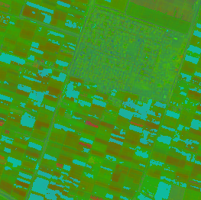
Figure 9 — Final colour-coded encroachment map. Red = confirmed encroachment, yellow = vegetation change, green = stable farmland.
The map shows discrete red encroachment clusters distributed across the agricultural matrix, several adjacent to the existing urban core in the east, consistent with the typical pattern of peri-urban expansion. The dense built-up area in the lower right is correctly excluded from the agricultural analysis. Figures 10 and 11 are reserved for the building-detection outputs and an interactive-map view, and Table 5 for the quantitative results read from the generated report.

6.1 Building-Detection Output
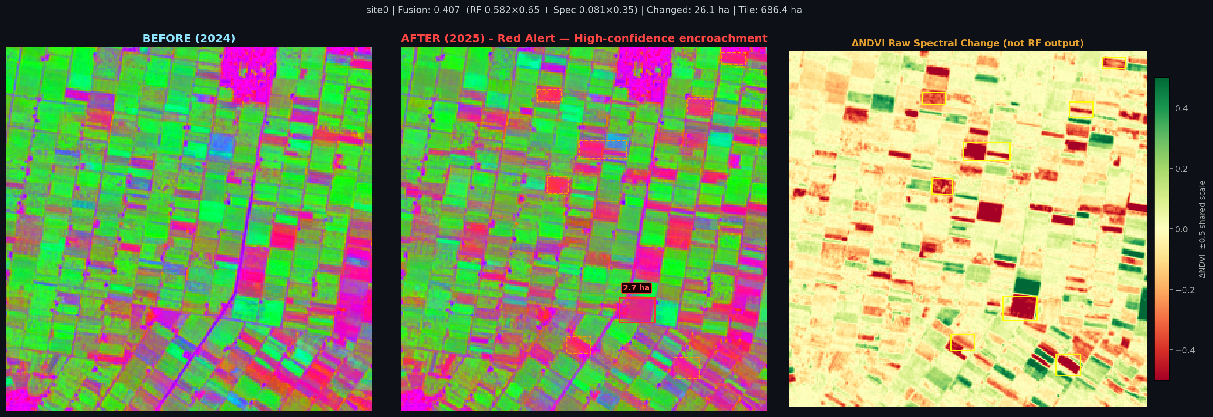
Figure 10 — Site-level pipeline output for Site 0 (Red Alert, fusion score 0.407). Three-panel view: T1 reference composite (left), T2 composite (centre), and detected change overlay (right). Total area flagged: 26.1 ha across 28 change clusters.

6.2 Interactive Map / Region Chip
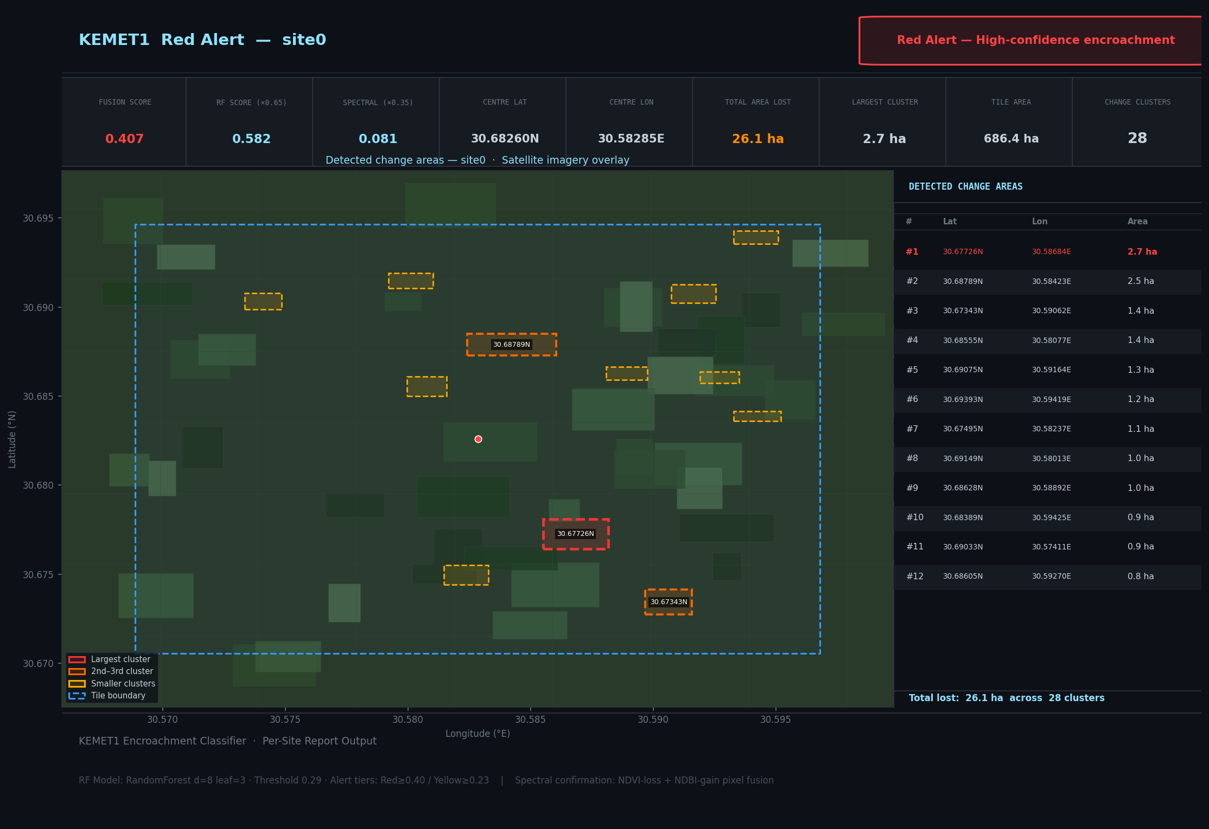
Figure 11 — Interactive map view for Site 0 (30.68°N, 30.58°E, Gharbia Governorate). The dark-themed Leaflet interface displays fusion score, alarm level, total area lost, and a table of individual change clusters with geocoded coordinates.

6.3 Quantitative Results
Table 4 records the numerical results of the run. The values can be filled directly from the corresponding fields of the generated report.json file.
Quantity | Value | Report field
Total encroachment area (ha) | 1,347.9 | encroachment_ha
Spectral degradation area (ha) | 247.3 | yellow_alert_ha
Number of encroachment regions | 76 | total_regions
Change-detection weight | 0.65 | alert_weights.change_detection
Spectral weight | 0.35 | alert_weights.spectral
Table 5 — Quantitative results of the KEMET1 system on the KEMET1 BeforeAfter dataset (78 positive tiles, Nile Delta).
Filling the result slots
Figure 9 is the final_colored.png output. Figure 10 is the building mask or polygon overlay from Stage 07, and Figure 11 can be a screenshot of interactive_map.html or a before/after chip from region_chips/. The values in Table 4 are read directly from the fields of report.json. Insert each image by clicking its placeholder and replacing it with the file.

7. Performance Evaluation
Because the system operates largely in a zero-shot manner on a scene for which no pixel-level ground truth is available, its evaluation combines the benchmark performance of its component models with the operational quantities produced on the study scene. This section defines the relevant metrics and interprets the results against expectation.

7.1 Metrics for the Detection Models
The change- and building-detection tasks are evaluated with the standard metrics of binary and instance detection, defined in Equations (11) to (13). Precision is the fraction of detections that are correct, recall is the fraction of true objects that are found, and the F1-score is their harmonic mean, summarising the trade-off between the two.
Precision = TP / ( TP + FP ) (11)
Recall = TP / ( TP + FN ) (12)
F1 = 2 · Precision · Recall / ( Precision + Recall ) (13)
where TP, FP, and FN are the counts of true-positive, false-positive, and false-negative detections. These metrics matter because detection must balance two opposing failure modes: flagging too much lowers precision, while flagging too little lowers recall. For the change model, the ChangeFormer family reports an F1-score of 0.906 on the LEVIR-CD benchmark under matched conditions; for the validated KEMET1 Random Forest, the project reports a validation AUC of 0.861 (test AUC: 0.872), indicating strong separation between encroachment and non-encroachment sites.

7.2 The Area-under-Curve Metric
The area under the receiver-operating-characteristic curve (AUC), reported for the KEMET1 classifier, measures the probability that the model ranks a randomly chosen encroachment site above a randomly chosen non-encroachment site. It ranges from 0.5 for random guessing to 1.0 for perfect separation, and, unlike accuracy, it is insensitive to class imbalance and to the choice of decision threshold. The observed validation AUC of 0.861 (test: 0.872) indicates that the classifier assigns higher scores to genuine encroachment in the large majority of cases, and on the full 300-tile operational evaluation the pooled AUC reaches 0.990, reflecting the combined benefit of the temporal-consistency filter. These values make it the property most relevant to a screening tool intended to prioritise sites for inspection.

7.3 Operational Quantities
On the study scene itself, the evaluation rests on the areas and counts produced by the final stage, since no reference mask exists for direct pixel comparison. The relevant quantities are the total encroachment area, the spectral-degradation area, and the number of detected encroachment regions, all of which are recorded in the JSON report and are to be entered in Table 5 from the run. Interpreted against expectation, a modest encroachment area distributed across a number of discrete regions adjacent to existing settlement is consistent with peri-urban expansion, whereas an implausibly large changed area would indicate over-sensitivity of the change stage on out-of-domain imagery, a known risk discussed in the next section.

8. Discussion and Limitations

8.1 Strengths
The system has several genuine strengths. Its architecture is modular, with each stage exposing a uniform interface, which makes the pipeline easy to test stage by stage and to extend. Its decision logic is fully interpretable, so that every classified pixel can be explained in terms of its change, agriculture, and building evidence. It requires little or no task-specific training, relying on strong pre-trained models and transparent spectral rules, which makes it immediately applicable to new areas. Finally, it degrades gracefully: every learned stage has a spectral or heuristic fallback, so the pipeline can run end to end even when a model is unavailable.

8.2 Limitations and Challenges
The principal limitation is the domain gap affecting the deep models. The change and building detectors were trained on very-high-resolution aerial imagery, whereas the system applies them to ten-metre Sentinel-2 data of a different region; this mismatch can make the change stage over-sensitive, flagging more of the scene as changed than genuine construction would explain. The reliance on a hard probability threshold compounds this, since small shifts in the input distribution can move many pixels across the threshold. A second challenge is computational: dense inference on a large scene is slow without a dedicated graphics processor, which discourages the repeated experimentation needed to recalibrate thresholds. A third is that the absence of local ground-truth labels prevents a direct pixel-level accuracy assessment on the study scene, so evaluation leans on benchmark figures and operational plausibility.

8.3 Future Work
The clearest path to improvement is domain adaptation: fine-tuning the change and building detectors on a modest set of labelled Nile Delta examples would reduce the domain gap and allow the thresholds to be recalibrated with confidence. Incorporating the spectral built-up and vegetation signals more tightly into the change decision, rather than only into the final score, would provide additional corroboration and reduce false alarms. Finally, extending the temporal analysis to longer sequences of images would let the system distinguish permanent construction from recurring seasonal change even more reliably than the current majority-based dampening allows.

9. Summary and Contribution
This chapter has documented the complete artificial-intelligence system developed by the Data & AI Team to detect buildings constructed on agricultural land in the Egypt Nile Delta. Beginning from two Sentinel-2 images captured at different times, KEMET1 BeforeAfter dataset (300 Sentinel-2 tile pairs across the Nile Delta) specific Areas, the eight-stage pipeline acquires and cleans the imagery, removes clouds, derives spectral indices, detects where the landscape changed, segments the farmland, locates the buildings, and finally fuses all of this evidence into a single, interpretable classification.
The system's contribution is a modular, largely training-free pipeline that combines deep-learning models, a Siamese Transformer for change, a semantic segmenter for farmland, and an instance segmenter for buildings, with transparent spectral and logical rules, and that degrades gracefully to simpler methods whenever a model is unavailable. Its headline deliverable is a colour-coded map, backed by hectare-level statistics, geolocated regions, vector polygons, and an interactive map, in which every classified pixel can be traced to its underlying evidence. This interpretability is essential for a tool intended to support land-use enforcement and food-security planning, and it constitutes the Data & AI Team's contribution to the wider graduation project.

