Assignment 01 – To-Do List App

Name: Shahd Ahmed Mahmoud Owais
Helwan University – Faculty of Engineering (FEHU)

1. Project Overview
The purpose of this assignment was to create a simple To-Do List application using React Native and Expo. The application allows users to add tasks, view them in a scrollable list, and provides a clear interface for goal management.
Key Components Implemented:
- Text: For displaying the title of the app.
- TextInput: For user input of tasks/goals.
- Button: To add items to the list.
- FlatList: To display the list of goals and handle scrolling.

2. App Logic
The app uses React Native state management to handle user interactions.

States:
- enteredGoalText: stores the text typed in the TextInput.
- courseGoals: stores the array of goals added by the user.

Functions:
- addGoalHandler(): triggered on button click. Adds the input text to the courseGoals array and clears the TextInput.

3. Design
The design is clean and user-friendly. Consistent colors and custom fonts enhance usability.

Color Palette:
- Primary Color: #4a90e2 (blue)
- Secondary Color: #ffffff (white)
- Accent Color: #f5a623 (orange)

Fonts:
- Heading Font: Playfair Display (Bold)
- Body Font: DM Sans (Regular)
Fonts added using Expo Fonts Documentation.
Screenshots:
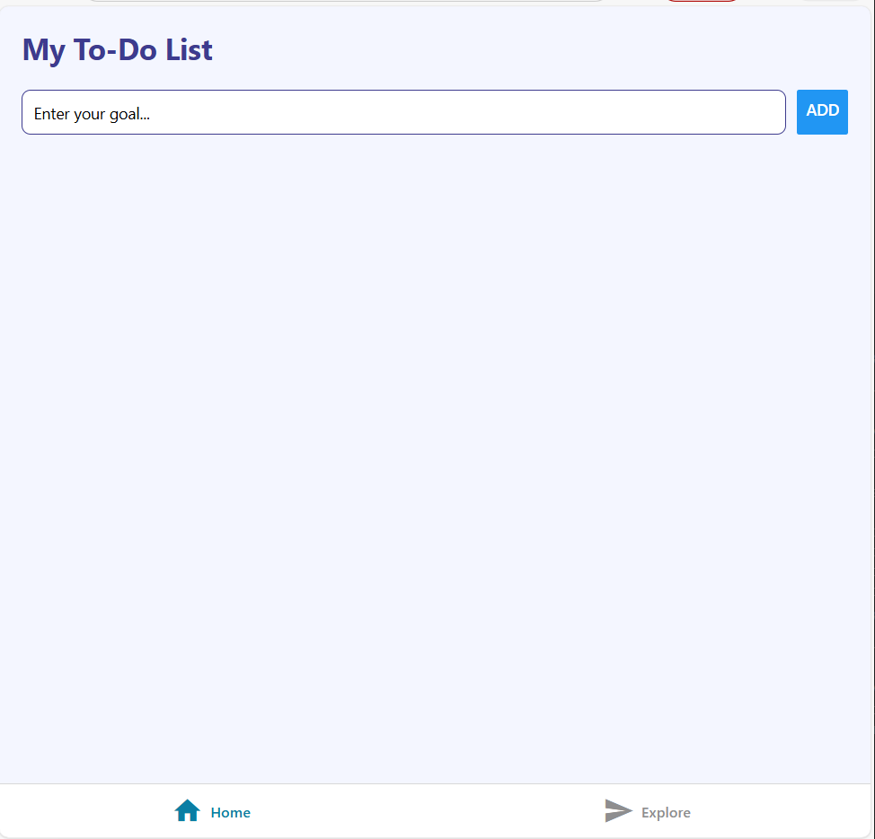
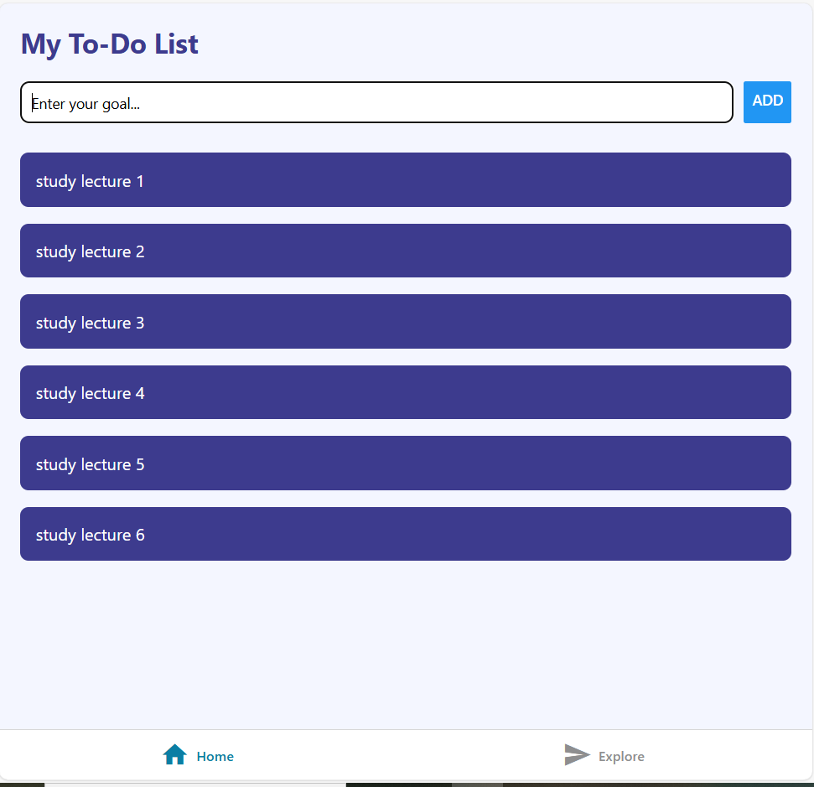
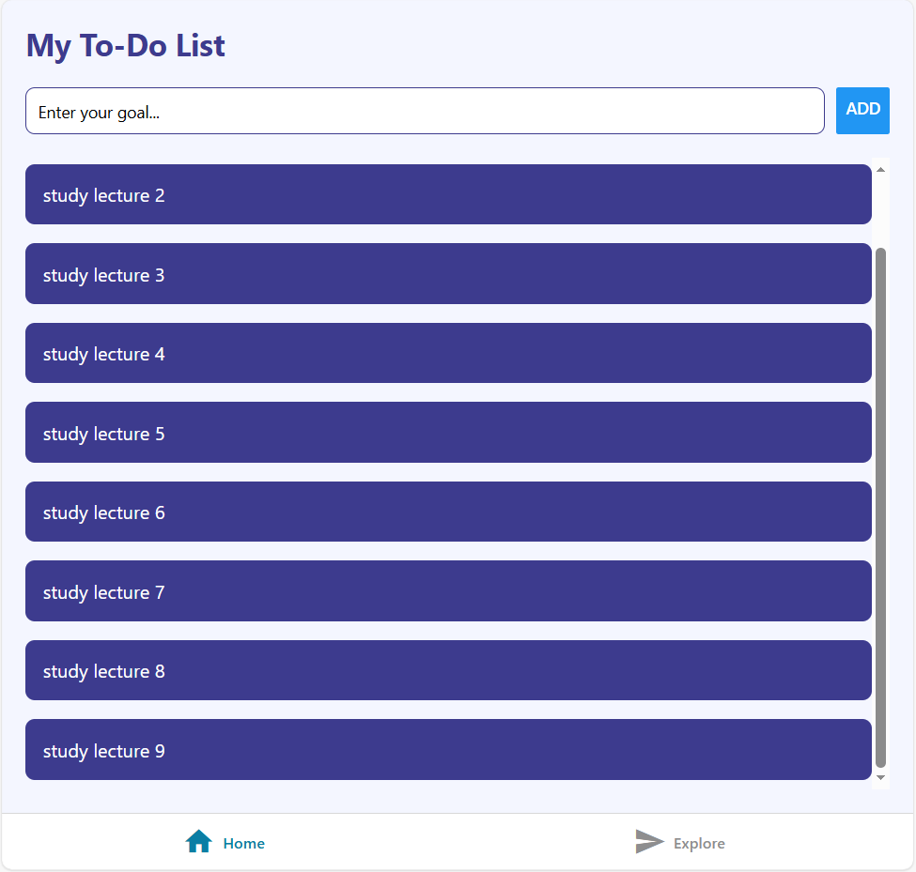

4. Code & Deployment
- Expo Snack Link: Talking Blue Fudge
- GitHub Repository Link: To-Do List Mobile App

Note for Instructor
Please note that the node_modules folder has been removed from this repository to reduce its size.
Before running the project, make sure to install the dependencies by running:
npm install

5. Conclusion
The app successfully demonstrates:
- State management in React Native
- Event handling via buttons
- Dynamic rendering using FlatList
- Custom fonts and color consistency
It fulfills all the requirements of Assignment 01 and provides a simple yet elegant user interface.

