Abdelrahman Saad Idrees

Task 1: Deep Protocol and OS Fingerprinting

Full-Range Service Enumeration:

Intro:
After doing the research, the command that will be used is :
sudo nmap -sS -p- -sV -oX file_name.xml -oN task1_file_name.nmap <TARGET_IPV4>
Explanation of flags:
- -sS = SYN stealth scan.
- -p- = tells Nmap to try every TCP port from 1 through 65535.
- -sV = for ports that respond as open, ask for their name and version.
- -oX = XML output.
- -oN = normal human-readable output(to make it in the .nmap format)

Screenshots:
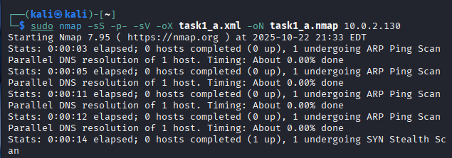
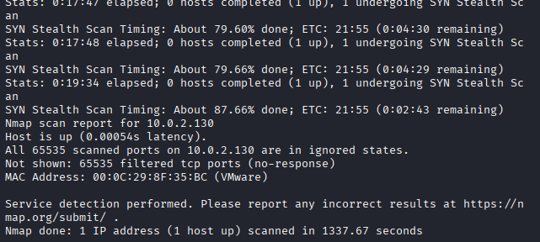

Description:
In this point, we want to traverse on all ports on the target machine using SYN stealth scan and report the service name and version that we found.

Aggressive OS Detection and Timing:

Intro:
After doing the research, the command that will be used is :
sudo nmap -O -sV --traceroute -T0 -oN file_name.nmap <TARGET_IPV4>
Explanation of flags:
- -O = OS detection.
- --traceroute = run traceroute.
- -T0 = paranoid timing (very slow, minimal network impact). May greatly increase scan time.
- -oN creates .nmap.

Screenshots:
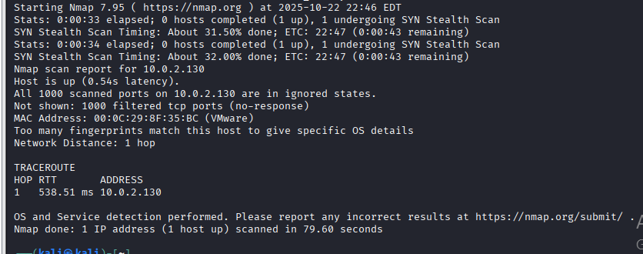

Description:
In this point, we want to discover the OS and more info about the service that exist in the target.
To do so, we created a path to the target.
The idea is to do this with minimal visible impact by using the slowest timing template.
So we sent those probes very slowly using -T0.
And By this we reduced the chance of detection, logging spikes, or disrupting the target.

IPv6 Scan:

Intro:
Here we perform host discovery and a TCP port scan against an IPv6 address (instead of IPv4).
Scan top 1000 ports.
Detect the service and the version.
We want to find which services are reachable over IPv6 and compare how IPv6 scanning behavior differs from IPv4.

Work
When I wrote sudo nmap -6 -sS --top-ports 1000 -sV -T2 -oN task1_ipv6.nmap <TARGET_IPV6>
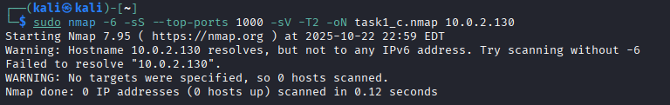
And I think that is becaue the blocking
so after “netsh advfirewall set allprofiles state on” in the windows virtual
And changing the command to
sudo nmap -6 -Pn -sS --top-ports 1000 -sV -T2 -oN task1_ipv6_linklocal.nmap "fe80::71e3:4bfa:589c:d757%eth0"
which is :
- -6 → Use IPv6 scanning mode
- -Pn → Skip host discovery (assume host is up)
- -sS → TCP SYN scan (stealthy)
- --top-ports 1000 → Scan the 1000 most common ports
- -sV → Detect service versions on open ports
- -T2 → Moderate timing (less aggressive)
  - We can use T0 but it is tooo slow.
Here is the output screenshot
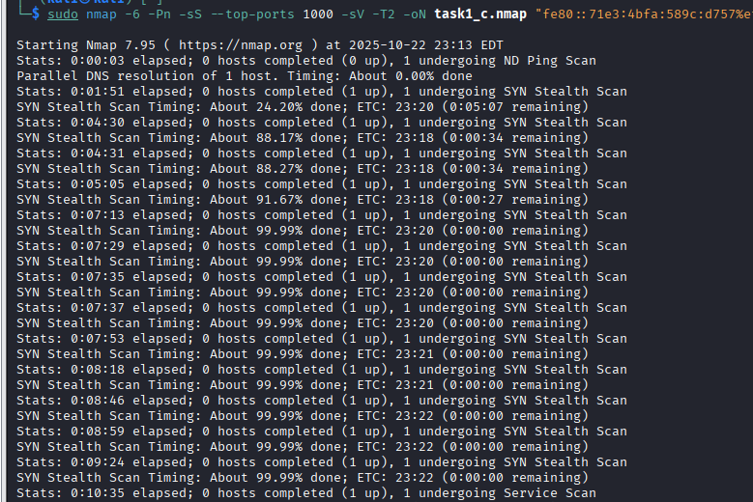

Task 2: Evasion and Customized Packet Crafting

Custom MTU and Data Length:
send very small IP packets.
add extra random payload bytes so you can notice the IP fragmentation behavior, how IDS/firewalls / middleboxes handle fragmented/misaligned packets, whether the target reassembles fragments and responds.

Start a capture on the scanning host
Run the Nmap scan (IPv4 example)
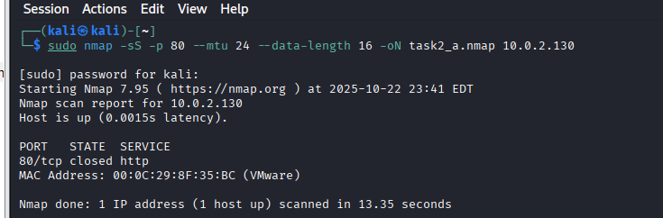
The flags that used in this command are :
- --mtu 24 — request Nmap to craft packets with an IP payload size that forces fragmentation (very small).
- --data-length 16 — append 16 random bytes to each probe packet.
- -sS — SYN stealth scan so you still get port responses if reassembly happens.

Bad Checksum/Firewall Bypass:
Send packets with intentionally incorrect checksums to see whether older or misconfigured firewalls will forward them to the target.
Because there are devices that accept this corrupted scenarios.
The command that I will use is
Using --badsum produced malformed packets; the capture shows incorrect IP/TCP checksums and the target did not reply. This indicates modern NIC/OS stacks or firewalls dropped invalid checksums — bypasses are unlikely on up-to-date infrastructure.”

The output is
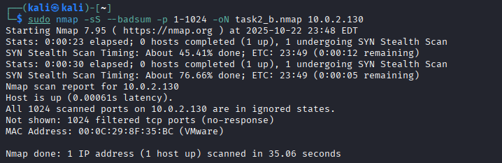
Running nmap --badsum against 10.0.2.130 produced no responses: all scanned ports were reported as filtered, indicating malformed packets were dropped by the network/host.

List Scan and Input File:
Create a text file containing at least 20 IP addresses (some live, some inactive).
Use Nmap’s List Scan (-sL) with that file to just list the targets (no probes).
Then run a parallel ping scan (host discovery only) using the same input file (-iL) to see which hosts are up.

The first command is to create the file
cat > ips.txt <<'EOF'
10.0.2.10
10.0.2.11
……
EOF

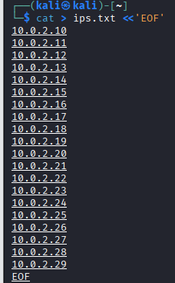

List the scan
- -sL => list scan (no probes)
- -iL ips.txt => read targets from file
- -oN => save human readable output
- -v => verbose (shows progress)
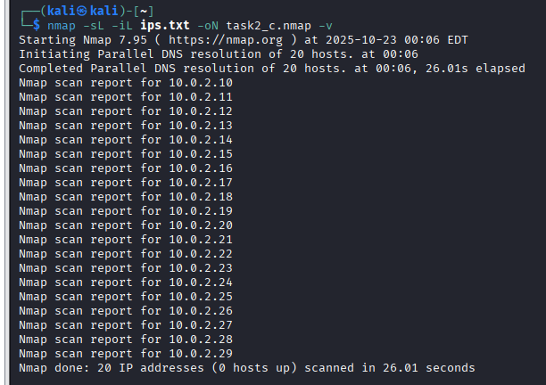

Parallel Ping Scan
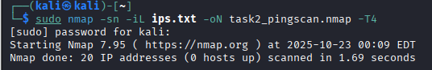
- -sn => ping scan only (no port scan)
- -T4 => faster timing (good in controlled lab)
- -oN => save output file

