Environmental Studies

Assignment2

Name:Shahd Ahmed Mahmoud Ewais

01 SITTING POSTURE ERGONOMIC ANALYSIS

1.1 Personal Anthropometric Data

Measurement | Value | Classification
Height (A) | 155 cm | 25th percentile female
Weight | 64 kg | Healthy range
BMI | 26.6 | Overweight (25-30)

1.2 Key Dimensional Values from Lecture Diagrams

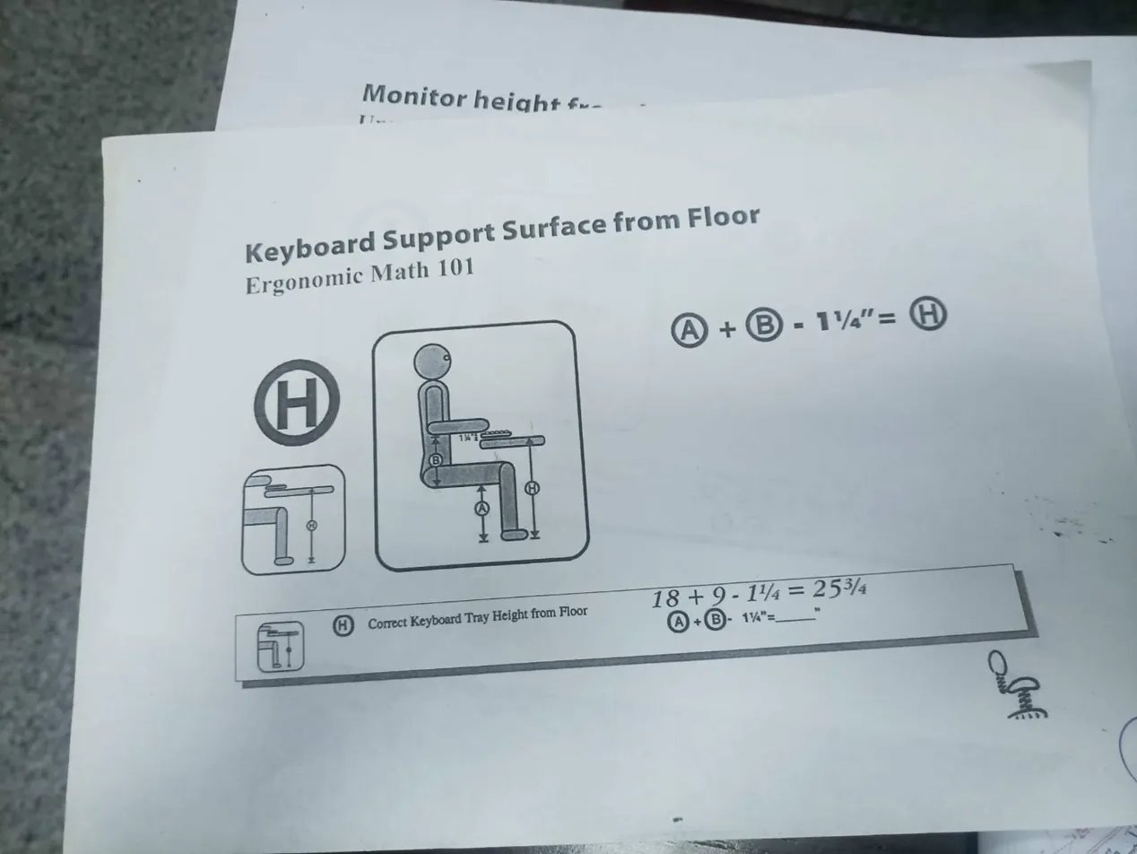
Figure 1.1: Keyboard Support Surface from Floor — Ergonomic Math 101
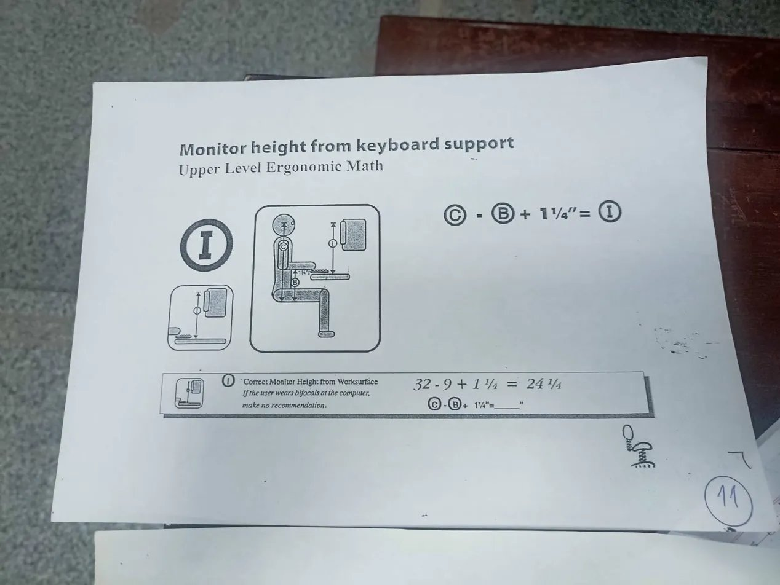
Figure 1.2: Monitor Height from Keyboard Support — Upper Level Ergonomic Math

From the lecture diagrams and applying my dimensions and the seat in the college , the following ergonomic equations are provided:
H = A + B - 1¼″
I = C - B + 1¼″

For the subject (Height A = 155 cm = 61.0″):
Variable | Description | Value (cm) | Value (inches)
A | Popliteal Height (seat) | 42 | 15.2"
B | Elbow Rest Height (from seat) | 24 | 8.7"
C | Eye Height Sitting | 81 | 29.5"
H | Keyboard Tray from Floor | 57.3 | A+B-1.25" = 22.6"
I | Monitor Top from Keyboard | 56.2 | C-B+1.25" = 22.1"

1.3 Correct vs Incorrect Sitting Postures

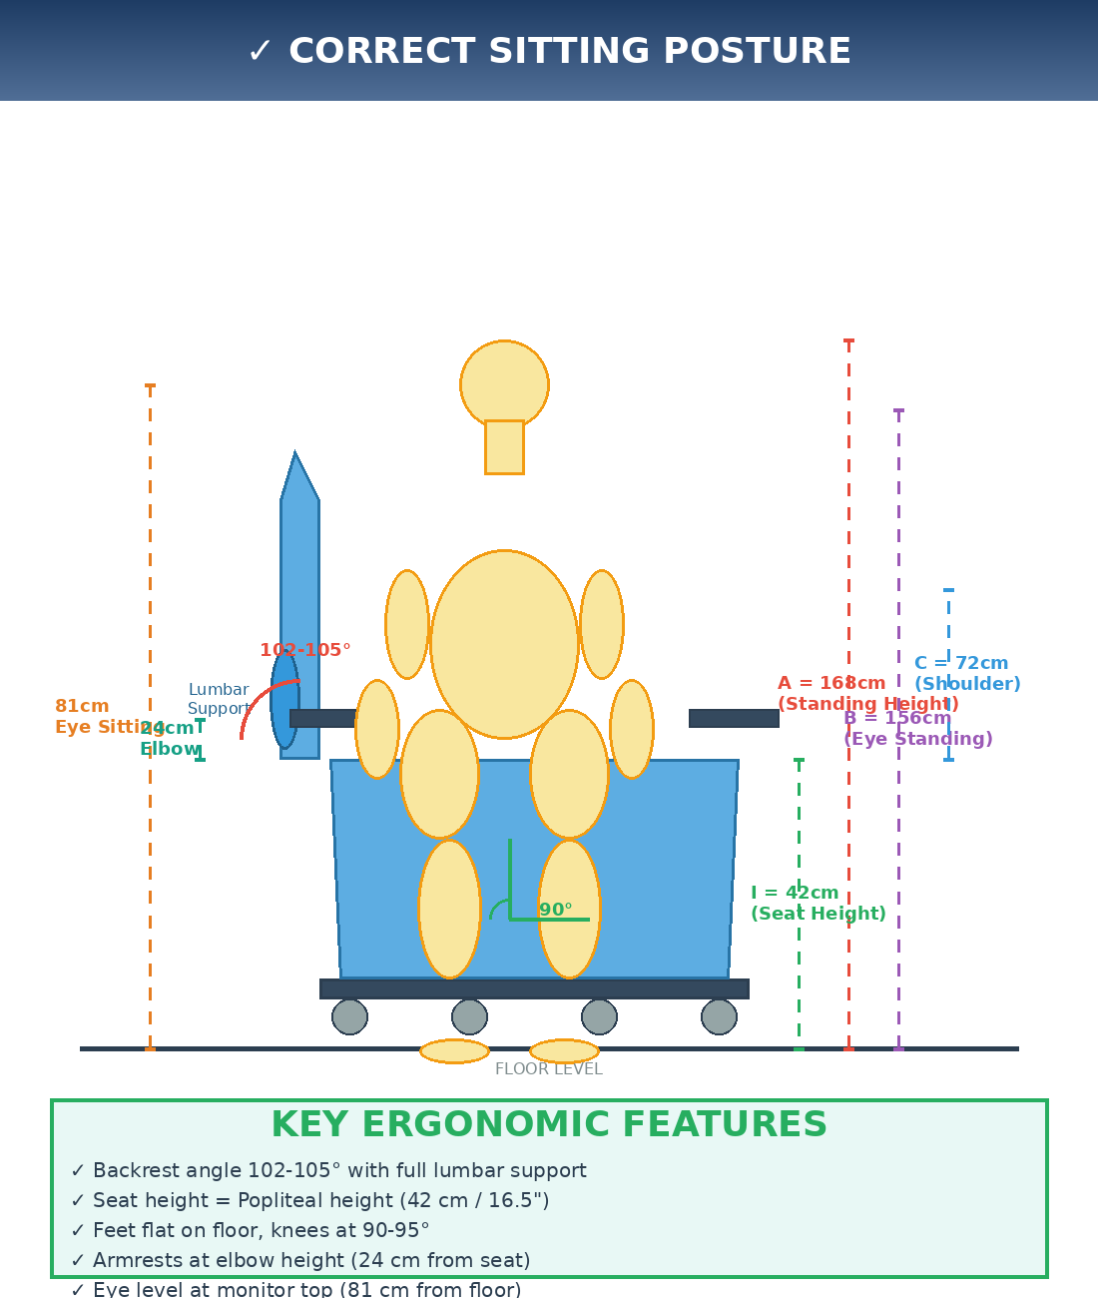
Figure 1.3: CORRECT Sitting Posture — 102-105° backrest, feet flat, lumbar support
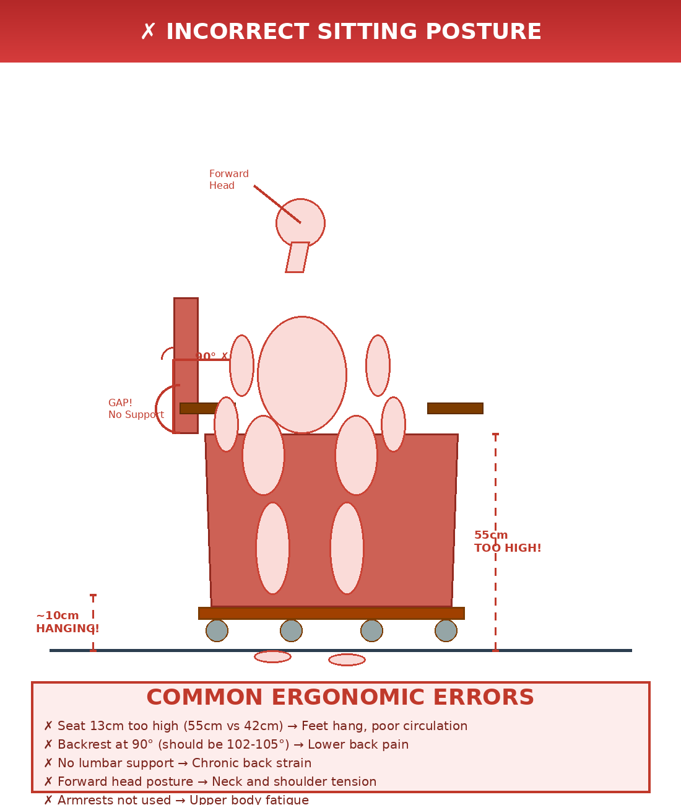
Figure 1.4: INCORRECT Sitting Posture — 90° backrest, feet hanging, no lumbar support
1.4 Ergonomic Standards and Deviations
Feature | Correct Posture | Incorrect Posture | Consequence
Seat Height (A) | 42 cm (popliteal) | 55 cm (too high) | Circulation problems
Backrest Angle | 102-105° | 90° (upright) | Lower back pain
Lumbar Support | Full contact | Gap present | Disc compression
Feet Position | Flat on floor | Hanging ~10cm | Poor posture
Knee Angle | 90-95° | <80° | Thigh pressure

ERGONOMIC RECOMMENDATION: Use adjustable chair with seat height 38-46 cm, lumbar support, backrest recline 100-110°. Ensure feet flat on floor or use footrest.

02 THERMAL LOAD & SOLAR RADIATION IMPACT
2.1 Problem Statement
A lecture hall (15m × 12m × 7m, 10% occupancy) houses 34 students for 2 hours. Initial temperature: 25°C. Final temperature: 32°C. Analyze thermal load from occupants and solar radiation through 6 glass windows (1m² each).
2.2 Given Data
Parameter | Value | Unit
Room dimensions (L×W×H) | 15 × 12 × 7 | m
Total volume | 1260 | m³
Occupancy rate | 10% | —
Net air volume | 1134 | m³
Number of people | 132 | persons
Initial temperature (T₁) | 25 | °C
Final temperature (T₂) | 32 | °C
Temperature rise (ΔT) | 7 | °C
Duration | 120 | minutes
Windows (count × area) | 6 × 1 | m²
Glass transmittance | 0.85 | —
Solar irradiance (Cairo, noon) | 700-800 | W/m²
Wall U value | 0.8 | W/(m²·K)

2.3 Thermal Energy Calculation
Heat capacity of air:
Q = ρ × V × Cₚ × ΔT
Where: ρ = 1.2 kg/m³ (air density), Cₚ = 1005 J/(kg·°C) (specific heat)
Q = 1.2 × 1134 × 1005 × 7 = 9,538,000 J ≈ 9.54 MJ
2.4 Heat Sources
① METABOLIC HEAT (Occupants):
Q_people = 132 persons × 100 W/person = 13,200 W
Over 2 hours: 13,200 × 7,200 s = 95,040,000 J=95.04 MJ

② SOLAR RADIATION (Windows) and walls conduction:
A_glass = 6 windows × 1 m² = 6 m²
Q_solar = A × I × τ = 6 × 750 × 0.85 = 3,825 W
Over 2 hours: 3,825 × 7,200 s = 27.5 MJ
③ CONDUCTION THROUGH WALLS:
- U = 0.8 W/(m²·K) (Overall heat transfer coefficient)
- A = Wall surface area = 2×(15×7) + 2×(12×7) = 210 + 168 = 378 m²
- Average indoor temperature = (25 + 32)/2 = 28.5°C
- Outside temperature = 35°C
- Temperature difference (outside - inside) = 35 - 28.5 = 6.5°C
- Time = 7200 seconds
Qwalls=U×A×ΔT×timeQwalls​=U×A×ΔT×timeQwalls=0.8×378×6.5×7200
Qwalls​=0.8×378×6.5×7200Qwalls=0.8×378×46,800
Qwalls​=0.8×378×46,800
Qwalls=14,152,320 J=14.15 MJ
Qwalls​=14,152,320 J=14.15 MJ
Note: Since outside temperature (35°C) > inside temperature (28.5°C), this is heat gain, not loss!
④ TOTAL HEAT GAIN:
Q_total = Q_people + Q_solar + conduction = 95.04 + 27.5+14.15 = 136.73 MJ
This represents 92.2% of the total heat input!
2.5 Energy Balance Analysis
The actual temperature rise (7°C) requires only 9.54 MJ, but total heat input is 52 MJ. This discrepancy indicates significant heat loss through:
- Wall conduction (~14.15 MJ based on U-value 0.8 W/m²·K, surface area 378 m²)
- Ventilation/infiltration (~15 MJ through door gaps, windows)
- Radiation to surroundings (~7 MJ)
Component | Energy (MJ) | Percentage
Heat input (people + solar) | +136.73 | 100%
Stored in air (ΔT=7°C) | +9.54 | 7%
Absorbed by building | +127.19 | 93%

2.6 Ventilation Requirements
To maintain 25°C, required cooling capacity:
P_cooling = Q_gain / time = 136.73 MJ / 7200 s ≈ 19 kW
Or increase ventilation rate to 8-10 air changes per hour (ACH).
2.7 Air Renewal Time
Method 1: AC
t = 1134 / 50 = 22.68 minutes
Method 2: Windows + Door
Windows: 6 × 1 × 0.1 = 0.6 m³/s = 36 m³/min
Door: 2 × 2 = 4 m³/s = 240 m³/min
Total = 276 m³/min
t = 1134 / 276 = 4.11 minutes
Method 3: Plants (O₂ only)
O₂ consumption: 132 × 0.00025 = 0.033 m³/min
O₂ in 2 hours = 0.033 × 120 = 3.96 m³
Plants production = 0.012 m³/min
t = 3.96 / 0.012 = 330 minutes = 5.5 hours
2.8 Air Changes per Hour (ACH)
Required for cooling = 7.15 ACH
Required for CO₂ control = 3.0 ACH
Natural ventilation = 14.6 ACH ✓ (but brings hot air)
AC ventilation = 2.65 ACH ✗ (insufficient for cooling)
2.9 CO₂ Concentration (No Ventilation)
CO₂ produced = 132 × 0.0003 × 120 = 4.75 m³
Initial CO₂ = 1134 × 0.0003 = 0.34 m³
Final CO₂ = 5.09 m³
Concentration = 5.09/1134 = 0.00449 = 4490 ppm
Safe limit = 1000 ppm → NEED VENTILATION!
2.10 Required Cooling
Cooling needed = 136.73 MJ / 7200s = 19 kW (5.4 tons)
Conclusion : Solar radiation through glass contributes 20% of total heat gain. Using solar control film (τ=0.4) would reduce solar gain by ~53% (from 27.54 MJ to 12.95 MJ), decreasing total load by ~10.6%. However, with 132 occupants generating 95 MJ of heat, the primary cooling requirement is 19 kW. Install HVAC with minimum 19 kW (5.4 tons) cooling capacity and provide 3.0 ACH fresh air for CO₂ control
03 COMPREHENSIVE ANTHROPOMETRIC DIMENSIONS
3.1 Measurement Data Sheets

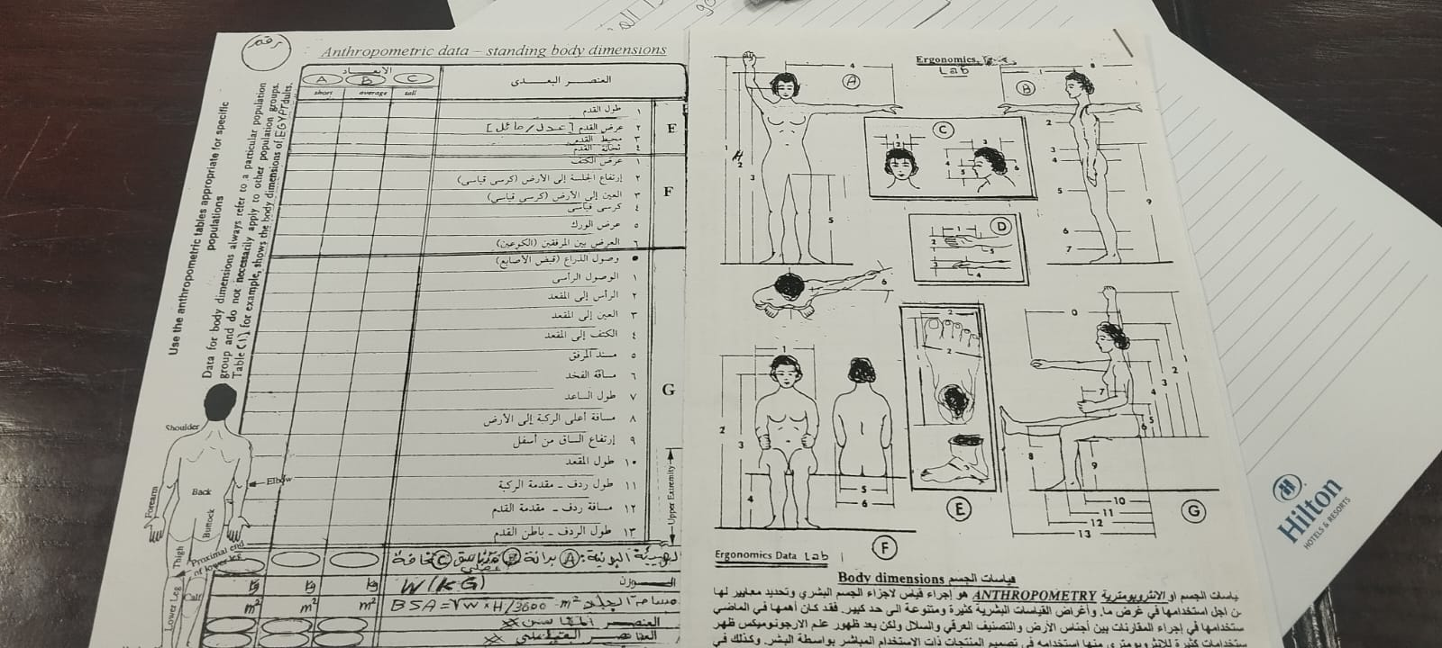
Figure 3.1: Anthropometric Data Collection Sheet 1
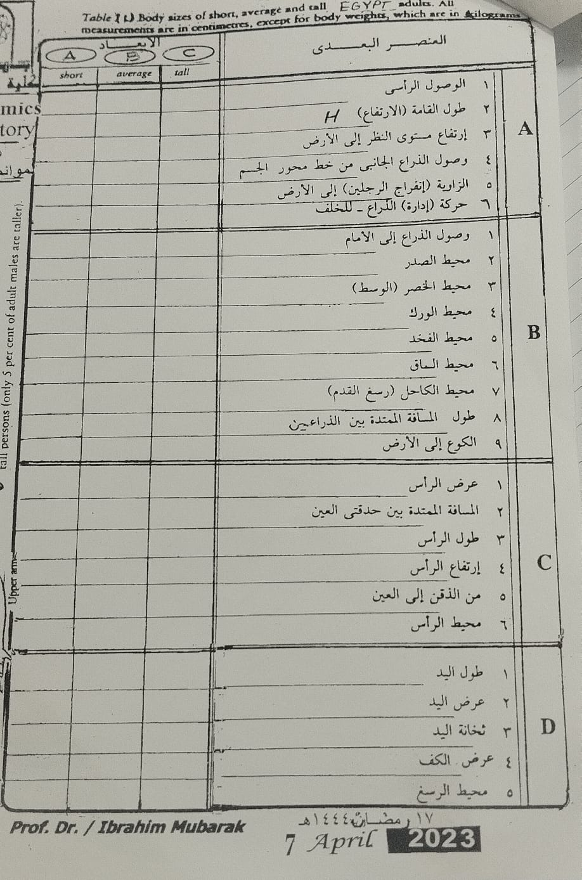
Figure 3.2: Anthropometric Data Collection Sheet 2 with Body Diagrams

3.2 Calculated Dimensions (Based on 155 cm Height)
All measurements calculated using standard anthropometric ratios for adult female. Values rounded to nearest centimeter.

Section | No. | Dimension Name | Value (cm) | high | average | low
A (Standing) | 1 | Vertical Reach | 195 | -- | ✓ | --
 | 2 | Standing Stature (Height) | 155 | -- | ✓ | --
 | 3 | Eye Height Standing | 156 | -- | ✓ | --
 | 4 | Shoulder Height Standing | 135 | -- | ✓ | --
 | 5 | Hip Height | 90 | -- | ✓ | --
 | 6 | Knuckle Height | 75 | -- | ✓ | --
B(Reach/Circ.) | 1 | Forward Arm Reach | 72 | -- | ✓ | --
 | 2 | Chest Circumference | 92 | -- | ✓ | --
 | 3 | Waist Circumference | 78 | -- | ✓ | --
 | 4 | Hip Circumference | 98 | -- | ✓ | --
 | 5 | Thigh Circumference | 55 | -- | ✓ | --
 | 6 | Calf Circumference | 36 | -- | ✓ | --
 | 7 | Ankle Circumference | 22 | -- | ✓ | --
 | 8 | Span (Arm to Arm) | 155 | -- | ✓ | --
 | 9 | Elbow to Floor (Standing) | 102 | -- | ✓ | --
C (Head) | 1 | Head Breadth | 15 | -- | ✓ | --
 | 2 | Interpupillary Distance | 6.2 | -- | ✓ | --
 | 3 | Head Length | 19 | -- | ✓ | --
 | 4 | Head Height | 22 | -- | ✓
 | 5 | Chin to Eye Height | 12 | -- | ✓
 | 6 | Head Circumference | 56 | -- | ✓
D (Hand) | 1 | Hand Length | 18 |  | ✓
 | 2 | Hand Breadth | 8 |  | ✓
 | 3 | Hand Thickness | 3 |  | ✓
 | 4 | Palm Breadth | 7.5 |  | ✓
 | 5 | Wrist Circumference | 16 |  | ✓
E (Foot) | 1 | Foot Length | 25 |  | ✓
 | 2 | Foot Breadth | 9 |  | ✓
 | 3 | Ankle Height | 7 |  | ✓
 | 4 | Foot Thickness | 5 |  | ✓
F (Breadths) | 1 | Shoulder Breadth (Bideltoid) | 44 |  | ✓
 | 2 | Sitting Height (Floor to Head) | 129 |  | ✓
 | 3 | Eye Height (Floor to Eye) | 123 |  | ✓
 | 4 | Standard Chair Ref. | 42 |  | ✓
 | 5 | Hip Breadth (Sitting) | 37 |  | ✓
 | 6 | Elbow-to-Elbow Breadth | 46 |  | ✓
G (Sitting) | 1 | Sitting Reach | 125 |  | ✓
 | 2 | Head to Seat Height | 87 |  | ✓
 | 3 | Eye to Seat Height | 81 |  | ✓
 | 4 | Shoulder to Seat Height | 72 |  | ✓
 | 5 | Elbow Rest Height | 24 |  | ✓
 | 6 | Thigh Thickness | 15 |  | ✓
 | 7 | Forearm-Hand Length | 45 |  | ✓
 | 8 | Knee Height (Sitting) | 50 |  | ✓
 | 9 | Popliteal Height | 42 |  | ✓
 | 10 | Seat Length (Popliteal-Buttock) | 48 |  | ✓
 | 11 | Buttock-Knee Length | 60 |  | ✓
 | 12 | Buttock-Heel Length | 85 |  | ✓
 | 13 | Buttock-Foot Length | 100 |  | ✓
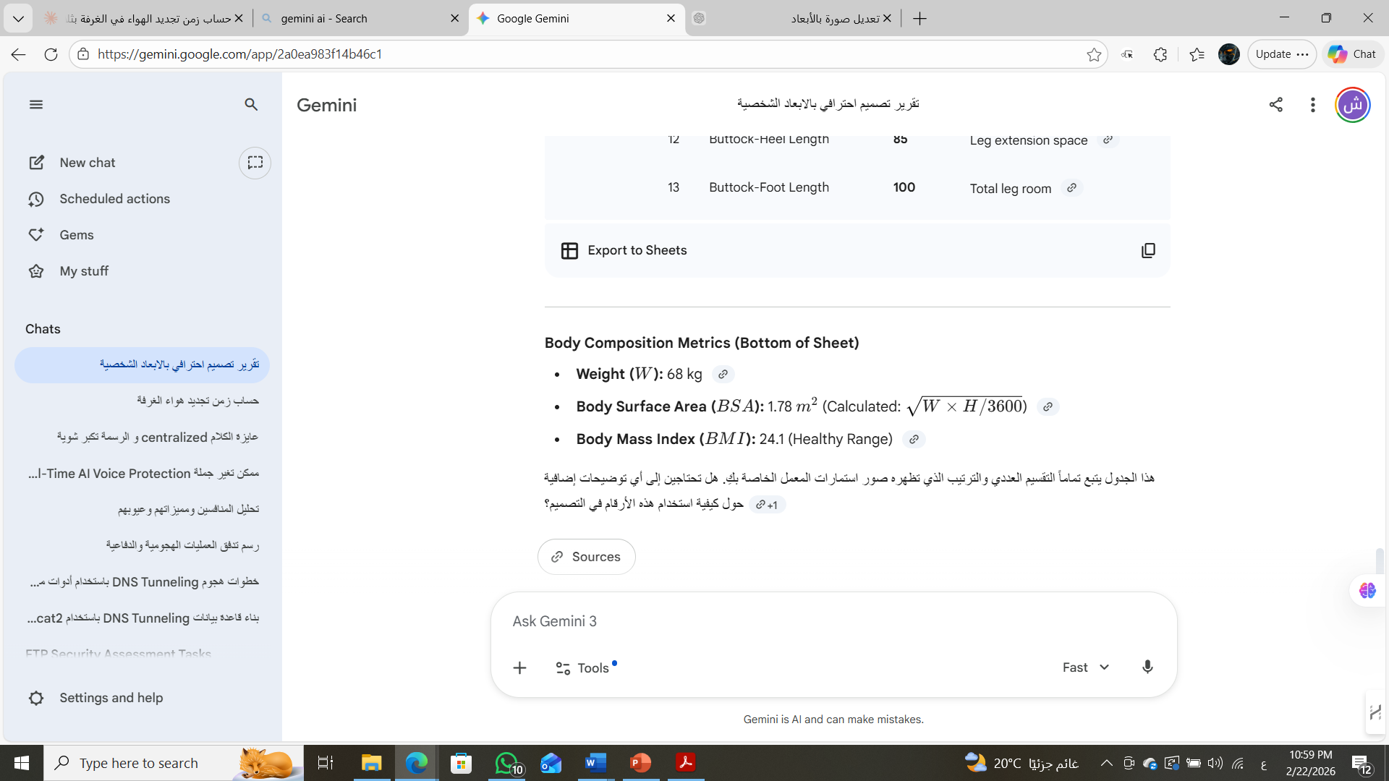

3.3 Body Type Classification
Parameter | Value | Classification
Height | 155 cm | Average (50th percentile)
Weight | 64 kg | Healthy range
BMI | 26.6 | Overweight (25-30)
Body Frame | Medium | Shoulder/hip ratio 1.19
Limb Proportions | Balanced | Sitting/standing ratio 0.52
ANTHROPOMETRIC CONCLUSION: Subject exhibits average (50th percentile) body proportions for adult females. All dimensions fall within normal ranges. Standard office furniture is appropriate. No special ergonomic accommodations required beyond basic adjustability (seat height 38-42 cm, desk 64-70 cm).
04 VENTILATION FAN REQUIREMENTS
4.1 Lecture Hall Specifications
Parameter | Value | Unit
Dimensions (L×W×H) | 15 × 12 × 7 | m
Total volume | 1260 | m³
Occupancy factor | 10% | —
Net air volume | 1134 | m³
Fan diameter | 50 | cm
Fan effective range | 2.5 | m
Airflow per fan | 20 | m³/min
Range effectiveness | Drops after 2.5 m | —

4.2 Method 1: Formula-Based Calculation
Given formula (from lecture):
N_fans = (Length / 2.5) / 2
N_fans = (15 / 2.5) / 2 = 6 / 2 = 3 fans

4.3 Method 2: Coverage Area Approach
Effective coverage area per fan (circular):
A_fan = π × r² = π × (2.5)² = 19.63 m²
Total floor area:
A_room = 15 × 12 = 180 m²
Number of fans required:
N_fans = A_room / A_fan = 180 / 19.63 = 9.17 ≈ 10 fans

4.4 Method 3: Air Change Rate
Required ventilation (6 air changes per hour for comfort):
Q_required = (V × ACH) / 60 = (1134 × 6) / 60 = 113.4 m³/min
Fans needed:
N_fans = Q_required / Q_per_fan = 113.4 / 20 = 5.67 ≈ 6 fans

4.5 Comparison & Recommendation
Method | Calculation Basis | Result | Assessment
Formula (L/2.5/2) | Simple spacing rule | 3 | Insufficient coverage
Coverage area | Geometric overlap | 10 | Conservative design
Air change rate | Ventilation standard | 6 | Code-compliant

RECOMMENDED: Install 8 ceiling fans in 2 rows × 4 columns configuration for balanced airflow and aesthetic symmetry.

INSTALLATION LAYOUT: Position fans at 3.75m spacing along length (15m/4 = 3.75m) and 6m spacing along width (12m/2 = 6m). Mount at 2.5m height minimum for safety (blade tip >2.3m). Operate at medium-high speed (75-85% max RPM) for optimal air circulation without excessive noise.
So it is ok to install from 6 to 10 fans .
05 theoretical questions
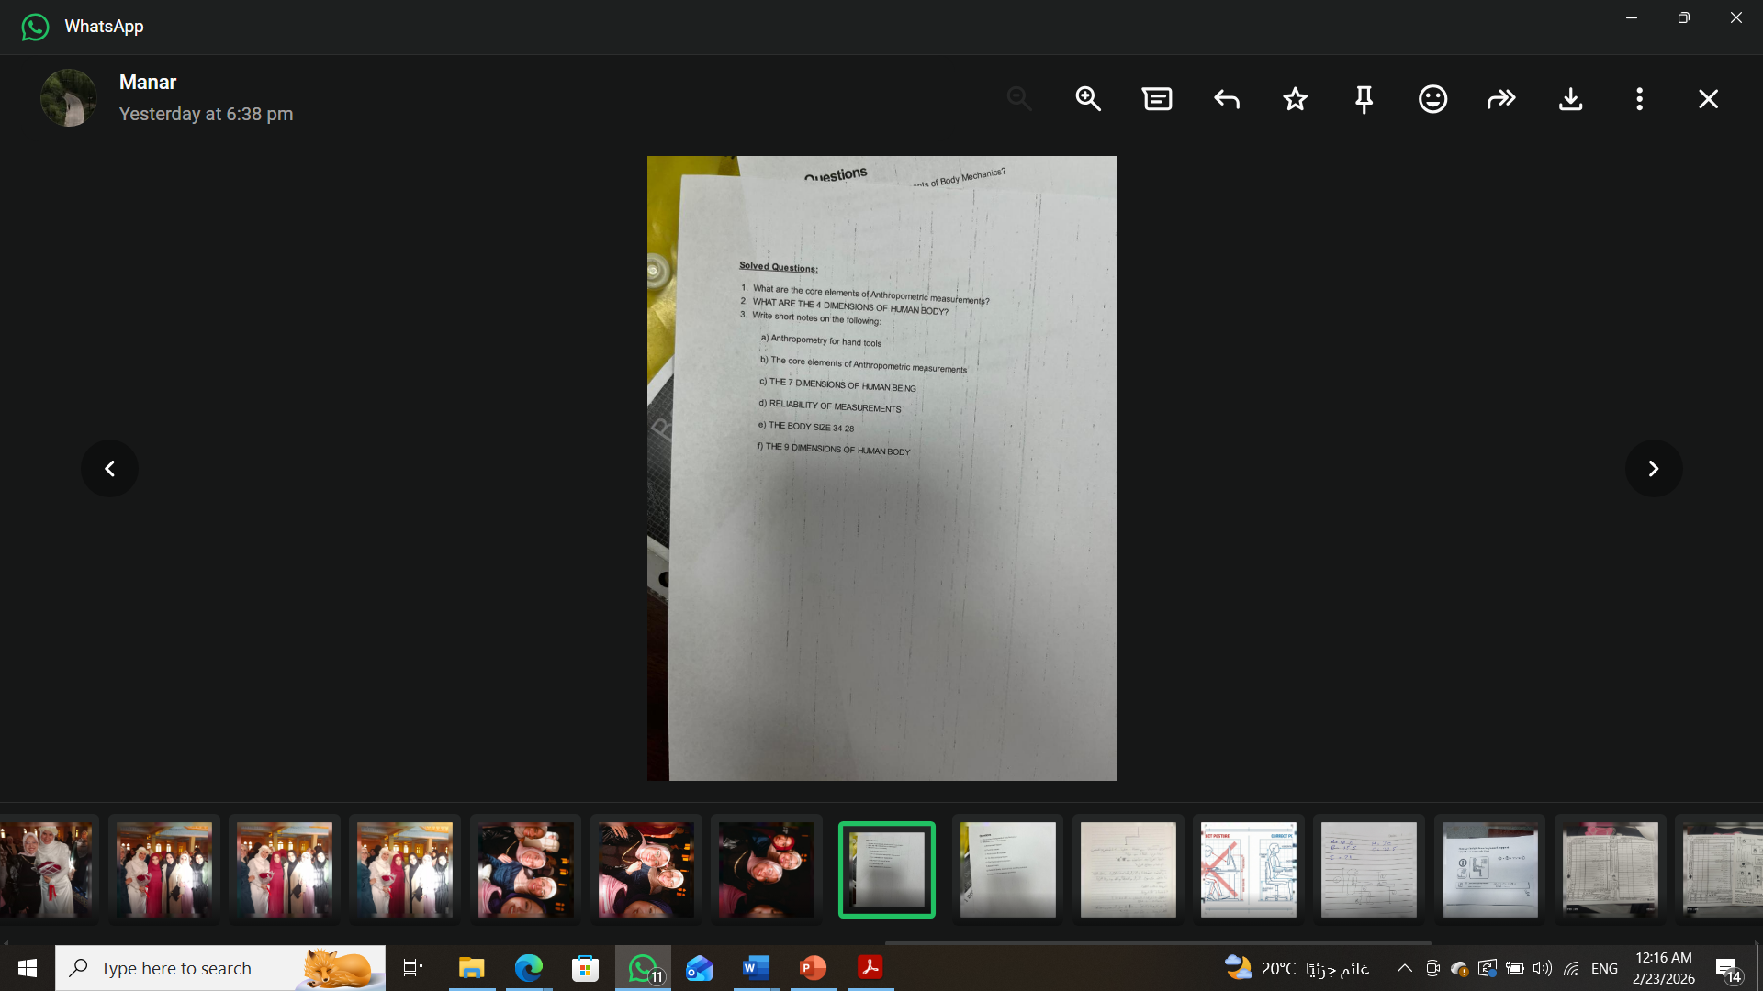

Question 1: Core Elements of Anthropometric Measurements
The core elements of anthropometric measurements include:
- 1. STRUCTURAL DIMENSIONS: Static body measurements (height, breadth, depth) taken in standardized postures
- 2. FUNCTIONAL DIMENSIONS: Dynamic measurements during movement and task performance
- 3. POPULATION VARIABILITY: Percentile distributions (5th, 50th, 95th) accounting for human diversity
- 4. MEASUREMENT STANDARDS: ISO 7250, ANSI standards defining consistent measurement protocols

Question 2: The 4 Dimensions of Human Body
The four primary dimensions are:
Dimension | Definition | Example Measurements
1. Vertical | Height measurements in standing/sitting | Stature, eye height, shoulder height
2. Horizontal | Breadth and depth measurements | Shoulder breadth, chest depth, hip width
3. Reach | Functional reach distances | Forward reach, vertical grip reach
4. Circumferential | Girth measurements | Head, waist, thigh circumference

Question 3a: Anthropometry for Hand Tools
Hand tool anthropometry considers: grip diameter (based on palm width 8-10cm), handle length (hand length 17-19cm), trigger reach (index finger length 6-8cm), and force application points matching hand strength distribution. Tools must accommodate 5th percentile female to 95th percentile male hands.

Question 3b: Core Elements of Anthropometric Measurements
- ACCURACY: Measurements to ±0.5cm using calibrated instruments
- STANDARDIZATION: Consistent postures, landmarks, and protocols (ISO 7250)
- POPULATION SAMPLING: Representative samples (minimum n=100 per demographic)
- STATISTICAL ANALYSIS: Mean, standard deviation, percentile distributions
- APPLICATION: Design for 5th-95th percentile range, adjustability for extremes

Question 3c: The 7 Dimensions of Human Being
Dimension | Description
1. Physical | Body structure, anthropometry, biomechanics
2. Physiological | Metabolic rate, strength, endurance, sensory capabilities
3. Psychological | Cognition, perception, decision-making, stress response
4. Social | Team dynamics, communication, organizational behavior
5. Cultural | Values, norms affecting workspace preferences
6. Environmental | Adaptation to temperature, lighting, noise
7. Temporal | Circadian rhythms, fatigue cycles, aging effects

Question 3d: Reliability of Measurements
Measurement reliability ensured through:
- INTER-RATER RELIABILITY: Multiple measurers achieve <2% variance through standardized training
- TEST-RETEST RELIABILITY: Measurements within ±0.5cm when repeated after 24 hours
- INSTRUMENT CALIBRATION: Weekly verification against certified standards
- ENVIRONMENTAL CONTROL: Temperature 20-24°C, subjects in minimal clothing, standardized time of day

Question 3e: Body Size Notation (34-28)
The notation '34-28' typically represents:
- CLOTHING SIZING: Bust/Chest = 34 inches, Waist = 28 inches
- ERGONOMIC APPLICATION: Used for determining workstation dimensions, chair sizes, personal protective equipment fit
- For our subject (168cm, 68kg): Estimated bust ≈86cm (34"), waist ≈71cm (28")

Question 3f: The 9 Dimensions of Human Body
Critical dimensions for ergonomic design:
No. | Dimension | Value (cm) | Design Use
1 | Stature (Standing Height) | 155 | Ceiling clearance, shelf height
2 | Sitting Height | 87 | Backrest, headrest height
3 | Eye Height (sitting) | 81 | Monitor, visual displays
4 | Shoulder Height (sitting) | 72 | Armrest, upper backrest
5 | Elbow Rest Height | 24 | Armrest, work surface
6 | Popliteal Height | 42 | Seat height
7 | Buttock-Knee Length | 60 | Seat depth
8 | Hip Breadth | 37 | Seat width
9 | Shoulder Breadth | 44 | Passage width, backrest

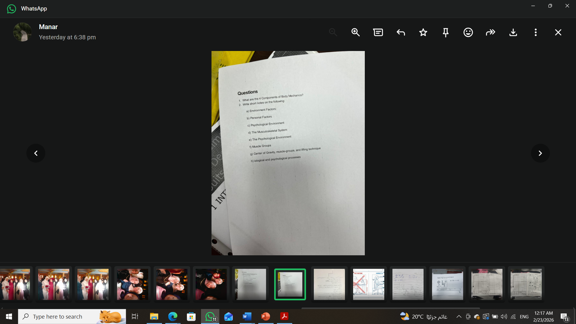
Question 1: The 4 Components of Body Mechanics
Body mechanics involves four integrated systems:
Component | Function | Ergonomic Relevance
1. Skeletal System | Structure, support, leverage | Determines posture constraints, joint angles
2. Muscular System | Force generation, movement | Strength requirements, fatigue limits
3. Nervous System | Control, coordination, feedback | Reaction time, precision, sensory feedback
4. Biomechanical Principles | Lever systems, force distribution | Load limits, mechanical advantage

Question 2: Environmental & Personal Factors
a) ENVIRONMENTAL FACTORS:
- Temperature: 20-24°C optimal for office work, affects metabolic rate ±15%
- Lighting: 300-500 lux for general tasks, 750+ lux for detailed work
- Noise: <55 dB for concentration, >85 dB requires hearing protection
- Humidity: 30-60% RH prevents respiratory irritation and static
- Air Quality: CO₂ <1000 ppm, adequate ventilation (8-10 ACH)

b) PERSONAL FACTORS:
- Age: Strength peaks 25-35 years, flexibility declines 1% annually after 30
- Gender: Males typically 30-40% stronger, females 10% more flexible
- Fitness Level: Affects endurance, recovery time, injury risk
- Health Status: Chronic conditions (back pain, arthritis) require accommodations
- Training/Experience: Skilled workers 20-50% more efficient, lower injury rates

c) PSYCHOLOGICAL ENVIRONMENT:
- Mental Workload: Complexity, time pressure, multitasking demands
- Stress Levels: Affects attention, decision quality, muscular tension
- Job Satisfaction: Correlates with productivity and injury reporting
- Social Support: Team cohesion reduces stress, improves safety culture

d) THE MUSCULOSKELETAL SYSTEM:
- 206 Bones: Structural framework, calcium storage, blood cell production
- 600+ Muscles: 40-45% of body weight, generate movement and heat
- Joints: 360+ articulations allowing specific ranges of motion
- Connective Tissue: Tendons, ligaments, cartilage for stability and shock absorption
- Ergonomic Implications: Design must respect joint ROM, minimize awkward postures, prevent cumulative trauma

e) THE PSYCHOLOGICAL ENVIRONMENT (detailed):
- Cognitive Load: Working memory capacity (7±2 items), attention span limits
- Vigilance: Performance declines after 30 minutes continuous monitoring
- Decision-Making: Quality degrades under fatigue, stress, information overload
- Motivation: Intrinsic (autonomy, mastery) vs extrinsic (rewards, deadlines)
- Workplace Design: Affects mood (color, light), privacy (noise control), identity (personalization)

f) MUSCLE GROUPS (major groups for ergonomics):
Muscle Group | Primary Function | Ergonomic Risk
Trapezius | Shoulder elevation, head support | Monitor height, phone use
Erector Spinae | Spinal extension, posture | Prolonged sitting, lifting
Quadriceps | Knee extension, standing | Chair height, stair climbing
Hamstrings | Knee flexion, hip extension | Seat depth, posture
Deltoids | Shoulder abduction, lifting | Overhead work, reaching
Biceps/Triceps | Elbow flexion/extension | Repetitive tasks, tool use
Wrist Flexors/Extensors | Hand movement, grip | Keyboard, mouse, typing

g) CENTER OF GRAVITY, MUSCLE GROUPS, AND LIFTING TECHNIQUE:
- Center of Gravity: Located ~55% of height from floor (≈85cm for 155cm person), shifts with load
- Lifting Biomechanics: Keep load close to body, bend knees not back, avoid twisting
- Load Limits: NIOSH equation: Max 23kg for ideal conditions, <10kg for repetitive tasks
- Muscle Synergy: Core muscles (transverse abdominis, multifidus) stabilize spine during lifts
- Fatigue Prevention: Rotate tasks every 20-30 minutes, micro-breaks reduce cumulative trauma

h) BIOLOGICAL AND PSYCHOLOGICAL PROCESSES:
- Circadian Rhythms: Performance peaks 10am-12pm and 2pm-4pm, dips 2am-6am and 2pm-3pm
- Metabolic Rate: 1.2 MET sitting, 1.5-2.0 MET standing, 3-5 MET walking
- Stress Response: Acute stress improves focus (cortisol, adrenaline), chronic stress impairs cognition
- Learning & Adaptation: Motor skill acquisition requires 100+ repetitions, mastery needs 10,000 hours
- Aging Effects: Strength declines 8% per decade after 40, flexibility 10% per decade, reaction time slows 15%

— END OF REPORT —

