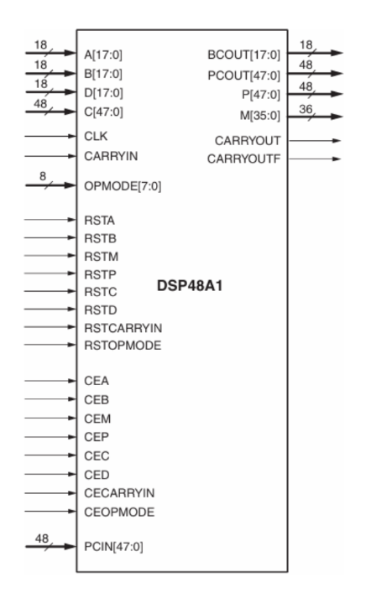**Spartan6 - DSP48A1**

By: **Shahd Gamal Mahmoud**

Table of Contents

**1.** **RTL Code** 2

➢ BLOCK (REG + MUX) 2

➢ Design DSP 3

**2.** **Testbench Code** 5

**3.** **Do File** 8

**4.** **QuestaSim Snippets** 9

➢ Waves 9

**5.** **Constraint File** 10

**6.** **Elaboration** 11

➢ Schematic Snippets 11

➢ Messages (No Errors or Warnings) 11

**7.** **Synthesis** 12

➢ Schematic Snippets 12

➢ Messages (No Errors) 12

➢ Utilization report 13

➢ Time report 13

**8.** **Implementation** 14

➢ Device Snippets 14

➢ Messages (No Errors) 14

➢ Utilization report 15

➢ Time report 15

**9.** **Linting** 16

➢ Lint Checks (No Errors or Warnings) 16

1. **RTL Code**

* 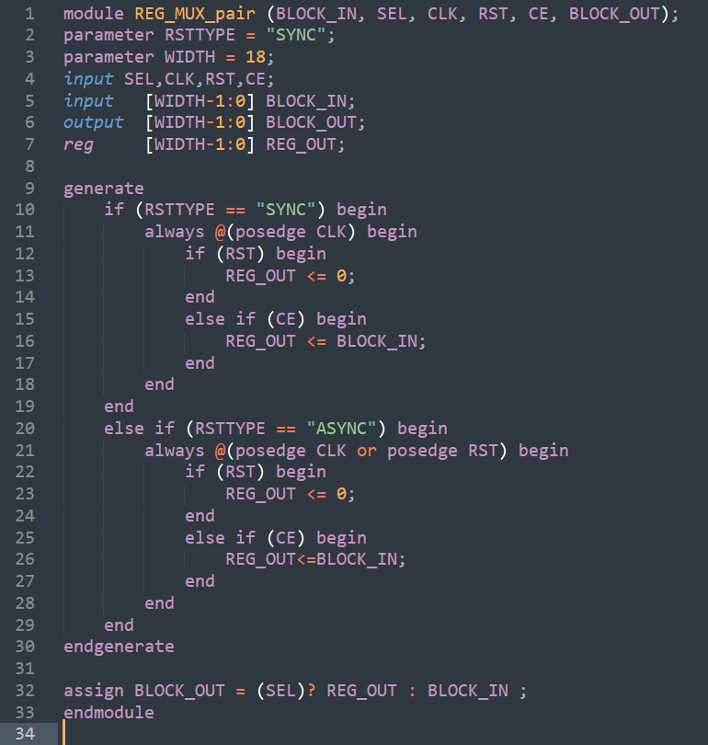BLOCK (REG + MUX)
* 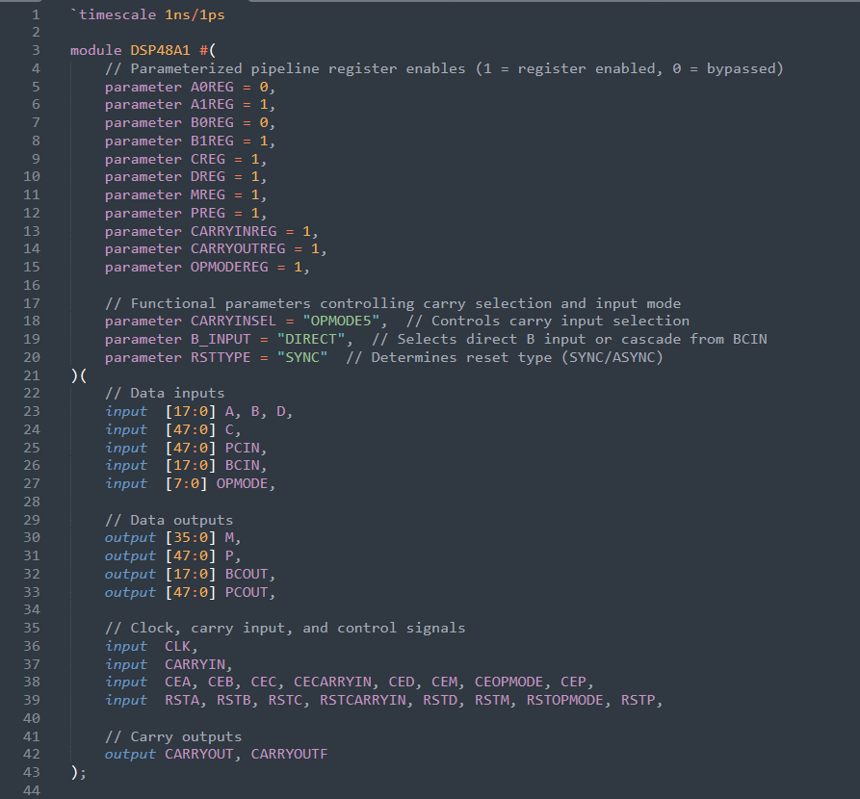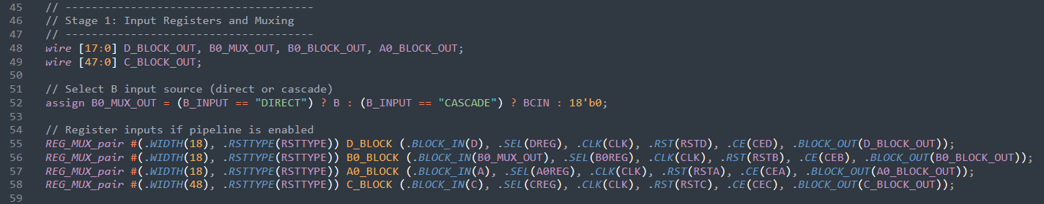Design DSP

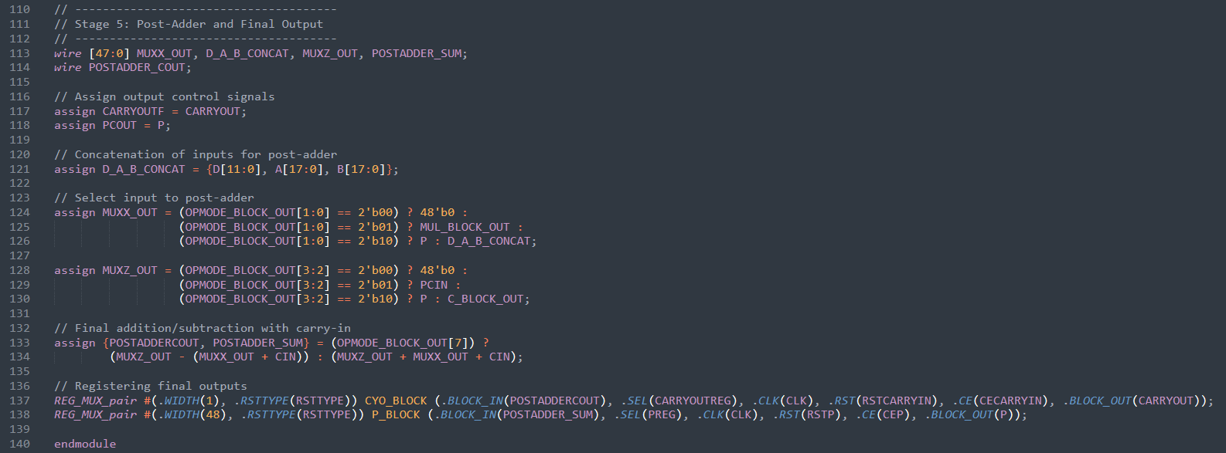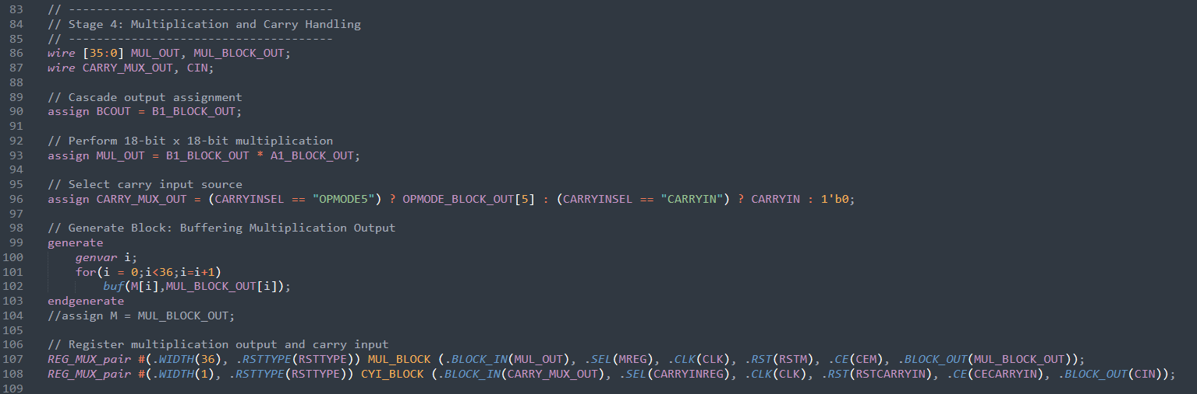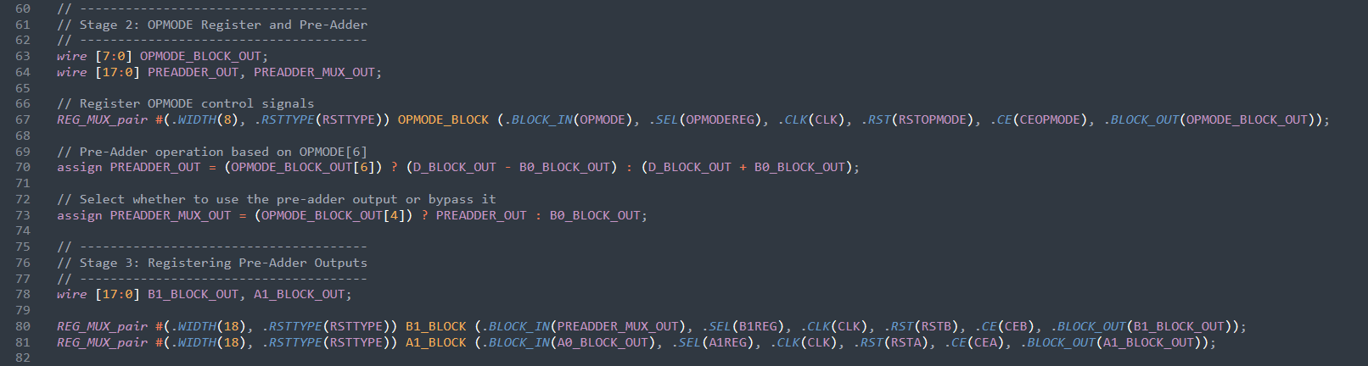

1. 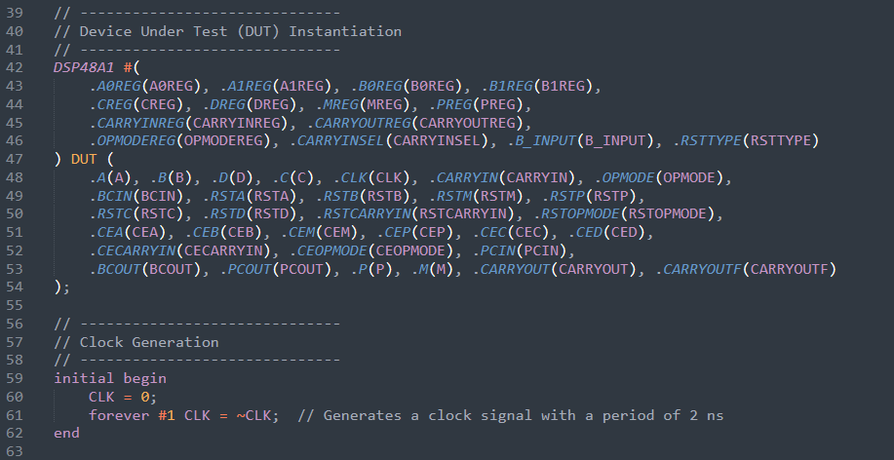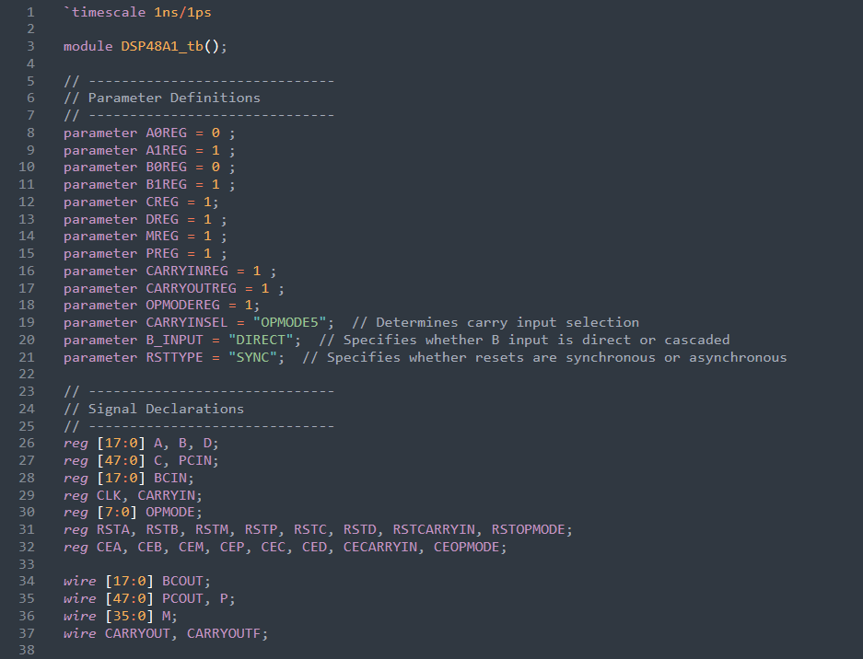**Testbench Code**

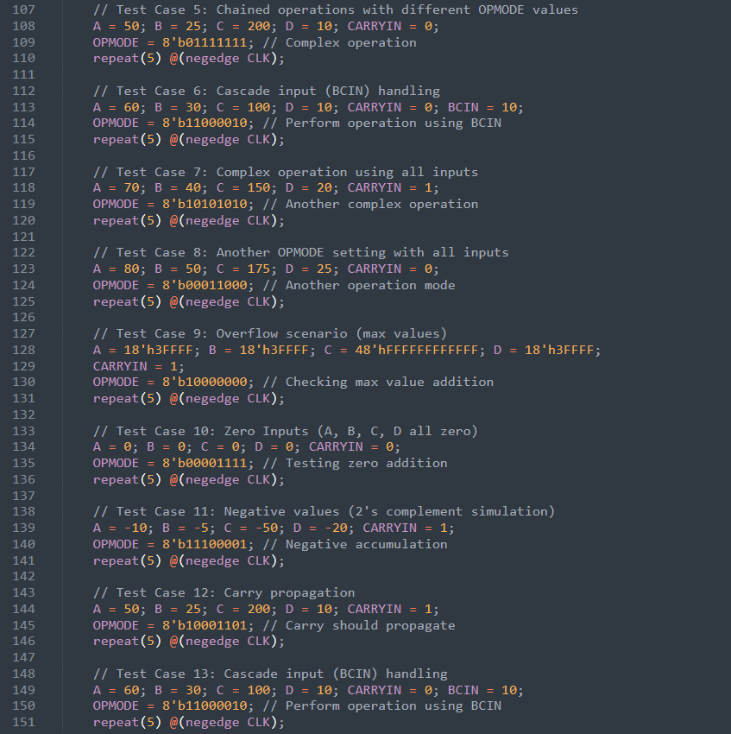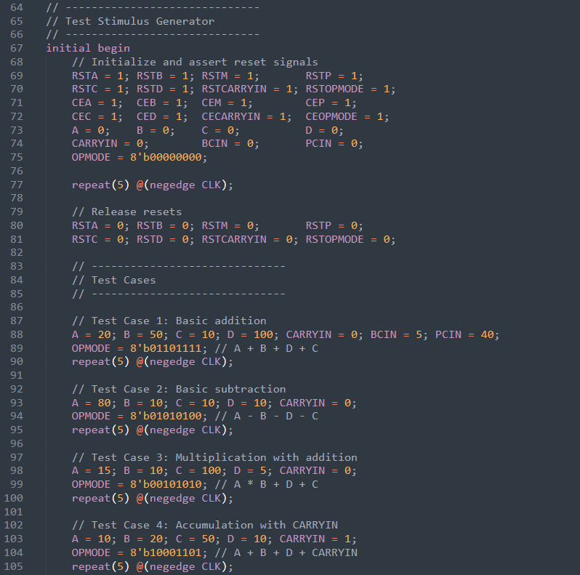

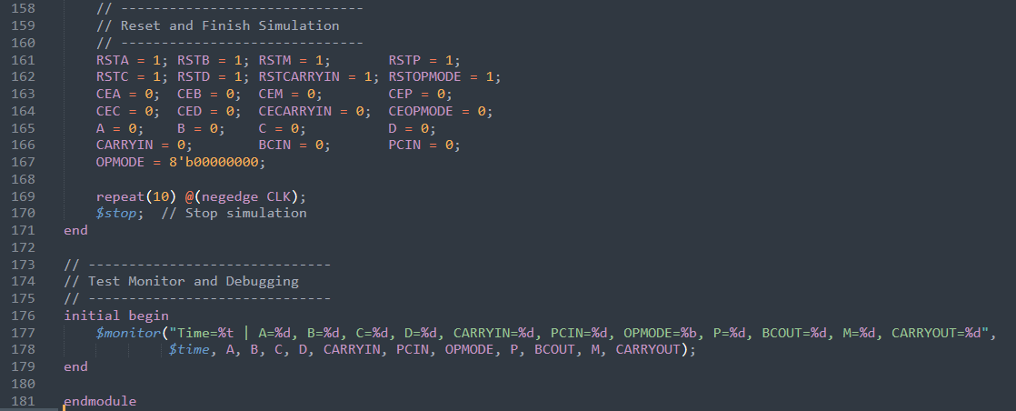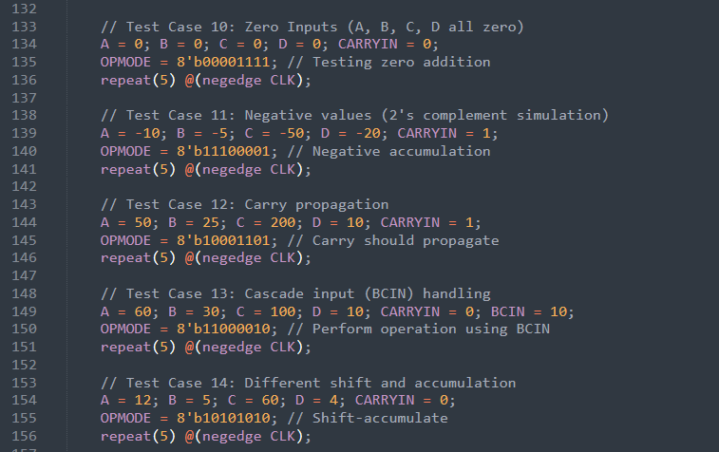

1. 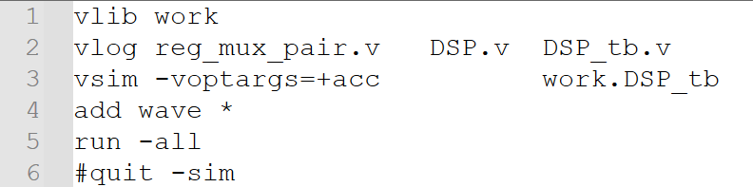**Do File**
2. **QuestaSim Snippets**

* 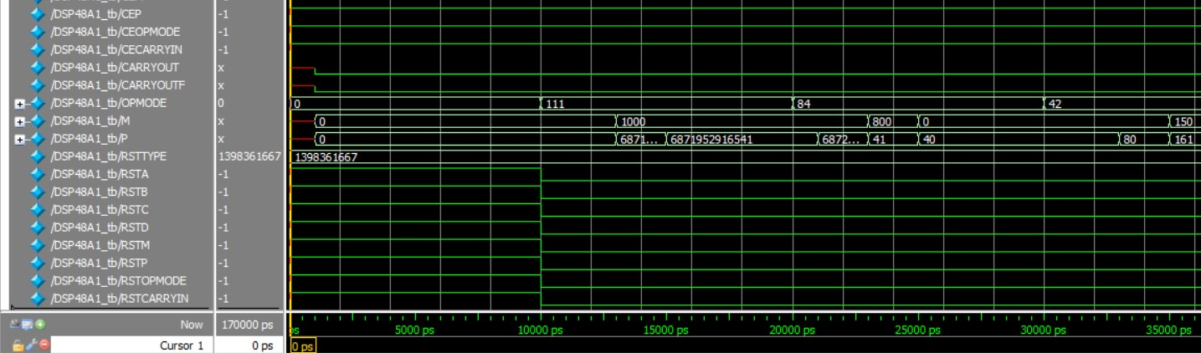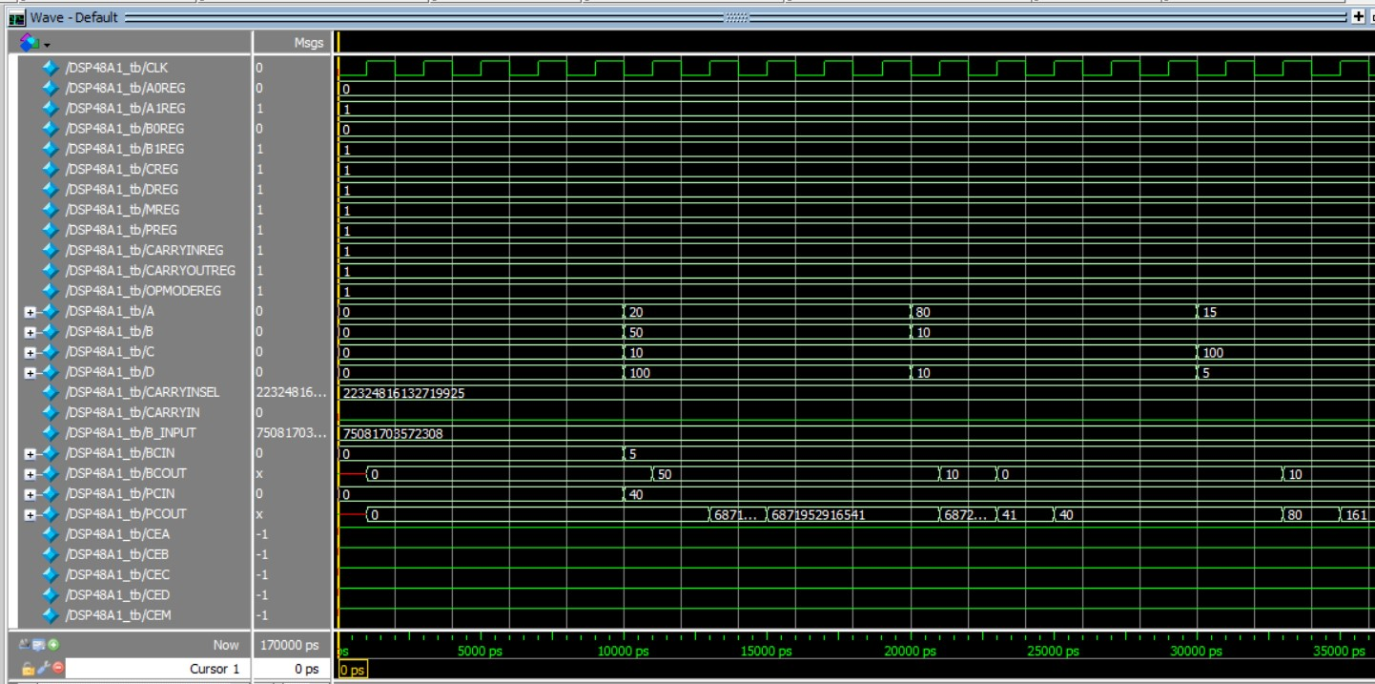Waves

1. **Constraint File**
2. **Elaboration**

* 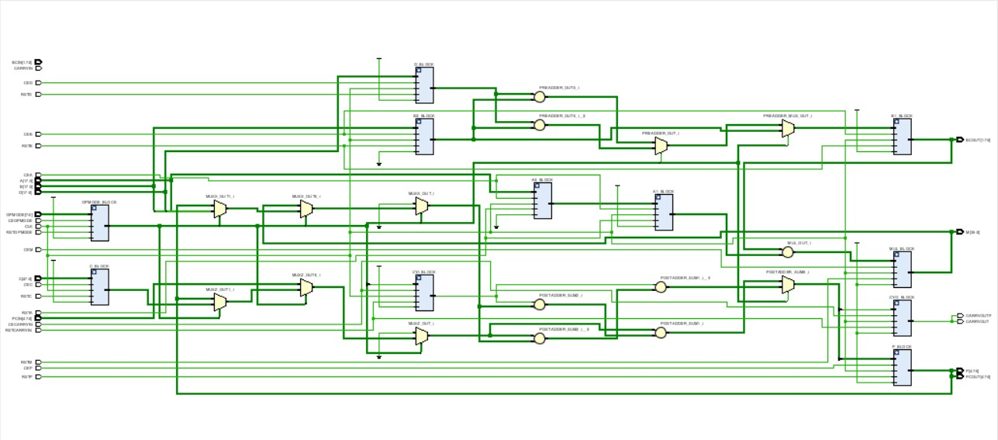Schematic Snippets
* 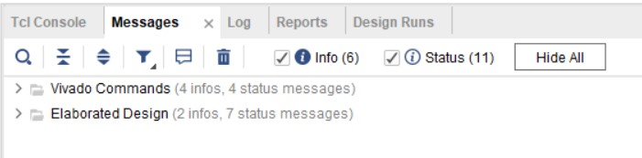Messages (No Errors or Warnings)

1. **Synthesis**

* 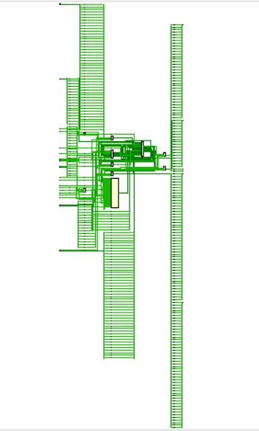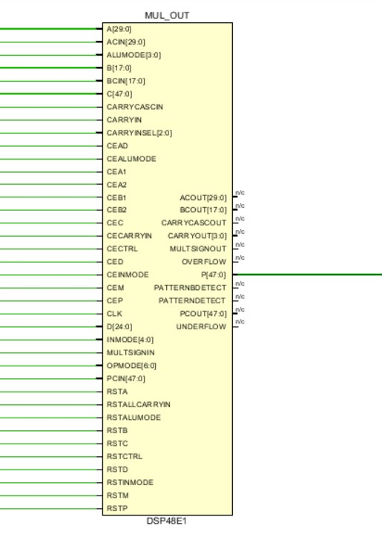Schematic Snippets
* 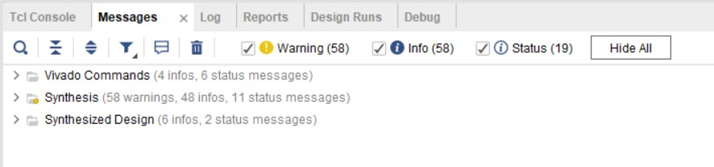Messages (No Errors)
* 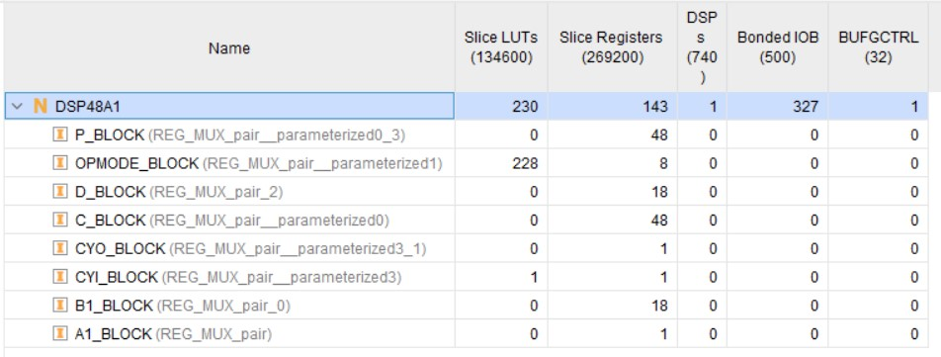Utilization report
* 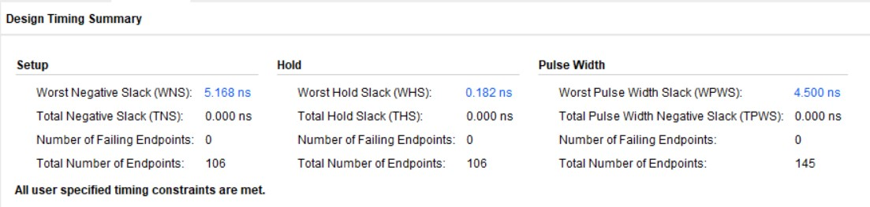Time report

1. **Implementation**

* 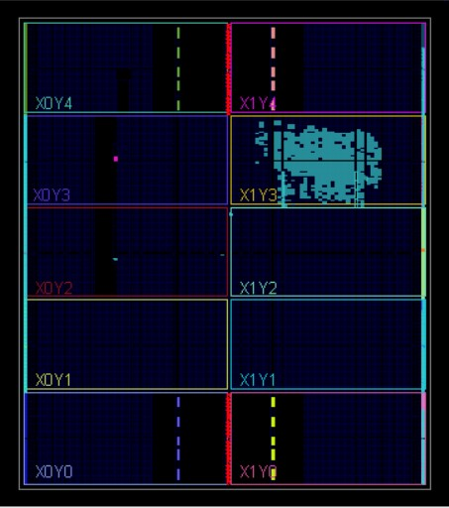Device Snippets
* 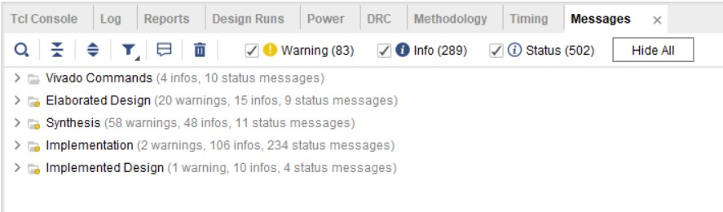Messages (No Errors)
* 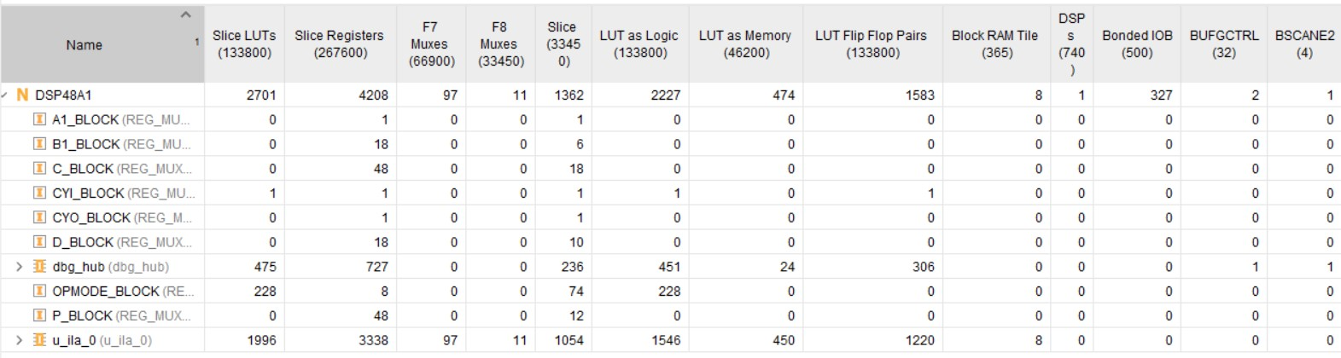Utilization report
* 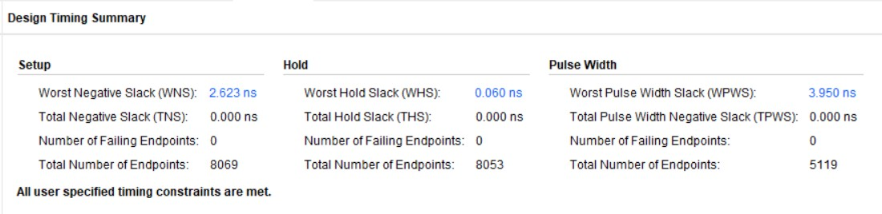Time report

1. **Linting**

* 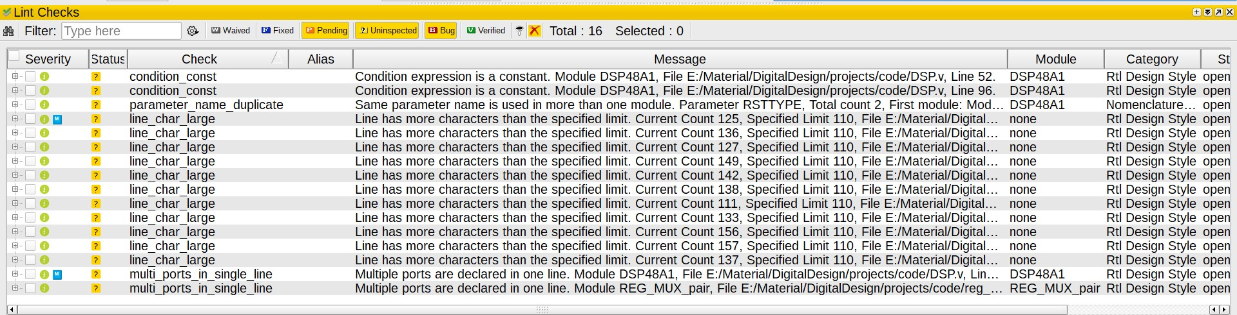Lint Checks (No Errors or Warnings)