
Faculty of Engineering and Technology
Linux Laboratory ENCS3130
Project 1

Shahd Qatre 1200431
Sondos Shahin 1200166

Instructor: Dr. Khader Mohammad
Assistant: katy Sadi
Section: 3

The goal of this project is to write a shell script code that encode and scale features of a dataset written in a text file.
Our dataset:
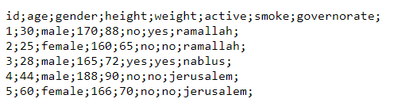
Our menu:
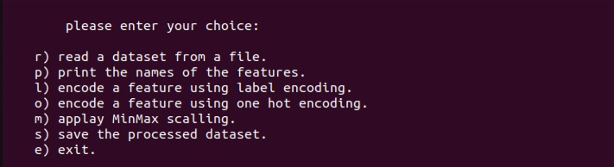
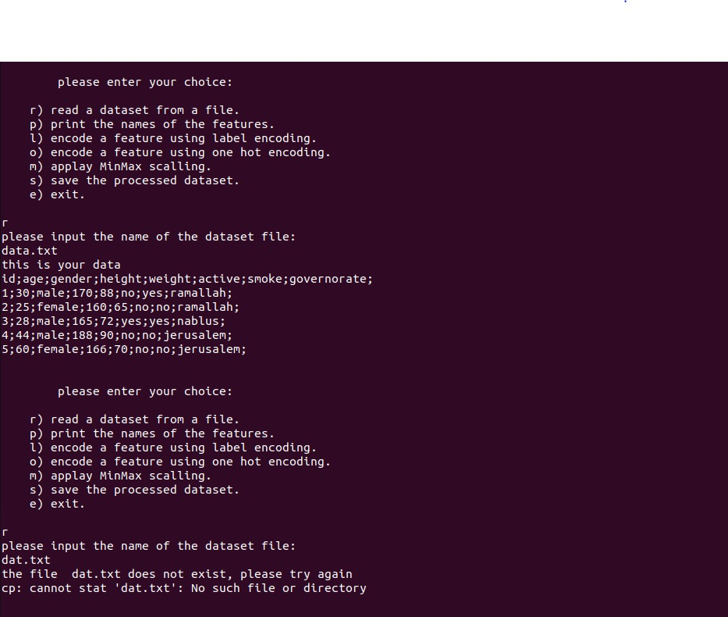
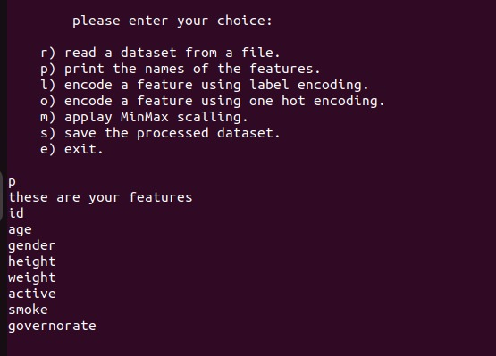

for option l: result:
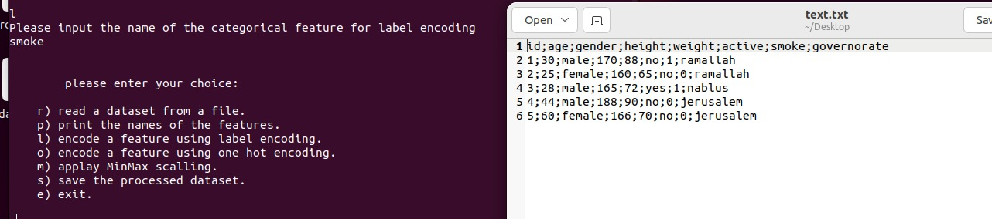

for option o: result:
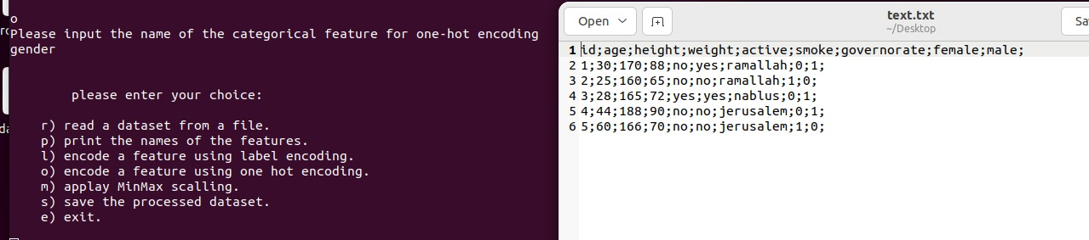

There are 2 cases for option m:
Case 1:
If the entered feature is categorical:
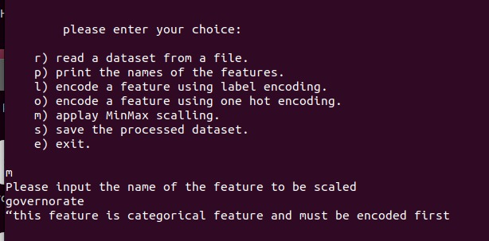
Case 1:
If the entered feature is numerical:
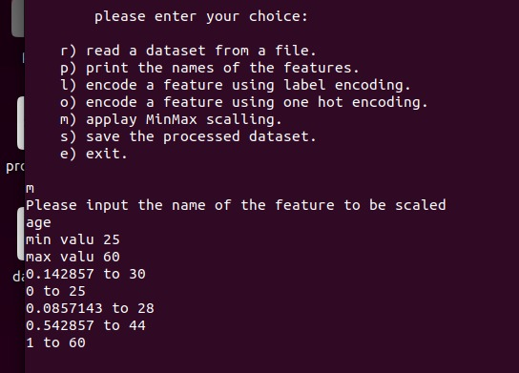

Option s: result:
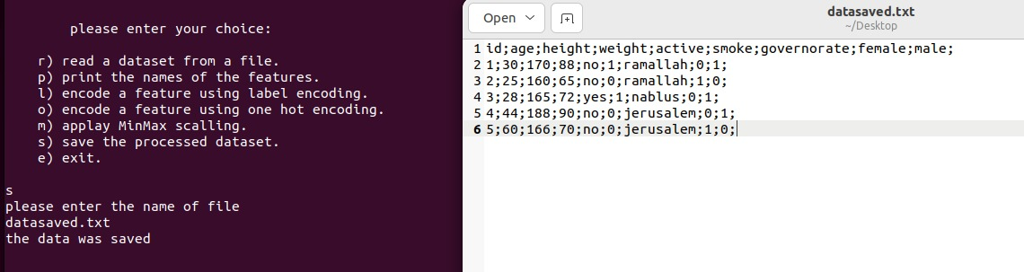

There are 2 cases for the exit option:
Case a:
If the processed dataset is not saved – the program returns to the menu:

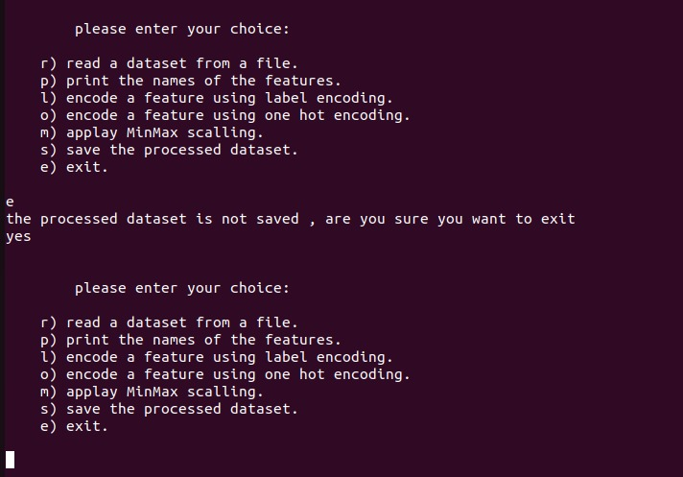

Case b:
If the processed dataset is saved – the program ends:
