
FACULTY OF ENGINEERING TECHNOLOGY
ELECTRIC & COMPUTER ENGINEERING DEPARTMENT
ENCS4320 — Applied Cryptography (Term 1253)
SecureVault
A Multi-User Encrypted Document Exchange System

Prepared by: Numbers:
Dania Abuayyash 1210464
Shahd Shreteh 1210444
Besan Maaly 1222776

Instructor: Dr. Ahmad Shawahna

Section: 2
Date: 27/09/2026

1. Introduction
SecureVault lets users store private documents on a server they do not trust and share them with each other. The server keeps every byte that users upload, but it can never read a document, never learn a password, and never change a file without the change being detected.
The system is written in Python. It has a TCP server protected with TLS (version 1.2 or newer), a command-line client (securevault_cli.py), and separate packages for authentication (src/auth), cryptography (src/crypto), key trust (src/trust), storage (src/storage) and networking (src/network). A test suite of 219 tests covers every primitive and the full end-to-end flow; all of them pass.
In short, the design works like this: a password is never sent anywhere; it is stretched with Argon2id on the user’s own machine. Each document is encrypted with its own fresh keys using AES-256-CBC and protected with HMAC-SHA256 (Encrypt-then-MAC). The document keys are handed to the recipient using X25519 key agreement, and the owner signs the document with Ed25519 so the recipient can prove who wrote it. Public keys are trusted using Trust-On-First-Use (TOFU) with change detection. Finally, every byte between client and server now travels inside a TLS channel whose server certificate the client checks against a certificate it was given in advance (server.crt), so a network attacker cannot read or change session tokens, usernames or metadata.

2. Threat Model
We use the three parties described in the project specification. Our design must stay safe even when the server and the network behave as badly as the table allows.
Party | What we assume
Users | Run our client on a trusted machine. Each user knows only their own password. Nobody can read an honest user’s memory or disk.
Server | Honest-but-curious: it follows the protocol and does not delete or invent data, but it reads everything it stores. Its whole database may be stolen.
Attacker | Sees and changes all network traffic, replays old messages, registers their own accounts, and may get a full copy of the server database.

What the attacker wants: read a document, learn a password, make a user accept a changed or fake document, pretend to be another user, or make an old document be accepted again.
Out of scope: malware on the user’s machine, forcing a user to reveal their password, traffic analysis (file sizes and timing), and denial of service. We mention some of these again in Section 7 (Limitations).

3. Design

3.1 Architecture
We chose a client–server design over real TCP sockets, wrapped in TLS. The server has three jobs only: it checks logins, it stores opaque encrypted objects, and it passes them to the right user. All cryptography that touches document content or private keys runs on the client. The server is structurally unable to read documents because it never receives a document key or a private key in usable form. TLS protects the connection itself; it does not replace any of our own layers.
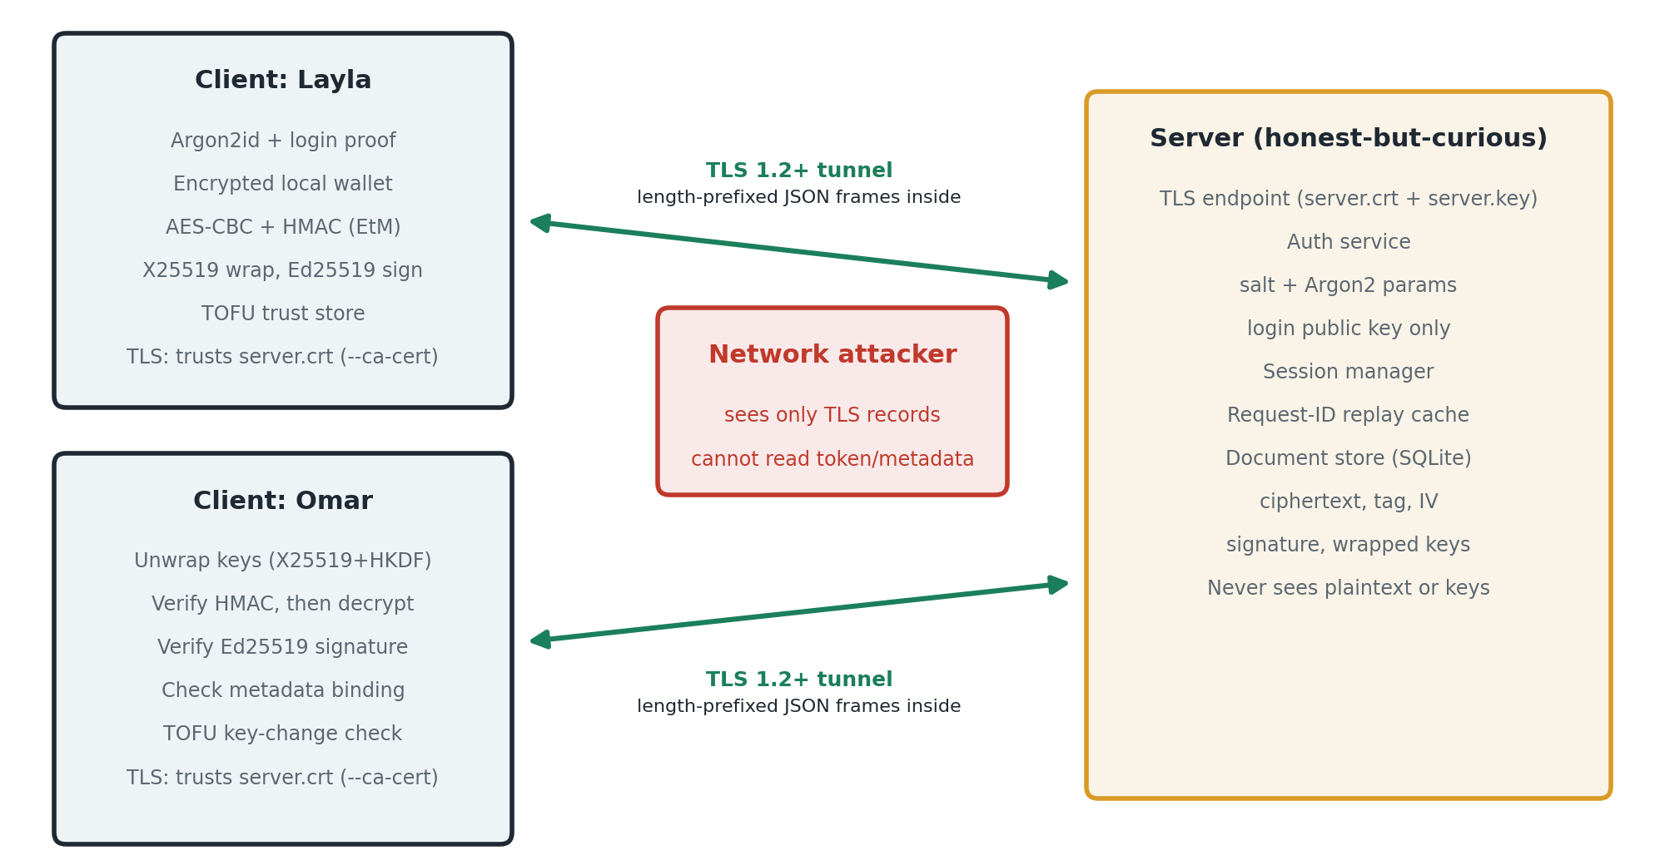
Figure 1. SecureVault architecture. Client–server traffic runs inside a TLS 1.2+ channel; everything the server stores is either public or encrypted.
The server exposes nine operations: signup, login_begin, login_finish, logout, get_public_keys, upload_document, share_document, list_documents and retrieve_document. All but the first three need a valid session token. Each request carries a random 128-bit request_id; the server remembers the answer to every (user, request_id) pair for one hour, so a replayed request never runs twice.
Transport security (TLS). generate_tls_cert.py creates a self-signed certificate (server.crt) and key (server.key): RSA-3072, SHA-256, SAN localhost and 127.0.0.1, valid 365 days. The server (securevault_cli.py server --cert --key) accepts only TLS 1.2 or newer and drops any connection whose handshake fails. The client (shell --ca-cert server.crt) uses ssl.create_default_context(cafile=server.crt), so it checks the certificate and host name before sending any frame.

3.2 Key Hierarchy
Each key has exactly one job. This keeps the damage small if one key is exposed and makes it easy to reason about each property.
Key | Size | Created by / from | Where it lives | Purpose
Password secret | 32 B | Argon2id(password, salt) | Client memory only | Root for the login key and the wallet key
Login key pair (X25519) | 32 B | HMAC(password secret, label) | Private: client memory; public: server | Prove the password at login without sending it
Wallet keys | 32 + 32 B | HKDF(password secret) with its own salt | Client memory only | Encrypt + MAC the file that holds the private keys
Identity X25519 key pair | 32 B | OS random (secrets) | Private: encrypted wallet; public: server | Key agreement to share document keys
Identity Ed25519 key pair | 32 B | OS random | Private: encrypted wallet; public: server | Sign documents (non-repudiation)
Document keys K_enc, K_mac | 32 + 32 B | OS random, new for every document | Only inside the wrapped-key package | AES-256-CBC and HMAC-SHA256 of one document
Wrapping keys | 32 + 32 B | HKDF(X25519 shared secret, random 32 B salt, context) | Never stored | Encrypt + MAC the document keys for one recipient

Private keys at rest. The two identity private keys are stored in an encrypted wallet (data/cli_wallets/<user>.json). The wallet is encrypted with AES-256-CBC and authenticated with HMAC-SHA256 using keys derived from the password through Argon2id and HKDF. The same encrypted bundle is also uploaded to the server at sign-up, so it could be recovered from the password alone; the server cannot open it.

3.3 Byte-Level Formats
All length prefixes are unsigned big-endian integers. A fixed ASCII domain label starts every authenticated message, so a tag or signature made for one purpose can never be reused for another. ‖ means concatenation.
Object | Exact byte layout
Wire frame (TLS over TCP) | Carried inside a TLS 1.2+ record stream: len (4 B) ‖ UTF-8 JSON body (max 8 MiB). Byte values are base64 inside {"__securevault_bytes__": ...}. Body fields: version=1, kind, operation, request_id, payload, session_token, success, error_code, error_message.
Document MAC input | "SecureVault-Document-EtM-v1" ‖ len(meta) (8 B) ‖ meta ‖ len(IV) (8 B) ‖ IV (16 B) ‖ len(ct) (8 B) ‖ ct
Stored document | document_id ‖ owner ‖ IV (16 B) ‖ ciphertext (16·k B) ‖ metadata (canonical JSON) ‖ tag (32 B) ‖ content_hash (32 B) ‖ signed metadata ‖ signature (64 B)
Canonical metadata | JSON with sorted keys, no spaces, UTF-8, e.g. {"document_id":"...","filename":"thesis.pdf","owner":"layla","recipient":"omar","size":20417}
Signature message | "SecureVault-Document-Signature-v1" ‖ len (8 B) ‖ SHA-256(plaintext) (32 B) ‖ len (8 B) ‖ canonical metadata
Key-wrap HKDF info | "SecureVault-Document-Key-Wrap-v1" ‖ [len (4 B) ‖ value] for: sender, recipient, document_id, sender X25519 pub, recipient X25519 pub
Wrapped-key package | kdf_salt (32 B) ‖ IV (16 B) ‖ ct of K_enc‖K_mac (80 B) ‖ metadata (purpose, sender, recipient, document_id, both public keys, salt) ‖ tag (32 B)
Login proof | HMAC-SHA256(shared, "SecureVault-Login-v1" ‖ len(user) (2 B) ‖ user ‖ len(nonce) (2 B) ‖ nonce (32 B) ‖ server ephemeral pub (32 B) ‖ challenge_id)
Credential record | username, algorithm="Argon2id", salt (16 B), memory_cost, time_cost, parallelism, hash_length=32, version=19, login public key (32 B), X25519 pub (32 B), Ed25519 pub (32 B), encrypted wallet, created_at

3.4 Life of a Document
Figure 2 follows thesis-draft.pdf from Layla’s disk to Omar’s screen.
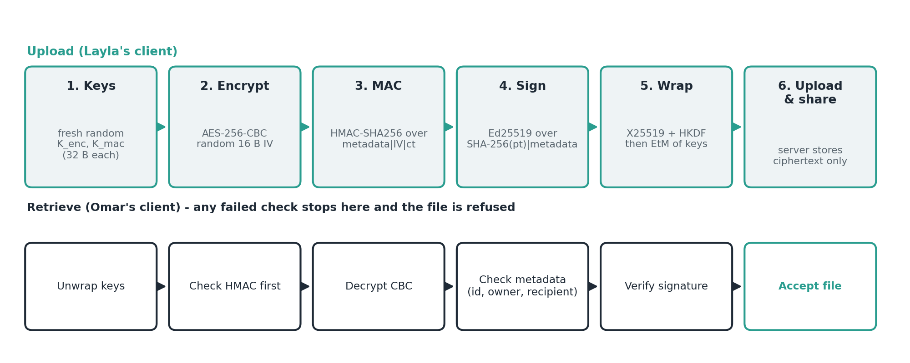
Figure 2. Upload path (top) and verified retrieval path (bottom).
- Sign-up (both users). The client makes a random 16-byte salt, runs Argon2id, derives the login public key, makes the X25519 and Ed25519 identity keys, and encrypts them into the wallet. Only public values and the encrypted wallet are sent.
- Login. The server returns the user’s salt and Argon2 parameters, a fresh 32-byte nonce and a fresh ephemeral X25519 public key. The client recomputes the login private key from the password, does X25519 with the server’s ephemeral key, and returns an HMAC proof. The challenge can be used once and expires after 60 seconds. On success the server issues a random session token valid for 30 minutes.
- Get Omar’s keys. Layla asks for Omar’s public keys. Her TOFU store saves them the first time and refuses them if they ever change.
- Encrypt. New random K_enc and K_mac are made. The metadata (file name, size, document_id, owner, recipient) is written as canonical JSON. The file is padded (PKCS#7) and encrypted with AES-256-CBC under a new random IV. HMAC-SHA256 is computed over metadata, IV and ciphertext.
- Sign. Layla signs SHA-256(plaintext) together with the same canonical metadata using her Ed25519 key.
- Wrap. X25519(Layla private, Omar public) gives a shared secret. HKDF with a random salt and the full context (both names, both keys, document_id) gives two wrapping keys, which encrypt and MAC K_enc ‖ K_mac.
- Upload and share. The ciphertext, tag, metadata and signature are uploaded; the wrapped-key package is stored as a share for Omar.
- Retrieve and verify. Omar’s client gets Layla’s keys (TOFU check), unwraps the document keys, checks the HMAC before decrypting, decrypts, checks that the signed metadata equals the encrypted metadata and names the right document_id, owner and recipient, and finally verifies Layla’s Ed25519 signature. If any check fails, the file is refused and nothing is written to disk.

4. Design Decisions and Justification

4.1 Protecting Passwords — Argon2id
Choice. Argon2id with a 16-byte random salt, memory = 32 MiB, time cost = 1, parallelism = 1, 32-byte output. Implemented with the argon2-cffi library.
Measurement. scripts/benchmark_argon2.py ran 10 trials after 2 warm-up runs. One derivation took a median of 23.8 ms (min 22.1 ms, max 24.2 ms), which is about 42 guesses per second on one CPU core.
Why it resists a GPU. Each guess must fill and read 32 MiB of memory, so a GPU is limited by memory bandwidth, not by its number of cores. Appendix A shows that for an 8-character alphanumeric password this means about 440 years per account on a high-end GPU, compared with about 83 minutes if we had used a bare SHA-256.
Salt. 16 bytes from the OS random generator, stored in the clear next to the record. The salt is not secret: its only job is to make two users with the same password look different and to stop pre-computed tables. The test test_create_password_record_generates_random_salt checks this.
Second use of the password secret. Yes — the same Argon2 output creates the login key and (through HKDF with a separate label and salt) the wallet key. So a password change must: derive a new login key, re-encrypt the wallet with the new password, and upload both. Document keys and identity keys do not change, so no document needs re-encryption. A password-change command is not yet implemented (Section 7).
Rejected. PBKDF2: not memory-hard, so GPUs win back almost all of the slowdown. bcrypt: fixed 4 KiB of memory, too small for modern GPUs. scrypt: memory-hard, but its three parameters are less standard and harder to justify than Argon2id. A home-made construction on a plain hash: fast on GPUs and fails the requirement.

4.2 Protecting Document Contents — AES-256-CBC + HMAC-SHA256
Choice. Our own AES-256 (FIPS-197) in CBC mode with PKCS#7 padding, and our own HMAC-SHA256 (RFC 2104), put together as Encrypt-then-MAC.
Why this order. We encrypt first, then MAC the ciphertext. On retrieval the tag is checked before any decryption, so a changed ciphertext never reaches the CBC and padding code. This removes padding-oracle attacks at the root: the attacker only ever sees one answer, “integrity verification failed”. MAC-then-Encrypt would force decryption first and open the padding oracle again. Encrypt-and-MAC puts a MAC on the plaintext, which can leak information about it.
How many keys. Two per document: K_enc (32 B) and K_mac (32 B), both new and random for every document. Using separate keys means the cipher and the MAC never share key material.
IVs and nonces — why they never repeat, even after a crash. Every document gets brand-new random keys, so each K_enc encrypts exactly one message with exactly one IV. An IV cannot repeat under the same key because the key is never used twice. The IV itself is 16 bytes from secrets.token_bytes, which reads the OS random generator and keeps no state in our program, so a crash or restart cannot reset it. Key wrapping follows the same rule: a fresh 32-byte HKDF salt makes the wrapping keys new for every share.
Rejected. AES-GCM: a good AEAD, but a correct, constant-time GHASH (multiplication in GF(2^128)) written by hand is risky and hard to verify within the time. AES-CCM: two passes and no real gain for our scope. ChaCha20-Poly1305: Poly1305 arithmetic mod 2^130−5 is just as easy to get wrong.

4.3 Public-Key Cryptography — X25519 and Ed25519
Where we need it. Two places. (1) Key agreement: Layla must give Omar the document keys through a server that must not learn them; without public-key crypto they would need a shared secret agreed in advance. (2) Signatures: only a private key held by one person can give non-repudiation.
Curve choice. Curve25519. Its Montgomery ladder has no special cases, is constant-time by design, and has a clear public description (RFC 7748). We wrote X25519 ourselves and checked it against the RFC 7748 test vectors. For signatures we use Ed25519 (RFC 8032) from the cryptography library; its nonce is derived deterministically from the key and message, so the classic ECDSA failure (a repeated nonce leaks the key) cannot happen.
Security level. Curve25519 gives about 128-bit security. AES-256 and HMAC-SHA256 give at least 128 bits too, so the public-key part is not a weak link. For the same 128-bit level, finite-field DH or RSA would need a 3072-bit modulus.
Measured advantage. On the same machine, our pure-Python X25519 takes 1.39 ms per operation. A single 3072-bit modular exponentiation in Python (the core of finite-field DH at the same level) takes 5.7 ms with a 256-bit exponent and 67 ms with a full 3072-bit exponent — about 4× to 48× slower. Public keys are also 12× smaller (32 B vs 384 B).
Rejected. RSA: 3072-bit keys, expensive, and OAEP/PSS padding is hard to write safely. Finite-field DH: same key sizes as RSA and slower (measured above). NIST P-256 with ECDSA: point-at-infinity special cases and nonce sensitivity.

4.4 Trusting a Public Key — TOFU with Change Detection
Choice. The first time a client sees another user’s keys it stores them in a local SQLite trust store with a SHA-256 fingerprint (src/trust/tofu.py). On every later contact it compares the new keys with the stored ones; any difference raises KeyChangeDetected and the operation stops. The fingerprint covers the username and both public keys, shown as groups of four hex digits, and a short 24-digit verification code can be read aloud to compare out of band. A peer can be marked as manually verified.
What it assumes. The very first contact is not under an active man-in-the-middle attack. If the users want more, they compare the verification code by phone or in person at first contact.
Rejected. Mandatory fingerprint comparison for every new contact: strongest, but unrealistic when users have never met. A small certificate authority: brings back a trusted third party and needs issuing and revocation.

4.5 Signatures Versus MACs
 | HMAC-SHA256 | Ed25519 signature
Where used | Document integrity (EtM), wrapped-key integrity, wallet integrity, login proof | Owner signs SHA-256(plaintext) and the canonical metadata
Who has the key | At least two parties (owner and recipient share K_mac) | Only the owner has the private key
Non-repudiation? | No. Omar also has K_mac, so he could have made the tag himself. A third party cannot tell who made it, however long the tag is. | Yes. Only Layla’s private key can make a signature that verifies under her public key.

How a third party checks authorship. Omar gives the judge the file, the signed metadata, the 64-byte signature, and Layla’s Ed25519 public key. The judge checks the key against Layla’s fingerprint (from Layla herself), recomputes SHA-256 of the file, rebuilds the signature message, and runs Ed25519 verification.

4.6 Architecture and Error Handling
Choice. Client–server over TCP with length-prefixed JSON frames, carried inside a TLS 1.2+ channel. A shared-directory simulation was rejected because live rejections are harder to show. Peer-to-peer was rejected because it adds NAT and connection problems with no security gain.
Why TLS on top of our own cryptography. In plain TCP the session token, usernames and metadata were readable, so a network attacker could reuse a token. TLS encrypts and authenticates every frame and its record sequence numbers stop in-channel replay. TLS stops the network attacker; our end-to-end layer still stops the honest-but-curious server. The client trusts only our self-signed server.crt, which acts as certificate pinning with no third party. TLS comes from Python’s ssl module: it wraps the transport and is not one of the required primitives.
Rejected. A per-request HMAC bound to the session: stops token reuse but leaves metadata readable. Mutual TLS: duplicates what our Argon2id login already proves and needs a certificate per user.
What the client says on failure. The client names the check that failed (integrity, metadata binding, or producer signature) so a user knows the file was refused and why. This does not help an attacker: the integrity failure is one fixed message for every kind of change to IV, ciphertext, metadata or tag, and padding errors can only happen after the MAC has already passed. Login failures return the same message (AUTHENTICATION_FAILED) for a wrong password and an unknown user.

5. Security Argument
Property | Mechanism that provides it
Confidentiality | AES-256-CBC with per-document random keys. Keys reach the recipient only inside an X25519 + HKDF wrapped package. The server never has K_enc or any private key.
Integrity | HMAC-SHA256 over metadata ‖ IV ‖ ciphertext, checked before decryption (Encrypt-then-MAC). The wrapped keys have their own HMAC.
Data-origin authentication | Ed25519 signature by the owner over the content hash and metadata, verified with the owner’s TOFU-pinned public key. Key wrapping also uses the sender’s X25519 key, so only the real sender could have made the package.
Non-repudiation | Ed25519 signature only (see 4.5). The HMAC cannot give it.
Credential protection | Argon2id (32 MiB, per-user 16 B salt). The server stores only the salt, parameters and a login public key; no password hash is sent at login (challenge-response with a fresh nonce and ephemeral key).
Freshness | Login challenges are single-use and expire in 60 s. Every request has a random request_id that the server will not execute twice. document_id is a primary key, so an old upload cannot overwrite or duplicate a document. document_id, owner and recipient are bound into the MAC, the signature and the key-wrap context, so a captured object cannot be replayed under another ID or to another user.
Metadata binding | Canonical metadata is inside the HMAC input and inside the signed message. The client also checks that encrypted metadata == signed metadata and that document_id/owner/recipient match the request.
Transport protection | TLS 1.2+ with the server certificate checked against the trusted server.crt (host name included). Session tokens, usernames, metadata and request IDs are encrypted and integrity-protected on the wire; a network attacker cannot steal a token, impersonate the server, or replay frames inside a connection.

How the properties fit together. Order matters. The HMAC is checked first, so tampered data never reaches decryption. The signature is checked on the decrypted plaintext and on exactly the same metadata bytes that the HMAC protected, so an attacker cannot pair a valid ciphertext with different signed metadata (test test_signed_metadata_tampering_fails). The key-wrap context includes both usernames, both public keys and the document_id, so a wrapped package cannot be moved to a different document or user (test_wrong_document_id_fails). Domain labels on every MAC and signature stop a value made for one purpose from being accepted for another.

6. Implementation and Testing

6.1 From-Scratch Rule and Library Use
Component | Source | Test evidence
AES-256 block cipher, CBC mode, PKCS#7 padding | Written by us | NIST SP 800-38A vectors + library match
HMAC-SHA256, HKDF-SHA256 | Written by us (on hashlib SHA-256) | RFC 4231, RFC 5869 vectors
X25519 (Montgomery ladder, clamping) | Written by us | RFC 7748 vectors + library match
Encrypt-then-MAC scheme, key wrapping, metadata binding | Written by us | 17 + 15 + 16 tests incl. every tamper case
Login protocol, TOFU store, wallet encryption | Written by us | 11 + 15 tests; CLI flow
Argon2id / Ed25519 / SHA-256 | Libraries: argon2-cffi / cryptography / hashlib | Parameter tests; RFC 8032 vector
X25519 + HMAC inside the login path | Library: cryptography / hmac | Login tests
TLS 1.2+ channel | Library: Python ssl (not counted) | Live demo (Figure 3a)

Eleven of the fifteen cryptographic components (about 73%) are our own code. Argon2id and Ed25519 come from libraries because both are long, subtle algorithms where a small bug silently destroys security. The login module still uses the library X25519 and hmac through a pluggable make_mac function; switching to our own is a one-line change (future work).

6.2 Test Suite
Run with python -m pytest tests -q. Result: 219 passed in 6.28 s on the demonstration laptop (Figure 4c). Correctness is shown in three ways: (1) official test vectors from the standards (SP 800-38A, RFC 4231, RFC 5869, RFC 7748, RFC 8032); (2) cross-checks against the cryptography library inside the test files; (3) negative tests that change one byte or one field and expect a rejection. Tests per area: AES 9, CBC 13, padding 9, HMAC 14, HKDF 14, X25519 12, signatures 17, document crypto 17, sharing 16, key wrap 15, password/login/signup/store/session/timing 11/11/2/6/2/1, TOFU 15, storage 13, protocol 21, end-to-end 1.

6.3 Demonstration Results
Live run on 27/09/2026 (Windows 11, Python 3.13), with Alice and Bob in the roles of Layla and Omar. Figure 3 shows the normal path over TLS: the certificate is created and the server starts (a); Alice logs in with --ca-cert server.crt, uploads massage.txt and shares it as demo2 while the server receives encrypted fields only (b); Bob retrieves it, the HMAC is checked before decryption and Alice’s Ed25519 signature verifies (c); the decrypted file equals the original (d). Figure 4 shows the attacks: tamper_metadata.py plays a malicious server and renames the file inside document_metadata (a), and the next retrieval is refused with “Document integrity verification failed.” (b). tamper_test.py flips one ciphertext bit with the same result. All 219 tests pass (c), and a used login challenge cannot be replayed (d). The credential and document rows can be opened in users.db and documents.db to show that only salts, public keys and ciphertext are stored.
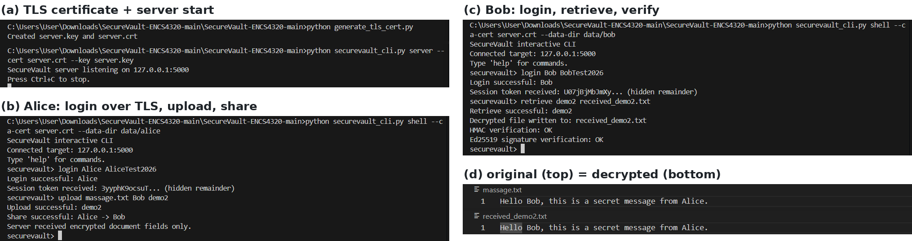
Figure 3. Upload, share and verified retrieval over TLS.
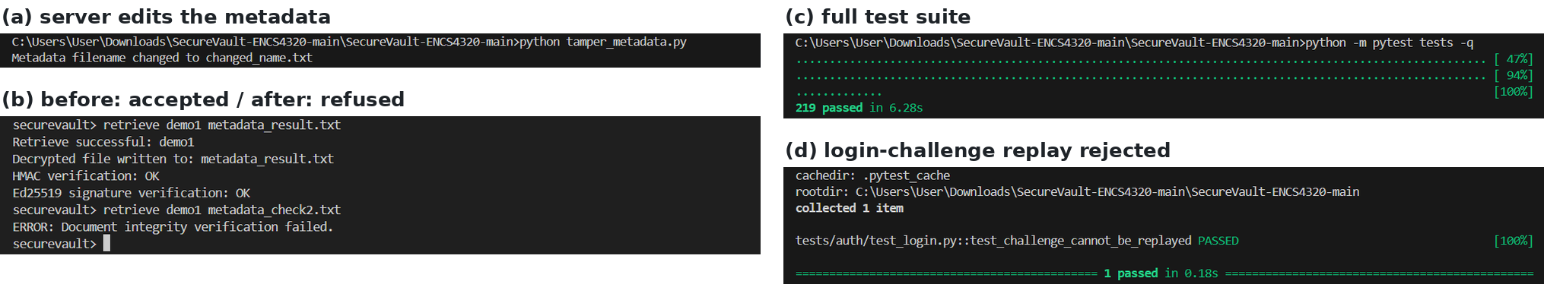
Figure 4. Metadata tampering refused; test suite and replay test pass.

7. Limitations
We do not claim unconditional security. These are the attacks our design does not stop, and what it would take to stop them.
- Self-signed server certificate. TLS is only as strong as the way server.crt reaches each client; server.key is unencrypted on disk and there is no rotation. The server itself still sees metadata after TLS. Fix: share the certificate fingerprint out of band and protect server.key.
- Plaintext hash is visible to the server. The signed SHA-256(plaintext) is stored in the clear. If a document is guessable (for example a known form), the server can confirm a guess. Fix: sign the ciphertext and tag instead of the plaintext hash, or keep the hash inside the encrypted part.
- Freshness is enforced mainly at the server. Request IDs (in-memory cache, lost on restart), unique document IDs and single-use challenges stop replays, but there is no signed timestamp or counter, so the client cannot tell an old version from a new one. Fix: a signed timestamp and per-owner counter in the metadata.
- First contact under attack (TOFU). If the attacker swaps keys the very first time, TOFU cannot notice. Fix: compare the verification code out of band before the first share.
- Weak passwords. A word-list password falls in minutes even with Argon2id, and our 24 ms work factor is low. Fix: a dictionary check at sign-up and 64 MiB / t = 3 (about 0.2 s per login).
- One recipient per upload. The recipient’s name is bound into the document metadata, so sharing with a second person needs a new upload. Fix: bind recipients only in the wrapped-key package.
- No password change or key revocation yet. Fix: a command that re-derives the login key and re-encrypts the wallet; and a signed key-change notice for TOFU.

8. AI Usage Statement and Contributions

8.1 AI Usage Statement
AI tools were used to assist with some parts of the code development and debugging process. They were also used to help improve the wording and organization of the report and presentation. The team reviewed all AI-assisted work and verified the technical information using the actual source code, the project requirements, the test results, and the benchmark results. All final design decisions, implementation choices, testing, report content, presentation content, and submitted materials were reviewed and approved by the team.

8.2 Contribution Statements
Member | Contribution
Besan Maaly (1222776) | Worked on the Server, Files, and Sharing part, including the server implementation, client-server communication, file upload and download, document sharing, metadata handling, storage format, replay/freshness handling, integration testing, and demo setup. She contributed with the team to preparing, writing, and reviewing the final report and presentation.
Shahd Shreteh (1210444) | Worked on Cryptography and Key Management, including symmetric encryption, authentication and integrity mechanisms, key generation and derivation, public-key cryptography, digital signatures, key management, public-key trust mechanisms, and testing of the cryptographic primitives. She contributed with the team to preparing, writing, and reviewing the final report and presentation.
Dania Abuayyash (1210464) | Worked on Authentication and User Management, including sign-up, login, password protection, credential storage, session/login state, user database, and authentication-related testing. She also worked on the TLS implementation and secure client-server communication. She contributed with the team to preparing, writing, and reviewing the final report and presentation.

References
- NIST FIPS 197, Advanced Encryption Standard (AES).
- NIST SP 800-38A, Recommendation for Block Cipher Modes of Operation.
- RFC 2104 (HMAC); RFC 4231 (HMAC-SHA test vectors).
- RFC 5869, HMAC-based Extract-and-Expand Key Derivation Function (HKDF).
- RFC 7748, Elliptic Curves for Security (X25519).
- RFC 8032, Edwards-Curve Digital Signature Algorithm (EdDSA).
- RFC 9106, Argon2 Memory-Hard Function for Password Hashing.
- Bellare and Namprempre, Authenticated Encryption (Encrypt-then-MAC composition).
- ENCS4320 Final Project specification, Term 1253, Birzeit University.

Appendix A. Offline Guessing Arithmetic
Assume the attacker has the whole credential database and the user picked a random 8-character password from 62 symbols.
Password space = 62^8 = 2.18 × 10^14. On average the attacker searches half of it: 1.09 × 10^14 guesses. Each guess must run Argon2id and then HMAC + X25519 to compare with the stored login public key; we count only the Argon2id cost.
Attacker | Guesses per second | Average time per account
One CPU core, our parameters (measured: 23.8 ms/guess) | 42 | 2.6 × 10^12 s ≈ 82,000 years
One high-end GPU, our parameters (estimate, see below) | ≈ 7,800 | 1.4 × 10^10 s ≈ 440 years
One high-end GPU, bare SHA-256 (for comparison) | ≈ 2.2 × 10^10 | ≈ 5,000 s ≈ 83 minutes

GPU estimate. With t = 1, Argon2id writes 32,768 blocks of 1 KiB, each built from two earlier blocks, so one guess moves about 100 MiB (rounded to 128 MiB). At about 1 TB/s of GPU memory bandwidth that is at most 10^12 / (1.28 × 10^8) ≈ 7,800 guesses per second, an upper bound, not a measured rate. The CPU number comes from scripts/estimate_offline_attack.py 0.0238.

