**Selected Values**

|  |  |  |  |
| --- | --- | --- | --- |
| **Input** | **Low** | **Medium** | **High** |
| **Temperature (0 to 50)** | 0 to 27 | 22 to 38 | 33 to 50 |
| **Dissolve Oxygen (0 to 40)** | 0 to 7 | 6 to 9 | 8 to 40 |
| **pH (0 to 9)** | 0 to 4 | 3 to 6 | 5 to 9 |

|  |  |  |  |
| --- | --- | --- | --- |
| **Output** | **Poor** | **Medium** | **Good** |
| **Water Quality (0 to 1)** | 0 to 0.4 | 0.3 to 0.7 | 0.6 to 1 |

**Member Function Of Temperature**

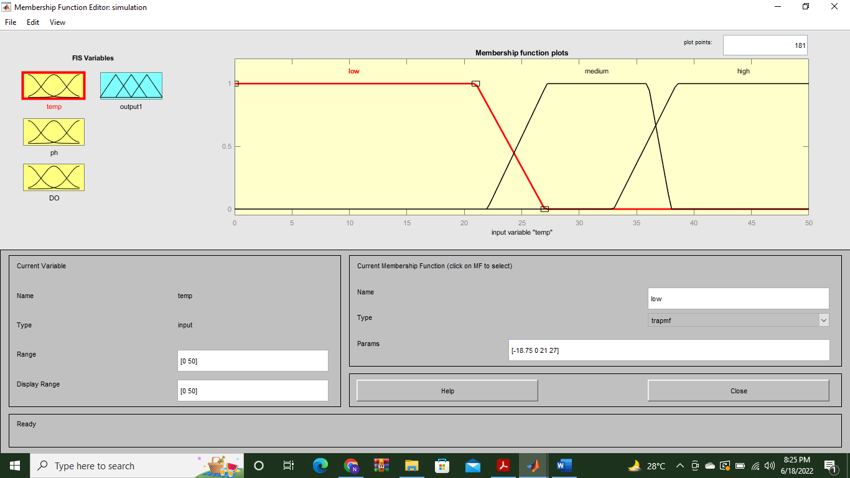

**Member Function Of Ph**

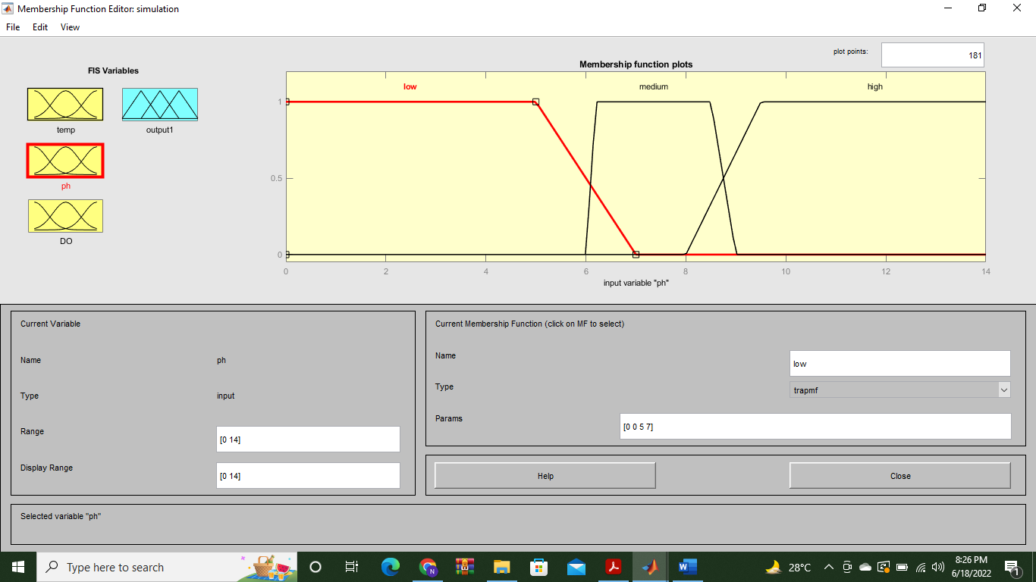

**Member Function Of DO**

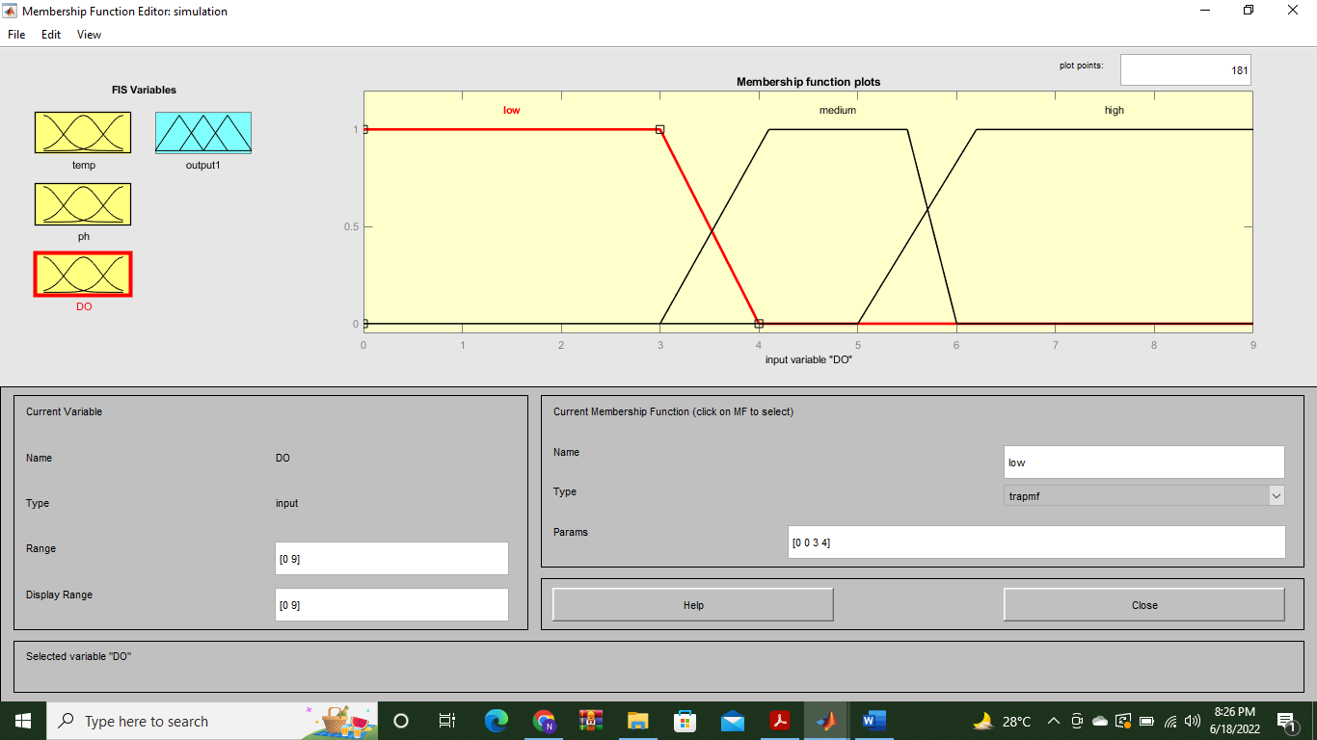

**Member Function Of Water Quality OutPut**

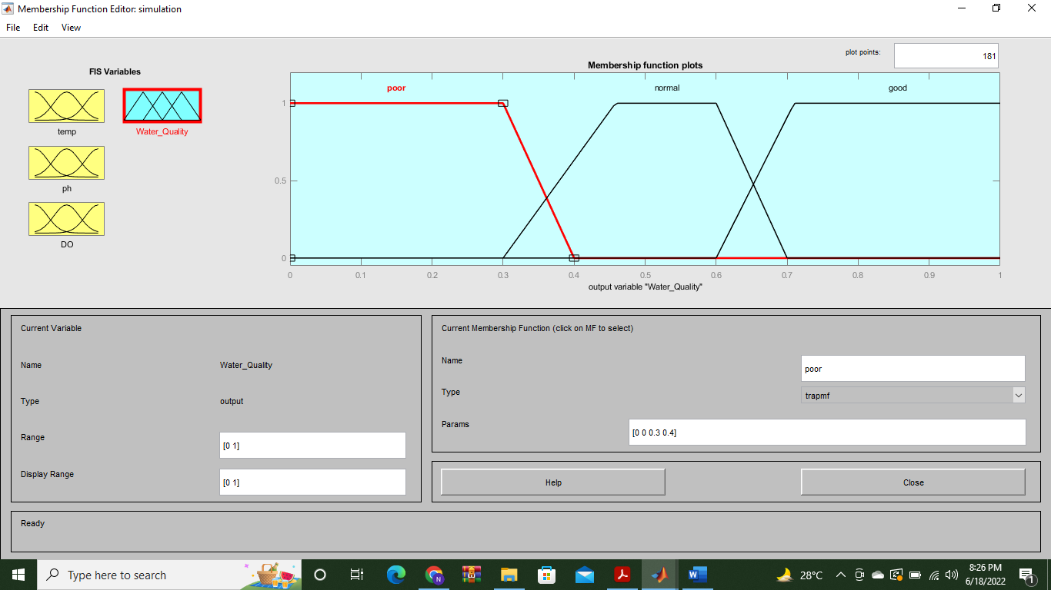

**2D Graph Of Temperature**

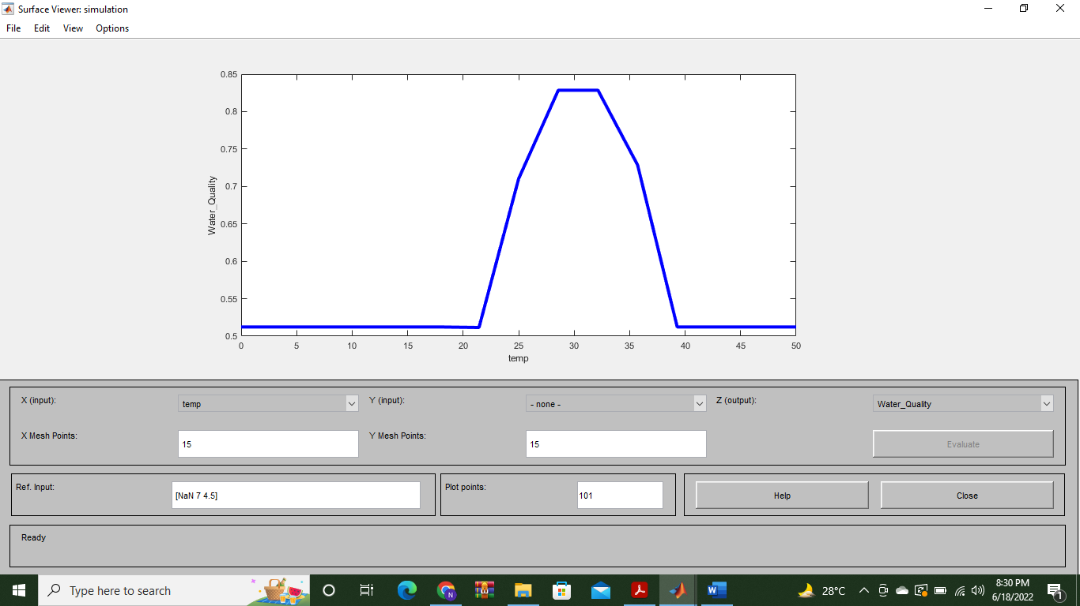

**2D Graph Of Ph**

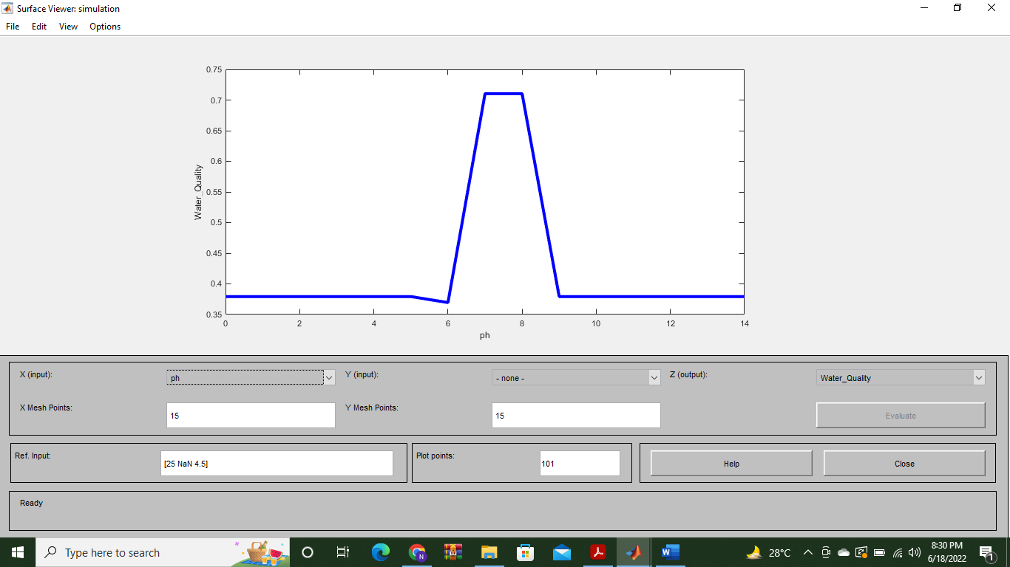

**2D Graph Of DO**

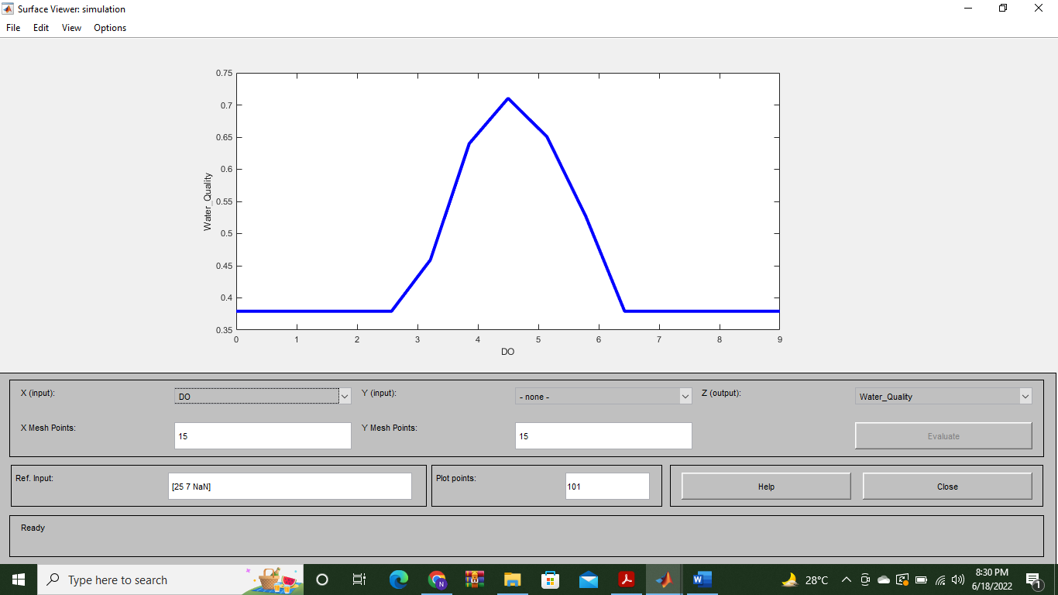

**3D Graph Of Temperature And Ph And its impact on water Quality**

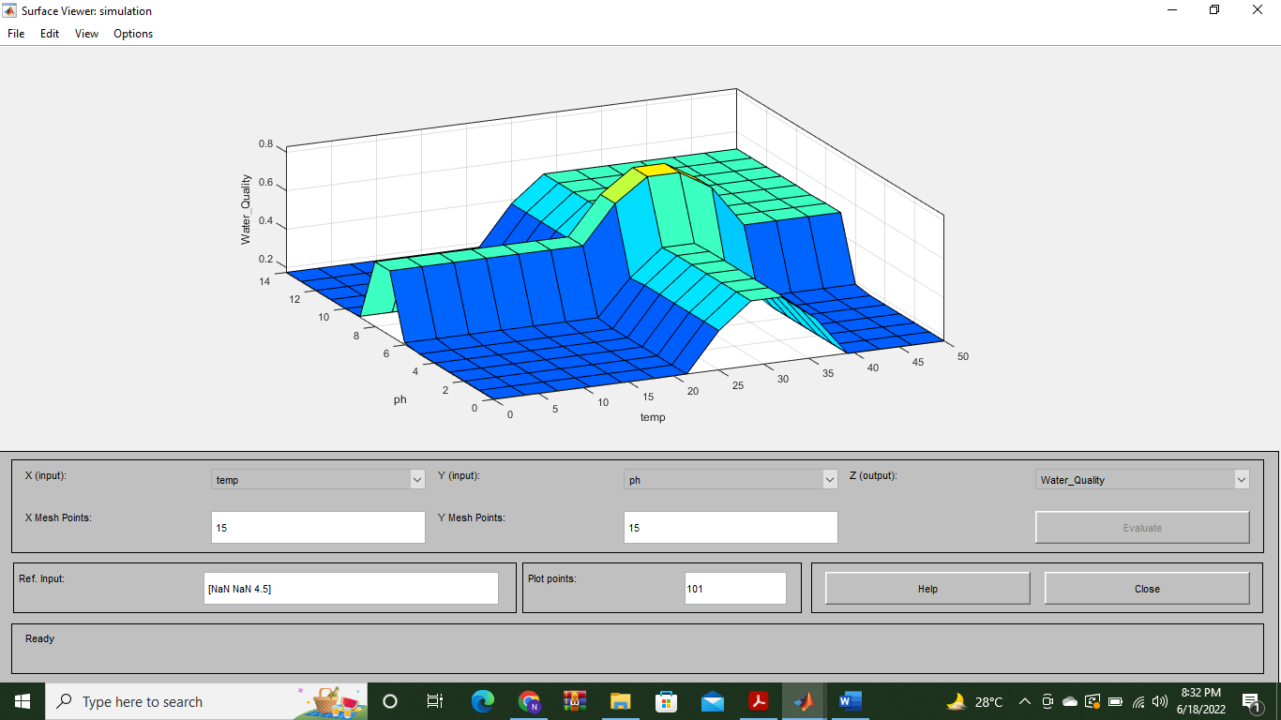

**3D Graph Of Temperature And DO And its impact on water Quality**

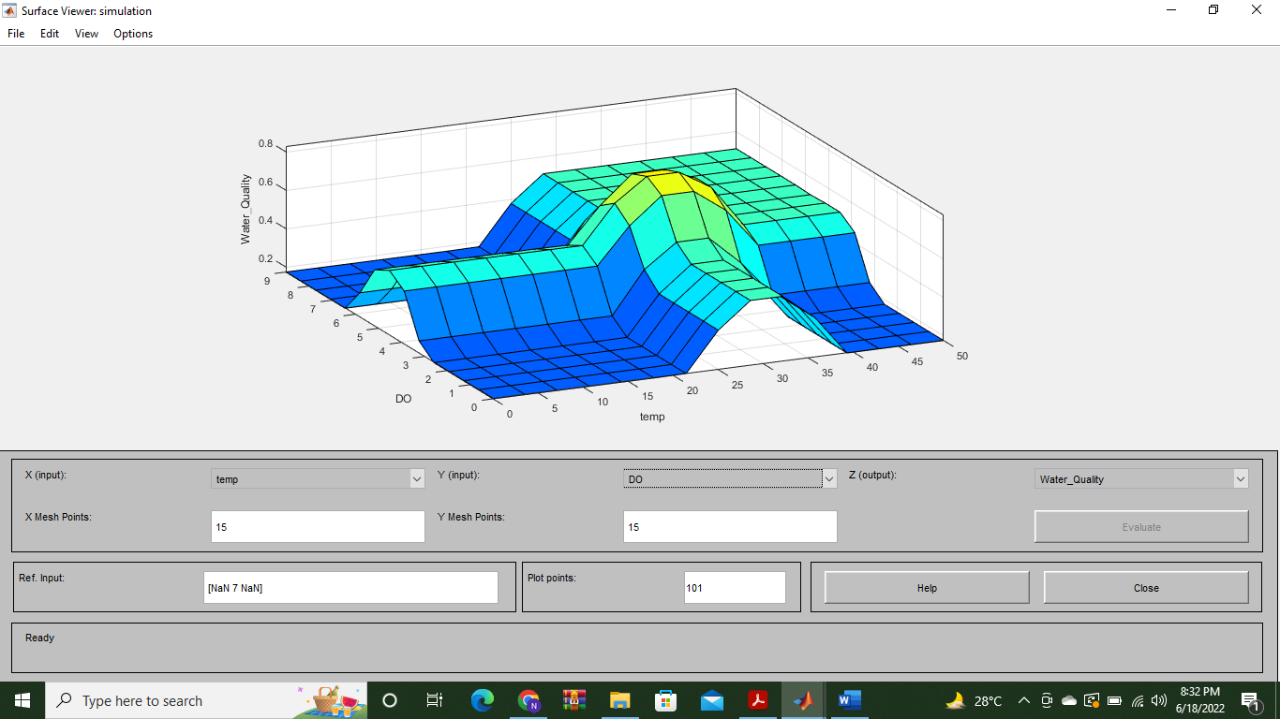

**3D Graph Of Ph And Do And its impact on water Quality**

