- Create one IAM user and assign EC2 and S3 full access roles.
Goto AWS account, login, then search IAM , select Users, create users, give name , password, next, select services, ec2 and s3, next
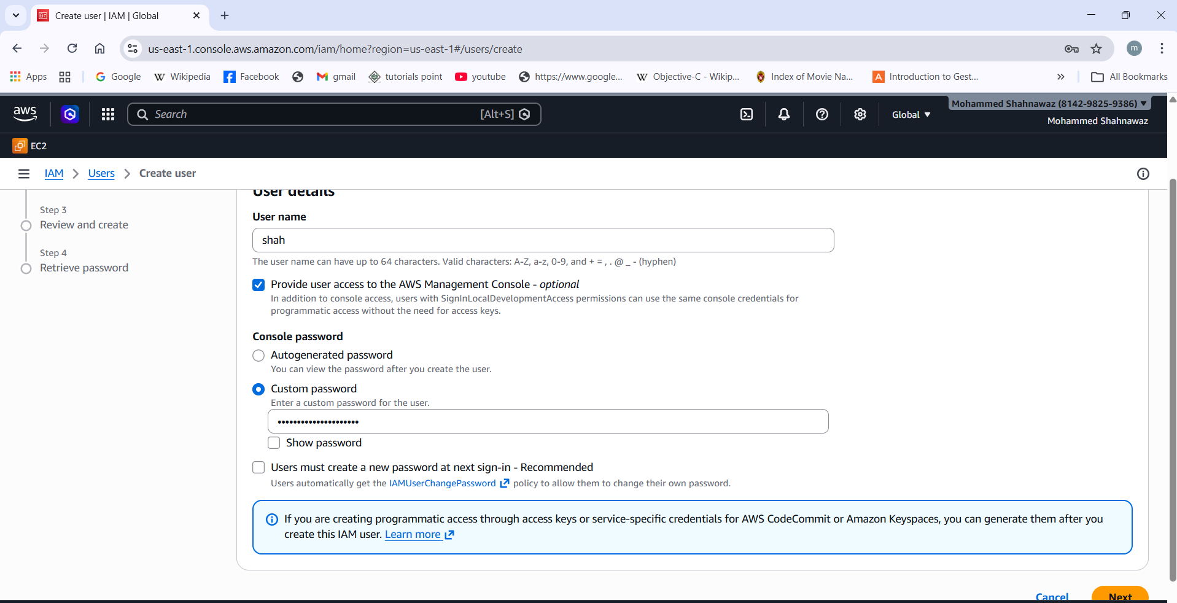
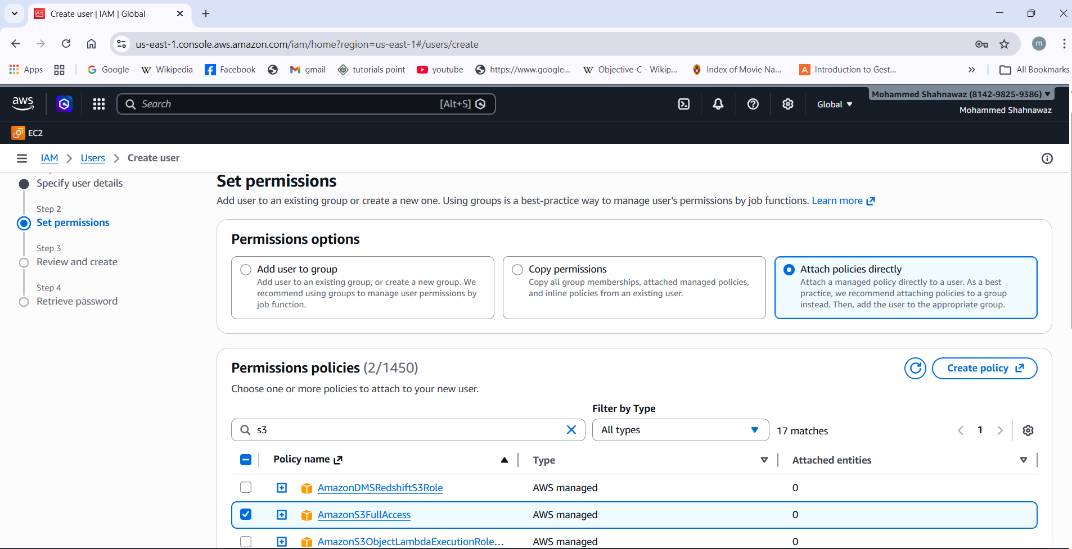
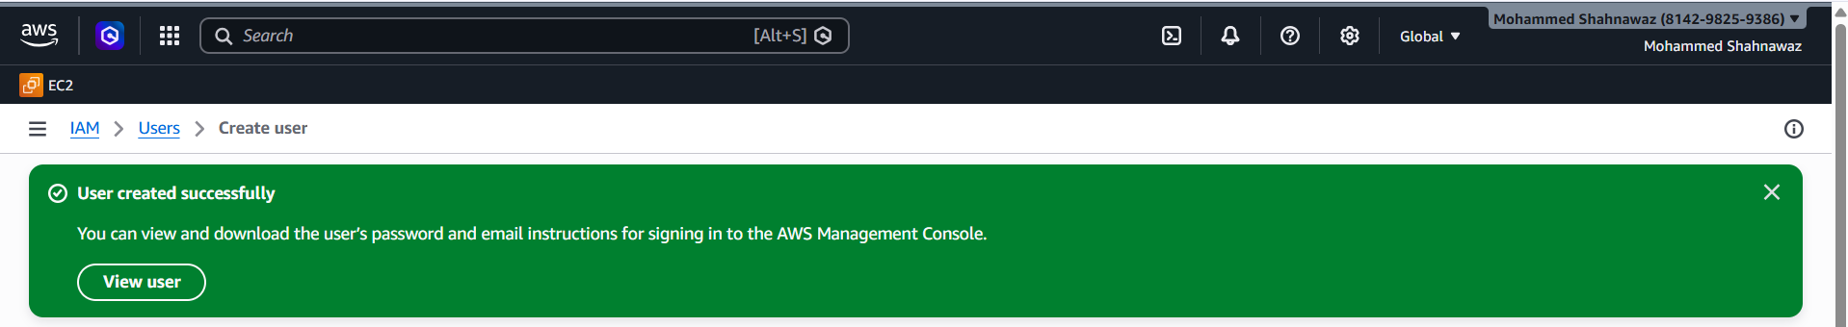
2. Create one group in IAM and assign read access for EC2.
Goto user groups, create group, give name, select services as ec2 read only access
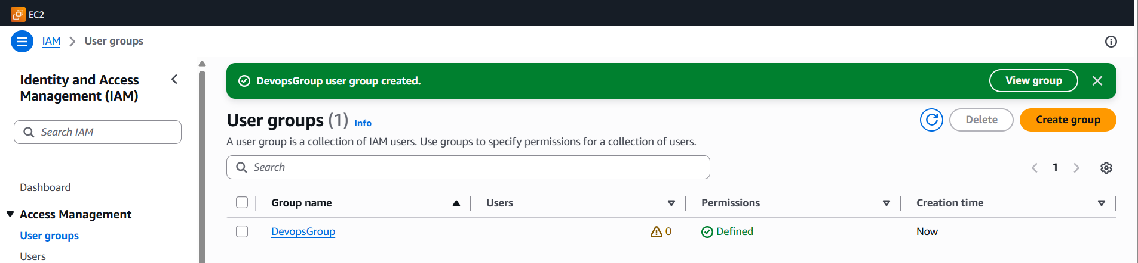
3. Create a new user named "Devops" and add to the group created in task 2.
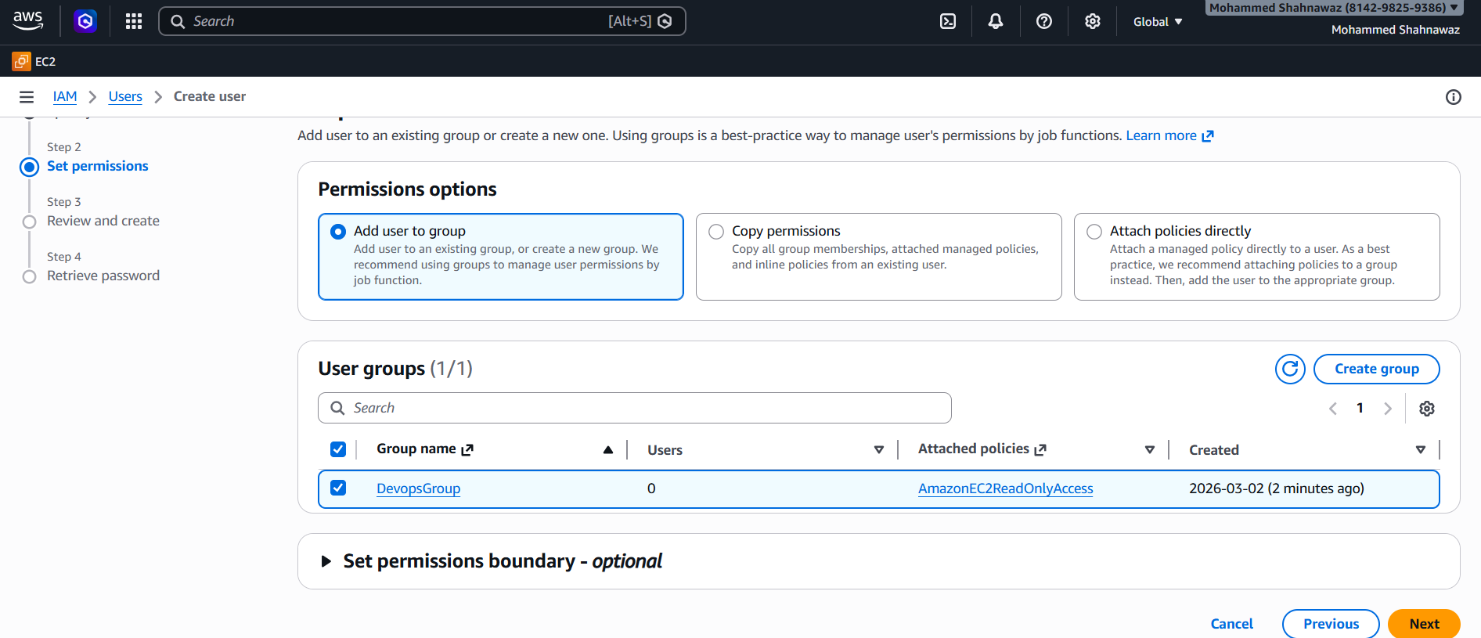
4. Write a bash script to create an IAM user with VPC full access. 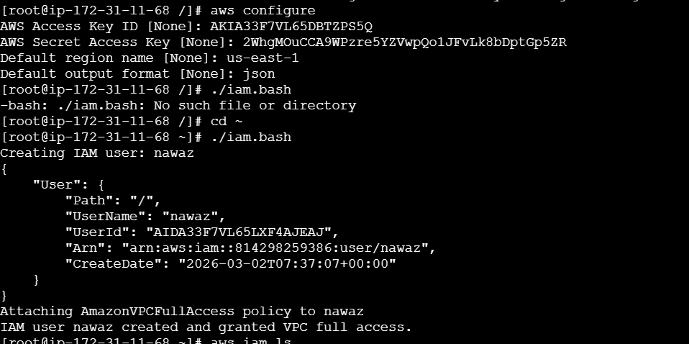
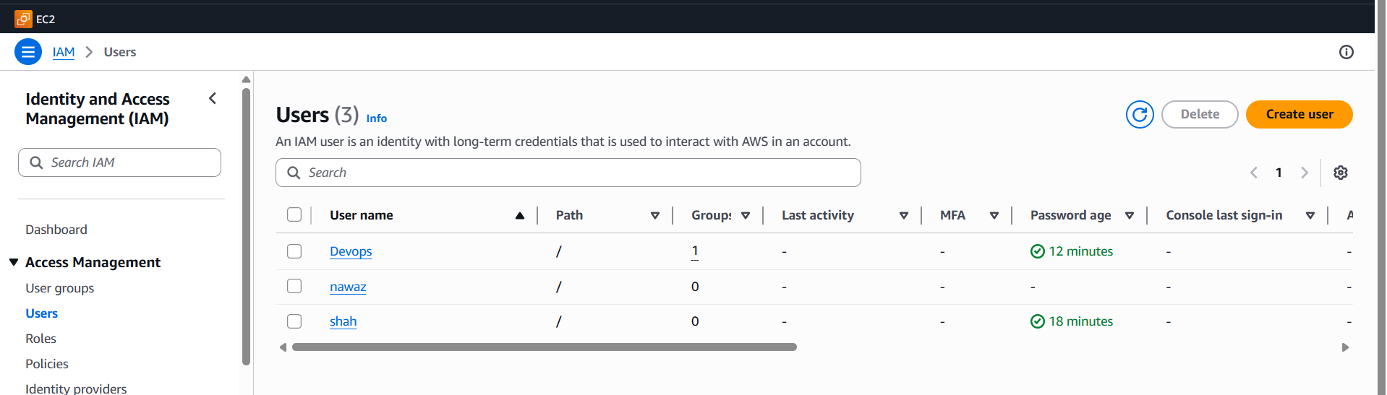
5. Create an IAM policy to allow EC2 access for a specific user in specific regions only.
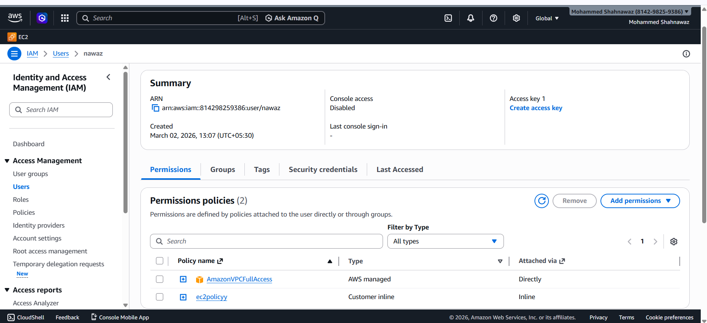
6. We have two accounts: Account A and Account B. Account A user should access an S3 bucket in Account B.
(Collaborate with a team member and execute this. This is mostly asked in every interview.)
