- Create an S3 bucket and upload some objects to S3.
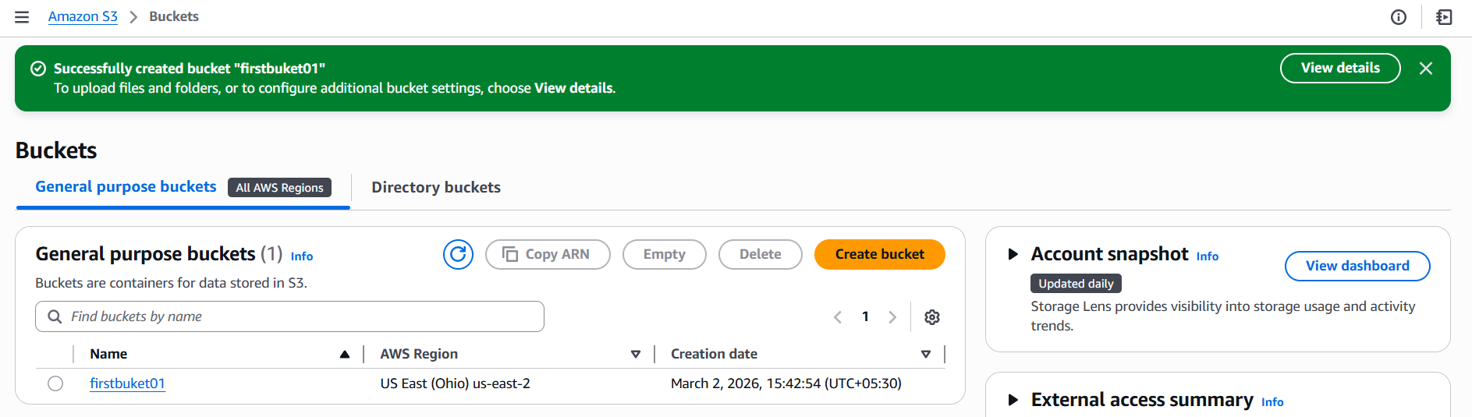
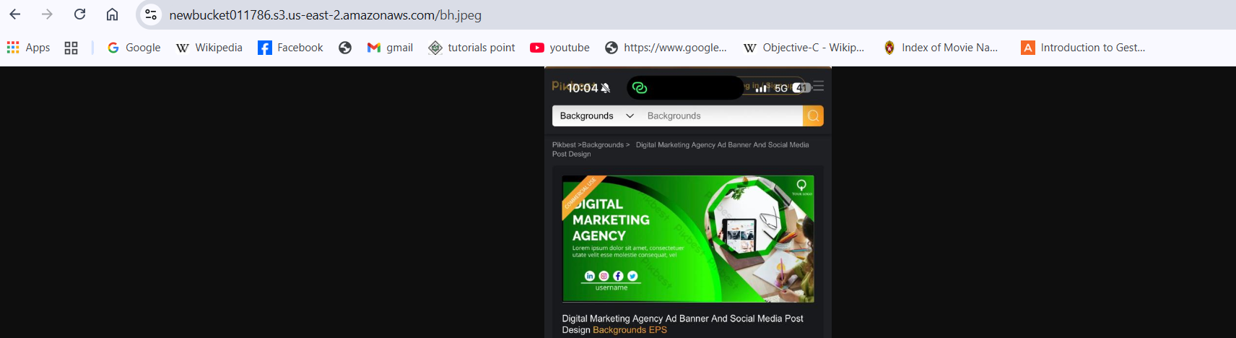
- Deploy a static website in the S3 bucket.
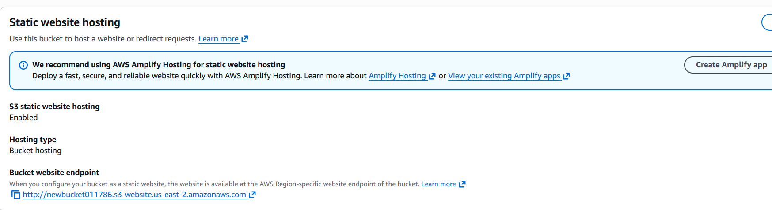
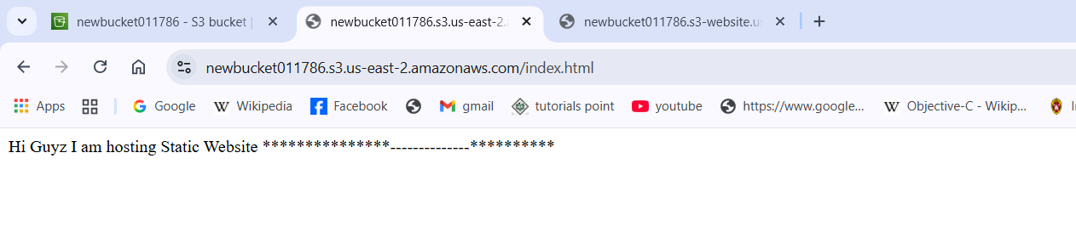
- Enable cross-region replication on S3 buckets.
We need two buckets for replication process in two different regions with in the same account then Goto bucket if already created then enable versioning then select management then select create replicate rule and give the source and destination buckets details in the rule once rule is created then goto source bucket and add any file then you can observe that added file now is replicated in the destination bucket.

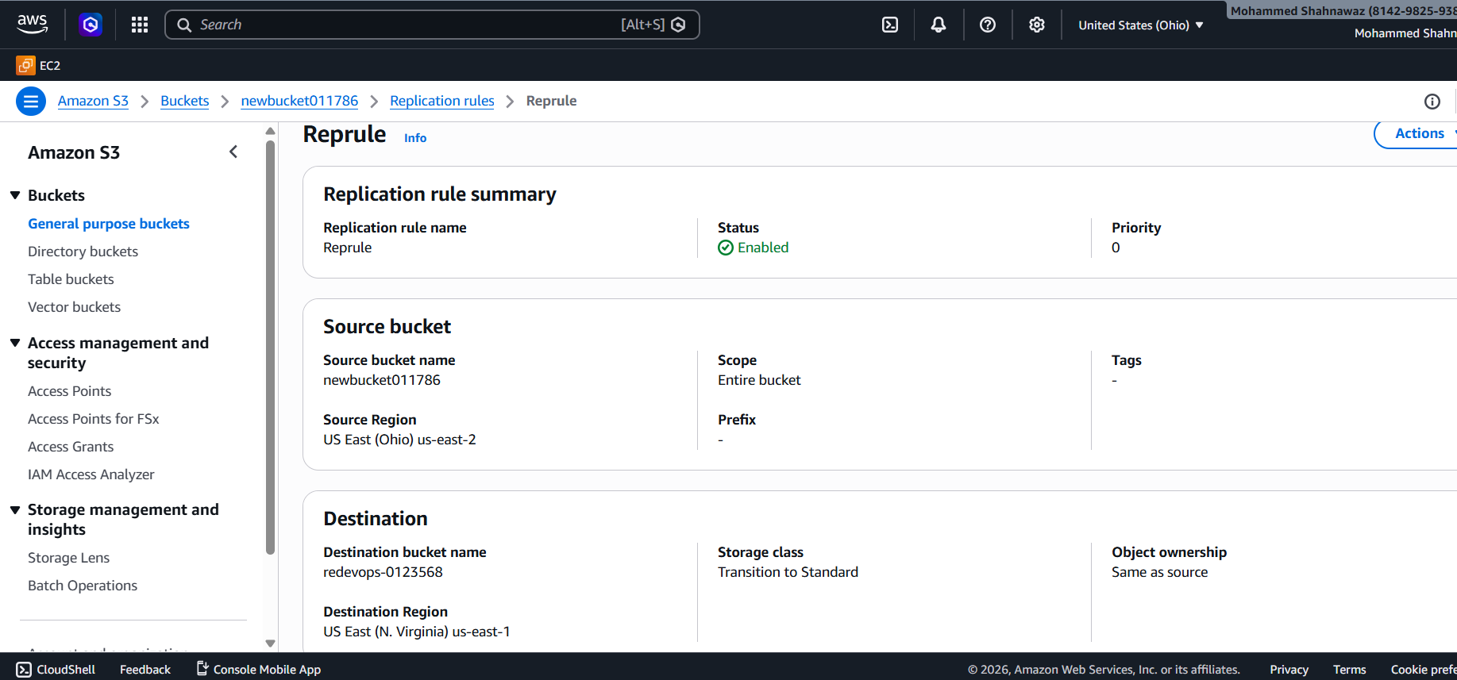
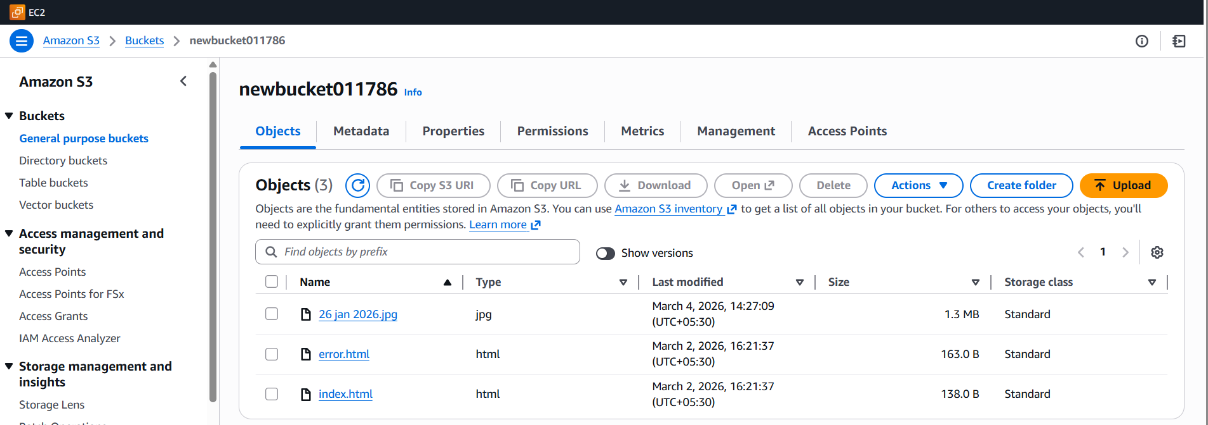
- Configure a bucket policy so only the Admin user can see the objects of the S3 bucket.
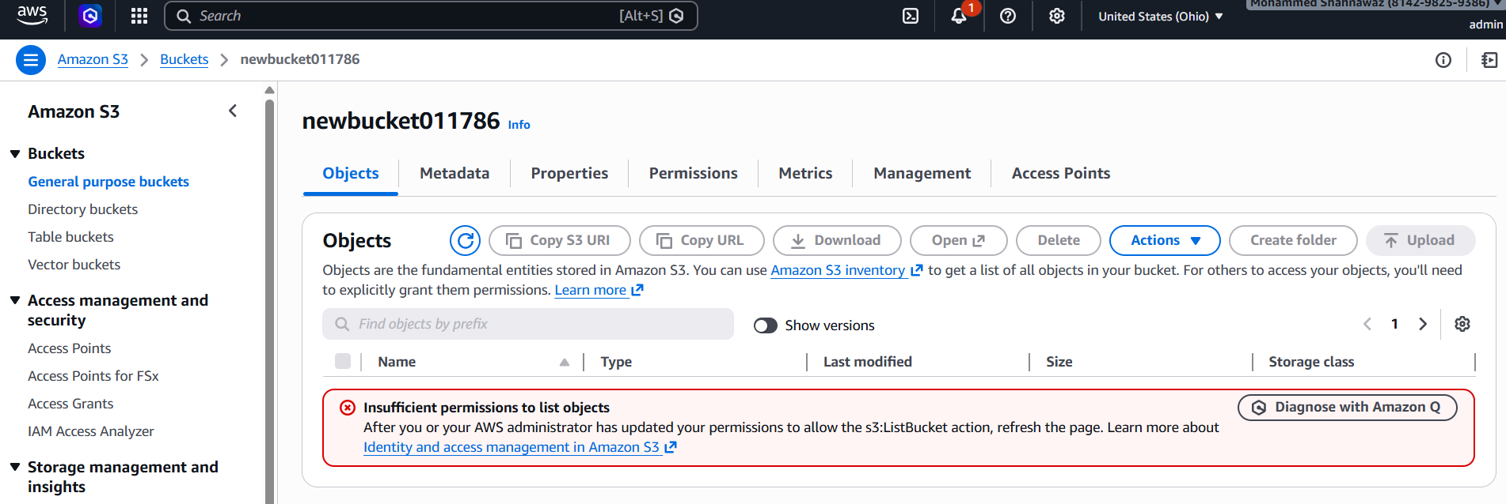
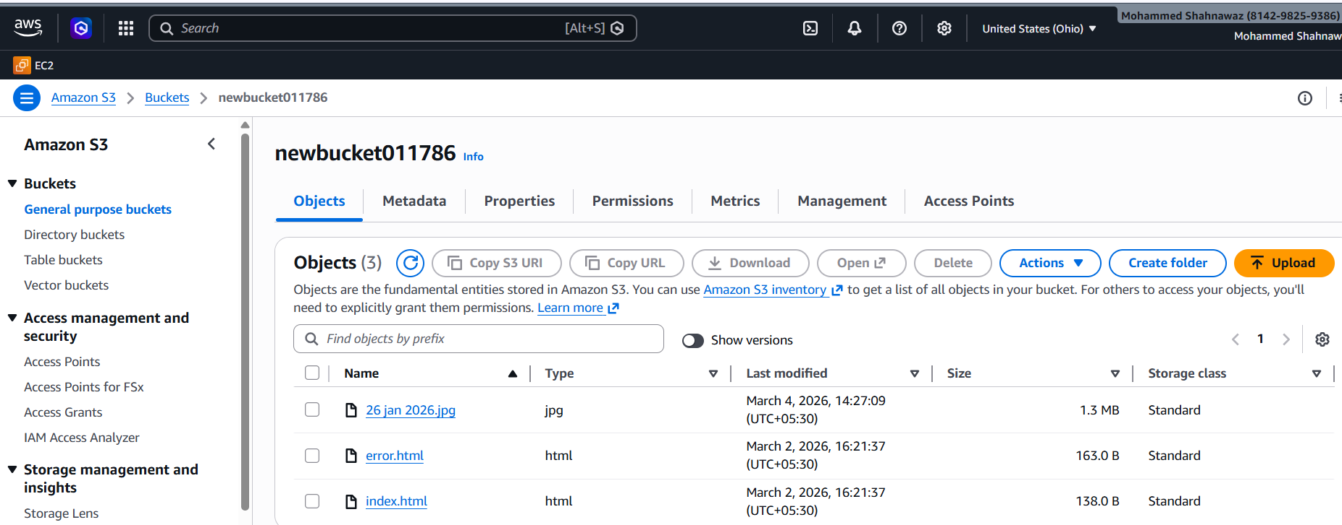
- Set up lifecycle policies to automatically transition or delete objects based on specific criteria.
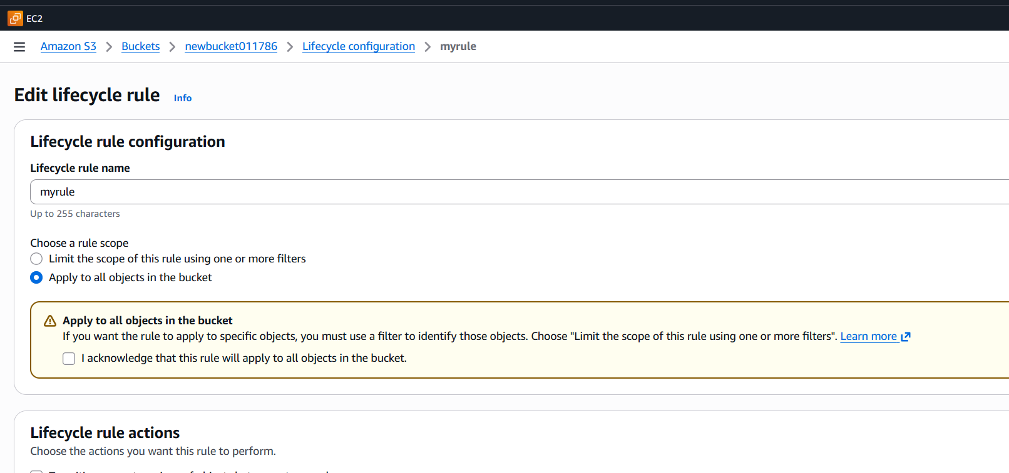
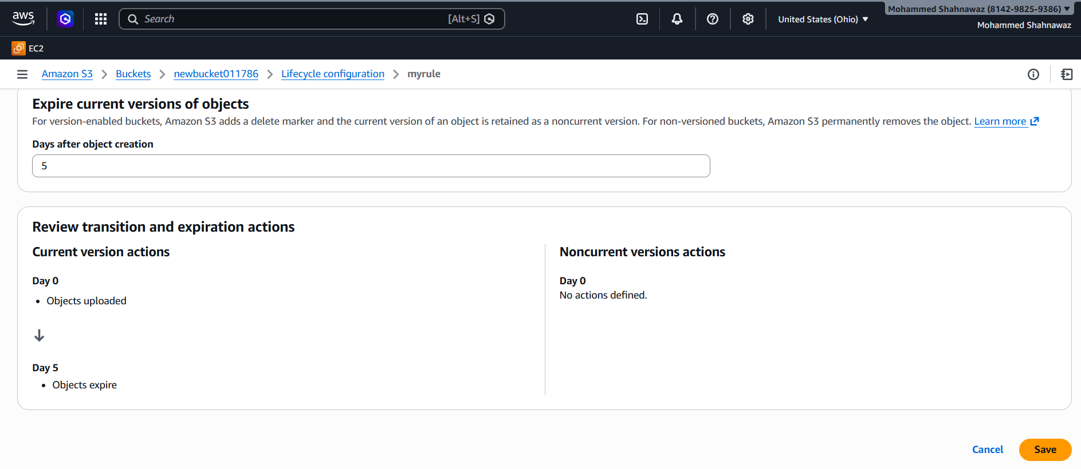
- Push some objects to S3 using the AWS CLI.
First install awscliv2 on windows desktop to communicate with aws s3 and local machine then configure aws on machine then provide secure key and access key then region then format all done now you can push any data to s3 bucket with cmd aws s3 cp file name bucketname.
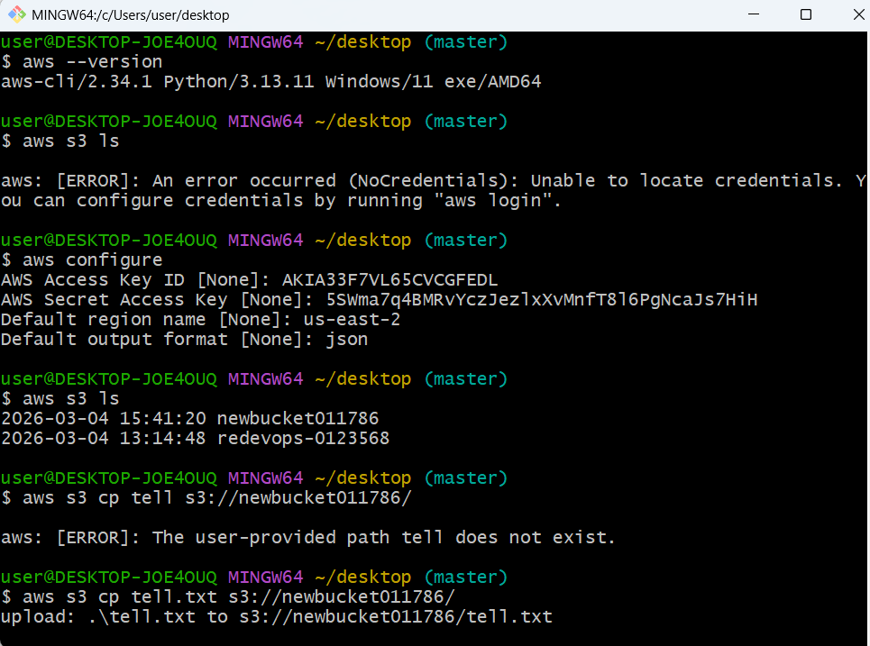
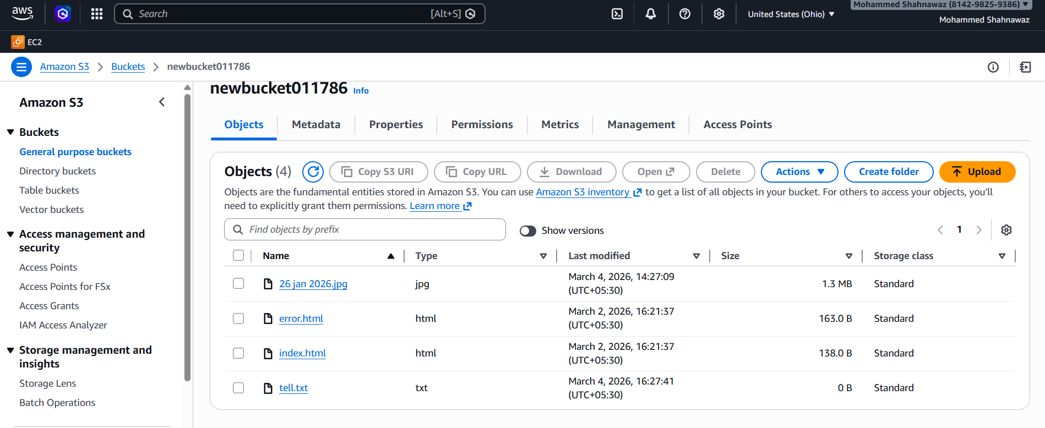

- Write a Bash script to create an S3 bucket.
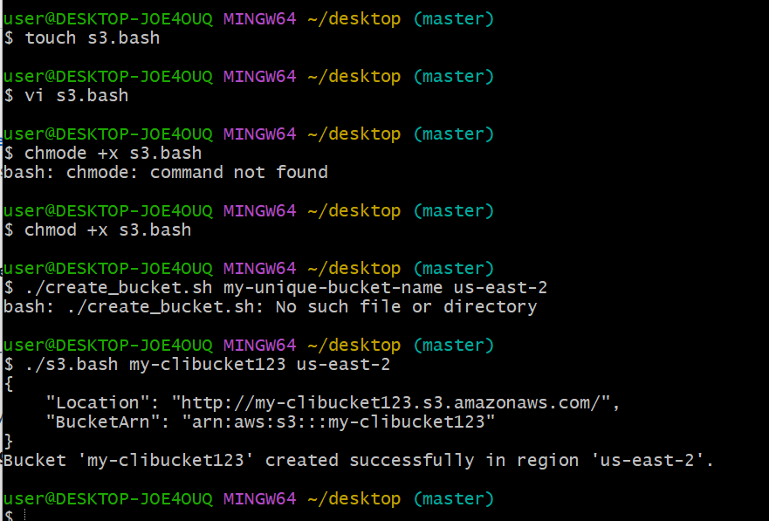
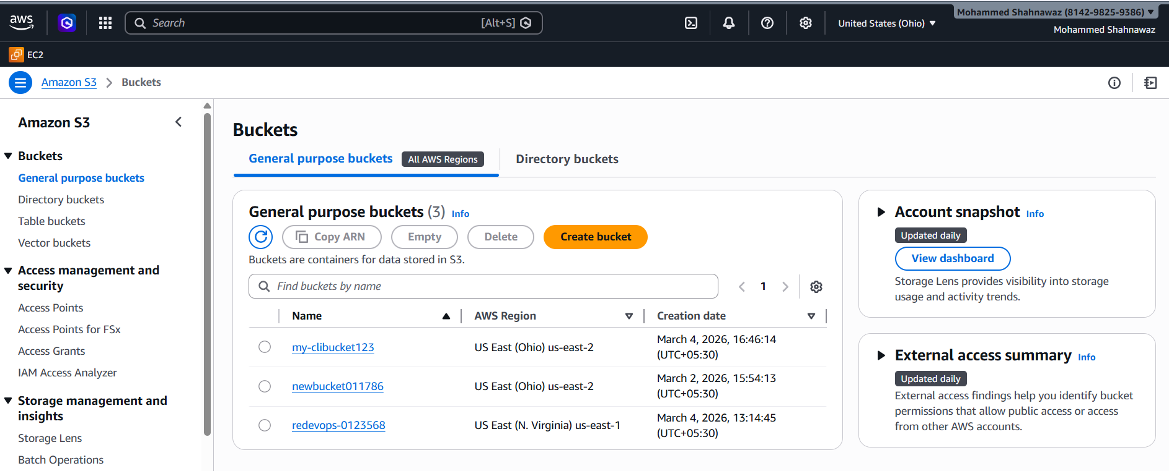

- Upload a 1 GB file to S3 using the CLI.
dd if=/dev/zero of=1GBfile bs=1M count=1024 this command is used to create 1 gb file
