- Create VPC with 2 private and 2 public subnets.
Log in to aws console click on vpc dashboard create new vpc give a name to vpc then assign a range of Ipv4 cidr and hit create.
Then click on subnet create subnet select your vpc then give a name to subnet then select a range of ip that you want to assign as you like hit create.
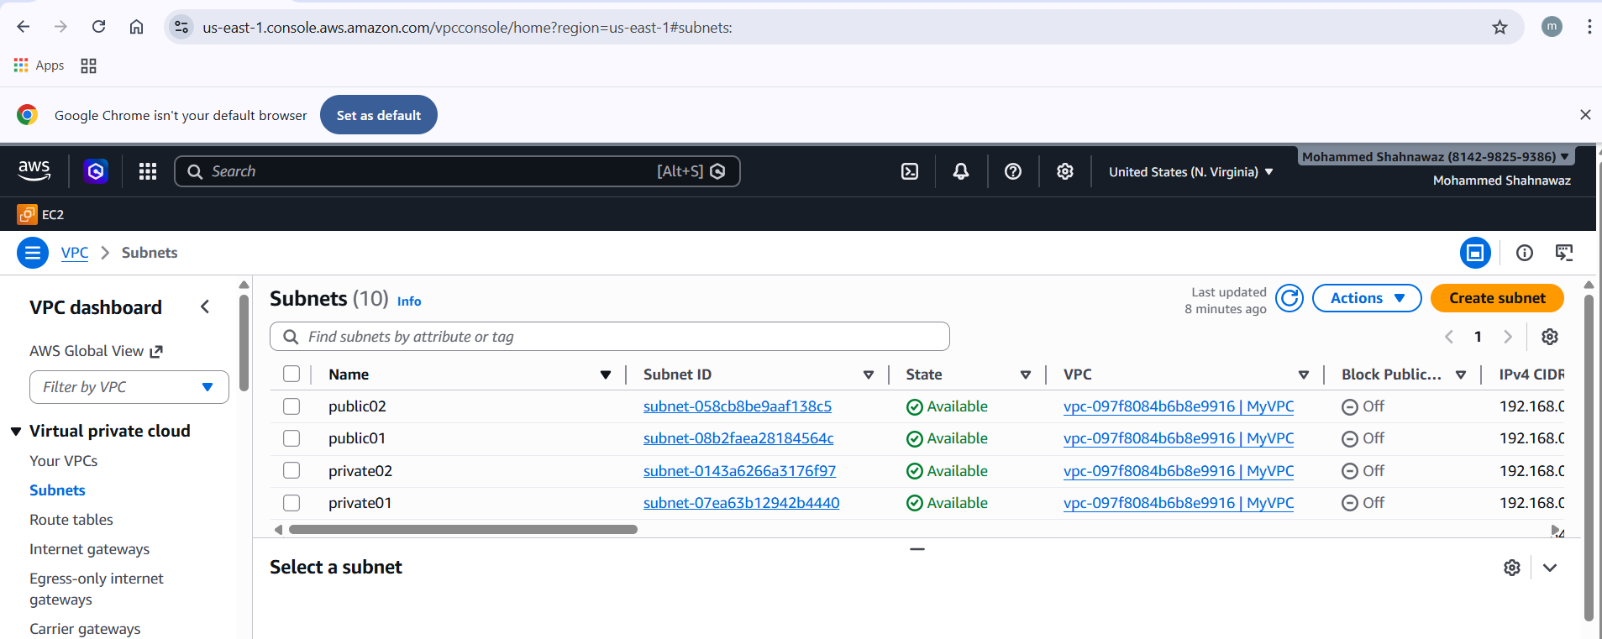

- Enable DNS Hostname in VPC.
Select the vpc then click on actions select vpc settings select enable dns hostname
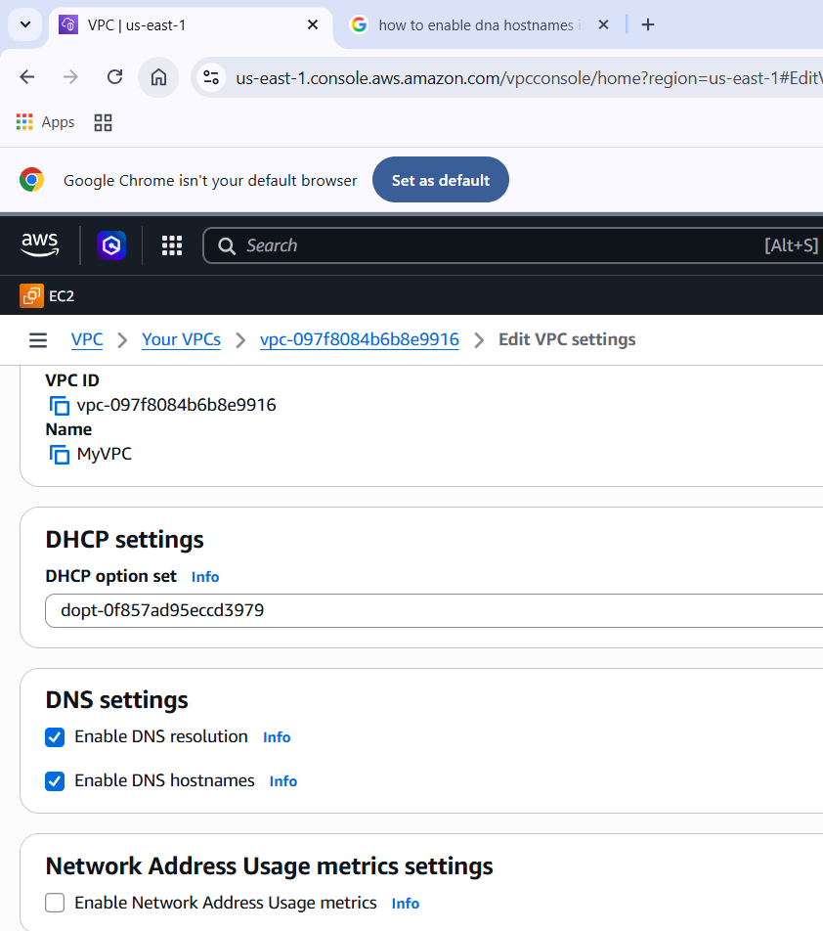

- Enable Auto Assign Public IP in 2 public subnets.
Go to subnet setting through actions and check enable auto assign public ip
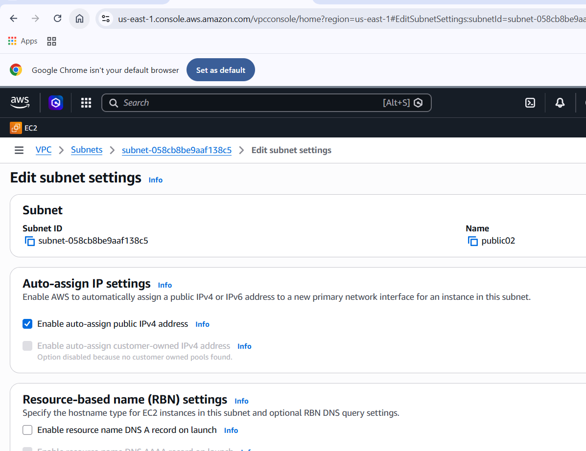

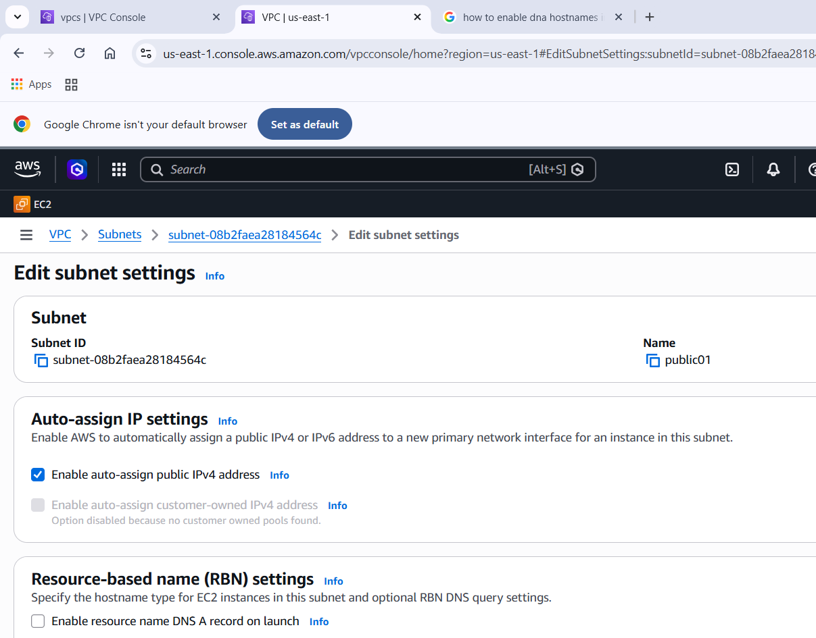
- Add 2 private subnets in private route table.
Go to route table create new route table give a name as private then select vpc hot enter
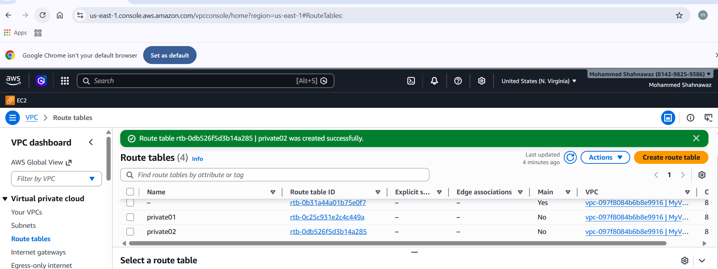

- Add 2 public subnets in public route table.
Go to route table create new route table give a name as public then select vpc hot enter configure internet gateway with aname and attacj it to your vpc then goto subnet association select the public then goto route edit route then select all traffic and internet gateway id
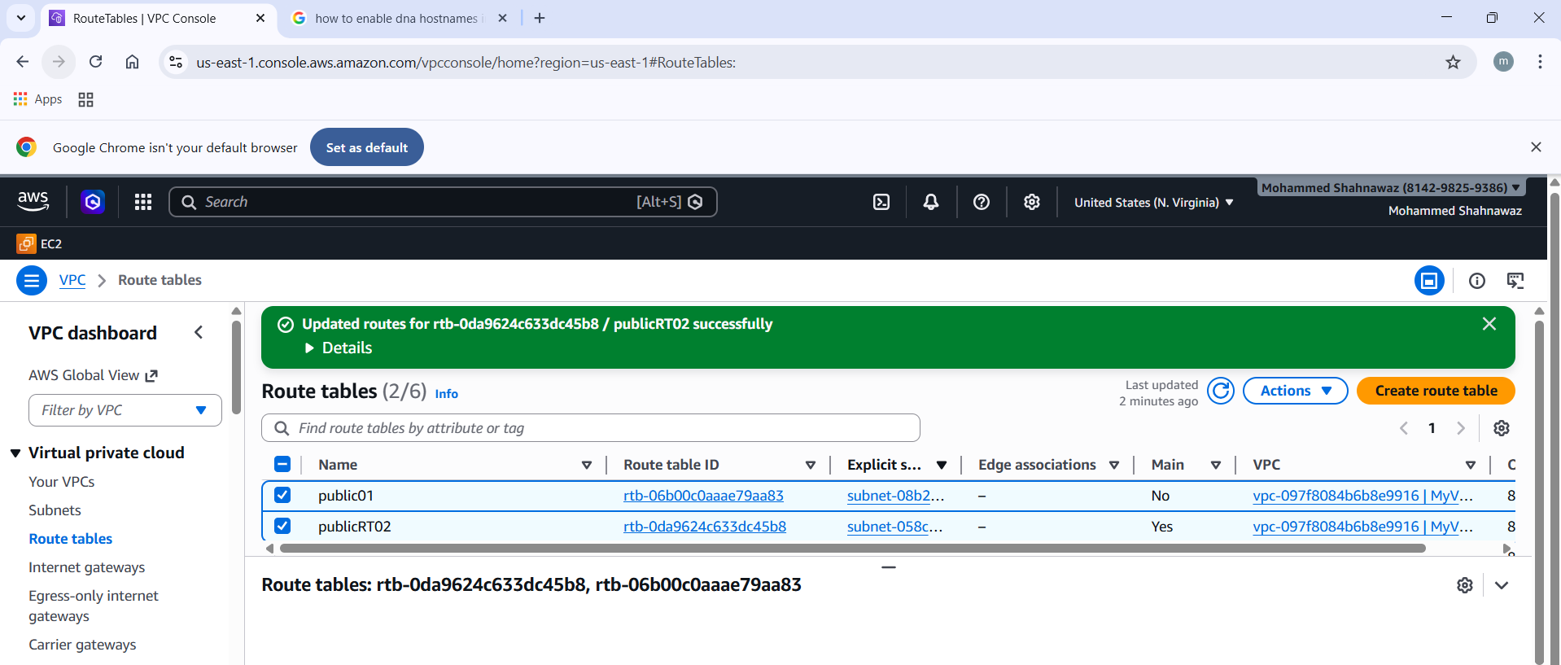

- Public route table will have the routes to internet and local.
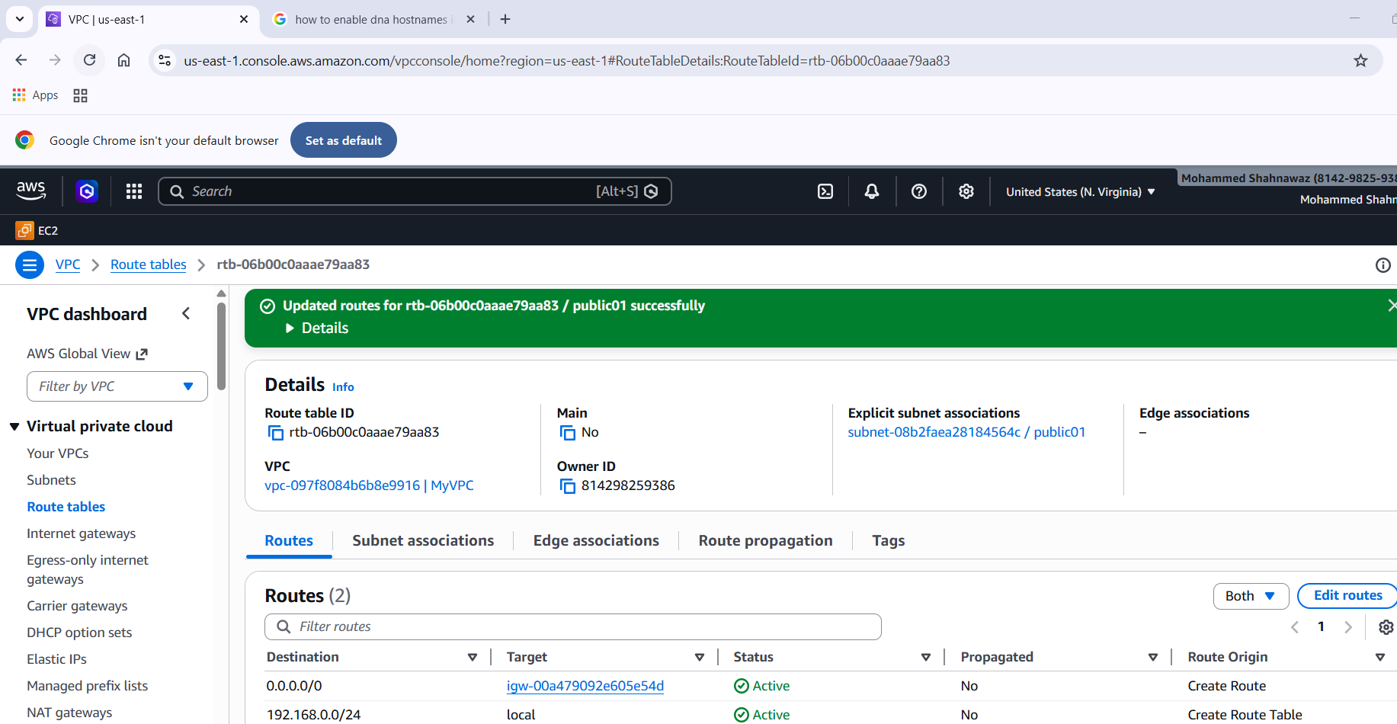
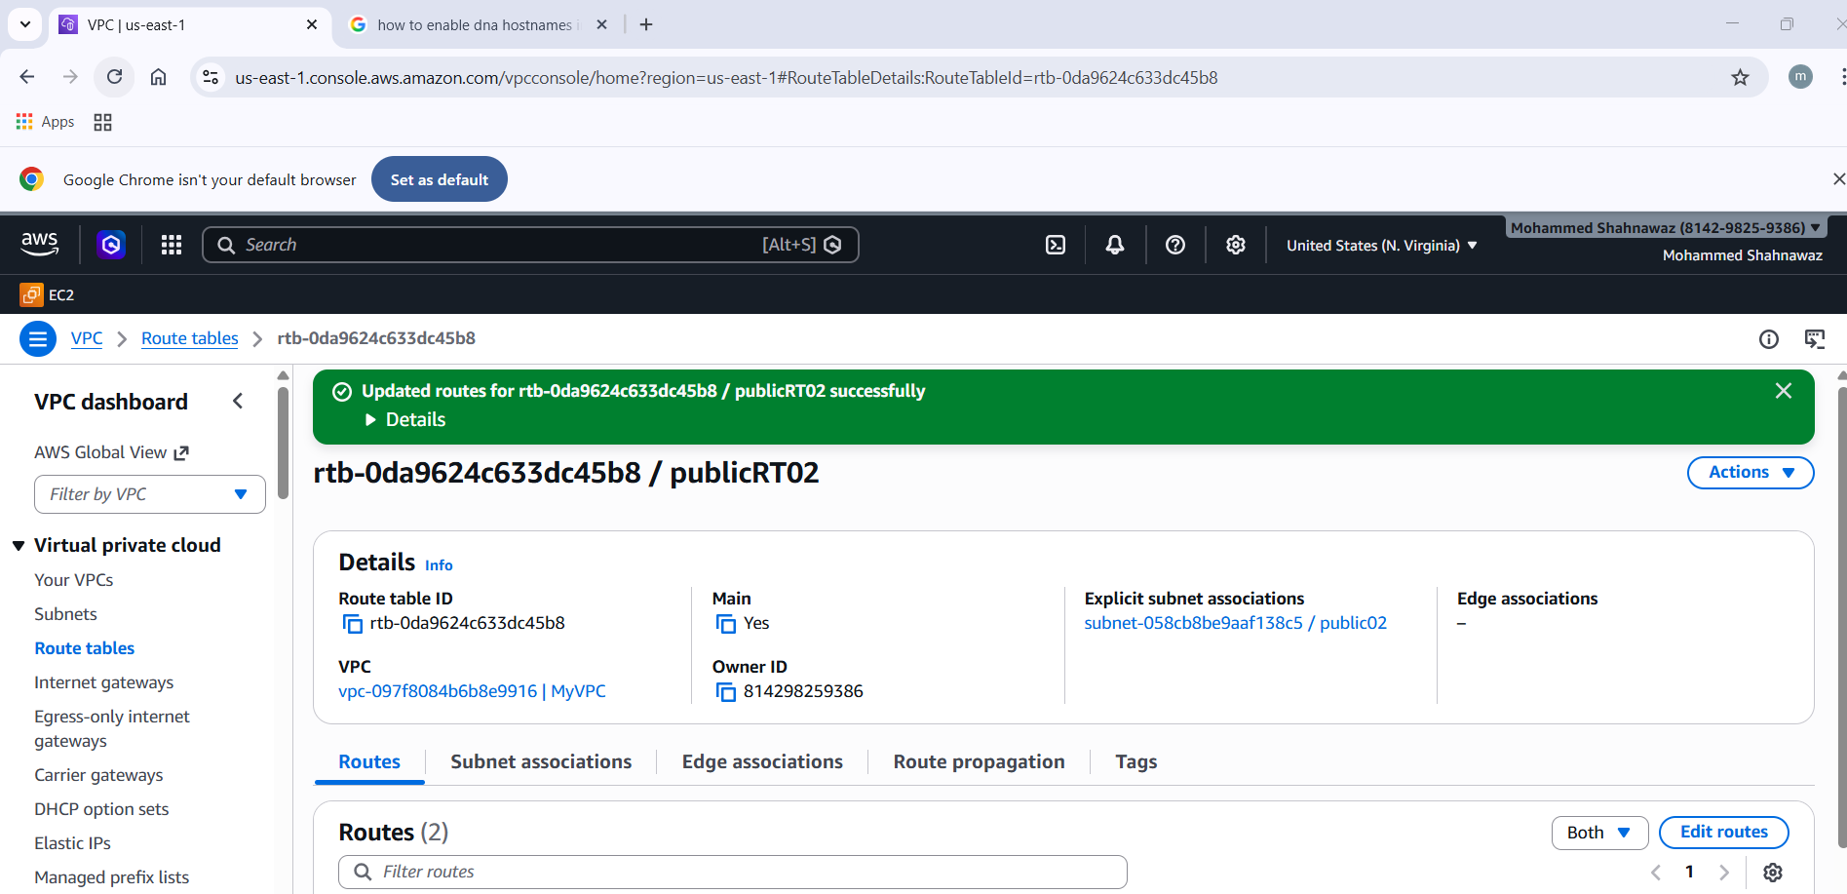
- Create EC2 in public subnet with t2.micro and install PHP.
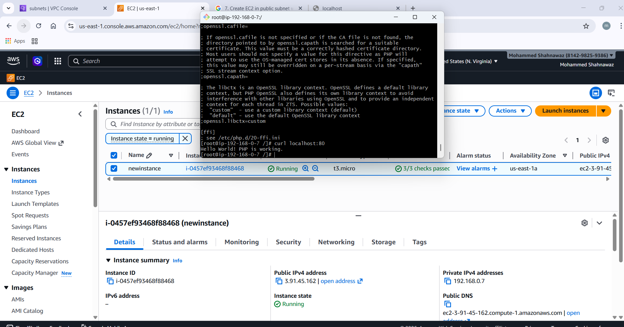
- Configure NAT gateway in public subnet and connect to private instance.
NAT gateway will allow only to connect to internet through public subnet only if we try to connect to internet directly through ssh command it will show connection time out. So first launch two ec2 with same vpc and different subnets one as public and one as private. Now come back to vpc dashboard open routing table and configure public with igw and for private nat gateway. Then save it now on gitbash terminal connect with public instance first and ping google.com communication will be successful and now connect to private instance being in that public instance and try to ping google.com it will ping.

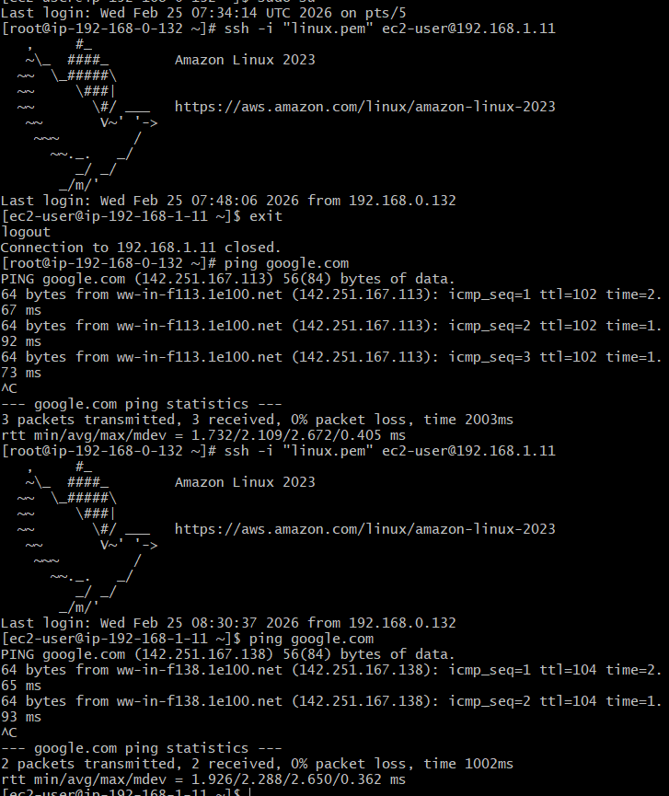

- Install Apache Tomcat in private EC2 and deploy a sample app.
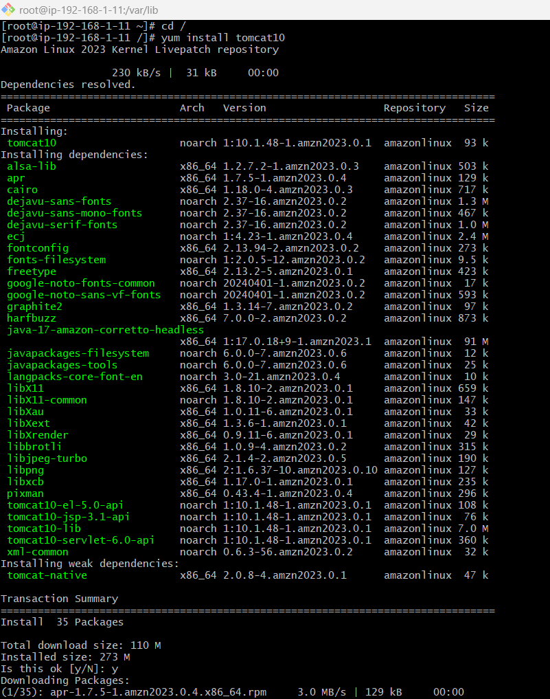

- Configure VPC flow logs and store the logs in S3 and CloudWatch.
Flow logs are useful for checking threats happened in passed or unauthorisation entries or any other details whatever is done in the vpc is captured and stored for security purposes these data is stroed in s3 buckets which is also a service provided by aws so create a bucket in s3 and give name then configure accordingly and save noe you will get arn numner paste in the flow log sheets configuration similarly for cloud watch also.
