AUTO SCALING GROUPS
- Create one VPC in N. Virginia region.
Goto Aws open vpc create vpc give name to vpc then select cidr range then create
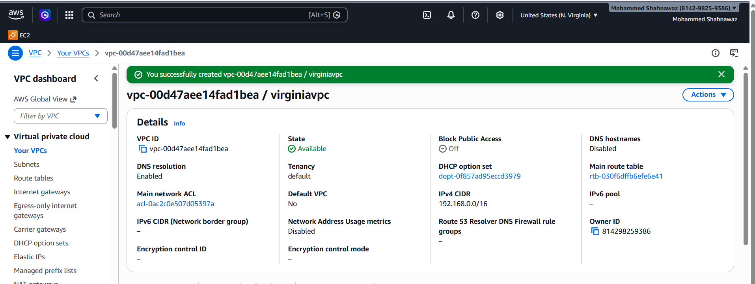
- Create two subnets: one public subnet and one private subnet.
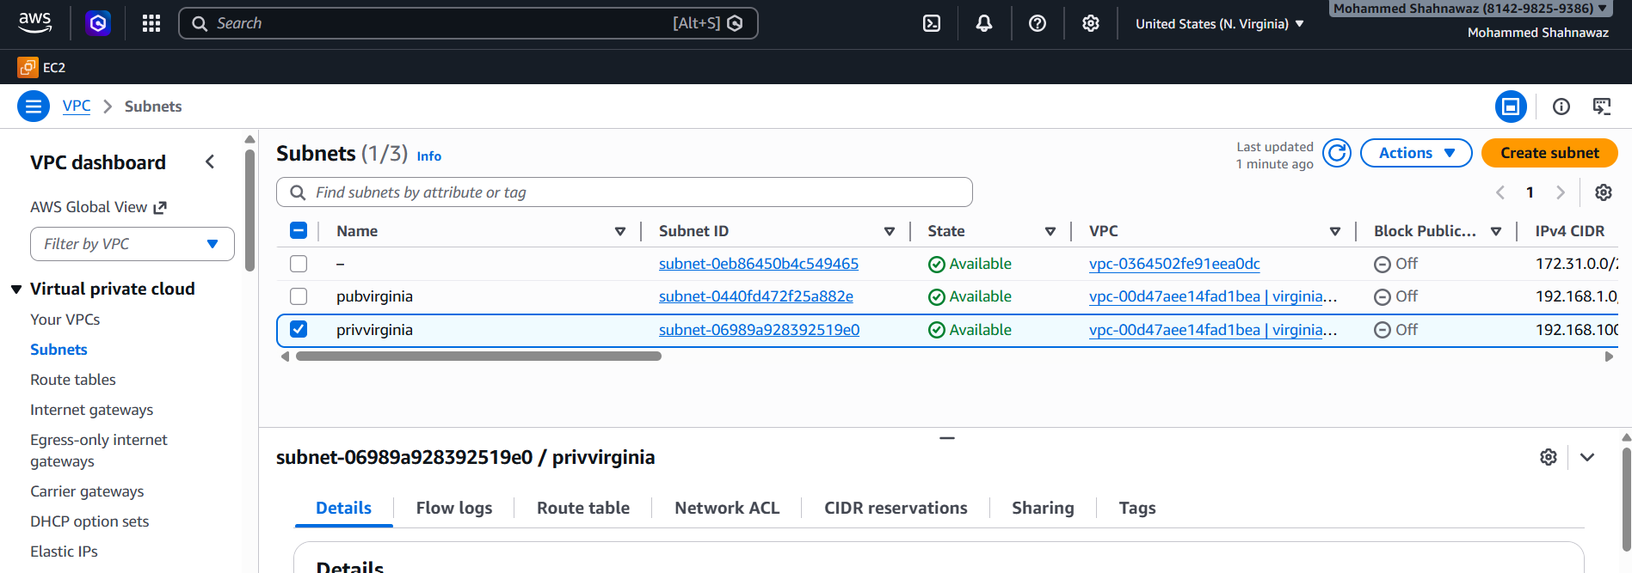
- Attach an IGW to the VPC.
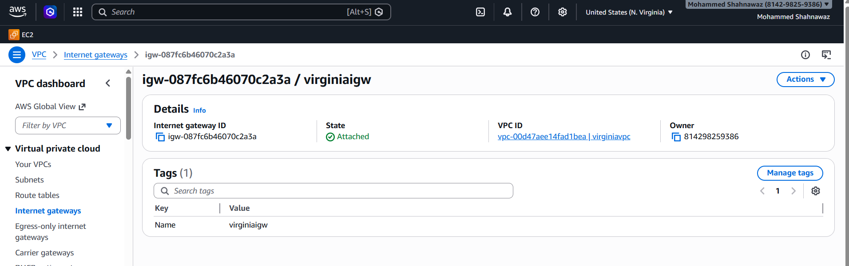

- Create one public route table (RT) and one private route table.
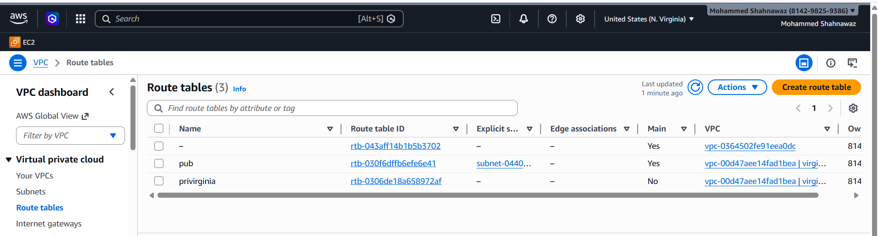
- Deploy a NAT gateway in the public subnet and attach the NAT gateway to the private subnet.
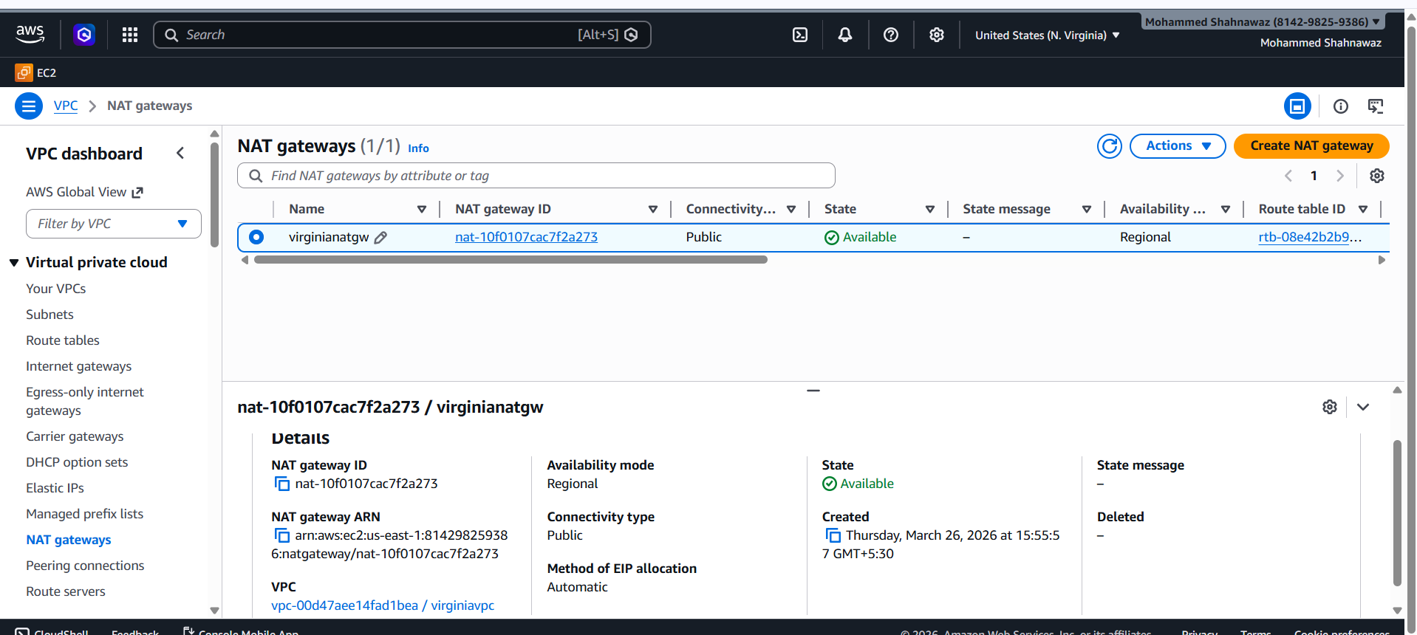
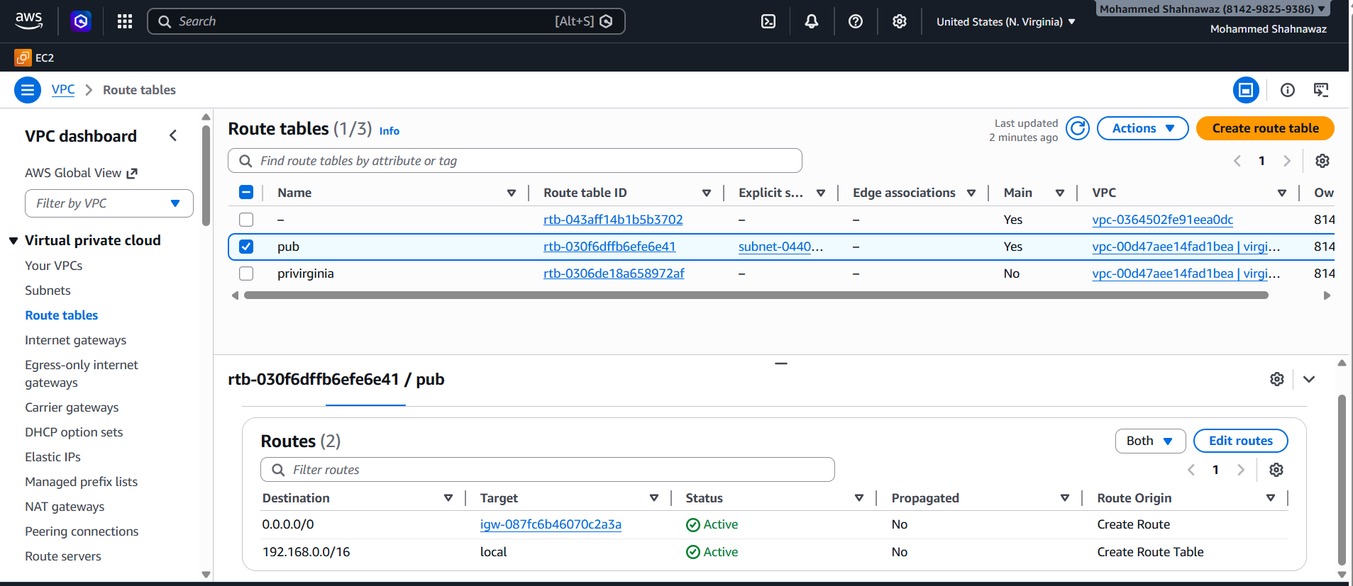
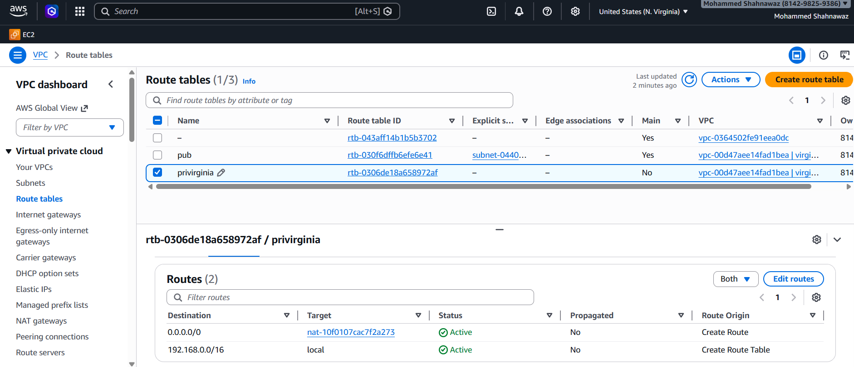
- Create two instances, one in the public subnet and one in the private subnet.
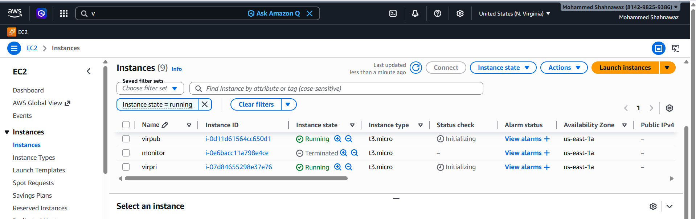
- Deploy Apache server on both EC2 instances with a sample index.html file.
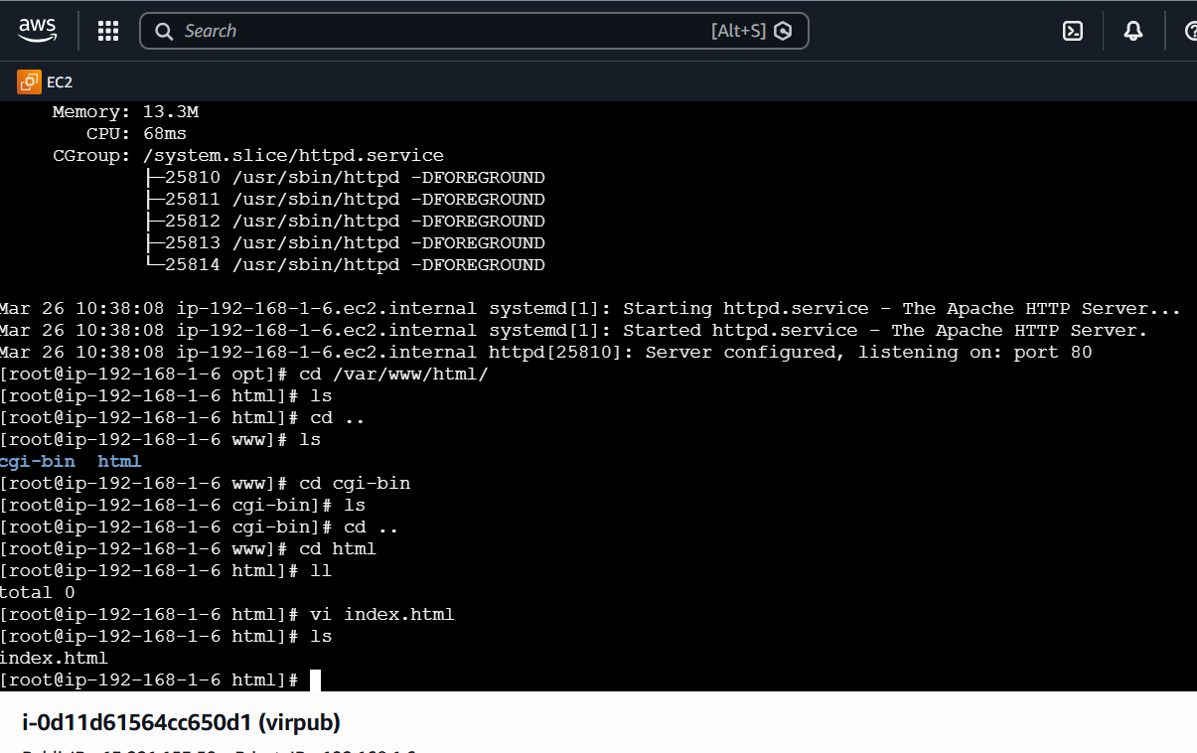
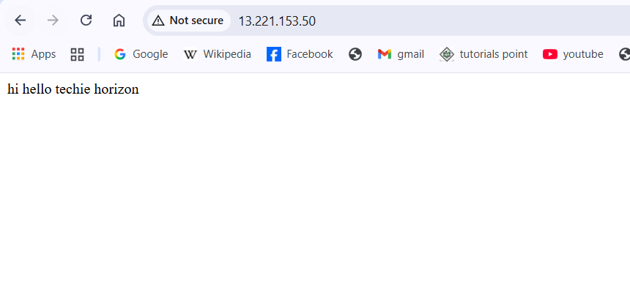
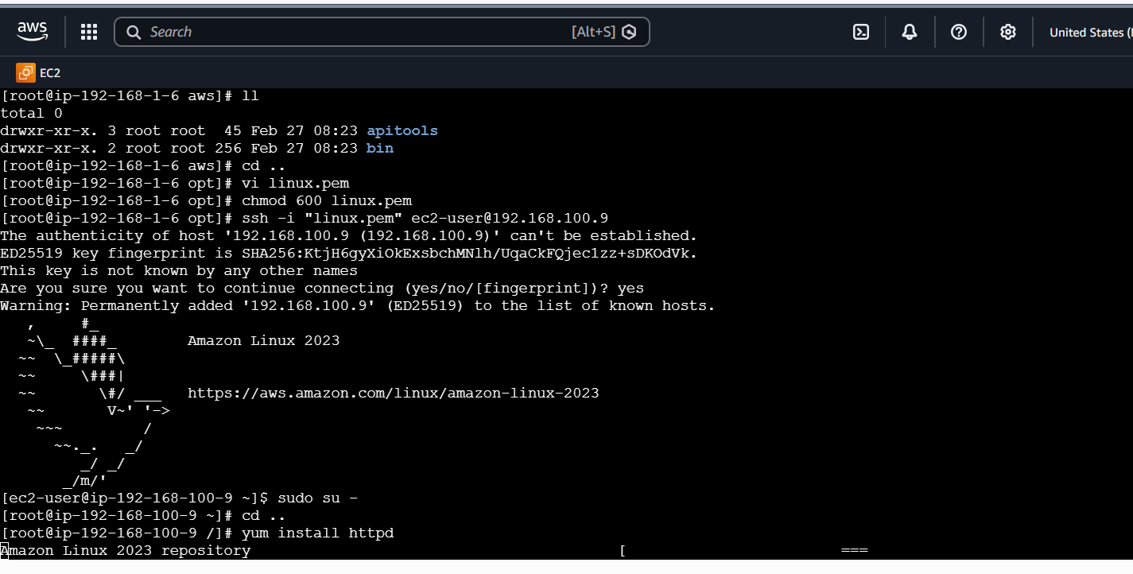
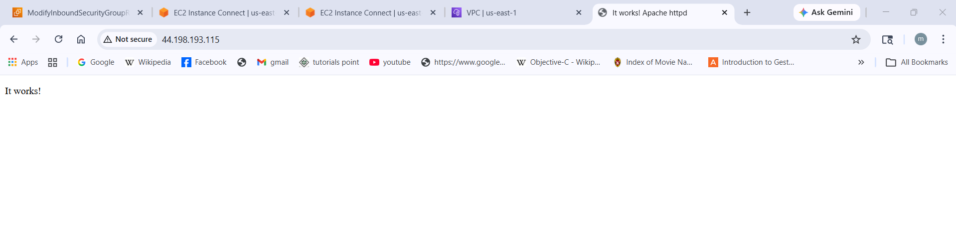
- Create one application load balancer and attach it to both EC2 instances.
Go to EC2 → Load Balancing → Target Groups.
Click Create target group.
Target type: Choose Instances.
Protocol: HTTP (port 80) or HTTPS (port 443).
VPC: Select the VPC where your EC2s are running.
Register your two EC2 instances into this target group.
Configure health checks (default: / on port 80).
Go to EC2 → Load Balancers → Create Load Balancer.
Select Application Load Balancer.
Configure:
Name: e.g., my-app-alb.
Scheme: Internet-facing (if public).
IP address type: IPv4.
Listeners: Add HTTP (port 80) or HTTPS (port 443).
Availability Zones: Select at least two AZs and their subnets.
Assign a Security Group that allows inbound traffic on port 80/443.
During ALB creation, choose the target group you created earlier.
This ensures traffic is routed to your EC2 instances.

Test the Setup
Once the ALB is active, copy its DNS name (e.g., my-app-alb-123456.us-east-1.elb.amazonaws.com).
Open it in a browser → it should load your application from one of the EC2s.
The ALB will automatically distribute traffic between both instances.

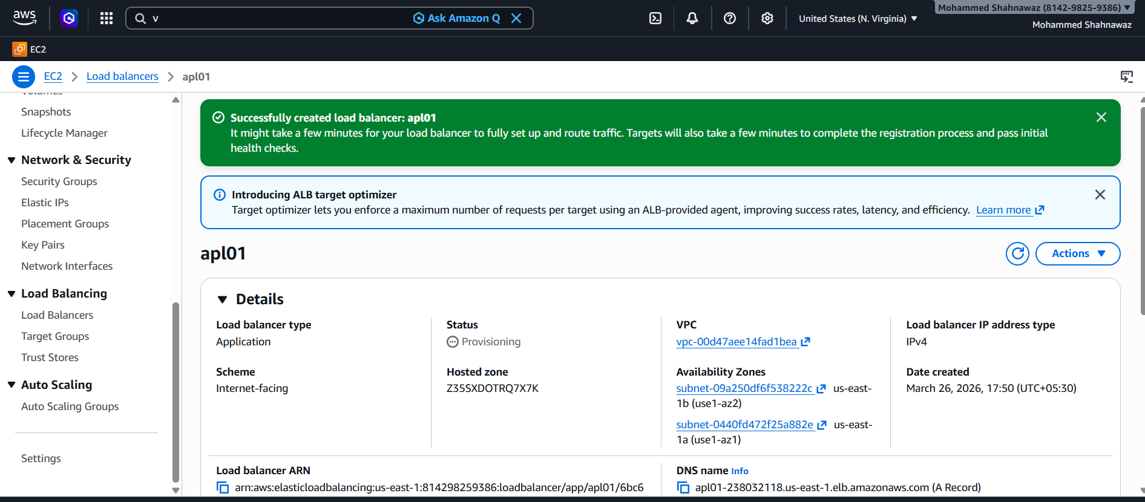
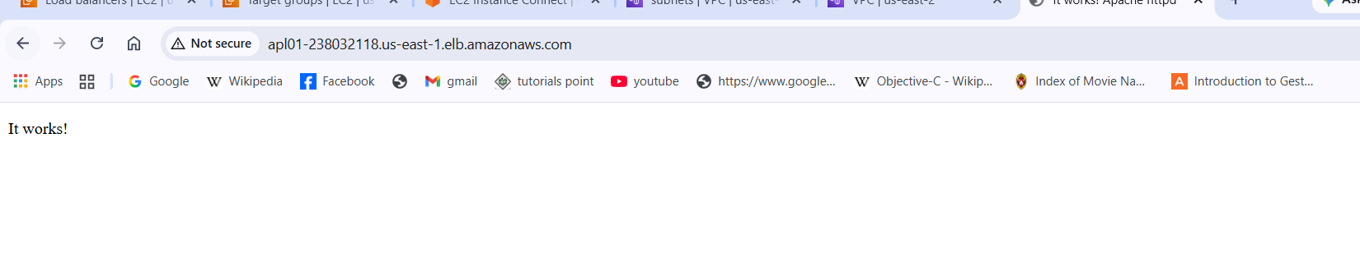

- Store the VPC flow logs in a CloudWatch log group.
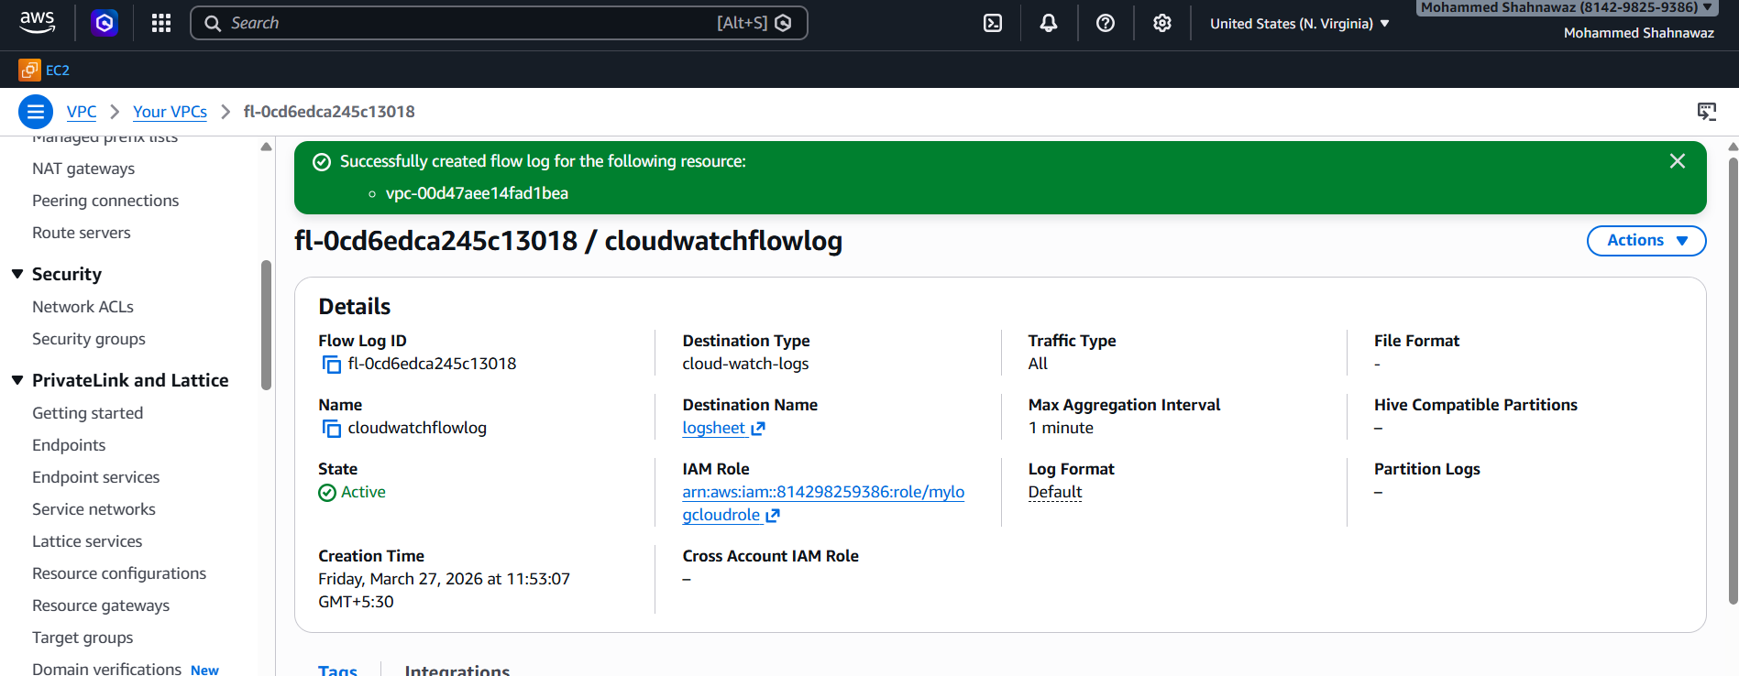
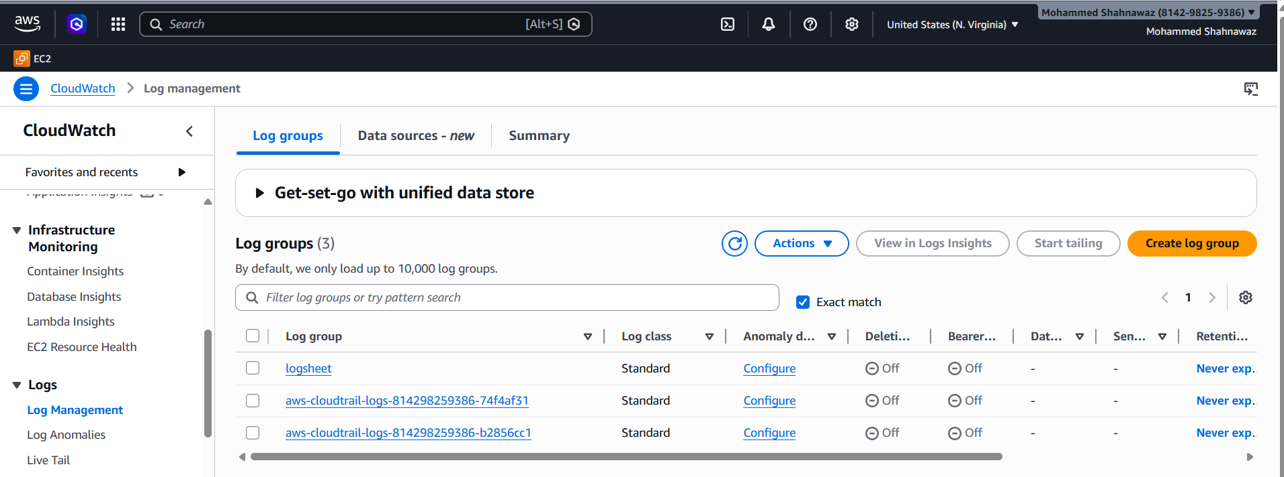
- Create monitoring dashboards to monitor CPU utilization and to monitor the Apache service.
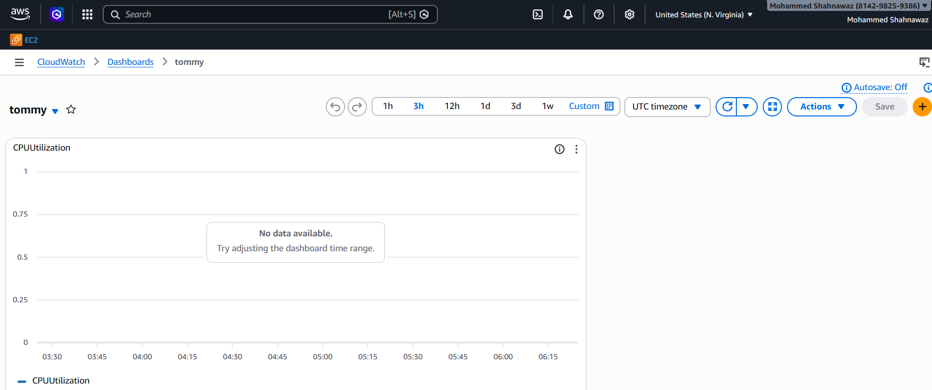

- If CPU utilization is more than 70%, then it should trigger auto scaling and launch new instance.
