RDS
- Create MariaDB DB on EC2.
Step 1: Launch an EC2 Instance
- Go to the AWS Management Console → EC2.
- Click Launch Instance.
- Choose an Amazon Linux 2 or Ubuntu AMI (both are common choices).
- Select an instance type (e.g., t2.micro for testing).
- Configure security group:
- Allow SSH (port 22) from your IP.
- Allow MySQL/Aurora (port 3306) if you want remote DB access.
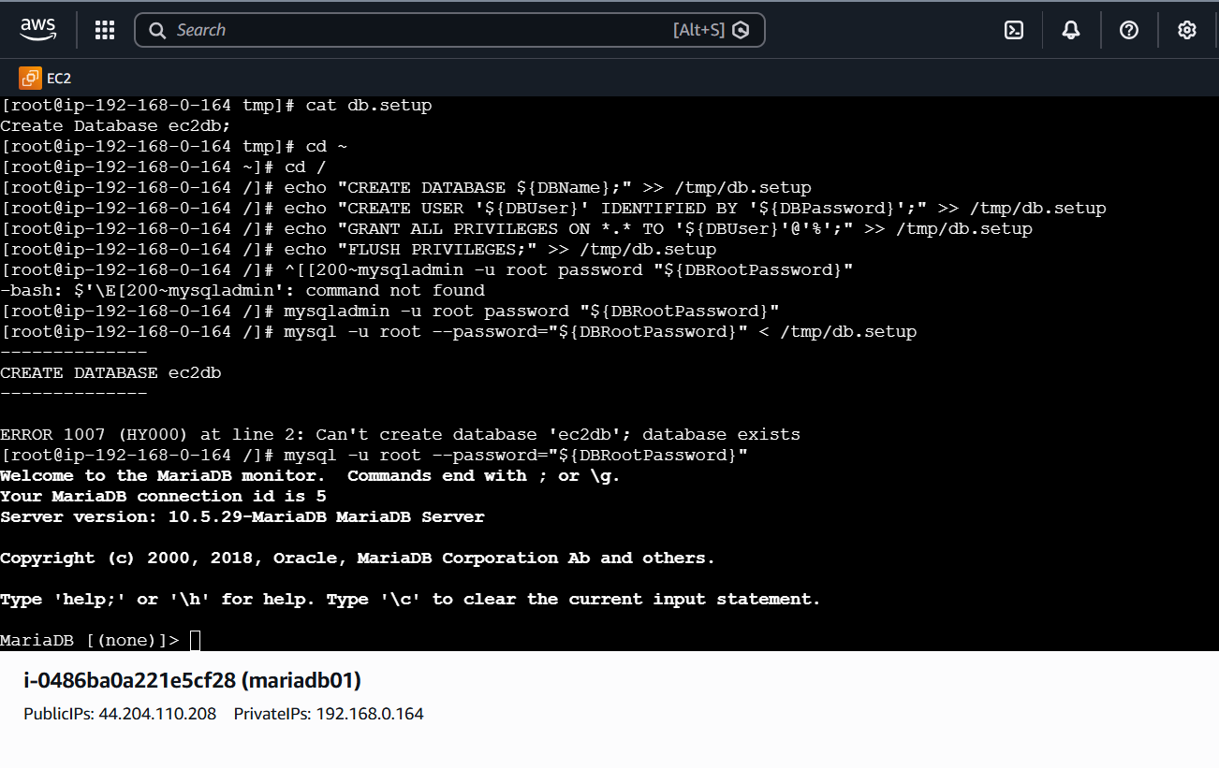

- Insert some dummy data.
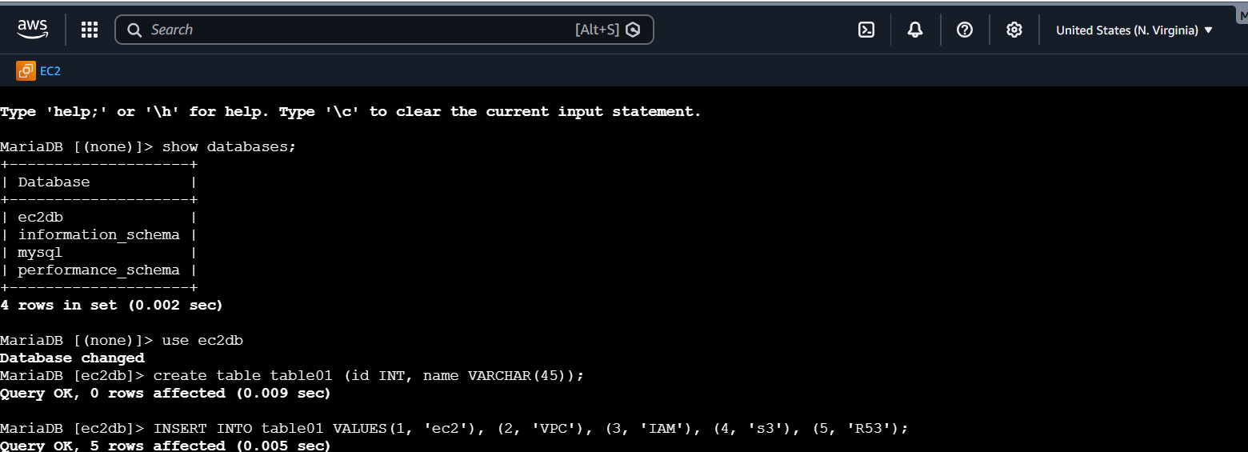
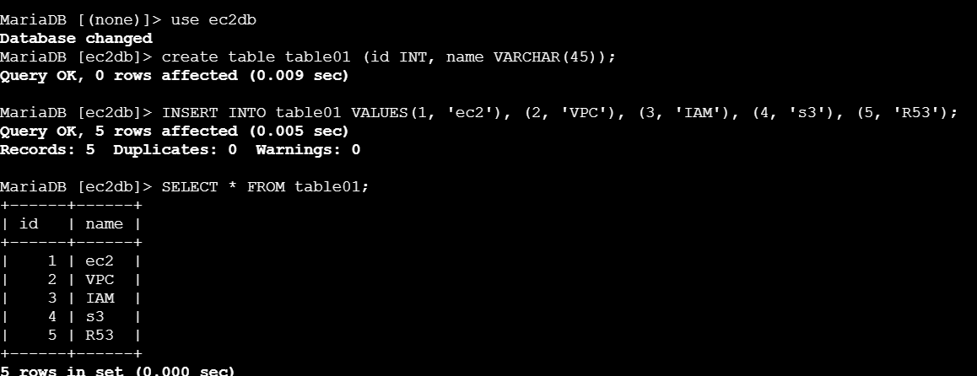
- Take the backup of dummy data on EC2.
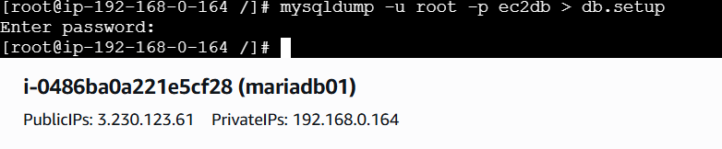
- Launch MariaDB RDS instance.
To launch a MariaDB RDS instance in AWS, you use the Amazon RDS console (or CLI) to create a managed database service. The key steps are: choose MariaDB as the engine, define your VPC/subnet, set credentials, and configure storage/security.

🔹 Step-by-Step Guide (AWS Console)

Sign in and Navigate
- Log in to the AWS Management Console.
- Go to Amazon RDS → [Databases].
- Click Create database.

2. Choose Database Engine
- Select MariaDB under Engine options.
- Choose Standard create (gives full control).
- Pick a template:
  - Free tier (if eligible).
  - Production or Dev/Test depending on workload.

3. Configure Settings
- DB instance identifier: e.g., mariadb-demo.
- Master username: e.g., admin.
- Master password: set a strong password.

Instance Size & Storage
- DB instance class: choose based on workload (e.g., db.t3.micro for testing).
- Storage type: General Purpose SSD (gp2/gp3).
- Allocated storage: start with 20 GB (scalable later).
- Enable Auto-scaling if needed.

Connectivity
- VPC: select your existing VPC.
- Subnet group: ensure subnets are defined.
- Public access: choose Yes if you want external access.
- VPC security groups: allow inbound traffic on port 3306 (MariaDB/MySQL default).

Additional Configurations
- Database name: optional initial DB.
- Backup retention: set (e.g., 7 days).
- Monitoring: enable CloudWatch if needed.
- Encryption: enable if handling sensitive data.

Launch
- Review settings.
- Click Create database.
- AWS will provision the instance (takes a few minutes).

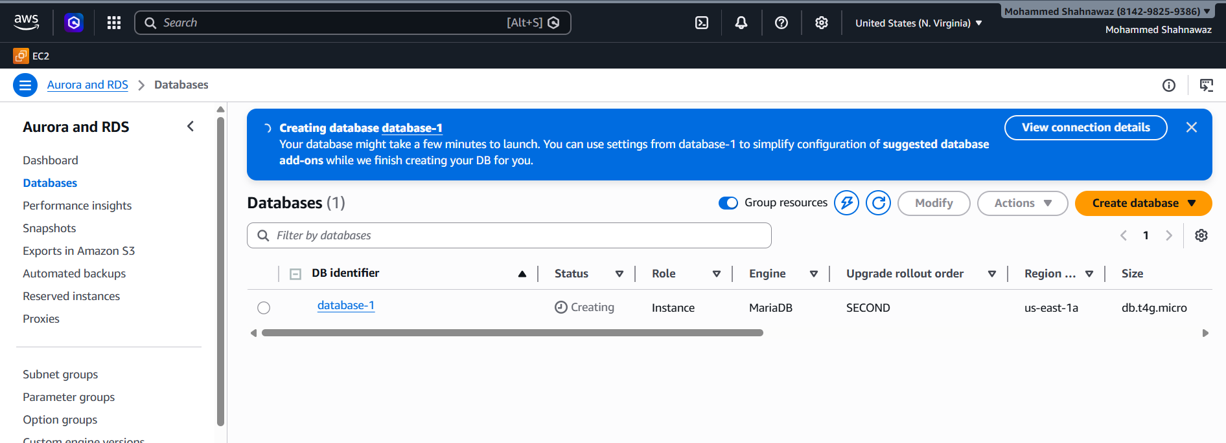

- Migrate database from EC2 to RDS.
- Get RDS Endpoint
- database-1.c2dyo20q8y88.us-east-1.rds.amazonaws.com
- Now restore backup.
- mysql -h database-1.c2dyo20q8y88.us-east-1.rds.amazonaws.com -u admin -p company < company_backup.sql
- Enter password: ********
- Now data is migrated.
- Verify:
- mysql -h <RDS-ENDPOINT> -u admin -p
- USE company;
SELECT * FROM employees;
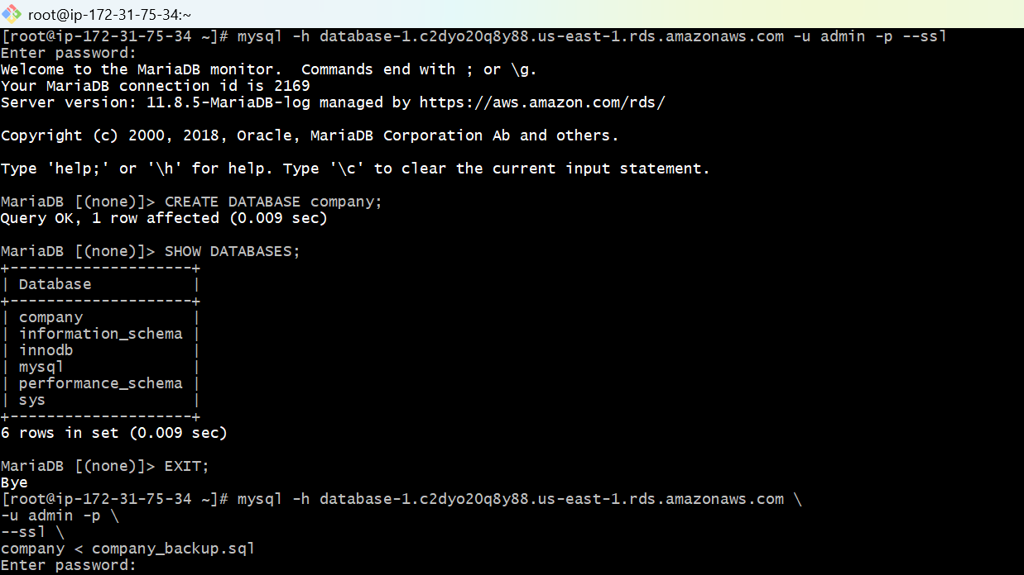

- Install MySQL DB on EC2.
- Install MySQL
- -sudo dnf update -y
- -sudo dnf remove mariadb* -y
- -sudo dnf clean all
- -sudo dnf install mysql-community-server -y --nogpgcheck
- This installs:
- mysql-server
- mysql-client
- mysql-libs
- mysql-plugins
- -sudo mysqld --initialize --user=mysql
- -sudo systemctl start mysqld
- -sudo systemctl enable mysqld
- -sudo systemctl status mysqld
- You should see:
- active (running)
- Get temporary root password
- -sudo grep 'temporary password' /var/log/mysqld.log
- Example output:
- temporary password: dFyhgu8TLr!
- Login to MySQL
- -mysql -u root -p
- Enter the temporary password.
      - Change root password
- Inside MySQL run:
- -ALTER USER 'root'@'localhost' IDENTIFIED BY 'Admin@123';
- -SHOW DATABASES;
- You will see:
- Exit MySQL
- exit

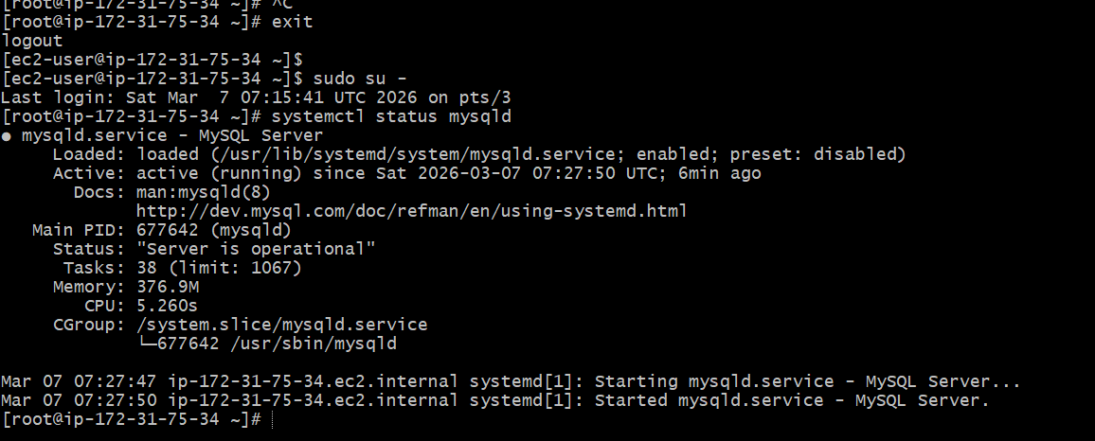
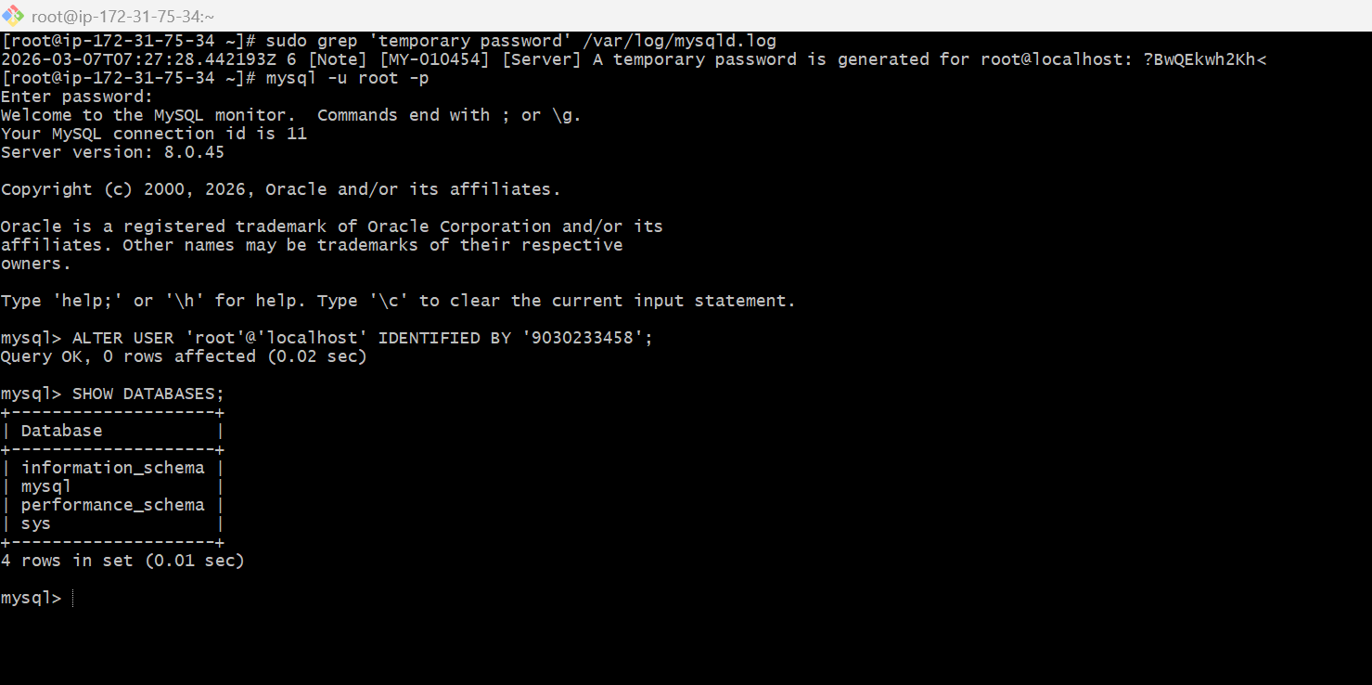

- Launch MySQL RDS image.
- Steps:
- Login to AWS ConsoleSearch for RDSClick Amazon RDS
  - Select DatabasesClick Create Database
- Select Database Creation Method
- Choose: Standard Create
- Engine Type: mysql
  - Engine Version: MySQL 8.4.7
- Template Choose: Free Tier
- DB Instance Identifier: database-2
- Master Username: admin
- Credentials Management
- Choose: Self managed
- Password: ********
- Confirm the password: ********
- Instance type: db.t3.micro
- Storage Configuration
- Storage Type: General Purpose SSD (gp2)
- Allocated Storage: 20 GB
      - Availability & Durability
- Do not create standby instance
- Multi-AZ is mainly used for production environments.
- Connectivity Configuration
- Compute Resource
- Select:
- Don't connect to an EC2 compute resource
- Network Type: IPv4
- Select Default VPC and default public subnets(with different zones)
- Public Access: Yes (This allows EC2 instances to connect to the database).
- Select default VPC Security Group.
- Monitoring Database Insights – Standard
- Do not enable Enhanced Monitoring.
- Additional Configuration
- Keep default settings:
- Clock on Create Database
- Create Database
- The database status will show: Creating
- After 5–10 minutes it will change to: Available
- Go to RDS → Databases → database-2
  - Copy the Endpoint.

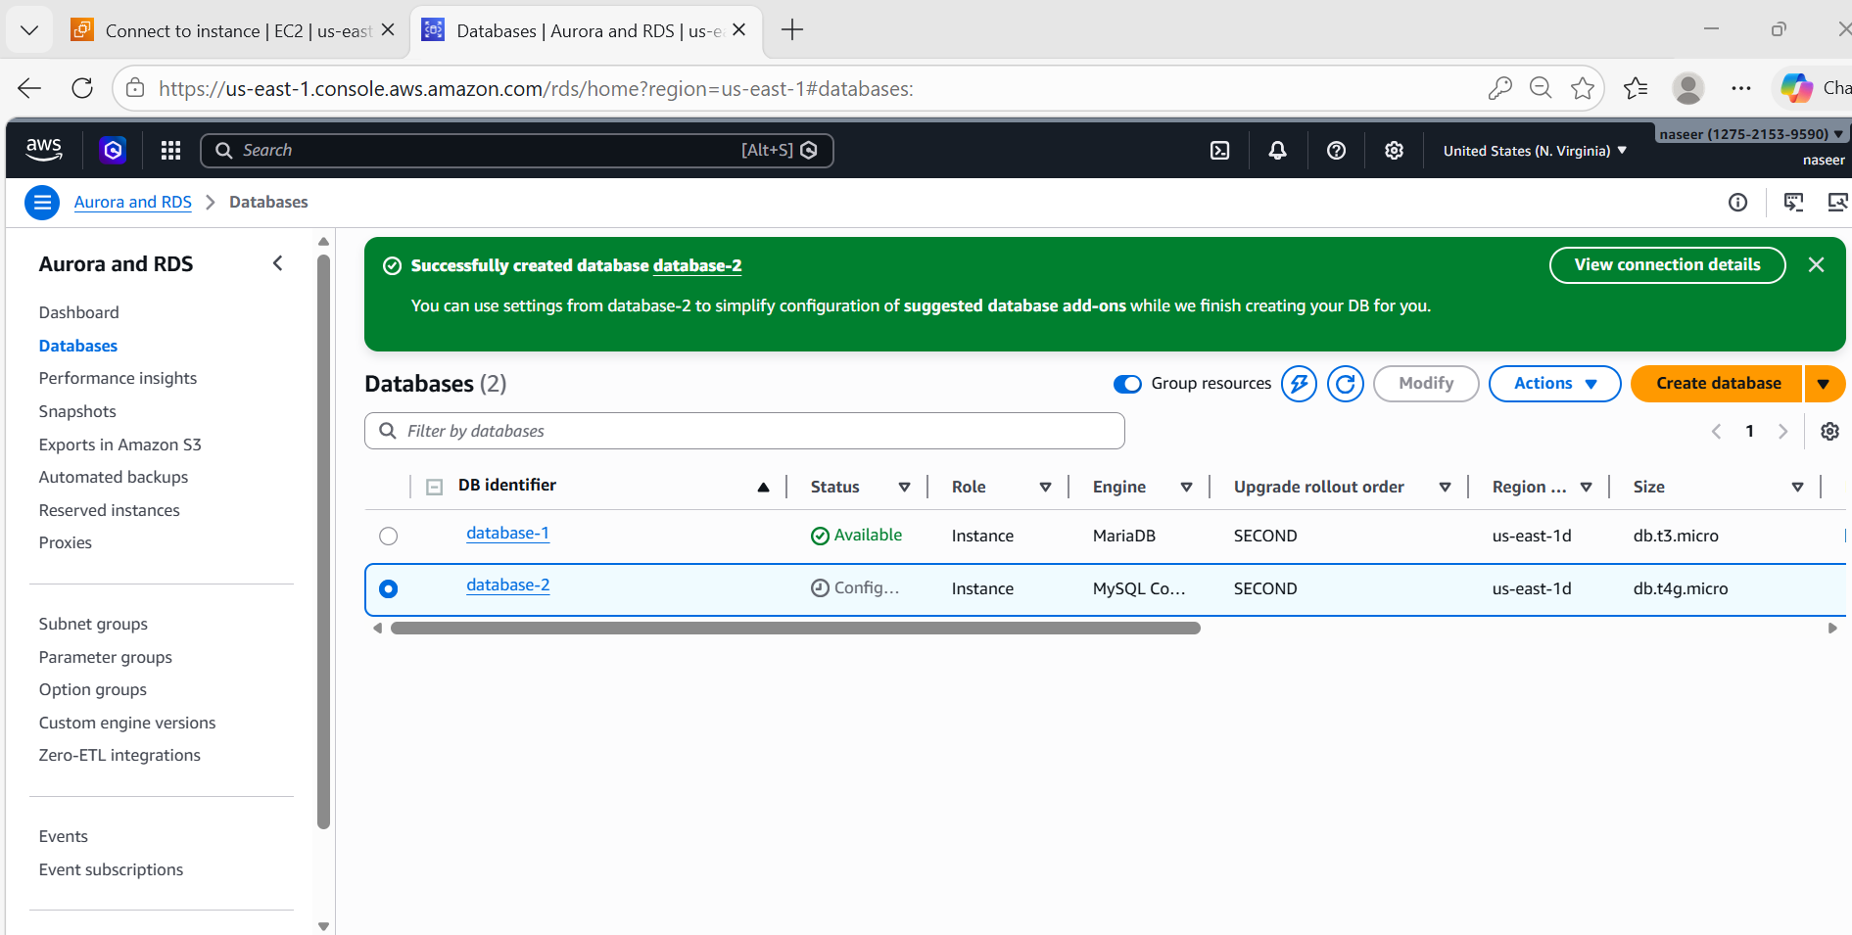

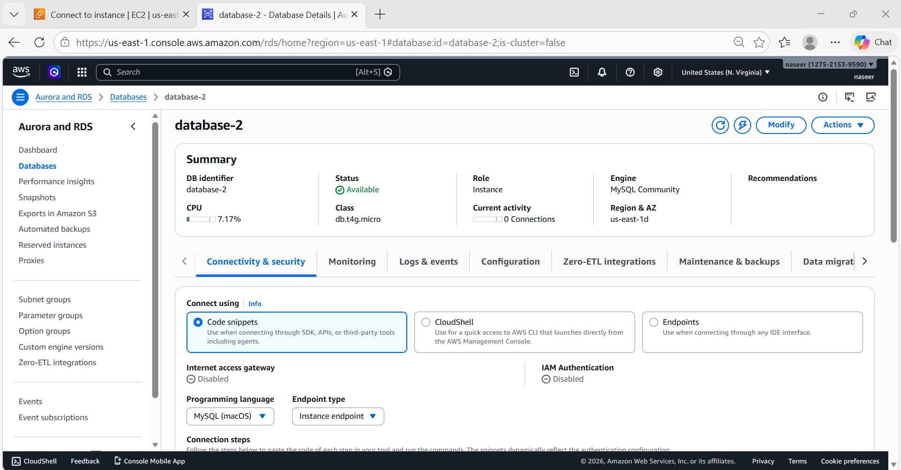

- Configure Multi-AZ.
- Steps:
- Go to RDS → DatabasesSelect mysql-rdsClick on ModifyAvailability & Durability
- Enable: Multi-AZ deployment and click continue Then Apply Immediately.
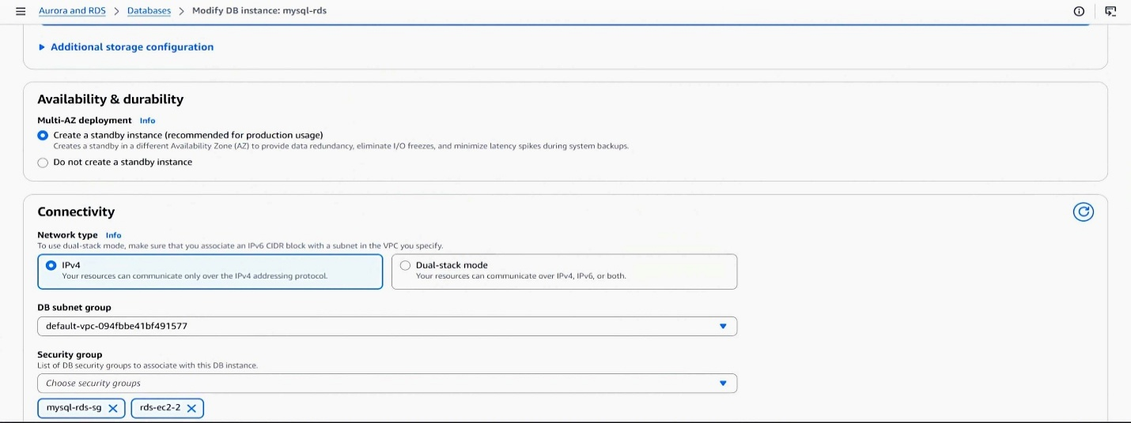
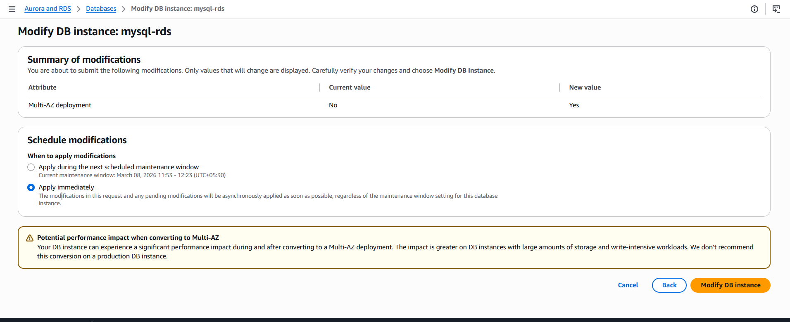
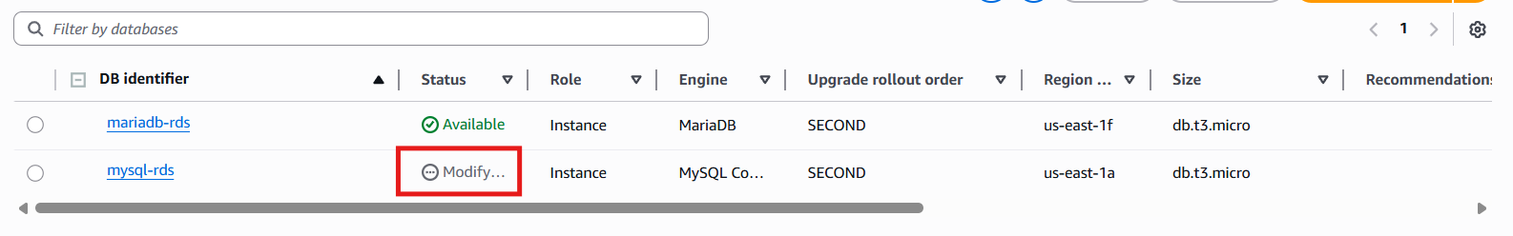
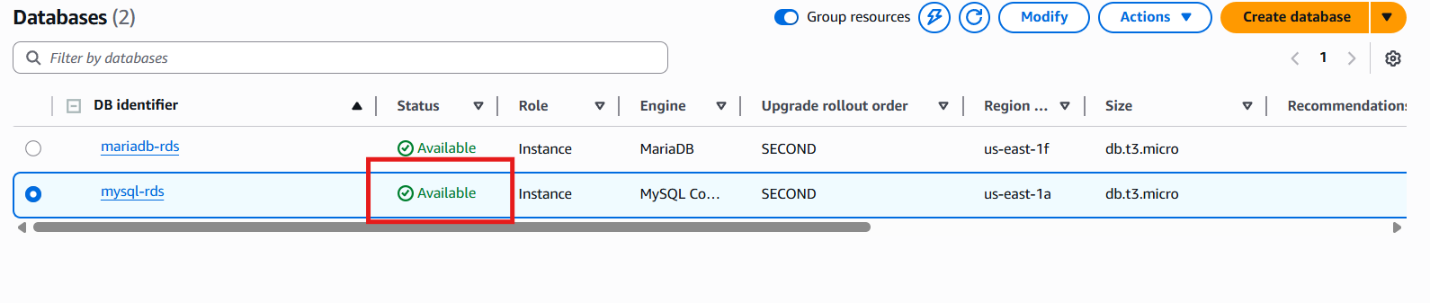

- Take backup of DB and restore the DB.
- Go to RDS → Databases select database-1
- Actions → Take Snapshot
- Snapshot Name: backup-8776756
- Create Snapshot
- Restore DB
- Go to SnapshotsSelect backup-8776756Restore Snapshot
- Restore
- Now a new DB instance will be created.

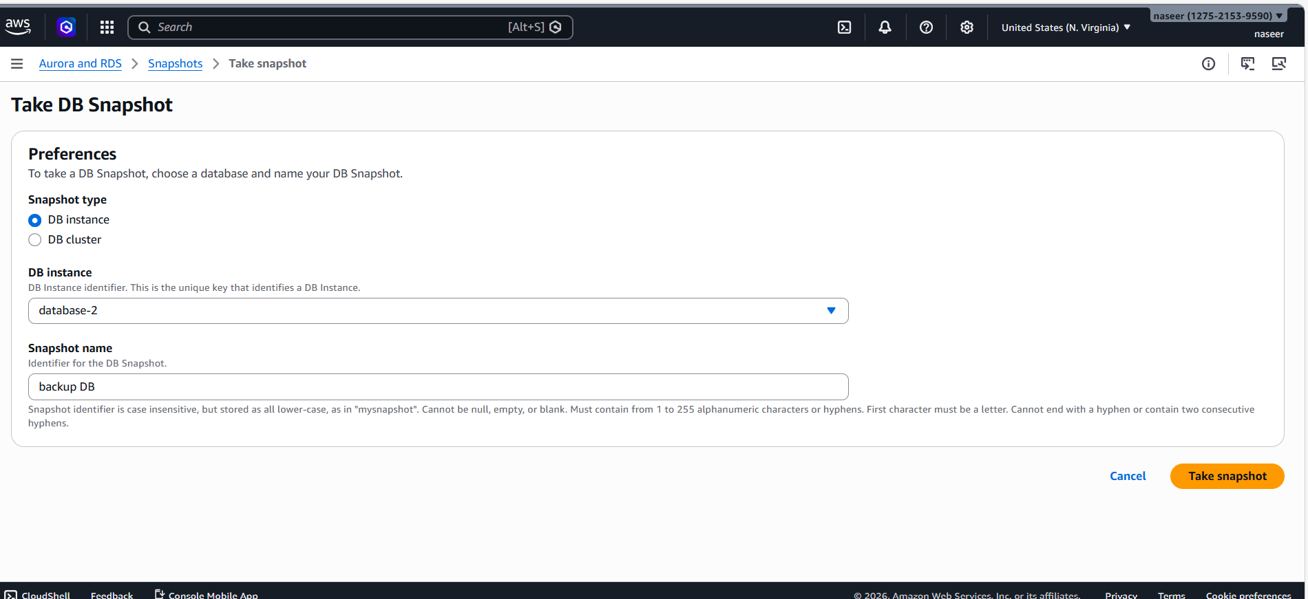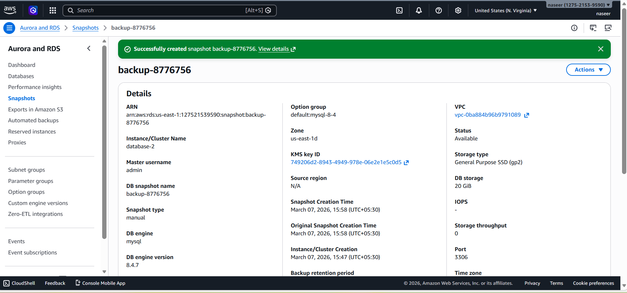

- Create read replica.
- Steps:
- Go to RDS → Databases
- Select database-1Actions → Create Read Replica
- Replica DB Name:database1-replica
- Instance type: db.t3.micro
- Create Read Replica

