✈
Airline Loyalty Program
End-to-End Data Engineering & BI Project

Author | Shahd Safwat Mohamed

Program | NTI Digital Egypt Youth HireReady

Track | Data Engineering & Analytics

Date | June 2026

Tools | SSIS · SSAS Tabular · Power BI · SQL Server

Table of Contents

1.1 Dataset Summary 3
1.2 Technology Stack 3
2.1 Stage 1 — Conceptual Model 4
2.2 Stage 2 — Logical Model 5
2.3 Stage 3 — Physical Model 6
3.1 ODS Layer (Operational Data Store) 9
Key Design Decisions 9
3.2 STG Layer (Staging) 10
Transformations Applied 10
3.3 DWH Layer (Data Warehouse) 11
4.1 Key DAX Measures 13
5.1 Overview Page 15
5.2 Customers Page 15
5.3 Flights Page 17
5.4 Loyalty Page 17
5.5 Geography Page 19

1. Project Overview

This project is a complete end-to-end Data Engineering and Business Intelligence pipeline built on a real-world Airline Loyalty Program dataset. The project covers every stage of a modern data pipeline — from raw CSV ingestion to an interactive Power BI dashboard — implemented using Microsoft's BI stack.

The dataset contains loyalty program data for a Canadian airline, including customer demographics, flight activity records for 2017–2018, and a date calendar. The goal is to transform raw data into meaningful business insights about customer behavior, flight patterns, loyalty tier performance, and churn analysis.

1.1 Dataset Summary
File | Rows | Description
Customer Loyalty History | 16,737 | Customer demographics, loyalty tier, CLV, enrollment & cancellation
Customer Flight Activity | 392,936 | Monthly flight records: flights, distance, points accumulated & redeemed
Calendar | 2,557 | Date dimension (2012–2018), daily granularity

1.2 Technology Stack
- SSIS (SQL Server Integration Services) — ETL pipeline across ODS, STG, and DWH layers
- SQL Server (SSMS) — Data storage and transformation
- SSAS Tabular — Semantic model with DAX measures
- Power BI — Interactive 5-page dashboard

2. Data Modeling — 3 Stages

Data modeling followed the standard three-stage approach: starting from a high-level conceptual model, refining into a logical model with dimension types, and finally implementing the physical model in SQL Server as a Star Schema.

2.1 Stage 1 — Conceptual Model
The conceptual model identifies the main business entities and the relationships between them, without worrying about technical implementation details. The goal is to understand what data exists and how entities relate to each other.

Conceptual Model — Main Entities & Relationships
CUSTOMER  Loyalty Number (PK)  Country / Province / City  Gender / Education  Salary / Marital Status  Loyalty Card Tier  Enrollment Type / Date  Cancellation Date | 1  ───  M | FLIGHT ACTIVITY  Loyalty Number (FK)  Year / Month  Total Flights  Distance (km)  Points Accumulated  Points Redeemed  Dollar Cost Redeemed | M  ───  1 | DATE  Date Key (PK)  Year / Month  MonthName

Relationships:
• Customer (1) ──── (M) Flight Activity [on: Loyalty Number]
• Date (1) ──── (M) Flight Activity [on: Year + Month = Date Key] — Role Playing ×3
Figure 1 — Conceptual Model: 3 main entities with their attributes and cardinality

2.2 Stage 2 — Logical Model
The logical model translates the conceptual model into a structured schema design. Here we decide the dimension types, identify foreign keys, and define the Star Schema structure. No physical implementation details yet.

Logical Model — Star Schema with Dimension Types
Dimension Table | Type | Reason
DIM_Date | Conformed + Role Playing | Used 3 times: Flight Date (Active), Enrollment Date, Cancellation Date (Inactive via USERELATIONSHIP)
DIM_City + DIM_Country | Snowflake Dimension | City linked to Country via con_id — separate tables for normalization
DIM_Gender | Static / Fixed Dimension | Values never change: Male / Female
DIM_Education | Static / Fixed Dimension | 5 fixed levels: High School → Doctor
DIM_Marital_Status | Static / Fixed Dimension | 3 fixed values: Single / Married / Divorced
DIM_Enrollment_Type | Junk Dimension | Groups Enrollment_Type + Loyalty_Card — small flags combined into one table
Loyalty_Number in FACT | Degenerate Dimension | No separate customer dimension — Loyalty Number lives directly in the Fact table

Dimension Types Used in This Project:
• Conformed + Role Playing — DIM_Date used 3 times with different roles
• Snowflake — DIM_City linked to DIM_Country (2 separate tables)
• Junk — DIM_Enrollment_Type combines Enrollment_Type + Loyalty_Card
• Static / Fixed — DIM_Gender, DIM_Education, DIM_Marital_Status (values never change)
• Degenerate — Loyalty_Number kept directly in Fact table (no separate customer dimension)
Figure 2 — Logical Model: Dimension types and their justification
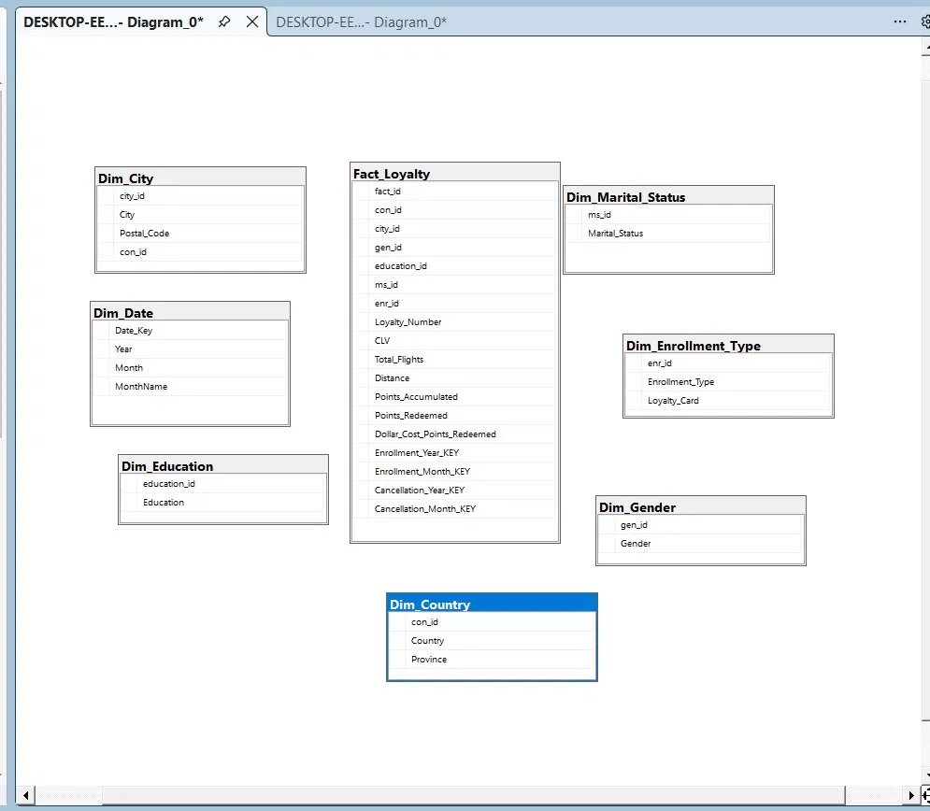

2.3 Stage 3 — Physical Model
The physical model is the actual implementation in SQL Server. Tables are created with proper data types, primary keys, foreign keys, and constraints. The Star Schema is fully implemented with 7 dimension tables and 1 fact table.

Physical Model — Final Star Schema in SQL Server
DIM_Date
Date_Key (PK) · Year · Month · MonthName
Role Playing ×3
 |  | ↓
DIM_City + DIM_Country  city_id · City · Postal Code  con_id · Country · Province  Snowflake | → | FACT_Loyalty  Loyalty_Number (Degenerate)  date_key · gen_id · ms_id  education_id · city_id · enr_id  Enrollment / Cancellation KEYs  ── Measures ──  Total_Flights · Distance  Points_Accumulated · Redeemed  CLV · Salary | ← | DIM_Gender  gen_id · Gender  DIM_Marital_Status  ms_id · Marital_Status  Static / Fixed
 |  | ↑
DIM_Education
education_id · Education
DIM_Enrollment_Type
enr_id · Enrollment_Type · Loyalty_Card
Static / Junk
Figure 3 — Physical Star Schema: FACT_Loyalty at center, surrounded by 7 dimension tables

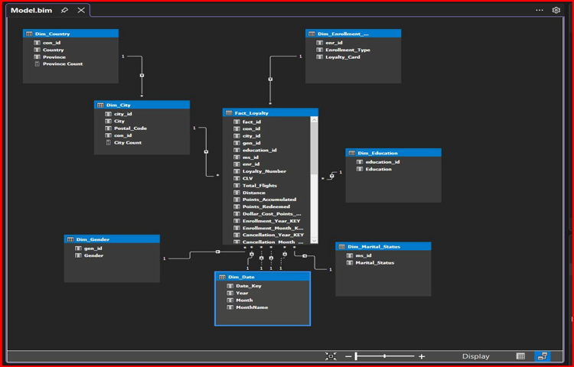

Figure 4 — Actual Physical Model in SSAS Tabular (Model.bim) — SQL Server Implementation
3. Phase 1 — SSIS ETL Pipeline

3.1 ODS Layer (Operational Data Store)
The ODS layer is the first landing zone for raw data. All three CSV files are ingested and merged into a single table — ODS_Airline_Loyalty. No transformations are applied at this stage; the goal is to preserve source data exactly as-is.

Key Design Decisions
- All columns stored as NVARCHAR — no data type assumptions at this stage
- Three CSV files merged using two sequential Merge Join transformations (LEFT OUTER JOIN)
- Calendar joined via a derived Date_Value column (YYYY-MM format) matching Start of Month
- ETL_LoadDate metadata column tracks when each batch was loaded

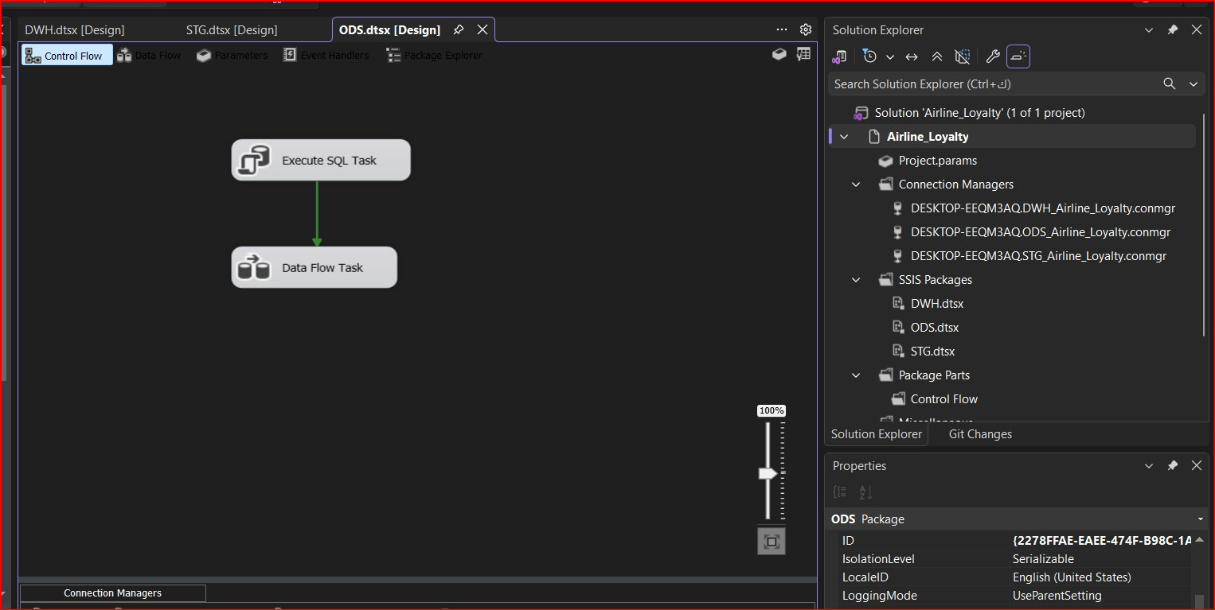
Figure 5 — ODS Data Flow: CSV Sources → Sort → Merge Join → Derived Column → OLE DB Destination
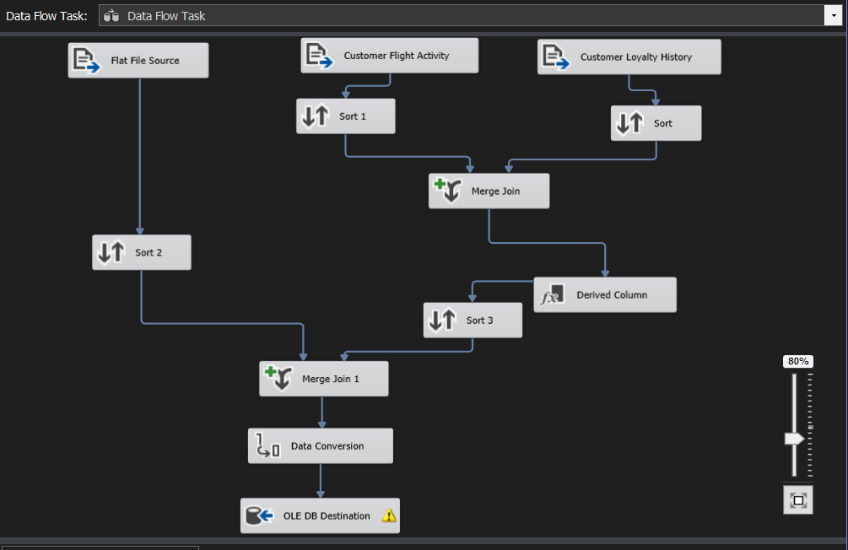

3.2 STG Layer (Staging)
The STG layer handles all data cleaning and preparation. This is where NULL values are handled, data types are enforced, and derived columns are created for the DWH layer.

Transformations Applied
- NULL handling: Cancellation_Year and Cancellation_Month NULLs preserved to identify active customers
- Date Key generation: Enrollment_Year_KEY, Enrollment_Month_KEY, Cancellation_Year_KEY, Cancellation_Month_KEY created as YYYYMM integers
- Membership_Duration_Years: Derived as Cancellation_Year minus Enrollment_Year
- Negative Salary values flagged for downstream handling

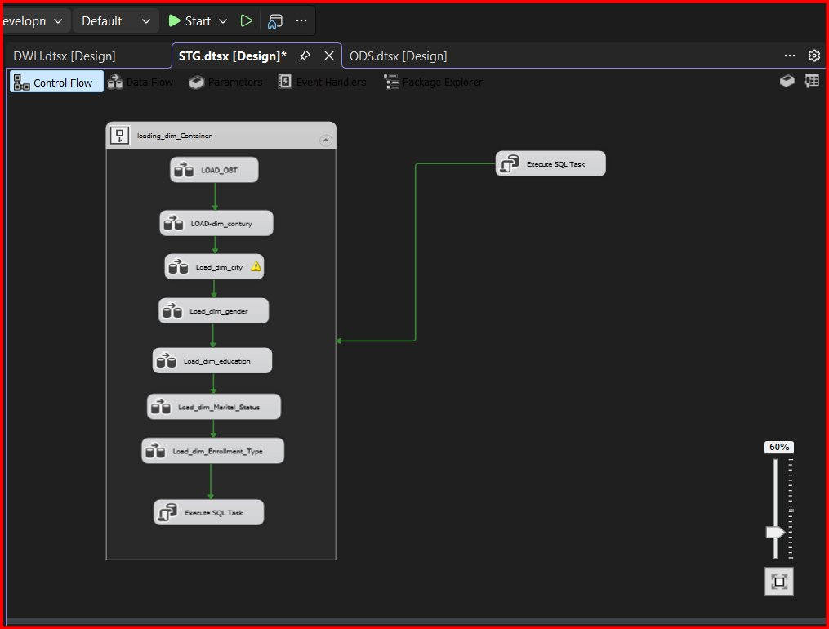
Figure 6 — STG Control Flow: Dimension loads followed by OBT load and Execute SQL Task

3.3 DWH Layer (Data Warehouse)
The DWH layer implements the Star Schema. Data is loaded from STG into dimension tables first, followed by the Fact table. Foreign key resolution is handled via Lookup transformations.

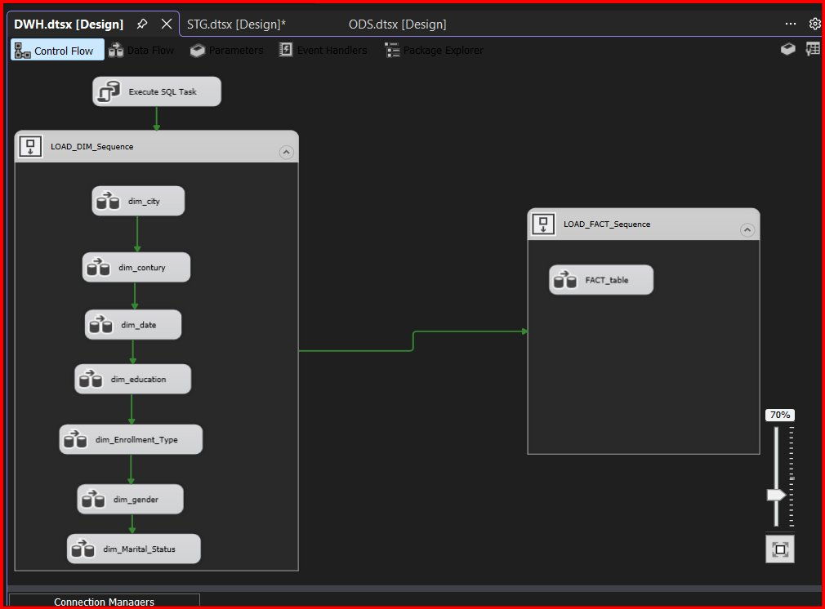
Figure 7 — DWH Control Flow: Dimensions loaded before Fact table

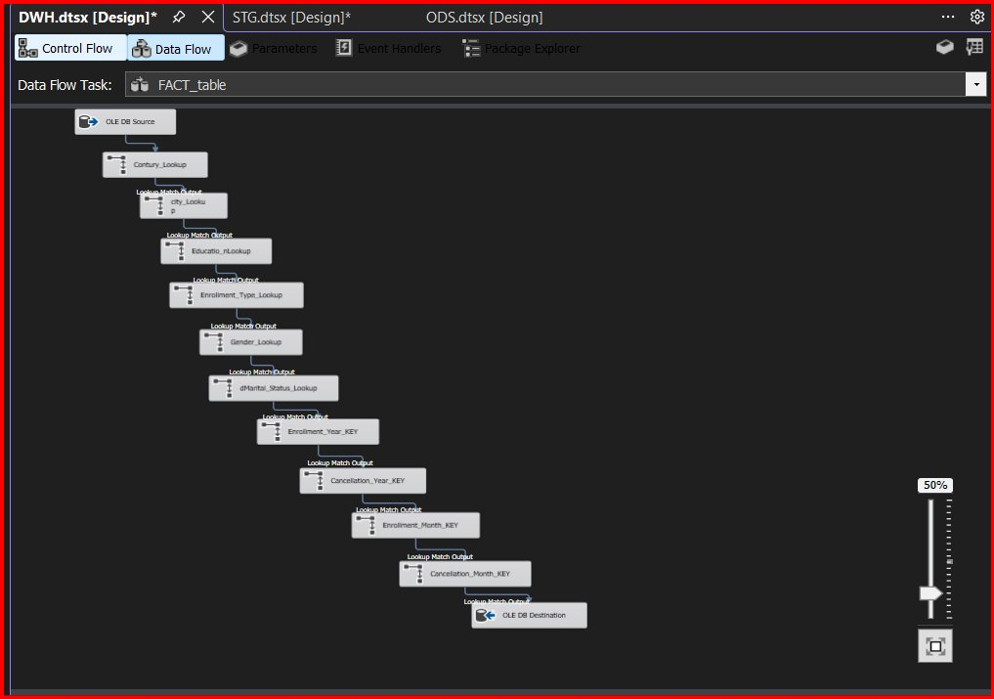
Figure 8 — DWH Fact Data Flow: 8 sequential Lookup transformations for FK resolution

4. Phase 2 — SSAS Tabular & DAX Measures

The SSAS Tabular model (Airline_Loyalty_SSAS) connects directly to the DWH SQL Server database. All business metrics are defined as DAX measures and published to Power BI via Live Connection.

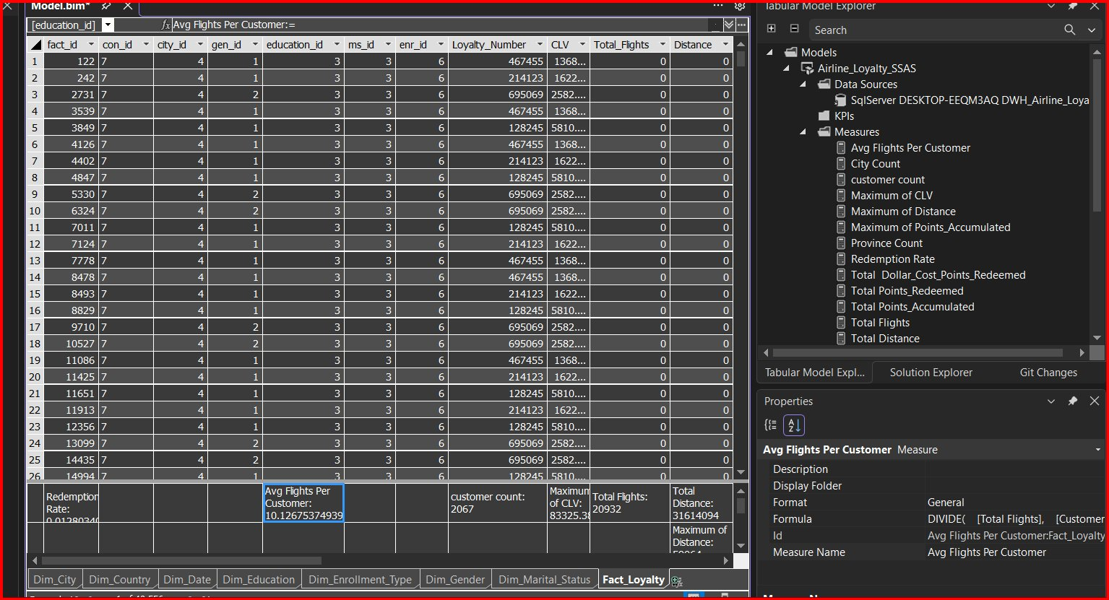
Figure 9 — SSAS Tabular Model: Fact_Loyalty with 392,936 rows and all DAX measures

4.1 Key DAX Measures
Measure | DAX Formula
customer count | DISTINCTCOUNT(Fact_Loyalty[Loyalty_Number])
Active Customers | CALCULATE(DISTINCTCOUNT(...), ISBLANK([Cancellation_Year_KEY]))
Churn Rate | DIVIDE([Cancelled Customers], [customer count], 0)
Total CLV | SUMX(VALUES([Loyalty_Number]), CALCULATE(MAX([CLV])))
Avg CLV | DIVIDE([Total CLV], [customer count], 0)
Redemption Rate | DIVIDE([Total Points_Redeemed], [Total Points_Accumulated], 0)
Avg Flights Per Customer | DIVIDE([Total Flights], [customer count], 0)
Enrollments by Month | CALCULATE([customer count], USERELATIONSHIP(...))

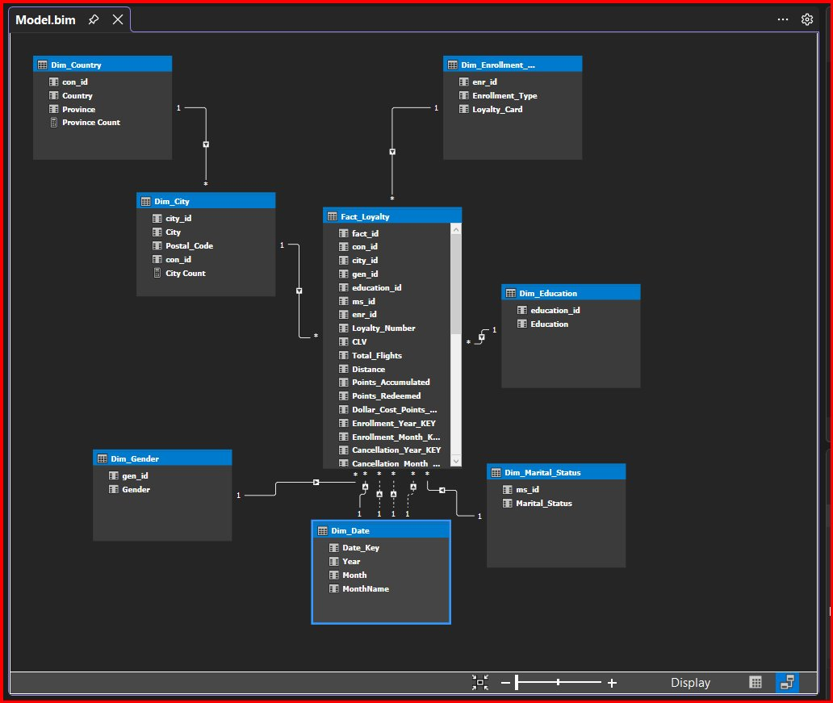
Figure 10 — SSAS Tabular Model Explorer showing all DAX measures

5. Phase 3 — Power BI Dashboard

The Power BI dashboard connects to the SSAS Tabular model via Live Connection. The dashboard consists of 5 pages with a consistent blue color palette and a navigation sidebar for easy page switching.

5.1 Overview Page

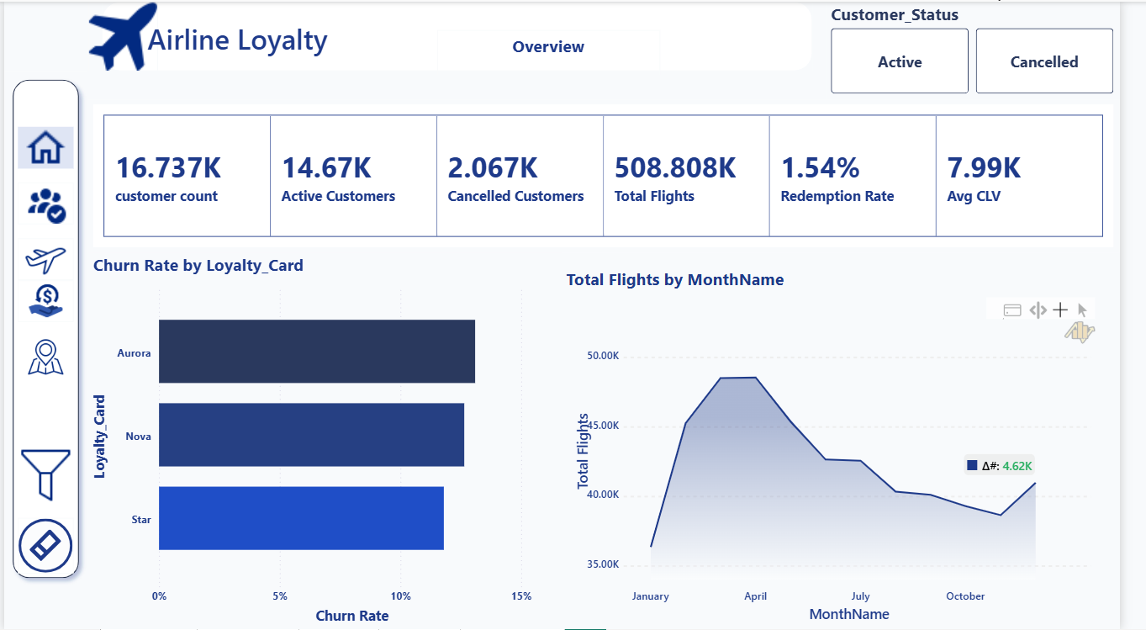
Figure 11 — Overview Page: KPI cards + Churn Rate by Loyalty Card + Total Flights by Month

5.2 Customers Page

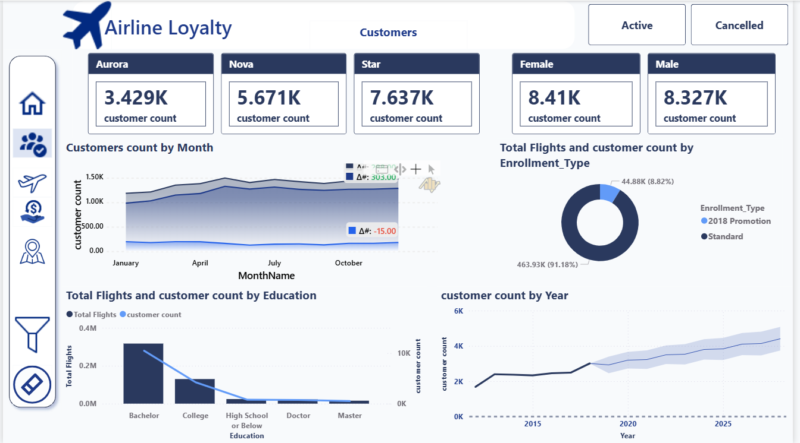
Figure 12 — Customers Page: Tier breakdown, gender split, education analysis, enrollment trend

5.3 Flights Page

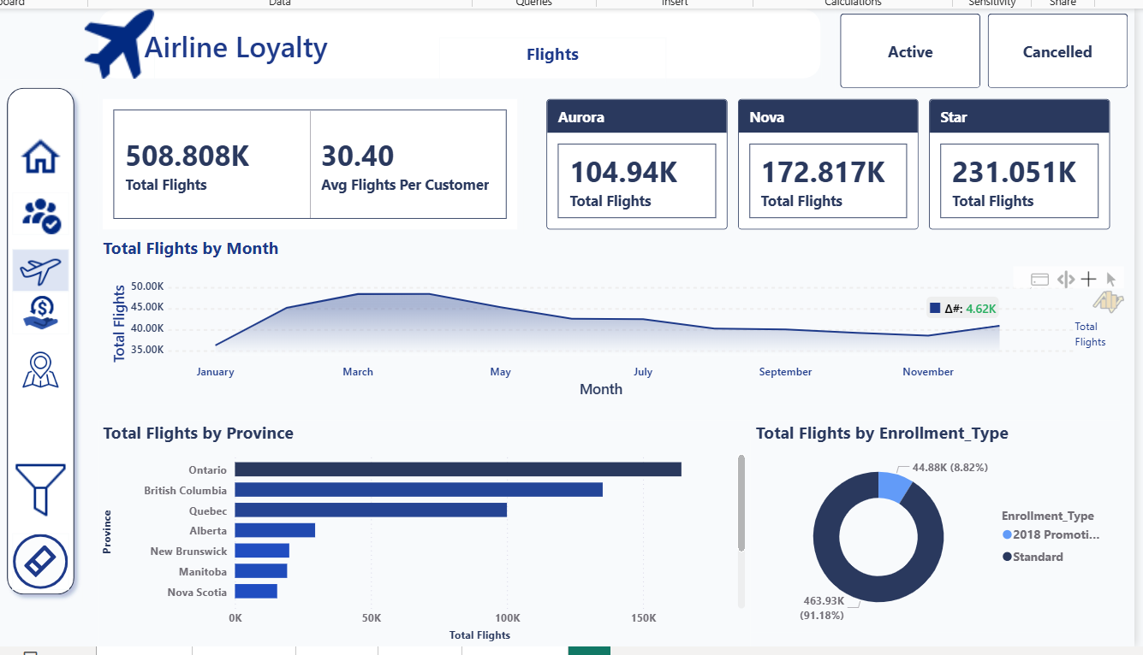
Figure 13 — Flights Page: Tier flight volumes, seasonality, province distribution, enrollment type

5.4 Loyalty Page

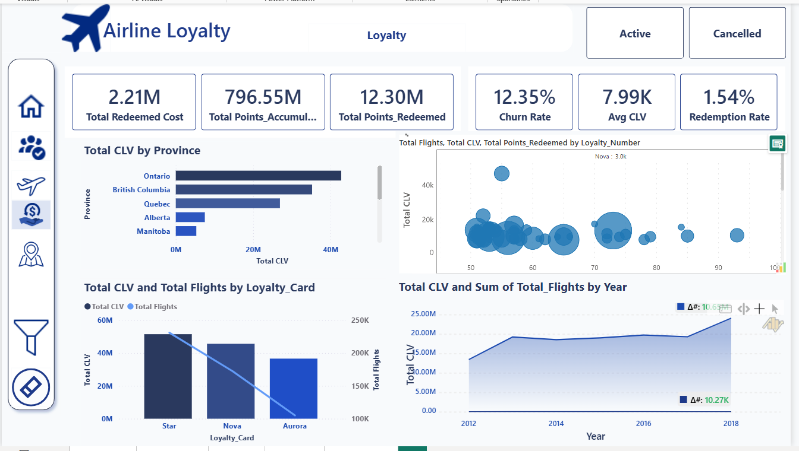
Figure 14 — Loyalty Page: Points KPIs, CLV by Province, CLV by Loyalty Card, CLV trend

5.5 Geography Page

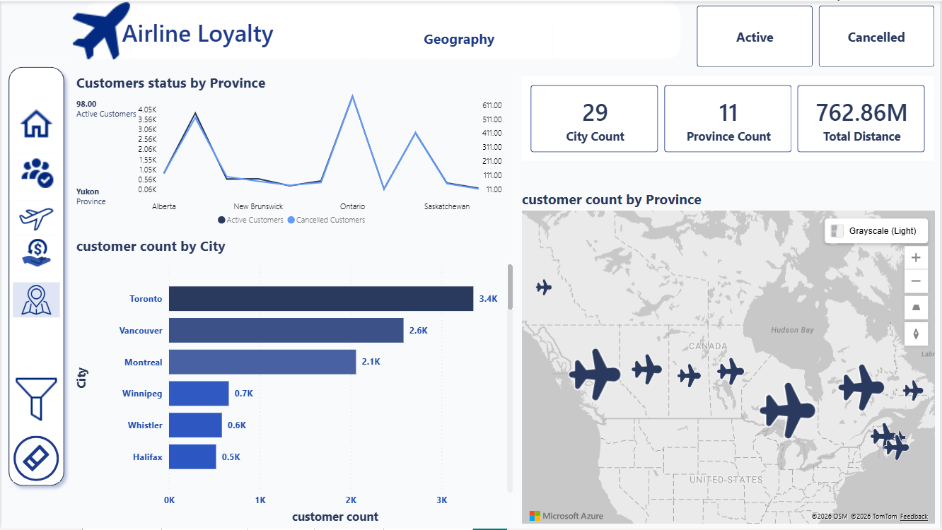
Figure 15 — Geography Page: Customer distribution across Canadian provinces and cities

6. Key Business Insights

- 16,737 total customers — 14,670 active (87.6%) and 2,067 cancelled (12.4%)
- Aurora tier customers have the highest average CLV ($10,673) despite being the smallest group
- Aurora also has the highest churn rate (13.1%) — the most valuable customers are leaving at the highest rate
- Flight activity peaks in July (1.96 flights/month) and dips in February (0.82)
- The 2018 Promotion awarded 1.5 points per km — contributing to +38% increase in points accumulated in 2018
- Total flights grew 28% from 2017 to 2018 (223K to 285K)
- Only 1.54% of accumulated points were redeemed — possible program awareness issue
- Ontario (32%), British Columbia (26%), and Quebec (20%) account for 78% of all customers

7. Challenges & Solutions

Challenge | Solution
Merge Join producing Cartesian Product (11M+ rows) | Fixed Sort transformations on correct join keys
Active customers lost in Cancellation Lookup | Set Redirect rows to no match output on Lookup
CLV double-counting in Power BI | Used SUMX + VALUES pattern: SUMX(VALUES([Loyalty_Number]), CALCULATE(MAX([CLV])))
SSAS project not found in Visual Studio | Opened .sln solution file instead of .dwproj directly
Salary column with 25% NULLs and 20 negative values | Preserved NULLs in ODS; flagging planned in STG layer

— End of Document —

