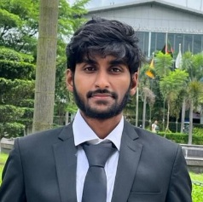
BIO DATA
Name: : Md. Husne Jaman Shahed
Id : 22-48203-02
Father’s Name : Md. Washim Uddin
Address : Kuril Kajibari,Kuratoli, Khilkhet, Dhaka
Mobile No. : 01792337307
Email Address : shahedjaman762@gmail.com
Marital Status : Unmarried
Religion : Islam
Nationality : Bangladeshi
Language Known : English, Bangla
Career Objective:
To obtain a challenging position in a reputable organization where I can apply my technical skills and academic knowledge to contribute to the company’s success and grow professionally.
Skills:
- Programming Languages: C++, Java , JavaScript, PHP, C#
- Database: SQL Server, MySQL, Oracle
- Soft Skills: Microsoft Word, PowerPoint, Communication, Problem-solving, Teamwork
Educational Qualification:
Examination/Degree | Board/University | Year of Passing | GPA/CGPA | Subject/Field
BSC | American International University of Bangladesh | Ongoing | 3.92(current) | CSE
HSC | Jassore | 2020 | 5.00 | Science
SSC | Jassore | 2018 | 5.00 | Science

Projects:
1. Online Courier System using Java
2. Basic Website using HTML, CSS, JavaScript and PHP
3. Pathology Management System using ASP.Net

Declaration: I hereby declare that all the information provided here is true to the best of my knowledge.

Date: 25-07-2025 Signature: ___________________

