**Student Assessment Submission and Declaration**

When submitting evidence for assessment, each student must sign a declaration confirming that the work is their own.

|  |  |  |  |
| --- | --- | --- | --- |
| Student name:Shahed Montaser. | | Assessor name:  **Rawan Baniyounes** | |
| Issue date (1St Submission):  **11/12/2023** | Submission date (1St Submission):  **20/1/2024** | | Submitted on: |
| In case of resubmission | | | |
| Issue date (2nd Submission): | Submission date (2nd Submission): | | Submitted on: |
| Programme: Higher National Diploma in Cloud Computing | | | |
|  | | | |
| Assignment number and title: 1: Conduct a research about developing an automatic system to improve the quality of education at Pearson based on the system's big data. | | | |

# Title Page

" Improving learning outcomes at Pearson by exploiting big data "

**Supervisor:  
"Rawan Baniyounes"**

**By:  
"Shahed Montaser"**

جدول المحتويات

Title Page 2

Introduction 4

Literature Review 6

Research objective(s) 7

Methodologies 8

Primary data (Collect and Analysis) 13

Secondary data (Collect and Analysis) 14

Suggested solution 18

الدورات المقترحة 18

Conclusion 20

Critical analysis of research findings and proposal to stakeholders 24

References list 26

Appendix 1 (Reflection) "ملحق 1 (خواطر)" 27

**Plagiarism** 33

# Introduction

London is the headquarters of Pearson PLC, a multinational publishing and education company headquartered in the United Kingdom. In the 1740s, it was established as a building company; However, in the twenties, she moved into publishing. It was formerly the largest book publisher in the world and is currently the largest educational company in the world.

(wikipedia, 2023)

Pearson is a multinational publishing and educational services company and the UK's largest awarding organization, offering academic and vocational qualifications under the Edexcel, BTEC, EDI, and LCCI brands.

(Pearson, 2023)

Pearson has two main business streams:

- Global Business Lines: Focused on school, higher education and professional areas (including textbooks and digital technologies for teachers and students). Pearson school brands include BTEC, Bug Club, Edexcel, Fronter, GradPoint, Schoolnet and SuccessNet. Pearson's higher education brands include eCollege, Mastering/MyLabs, Revel, Online Tutoring (Smartthinking), and Financial Times Publishing.

- Geographical Flows: Focused on the North American market, growth markets, and core markets.

(wikipedia, 2023)

The Pearson Education System, particularly BTEC, is a widely recognized and preferred brand for vocational qualifications at levels 3, 4 and 5. The BTEC International Level 3 qualification in IT includes a module on Big Data and Business Analytics, which introduces learners to the concepts of data and big data, emphasizing its importance in various job roles and providing the opportunity to engage data users from different fields.

(Pearson, 2020)

As the number of learners increases, the educational landscape is developing. A large amount of data has accumulated as a result of the rapid development of online learning between 2010 and the recent shift to distance learning. Big data plays an important role in education because it facilitates better learning and delivers educational materials more effectively.

(linked-in, 2021)

In this research, we will first talk about Pearson, its system, and its origin, then we will explain what big data is and what it includes, and finally we will see whether big data may increase the quality of education at Luminus College, which is affiliated with the Pearson system.

# Literature Review

With 35,000 employees in over 70 countries, Pearson is the world's largest learning organization, helping individuals of all ages achieve measurable progress in life through education. The Pearson BTEC Higher Nationals program is designed to help students secure the knowledge, skills, and behaviors necessary for success in the workplace. The BTEC Higher Nationals program aims to provide students with options to continue their education if they choose to pursue it after completing their Level 5 coursework. (Limited، 2020)

Big data refers to large and complex datasets generated by various sources, including social media, sensors, and other digital devices. In recent years, big data has become increasingly important in academic fields, as it provides researchers with access to vast amounts of information that can be used to gain insights into various phenomena. Big data offers numerous benefits in academic fields, including the ability to identify patterns and trends, make predictions, and develop new theories. It can also be used to enhance teaching and learning by providing educators with data-driven insights into student performance and behavior.

Big data has the potential to revolutionize the way educational companies like Pearson Education operate. By analyzing large quantities of data, such companies can gain insights into student behavior and performance, which can be used to improve the quality of their products and services. For example, Pearson Education can use big data to identify areas where students are struggling and develop targeted interventions to help them improve. They can also use big data to identify trends in the job market and develop training programs tailored to meet the needs of employers. Overall, big data has the potential to transform how educational companies operate and enhance the quality of education they provide to their customers.

(Pearson education, 2022)

(Chen، 2014)

(Siemens، 2013)

(Davenport، 2012)

Given that Pearson is the largest educational institution globally, it encompasses a vast number of employees and students, making it truly a case of big data. Since leveraging big data benefits the quality of education, Pearson must capitalize on it to enhance the quality of their educational offerings.

# Research objective(s)

1. Discuss Pearson, its concept, and its work.
2. Clarify the concept of big data and its uses.
3. Explain research methodologies.

4. Determine whether leveraging big data will benefit Pearson and improve the quality of education at Luminus College.

5. Propose an automated system for generating suggested courses for each Pearson student based on their performance throughout their academic journey.

# Methodologies

# Qualitative Research, Quantitative Research, and Mixed Research are three distinct approaches to conducting research, each with its own set of principles, methodologies, and purposes. Let's explain each one in detail:

# - Qualitative Research:

# Qualitative research is often used when the goal is to explore complex phenomena, generate hypotheses, or gain an in-depth understanding of a particular subject. The aim of qualitative research is to understand the underlying motivations, attitudes, and behaviors of individuals. Instead of focusing on numerical measurement, it emphasizes the richness and depth of data.

# Data Collection Techniques: Common methods include open surveys, focus groups, participant observation, and interviews. Researchers often collect non-numerical data, such as written or visual records. Qualitative research is inherently interpretive, often involving the analysis of data to find themes, patterns, and meanings within the collected information. To gain new insights, researchers may use thematic analysis and coding.

# The learning outcomes and their analysis constituted the qualitative data I used in my research, as it relied on deep, analyzed data to generate a method that could benefit my university in developing its system.

# - Quantitative Research:

# Quantitative research is often used when the goal is to measure relationships, make predictions, or generalize results to a larger population. Testing hypotheses and extrapolating results to a broader population are objectives of quantitative research. It involves measuring variables using statistical analysis and numerical data.

# Data Collection Techniques: Examples of common methods include experiments, structured observations, and statistical analysis of existing datasets. Researchers collect numerical data so that statistical methods can be applied to analyze it. Common statistical techniques include regression analysis, inferential statistics, and descriptive statistics. The goal is to identify trends, connections, and results of statistical significance.

# In my research, grades were the quantitative data I relied upon, which I analyzed in the form of charts and graphs.

# - Mixed Research:

# Mixed research is used when researchers want to triangulate results, validate or complement one set of data with another, or gain a more comprehensive understanding of a research problem. Mixed methods combine quantitative and qualitative components in a single investigation. This approach gathers data from multiple sources in an attempt to provide a more holistic understanding of the research problem.

# Throughout the research process, there are various points where qualitative and quantitative data can be integrated. This may involve collecting both types of data simultaneously or sequentially, and the analysis of results allows for cross-validation and a more comprehensive interpretation.

# Benefits: When a research question is addressed from a broad and deep perspective, mixed methods can provide a more complex and comprehensive view. It enables researchers to leverage the advantages that come with using both quantitative and qualitative methods.

# I definitely used a mixed approach in my research because I relied on both quantitative and qualitative data, as I could not rely on one without the other to confirm effective results and ensure good outcomes.

# The following methods were not used in my research:

# Here are three commonly used data collection methods in research, along with their general justifications:

# Surveys: Surveys involve collecting data from a sample of participants through administering structured questionnaires or interviews. Participants respond to predefined questions, and the collected data is typically quantitative. Surveys are a common method when researchers aim to efficiently gather data from a large number of participants. They are cost-effective, provide standardized data that is easy to analyze, and are suitable for studying attitudes, opinions, and behaviors among populations. Surveys are often used in quantitative research to make generalizations about a larger population.

# Interviews: Interviews involve direct interaction between the researcher and the participant. The researcher asks open or structured questions to gather qualitative data, and the answers are usually recorded and analyzed later. Interviews are a valuable method when an in-depth understanding is required, or when exploring personal experiences or clarifying complex issues. They allow researchers to delve deeper into participants' thoughts, feelings, and perspectives. Interviews are commonly used in qualitative research to reveal rich, nuanced insights that may not be captured by more structured methods like surveys.

# Observation: Observation involves systematically watching and recording behaviors, events, or activities in a natural setting. Researchers can be passive observers or actively engage with participants. Observation is suitable for situations that require direct and firsthand information about behavior or phenomena. It is often used in both qualitative and quantitative research to gather data on behaviors, interactions, or patterns within their natural context. Observation allows researchers to study behavior as it occurs naturally, without relying on participants' self-reports, and is especially useful when studying non-verbal cues and social dynamics.

# General Justifications for Choice:

# The choice of data collection methods depends on several factors, including the research question, the nature of the phenomenon under study, available resources, and the study's objectives. Researchers often consider the following criteria when selecting data collection methods:

# Research Goals: The specific goals of the research, such as exploring, describing, explaining, or testing hypotheses, influence the choice of data collection methods. The goals of my research necessitated collecting and analyzing both quantitative and qualitative data.

# Type of Data Required: Whether the research aims to collect qualitative or quantitative data, or a combination of both, guides the selection of appropriate methods. Therefore, based on the data relied upon in my research, I chose data mining and mixed methods.

# Resources and Constraints: Practical considerations such as budget, time, and available expertise can affect the choice of data collection methods. Some methods may be more resource-intensive than others. In my research, limited time and expertise constrained me in choosing suitable research methodologies and methods.

# Audience Characteristics: The characteristics of the target audience, such as size, accessibility, and diversity, can affect the feasibility and suitability of certain data collection methods. For instance, the students at my university are the demographic targeted by my research, and the mechanism relies on gathering student data.

# By carefully considering these factors, researchers can choose data collection methods that align with the specific requirements and objectives of their study. Additionally, a mixed-methods approach can be selected when a comprehensive understanding of the research question is best achieved by combining qualitative and quantitative data.

# Since I study within the Pearson educational system and conduct research on my past grades while exploring how big data can benefit my college, I will explain here the research methodology I used and its benefits for my research:

# Chosen Methodology: Data Mining to Analyze Educational Data within the Pearson Educational System.

# Definition:

# I chose to use data mining techniques to analyze educational data, focusing specifically on my academic records within the Pearson educational system. This methodology involves applying data mining to uncover patterns and insights related to my academic performance, learning behavior, learning outcomes, and other relevant factors in the context of the Pearson educational platform.

# Clarification:

# Personalized Educational Insights: Data mining allows for detailed analysis of my academic records in Pearson, helping to identify patterns in my performance, learning preferences, and areas of strength and weakness. This can provide personalized insights to enhance my learning experience.

# Course Improvement: Through data mining, I can analyze my performance in specific Pearson courses, gaining insights into areas where the curriculum can be improved. This may involve designing training courses that better meet student needs or enhancing teaching methods.

# Resource Allocation within Pearson (LTUC): Big data techniques, along with data mining, can assist (LTUC) in optimizing resource allocation. This includes efficiently distributing educational resources, support services, and learning materials to areas of greatest need, enhancing the overall learning experience. For example, the university might determine the capabilities of each teacher (one of the resources) and assess students' understanding of each one, ensuring that difficult subjects requiring deep understanding are taught only by those teachers capable of explaining them well.

# Justification:

# Enhanced Learning Experience: Data mining within the Pearson educational system allows for a deeper dive into my academic journey, helping me understand my unique learning patterns and preferences. This personalized insight contributes to a more effective and tailored educational experience.

# Proactive Academic Support: The predictive modeling capabilities of data mining enable me to receive early warnings about potential academic challenges. This proactive approach allows for timely intervention and support, ultimately improving my chances of academic success.

# Continuous Improvement in Pearson Courses: By analyzing my performance in Pearson courses, data mining supports ongoing improvements in curricula and teaching strategies. This not only benefits me but also helps future students by creating a more effective and engaging learning environment.

# Effective Use of Pearson Resources: Big data techniques ensure that Pearson optimally allocates its educational resources. This means that the educational platform can allocate support services, faculty assistance, and learning materials in ways that maximize their impact on student success.

# In summary, choosing data mining within the Pearson educational system aligns with the research needs by providing a personalized, data-driven approach to understanding academic performance and improving the overall educational experience within the specific context of the Pearson educational platform, especially for my university (LTUC).

# Primary data (Collect and Analysis)

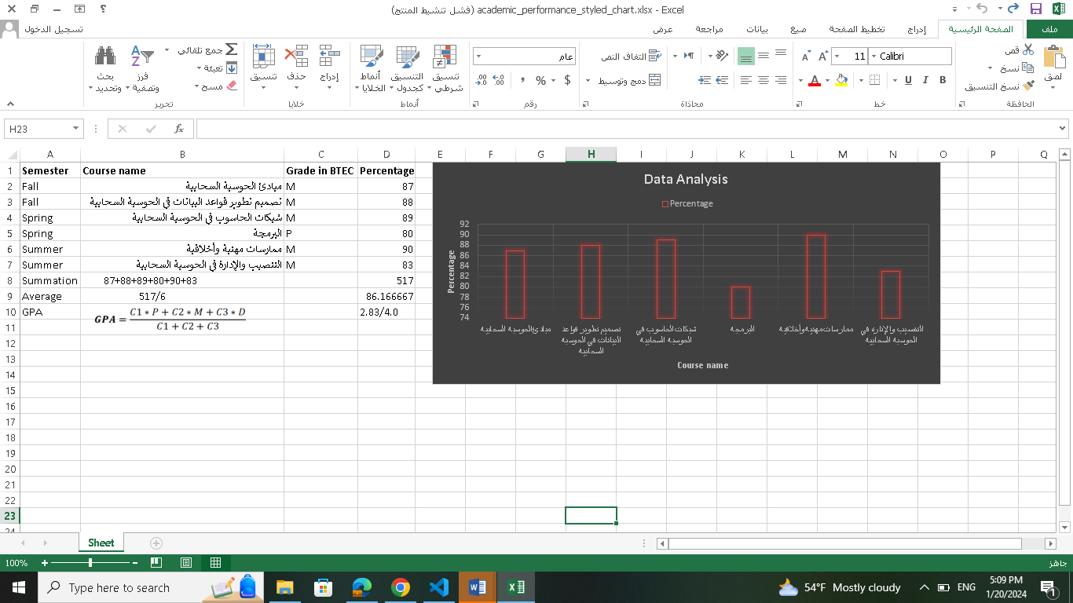

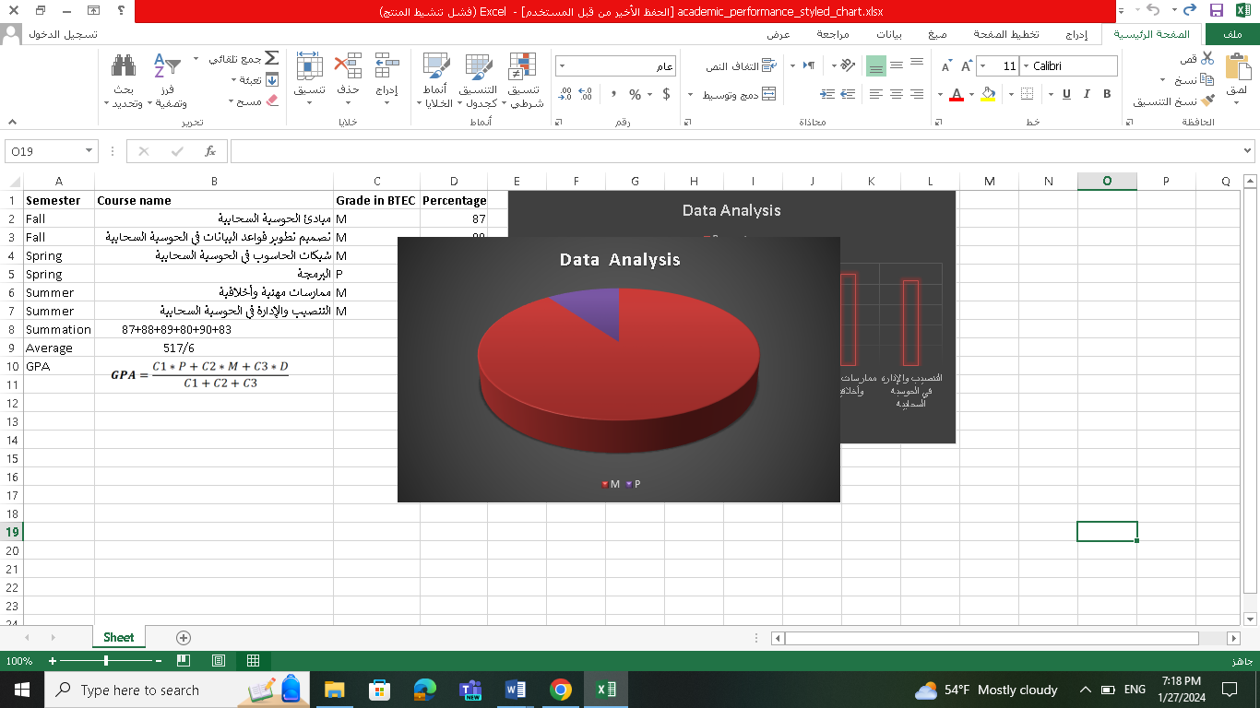

# Secondary data (Collect and Analysis)

Data analysis:

|  |  |
| --- | --- |
| LOs | course |
| "Identify the core algorithms for implementing a process and determine the programming process for a specific application."  "Explain the characteristics of procedural programming, object-oriented programming, and event-driven programming."  "Implement core algorithms in code using an IDE."  "Identify the debugging process and explain the importance of coding standards." | Programming |
| "Study the fundamentals of cloud computing in relation to application areas, architecture, and platform."  "Design a cloud-hosted deployment model for a given scenario."  "Explain the different approaches of Cloud Service Providers (CSPs) to provide a cloud architecture framework for business applications."  "Assess the technical challenges and risks of migrating IT systems to the cloud." | Cloud computing fundamentals |
| "Examine the common networking principles used in cloud infrastructure to support connectivity."  "Explain the operation of networking technologies within cloud infrastructure."  "Optimize network performance for a cloud-based system developed for a specific business use case." | Networking in the cloud |
| "Design a cloud-based relational database system using appropriate design tools and methods for a real-world problem." | Design and development of databases in cloud computing |
| - "Discuss the principles of cloud architecture used to design a technological solution for organizational migration to the cloud."  "Develop a cloud-based prototype using an appropriate development methodology for the business case."  "Test the prototype solution against the requirements of the business case."  "Discuss the value gained from developing a cloud-based solution to support sustainable organizational performance." | Deploying and operating in the cloud |
| "Demonstrate a range of interpersonal and transferable communication skills to the target audience."  "Apply critical thinking and reasoning to a range of problem-solving scenarios."  "Discuss the importance and dynamics of working within a team and the impact of teamwork in different environments." | Professional practice |

Mark P:

|  |  |  |
| --- | --- | --- |
| ID | LOs | Codes numbers |
| 1 | "Identify the core algorithms for implementing a process and determine the programming process for a specific application." | 1,2 |
| 2 | "Explain the characteristics of procedural programming, object-oriented programming, and event-driven programming." | 2 |
| 3 | "Implement the core algorithms in code using an IDE." | 1,2 |
| 4 | "Identify the debugging process and explain the importance of coding standards." | 2,3 |

|  |  |
| --- | --- |
| ID | Codes |
| 1 | Algorithm analysis |
| 2 | Application programming |
| 3 | Identify and solve programming errors |

|  |  |  |
| --- | --- | --- |
| ID | Themes | Codes numbers |
| 1 | Programming skills | 1,2 |

|  |  |
| --- | --- |
| ID | Theme description |
| 1 | Writing a series of instructions or commands that define the behavior of the computer to execute and complete a specific task. This allows programmers to develop interactive applications and programs that serve various purposes, and programming is based on the use of programming languages to achieve the desired objectives. |

Mark M:

|  |  |  |
| --- | --- | --- |
| ID | LOs | Codes numbers |
| 1 | "Study the fundamentals of cloud computing concerning application domains, architecture, and platforms." | 1 |
| 2 | "Design a cloud-hosted deployment model for a given scenario." | 1,2,3 |
| 3 | "Explain the different approaches of Cloud Service Providers (CSPs) to provide a cloud infrastructure framework for business uses." | 2 |
| 4 | "Assess the technical challenges and risks of migrating IT systems to the cloud." | 1,3 |
| 5 | "Examine common networking principles used in cloud infrastructure to support connectivity." | 1,4 |
| 6 | "Explain the operation of networking technologies within the cloud infrastructure." | 1,4 |
| 7 | "Optimize network performance for a cloud-based system developed for a specific business use case." | 1,4 |
| 8 | "Design a cloud-based relational database system using appropriate design tools and methods for a real-world problem." | 1,5,6 |
| 9 | "Discuss the cloud architecture principles used to design a technological solution for organizational transition to the cloud." | 1,2,3,4,6 |
| 10 | "Develop a cloud-based prototype using an appropriate development methodology for the business case." | 1,2,6 |
| 11 | "Test the prototype solution against the requirements of the business case." | 1,2,3,4,6,7 |
| 12 | "Discuss the value gained from developing a cloud-based solution to support sustainable organizational performance." | 3 |
| 13 | "Demonstrate a range of interpersonal and transferable communication skills to the target audience." | 9 |
| 14 | "Apply critical thinking and reasoning to a range of problem-solving scenarios." | 8 |
| 15 | "Discuss the importance and dynamics of working within a team and the impact of teamwork in different environments." | 8 |

|  |  |
| --- | --- |
| ID | Codes |
| 1 | Fundamentals and Principles of Cloud Computing and Service Models |
| 2 | Cloud Service Providers and Offered Services |
| 3 | Benefits and Risks of Cloud Migration |
| 4 | Network Support in the Cloud and Its Definition |
| 5 | Introduction to Databases and Their Design |
| 6 | Applying Databases in the Cloud |
| 7 | Testing the Designed Cloud Solution |
| 8 | Critical Thinking and Problem-Solving |
| 9 | Teamwork and Communication Skills |

|  |  |  |
| --- | --- | --- |
| ID | Themes | Codes numbers |
| 1 | Cloud computing | 1,2,3,4,6,7 |
| 2 | Database | 5 |
| 3 | Problem-solving | 8 |
| 4 | Teamwork | 9 |

|  |  |
| --- | --- |
| ID | Theme description |
| 1 | Providing online computing resources (IaaS, PaaS, SaaS) with major providers like Amazon and Microsoft, including various services such as networking and virtual databases. |
| 2 | Organizing and storing data in a systematic manner that enables efficient retrieval and updating of information. It is used to store and manage data in an organized way, providing means for effective searching and querying. |
| 3 | Identifying and understanding challenges or difficulties and applying effective strategies to achieve solutions. |
| 4 | Group or team collaboration to achieve a common goal, where individuals share common guidance and contribute their skills to achieve success and effectiveness in task completion. |

# Suggested solution

These steps can be followed to obtain results for each student based on their grades:

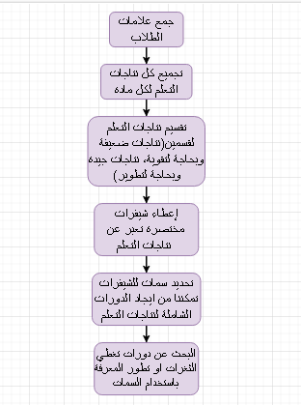

# Suggested courses

I was able to obtain a set of courses that help me improve my skills in the subjects I have completed, which can also assist other students:

Programming skills:

<https://www.coursera.org/learn/java-programming?specialization=java-programming#modules>

Cloud computing:

<https://www.coursera.org/specializations/cloud-computing#courses>

Databases:

<https://www.coursera.org/learn/database-management>

Problem-solving:

<https://www.edx.org/learn/critical-thinking-skills/rochester-institute-of-technology-critical-thinking-problem-solving?index=product&queryID=5f8f2193b04cf3c2efeee62dee27621f&position=1&results_level=first-level-results&term=Critical+Thinking+%26+Problem-Solving&objectID=course-772eb266-036a-4248-ac03-c3c0bac56c70&campaign=Critical+Thinking+%26+Problem+Solving&source=edX&product_category=course&placement_url=https%3A%2F%2Fwww.edx.org%2Fsearch>

Team work:

<https://www.edx.org/learn/teamwork/rochester-institute-of-technology-teamwork-collaboration?index=product&queryID=d84a3fd22744600e6aed30d259606724&position=3&results_level=first-level-results&term=Teamwork+Foundations&objectID=course-ec15bd20-bfcd-4e88-8c2b-fbf770e8a38c&campaign=Teamwork+%26+Collaboration&source=edX&product_category=course&placement_url=https%3A%2F%2Fwww.edx.org%2Fsearch>

- I did not incur any costs during my research except for internet expenses. I faced a few minor issues while collecting primary and secondary data, including:

I had some difficulty finding my grades files to know my scores in previous courses, as my device does not have enough space to keep them.

I also faced challenges learning to use Excel, as I had never used it before.

The biggest difficulty was understanding the research process, as I had never conducted a complete research study before.

# Conclusion

I conducted a data analysis, including a critical evaluation of different research methodologies, and here’s how I can make a judgment and justify my choice of research method:  
*Analysis and Judgment:*  
After conducting a comprehensive analysis of the data, it became clear that the patterns and ideas derived from my academic records within the Pearson educational system play an effective role in shaping a more effective and personalized learning experience. Data mining conducted a careful examination of my academic journey, highlighting various aspects, including learning preferences, performance trends, and potential areas for improvement.

The personal insights gained from data mining provided a retrospective understanding of my academic history and laid the foundation for proactive measures to enhance future learning outcomes. Predictive modeling has proven to be particularly valuable, providing insight into potential challenges and opportunities for improvement.

It is known that I chose data mining as my research methodology. There are several factors that influenced this decision:

- Nature of Data: The complex and multidimensional nature of educational data within Pearson necessitated an approach that could effectively handle large data sets and uncover complex patterns. Data mining, with its ability to extract meaningful insights from comprehensive data sets, has proven to be the most suitable option.

- Exploratory focus: The research aims not only to understand historical academic performance, but also to explore potential areas for improvement and customization. Data mining, as an exploratory method, allowed for the discovery of patterns without a priori hypotheses, which aligns well with the research objectives.

- Predictive ability: The desire to go beyond mere descriptive analysis and delve into predictive modeling was a key factor. The ability of data mining to develop predictive models based on historical data has been critical for predicting future academic performance and identifying early indicators of potential challenges.

- Practical application: The research was not only academic, but targeted practical applications to enhance the learning experience within the Pearson educational system. Data mining, with its practical application in improving courses, resources and support services, has proven its value in the real world.

My choice of research methodology was based on a critical evaluation of different research methodologies and an assessment of the strengths, weaknesses, and appropriateness of the different methods within the context of the objective of my research. Here I will provide a general critical assessment of common research methodologies: qualitative, quantitative and mixed methods.

*Qualitative research:

strength point:

- In-depth understanding: Qualitative research excels at providing rich, detailed insights into complex phenomena. It allows researchers to explore the depth and nuances of the topic.

- Flexibility: Qualitative methods are flexible and adaptable, enabling researchers to modify their approach during the study based on emerging findings.

Weaknesses:

- Subjectivity: Interpretation of qualitative data is often subjective, and results may be affected by the researcher’s bias or point of view.

- Limited generalizability: Qualitative research is usually context-specific, making it difficult to generalize findings to broader populations.

Appropriateness: Qualitative research is appropriate when exploring complex social phenomena, generating hypotheses, or gaining an in-depth understanding of individual experiences.

*Quantitative research:

strength point:

- Objectivity: Quantitative research aims for objectivity through structured data collection and statistical analysis, which reduces the influence of researcher bias.

- Generalizability: Quantitative methods allow results to be generalized to larger populations, enhancing external validity.

Weaknesses:

Lack of depth: Quantitative research may lack the depth of understanding that qualitative approaches provide, because it focuses on numerical data and statistical relationships.

- Rigidity: The fixed nature of structured surveys or experiments may limit the exploration of unexpected factors.

Suitability: Quantitative research is suitable for testing hypotheses, examining relationships between variables, and making generalizations based on numerical data.

*Mixed methods research:

strength point:

- Comprehensive understanding: Combining qualitative and quantitative data provides a more comprehensive and comprehensive understanding of the research question.

- Methodological triangulation: Using both methods can enhance the validity of the results through triangulation, validating the results from multiple perspectives.

Weaknesses:

- Complexity: Integration between qualitative and quantitative components can be complex and resource-intensive, requiring expertise in both approaches.

- Time consuming: Conducting both types of research can take a long time, which may lengthen the overall duration of the study.

Appropriateness: Mixed methods research is appropriate when researchers seek a more complete understanding, want to validate or supplement findings, and when the research question benefits from a combination of qualitative and quantitative insights.It is certain that my research will benefit the students of my university as well, not just me. Therefore, I must publish this research to the target audience, which is my university students and teachers. Here are the methods for publishing the research that I will rely on:

Sending a personalized message to each student on the Teams platform, where I can reach all students and teachers of my university.

Organizing a workshop in coordination with the university administration targeting students, in which I briefly explain my research and present to them how to create course proposals for them upon graduation or during their studies.

Utilizing social media so that I can publish the research on it and send it to students or refer to them.

Making small leaflets about the research and distributing them to students so that those interested can contact me and obtain the research.

# Critical analysis of research findings and proposal to stakeholders

* Critical analysis of research results:

My choice of data mining and mixed methods proved effective in obtaining quantitative and qualitative insights. This combination allowed for a comprehensive understanding of educational data within the Pearson system. Key findings revealed patterns in academic performance, learning preferences, and potential areas for improvement. These insights are essential to enhancing the overall learning experience within the Pearson Education system.

Acknowledging limitations in terms of resource intensity in data extraction and potential biases in qualitative analysis is essential for a transparent evaluation. Comparing the findings with existing literature highlighted unique aspects while also aligning them with broader trends, which contributed to the validity of the research. Recognizing the context-specific nature of findings ensures a realistic understanding of generalizability to other educational systems.

*Recommendations for targeted stakeholders:

The research has identified challenges such as differences in student performance, potential gaps in learning support, and opportunities for personalized learning experiences. Linking these challenges to specific research findings, such as patterns of academic performance and learning preferences, provides a clear rationale for each recommendation. Prioritizing recommendations is crucial; For example, focusing on personalized learning styles and targeted support for students facing academic challenges.

The potential benefits, such as improved student outcomes and a more personalized learning environment, serve as an incentive for stakeholders. Defining a long-term vision emphasizes that addressing the challenges students face contributes to sustainable improvements in the educational experience over time.

In conclusion, the choice of data mining within the Pearson Education System is justified by its ability to handle the complexity of educational data, provide personalized insights, support exploratory analysis, and provide predictive modeling for proactive measures. Critical evaluation of the various research methodologies confirmed the suitability of data extraction in addressing the research objectives and ensuring the practical application of the findings in the context of the Pearson education system.

# References list

(wikipedia, 2023)

(Pearson, 2023)

(Pearson, 2020)

(linked-in, 2021)

(Limited، 2020)

(Pearson education, 2022)

(Chen، 2014)

(Siemens، 2013)

(Davenport، 2012)

Certainly, my previous grades and materials are the most important reference for my research.

# Appendix 1 (Reflection)

I believe, based on my limited experience in research, that my research has achieved its desired goals.

What confirmed the success of my research was that I actually took courses that could benefit me and develop me in the way I followed.

What will truly confirm its success for me is the opinion of the people responsible for me in this research.

One of the goals of my research was to talk about Pearson and its system, and this is what was included in the introduction to my research and some parts of the research since I am a student under the Pearson umbrella.

The second goal was to talk about big data and its concept. This is what parts of my research included, as Pearson is a large institution with thousands of students and employees, and it must benefit from the enormous amount of data it possesses.

My third goal was to clarify research methodologies, and my research included this in most of its aspects.

The fourth goal benefited me personally, and the benefit would certainly be greater if this goal were applied to Pearson as a whole.

Finally, the system included in my research was proposed, and it is hoped that Pearson will adopt it in the future, as it will benefit it and the students.

I believe that the method of collecting data was the optimal methodology, as the grades were my grades, so I did not have to conduct interviews or questionnaires, for example, because they would not be useful in my research.

The methodology that I followed in searching for courses that could improve my performance led to satisfactory results, as the courses that I took included the weak points that I wanted to strengthen and the strengths that I wanted to develop in all the courses that I chose.

The biggest problem was the lack of time and the abundance of materials and tasks. The second problem was searching for the tag files again and analyzing them. But I was trying to solve the problem as soon as it appeared, as I tried to use all the time I had. I was able to find my scores as well and analyze them.

I also faced a problem with the lack of internet access, and this was the most difficult.

Let us summarize the strengths and weaknesses of the research process based on the considerations and methodologies discussed in the previous questions:

strength point:

- Comprehensive understanding: Using data mining within the Pearson Education system and my university specifically has allowed me to gain a comprehensive understanding of the academic performance, learning styles, and potential areas for improvement of all students.

- Personalized Insights: The data mining approach provided me with personalized insights into individual learning experiences, enabling a more personalized and effective learning journey.

- Predictive Modeling: Incorporating predictive modeling has enhanced the research's ability to predict future academic performance and identify early indicators of challenges.

- Practical application: My research focused on practical applications within the educational system, aligned with real-world needs and providing actionable insights for improvement.

Integration of mixed methods: Integrating qualitative and quantitative aspects into a research design allowed for methodological triangulation, which enhanced the validity of the findings.

Weaknesses:

- Resource intensity: Data mining, especially if it is applied to educational data at my entire university, requires intensive resources in terms of time and experience. This may lead to long periods and increased costs, but I did not face this point as my marks are not that dense or numerous.

Complexity of mixed methods design: Integrating qualitative and quantitative components in a mixed methods design is complex, requiring careful planning and experience with both methodologies.

*Data mining:

Advantages:

Pattern Discovery: Data mining excels at discovering complex patterns and relationships within large data sets.

Predictive Modeling: The ability to create predictive models enhances the practical applicability of the insights I proposed in my research to my entire university system.

Limitations:

Data Privacy Concerns: Data mining, especially regarding the educational data of my university students, raises privacy concerns that need to be carefully managed.

Resource Intensive: Requires expertise, specialized software, and potentially significant computing resources.

**Plagiarism**

Plagiarism is a particular form of cheating. Plagiarism must be avoided at all costs and students who break the rules, however innocently, may be penalised. It is your responsibility to ensure that you understand correct referencing practices. As a university level student, you are expected to use appropriate references throughout and keep carefully detailed notes of all your sources of materials for material you have used in your work, including any material downloaded from the Internet. Please consult the relevant unit lecturer or your course tutor if you need any further advice.

**Student Declaration**

|  |
| --- |
| **Student declaration**  I certify that the assignment submission is entirely my own work and I fully understand the consequences of plagiarism. I understand that making a false declaration is a form of malpractice.  Student signature: Date: |