**Lead Management & Task Tracking System**

Phase 2: Org Setup & Configuration

## **1. Salesforce Editions**

->Salesforce provides multiple editions: Essentials, Professional, Enterprise, Unlimited, and Developer.

->For this project:

Use Developer Edition (free, full features) to implement lead management, task automation, and reporting.

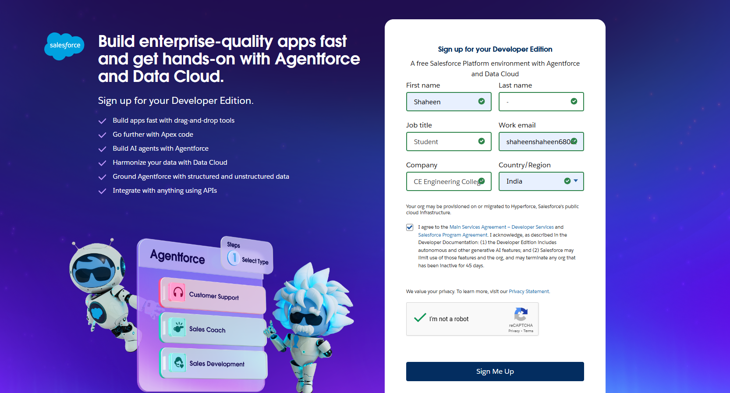

## **2. Company Profile Setup**

Defines basic information for the Salesforce org.

Configuration for project:

* Company Name: *Lead & Task Management System*
* Default Locale: English (India)
* Currency: INR
* Time Zone: Asia/Kolkata

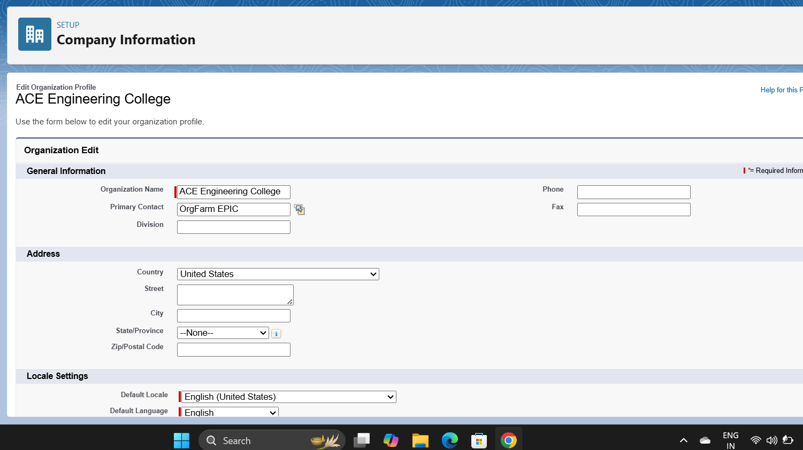

## **3. Business Hours & Holidays**

Business hours are used for task assignments and workflow rules.

Setup:

* Business Hours: Mon–Sat, 9:00 AM – 6:00 PM IST
* Holidays: National holidays like 26th Jan, 15th Aug, 2nd Oct

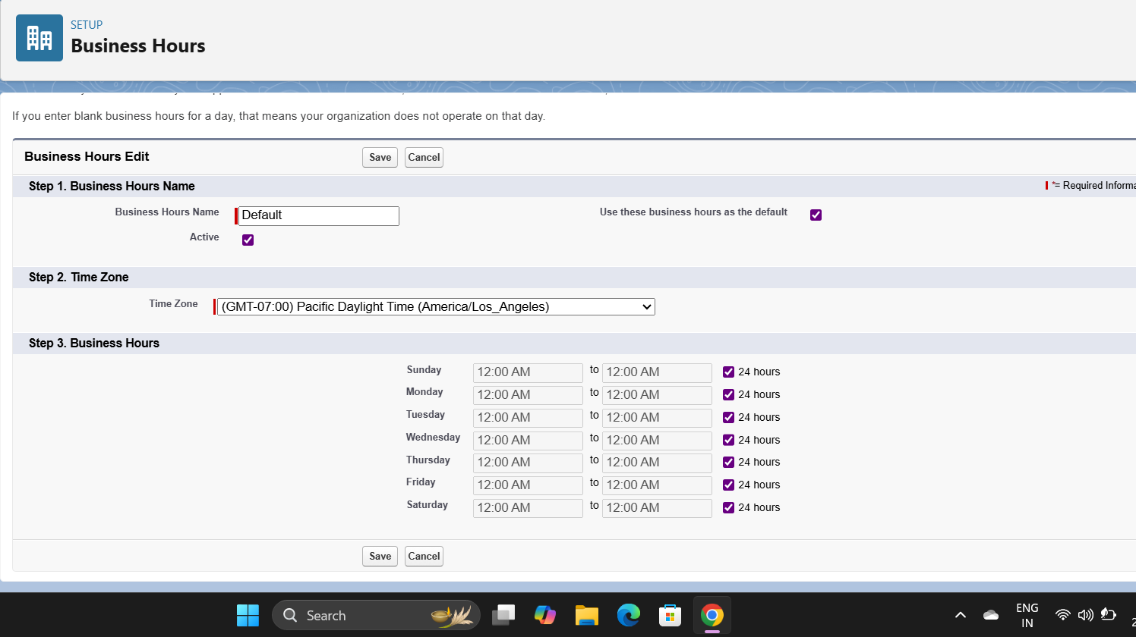

## **4. Fiscal Year Settings**

* Defines the reporting period for Salesforce.
* For India, set Standard Fiscal Year: April 1 – March 31.

## **5. User Setup & Licenses**

Create users according to project roles:

| Role | License Type | Permissions |
| --- | --- | --- |
| System Admin | Salesforce Admin | Full access to all objects |
| Sales Manager | Salesforce | Manage Leads, View all reports |
| Sales Agent | Salesforce Platform | Manage own leads & tasks |

## **6. Profiles**

Profiles define access to objects and features:

* System Admin → Full access.
* Sales Manager → Modify All Leads, Tasks, Reports.
* Sales Agent → Create, Read, Update Leads & Tasks (no delete).

## **7. Roles**

* Define hierarchy to control record visibility: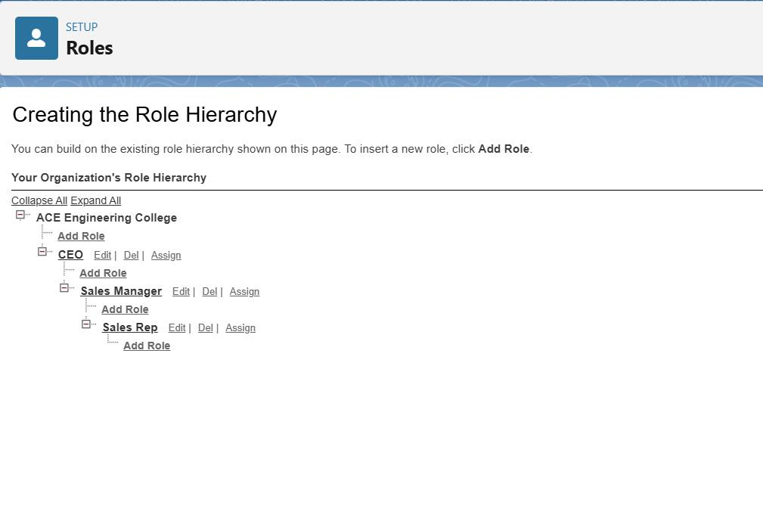
* Sales Agents see only their leads.
* Sales Managers see all leads under their hierarchy.

## **8. Permission Sets**

* Use to grant additional access without changing profile.
* Example: Permission set to allow agents to export reports.

## **9. Organization-Wide Defaults (OWD)**

* Set Leads → Private
* Set Tasks → Controlled by Parent (Task visibility depends on associated Lead)

## **10. Sharing Rules**

* Grant managers visibility of all leads:
  + Rule: All Leads owned by Sales Agents → Shared with Sales Manager role.