**Lead Management & Task Tracking System**

**Phase 3: Data Modeling & Relationships**

## 1. Standard & Custom Objects

Salesforce provides standard objects like Lead, Account, Contact, Opportunity, Task, and Event.  
For this project, custom objects ma y be created for project-specific tracking such as 'Client Feedback' or 'Follow-up Notes'.

## 2. Fields

Custom fields are added to objects to store specific information. Examples:  
- Lead Object: Lead Source, Industry, Lead Status  
- Task Object: Task Type, Priority, Completion Status  
- Client Feedback: Rating, Feedback Date, Comment

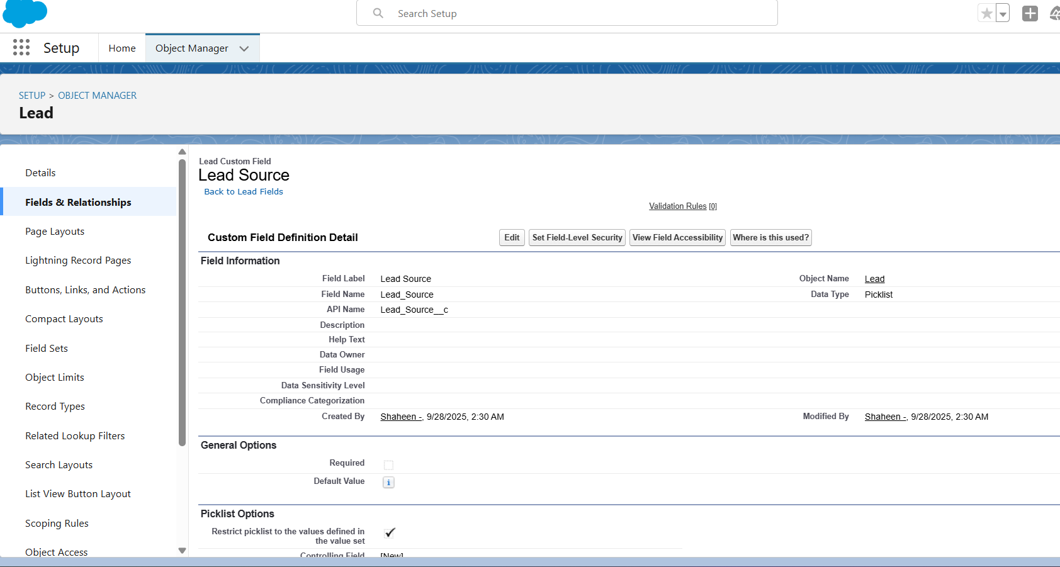

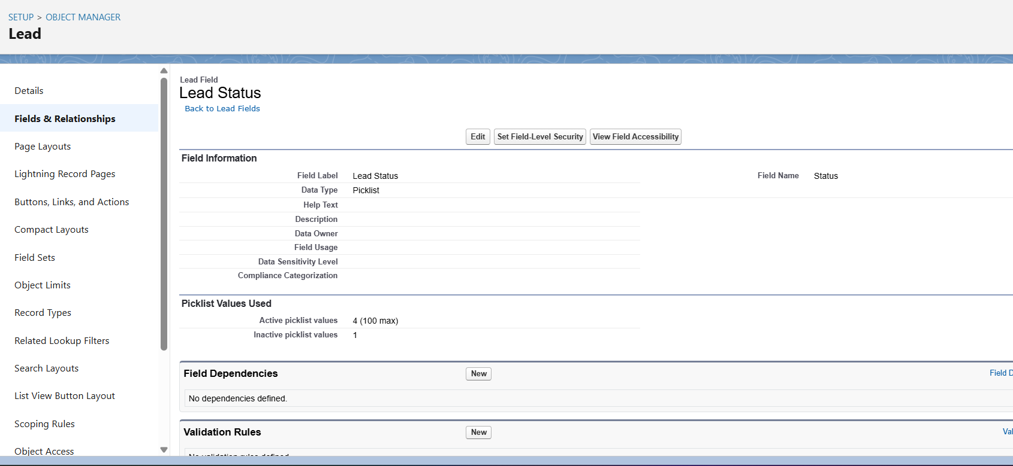

## 3. Record Types

Record Types allow different page layouts and business processes for the same object.  
Example:  
- Lead Object: 'Retail Lead', 'Healthcare Lead'

## 4. Page Layouts

Page layouts define how fields are displayed on object records.  
Example: Sales Agent layout shows only relevant fields for daily operations, while Sales Manager layout includes reporting fields.

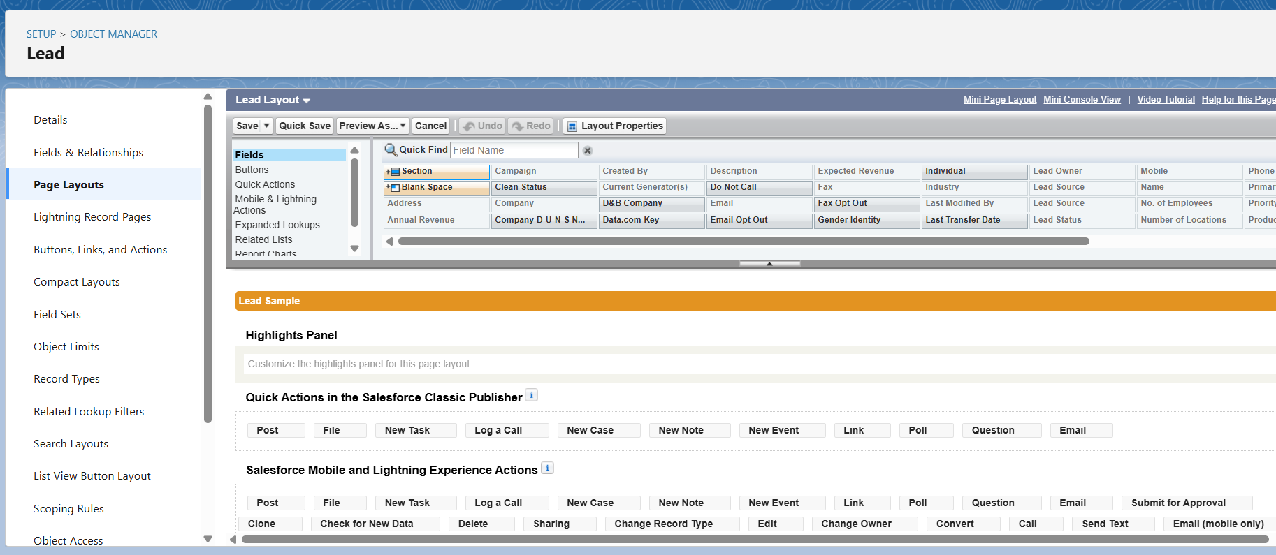

## 5. Compact Layouts

Compact layouts define the key fields displayed in highlights panel and mobile view.  
Example: Lead Name, Company, Lead Status, Priority.

## 6. Schema Builder

Schema Builder allows visualization of object relationships and fields.  
Use it to design and review custom objects, fields, and relationships.

## 7. Relationships

- Lookup Relationship: Optional link between objects (e.g., Lead → Campaign).  
- Master-Detail: Strong parent-child relationship (e.g., Lead → Follow-up Notes).  
- Hierarchical: Special relationship for User object (e.g., Sales Agent → Sales Manager).

## 8. Junction Objects

Used to model many-to-many relationships.  
Example: 'Lead Assignment' linking Sales Agents to multiple Leads.

## 9. External Objects

External objects allow Salesforce to access data stored outside the org.  
Example: Accessing client data from an ERP or hospital database.

## Deliverables for Phase 3

- List of standard and custom objects  
- Custom fields and record types documentation  
- Page layouts and compact layouts configuration  
- Schema diagram using Schema Builder  
- Relationship mappings (Lookup, Master-Detail, Junction, External)