**Lead Management & Task Tracking System**

**Phase 4: Automation (Workflows, Process Builder, Flows)**

## 1. Introduction

This phase focuses on automating critical business processes in Salesforce to improve efficiency in **lead management, task assignment, and tracking**. Automation helps sales teams focus on selling rather than manual updates, reduces errors, ensures timely follow-ups, and improves reporting accuracy.

**Key Objectives:**

* Automate lead assignment and follow-ups.
* Ensure timely notifications for tasks and approvals.
* Reduce repetitive manual work for sales reps and managers.
* Maintain accurate lead and task data.

## 2. Validation Rules

Validation rules enforce data integrity. They prevent incorrect or incomplete data from being saved.

**Examples:**

* Lead email must be in a valid format.
* Lead phone number cannot be blank.
* Task due date cannot be in the past.

**Benefits:**

* Ensures clean data for reporting and analysis.
* Reduces manual errors in lead and task management.

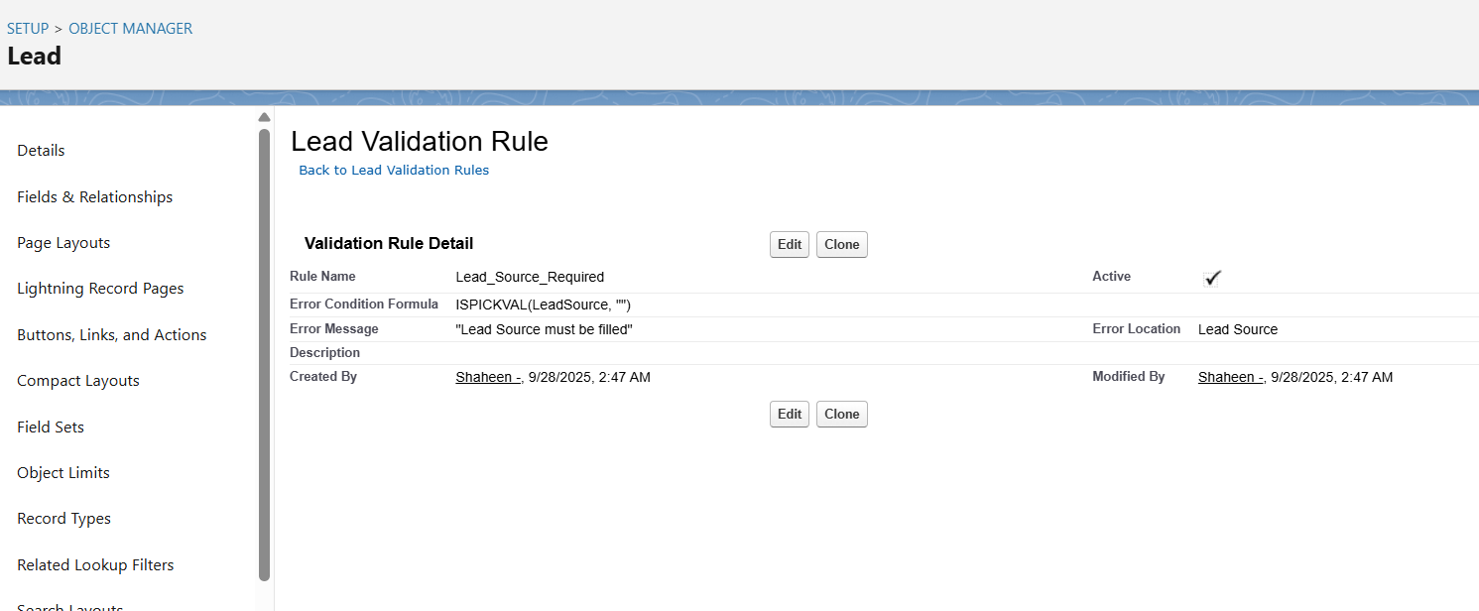

## 3. Workflow Rules

Workflow rules automate **simple, repetitive tasks** such as sending emails, creating tasks, or updating fields.

**Examples:**

* When a new lead is created → send an email alert to the assigned sales rep.
* If a lead is marked as “Hot” → create a task to call the lead within 24 hours.
* When a task is completed → update lead status to “Contacted.”

**Benefits:**

* Automates routine tasks.
* Improves timely engagement with leads.
* Ensures consistent sales process.

## 4. Process Builder

Process Builder enables **multi-step automation with conditions**. It is more advanced than Workflow Rules.

**Examples:**

* When a lead is converted → automatically create an opportunity and assign a follow-up task to the account manager.
* When a task is overdue → change lead priority to “High” and notify the manager.

**Benefits:**

* Reduces manual updates across multiple objects.
* Improves task follow-up and lead conversion efficiency.

## 5. Approval Process

Approval processes are optional but useful for **high-value leads or special discounts**.

**Examples:**

* Lead discount requests → require manager approval before applying in Salesforce.
* Opportunity approval → for deals above a certain amount, require director approval.

**Benefits:**

* Enforces business rules for approvals.
* Ensures accountability in decision-making.

## 6. Flow Builder

Flow Builder allows **more complex automation**, including screen flows, auto-launched flows, scheduled flows, and record-triggered flows.

**Types & Examples:**

* **Screen Flow:** Guided input for adding new leads to ensure all required data is collected.
* **Record-Triggered Flow:** When a lead is updated to “Qualified,” automatically assign the next task to the sales rep.
* **Scheduled Flow:** Weekly reminders for pending follow-up tasks.
* **Auto-Launched Flow:** Automatically assign tasks to reps based on lead territory or priority.

**Benefits:**

* Handles complex automation scenarios.
* Ensures real-time or scheduled actions without manual intervention

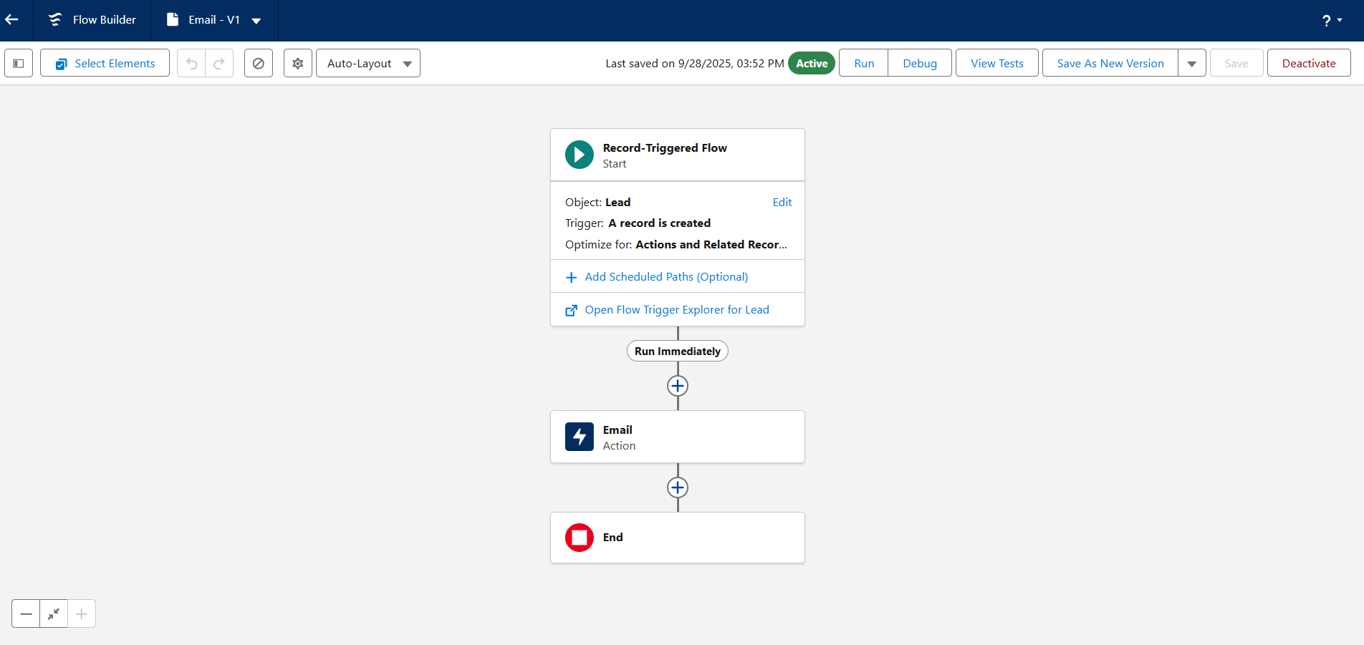

## 7. Email Alerts

Email alerts send **automatic messages** to sales reps, managers, or leads when certain events occur.

**Examples:**

* Notify reps when a high-priority lead is assigned.
* Send follow-up reminders to leads after an initial contact.
* Inform managers when a lead hasn’t been contacted for X days.