**Lead Management & Task Tracking System Phase 8: Data Management & Deployment**

## 1. Introduction

This phase focuses on managing Salesforce data efficiently and deploying changes between orgs. Proper data management ensures data integrity, avoids duplicates, and facilitates smooth migration across environments.

Objectives:

* Import and export leads, tasks, and related records.
* Prevent duplicate records and maintain data quality.
* Deploy changes safely across Salesforce environments.

## 2. Data Import Wizard

Purpose: Import data declaratively via Salesforce UI.

Setup Steps:

1. Go to Setup → Data → Data Import Wizard.
2. Select the object (Lead, Task, Account, Contact).
3. Choose Add New Records or Update Existing Records.
4. Upload CSV file with data.
5. Map CSV columns to Salesforce fields.
6. Start the import process.

Example: Import a CSV of new leads to the system.

Benefits:

* Simple, no coding required.
* Ideal for small to medium-sized data imports.

Deliverable: Leads and tasks imported successfully using Data Import Wizard.

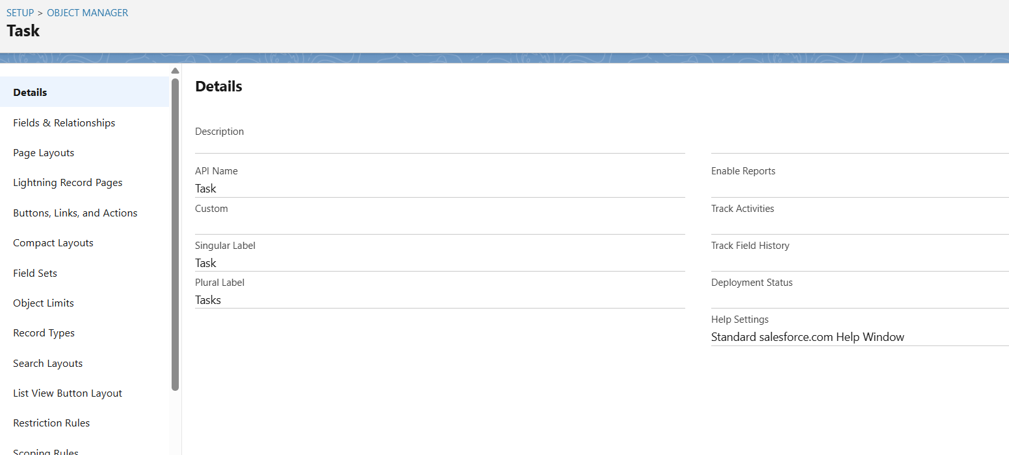

## 3. Data Loader

Purpose: Bulk import, update, delete, and export Salesforce data.

Setup Steps:

1. Install Salesforce Data Loader desktop application.
2. Login using your Salesforce credentials (or OAuth).
3. Choose operation: Insert, Update, Upsert, Delete, Export.
4. Select object (Lead, Task, etc.).
5. Map CSV columns to Salesforce fields.
6. Execute operation and review success/failure logs.

Benefits:

* Handles large data volumes (>50,000 records).
* Supports automation via command-line operations.

Deliverable: Bulk lead and task data managed with Data Loader.

## 4. Duplicate Rules

Purpose: Prevent duplicate records in Salesforce.

Setup Steps:

1. Go to Setup → Duplicate Management → Duplicate Rules.
2. Create a Duplicate Rule for Leads:
   * Matching Rule: Match by Email and Company.
   * Action: Alert user or block creation.
3. Activate the rule.

Benefits:

* Ensures data quality.
* Avoids redundant leads and tasks.

Deliverable: Duplicate rules configured for Leads and Tasks.

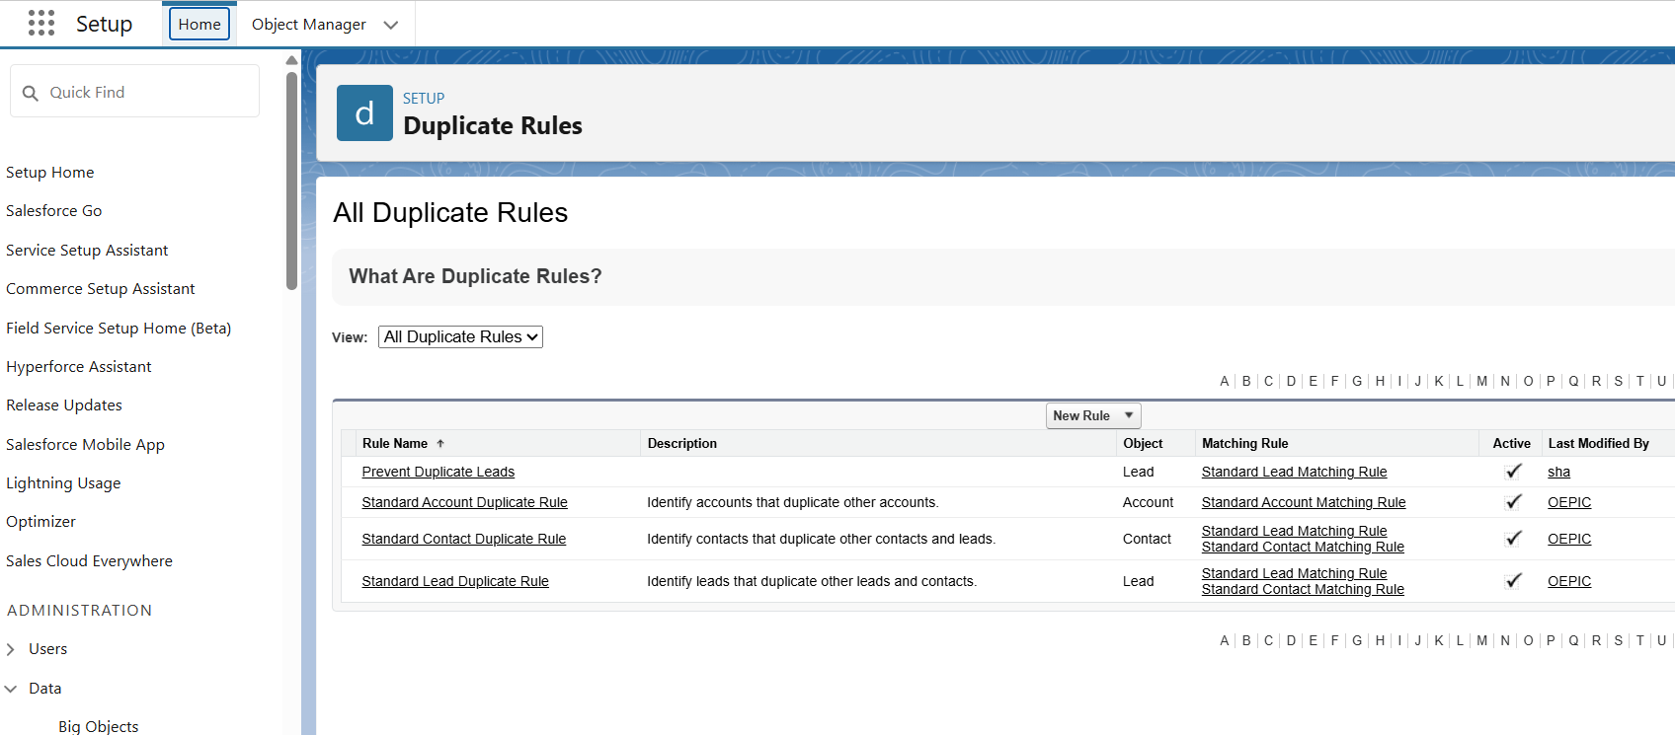

## 5. Data Export & Backup

Purpose: Regularly backup Salesforce data.

Setup Steps:

1. Go to Setup → Data → Data Export.
2. Select objects to export (Lead, Task, Account, Contact).
3. Choose frequency: weekly or monthly.
4. Download ZIP file containing CSVs of all selected objects.

Benefits:

* Protects against data loss.
* Useful for migration and reporting.

Deliverable: Scheduled data exports and backups configured.

## 6. Change Sets

Purpose: Deploy metadata changes between Salesforce orgs (e.g., Sandbox → Production).

Setup Steps:

1. Go to Setup → Outbound Change Sets in Sandbox.
2. Create new Change Set and add components (Objects, Fields, Apex Classes, LWCs, Flows).
3. Upload the Change Set to Production.
4. In Production, go to Inbound Change Sets and Deploy.

Benefits:

* Declarative deployment method.
* Track components and ensure consistency.

Deliverable: Sandbox changes deployed to Production using Change Sets.

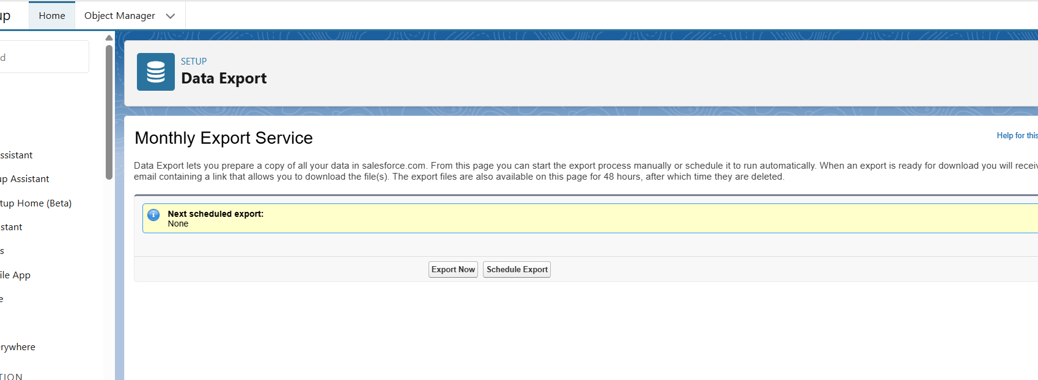

## 7. Unmanaged vs Managed Packages

Purpose: Package and deploy customizations.

Unmanaged Package:

* Used for one-time deployment of components.
* Customizations can be edited in target org.

Managed Package:

* Used for distributing apps (AppExchange).
* Upgrades are controlled by the publisher.
* Components are protected and cannot be edited.

Setup Steps:

1. Go to Setup → Packages → New Package.
2. Add components (Objects, Apex Classes, LWC, Flows).
3. Upload package (Managed or Unmanaged).

Deliverable: Custom Lead Management & Task Tracking app packaged for deployment.