# Enterprise Web Application Deployment on AWS with CI/CD, Auto Scaling, and Monitoring

This project demonstrates deploying an enterprise web application on AWS using best practices for CI/CD, auto-scaling, networking, security, and monitoring.

---

## Project Overview
- **CI/CD**: Continuous Integration and Deployment for web servers
- **Auto Scaling**: Automatically scale EC2 instances based on load
- **Monitoring**: CloudWatch for EC2, RDS, and ALB metrics
- **Networking**: VPC with public subnets, security groups, and proper IP management
- **Database**: MySQL RDS instance with Multi-AZ for high availability
- **Load Balancer**: Application Load Balancer (ALB) to distribute traffic

---

## Screenshots

### 1️⃣ VPC & Networking

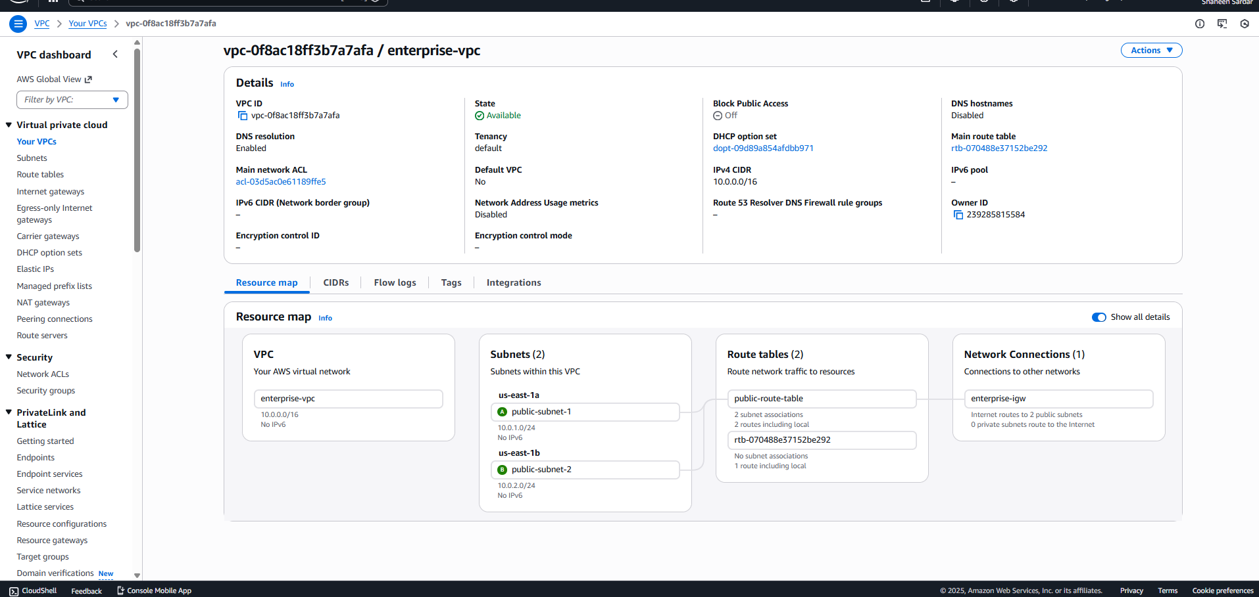

![VPC Overview](screenshots/01_VPC_Dashboard.png)

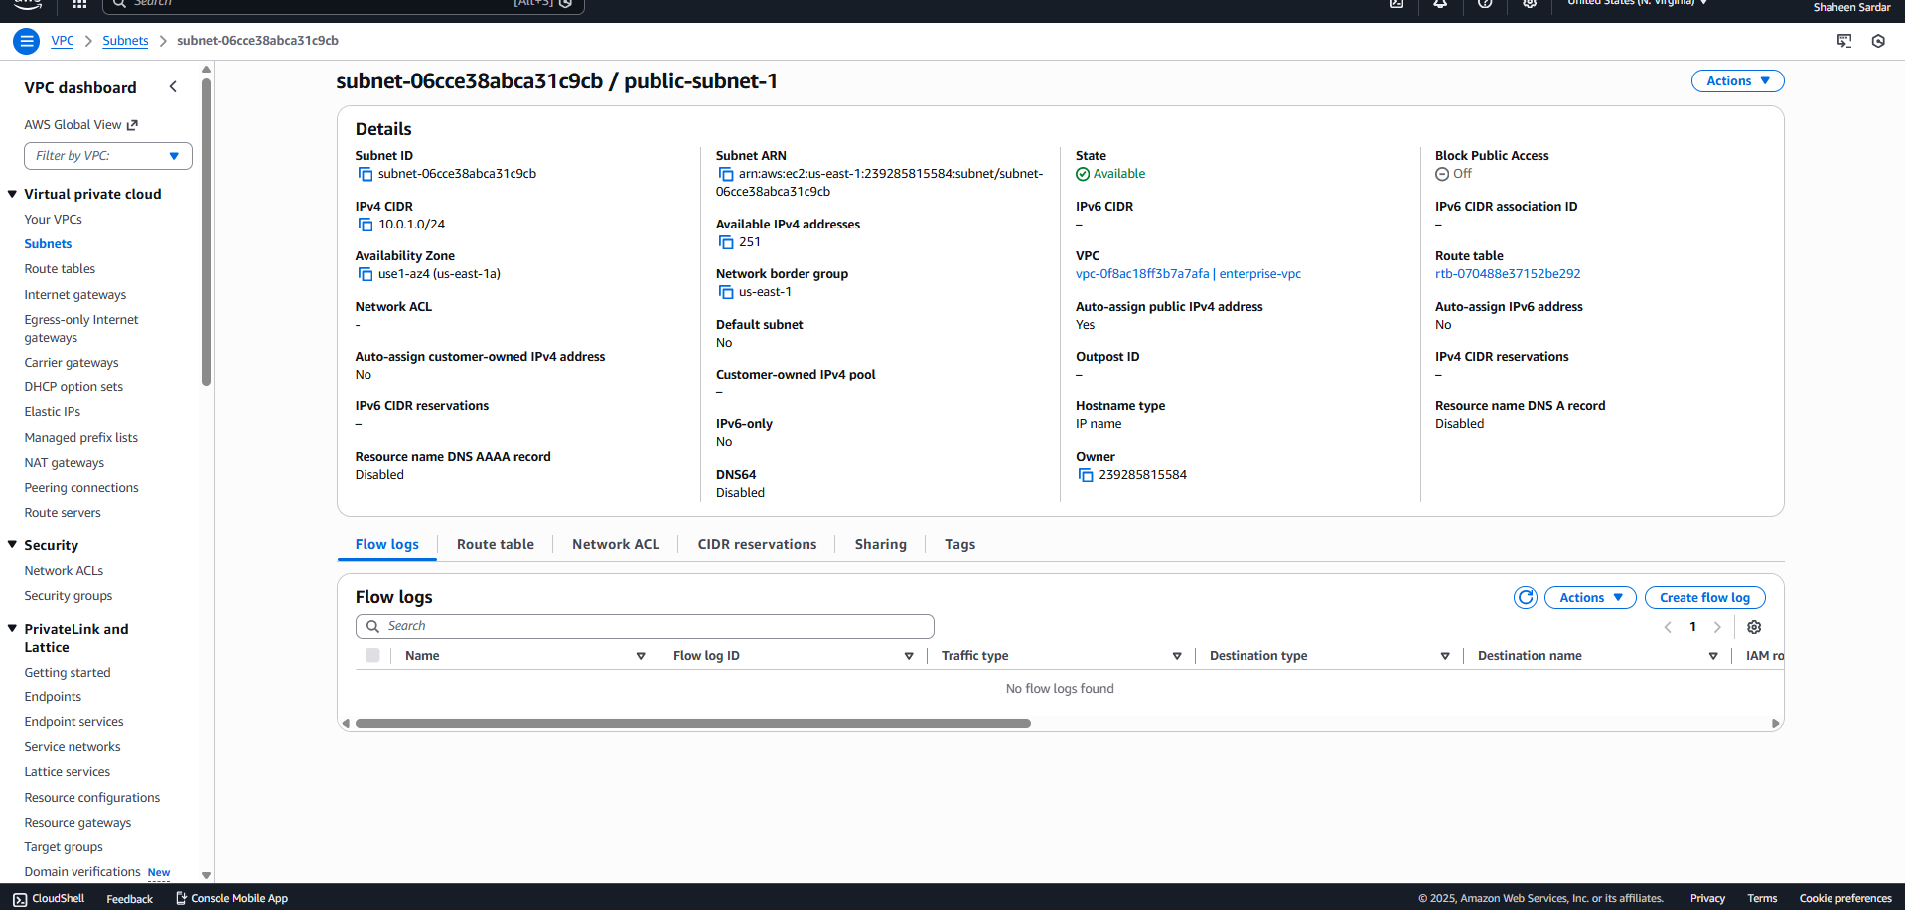

![Public Subnets](screenshots/02_Public_Subnets.png)

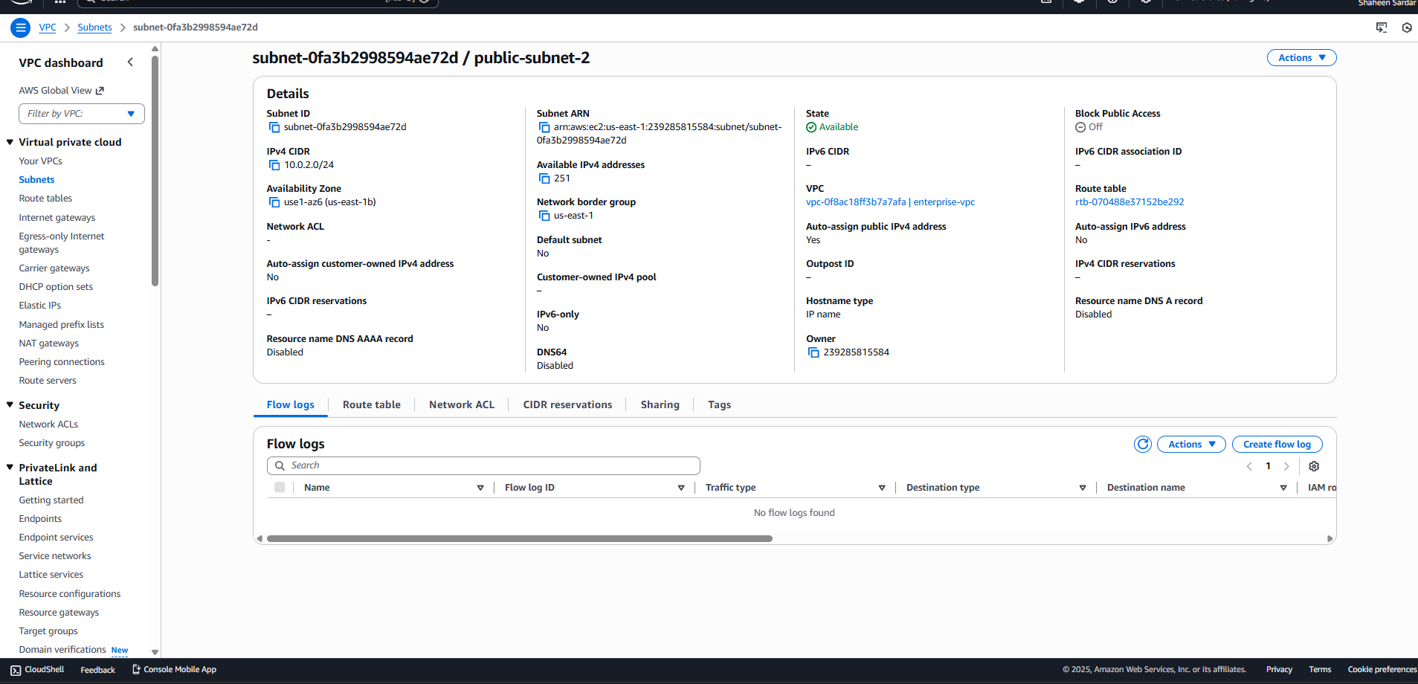

![EC2 Public IPs](screenshots/03_EC2_PublicIPs.png)

### 2️⃣ EC2 / Web Servers

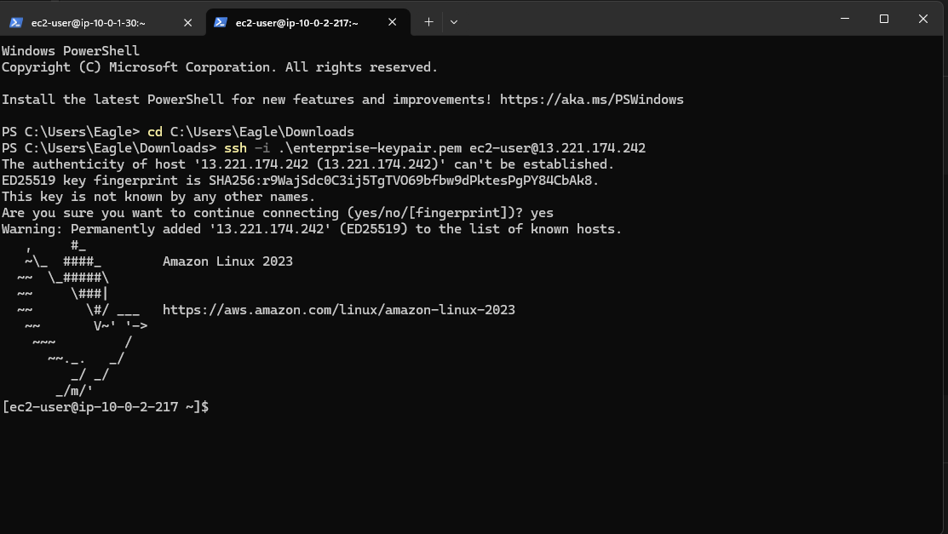

![SSH WS2](screenshots/05_SSH_WS2.png)

### 3️⃣ Security Groups

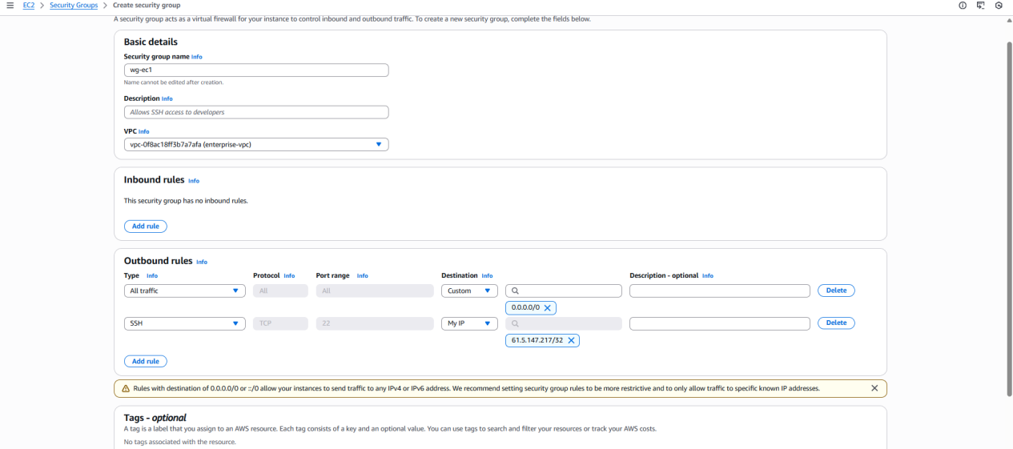

![Security Group](screenshots/06_SG_WS.png)

### 4️⃣ Load Balancer (ALB)
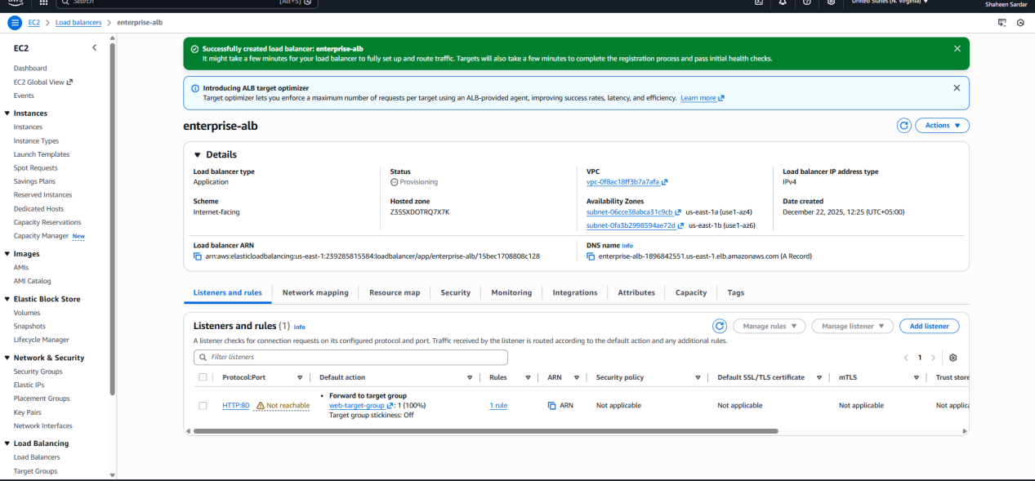

![ALB Configuration](screenshots/07_ALB_Config.png)

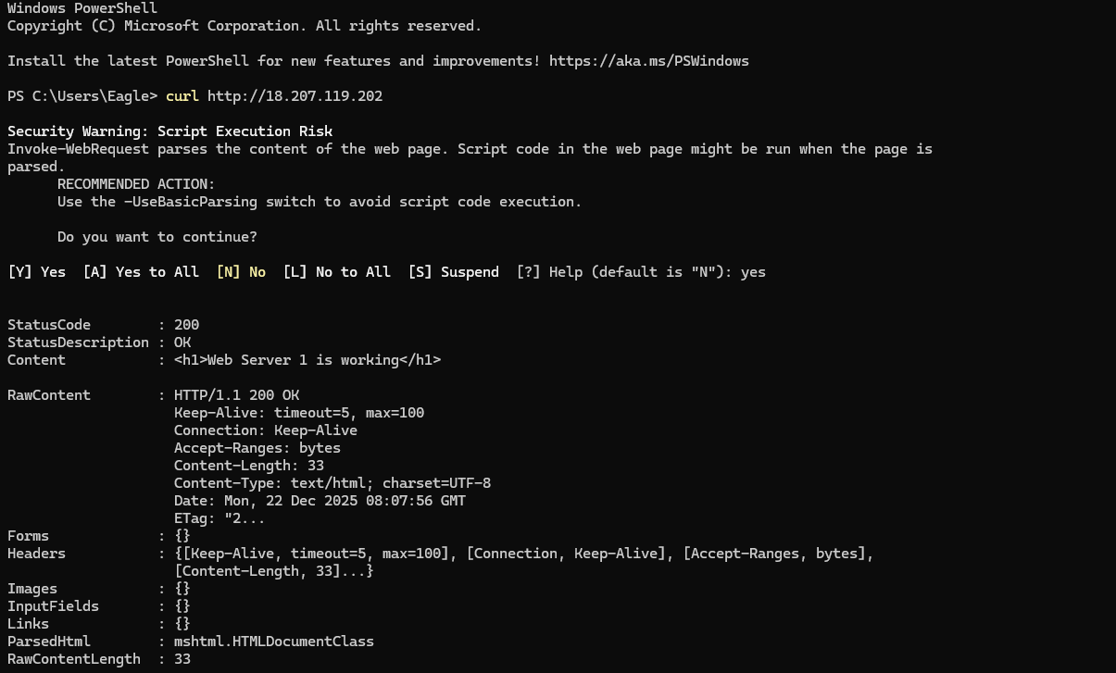

![ALB Browser Test](screenshots/08_ALB_Browser_Test.png)

### 5️⃣ Database (RDS)

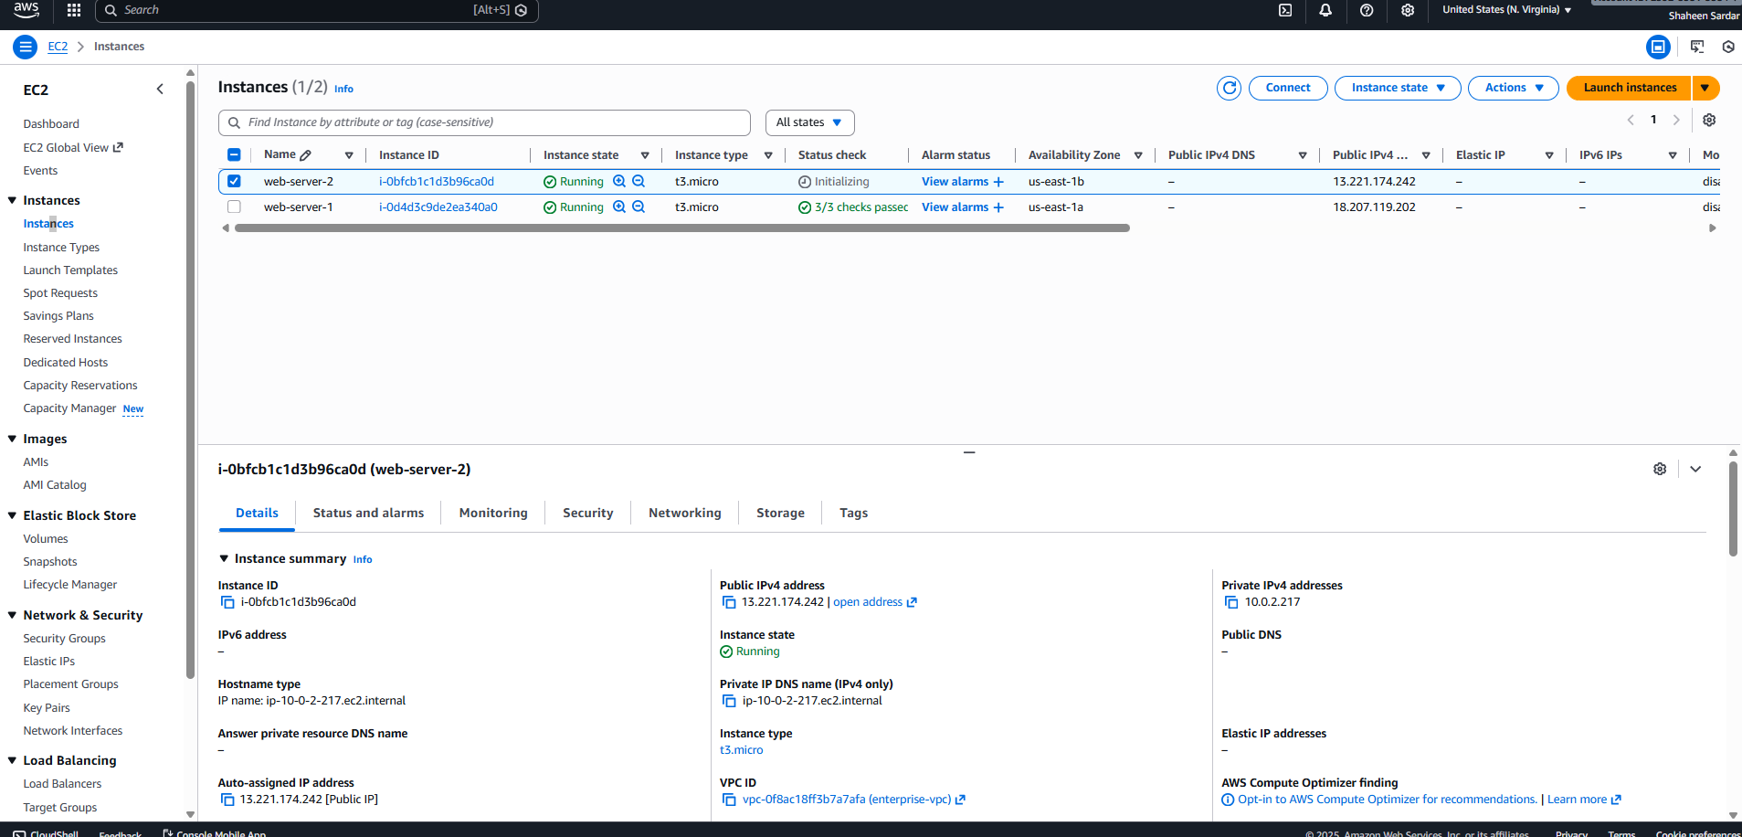

![RDS Dashboard](screenshots/09_RDS_Dashboard.png)

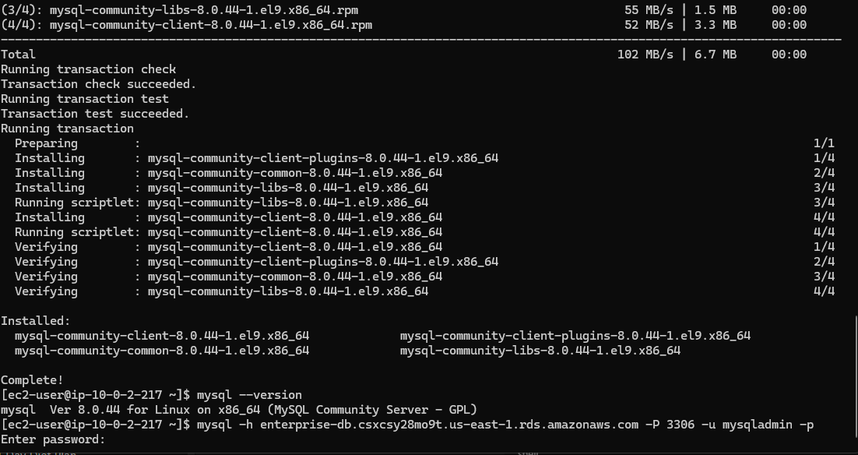

![EC2 RDS Connection](screenshots/10_EC2_RDS_Connection.png)

### 6️⃣ IAM Roles & Users
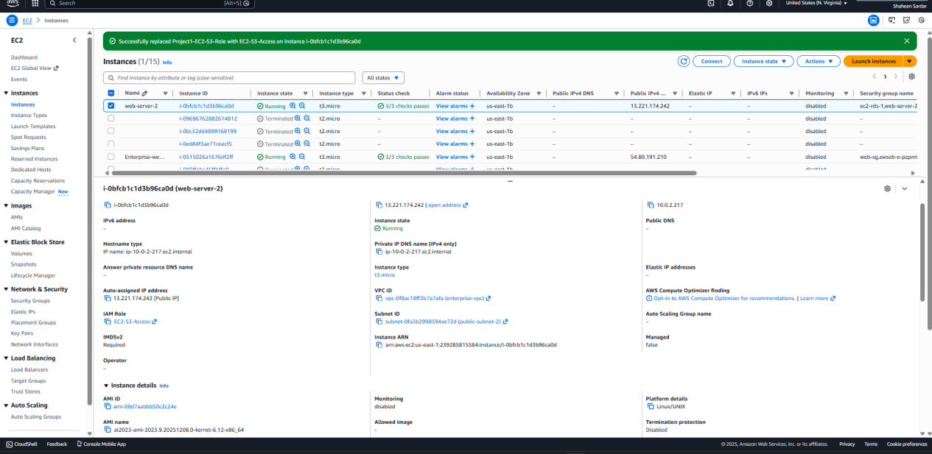

![IAM Role](screenshots/11_IAM_Role.png)

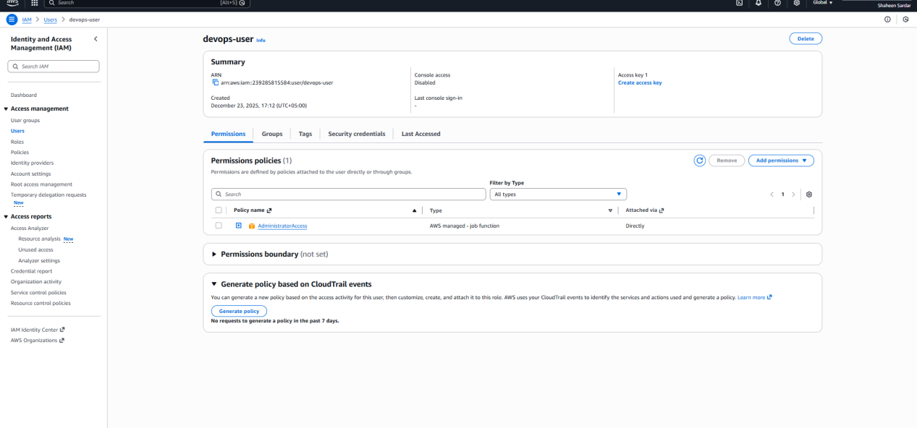
![IAM User](screenshots/12_IAM_User.png)

## How to Run / Test
1. Clone this repository:
```bash
git clone <your-repo-url>

