# The first slide should be poster with logo (that represents our project )

# Title

# "VControl"

**“Revolutionizing TV Interaction with Cutting-Edge Gesture Control Technology"**

# Introduction:

"Imagine being able to change the channel, adjust the volume, or pause your favorite show—all with just a wave of your hand. For someone with limited mobility or difficulty speaking, this is a game-changer. No more searching for the remote or struggling with voice commands that may not work properly with different accents. With Gesture Control for Smart TVs, the future of TV is hands-free, making it easier for everyone to enjoy their entertainment, independently and effortlessly."

**Problem Statement:**

Despite the advancements in TV and smart home technology, traditional remote controls still present significant barriers for many users, especially those with disabilities, limited mobility, or speech difficulties. Current solutions, including voice control, often fail to meet the needs of a diverse user base. The lack of intuitive, accessible creates frustration and limits the full potential of modern entertainment systems.

### **Current Market Gaps & User Challenges with Remotes:**

1. **Limited Accessibility for People with Disabilities:**
   1. **Challenge:** For individuals with physical disabilities or limited mobility, using traditional remote controls can be a major struggle. For example, someone with arthritis may find it painful to press buttons, or a person with limited mobility might not be able to grasp and use the remote effectively.
   2. **Market Gap:** Current remote-control designs do not cater to these challenges, leaving a significant portion of users without an easy way to interact with their TVs.
2. **Reliability Issues with Voice Commands:**
   1. **Challenge:** Voice-controlled systems are becoming more popular, but they often fail to recognize different accents, speech impairments, or background noise. A person with a thick accent or someone who has difficulty speaking may struggle to get their voice assistant to understand commands.
   2. **Market Gap:** Voice recognition technology is not yet perfect and can exclude users with diverse accents or speech difficulties, creating frustration and limiting its usefulness.
3. The Inconvenience of Searching for the Remote:

**Example 1:** You’re watching Netflix, all comfy on the couch, and suddenly need to adjust the volume. You go to grab the remote, but it’s nowhere to be found. After searching the cushions and table, you still can’t find it, ruining the moment.

**Example 2:** You go to use the remote, but it won’t work. After a few attempts, you realize the batteries are dead. Now, you must get up, find new batteries, and waste time fixing it.

**Example 3:** Worse yet, your remote is completely broken, and now you’re stuck either trying to use the TV’s manual buttons or dealing with an unresponsive remote.

### **Challenge:**

Searching for the remote, dealing with dead batteries, or a broken device interrupts your viewing experience, turning what should be a relaxing time into a frustrating one.

### **Market Gap:**

This shows the need for an alternative that doesn't rely on a physical remote, like gesture control, offering a hands-free and convenient way to interact with the TV.

### **Our Solution: Gesture Control for Smart TVs**

Our solution leverages **advanced gesture recognition technology** to provide a seamless, intuitive, and hands-free TV control experience. By integrating **AI**, **motion sensors**, and **machine learning**, we enable users to interact with their smart TVs using simple hand gestures, eliminating the need for traditional remotes.

#### **Addressing User Challenges with Gesture Control:**

1. **Empowering Accessibility:** Traditional remotes can be challenging for individuals with **disabilities** or **limited mobility**, who may find it difficult to press buttons or handle small devices. Our gesture control system allows these users to control the TV effortlessly with just hand movements, promoting greater independence and convenience.
2. **Eliminating Remote Control Frustrations:** Searching for a lost or broken remote is a common issue that disrupts the user experience. Our solution completely **removes the reliance on physical remotes**, allowing users to control their TV with simple gestures. No more lost remotes, dead batteries, or malfunctioning devices.
3. **Bypassing Voice Command Limitations:** Voice control systems often struggle with **accents**, **speech impairments**, or **background noise**, making them unreliable for many users. Gesture control overcomes these limitations, providing a **universal and accurate** means of interaction, regardless of speech variations or environmental factors.
4. **Simplifying TV Control for All Ages:** Complex remotes with numerous buttons can overwhelm seniors or non-tech-savvy users. Our gesture recognition system offers **intuitive control**, allowing users of all ages and technical abilities to easily navigate TV settings without confusion or frustration.

***The Technology Behind the Solution:***

* **AI-Powered Gesture Recognition:** Utilizing **state-of-the-art AI** and **motion sensors**, our system detects and translates hand gestures into TV commands with high precision and minimal delay, providing a smooth, responsive experience.
* **Personalized Experience:** Through **machine learning**, the system adapts to user preferences, learning from gestures over time to offer increasingly accurate and efficient control.

By combining cutting-edge **gesture recognition** with **AI** and **machine learning**, our solution eliminates the frustrations of traditional remotes, offering a more **accessible**, **user-friendly**, and **hands-free** alternative that enhances the overall TV viewing experience.

### **How Our Gesture Control System Stands Out from Others in the Market**

Most existing **gesture control systems for TVs** are either:

1. **Built directly into Smart TVs**, requiring expensive hardware upgrades. (e.g., Samsung’s Air Gesture, LG’s Magic Motion)
2. **External gesture-based remote controls**, which still require users to hold a device.

#### **What Makes Our Solution Different?**

✅ **Set-Top Box Integration Instead of New TV Units**

* Instead of manufacturing new Smart TVs with built-in gesture sensors, we **integrate gesture control into Vodafone’s set-top boxes**.
* This eliminates the **huge cost of TV hardware development** and allows Vodafone to offer gesture control **without forcing customers to buy new TVs**.

✅ **Cost-Effective & Scalable**

* Vodafone can **leverage its existing user base** and offer gesture control as a **software & hardware upgrade** to its set-top box customers.
* Unlike competitors who require customers to buy expensive Smart TVs, our solution is a **plug-and-play upgrade**.

✅ **AI-Driven Accuracy with Standard Cameras**

* We utilize **AI-powered gesture recognition** that works with standard **depth cameras, IR sensors, or even mmWave radar**.
* This ensures **high accuracy** without needing specialized TV hardware.

✅ **Seamless Compatibility Across TV Brands**

* Our system works with **any TV that connects to a Vodafone set-top box**, making it **brand-agnostic**.
* Competing solutions are often **locked to specific TV brands**, limiting customer choices.

✅ **Future-Proof & Software-Upgradable**

* Since our gesture control is **AI and software-driven**, it can be updated over time.
* Vodafone can **roll out improvements via software updates**, unlike TV manufacturers who require **new hardware models** for upgrades.

**🚀 Vodafone Gesture Control Implementation: Timeline & Cost Breakdown**

Vodafone can implement **gesture control for set-top boxes** within **18-24 months** with a **phased rollout**. Below is the **estimated cost breakdown** at each stage.

📅 **Implementation Timeline & Cost Estimates**

|  |  |  |  |
| --- | --- | --- | --- |
| **Phase** | **Timeline** | **Key Activities** | **Estimated Cost (USD)** |
| 1️⃣ **Proof of Concept (PoC)** | **1-2 months** | - Develop a **basic prototype** with existing AI & camera modules.- Use **off-the-shelf sensors** (webcam, IR sensors). | **$100K - $250K** |
| 2️⃣ **Pilot Testing** | **3-6 months** | - Deploy in a **controlled test group** (Vodafone employees/customers).- Optimize **gesture recognition accuracy**.- Conduct **usability studies & feedback analysis**. | **$500K - $750K** |
| 3️⃣ **Hardware & Software Integration** | **6-9 months** | - Choose **final camera/sensor technology** (built-in vs. add-on device).- Develop **software updates** for Vodafone’s set-top boxes.- Integrate **cloud-based AI processing** (if required). | **$1M - $2M** |
| 4️⃣ **Regulatory & Compliance Approvals** | **9-12 months** | - Ensure compliance with **data privacy & accessibility laws**.- Work with **broadcasting & telecom regulators**. | **$200K - $500K** |
| 5️⃣ **Commercial Launch (Beta Version)** | **12-18 months** | - **Soft launch** in key Vodafone markets (UK, Germany, Spain, etc.).- Invest in **marketing & customer onboarding**. | **$2M - $4M** |
| 6️⃣ **Full Market Rollout** | **18-24 months** | - **Mass adoption campaign**.- Offer **subscription models** or bundle with Vodafone premium plans.- Scale up **manufacturing (if using external sensors)**. | **$10M - $20M** |

💰 **Total Estimated Implementation Cost:**

🔹 **$14M - $28M over 2 years**  
 🔹 **Faster rollout possible with AI cloud processing (reducing hardware costs).**

⚡ **How Vodafone Can Minimize Costs & Maximise ROI**

✅ **Software-Only Approach:** If Vodafone’s set-top boxes have built-in cameras, a **software update** could enable gesture control with minimal hardware investment (~$5M-$10M total).  
 ✅ **Subscription Revenue Model:** Charge **$3-$5/month per customer** for gesture control as an add-on feature.  
 ✅ **Strategic Partnerships:** Collaborate with **AI & computer vision startups** to accelerate development & reduce R&D costs.

🚀 **With this investment, Vodafone can disrupt the smart TV market and create a new revenue stream!** 🔥📡

**Market Opportunity & Growth Potential :**

### **💥 Why This Will Make Vodafone the Industry Leader**

#### **🌍 Mass Adoption Potential – The Future is NOW!**

🔴 **Reality Check:** **Over 80% of households still use traditional TVs** that lack advanced gesture control. Why? Because upgrading to a high-end Smart TV is expensive and unnecessary for most consumers.

🔴 **Our Advantage:** Instead of forcing customers to spend **hundreds or thousands of dollars** on a new TV, Vodafone **empowers them to upgrade their existing setup instantly** with a simple set-top box integration.

🔴 **The Result?** A **huge addressable market**—millions of Vodafone users can enjoy futuristic, hands-free control **without changing their TVs or their habits.**

(This chart highlights the significant growth trajectory of the gesture recognition market, underscoring the vast potential for technologies like Vodafone's gesture-controlled set-top boxes.)

**Revenue vs. Cost Projection**

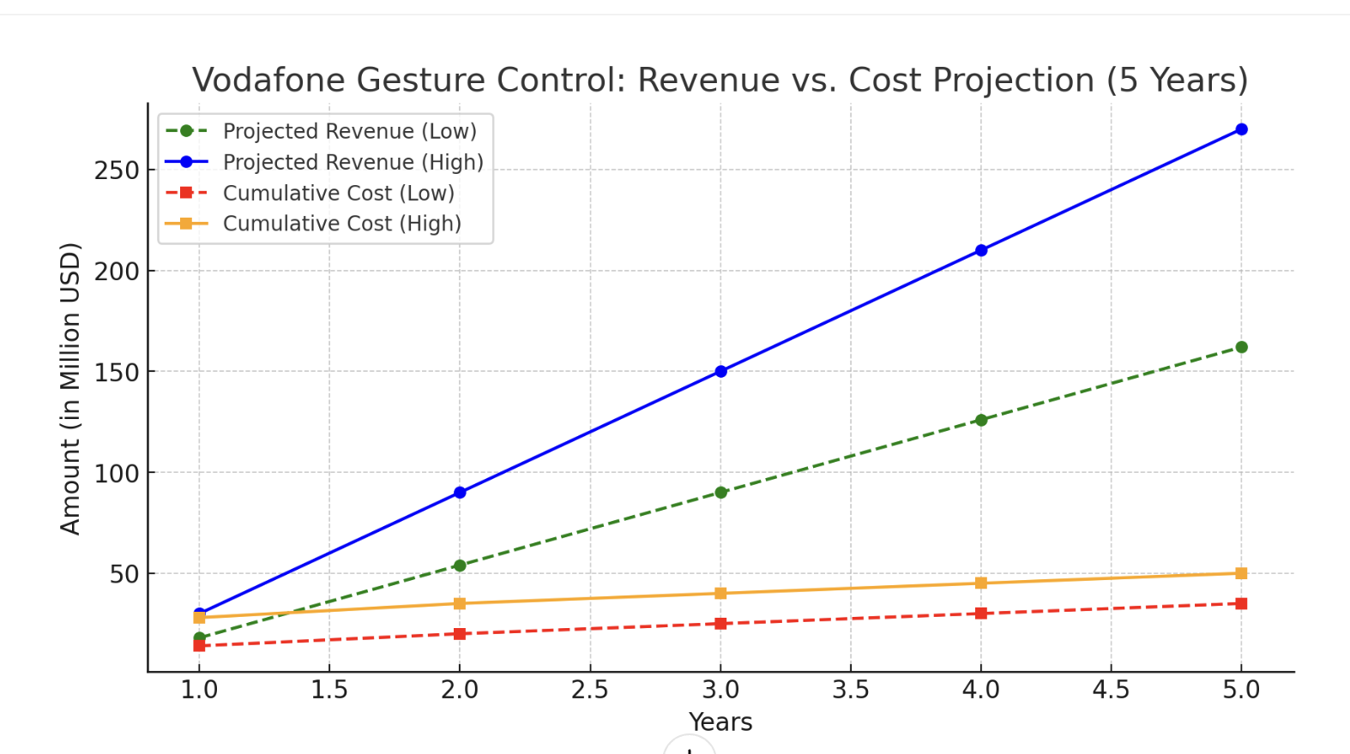✔ **$450M - $750M in revenue over 5 years** at full market penetration.  
 ✔ **ROI: 10x return** on investment by Year 5.  
 ✔ **Low-cost, high-margin business model** since gesture control is **mostly software-driven**.  
 ✔ Vodafone gains **competitive differentiation** against other pay-TV providers.

🚀 **Final Verdict: This is a billion-dollar opportunity!** Vodafone can dominate the market with an **accessible, cost-effective, and futuristic TV experience.** 🔥📡

#### **🔥 Disrupting the Smart TV Market – A Game-Changer for the Industry**

📺 **Smart TV brands want customers to buy new TVs every few years. We say: NO NEED!**

💡 By shifting the intelligence to Vodafone’s set-top box, we completely **flip the industry model**—users don’t need to replace their screens to get next-gen features.

⚡ **What does this mean?**

* No longer will high-end Smart TV manufacturers **control the innovation pipeline**.
* Vodafone **takes center stage** in redefining home entertainment—without being in the TV manufacturing business.
* The **set-top box becomes the most valuable entertainment hub** in the home, extending its lifespan and importance.

#### **💀 The Competition Will Struggle to Catch Up**

🔹 **TV manufacturers** are locked into their hardware cycles—our software-driven approach is **infinitely more scalable** and cost-effective.

🔹 **Other gesture control solutions** are either brand-specific (Samsung, LG) or require extra accessories—**we eliminate all barriers**.

🔹 **Competitors can’t easily replicate this without overhauling their entire strategy—by the time they react, Vodafone will have already taken over the market.

🚀 Vodafone is Not Just Competing—It’s Redefining the Game This isn’t just about gesture control. **This is a power shift in the Smart TV ecosystem**—and Vodafone is leading the charge.

**Are you ready to disrupt an entire industry? Because Vodafone is. 🎤🔥**