High-Availability Student Management System

Project Proposal Report & ER Diagram

DESCRIPTION:
This project develops a mission-critical Student Management System designed to handle the complexities of university course registration with enterprise-grade reliability and data integrity. The system implements a three-tier architecture with a .NET frontend, dual business logic layers (LINQ and Stored Procedures accessible via the Factory Pattern), and a SQL Server backend that leverages advanced database features, including stored procedures, functions, triggers, views, CTEs, indexes, and table partitioning. The application supports two primary user roles: students who can view their academic records and register for courses, and administrators who manage the entire academic catalog, student records, and grade assignments.
As an extra credit component, the system demonstrates production-ready high availability by deploying the SQL Server database as a 3-node Availability Group on Kubernetes using DH2i DxEnterprise clustering software. This containerized HA solution will be implemented in both Sidecar and Custom Image patterns, with a live failover demonstration showing zero data loss and automatic recovery during simulated database node failures. The complete system demonstrates how modern database systems can maintain service continuity during critical enrollment periods, when thousands of concurrent users rely on uninterrupted access.

PROBLEM STATEMENT AND MOTIVATION:
University course registration systems are mission-critical applications that experience high concurrent usage during peak enrollment periods. System downtime during these windows can prevent thousands of students from registering for courses, causing significant operational disruptions and student dissatisfaction. Traditional student management systems often lack the robust data validation required to prevent registration errors such as prerequisite violations, schedule conflicts, and capacity overflows. Additionally, these systems often fail to maintain comprehensive audit trails for grade modifications, which are crucial for ensuring academic integrity and compliance with requirements.
This project addresses these challenges by implementing a Student Management System with a focus on data integrity, automated business rule enforcement, and high availability. The system will leverage SQL Server's advanced database features to ensure data consistency and implement containerized high availability using Kubernetes and SQL Server Availability Groups, guaranteeing zero downtime during database node failures. The application will demonstrate enterprise-grade architectural patterns by providing dual business logic implementations (LINQ and Stored Procedures) accessible through a Factory Pattern, allowing runtime selection of data access strategies.

KEY OBJECTIVES AND ACHIEVEMENT PLAN
Objective 1: Implement Comprehensive Business Logic Enforcement
- Develop sp_RegisterStudentForCourse stored procedure with multi-step validation: check for active student holds, verify direct prerequisites are satisfied, confirm course capacity availability, and execute atomic transaction for enrollment
- Create fn_CheckPrerequisitesMet scalar function to validate student has passed all required prerequisite courses with grades D or better
- Create fn_CalculateGPA scalar function using CTEs to convert letter grades to grade points and compute weighted cumulative GPA
- Create fn_GetStudentTranscript table-valued function to return formatted course history with grades and semesters
- Ensure all business rules are enforced at the database level through constraints, functions, and stored procedure logic before any data modification occurs
Objective 2: Ensure Data Integrity and Auditability
- Implement trg_After_GradeUpdate AFTER trigger on Enrollments table to automatically capture all grade modifications into Audit_GradeChanges table with old value, new value, timestamp, and administrator ID
- Implement trg_InsteadOf_DeleteStudent INSTEAD OF trigger on Students table to prevent hard deletes and enforce soft-delete pattern by updating EnrollmentStatus to 'Inactive' for historical data preservation
- Use database transactions with proper error handling in all stored procedures to maintain referential integrity across related tables (Enrollments, CourseOfferings, StudentHolds)
- Apply CHECK constraints on Grade columns and foreign key constraints across all relationships to prevent invalid data entry
Objective 3: Build Dual Business Logic Architectures
- Create Entity Framework data model with DbContext mapping all 9 database tables (Students, Courses, Enrollments, etc.) for object-relational mapping
- Implement the LinqStudentRepository class containing all business operations (RegisterForCourse, DropCourse, GetTranscript, CalculateGPA) using LINQ queries against the Entity Framework context
- Implement the SpStudentRepository class containing identical business operations by calling corresponding stored procedures (sp_RegisterStudentForCourse, etc.) through ADO.NET SqlCommand execution
- Implement Factory Pattern with RepositoryFactory class that reads configuration (app.config or appsettings.json) to instantiate and return appropriate repository implementation at runtime
- Ensure both implementations provide identical public interfaces through the IStudentRepository contract for seamless switching
Objective 4: Optimize Query Performance and Scalability
- Design and implement RANGE RIGHT table partitioning on Enrollments table by EnrollmentDate with yearly boundaries (2023, 2024, 2025, 2026) to isolate current semester data for faster query performance
- Create clustered indexes on all primary keys (automatic) and non-clustered indexes on all foreign keys (StudentID, OfferingID, CourseID, SemesterID, DepartmentID) to optimize JOIN operations
- Create filtered index on Students table WHERE EnrollmentStatus = 'Active' to accelerate active student queries
- Create filtered index on Enrollments table WHERE Grade = 'F' to quickly identify students needing academic intervention
- Implement non-recursive CTE in fn_CalculateGPA for grade point aggregation and recursive CTE in sp_GetDepartmentHierarchy for organizational reporting
- Create views (vw_StudentTranscript, vw_CourseCatalog, vw_AvailableCourseOfferings) to encapsulate complex multi-table JOINs and simplify application queries
Objective 5: Demonstrate High Availability and Failover Capabilities (Extra Credit)
- Deploy 3-node SQL Server Availability Group on local Kubernetes cluster (Minikube or Docker Desktop Kubernetes) with synchronous commit mode for zero data loss protection
- Configure DH2i DxEnterprise as the clustering layer to manage AG listener endpoints, health monitoring, and automatic failover orchestration
- Implement Sidecar deployment pattern: create Kubernetes Pod YAML with two containers (mcr.microsoft.com/mssql/server and dh2i/dxenterprise) sharing network namespace for cluster communication
- Implement Custom Image deployment pattern: create Dockerfile based on mcr.microsoft.com/mssql/server with DH2i software installation commands, build custom image, and deploy as single-container pods
- Configure .NET application connection string to use AG listener DNS name with MultiSubnetFailover=True and implement retry logic (Polly library) for transient connection failures
- Demonstrate live failover: run continuous workload (100 student registrations via sp_RegisterStudentForCourse), identify PRIMARY replica, execute kubectl delete pod on primary node, observe automatic secondary promotion, verify zero data loss and application auto-recovery within 5 seconds

SYSTEM MAIN FEATURES, OPERATIONS, AND OUTCOMES
Feature 1: Intelligent Course Registration with Multi-Level Validation
- Operation: Student searches available course offerings for upcoming semester through the application interface, selects desired course, and clicks "Register" button which invokes the business logic layer
- Processing: Application calls either LinqStudentRepository.RegisterForCourse() or SpStudentRepository.RegisterForCourse() depending on Factory configuration; LINQ implementation executes multiple queries to check StudentHolds, calls fn_CheckPrerequisitesMet, verifies capacity, and performs INSERT/UPDATE in transaction; SP implementation calls sp_RegisterStudentForCourse which performs identical validations server-side: (1) queries StudentHolds table for active holds and returns error if found, (2) invokes fn_CheckPrerequisitesMet(@StudentID, @CourseID) which checks Enrollments history against CoursePrerequisites table for passing grades on required courses, (3) compares CurrentEnrollment against MaxCapacity in CourseOfferings, (4) wraps INSERT into Enrollments and UPDATE of CourseOfferings.CurrentEnrollment in BEGIN TRANSACTION/COMMIT block with TRY/CATCH error handling
- Outcome: Students are prevented from registering for courses when they have financial or academic holds, have not completed required prerequisite courses, or when courses are at maximum capacity; course enrollment counters remain accurate even under high concurrent registration load; all operations are atomic ensuring no partial registrations occur; error messages clearly indicate which validation failed (hold reason, missing prerequisite course code, or "course full" message) enabling students to take corrective action

Feature 2: Automated Grade Change Auditing for Academic Integrity
- Operation: Administrator navigates to grade management interface, searches for student enrollment record, enters new grade value (A, B, C, D, or F), and submits the grade change through the application
- Processing: Application executes UPDATE statement on Enrollments table changing Grade column from old value to new value; immediately after UPDATE commits, SQL Server automatically fires trg_After_GradeUpdate trigger which detects the Grade column change using UPDATE(Grade) function; trigger captures data from both INSERTED (new values) and DELETED (old values) pseudo-tables in a single INSERT statement; new record is created in Audit_GradeChanges table containing EnrollmentID (from INSERTED), old Grade value (from DELETED), new Grade value (from INSERTED), SYSTEM_USER (administrator Windows/SQL login name), and GETDATE() timestamp; trigger logic includes WHERE clause filtering to only log actual changes (handles NULL to value, value to NULL, and value to different value scenarios)
- Outcome: Complete immutable audit trail of every grade modification made in the system without requiring administrators to manually log changes; audit records cannot be modified or deleted (enforced by removing UPDATE/DELETE permissions on Audit_GradeChanges table); compliance officers and department chairs can query audit table to investigate grade disputes, identify patterns of grade inflation, or review administrator actions during specific time periods; academic integrity investigations have full forensic trail showing who changed what grade, when it was changed, and what the previous value was
Feature 3: Real-Time Transcript Generation and GPA Calculation
- Operation: Student clicks "View Transcript" button on dashboard or administrator requests transcript for advising purposes through the application interface
- Processing: Application queries vw_StudentTranscript view which performs 5-table JOIN (Students → Enrollments → CourseOfferings → Courses → Semesters) filtering by @StudentID and WHERE Grade IS NOT NULL to show only completed courses; view returns formatted result set with CourseCode, CourseTitle, Credits, Year, Season, and Grade columns; simultaneously, application calls fn_CalculateGPA(@StudentID) scalar function which internally uses non-recursive CTE named StudentGrades to transform letter grades into numeric grade points (A=4.0, B=3.0, C=2.0, D=1.0, F=0.0) by joining Enrollments → CourseOfferings → Courses for Credits values; CTE then calculates weighted GPA using formula SUM(GradePoint × Credits) / SUM(Credits) with NULLIF to handle division by zero for students with no completed courses; function returns single DECIMAL(3,2) value rounded to two decimal places
- Outcome: Students receive instant access to professionally formatted transcript showing complete academic history organized by semester without waiting for registrar office processing; GPA calculation is mathematically accurate, weighted by course credits, and automatically excludes in-progress courses (NULL grades); transcript data can be exported to PDF for job applications or graduate school submissions; advisors can pull transcripts during registration appointments to verify degree progress and identify courses needing grade replacement; system eliminates manual transcript generation workload from registrar staff while ensuring data accuracy through database-level view and function logic
Feature 4: Department Organizational Hierarchy with Recursive Reporting
- Operation: Administrator or dean requests enrollment statistics report showing hierarchical department structure (e.g., College of Engineering containing Computer Science, Electrical Engineering, Mechanical Engineering sub-departments)
- Processing: Application calls sp_GetDepartmentHierarchy stored procedure which executes recursive CTE named DepartmentHierarchy; CTE anchor member selects top-level departments (colleges) WHERE ParentDepartmentID IS NULL with Level = 0 and initializes HierarchyPath string with department name; recursive member performs UNION ALL joining Departments table back to DepartmentHierarchy on d.ParentDepartmentID = dh.DepartmentID, incrementing Level by 1, and concatenating parent path with ' > ' separator to build full organizational path (e.g., "Engineering > Computer Science > AI Research Lab"); recursion continues until all organizational levels are traversed; final SELECT formats output with REPLICATE(' ', Level) to indent department names for visual hierarchy representation; procedure can optionally JOIN to Enrollments and Students tables to aggregate enrollment counts at each hierarchy level using GROUP BY with ROLLUP for subtotals
- Outcome: Administrators can visualize complete organizational structure of academic departments in tree format showing reporting relationships and nested sub-departments up to unlimited depth; enrollment reports show student distribution across colleges, departments, and programs with rollup subtotals for resource allocation decisions; deans can identify which departments have growing enrollment requiring additional faculty hiring or which departments are underutilized requiring program consolidation; recursive CTE handles arbitrary hierarchy depth without requiring hardcoded JOIN levels or multiple queries; report demonstrates advanced SQL capabilities using recursive common table expressions for hierarchical data traversal
Feature 5: Zero-Downtime High Availability with Kubernetes Automatic Failover (Extra Credit)
- Operation: The .NET application connects to the SQL Server database through an Availability Group listener and handles continuous student registrations. During testing, a simulated node failure demonstrates automatic failover and recovery.
- Processing: When the pod is deleted, Kubernetes removes it from service. DH2i DxEnterprise notices the missing PRIMARY within 2–3 seconds and starts failover. It promotes a SECONDARY to PRIMARY, updates the AG listener to the new node, and re-establishes quorum. The app briefly loses its SQL connection and throws transient errors, but Polly retries plus Multi-Subnet Failover in the connection string let it reconnect quickly to the new PRIMARY. Any in-flight transactions on the failed node are rolled back (no partial writes), and the app continues as normal. Kubernetes then recreates the deleted pod, which syncs up and returns as a SECONDARY.
- Outcome: Failover completes in under 5 seconds with uninterrupted service. Users only experience a short processing delay but no errors or duplicated data. The system achieves near-continuous availability comparable to enterprise SQL clustering solutions, implemented through containerized deployment on Kubernetes.

Extra Credit Implementation Plan: Kubernetes-Based High Availability
Deployment Architecture: 3-node SQL Server Availability Group running on local Kubernetes cluster using kind (Kubernetes-in-Docker) with DH2i DxEnterprise for container-based clustering
Implementation Approach 1 - Sidecar Pattern:
- Kubernetes Pod definition with two containers: (1) mssql-server official Microsoft container, (2) dxenterprise sidecar container for clustering management
- Containers share network namespace allowing DxEnterprise to manage AG listener and health monitoring for the SQL Server instance
Implementation Approach 2 - Custom Image Pattern:
- Create custom Dockerfile using mcr.microsoft.com/mssql/server as base image
- Add DH2i DxEnterprise installation commands and configuration scripts directly into the image build process
- Demonstrate simplified deployment with single container per pod containing both SQL Server and clustering software
Failover Demonstration:
- Connect .NET application to AG listener
- Execute stress test by continuously registering 100 students in courses
- Identify current PRIMARY replica
- Trigger failover by executing kubectl delete pod <primary-sql-pod>
- Observe application connection interruption, automatic secondary promotion to primary, AG listener update, and application reconnection
- Verify all 100 student registrations completed successfully with zero data loss despite mid-process database node failure
Technologies Required: SQL Server 2019/2022, Kubernetes 1.24+, DH2i DxEnterprise, .NET 6+, Docker
Expected Outcome: Demonstrate production-ready high availability configuration capable of surviving database node failures with sub-5-second failover time and automatic application recovery, proving the system can maintain service continuity during critical enrollment periods even when infrastructure failures occur.

[ER diagram] (just paste your ER diagram picture here) [20]

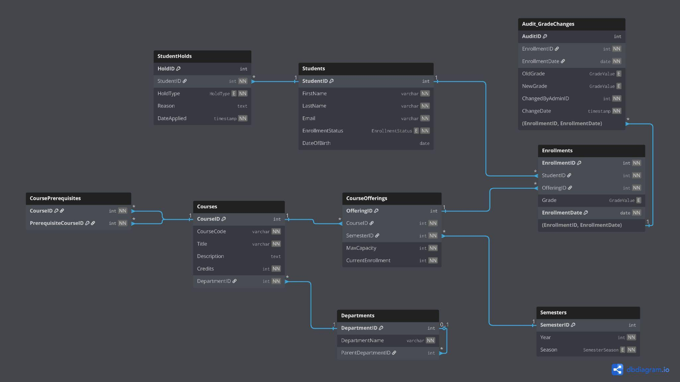

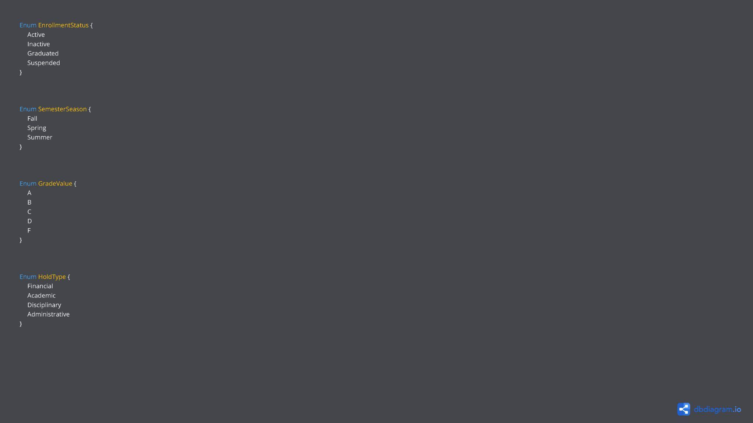

Names | Roll numbers
Mustufa | 26100038
Eman Nabeel | 26100270
Dayyan Ali Akhtar | 26100007
Shaheer Ahmad | 26100279

