**AIR UNIVERSITY, ISLAMABAD**

**Department of Cyber Security**

Secure Software Design & Development Lab (CY- 256L)

Lab Task # 13

**Submitted to:** Sir Mahaz Khan

**Submitted by:** Mirza Shaheer Baig (231330)

**CLASS:** BSCYS-4 A

**Submitted on: 30/05/2025**

**What is Jenkins?**

Jenkins is a powerful application that allows continuous integration and continuous delivery of projects, regardless of the platform you are working on. It is a free source that can handle any kind of build or continuous integration. You can integrate Jenkins with a number of testing and deployment

**Pre requisites:**

Java should be installed on your machine.

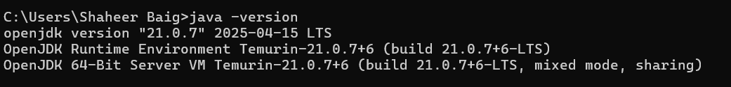

## Download Jenkins:

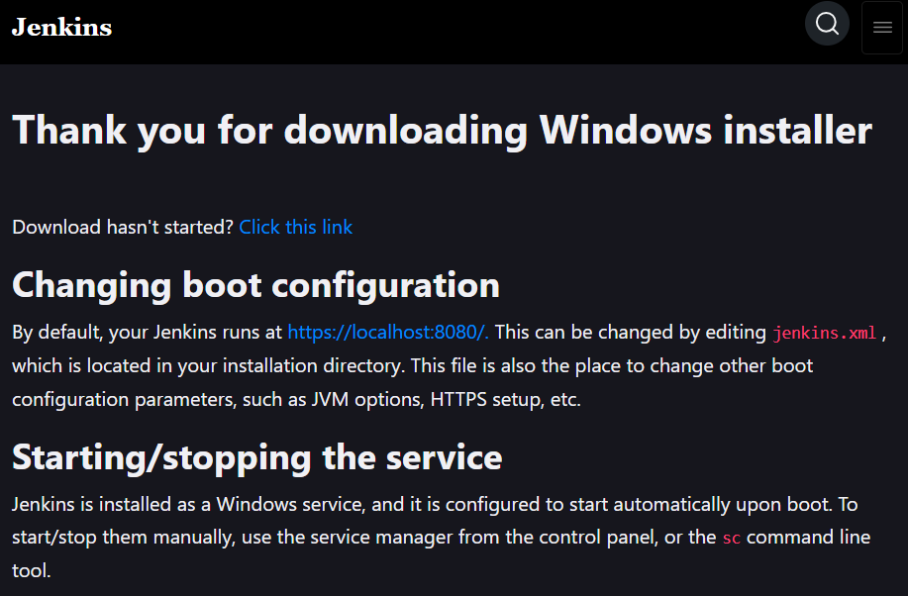

**Starting Jenkins**

Open the command prompt. From the command prompt, browse to the directory where the jenkins.war file is present. Run the following command

D:\ –jar Jenkins.war

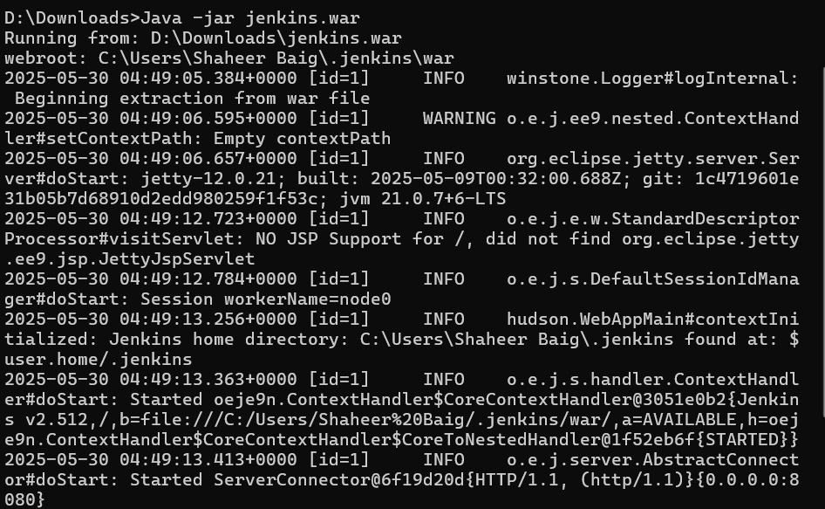

After the command is run, various tasks will run, one of which is the extraction of the war file which is done by an embedded webserver called winstone.

Once the processing is complete without major errors, the following line will come in the output of the command prompt.

Copy the password and save it somewhere for later use.

**Accessing Jenkins**

Once Jenkins is up and running, one can access Jenkins from the

link − http://localhost:8080

This link will bring up the Jenkins dashboard. Write password that you saved previously.

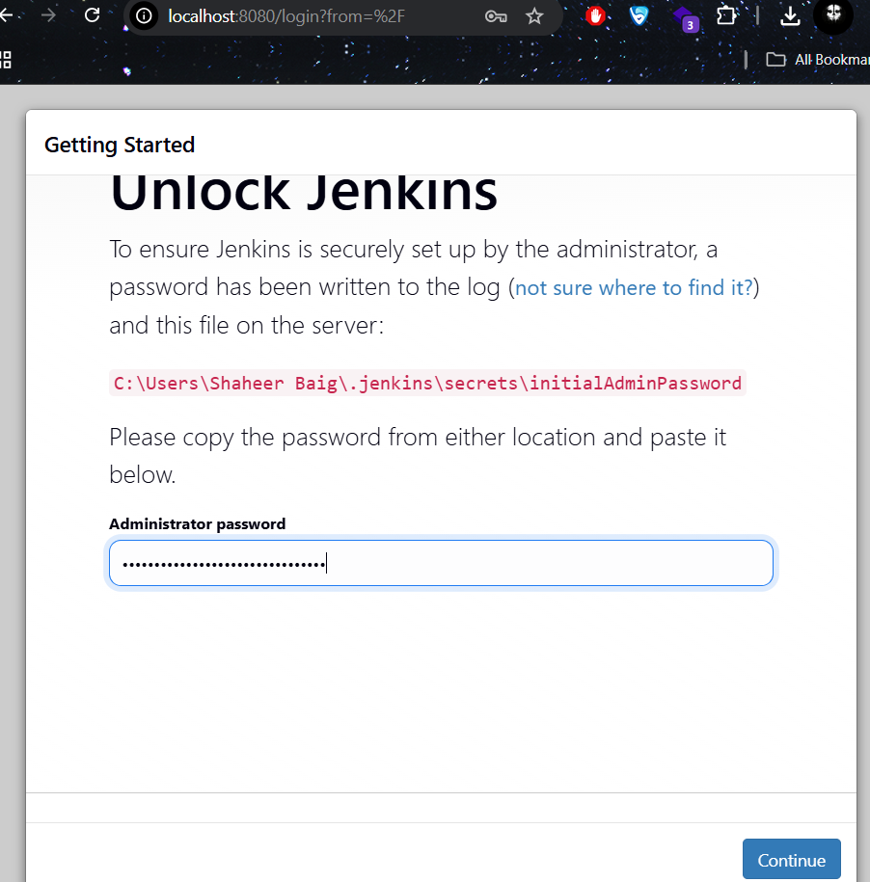

Select and install suggested plugins.

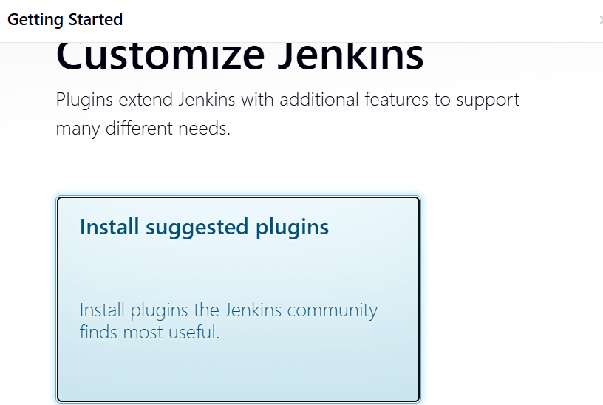

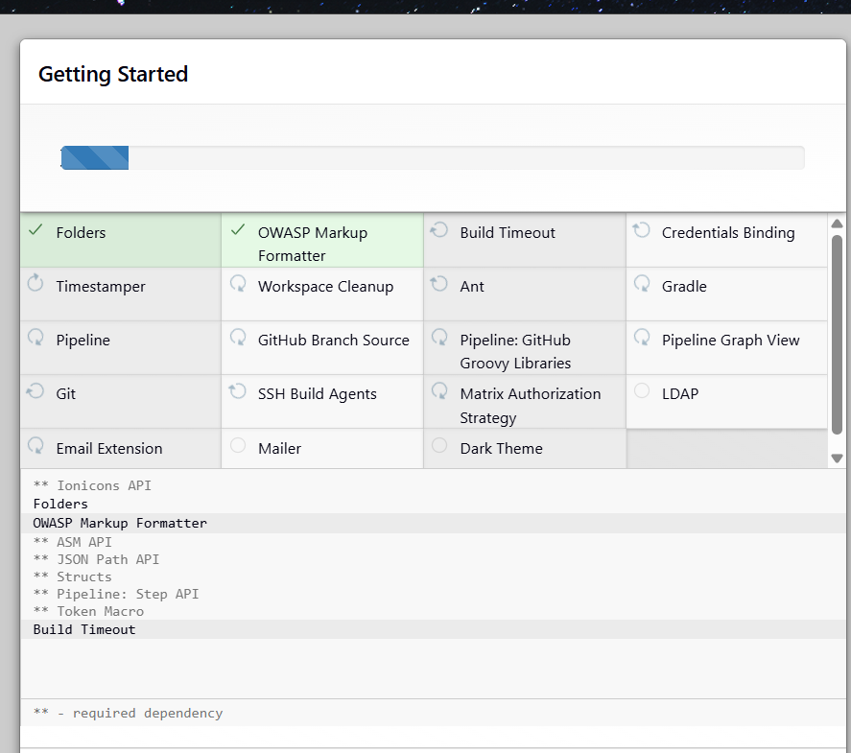

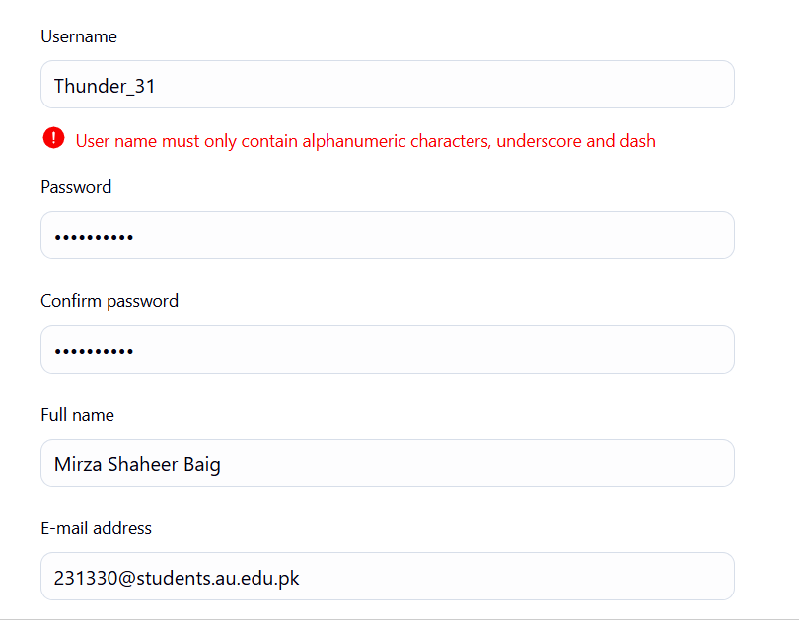

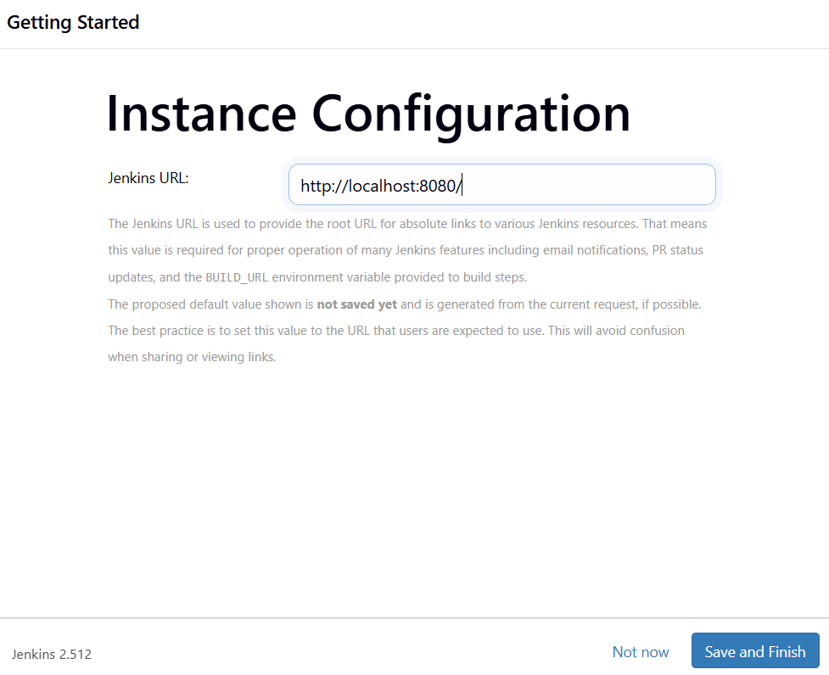

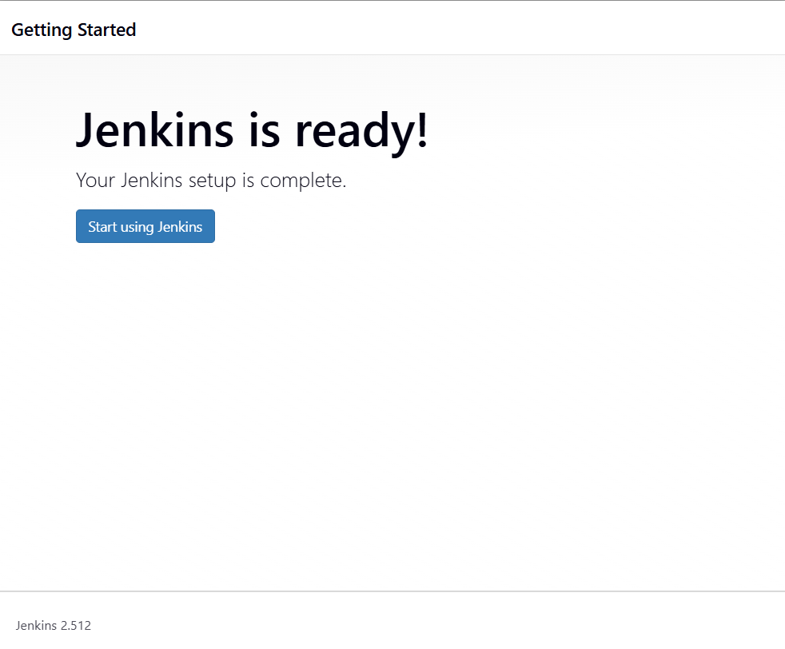

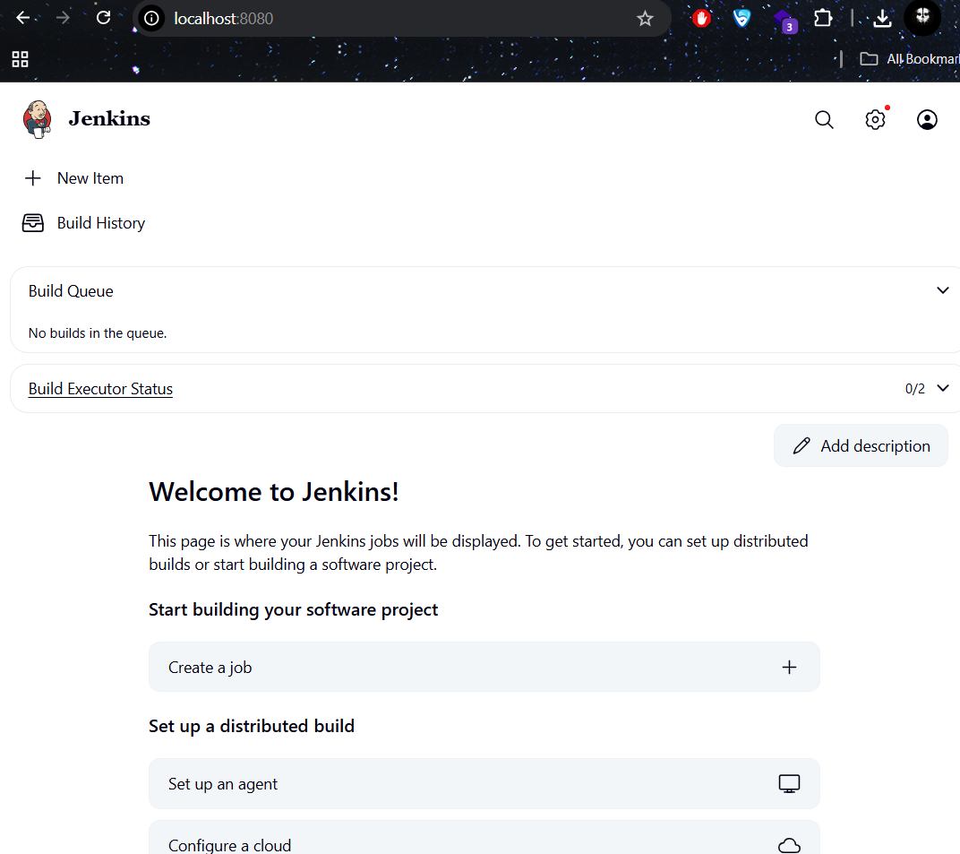

**What is Tomcat?**

Tomcat is an open-source web server and servlet. The Apache Software Foundation has developed it. It is used widely for hosting Java-based applications on the web. It is built on Java technologies and implements the Java Servlet and JavaServer Pages (JSP) specifications. Tomcat acts as a bridge between web servers and Java-based applications, facilitating the execution of dynamic content and processing client requests.

**Download Tomcat**

The official website for tomcat is Tomcat. If you click the given link, you can get the home page of the tomcat official website as shown below.

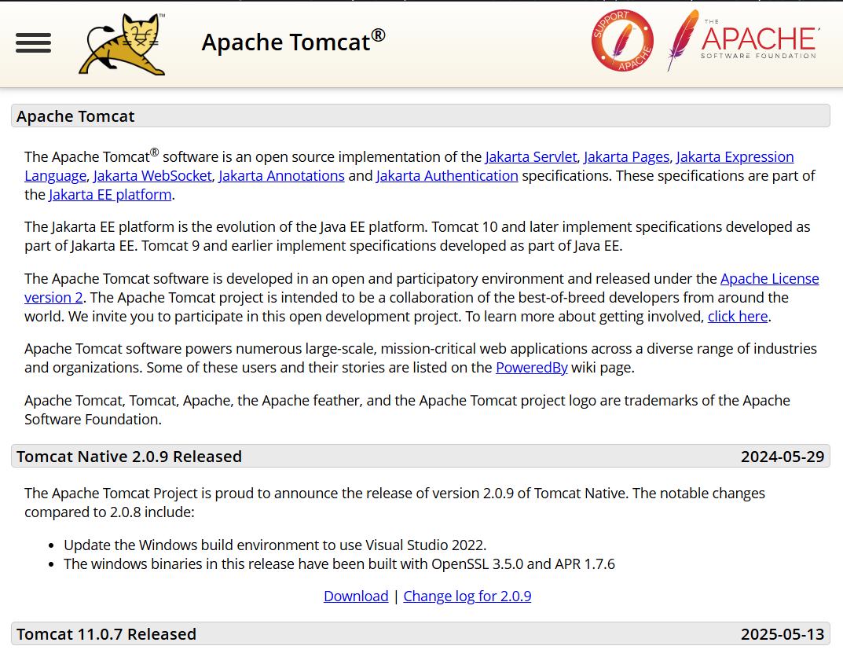

Browse to the link https://tomcat.apache.org/download-70.cgi to get the download for tomcat.

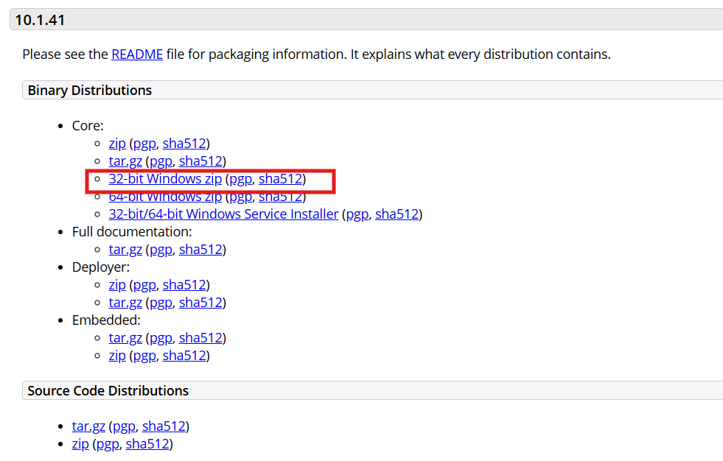

Go to the ‘Binary Distributions’ section. Download the 32-bit Windows zip file.

Then unzip the contents of the downloaded zip file.

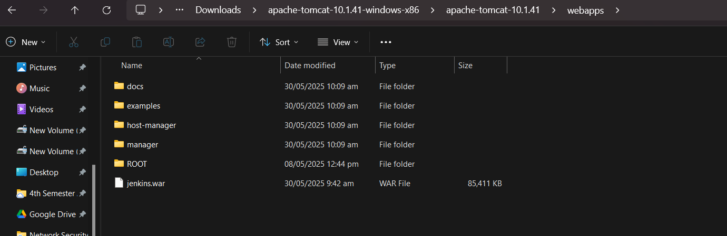

**Jenkins and Tomcat Setup**

Copy the Jenkis.war file which was downloaded from the previous section and copy it to the webapps folder in the tomcat folder.

Now open the command prompt. From the command prompt, browse to the directory where the tomcat7 folder is location. Browse to the bin directory in this folder and run the start.bat file

E:\Apps\tomcat7\bin>startup.bat

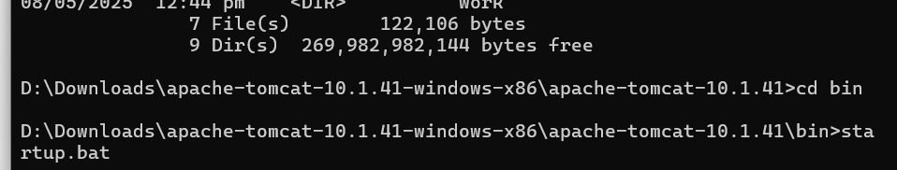

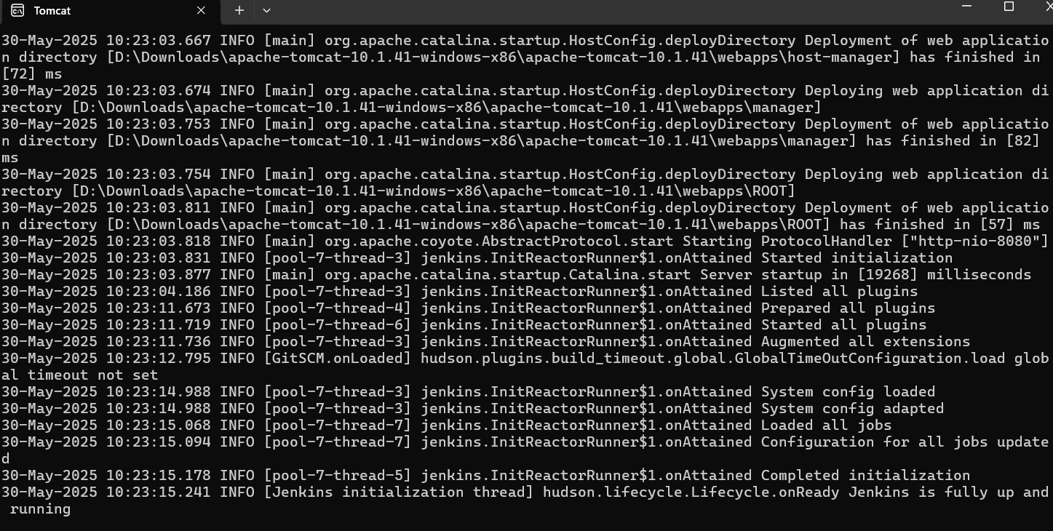

Open the browser and go to the link − **http://localhost:8080/jenkins.**

Jenkins will be up and running on tomcat.

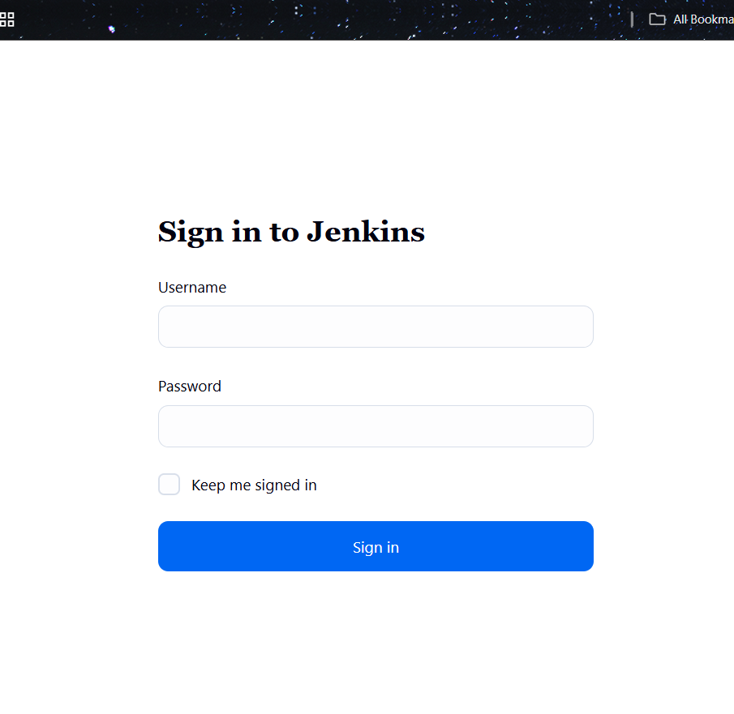

**Jenkins - Git Setup**

For this exercise, you have to ensure that Internet connectivity is

present from the machine on which Jenkins is installed. In your

Jenkins Dashboard (Home screen), click the Manage Jenkins option

on the left hand side.

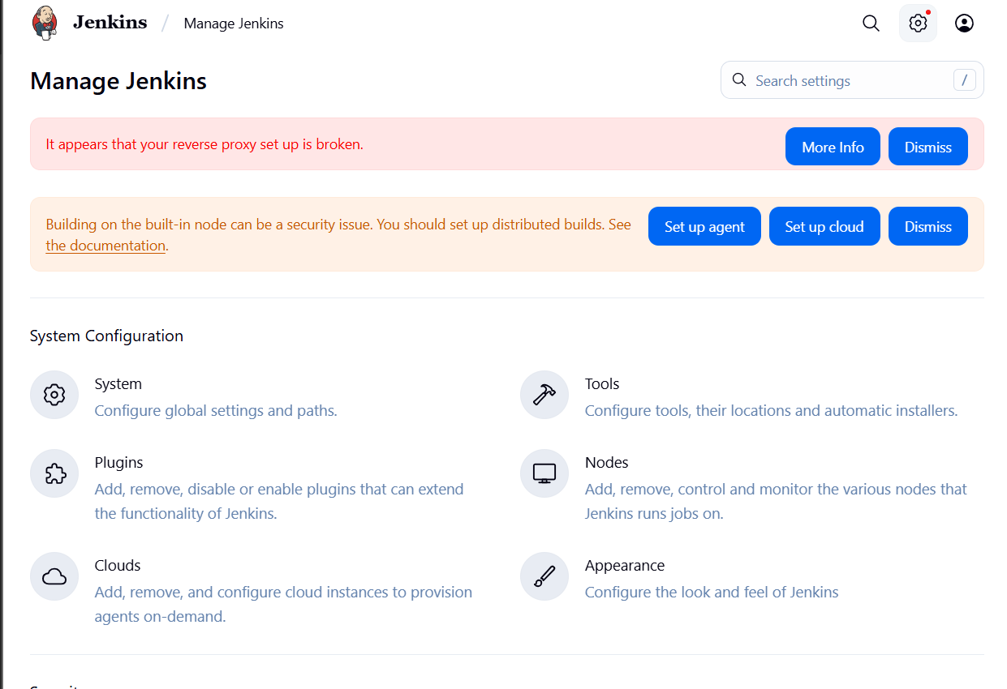

In the next screen, click the ‘Plugins’ option.

In the next screen, click the Available tab. This tab will give a list of plugins which are available for downloading. In the ‘Filter’ tab type ‘Git Push’

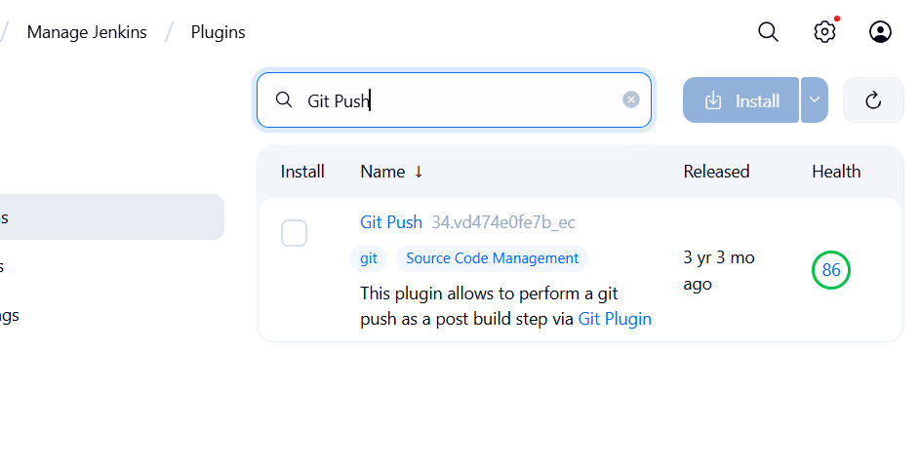

The installation will then begin and the screen will be refreshed to show the status of the download.

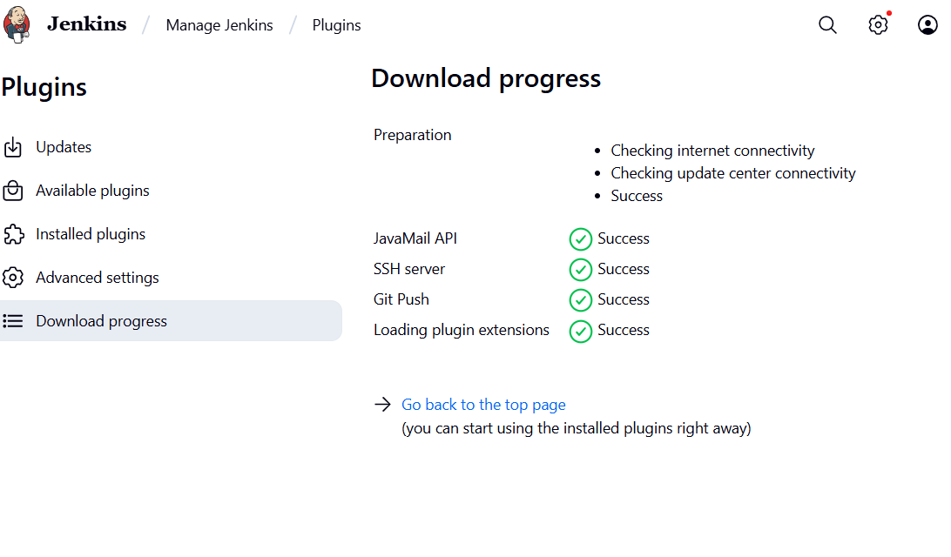

Once all installations are complete, restart Jenkins by issue the following command in the

browser. http://localhost:8080/jenkins/restart

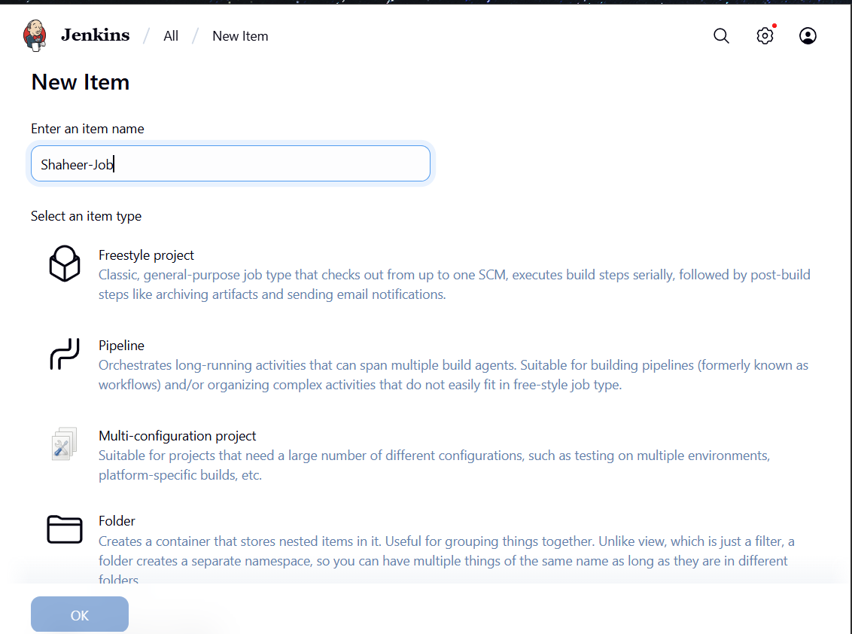

**Jenkins - Setup Build Jobs**

For this exercise, we will create a job in Jenkins which picks up a simple HelloWorld application, builds and runs the java program.

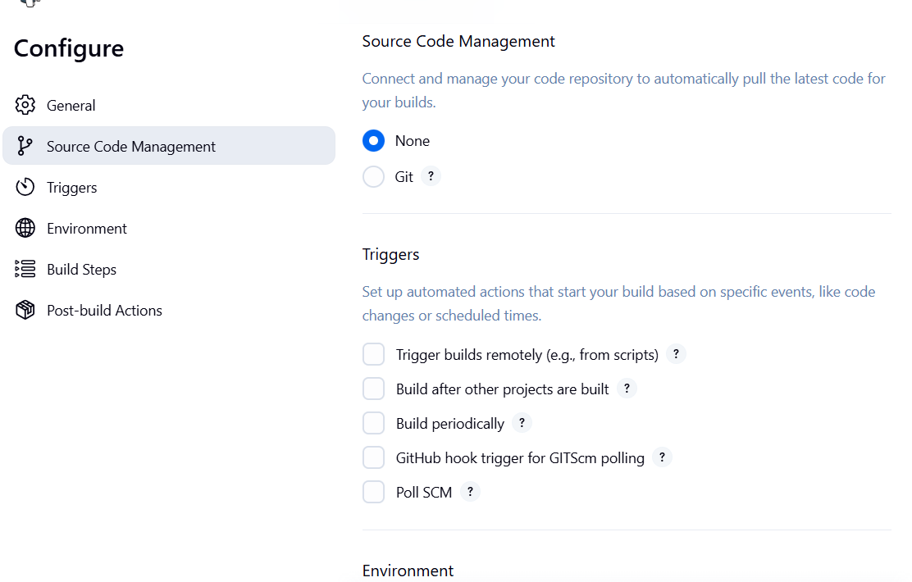

The following screen will come up in which you can specify the details of the job.

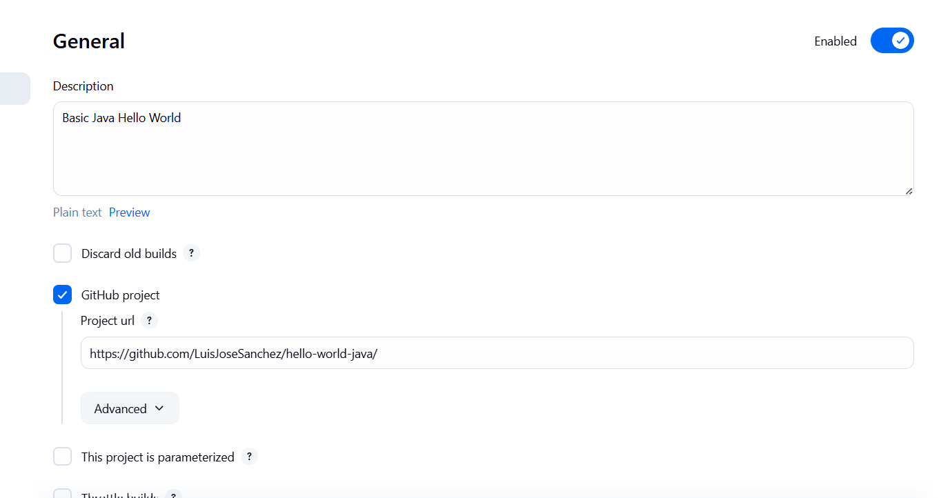

We need to specify the location of files which need to be built. If you repository if hosted on Github, you can also enter the url of that repository here:

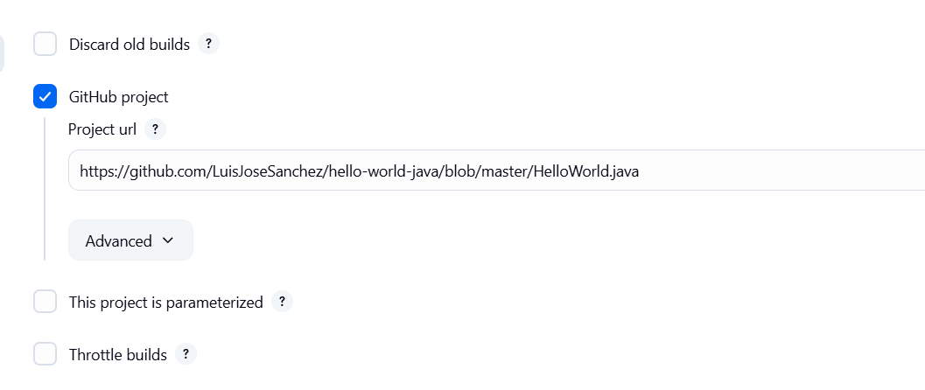

Now go to the Build section and click on Add build step → Execute Windows batch command

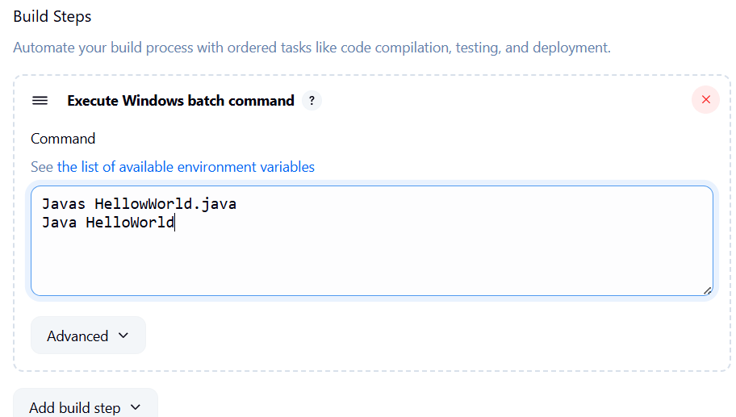

Once saved, you can click on the Build Now option to see if you have successfully defined the job.

