**AIR UNIVERSITY, ISLAMABAD**

**Department of Cyber Security**

Secure Software Design & Development Lab (CY- 256L)

Lab Task-14

**Submitted to:** Sir Mahaz Khan

**Submitted by:** Mirza Shaheer Baig (231330)

**CLASS:** BSCYS-4 A

**Submitted on: 13/06/2025**

**Pre requisites:**

Jenkins should be installed and configured on your machine.

Now you can begin with setting up the pipeline:

**What is Jenkins File?**

A Jenkins file is a script written in the Groovy programming language that defines the steps to be executed by a Jenkins pipeline. The pipeline is a series of steps executed in a particular order.

Make a new file named Jenkinsfile in any of your existing GitHub repository and paste the code

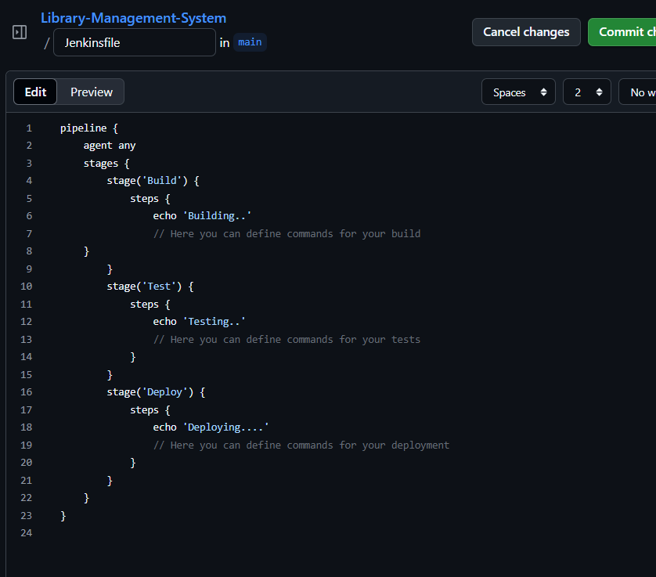

* Click on Commit Changes
* The file will appear in your repository:

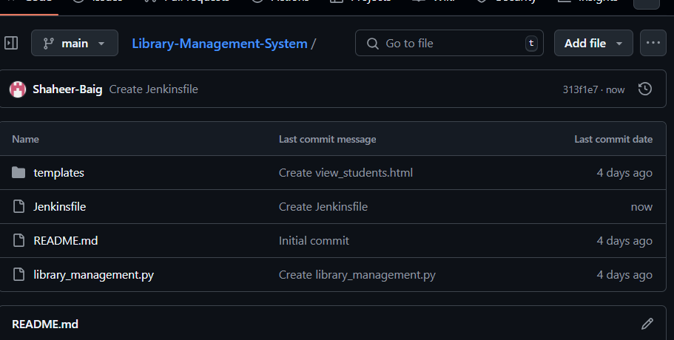

**Create Pipeline:**

Now start Jenkins

* Go to Jenkins dashboard.

Click on new item.

Add name of your pipeline as **myfirstpipeline.**

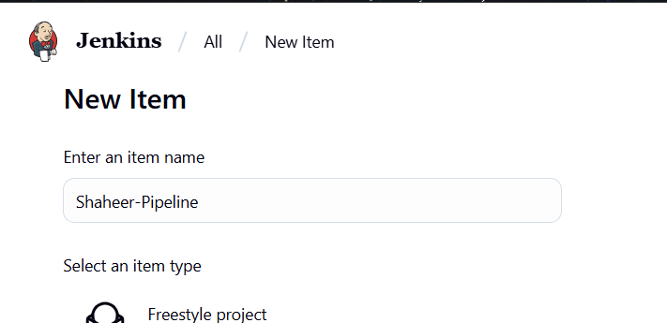

Select multibranch pipeline option:

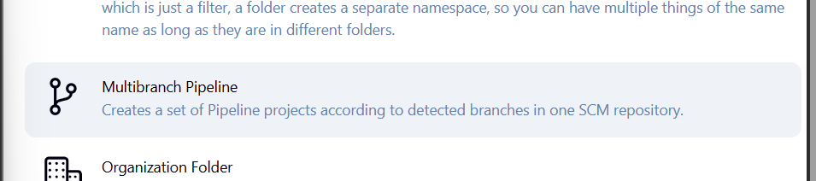

* A new pipeline will be created:

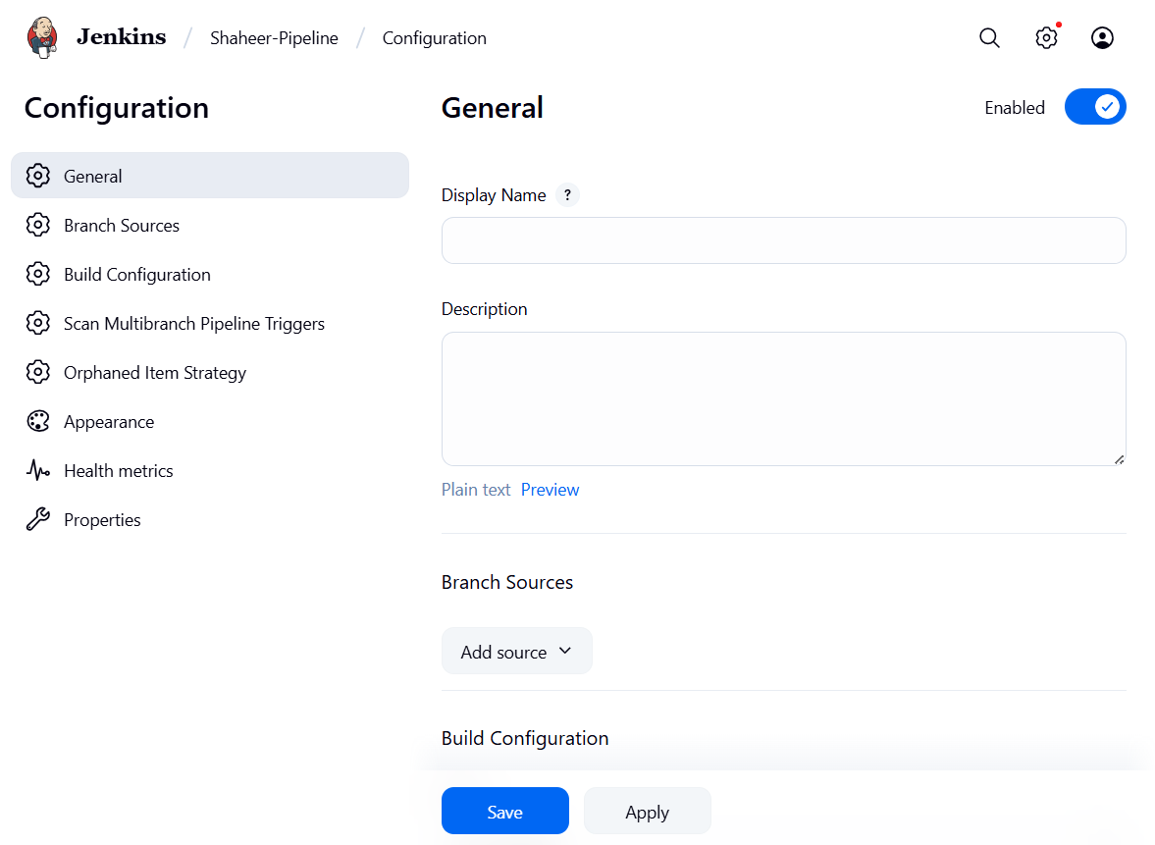

* Now click on add source option:

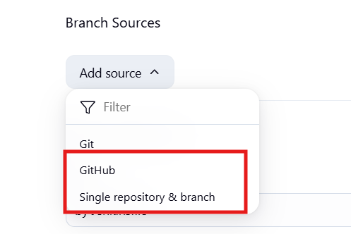

* Paste the link of your github repository where you created the JenkinsFile

**Validate URL:**

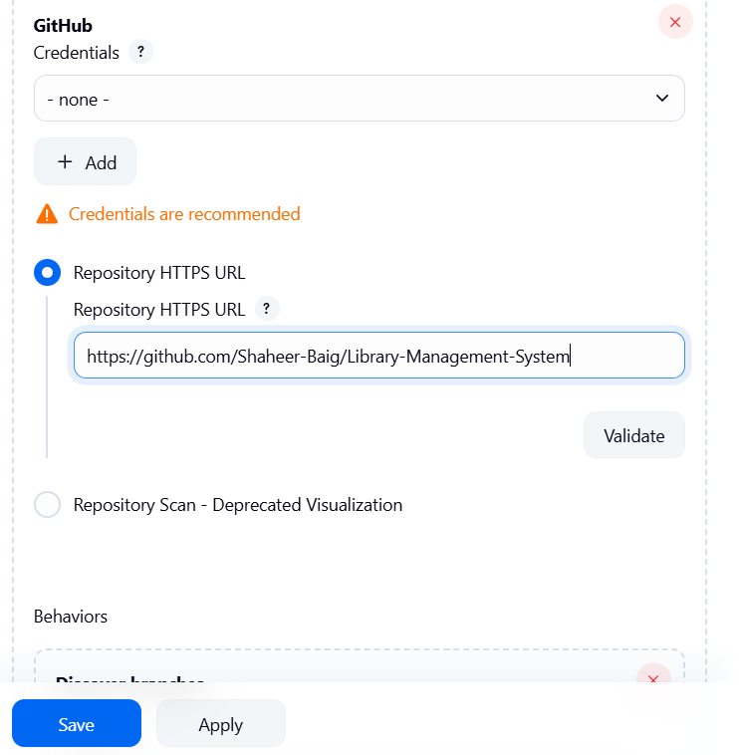

Validate the link to see if it is correct.

And click on **save.**

* It will start scanning the repository.
* It will scan all the branches one by one to look for Jenkinsfile
* When it is found, the scanning stops and the exits successfully.

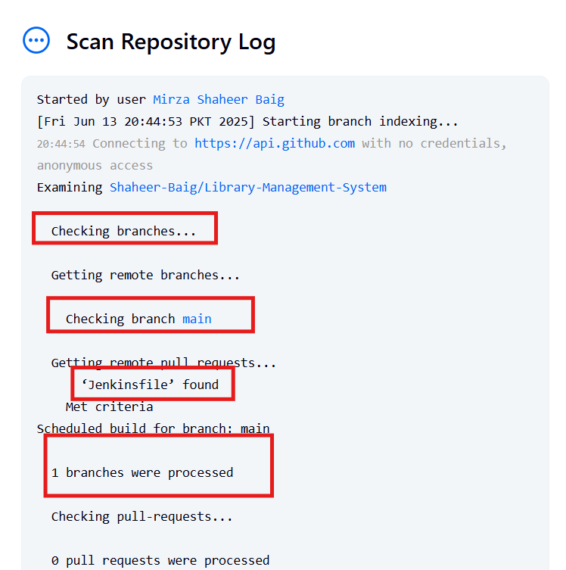

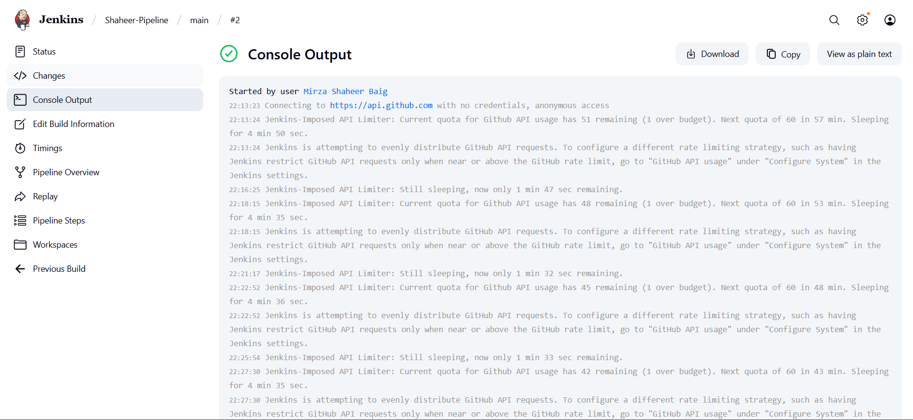

**Stages:**

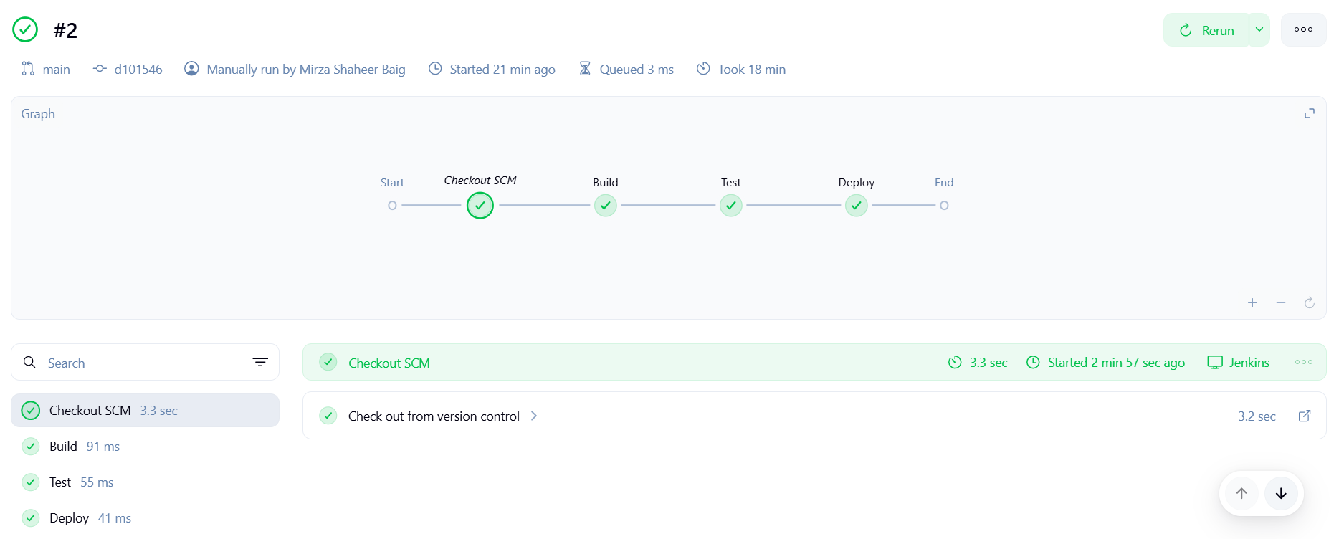

**Post Build Actions:**

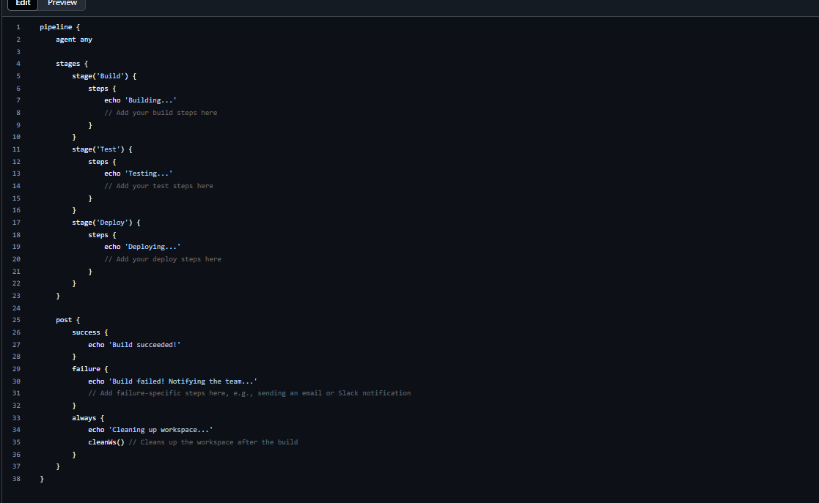

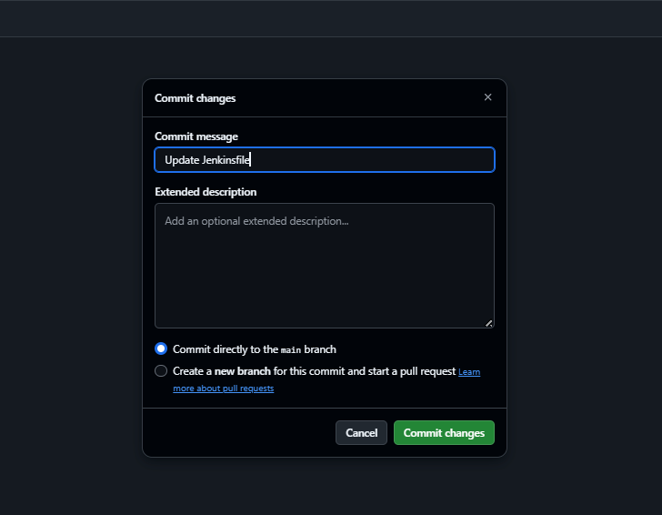

**Build Again:**

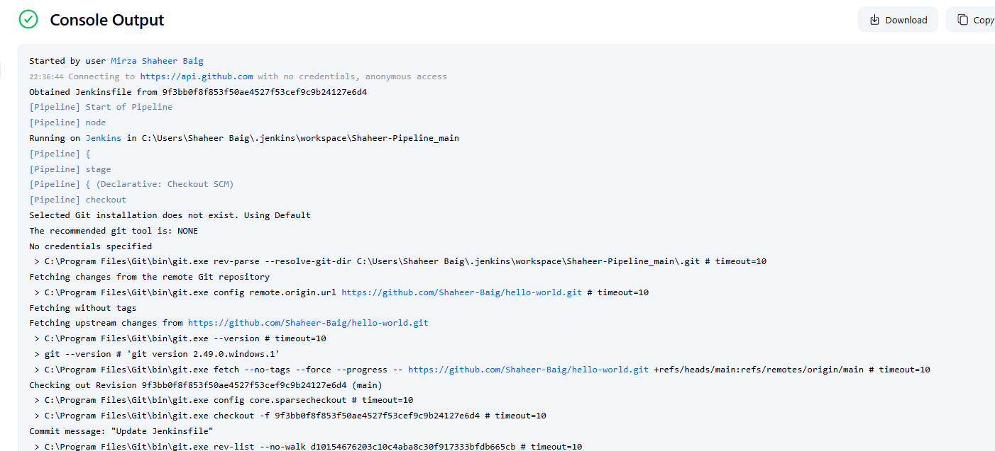

**Stages:**

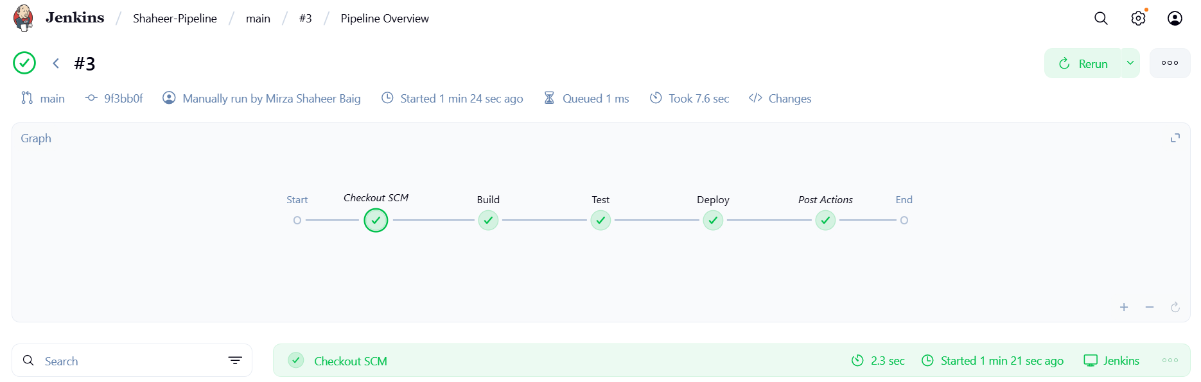

**Define Conditionals for each stage:**

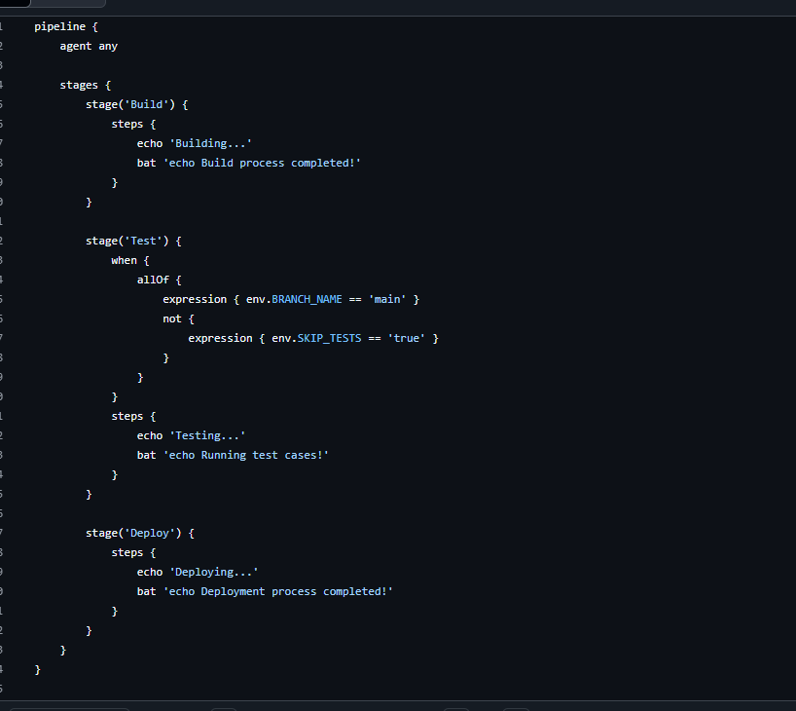



**Build Again:**

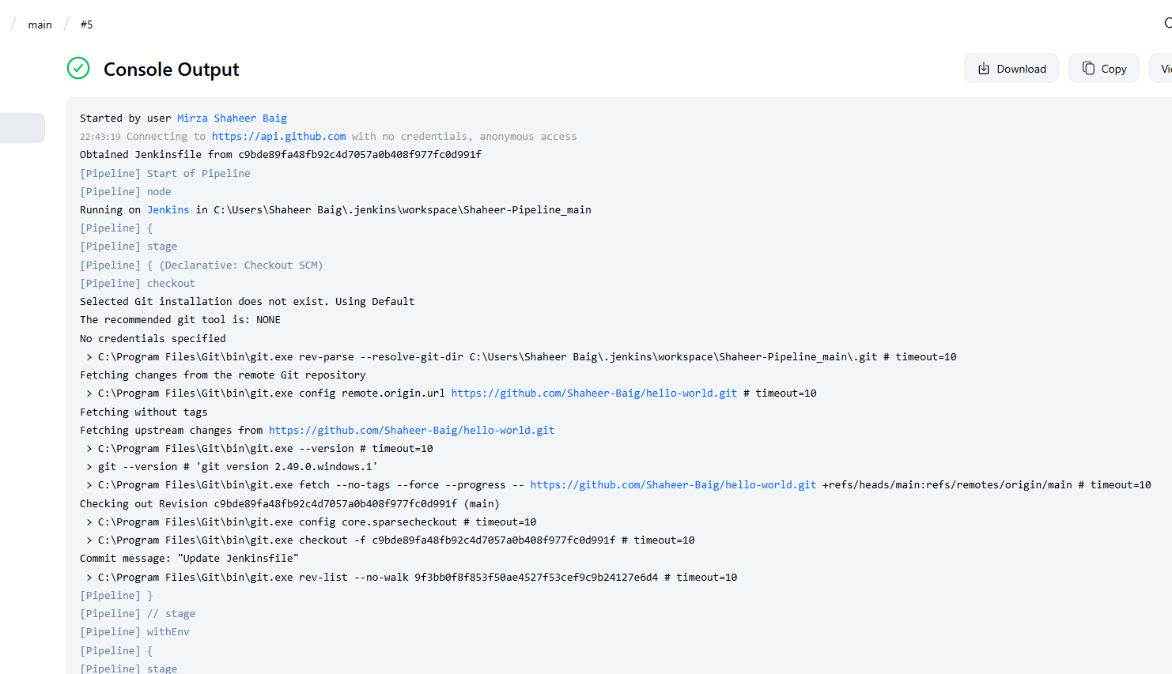

**Stages:**

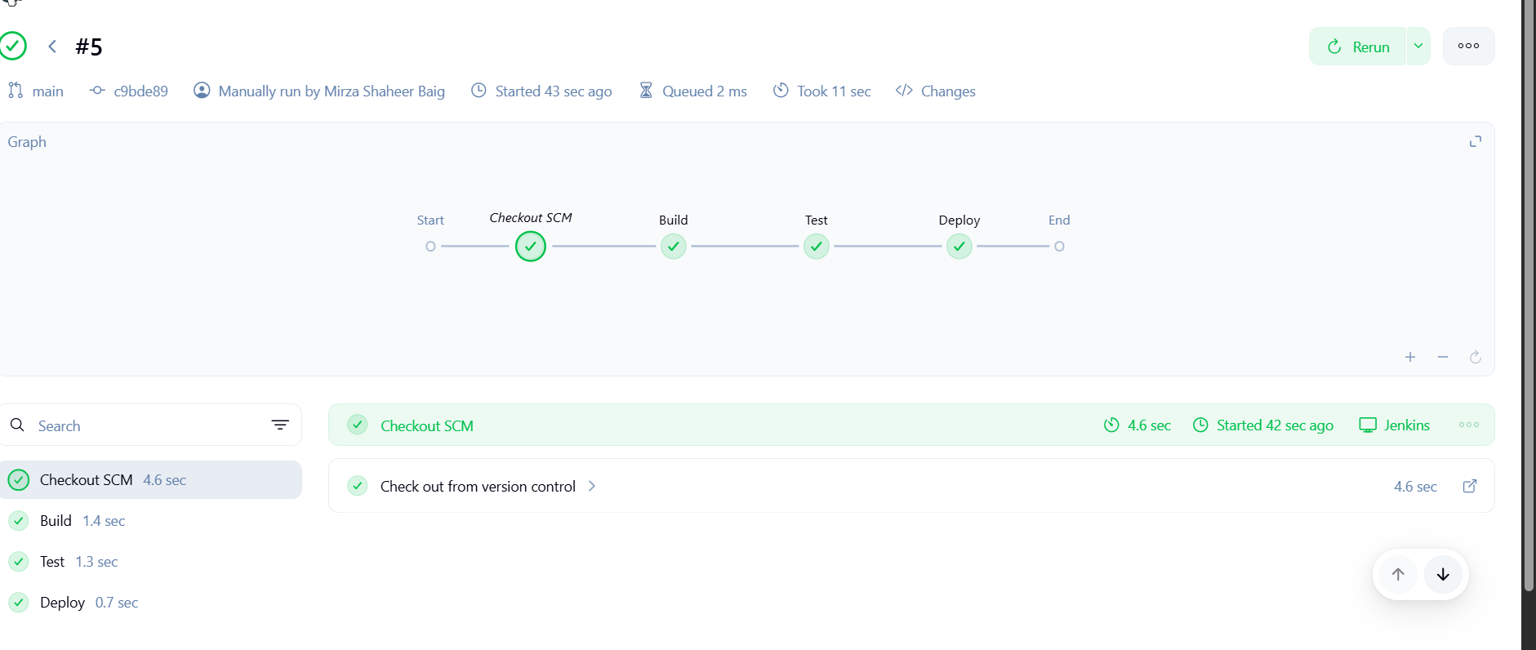

## Environment Variables:

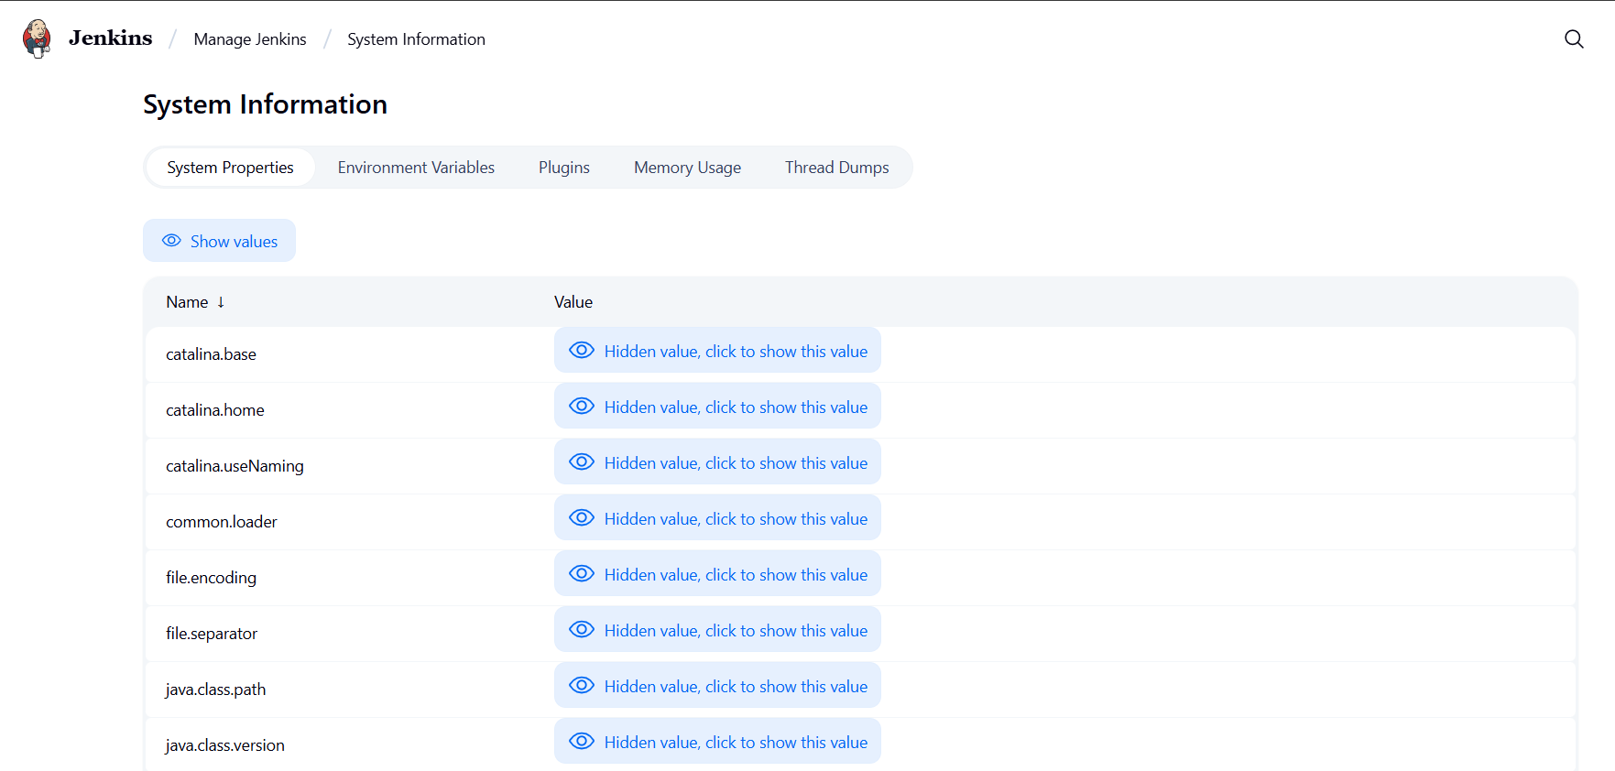

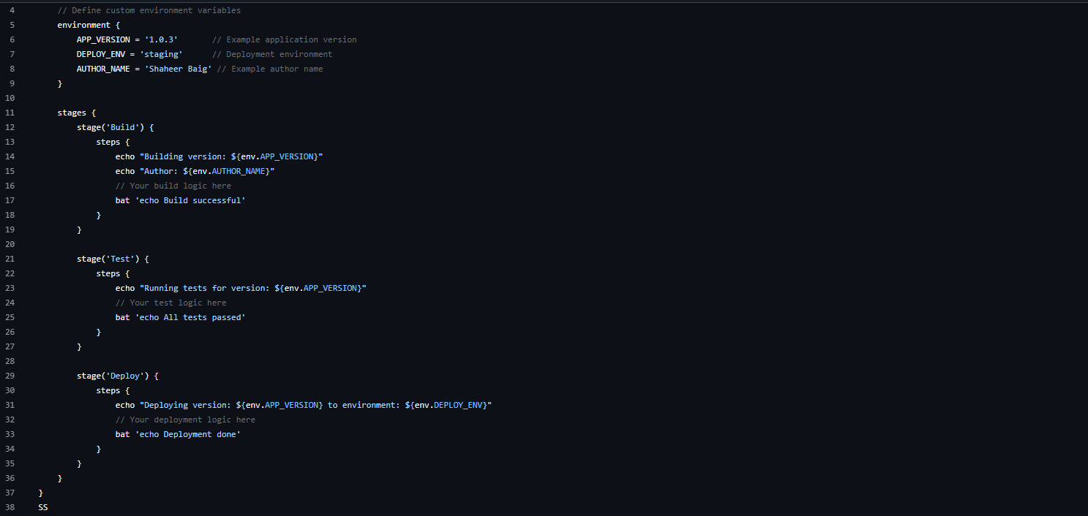



**Built Again:**

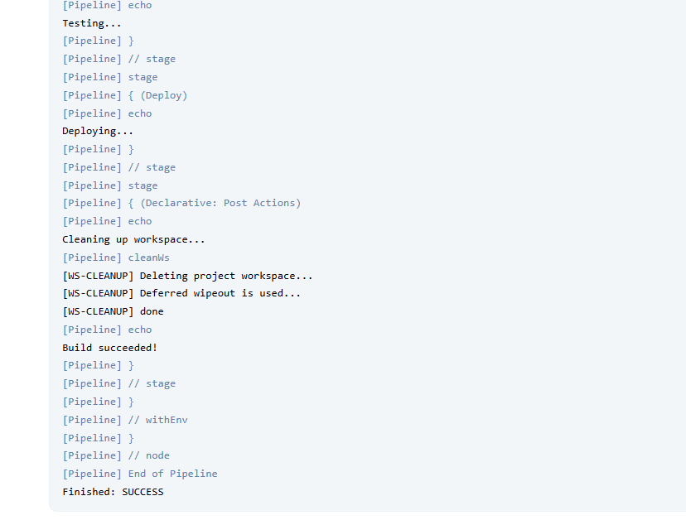

**Tools attribute for build tools:**

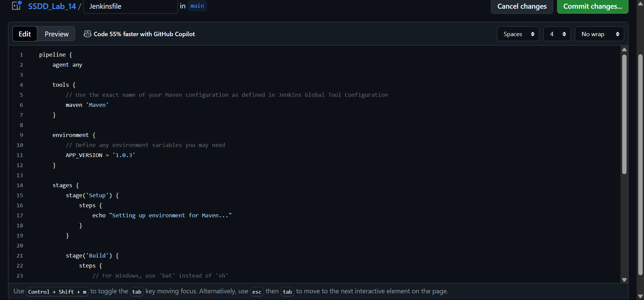

**Create pom.xml:**

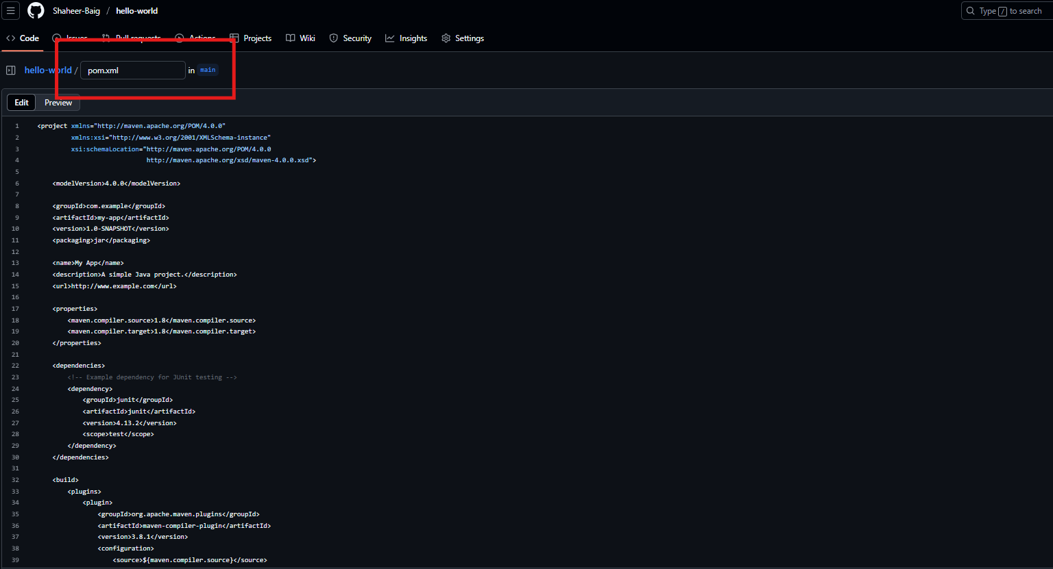

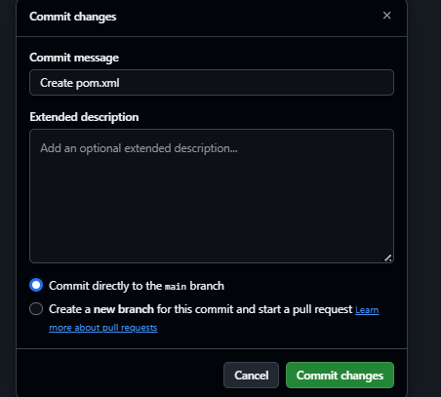

**Build Again:**

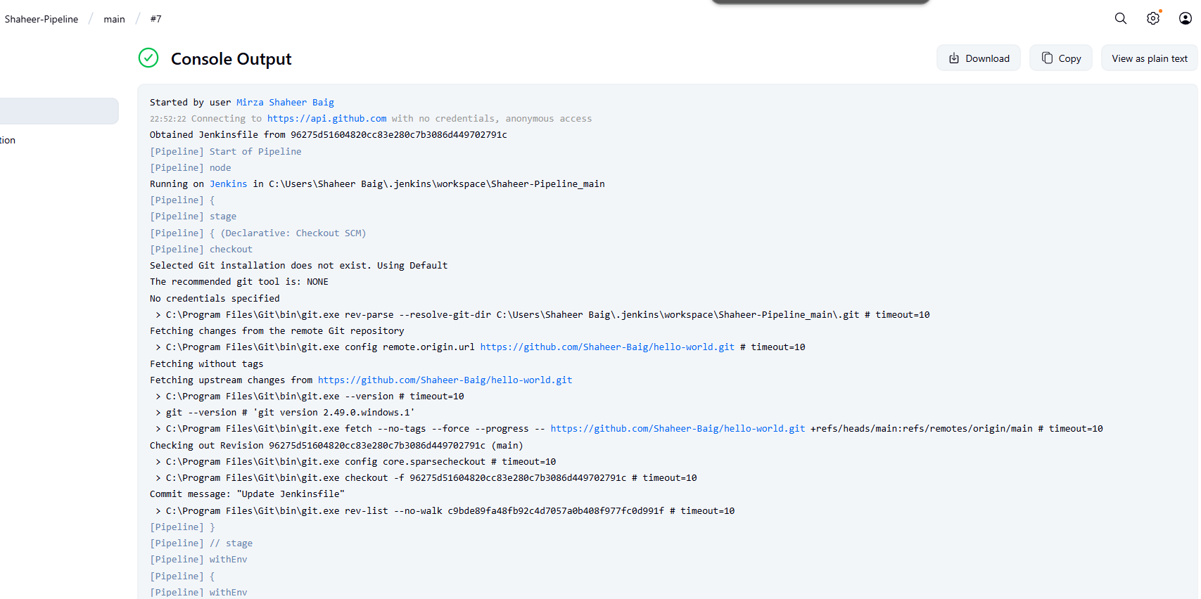

**Stages:**

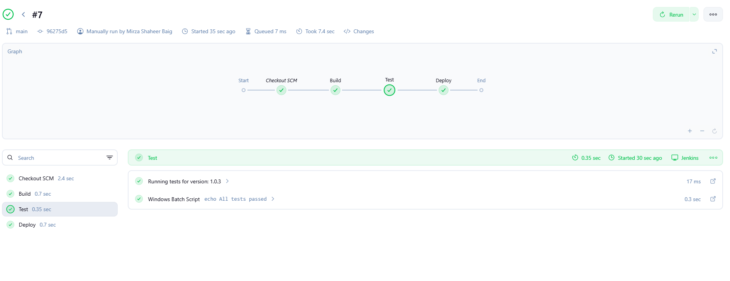

**Parameters in Jenkins:**

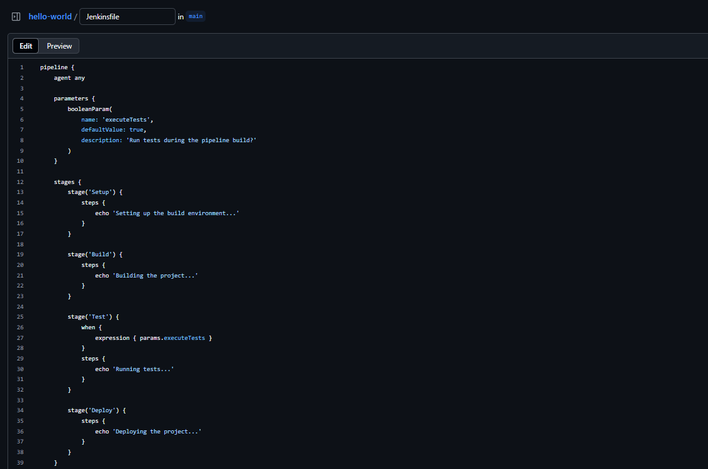



**Build Again:**

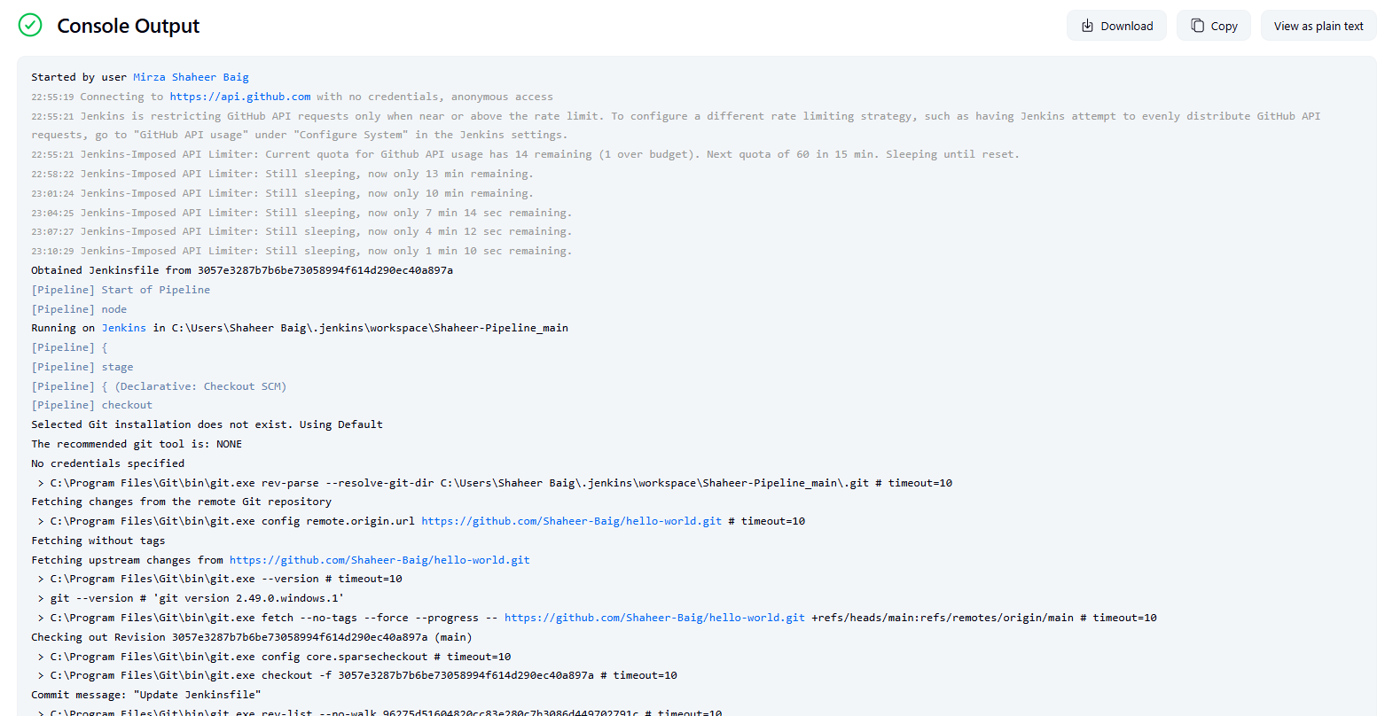

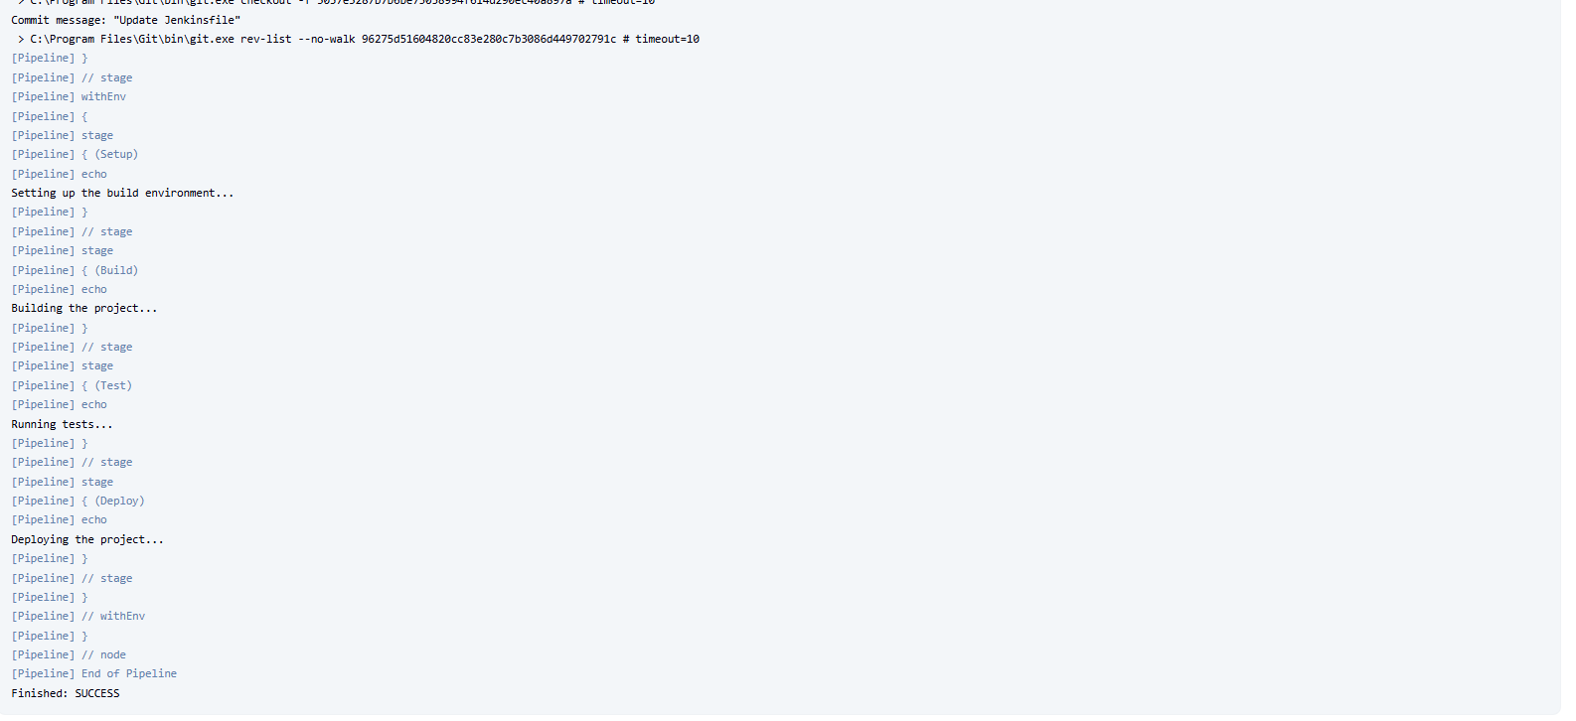

### Stages:

