Name shaheerRamzan
Roll no i263001
Lab12 section A

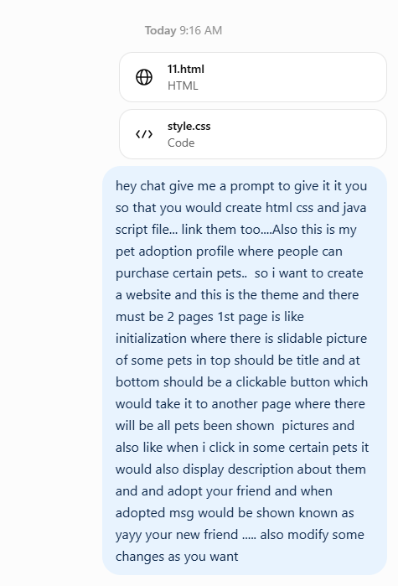
Gave this prompt to gpt and html and css files too and because of that he gpt gave me a prompt to give it to gemini and when i pasted that prompt to gemini, gemini gave me the following

I want you to create a complete, attractive and fully functional Pet Adoption Website called "Petofy – Your New Best Friend" using HTML, CSS, and JavaScript.
I have already uploaded my existing HTML and CSS files. First, examine those files and use them as the starting point. Improve the existing code rather than ignoring my original project.
IMPORTANT: Create exactly TWO HTML pages and connect all files properly.
- Project files
Create these four files:
- index.html – Landing page.
- pets.html – Pet gallery and adoption page.
- style.css – Styling for both pages.
- script.js – All JavaScript functionality.
Make sure all files are properly linked and everything works when I open index.html in my browser.
2. First Page – Landing Page
Create a beautiful welcome page for Petofy.
Design requirements:
- A large and attractive title: "Petofy".
- A subtitle: "Your New Best Friend Awaits!"
- At the top or center, create an automatic image slider showing different pets, including cats, dogs, rabbits, horses and other animals.
- Add smooth sliding or fading transitions.
- Include a short welcoming description about adopting pets.
- At the bottom, add an attractive clickable button saying "Find Your Best Friend".
- When clicked, this button should navigate to pets.html.
The landing page should look modern, welcoming and visually appealing.
3. Second Page – Available Pets
This is the main page of the website.
Display available pets in an attractive grid layout with individual cards.
Each pet card should contain:
- Pet picture.
- Pet name.
- Animal type.
- Age.
- Breed.
- Adoption fee (if applicable).
- A clickable "View Details" button.
Initially include these pets from my existing project:
- Coco – Persian Cat – 20 Days.
- Rex – Golden Retriever – 2 Years.
- Icy – Donkey – 1 Year – Mammoth.
- Frost – Horse – 1.5 Years – Green Monkey.
You can add a few more pets to make the website look complete.
4. Pet Details Functionality
When someone clicks on a particular pet or its "View Details" button:
- Display a larger picture of that pet.
- Show its name, age, breed, description and adoption fee.
- Include an "Adopt Your Friend" button.
- Add a close button to return to the pet gallery.
You can implement this using a modal popup.
5. Adoption Functionality
When someone clicks "Adopt Your Friend":
- Display a beautiful success message.
- The message must say:
"YAYY! YOUR NEW FRIEND! 🐾"
- Add another line saying "Congratulations! Your new best friend is waiting for you!"
- Include the adopted pet's name in the message.
- Add a button to return to the available pets.
For this project, simulate the adoption process rather than collecting real payments or personal information.
6. Additional Features
I want you to add some creative improvements:
- A navigation bar with Home, Available Pets and About Us.
- Search functionality to find pets by name or animal type.
- Filter options for cats, dogs, horses and other animals.
- Smooth hover effects on pet cards.
- Beautiful buttons with animations.
- A responsive layout that works on mobile and desktop.
- A small footer with a copyright notice.
7. Design Theme
Use a cute, modern and welcoming aesthetic.
Suggested colors:
- Cream or off-white background.
- Soft pastel green.
- Light brown.
- Warm orange accents.
Use rounded cards, attractive typography, subtle shadows and smooth animations.
Make the website feel like a professional pet adoption platform rather than a basic HTML assignment.
8. Coding Requirements
- Use HTML5, CSS3 and vanilla JavaScript.
- Do not use React, Bootstrap or other frameworks.
- Keep HTML, CSS and JavaScript in separate files.
- Link all files correctly.
- Use meaningful class names and properly structured code.
- Add comments to explain important JavaScript functions.
- Make sure every button actually works.
- Ensure there are no broken image links or JavaScript errors.
9. Final Output
Provide the complete code for all FOUR files separately.
Clearly label each file so I know where to paste its code.
Do not skip any code or provide incomplete snippets.
Finally, explain how to put all four files into one folder and run the website by opening index.html.

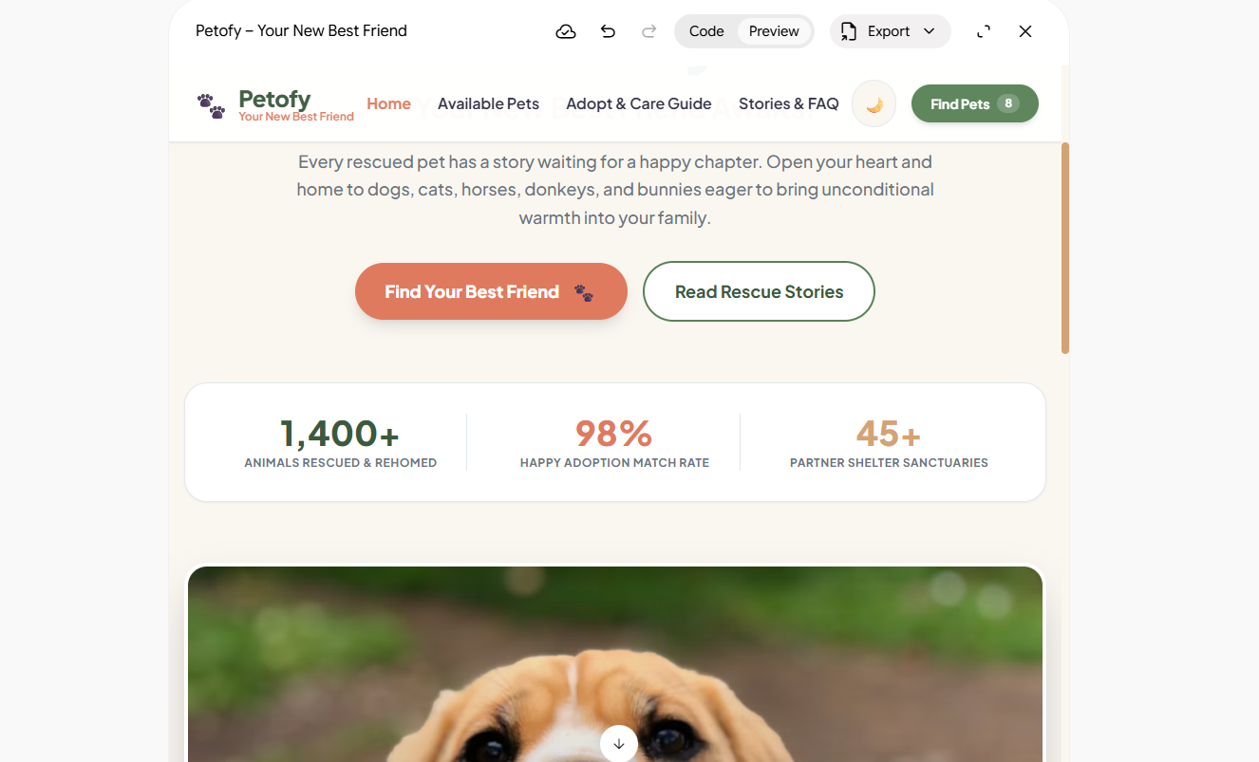

He then gave me the this preview and also gave me the html css and js files which were in one code only.

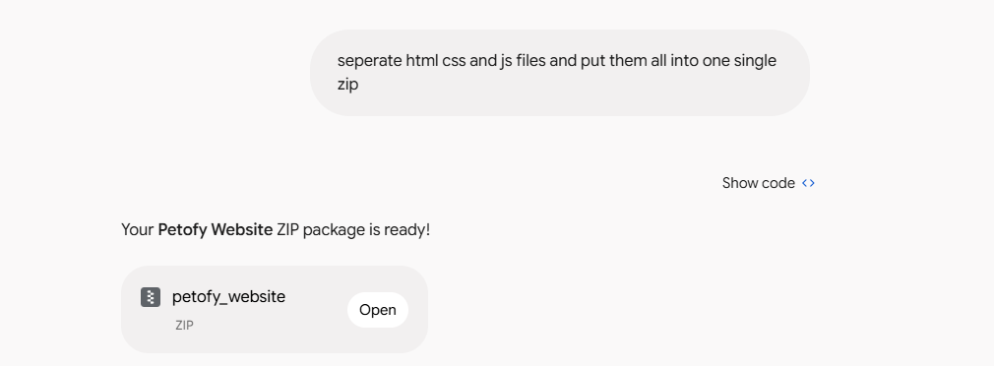
So now like i told him to separate files and combine into one zip file and he then gave me it.

END

