Hello @Brenda Kenne
These are some of the use cases of Datadog by SRE Team and requirements we would like to see in Datadog Alternative.
I have attached snapshots to give you a visual.

1. Holistic View of Errors in Containers
Instantly identify which container or microservice is throwing errors. Trace errors across distributed systems
This is especially critical when debugging intermittent issues like the 502 errors you previously resolved via cross-zone load balancing.

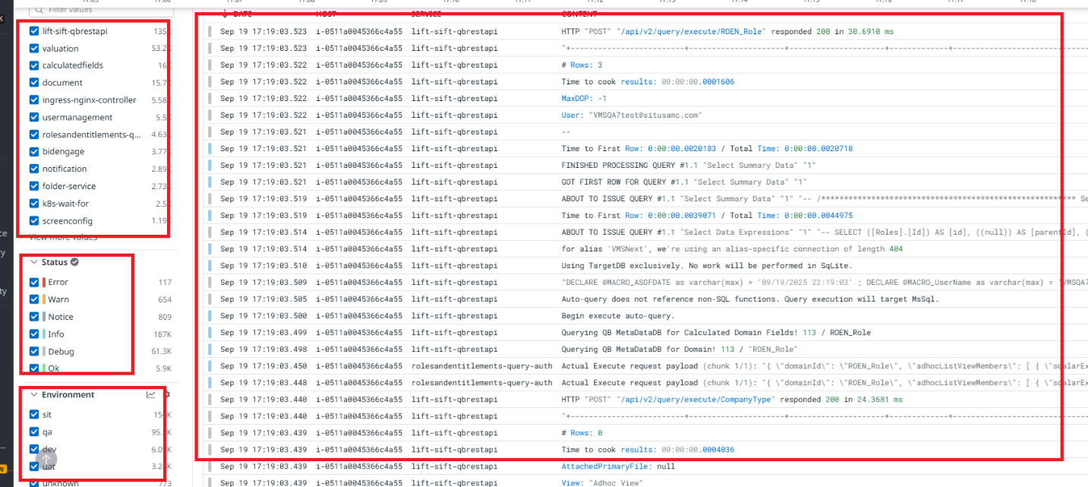
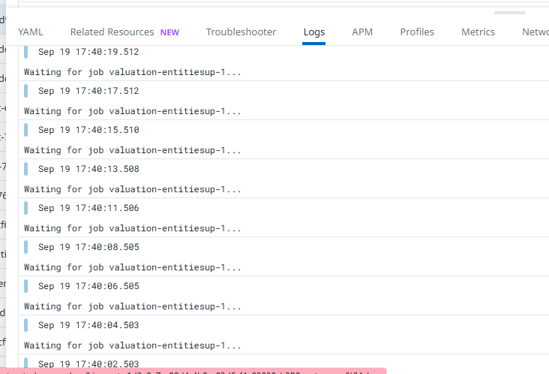
2. Deployment-Time Log Visibility
During deployments, Datadog helps: Monitor logs in real time to verify that services and entities (e.g., DB connections, proxies, app servers) are coming up correctly. Detect misconfigurations or failed health checks immediately.
We want to be able to filter logs based on environment
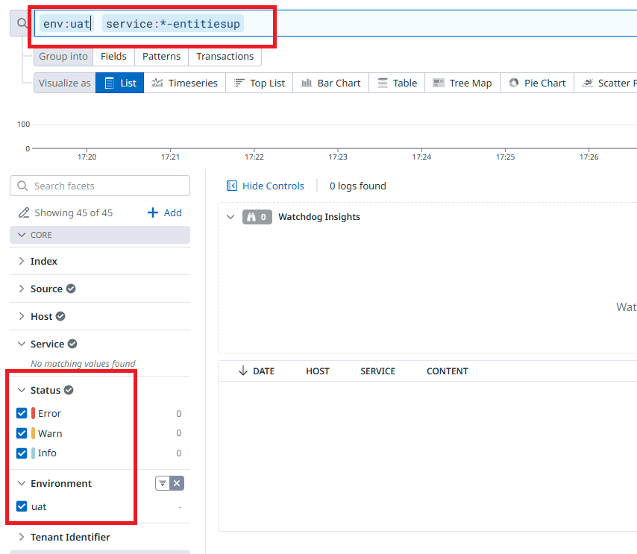
3. Kubernetes Cluster Overview
A live map of your cluster: nodes, pods, namespaces, and workloads. Health status of each component, including CPU, OOM kills, and pod restarts.
We can have a full glace on respective cluster in all Environment to see pods/services that need our proactive attention.
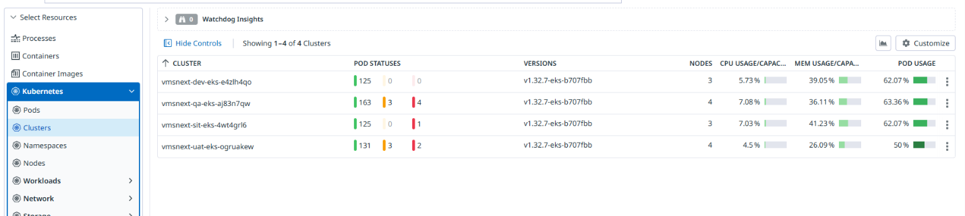

4. Pod-Level CPU and Memory Insights
Datadog gives you: Native support for HPA metrics and resource utilization trends.
