**Necessary Dependencies and Libraries**

* Flask
* Oracledb
* Datetime
* Threading

**Execution Process**

**Open CMD and make sure python and all dependencies are installed**

Just extract the files from dwh.rar  
place in a folder  
navigate that folder from your cmd (In my case it is placed at Desktop)

So,

cd Desktop

cd DWH

app.py

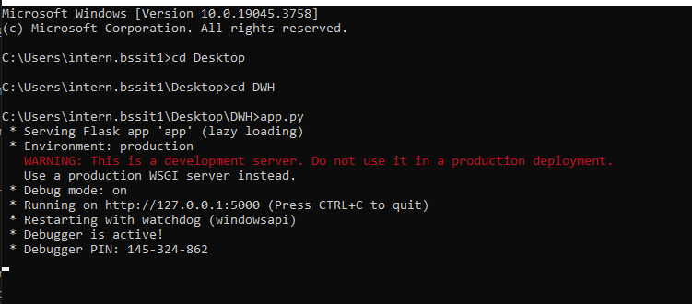

Go to your browser and check your app running at the given address