Sukkur IbA university
Project Progress - QueueLess

Shaheer Ahmed Siddiqui
CMS ID: 053-24-0038

QUEUELESS
Semester Project Progress Report
Less Waiting, Better Service.

Project detail | Information
Project | QueueLess — Virtual Queue Management System
Report date | 10 November 2026
Progress submission | Design screens, project document, and 1-minute demo/code explanation
Current stage | Initial project foundation and student-side frontend

1. Project Overview
QueueLess is a university virtual queue management system intended to reduce physical waiting at campus service offices. Students will be able to view services, join a queue, receive a token, and monitor their queue position and estimated waiting time. Staff will manage queues and call students, while administrators will manage users, services, counters, staff assignments, and system information.
Planned services include Student Affairs, Fee Office, Admissions Office, Examination Office, IT Support, and Document Verification.

2. Work Completed So Far

2.1 UI/UX Design Direction
A consistent visual direction has been selected. The interface uses a charcoal, mint, and light-gray palette with a clean SaaS style, reusable components, clear page hierarchy, readable tables, responsive layouts, restrained shadows, and consistent status badges.
Color | Hex code | Purpose
Charcoal | #222831 | Navigation, headings, strong text
Mint | #8FE3CF | Primary accents, actions, progress highlights
Light Gray | #EEEEEE | Backgrounds and secondary surfaces
White | #FFFFFF | Cards and content surfaces
Five key screen concepts were planned as design references: public homepage, student dashboard, student queue status, staff queue control, and administrator dashboard. These are visual references for implementation, not evidence that all five modules are complete.

2.2 Project Foundation
The application is being developed as a single Node.js/Express application using server-rendered EJS. The intended architecture separates presentation, application/business logic, and data access.
- An initial Express application scaffold and package configuration were prepared.
- EJS layout and reusable partial structure was introduced.
- Initial public-facing pages and shared styling foundation were prepared.
- A MySQL configuration/schema foundation was included for later integration.
- The project organization separates routes, controllers, middleware, services, models, tests, public assets, and views.

2.3 Public Pages
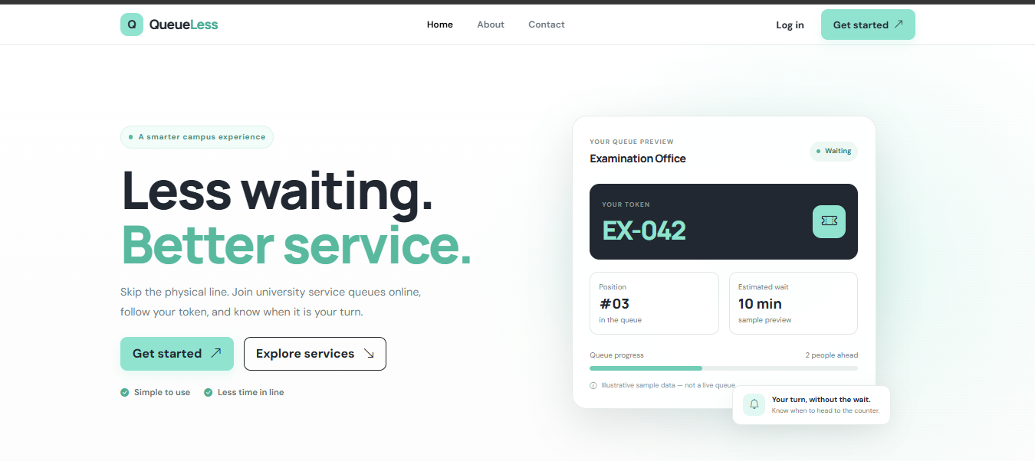
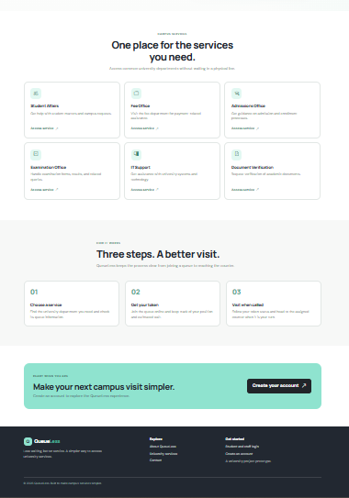

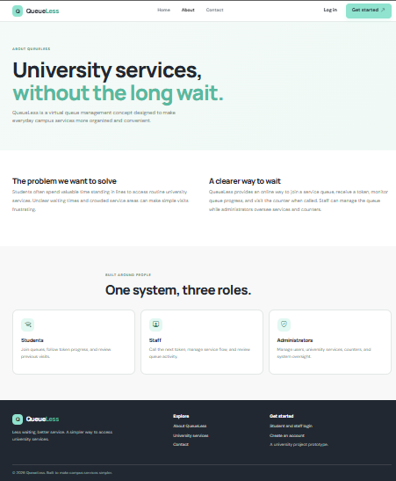

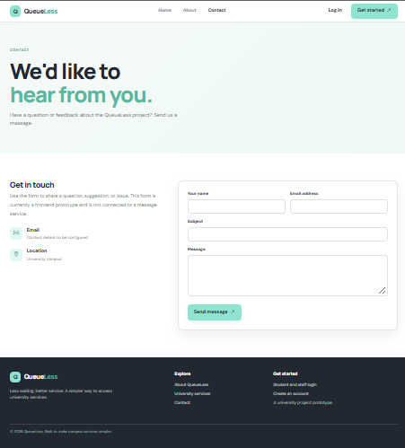
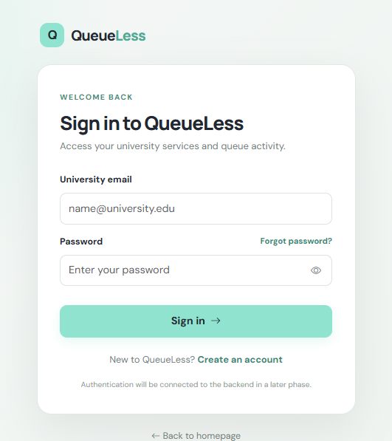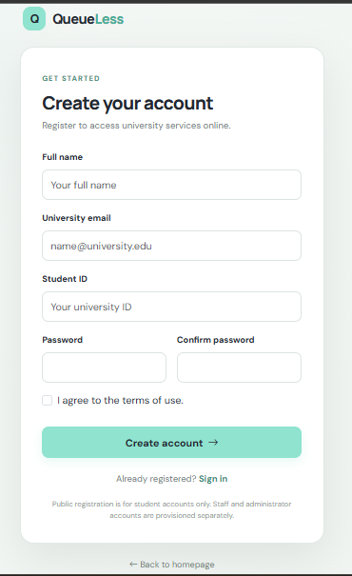
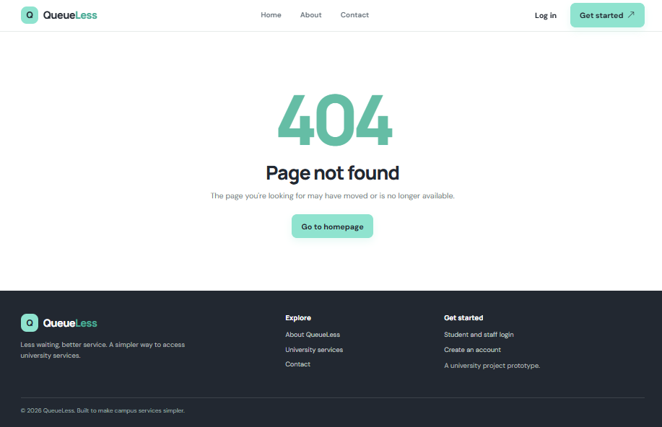
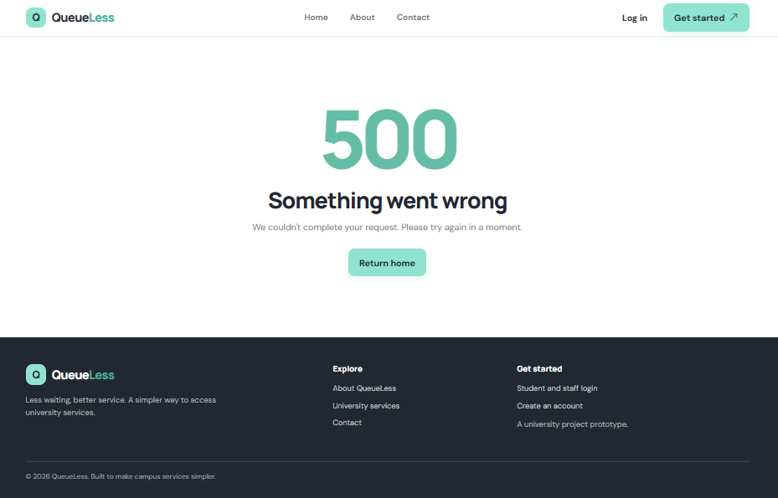

2.4 Student-Side Frontend
The first role-specific frontend module prepared is the Student Portal. Six pages have been created using a shared student layout and navigation.
Student page | Prepared interface
Dashboard | Summary cards, active-token preview, quick actions, services, and recent activity.
Available Services | University service cards with search/filter interface and join-queue interaction preview.
Queue Status | Token, current serving token, queue position, people ahead, estimated wait, progress, and cancellation confirmation UI.
My Queues | Active and past queue views with token/service details and filtering.
Queue History | Previous queue records with status, date/time, duration fields, and search/filter interface.
My Profile | Student information and profile/password form interfaces.
Reusable student navigation and styling were prepared. Browser-side interactions include responsive sidebar behavior, service search/filtering, queue tabs, table filtering, confirmation dialogs, and client-side form validation.

3. Current Implementation Status
Work area | Status
UI/UX direction and color palette | Prepared
Five key screen concepts | Prepared as visual references
Express/EJS project foundation | Initial scaffold prepared
Public website and authentication screens | Initial frontend scaffold prepared
Student portal — six pages | Frontend views prepared
Student browser-side interactions | Basic interactions prepared
MySQL schema and connection foundation | Prepared for integration
Student authentication/database integration | Pending
Queue creation, token allocation, cancellation backend | Pending
Staff portal | Not started
Administrator portal | Not started
End-to-end and responsive browser testing | Pending
One-minute demo/video | Not recorded

4. Architecture and Technology
Planned technology stack:
- Backend: Node.js and Express.js.
- Frontend/templates: EJS, HTML5, CSS3, Bootstrap 5, and Vanilla JavaScript.
- Database: MySQL.
- Static assets: served from the public/ directory.
- Organization: routes, middleware, controllers, services, models/data access, views, and tests.
High-level request flow:
Browser / EJS UI → Express Route → Middleware → Controller → Service → Data Access → MySQL
For example, when a student requests to join a queue, the route receives the request, middleware checks access, the controller coordinates the operation, the queue service applies business rules, and the data-access layer stores the queue entry in MySQL. The resulting information is rendered in the student's queue-status view. This is the intended workflow; full backend integration remains pending.

5. Work Remaining
- Verify local setup, dependency installation, environment variables, and database initialization.
- Implement registration, login, logout, password hashing, session handling, and role-based access control.
- Connect student pages to MySQL-backed services; implement queue joining, token generation, position calculation, cancellation, and history retrieval.
- Build the Staff Portal: dashboard, queue control, queue history, and profile.
- Build the Administrator Portal: dashboard, users, services, counters, staff assignments, queue monitor, reports, and settings.
- Complete validation, authorization, error handling, and automated tests.
- Test desktop, tablet, and mobile layouts; verify page rendering, links, and forms.
- Record the required one-minute demonstration and code explanation.

6. Proposed One-Minute Demonstration Plan
Time | What to demonstrate
0–10 sec | Introduce QueueLess and the problem of long queues at university offices.
10–25 sec | Show the visual design and public homepage, highlighting the charcoal/mint theme.
25–42 sec | Navigate through Student Dashboard, Available Services, and Queue Status screens.
42–55 sec | Briefly explain EJS layouts/partials and the Express route → controller → service flow.
55–60 sec | Mention the next step: database-backed student queue operations, then staff & admin modules.

7.Current Limitations and Accuracy Note
This report distinguishes prepared interface work from completed backend functionality. Sample queue values are for demonstration only and must not be described as live database or real-time queue data. Forms and queue actions not connected to backend endpoints are interface prototypes. Full application startup, EJS rendering, database integration, and browser-level responsiveness checks still need to be completed locally.

8. Conclusion
The project has established its visual direction, initial Express/EJS foundation, and first role-specific frontend module for students. The Student Portal contains the six planned screens and basic browser-side interactions. The next priority is to verify the application locally and connect student workflows to authentication, business logic, and MySQL. Staff and administrator modules, end-to-end testing, and the one-minute demonstration remain future work.

