SUKKUR IBA UNIVERSITY
COMPUTER ORGANIZATION AND ASSEMBLY LANGUAGE
LAB-5
SHAHEER AHMED SIDDIQUI
CMS ID: 053-24-0038
Submitted To: Sir Riaz Soomro

Table of Contents
Exercise of COAL Lab 05 2
Task 01: 2
Code: 2
Output: 3
Task 02: 3
Code: 3
Output: 4
Task 03: 4
Code: 4
Output: 5
Task 04: 5
Code: 5
Output: 7
Task 05: 7
Code: 7
Output: 9
Task 06: 9
Code: 9
Output: 11
Task 07: 11
Code: 11
Output: 13
Task 08: 13
Code: 13
Output: 16
Task 09: 16
Code: 16
Output: 19

Exercise of COAL Lab 05

Task 01:

Write an assembly language program that asks the user to input a character and checks if the entered character is “A” (without quotes). If the entered character is “A” (without quotes), the program should display a message, like, “The entered character is A”.

Code:
.MODEL SMALL
.STACK 100H
.DATA
MSG1 DB "Enter a character: $"
MSG2 DB "The entered character is A.$"
.CODE
MAIN PROC
MOV AX,@DATA
MOV DS,AX
MOV AH,9
LEA DX,MSG1
INT 21H
MOV AH,1
INT 21H

CMP AL,'A'

MOV AH,2
MOV DL,0DH
INT 21H
MOV DL,0AH
INT 21H

JZ LABEL1
JMP EXIT

LABEL1:
MOV AH,9
LEA DX,MSG2
INT 21H

EXIT:
MOV AH,4CH
INT 21H
MAIN ENDP
END MAIN

Output:


Task 02:

Write an assembly language program that asks the user to input a character and checks if the entered character is NOT (equal to) “A” (without quotes). If the entered character is NOT (equal to) “A” (without quotes), the program should display a message, like, “The entered character is not A”.

Code:
.MODEL SMALL
.STACK 100H
.DATA
MSG1 DB "Enter a character: $"
MSG2 DB "The entered character is not A.$"
.CODE
MAIN PROC
MOV AX,@DATA
MOV DS,AX
MOV AH,9
LEA DX,MSG1
INT 21H
MOV AH,1
INT 21H

CMP AL,'A'

MOV AH,2
MOV DL,0DH
INT 21H
MOV DL,0AH
INT 21H

JNZ LABEL1
JMP EXIT

LABEL1:
MOV AH,9
LEA DX,MSG2
INT 21H

EXIT:
MOV AH,4CH
INT 21H
MAIN ENDP
END MAIN

Output:
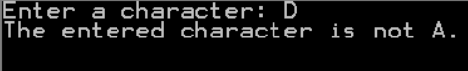

Task 03:

Now, combine the first two programs and check if the entered character is “A” or not and display a message accordingly.

Code:
.MODEL SMALL
.STACK 100H
.DATA
MSG1 DB "Enter a character: $"
MSG2 DB "The entered character is A: $"
MSG3 DB "The entered character is not A: $"
.CODE
MAIN PROC
MOV AX,@DATA
MOV DS,AX
MOV AH,9
LEA DX,MSG1
INT 21H
MOV AH,1
INT 21H

CMP AL,'A'

MOV AH,2
MOV DL,0DH
INT 21H
MOV DL,0AH
INT 21H
JE LABEL1
JMP LABEL2

LABEL1:
MOV AH,9
LEA DX,MSG2
INT 21H
JMP EXIT

LABEL2:
MOV AH,9
LEA DX,MSG3
INT 21H

EXIT:
MOV AH,4CH
INT 21H
MAIN ENDP
END MAIN

Output:


Task 04:

Write an assembly language program that asks the user to input two numbers and displays the absolute difference (if the difference/subtraction is negative, it should be made positive) of the two entered numbers.

Code:
.MODEL SMALL
.STACK 100H
.DATA
MSG1 DB "Enter the first number: $"
MSG2 DB "Enter the second number: $"
MSG3 DB "The absolute difference is: $"
.CODE
MAIN PROC
MOV AX,@DATA
MOV DS,AX

MOV AH,9
LEA DX,MSG1
INT 21H
MOV AH,1
INT 21H
MOV BL,AL

MOV AH,2
MOV DL,0DH
INT 21H
MOV DL,0AH
INT 21H

MOV AH,9
LEA DX,MSG2
INT 21H
MOV AH,1
INT 21H
SUB BL,AL
MOV AH,2
MOV DL,0DH
INT 21H
MOV DL,0AH
INT 21H

JS LABEL1
JMP LABEL2

LABEL1:
NEG BL

LABEL2:
MOV AH,9
LEA DX,MSG3
INT 21H
MOV AH,2
ADD BL,48
MOV DL,BL
INT 21H

EXIT:
MOV AH,4CH
INT 21H
MAIN ENDP
END MAIN

Output:
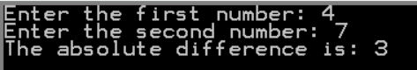

Task 05:

Write an assembly language program that asks the user to input two numbers and displays which of the numbers is greater.

Code:
.MODEL SMALL
.STACK 100H
.DATA
MSG1 DB "Enter the first number: $"
MSG2 DB "Enter the second number: $"
MSG3 DB " the first number is greater.$"
MSG4 DB " the second number is greater.$"
.CODE
MAIN PROC
MOV AX,@DATA
MOV DS,AX

MOV AH,9
LEA DX,MSG1
INT 21H
MOV AH,1
INT 21H
MOV BL,AL

MOV AH,2
MOV DL,0DH
INT 21H
MOV DL,0AH
INT 21H

MOV AH,9
LEA DX,MSG2
INT 21H
MOV AH,1
INT 21H
MOV CL,AL

CMP BL,CL

MOV AH,2
MOV DL,0DH
INT 21H
MOV DL,0AH
INT 21H

JG LABEL1
JMP LABEL2

LABEL1:
MOV AH,2
MOV DL,BL
INT 21H
MOV AH,9
LEA DX,MSG3
INT 21H
JMP EXIT

LABEL2:
MOV AH,2
MOV DL,CL
INT 21H
MOV AH,9
LEA DX,MSG4
INT 21H

EXIT:
MOV AH,4CH
INT 21H
MAIN ENDP
END MAIN

Output:
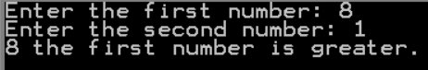

Task 06:

Write an assembly language program that asks the user to input two numbers and displays which of the numbers is smaller.

Code:
.MODEL SMALL
.STACK 100H
.DATA
MSG1 DB "Enter the first number: $"
MSG2 DB "Enter the second number: $"
MSG3 DB " the first number is smaller.$"
MSG4 DB " the second number is smaller.$"
.CODE
MAIN PROC
MOV AX,@DATA
MOV DS,AX

MOV AH,9
LEA DX,MSG1
INT 21H
MOV AH,1
INT 21H
MOV BL,AL

MOV AH,2
MOV DL,0DH
INT 21H
MOV DL,0AH
INT 21H

MOV AH,9
LEA DX,MSG2
INT 21H
MOV AH,1
INT 21H
MOV CL,AL

CMP BL,CL

MOV AH,2
MOV DL,0DH
INT 21H
MOV DL,0AH
INT 21H

JB LABEL1 ; or JL LABEL!
JMP LABEL2

LABEL1:
MOV AH,2
MOV DL,BL
INT 21H
MOV AH,9
LEA DX,MSG3
INT 21H
JMP EXIT

LABEL2:
MOV AH,2
MOV DL,CL
INT 21H
MOV AH,9
LEA DX,MSG4
INT 21H

EXIT:
MOV AH,4CH
INT 21H
MAIN ENDP
END MAIN

Output:
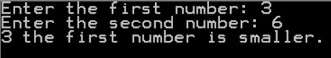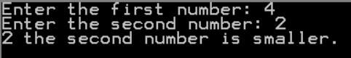

Task 07:

Write an assembly language program that asks the user to input two numbers and checks if the first number is greater or the second number is greater or both are equal.

Code:
.MODEL SMALL
.STACK 100H
.DATA
MSG1 DB "Enter the first number: $"
MSG2 DB "Enter the second number: $"
MSG3 DB " the first number is greater.$"
MSG4 DB " the second number is greater.$"
MSG5 DB "Both numbers equal.$"
.CODE
MAIN PROC
MOV AX,@DATA
MOV DS,AX

MOV AH,9
LEA DX,MSG1
INT 21H
MOV AH,1
INT 21H
MOV BL,AL

MOV AH,2
MOV DL,0DH
INT 21H
MOV DL,0AH
INT 21H

MOV AH,9
LEA DX,MSG2
INT 21H
MOV AH,1
INT 21H
MOV CL,AL

CMP BL,CL

MOV AH,2
MOV DL,0DH
INT 21H
MOV DL,0AH
INT 21H

JG LABEL1 ; jump if grater
JL LABEL2 ; jump if less

MOV AH,9 ; if equal
LEA DX,MSG5
INT 21H
JMP EXIT

LABEL1:
MOV AH,2
MOV DL,BL
INT 21H
MOV AH,9
LEA DX,MSG3
INT 21H
JMP EXIT

LABEL2:
MOV AH,2
MOV DL,CL
INT 21H
MOV AH,9
LEA DX,MSG4
INT 21H

EXIT:
MOV AH,4CH
INT 21H
MAIN ENDP
END MAIN

Output:
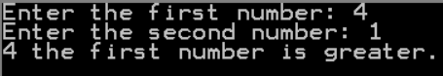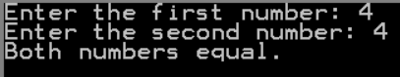

Task 08:

Write a program that reads three numbers from keyboard and prints the greatest number.

Code:
.MODEL SMALL
.STACK 100H
.DATA
MSG1 DB "Enter the first number: $"
MSG2 DB "Enter the second number: $"
MSG3 DB "Enter the third number: $"
MSG4 DB " the first number is greater.$"
MSG5 DB " the second number is greater.$"
MSG6 DB " the third number is greater.$"
MSG7 DB "All three numbers are equal.$"
.CODE
MAIN PROC
MOV AX,@DATA
MOV DS,AX

MOV AH,9
LEA DX,MSG1
INT 21H
MOV AH,1
INT 21H
MOV BL,AL
MOV AH,2
MOV DL,0DH
INT 21H
MOV DL,0AH
INT 21H

MOV AH,9
LEA DX,MSG2
INT 21H
MOV AH,1
INT 21H
MOV CL,AL

MOV AH,2
MOV DL,0DH
INT 21H
MOV DL,0AH
INT 21H

; third no
MOV AH,9
LEA DX,MSG3
INT 21H
MOV AH,1
INT 21H
MOV CH,AL

CMP BL,CL

MOV AH,2
MOV DL,0DH
INT 21H
MOV DL,0AH
INT 21H

JG LABEL1 ; jump if grater BL is greater than CL
JL LABEL2 ; jump if less BL is Less than CL

CMP BL,CH ; if both BL and CL are equal then compare BL with CH

JG LABEL1
JL LABEL3

MOV AH,9 ; if all are equal
LEA DX,MSG7
INT 21H

JMP EXIT

LABEL1: ; if BL is grater
CMP CH,BL
JG LABEL3
MOV AH,2
MOV DL,BL
INT 21H
MOV AH,9
LEA DX,MSG4
INT 21H
JMP EXIT

LABEL2: ; if CL is grater
CMP CH,CL
JG LABEL3
MOV AH,2
MOV DL,CL
INT 21H
MOV AH,9
LEA DX,MSG5
INT 21H
JMP EXIT

LABEL3: ; if CH is grater
MOV AH,2
MOV DL,CH
INT 21H
MOV AH,9
LEA DX,MSG6
INT 21H

EXIT:
MOV AH,4CH
INT 21H
MAIN ENDP
END MAIN

Output:
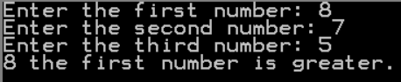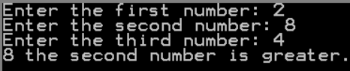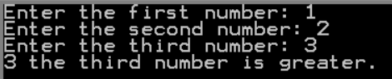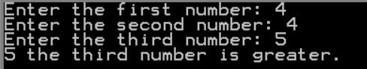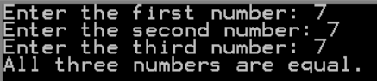

Task 09:

Write a program that reads three numbers from keyboard and print the smallest number.

Code:
.MODEL SMALL
.STACK 100H
.DATA
MSG1 DB "Enter the first number: $"
MSG2 DB "Enter the second number: $"
MSG3 DB "Enter the third number: $"
MSG4 DB "The Smallest number is: $"
MSG5 DB "ALL numbers are equal.$"
.CODE
MAIN PROC
MOV AX,@DATA
MOV DS,AX

MOV AH,9
LEA DX,MSG1
INT 21H
MOV AH,1
INT 21H
MOV BL,AL

MOV AH,2
MOV DL,0DH
INT 21H
MOV DL,0AH
INT 21H

MOV AH,9
LEA DX,MSG2
INT 21H
MOV AH,1
INT 21H
MOV CL,AL

MOV AH,2
MOV DL,0DH
INT 21H
MOV DL,0AH
INT 21H

; third no
MOV AH,9
LEA DX,MSG3
INT 21H
MOV AH,1
INT 21H
MOV CH,AL

CMP BL,CL

MOV AH,2
MOV DL,0DH
INT 21H
MOV DL,0AH
INT 21H

JL LABEL1 ; jump if BL is less than CL
JG LABEL2 ; jump if BL is greater than CL

CMP BL,CH ; if both BL and CL are equal

JL LABEL1 ; if BL is less than CH
JG LABEL3 ; if CH is less than

MOV AH,9 ; if all of them are equal
LEA DX,MSG5
INT 21H
JMP EXIT

LABEL1: ; if BL is grater
CMP CH,BL
JL LABEL3
MOV BH,BL
JMP LABEL4

LABEL2: ; if CL is grater
CMP CH,CL
JL LABEL3
MOV BH,CL
JMP LABEL4

LABEL3: ; if CH is grater
MOV BH,CH

LABEL4: ; print
MOV AH,9
LEA DX,MSG4
INT 21H
MOV AH,2
MOV DL,BH
INT 21H

EXIT:
MOV AH,4CH
INT 21H
MAIN ENDP
END MAIN

Output:
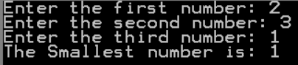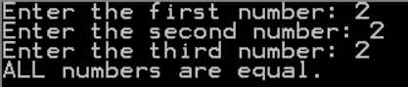

THE END

