1. **GitHub Repository:**

<https://github.com/ShaheerBKhan/COSC4353.git>

1. **Design and Development:**

So far, our design and development strategy has not changed. The plan is to first create a basic template of the web application. Then, once our fundamental requirements are met, we can continue to add on features and improve the design of the application. In doing so, it creates a constant cycle of small changes that are manageable and can be tasked out easily.

1. **Frontend Technologies and Screenshots:**

We will be using React with Javascript combined with HTML and CSS to design the frontend of our web application.

The purpose of using React with Javascript is it produces cleaner code (less repetitions) and from our research React seems to be much more maintainable alongside being faster, in the frontend, than vanilla javascript. Also, since it’s such a relevant technology there is a lot of support for it in the form of documentation and packages.

HTML and CSS are standard web application “languages” so we are using those as well.

**Screenshots and Page Responsibilities (Screenshots below):**

**Dashboard (View:** Shaheer Khan / Jose Hernandez**):**

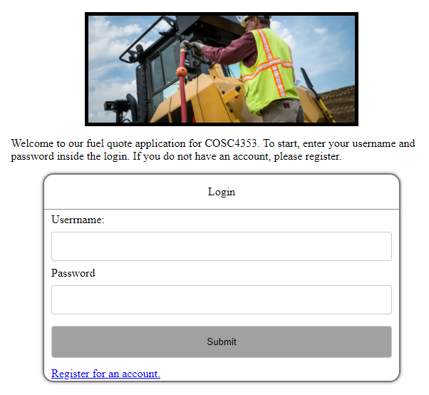

**Dashboard (Logged In) (View:** Shaheer Khan / Jose Hernandez**):**

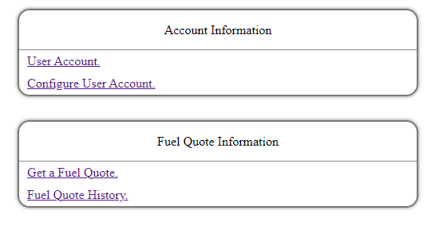

**User Registration First (Form:** Saineef Ali**):**



**User Registration Second (Form:** Saineef Ali**):**

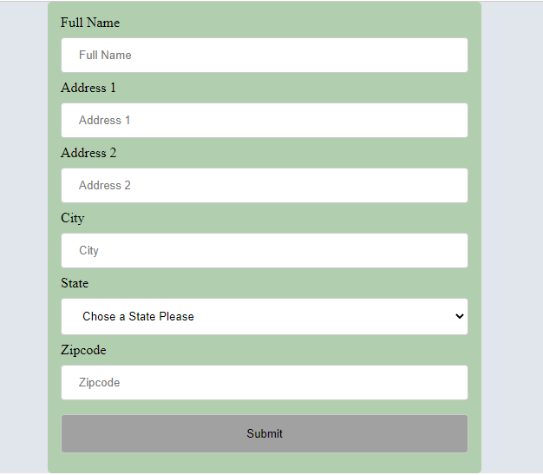

**User Account (View:** Shaheer Khan / Jose Hernandez**):**

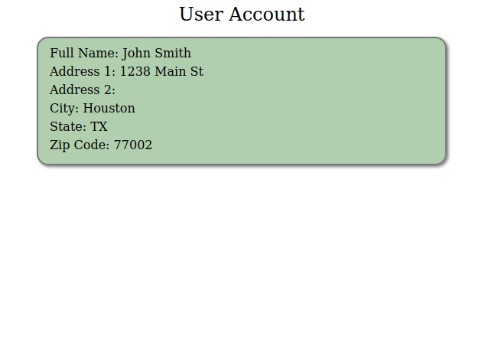

**Fuel Quote Form (Form:** Saineef Ali**):**

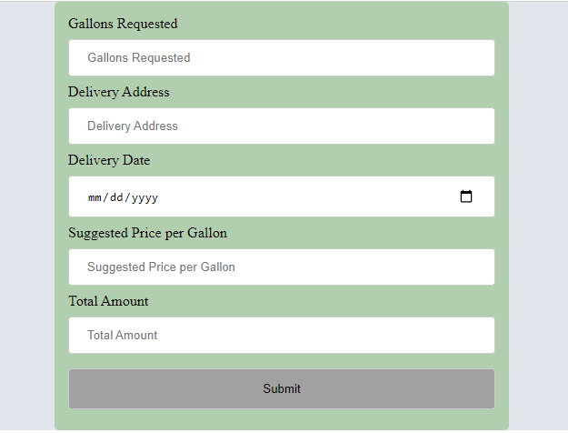

**Fuel Quote History (View:** Shaheer Khan and Jose Hernandez**):**

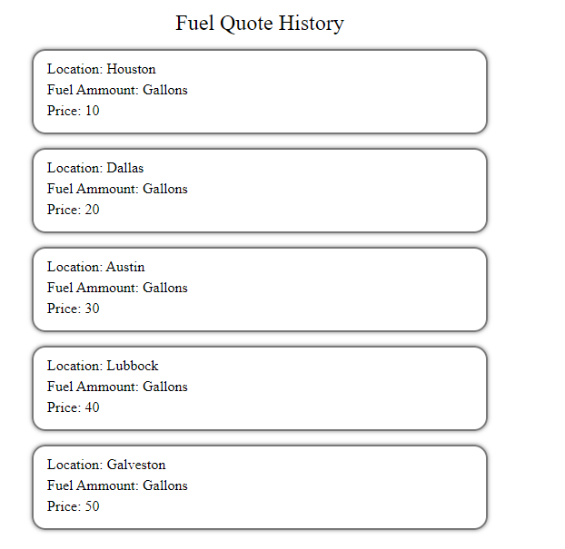

1. **Contributions:**

|  |  |  |
| --- | --- | --- |
| **Group Member Name** | **What is your contribution?** | **Discussion Notes** |
| Shaheer Khan  And  Jose Hernandez | Dashboard, Dashboard (Logged In), FuelQuoteHistory, UserAccount | Pair programming to design the viewing pages together. |
| Saineef Ali | FuelQuoteForm, UserRegistrationFirst(Form), UserRegistrationSecond(Form) | Created forms in HTML and converted them to be compatible with React. |

**Shaheer Khan pushed the code into the github repo.**