**COSC4353 Assignment 3:**

**1. Github Repository:**

<https://github.com/ShaheerBKhan/COSC4353>

**2. Backend Technologies:**

Express - Node.js.

* Originally, we were planning on using flask - python to create our backend. However, after doing a bit of research, it seemed express would fit our stack a bit better. So, we changed our project design to using Express - node.js.

**Code Coverage (Metrics):**

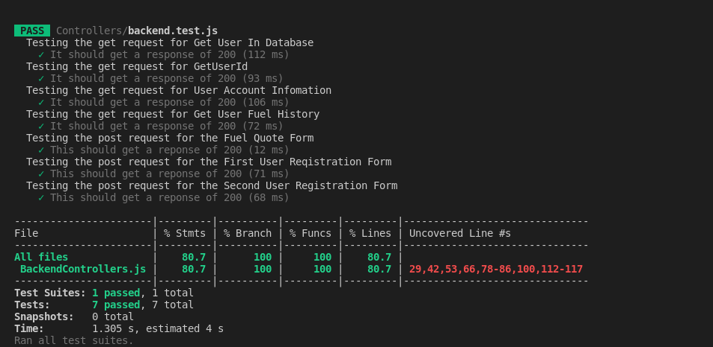

**3. Contributions:**

| Group Member Name | What is your contribution? | Discussion Notes |
| --- | --- | --- |
| Shaheer Khan | Connecting the Backend and Frontend using api’s.  (Found inside FrontendController.js and BackendController.js) | Decided the change from flask - python to express - node.js. |
| Jose Hernandez | Implemented unit tests and code coverage |  |
| Saineef Ali | Implement unit test and code coverage |  |

**Commits regarding connecting the backend and frontend were made using Shaheer Khan’s GitHub.**