**BAHRIA UNIVERSITY, ISLAMABAD**

**Department of Computer Science**

**CEN 444**

**Digital Image Processing**

**Lab Journal 12**

**Student Name: ____________________________**

**Enrolment No.: __________________________________**

**Title: Morphological Image Processing**

**Objectives:** To introduce fundamental morphological operations such as dilation and erosion and  
using them in combination: opening and closing. To  
perform morphological operations on an image in Python and extracting image components  
that are useful in representing and describing shapes of a region.

**Tools Used:** Python



**Task 1**

Read the image ‘eight.tif’. Write a function named ‘myMorphology’ to extract the boundaries of coins from the read image.   
[HINTS]:  
**1. First close the image then perform erosion.  
2. Take the difference of two images to find boundaries.**

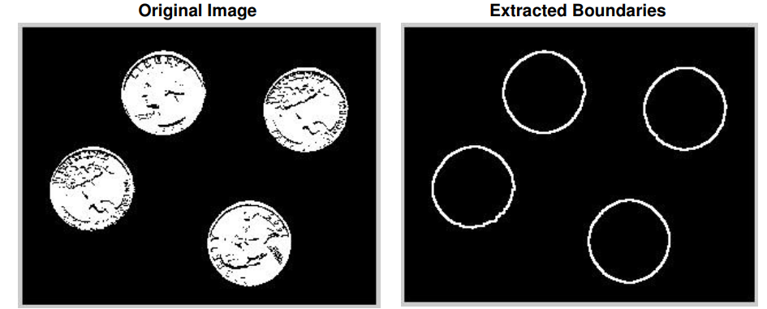

**Task 2**

Read the image ‘lines.png’. Use the opening operator to separate horizontal and vertical lines.

[HINTS]: Experiment with structuring elements of sizes 7x3, 9x3, 11x3 etc. to remove horizontal lines. Use the transpose of these structuring elements to eliminate vertical lines.

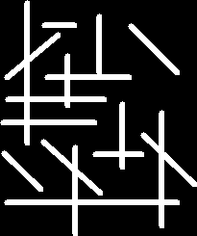

**Task 3**

You are provided with a printed document image (Image.png). You need to find the approximate number of lines and words in the given image.  
Hints:

* Binarize the image
* dilation with a horizontal structuring element to merge all characters in a line.
* Apply connected component labeling algorithm (connected component) to find the number of lines.
* Use a smaller horizontal structuring element to merge characters in a word together and again use the CC labeling algorithm to find the number of words in the image.

**Task 4**

Create an image through paint, snipping or even your mobile. The image should have a white background and your name written in it as foreground. Detect the text in the image and make a bounding box around it is using morphological operations.