**BAHRIA UNIVERSITY, ISLAMABAD**

**Department of Computer Science**

**CEN 444**

**Digital Image Processing**

**Lab Journal 5**

**Student Name: ____________________________**

**Enrolment No.: __________________________________**

**Title: Green Screen Effect, Monadic and Diadic Image Processing.**

**Objectives:** To introduce the basic concepts of image processing including monadic image processing operations and diadic image processing operations. Learning about green screen effect and implementing programs using the green screen effect to manipulate images and their backgrounds.

**Tools Used:** Jupyter notebook

**Task 1**

• **Brightness Adjustment**

Use OpenCV to adjust the brightness of the image.

*Hint: Increase pixel values to brighten or decrease to darken.*

• **Contrast Adjustment**

Implement contrast adjustment using OpenCV.

*Hint: Use the formula:  
 new_pixel = alpha * pixel + beta where alpha controls contrast.*

• **Gamma Correction**

Perform gamma correction on the image.

*Hint: Use the formula output_pixel = input_pixel^(1/gamma).*

• **Inverse Transformation (Negative)**

Convert the image to its negative.

*Hint: Subtract each pixel value from 255.*

**Task 2**

Implement the following diadic operations on colored images of your choice. Explain the effect of each operation on the image in one line with the output.

1. Addition
2. Subtraction
3. Multiplication
4. Division

**Task 3**

Green Screen Effect: Replace the background of the given image with three other backgrounds of your choice. Do NOT use library, do NOT write code in form of a complex functions (which are available on internet). Write the code from scratch using the method taught ONLY.

# **Algorithm Steps (Pseudocode):**

1. **Load foreground image** (green screen image) and **background image**.
2. **Convert** the foreground image from **BGR** to **HSV**.
3. **Define the HSV range** for green:
   * lower_green = [35, 100, 100]
   * upper_green = [85, 255, 255]
4. **Create a mask** to detect the green color:
   * mask = cv2.inRange(hsv_image, lower_green, upper_green)
5. **Invert the mask** to get the object:
   * mask_inv = cv2.bitwise_not(mask)
6. **Extract the object** (foreground) without the green background:
   * fg_part = cv2.bitwise_and(foreground_image, foreground_image, mask=mask_inv)
7. **Extract the corresponding region** from the background image:
   * bg_part = cv2.bitwise_and(background_image, background_image, mask=mask)
8. **Combine** the foreground and background:
   * final_image = cv2.add(fg_part, bg_part)
9. **Display or save** the final result.

**Task 4**

Vehicle Motion detection: The following two pictures are video frames from the same video which are fraction of seconds apart. There is almost no difference in them to naked eye. Find out which signal is open for the traffic to move i.e. on which lanes the traffic is moving on the road. Use a suitable image processing operation on these to answer the question.

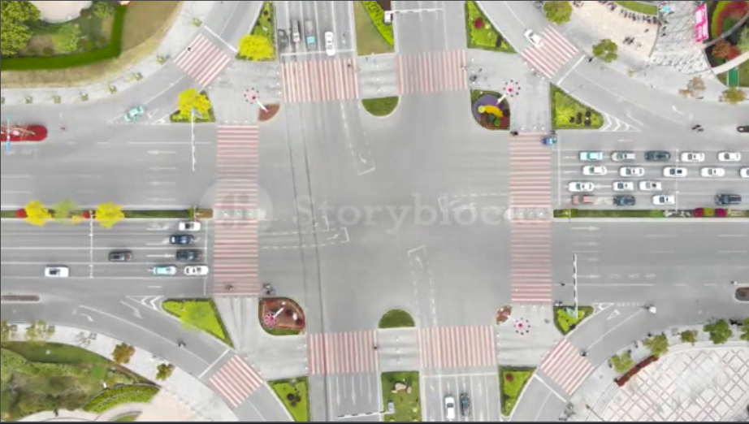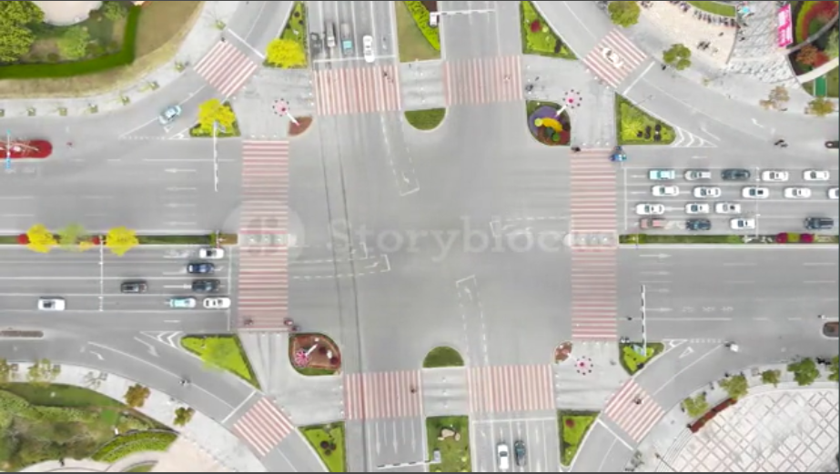

**Submission Date: Signature**