**Objectives**

* Demonstrate the concept of Continuous Integration and Continuous deployment on Windows Azure
  + Creation of resource - DevOps project, Steps involved in DevOps project creation - Choose the GIT repo, Select the framework, Provide project detail, Provision the application. For test purpose, choose the inbuilt code type selection option to proceed, not to use Global git repository

1. **DevOps project creation**

Logon to the Azure portal. Click on ‘Create a resource’

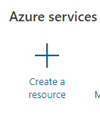

Scroll down the page to choose the item ‘DevOps starter’

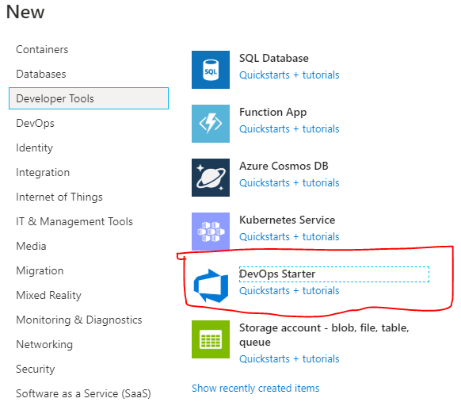

Choose the default option .NET and click ‘Next’

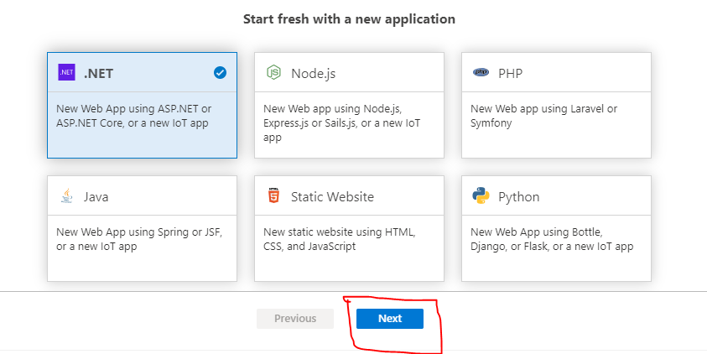

Provide the detail of the app in the next screen.

Project name: **DNAzure-TestWebApp**

Click on ‘Additional Settings’ to view the additional setting detail. The resource group will be the name of the project appended with ‘-rg’. This resource group contains the AppService plan & other components.

A new resource group gets created. This is where the DevOps project gets stored.

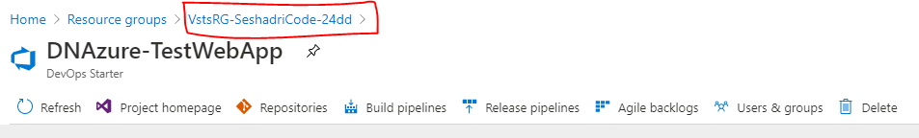

Click ‘Done’ to complete the process.

There will be a notification on the resource creation on the top blue navigation bar on the right side.

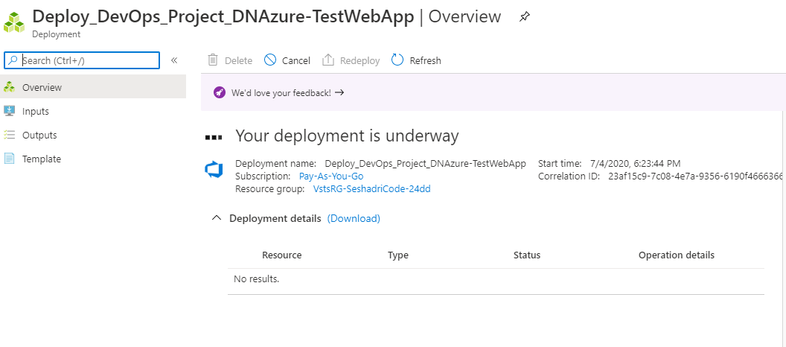

The above screenshot is of the deployment in-progress.

Once done, expand the ‘Deployment details’ to navigate to the resource.

The deployment shows the CI/CD pipeline. In few minutes the Continuous Integration and Continuous deployment will be complete.

‘Refresh’ link can be clicked to check the deployment progress.

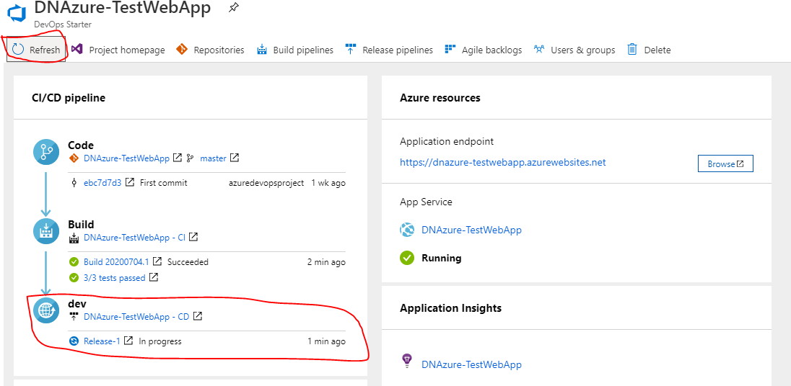

Once the release status changes to ‘Succeeded’, click the ‘Browse’ button on the right pane under the title ‘Azure resources’

This opens the website that is created using MVC template.

**Output>>**

